

**CAPSTONE PROJECT 1**

**ROOMY SYSTEM MANAGEMENT**

**Product Backlog Document**

Version 1.1

Date: Aug 29, 2018

**MENTOR** **: MSc. Phan Van Son**

**PROJECT TEAM** : **Blue team**

**TEAM’S MEMBER** : Huynh Quoc Nhat

Ho Trung Anh

Le Hoang Quoc

Huynh Vu Nhat Lan

Huynh Thi Thanh Van

**INTERNATIONAL SCHOOL**

**Project Information**

|  |  |  |  |  |  |
| --- | --- | --- | --- | --- | --- |
| **Project acronym** | RMY | | | | |
| **Project Tittle** | Roomy | | | | |
| **Start Date** | Aug 15, 2018 | | **End Date** | | Dec 5, 2018 |
| **Lead Institution** | International School, Duy Tan University | | | | |
| **Project Mentor & contact details** | MSc. Son, Phan Van  Email: [sonpvs@duytan.edu.vn](mailto:sonpvs@duytan.edu.vn)  Tel: 01675373265 | | | | |
| **Scrum Master & contact details** | Huynh Vu Ha Lan  Email: [huynhvuhalan.97@gmail.com](mailto:huynhvuhalan.97@gmail.com)  Tel: 0989342173 | | | | |
| **Team members** | **Name** | **Email** | | **Tel** | |
| Le Hoang Quoc | [quocle28292@gmail.com](mailto:quocle28292@gmail.com) | | 01657708105 | |
| Huynh Quoc Nhat | [huynhquocnhat97@gmail.com](mailto:huynhquocnhat97@gmail.com) | | 0905740256 | |
| Ho Trung Anh | [hotrunganhht1912@gmail.com](mailto:hotrunganhht1912@gmail.com) | | 09055258534 | |
|  | Huynh Thi Thanh Van | [thanhvandb97@gmail.com](mailto:thanhvandb97@gmail.com) | | 01229444661 | |

**Product Backlog Document**

|  |  |  |  |
| --- | --- | --- | --- |
| **Document Title** | Product Backlog Document |  |  |
| **Reporting Period** | Aug 29, 2018 |  |  |
| **Author(s) &**  **project** | Huynh Thi Thanh Van,  Huynh Vu Ha Lan | |  |
| **Team Information** | **Name** | **Role** |  |
| Le Hoang Quoc | Member |  |
| Huynh Quoc Nhat | Member |  |
| Ho Trung Anh | Member |  |
|  | Huynh Thi Thanh Van | Member |  |
|  | Huynh Vu Ha Lan | Scrum Master |  |
| **Date** | Sep 08, 2018 | **Filename** | Productbacklog_Ver1.1.docx |
| **Access** | Project and CMU Program | |  |

|  |  |  |
| --- | --- | --- |
| Document History | | |
| **Version** | **Date** | **Comments** |
| V1.0 | Aug 29, 2018 | Draft for Document |
| V1.1 | Sep 08, 2018 | Update Document |

**Document Approvals**

The following signatures are required for approval of this document.

|  |  |  |
| --- | --- | --- |
| MSc. Vo Van Son  *Mentor* |  | Date: |
| Huynh Vu Ha Lan  *Scrum Master* |  | Date: |

Table of Contents

1. Introduction 6

1.1. Purpose 6

1.2. Scope 6

1.3. References 6

2. Product Backlog 7

2.1. Product Backlog Specification 7

3. Breakdown into Sprint Backlog: 15

4. Constraint 24

5. Stack holders and User Descriptions Summary 24

1. **Introduction**

The agile product backlog in Scrum is a prioritized features list, containing short descriptions of all functionality desired in the product. When applying Scrum, it’s not necessary to start a project with a lengthy, upfront effort to document all requirements. Typically, a Scrum team and its product owner begin by writing down everything they can think of for agile backlog prioritization. This agile product backlog is almost always more than enough for a first sprint. The Scrum product backlog is then allowed to grow and change as more is learned about the product and its clients.

* 1. **Purpose**
* Provide a prioritized features list, containing short description of all functionality desired in the product.
* Lists everything that the product owner and Scrum team feels should be included in the software they are developing.
  1. **Scope**
* Lists the user’s role.
* Write all the user’s requirements.
* Lists some main function of website.
* Short description of all the functionality desired in the product.
* Given the priority of each feature and function of the product.
  1. **References**

***Table 1: References***

|  |  |  |
| --- | --- | --- |
| **No** | **Reference** | **Note** |
| 1 | <http://agilebench.com/blog/the-product-backlog-for-agile-teams> | How to create product backlog |
| 2 | <http://www.mountaingoatsoftware.com/agile/scrum/product-backlog/example/> | Product Backlog Example |

1. **Product Backlog**
   1. **Product Backlog Specification:**

**Priority and Estimates**

Priorities are set from 1 to 3.

◦ The maximum priorities are 1

◦ The minimum priorities are 3

◦ Priorities of some user stories can be the same with others

◦ If a user story has dependencies, it must have lower priority than its dependencies

[**Work breakdown structure**](https://en.wikipedia.org/wiki/Work_breakdown_structure)

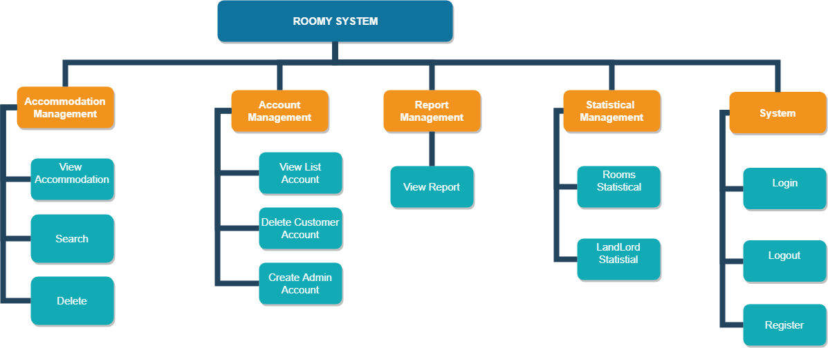

*Figure 1. Administrator Diagram*

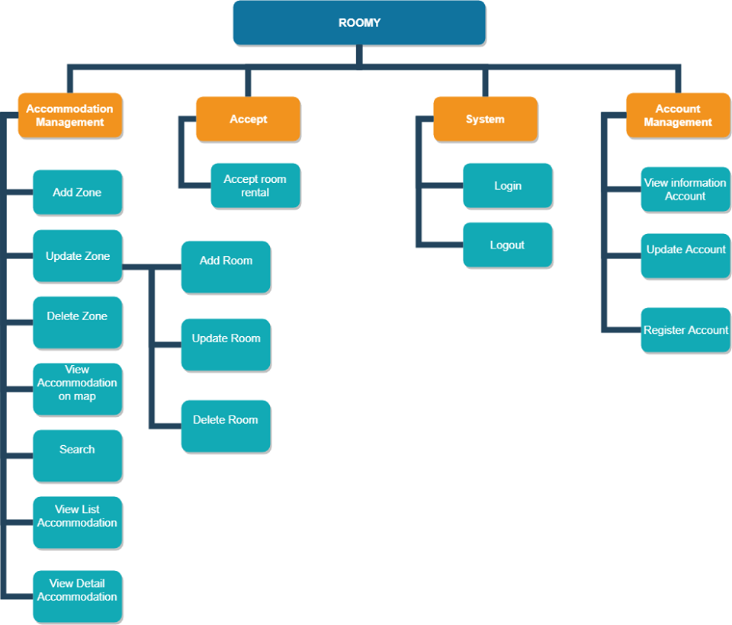

***Figure 2. Landlord Diagram***

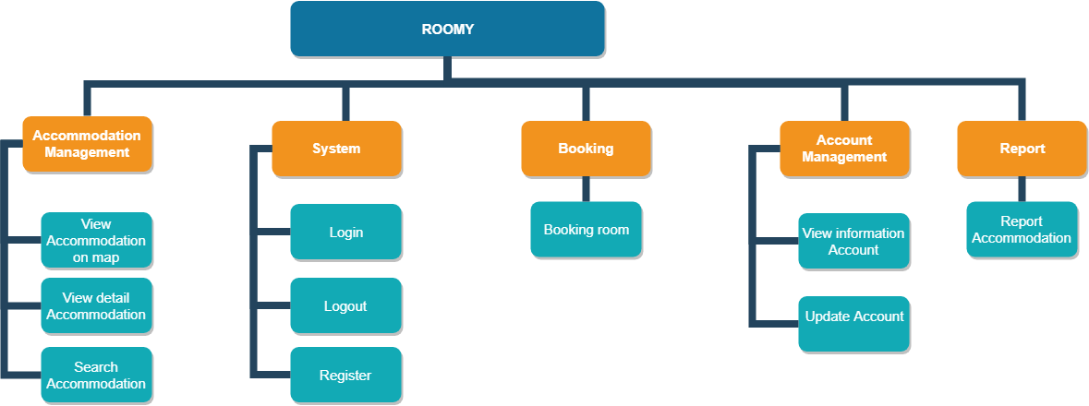

***Figure 2. Renter Diagr***

***Table 1: Product Backlog Specification (****Administrator****)***

|  |  |  |  |  |  |  |
| --- | --- | --- | --- | --- | --- | --- |
| **ID** | **Theme** | | **As a/an** | **I want to** | **So that** | **Priority** |
| **System** | | | | | | |
| PB01 | | Login | Administrator | Access to the system. | I can use the system for my goal. | 3 |
| PB02 | | Log out | Administrator | Log out my account from system. | I can stop using system and I can log in later. | 3 |
| **Account Management** | | | | | | |
| PB03 | | View list of users account | Administrator | View all user in the system. | I can get all the information of the user. | 2 |
| PB04 | | Delete user's account | Administrator | Delete any account in the system | I can delete the user’s account when users have not used for a long time. | 2 |
| PB05 | | Create the new Administrator account | Administrator | Create for the new Admin account. | I can create an account for the new admin to manage the system with me. | 2 |
| **Accommodation Management** | | | | | | |
| PB05 | | View list accommodation | Administrator | View list accommodation entered by Lanlord | I can see the list of zones and rooms of that zone entered by the Landlord | 2 |
| PB06 | | Search accommodation | Administrator | Searching list of accommodation in the system by ID. | I want to search an accommodation base on ID. | 2 |
| PB07 | | Delete accommodation | Administrator | Delete any accommodation in the system. | When accommodation had a lot of reports, I want to delete that accommodation from the system. | 2 |
|  | |  |  |  |  |  |
| **Report Management** | | | | | | |
| PB08 | | View list report | Administrator | View all user reports about accommodation. | I want to see all the reports on the accommodation based on the user response. | 3 |
| **Statistical** | | | | | | |
| PB09 | | Statistics about Lanlord account | Administrator | Listing to have statistics of Landlords account | I want to list to have statistics of all landlords accounts in the system | 1 |
| PB10 | | Statistics about accommodation | Administrator | Listing to have statistics of accommodation | I want to list to have statistics of all accommodations in the system and total of room. | 1 |

***Table 2: Product Backlog Specification (Landlord)***

|  |  |  |  |  |  |
| --- | --- | --- | --- | --- | --- |
| **ID** | **Theme** | **As a/an** | **I want to** | **So that** | **Priority** |
| **System** | | | | | |
| PB01 | Login | Landlord | Access to the system. | I can use the system for my goal. | 1 |
| PB02 | Logout | Landlord | Log out my account from system. | I can stop using the system and I can log in later | 1 |
| PB03 | Register | Landlord | Register account access to the system | I can register account to access system and use the system for my goal. | 3 |
| **Account Management** | | | | | |
| PB04 | View information account | Landlord | View detail account information of myself. | I can know information of me such as username, password, name, address, phone number… | 2 |
| PB05 | Update account | Landlord | Edit account information of myself or password | I can edit any account information such as username, name, address, phone number… or password | 2 |
| **Accommodation Management** | | | | | |
| PB06 | View accommodation on map | Landlord | View all accommodation on map | I want to see all the accommodation on the map based on location I have chosen. | 1 |
| PB07 | View detail accommodation | Landlord | View detailed information about the accommodation I selected. | I want view detailed information about the accommodation I selected: address, status, description,… on system. | 1 |
| PB08 | Search accommodation | Landlord | Search information about accommodation. | I want to see accommodations information by searching based on location, area of them. | 1 |
| PB09 | Add zone | Landlord | Add a new zone. | I want to add new the zone in the system if I need to. | 1 |
| PB07 | Update zone | Landlord | Update zone. | I want to update zone in the system when I need. | 1 |
| PB08 | Delete zone | Landlord | Delete any zone | I want to delete zone in the system when it don’t longer active. | 1 |
|  | Add room | Landlord | Add a new room | I want to add the rooms for my every zone in the system if I need to. | 1 |
|  | Update room | Lanlord | Update information room | I want to update the room for my every zone in the system when I need change | 1 |
|  | Delete room | Landlord | Delete any zone | I want to delete room of my every zone in the system when it doesn't longer active | 1 |
|  | View list accommodation | Landlord | View detail list accommodation. | I want to see detail about my accommodation after I entered. | 1 |
| **Accept** | | | | | |
| PB08 | Accept room rental | Landlord | Accept room rental | I would like to confirm to rent accommodation during the renter booking accommodation | 1 |

***Table 3: Product Backlog Specification (Renter)***

|  |  |  |  |  |  |
| --- | --- | --- | --- | --- | --- |
| **ID** | **Theme** | **As a/an** | **I want to** | **So that** | **Priority** |
| **Accommodation** | | | | | |
| PB01 | View accommodation on map | Renter | View all accommodation on map. | I want to see all the accommodation on the map based on location I have chosen. | 1 |
| PB02 | View detail accommodation | Renter | View detailed information about the accommodation I selected | I want to view detailed information about the accommodation I selected: address, status, description,… on system. | 1 |
|  | Search accommodation | Renter | Search information about accommodation. | I want to see accommodations information by searching based on location, area of them. | 1 |
| **System** | | | | | |
| PB03 | Login | Renter | Access to the system. | I can use my username/password to login into the system, I can use the function of the system. | 3 |
| PB05 | Logout | Renter | Log out my account from system. | I can stop using the system and I can log in later | 3 |
|  | Register | Renter | Register account access to the system | I can register account to access system and use the system for my goal. | 3 |
| **Account Management** | | | | | |
| PB06 | View information account | Admin | View detail account information of myself. | I can know information of me such as username, password, name, address, phone number… | 2 |
| PB07 | Update account | Admin | Edit account information of myself or password | I can edit any account information such as username, name, address, phone number… or password | 2 |
| Booking | | | | | |
| PB09 | Booking a room | Admin | Booking a room | I want to book an accommodation before I come to see that accommodation. | 1 |
| **Report** | | | | | |
| PB11 | Sent report to Admin | Admin | Sent report to Admin about accommodation | I can report to the Admin about the quality of accommodation | 1 |

1. **Breakdown into Sprint Backlog:**

|  |  |  |  |  |
| --- | --- | --- | --- | --- |
| **No.** | **Task Name** | Start | Finish | **Effort** |
| 1 | **Initial** | Aug 17, 18 | Aug 25, 18 |  |
| 1.1 | Gathering Requirement | Aug 17, 18 | Aug 18, 18 | 8 |
| 1.2 | Create Proposal Document | Aug 20, 18 | Aug 25, 18 | 20 |
| 1.2.1 | Introduction | Aug 20, 18 | Aug 20, 18 | 2 |
| 1.2.2 | Project Overview | Aug 20, 18 | Aug 20, 18 | 4 |
| 1.2.3 | Stakeholder and User Descriptions | Aug 21, 18 | Aug 25, 18 | 8 |
| 1.2.4 | Technical Constraints and Development process | Aug 22, 18 | Aug 23, 18 | 3 |
| 1.2.5 | Scrum Process | Aug 23, 18 | Aug 23, 18 | 1 |
| 1.2.6 | Master plan | Aug 23, 18 | Aug 24, 18 | 2 |
| 1.2.7 | Organization management | Aug 24, 18 | Aug 25, 18 | 2 |
| 2 | **Start Up** | Aug 25, 18 | Sep 05, 18 |  |
| 2.1 | Project’s Meeting | Aug 25, 18 | Aug 25, 18 | 5 |
| 2.2 | Create User Stories Document | Aug 26, 18 | Aug 28, 18 | 12 |
| 2.3 | Create Product Backlog Document | Aug 27, 18 | Aug 29, 18 | 8 |
| 2.4 | Review Document | Aug 29, 18 | Aug 29, 18 | 6 |
| 2.5 | Create Project Plan Document | Aug 30, 18 | Aug 31, 17 | 6 |
| 2.7 | Create Architecture Design Document | Sep 4, 18 | Sep 5, 18 | 5 |
| 2.8 | Review Document | Sep 5, 18 | Sep 5, 18 | 3 |
| **3** | **Development** | Sep 6, 18 | Nov 30, 18 |  |
| **3.1** | **Sprint 1 (Renter)** | Sep 6, 18 | Oct 3, 18 |  |
| 3.1.1 | Sprint Planning Meeting | Sep 6, 18 | Sep 6, 18 | 4 |
| 3.1.2 | Daily Meeting | Sep 6, 18 | Oct 3, 18 | 15 mins |
| 3.1.3 | Create Sprint Backlog | Sep 7, 18 | Sep 7, 18 | 3 |
| 3.1.4 | Create Test Plan document for Sprint 1 | Sep 8, 18 | Sep 8, 18 | 2 |
| 3.1.5 | Create Database document for Sprint 1 | Sep 8, 18 | Sep 12, 18 | 3 |
| 3.1.6 | Review Database document | Sep 12, 18 | Sep 12,18 | 3 |
| **3.1.7** | **Design user interface** |  |  |  |
| 3.1.7.1 | Design user interface of view accommodation on map | Sep 13, 18 | Sep 13, 18 | 2 |
| 3.1.7.2 | Design user interface of Register Account | Sep 14, 18 | Sep 14, 18 | 0.5 |
| 3.1.7.3 | Design user interface of Login | Sep 14, 18 | Sep 14, 18 | 1 |
| 3.1.7.4 | Design user interface of View Accommodation detail | Sep 15, 18 | Sep 15, 18 | 3 |
| 3.1.7.5 | Design user interface of Booking Accommodation | Sep 15, 18 | Sep 15, 18 | 1 |
| 3.1.7.6 | Design user interface of Booking Accommodation | Sep 15, 18 | Sep 15, 18 | 0.5 |
| **3.1.8** | **Test Design Interface** | **Sep 16, 18** | **Sep 17, 18** |  |
| 3.1.8.1 | Test Design user interface of view accommodation on map | Sep 16, 18 | Sep 16, 18 | **2** |
| 3.1.8.2 | Test Design user interface of Register Account | Sep 16, 18 | Sep 16, 18 | **1** |
| 3.1.8.3 | Test Design user interface of Login | Sep 17, 18 | Sep 17, 18 | 1 |
| 3.1.8.4 | Test Design user interface of View detail Accommodation | Sep 17, 18 | Sep 17, 18 | 2 |
| 3.1.8.5 | Test Design user interface of Booking Accommodation | Sep 17, 18 | Sep 17, 18 | 2 |
| 3.1.8.6 | Test Design user interface of Log-out | Sep 17, 18 | Sep 17, 18 | 1 |
| **3.1.9** | **Coding** |  |  |  |
| 3.1.9.1 | Code front-end for view accommodation on map | Sep 18, 18 | Sep 19, 18 | **3** |
| 3.1.9.2 | Code back-end for view accommodation on map | Sep 19, 18 | Sep 21, 18 | **3** |
| 3.1.9.3 | Code front-end for Register Account | Sep 18, 18 | Sep 19, 18 | **1.5** |
| 3.1.9.4 | Code back-end for Register Account | Sep 19, 18 | Sep 21, 18 | **2** |
| 3.1.9.5 | Code front-end for Login | Sep 18, 18 | Sep 18, 18 | **1.5** |
| 3.1.9.6 | Code back-end for Login | Sep 19, 18 | Sep 19, 18 | **2** |
| 3.1.9.7 | Code front-end View detail accommodation | Sep 19, 18 | Sep 21, 18 | **3** |
| 3.1.9.8 | Code Back-end for View list accommodation | Sep 21, 18 | Sep 22, 18 | **3** |
| 3.1.9.9 | Code front-end Search | Sep 20, 18 | Sep 20, 18 | **2** |
| 3.1.9.10 | Code back-end Search | Sep 21, 18 | Sep 22, 18 | **3** |
| 3.1.9.11 | Code back-end for Logout | Sep 22, 18 | Sep 22, 18 | **1** |
| **3.1.10** | **Testing** |  |  | **6** |  |  |  |  |  |
| 3.1.10.1 | Design Test Case for accommodation on map | Sep 23, 18 | Sep 23, 18 | 2 |  |  |  |  |  |
| 3.2.10.2 | Design Test Case for Register | Sep 23, 18 | Sep 24, 18 | 1 |  |  |  |  |  |
| 3.1.10.3 | Design Test Case for Login | Sep 24, 18 | Sep 24, 18 | 1 |  |  |  |  |  |
| 3.1.10.4 | Design Test Case for View detail Accommodation | Sep 24, 18 | Sep 25, 18 | 2 |  |  |  |  |  |
| 3.1.10.5 | Design Test Case for Search | Sep 24, 18 | Sep 25, 18 | 2 |  |  |  |  |  |
| 3.1.10.5 | Design Test Case for Log-out | Sep 24, 18 | Sep 25, 18 | 2 |  |  |  |  |  |
| **3.2.11** | **Fix Bug & Release** |  |  |  |
| 3.2.11.1 | Implement Test Case | Sep 24, 18 | Sep 28, 18 | 5 |
| 3.1.11.2 | Fix bugs and Report | Sep 28, 18 | Sep 30, 18 | 5 |
| 3.1.11.3 | Retest | Oct 1, 18 | Oct 2, 18 | 3 |
| 3.1.11.4 | Closing | Oct 3, 18 | Oct 3, 18 | 1 |
| **3.2** | **Sprint 2(Renter and Landlord)** | **Oct 4, 18** | **Oct 31, 18** |  |
| 3.2.1 | Sprint Planning Meeting | Oct 4, 18 | Oct 4, 18 | 4 |
| 3.2.2 | Daily Meeting | Oct 5, 18 | Oct 31, 18 | 15 mins |
| 3.2.3 | Create Sprint Backlog | Oct 5, 18 | Oct 5, 18 | 1 |
| 3.2.4 | Create Test Plan document for Sprint 2 | Oct 5, 18 | Oct 5, 18 | 1 |
| 3.2.5 | Create Database document for sprint 2 | Oct 5, 18 | Oct 6, 18 | 2 |
| 3.2.6 | Review Document | Oct 6, 18 | Oct 7, 18 | 2 |
| **3.2.4** | **Design user interface** |  |  |  |
| 3.2.4.1 | Design user interface of Booking room (Renter) | Oct 6, 18 | Oct 6, 18 | 2 |
| 3.2.4.2 | Design user interface of Update account( Renter) | Oct 6 , 18 | Oct 6, 18 | 1 |
| 3.2.4.3 | Design user interface of Add accommodation (Landlord) | Oct 6, 18 | Oct 7, 18 | 2 |
| 3.2.4.4 | Design user interface of Update accommodation (Landlord) | Oct 6, 18 | Oct 7, 18 | 0.5 |
| 3.2.4.5 | Design user interface of Delete accommodation (Landlord) | Oct 6, 18 | Oct 7, 18 | 0.5 |
| 3.2.4.6 | Design user interface of Search accommodation (Landlord) | Oct 7, 18 | Oct 8, 18 | 1 |
| 3.2.4.7 | Design user interface of View list accommodation (Landlord) | Oct 7, 18 | Oct 8, 18 | 2 |
| 3.2.4.8 | Design user interface of Update Account(Landlord) | Oct 8, 18 | Oct 8, 18 | 0.5 |
| 3.2.4.9 | Design user interface of View Account Information | Oct 8, 18 | Oct 8, 18 | 0.5 |
| **3.2.5** | **Coding** |  |  |  |
| 3.2.5.1 | Code front-end of Search accommodation information( Renter) | Oct 9, 18 | Oct 9, 18 | 1 |
| 3.2.5.2 | Code back-end of Search accommodation information( Renter) | Oct 10, 18 | Oct 12, 18 | 1.5 |
| 3.2.5.3 | Code front-end Add Zone (Landlord) | Oct 10, 18 | Oct 11, 18 | 1 |
| 3.2.5.5 | Code back-end of Add Zone(Landlord) | Oct 11, 18 | Oct 12, 18 | 2 |
|  | Code front-end Add Room (Landlord) | Oct 12,18 | Oct 12, 18 | 1 |
|  | Code back-end of Add Room (Landlord) | Oct 12,18 | Oct 14, 18 | 1 |
| 3.2.5.7 | Code front-end of Update Zone (Landlord) | Oct 12, 18 | Oct 12, 18 | **1** |
| 3.2.5.8 | Code back-end of Update Zone (Landlord) | Oct 14, 18 | Oct 16, 18 | **1.5** |
| 3.2.5.9 | Code front-end of Delete Zone(Landlord) | Oct 13, 18 | Oct 13, 18 | 1 |
| 3.2.5.10 | Code back-end of Delete Zone(Landlord) | Oct 14, 18 | Oct 14, 18 | 1 |
| 3.2.5.11 | Code front-end of Update Room (Landlord) | Oct 13, 18 | Oct 13, 18 | 1 |
| 3.2.5.12 | Code back-end of Update Room (Landlord) | Oct 13, 18 | Oct 14, 18 | 1 |
| 3.2.5.13 | Code front-end of Delete Room(Landlord) | Oct 14, 18 | Oct 14, 18 | 1 |
| 3.2.5.14 | Code back-end of Delete Room(Landlord) | Oct 14, 18 | Oct 15, 18 | 2 |
| 3.2.5.15 | Code front-end of View accommodation on map (Landlord) | Oct 14, 18 | Oct 15, 18 | 1 |
| 3.2.5.16 | Code back-end of View accommodation on map(Landlord) | Oct 15, 18 | Oct 17, 18 | 1.5 |
| 3.2.5.17 | Code front-end of Search accommodation (Landlord) | Oct 15, 18 | Oct 16, 18 | 1 |
| 3.2.5.18 | Code back-end of Search accommodation information (Landlord) | Oct 17, 18 | Oct 18, 18 | 2 |
| 3.2.5.19 | Code front-end of View Account Information | Oct 16, 18 | Oct 16, 18 | 1 |
| 3.2.5.20 | Code back-end View Account Information | Oct 17, 18 | Oct 17, 18 | 2 |
| 3.2.5.21 | Code front-end of Update Account | Oct 18, 18 | Oct 18, 18 | 1 |
| 3.2.5.22 | Code back-end of Update Account | Oct 18, 18 | Oct 19, 18 | 1 |
| **3.2.6** | **Testing** |  |  |  |
| 3.2.6.1 | Design test case for Booking room (Renter) | Oct 21, 18 | Oct 21, 18 | 1 |
| 3.2.6.2 | Design test case for Update account( Renter) | Oct 21, 18 | Oct 21 , 18 | 1 |
| 3.2.6.3 | Design user interface of Add accommodation (Landlord) | Oct 21, 18 | Oct 21, 18 | 1 |
| 3.2.6.4 | Design test case for Update accommodation (Landlord) | Oct 21, 18 | Oct 21, 18 | 1 |
| 3.2.6.5 | Design test case for Delete accommodation (Landlord) | Oct 21, 18 | Oct 21, 18 | 1 |
| 3.2.6.6 | Design test case for Search accommodation (Landlord) | Oct 22, 18 | Oct 22, 18 | 1 |
| 3.2.6.7 | Design test case for View list accommodation (Landlord) | Oct 22, 18 | Oct 22, 18 | 1.5 |
| 3.2.6.8 | Design test case for Update Account(Landlord) | Oct 22, 18 | Oct 22, 18 | 1 |
| 3.2.6.9 | Design test case for View Account Information | Oct 22, 18 | Oct 22, 18 | 1 |
| 3.2.6.10 | Design test case for Booking room (Renter) | Oct 22, 18 | Oct 22, 18 | 1 |
| **3.2.7** | **Fix Bug and Release** |  |  |  |
| 3.2.7.1 | Implement Test Case | Oct 23, 18 | Oct 25, 18 | 10 |
| 3.2.7.2 | Fix bugs and Report | Oct 26, 18 | Oct 29, 18 | 16 |
| 3.2.7.3 | Retest | Oct 29, 18 | Oct 30, 18 | 10 |
| 3.2.7.4 | Closing | Oct 31,18 | Oct 31, 18 | 3 |
| **3.3** | **Sprint 3 (Admin)** | Nov 1, 18 | Nov 25,18 |  |
| 3.3.1 | Sprint Planning Meeting | Nov 1, 18 | Nov 1, 18 | **4** |
| 3.3.2 | Daily Meeting | Nov 1,18 | Nov 25, 18 | **0.5** |
| 3.3.3 | Create Sprint Backlog | Nov 2, 18 | Nov 2, 18 | **2** |
| 3.3.4 | Create Test Plan document for Sprint 3 | Nov 2, 18 | Nov 3, 18 | **2** |
| 3.3.5 | Create Database document for Sprint 3 | Nov 1, 18 | Nov 3, 18 | **2** |
| 3.3.6 | Review Document | Nov 3, 18 | Nov 3, 18 | **1** |
| **3.3.4** | **Design user interface** |  |  |  |
| 3.3.4.1 | Design accept room rental | Nov 4,18 | Nov 4,18 | **1** |
| 3.3.4.2 | Design user interface of Statistic about accommodation | Nov 4, 18 | Nov 4, 18 | **1** |
| 3.3.4.3 | Design user interface of Statistic about Landlord Account | Nov 4, 18 | Nov 4, 18 | **1** |
| 3.3.4.4 | Design user interface of View List Accommodation | Nov 5, 18 | Nov 5, 18 | **1** |
| 3.3.4.5 | Design user interface of Search accommodation(Admin) | Nov 5, 18 | Nov 5, 18 | **0.5** |
| 3.3.4.6 | Design user interface of Delete Accommodation | Nov 5, 18 | Nov 5, 18 | **1** |
| 3.3.4.7 | Design user interface of accept room rental(Landlord) | Nov 5, 18 | Nov 5, 18 | 0.5 |
| 3.3.4.8 | Design user interface of accept room rental(Landlord) | Nov 5, 18 | Nov 5, 18 | 0.5 |
| 3.3.4.9 | Design User Interface of Delete User Account | Nov 5, 18 | Nov 5, 18 | 0.5 |
| 3.3.4.11 | Design user interface of View List User Account | Nov 6, 18 | Nov 6, 18 | 1 |
| 3.3.4.12 | Design User interface of Report (Renter, Landlord) | Nov 6, 18 | Nov 6, 18 | 0.5 |
| 3.3.4.13 | Design User Interface of View list Report (Admin) | Nov 6, 18 | Nov 6, 18 | 1 |
| **3.3.5** | **Coding** |  |  |  |
| 3.3.5.1 | Code front-end Statistic about accommodation | Nov 5,18 | Nov 5,18 | **1** |
| 3.3.5.2 | Code back-end Statistic about accommodation | Nov 6,18 | Nov 8,18 | **2** |
| 3.3.5.3 | Code front-end Statistic about accommodation | Nov 5, 18 | Nov 5, 18 | **1** |
| 3.3.5.4 | Code back-end of Statistic about accommodation | Nov 6, 18 | Nov 8, 18 | **1.5** |
| 3.3.5.5 | Code front-end of Statistic about Landlord Account | Nov 5, 18 | Nov 5, 18 | **0.5** |
| 3.3.5.6 | Code back-end of Statistic about Landlord Account | Nov 6, 18 | Nov 8, 18 | **1.5** |
| 3.3.5.7 | Code front-end of View List Accommodation | Nov 6, 18 | Nov 6, 18 | **1** |
| 3.3.5.8 | Code back-end of View List Accommodation | Nov 6, 18 | Nov 7, 18 | **1.5** |
| 3.3.5.9 | Code front-end of Search accommodation(Admin) | Nov 7, 18 | Nov 9, 18 | **0.5** |
| 3.3.5.10 | Code back-end of Search accommodation(Admin) | Nov 8, 18 | Nov 9, 18 | **1** |
| 3.3.5.11 | Code front-end of Delete Accommodation | Nov 6, 18 | Nov 6, 18 | **1** |
| 3.3.5.12 | Code back-end of Delete Accommodation | Nov 8, 18 | Nov 8, 18 | **1** |
| 3.3.5.13 | Code front-end of Create Account (Admin) | Nov 9, 18 | Nov 9, 18 | **1** |
| 3.3.5.14 | Code back-end of Create Account (Admin) | Nov 10, 18 | Nov 10, 18 | **1** |
| 3.3.5.15 | Code front-end of Delete Account (Admin) | Nov 7, 18 | Nov 7, 18 | **0.5** |
| 3.3.5.16 | Code back-end of Delete Account (Admin) | Nov 7, 18 | Nov 8, 18 | **1** |
| 3.3.5.17 | Code front-end of Login (Admin) | Nov 11, 18 | Nov 11, 18 | **1** |
| 3.3.5.18 | Code Back-end of Login (Admin) | Nov 11, 18 | Nov 12, 18 | **1** |
| 3.3.5.21 | Code back-end View List User Account (Admin) | Nov 11, 18 | Nov 11, 18 | **1** |
| 3.3.5.22 | Code Back-end of Code back-end View List User Account (Admin) | Nov 12, 18 | Nov 12, 18 | **1** |
| 3.3.5.23 | Code front-end of View List Report(Admin) | Nov 13, 18 | Nov 13, 18 | **1** |
| 3.3.5.24 | Code back-end of View List Report (Admin) | Nov 14, 18 | Nov 15, 18 | **1.5** |
| 3.3.5.25 | Code back-end of Log out | Nov 15, 18 | Nov 15, 18 | **0.5** |
| **3.3.6** | **Testing & Fix Bug** |  |  |  |
| 3.3.6.1 | Design Test Case accept room rental | Nov 16, 18 | Nov 16, 18 | 1.5 |
| 3.3.6.2 | Design Test Case for Statistic about accommodation | Nov 16, 18 | Nov 16, 18 | 1.5 |
| 3.3.6.3 | Design Test Case for Statistic about Landlord Account | Nov 16, 18 | Nov 16, 18 | 1.5 |
| 3.3.6.4 | Design Test Case for View List Accommodation | Nov 16, 18 | Nov 16, 18 | 1 |
| 3.3.6.5 | Design Test Case for Search accommodation(Admin) | Nov 16, 18 | Nov 16, 18 | 1 |
| 3.3.6.6 | Design Test Case for Delete Accommodation | Nov 17, 18 | Nov 17, 18 | 1 |
| 3.3.6.7 | Design Test Case for Create Account (Admin) | Nov 17, 18 | Nov 17, 18 | 1 |
| 3.3.6.8 | Design Test Case for Delete Account (Admin) | Nov 17, 18 | Nov 17, 18 | 1 |
| 3.3.6.9 | Design Test Case for Login (Admin) | Nov 17, 18 | Nov 17, 18 | 1 |
| 3.3.6.10 | Design Test Case for View List User Account (Admin) | Nov 18, 18 | Nov 18, 18 | 1 |
| 3.3.6.12 | Design Test Case for of Report (Renter, landlord) | Nov 18, 18 | Nov 18, 18 | 1 |
| 3.3.6.13 | Design Test Case for Log out | Nov 18, 18 | Nov 18, 18 | 1 |
| 3.3.6.14 | Implement Test Case | Nov 19, 18 | Nov 20, 18 | **15** |
| 3.3.6.15 | Fix bugs and Report | Nov 21, 18 | Nov 26, 18 | **20** |
| 3.3.6.16 | Retest | Nov 26, 18 | Nov 28, 17 | **10** |
| 3.3.13 | **Release Sprint 3** |  |  |  |
| 3.3.14 | Sprint 3 Review Meeting | Nov 28, 18 | Nov 28, 18 | **1** |
| 3.3.15 | Sprint 3 Retrospective | Nov 29, 18 | Nov 29, 18 | 1 |
| 3.3.16 | Closing | Nov 30,18 | Nov 30, 18 | 1 |

1. **Constraint**

**Table 5: Constraint**

|  |  |
| --- | --- |
| **Constraint** | **Condition** |
| **Time** | Project completion time limit in 3 months so time to complete project be restricted |
| **People constraint** | 4 people working together to finish the project |
| **Requirements** | According to Product owner’s Requirements |

1. **Stack holders and User Descriptions Summary**

***Table 6: Stakeholders and User Descriptions Summary***

|  |  |  |
| --- | --- | --- |
| **Name** | **Description** | **Role** |
| **Product Owner** | The Person who give the Requirement | Provide information to develop the website. Make the decision to accept and implement the project, do the unit test |
| **Scrum Master** | This is the stakeholder who leading, manage the website development Team | Controlling, managing, monitoring, make sure the project complete on time, within budget, according to plan and according to requirements |
| **Requirement Analyzer** | This is a stakeholder that works with the Analysts to correctly translate requests or needs into requirements to be used for design | Specifies the details of one or more a parts of the website’s functionality by describing one or the aspects of the requirements,  This will include functional and non-functional |
| **Software Architect** | This is a stakeholder that is primary for leading the website development | Responsible for the software architecture, which includes the key technical decisions that constrain the overall design for the project |
| **Coder** | This is a stakeholder that programs the software | Implement the project |