

**CAPSTONE PROJECT 1**

**ROOMY**

**DATABASE DESIGN DOCUMENT**

Version 1.2

Date: September 10, 2018

**MENTOR** **:** Mr. Phan Van Son

**PROJECT TEAM** : Blue Team

**TEAM’S MEMBER** : Huynh Quoc Nhat

Le Hoang Quoc

Huynh Vu Ha Lan

Huynh Thi Thanh Van

Ho Trung Anh

**INTERNATIONAL SCHOOL**

**Project Information**

|  |  |  |  |  |  |
| --- | --- | --- | --- | --- | --- |
|  |  | | | | |
| **Project Tittle** | Roomy system | | | | |
| **Start Date** | Aug 15, 2018 | | **End Date** | | Dec 5, 2018 |
| **Lead Institution** | International School, Duy Tan University | | | | |
| **Project Mentor & contact details** | Mr. Phan Van Son  Email: [sonpvs@duytan.edu.vn](mailto:sonpvs@duytan.edu.vn)  Tel: 01675373265 | | | | |
| **Scrum Master & contact details** | Huynh Vu Ha Lan  Email: [huynhvuhalan.97@gmail.com](mailto:huynhvuhalan.97@gmail.com)  Tel: 0989342173 | | | | |
| **Team members** | **Name** | **Email** | | **Tel** | |
| Le Hoang Quoc | [quocle28292@gmail.com](mailto:quocle28292@gmail.com) | | 01657708105 | |
| Huynh Quoc Nhat | [huynhquocnhat97@gmail.com](mailto:huynhquocnhat97@gmail.com) | | 0905740256 | |
| Ho Trung Anh | [hotrunganhht1912@gmail.com](mailto:hotrunganhht1912@gmail.com) | | 09055258534 | |
|  | Huynh Thi Thanh Van | [thanhvandb97@gmail.com](mailto:thanhvandb97@gmail.com) | | 01229444661 | |

**Database Design Document**

|  |  |  |  |
| --- | --- | --- | --- |
| **Document Title** | Database DesignDocument |  |  |
| **Reporting Period** | Sep 10, 2018 |  |  |
| **Author(s) &**  **project** | Le Hoang Quoc | |  |
| **Team Information** | **Name** | **Role** |  |
| Huynh Thi Thanh Van | Member |  |
| Le Hoang Quoc | Member |  |
| Huynh Quoc Nhat | Member |  |
|  | Ho Trung Anh | Member |  |
| **Date** | Aug 31, 2018 | **Filename** | Database_Ver1.0.docx |
| **Access** | Project and CMU Program | |  |

**REVISION HISTORY**

|  |  |  |  |
| --- | --- | --- | --- |
| **Version** | **Person** | **Date** | **Description** |
| V1.0 | Team | Sep 10, 2018 | Draft for Document |
| V1.1 | Trung Anh, HoangQuoc | Oct 9, 2018 | Update Database Document for sprint 2 |
| V1.2 | Hoang Quoc | Nov 1,2018 | Update Database Document for sprint 3 |

**Document Approvals**

The following signatures are required for approval of this document.

|  |  |  |
| --- | --- | --- |
| Mr. Phan Van Son  *Mentor* |  | Date: Sep , 2018 |
| Huynh Vu Ha Lan  *Scrum Master* |  | Date: Sep , 2018 |

1. **Introduction**
   1. **Purpose**

Place information system’s database design document describes structure of database and file structure of system. Database Design document will introduce all attribute the System that will help developer and tester base on this design to implement and test.

* 1. **Goal**

To create database tables most accurate.

* 1. **Scope**
* This Database Design Document provides the basic for “Roomy- Accommodation Find System” Database design.
* It defines the database that will support the “Roomy- Accommodation Find System” Data Model.
* It describes both logical and physical definition, non-functional issues, and the database interfaces; storage aspects are defined in the physical database design sections.
* The tables performance considerations requirements. The following topics are covered in this document:
* Assumptions and decisions on database design.
* Entity-mapping.
* Table column definitions.
* Primary, unique and foreign key definitions.
* Column and row level validation rules (check constraints).
* Rule for populating specific columns (sequences, derivations, demoralized (column)).
* Interfaces and dependencies with other components.
* Data access description.
* The database design for “Roomy- Accommodation Find System” is composed of definitions for database objects derived by mapping entities to tables attributes to columns, unique identifiers to unique keys and relationship to foreign keys.
* During design, these initial definitions are enhanced to support the functionality described in the functional specification/ user stories and defined in the primary and supporting modules of the application high level design.
  1. **Definitions, Acronyms and Abbreviations:**

|  |  |  |
| --- | --- | --- |
| **Abbreviations** | **Description** | **Comment** |
| PK/FK | Primary/ Foreign Key | Use to indicate a file is a Primary or Foreign key in a table |
| ERD | Entity Relationship Diagram | Show the relationship between entities in the system |
| AI | Auto increment | Auto increment |

1. **Database Design for sprint 1:**
   1. **Table Overview:**

|  |  |  |
| --- | --- | --- |
| No | Table name | Short Description |
| 1 | Users | This table shows all information of user that the system have. |
| 2 | Role | This table contains all the role of user in the system. |
| 3 | district | This table shows all the information of district that the system have. |
| 4 | provider | This table shows all the information of provider that the system have. |
| 5 | ward | This table shows all the information of ward that the system have. |
| 6 | zone | This table contains the location information of the landlord accommodation. |
| 7 | room | This table contains the information about the room of landlord that system have. |
| 8 | image | This table contains all the images of the landlord room. |
| 9 | status | This table contains all the status of the room. |
| 10 | type | This table contains all the type of the room. |
| 11 | contract | This table shows all the information of landlord and renter transactions. |

* 1. **Entity Relationship Diagram**

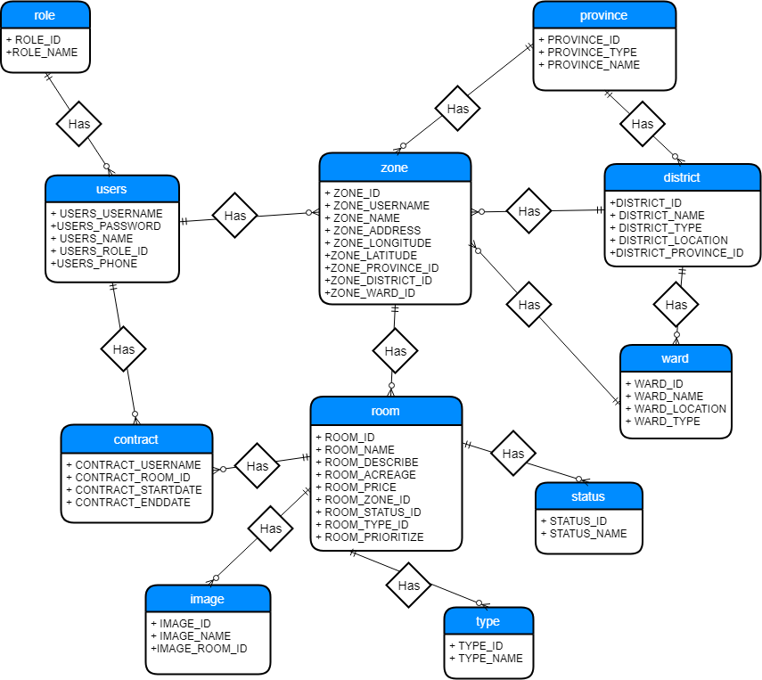

* 1. **Table Relationship Diagram:**

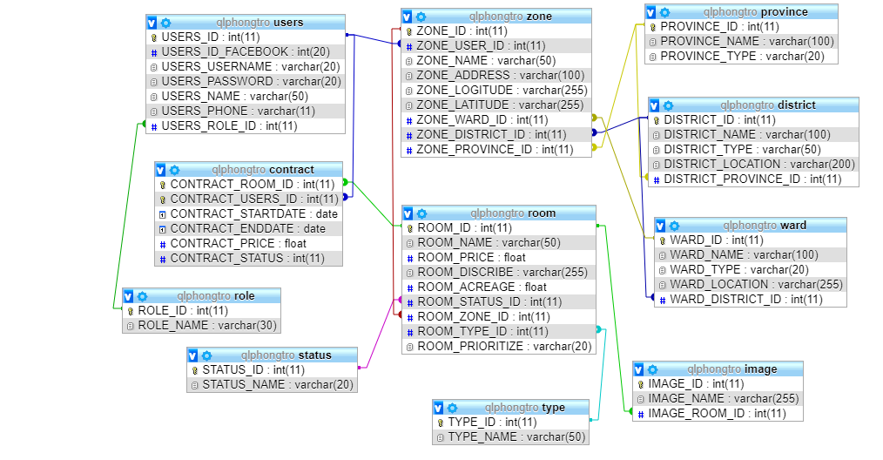

* 1. **Detail**
     1. **Role**

**This includes the attribute:**

|  |  |  |  |  |  |
| --- | --- | --- | --- | --- | --- |
| **Attributes** | **Datatype** | **Null** | **Key** | **Default** | **Extra** |
| ROLE_ID | int(11) | not | PK |  |  |
| ROLE_ID | varchar(30) |  |  |  |  |

* + 1. **Users**

**This includes the attribute:**

|  |  |  |  |  |  |
| --- | --- | --- | --- | --- | --- |
| **Attributes** | **Datatype** | **Null** | **Key** | **Default** | **Extra** |
| USERS_USERNAME | int(255) | Not | PK |  |  |
| USERS_PASSWORD | int(11) |  |  |  |  |
| USERS_NAME | varchar(50) |  |  |  |  |
| USERS_PHONE | varchar(11) |  |  |  |  |
| USERS_ROLE_ID | Int(11) | Not | FK |  |  |

* + 1. **Province**

**This includes the attribute:**

|  |  |  |  |  |  |
| --- | --- | --- | --- | --- | --- |
| **Attributes** | **Datatype** | **Null** | **Key** | **Default** | **Extra** |
| PROVINCE_ID | Int(11) | Not | PK |  |  |
| PROVINCE_NAME | varchar(255) |  |  |  |  |
| PROVINCE_TYPE | Varchar(20) |  |  |  |  |

* + 1. **District**

**This includes the attribute:**

|  |  |  |  |  |  |
| --- | --- | --- | --- | --- | --- |
| **Attributes** | **Datatype** | **Null** | **Key** | **Default** | **Extra** |
| DISTRICT_ID | Int(11) | Not | PK |  |  |
| DISTRICT_NAME | varchar(100) |  |  |  |  |
| DISTRICT_TYPE | varchar(50) |  |  |  |  |
| DISTRICT_LOCATION | varchar(200) |  |  |  |  |
| DISTRICT_PROVINCE_ID | int(11) |  | FK |  |  |

* + 1. **Ward**

**This includes the attribute:**

|  |  |  |  |  |  |
| --- | --- | --- | --- | --- | --- |
| **Attributes** | **Datatype** | **Null** | **Key** | **Default** | **Extra** |
| WARD_ID | int(11) | Not | PK |  |  |
| WARD_NAME | Varchar(100) |  |  |  |  |
| WARD_TYPE | Varchar(20) |  |  |  |  |
| WARD_LOCATION | Varchar(255) |  |  |  |  |
| WARD_DISTRICT_ID | Int(11) | not | FK |  |  |

* + 1. **Zone**

**This includes the attribute:**

|  |  |  |  |  |  |
| --- | --- | --- | --- | --- | --- |
| **Attributes** | **Datatype** | **Null** | **Key** | **Default** | **Extra** |
| ZONE_ID | Int(11) | Not | PK |  |  |
| ZONE_USERNAME | Varchar(20) | Not | FK |  |  |
| ZONE_NAME | Varchar(50) |  |  |  |  |
| ZONE_ADDRESS | Varchar(100) |  |  |  |  |
| ZONE_LOGITUDE | varchar(255) | Not |  |  |  |
| ZONE_LATITUDE | varchar(255) | Not |  |  |  |
| ZONE_PROVIDER_ID | Int(11) | Not | FK |  |  |
| ZONE_DISTRICT_ID | Int(11) | Not | FK |  |  |
| ZONE_WARD_ID | Int(11) | not | FK |  |  |

* + 1. **Room**

**This includes the attribute:**

|  |  |  |  |  |  |
| --- | --- | --- | --- | --- | --- |
| **Attributes** | **Datatype** | **Null** | **Key** | **Default** | **Extra** |
| ROOM_ID | int(11) | Not | PK |  |  |
| ROOM_NAME | varchar(50) |  |  |  |  |
| ROOM_PRICE | Float |  |  |  |  |
| ROOM_DISCRIBE | varchar(255) |  |  |  |  |
| ROOM_ACREAGE | float |  |  |  |  |
| ROOM_STATUS_ID | Int(11) | not | FK |  |  |
| ROOM_ZONE_ID | Int(11) | Not | FK |  |  |
| ROOM_TYPE_ID | Int(11) | Not | FK |  |  |
| ROOM_PRIORITIZE | Varchar(20) |  |  |  |  |

* + 1. **Image**

**This includes the attribute:**

|  |  |  |  |  |  |
| --- | --- | --- | --- | --- | --- |
| **Attributes** | **Datatype** | **Null** | **Key** | **Default** | **Extra** |
| IMAGE_ID | int(11) | Not | PK |  |  |
| IMAGE_NAME | varchar(255) |  |  |  |  |
| IMAGE_ROOM_ID | Int | not | FK |  |  |

* + 1. **Status**

**This includes the attribute:**

|  |  |  |  |  |  |
| --- | --- | --- | --- | --- | --- |
| **Attributes** | **Datatype** | **Null** | **Key** | **Default** | **Extra** |
| STATUS_ID | int(11) | Not | PK |  |  |
| STATUS_NAME | varchar(100) |  |  |  |  |

* + 1. **Type**

**This includes the attribute:**

|  |  |  |  |  |  |
| --- | --- | --- | --- | --- | --- |
| **Attributes** | **Datatype** | **Null** | **Key** | **Default** | **Extra** |
| TYPE_ID | int(11) | Not | PK |  |  |
| TYPE_NAME | varchar(100) |  |  |  |  |

* + 1. **Contract**

**This includes the attribute:**

|  |  |  |  |  |  |
| --- | --- | --- | --- | --- | --- |
| **Attributes** | **Datatype** | **Null** | **Key** | **Default** | **Extra** |
| CONTRACT_ROOM_ID | int(11) | Not | PK,FK |  |  |
| CONTRACT_USERS_USERNAME | varchar(20) | Not | PK,FK |  |  |
| CONTRACT_STARTDATE | Date | Not |  |  |  |
| CONTRACT_ENDDATE | Date | Not |  |  |  |
| CONTRACT_PRICE | Float | Not |  |  |  |
| CONTRACT_STATUS | Int(11) |  |  |  |  |

1. **Design Database for Sprint 2**
   1. **Table overview**

|  |  |  |
| --- | --- | --- |
| **No** | **Table name** | **Short Description** |
| 1 | users | This table shows all information of user that the system have. |
| 2 | role | This table contains all the role of user in the system. |
| 3 | district | This table shows all the information of district that the system have. |
| 4 | provider | This table shows all the information of provider that the system have. |
| 5 | ward | This table shows all the information of ward that the system have. |
| 6 | zone | This table contains the location information of the landlord accommodation. |
| 7 | room | This table contains the information about the room of landlord that system have. |
| 8 | image | This table contains all the images of the landlord room. |
| 9 | status | This table contains all the status of the room. |
| 10 | type | This table contains all the type of the room. |
| 11 | contract | This table shows all the information of landlord and renter transactions. |

* 1. **Entity Relationship Diagram**

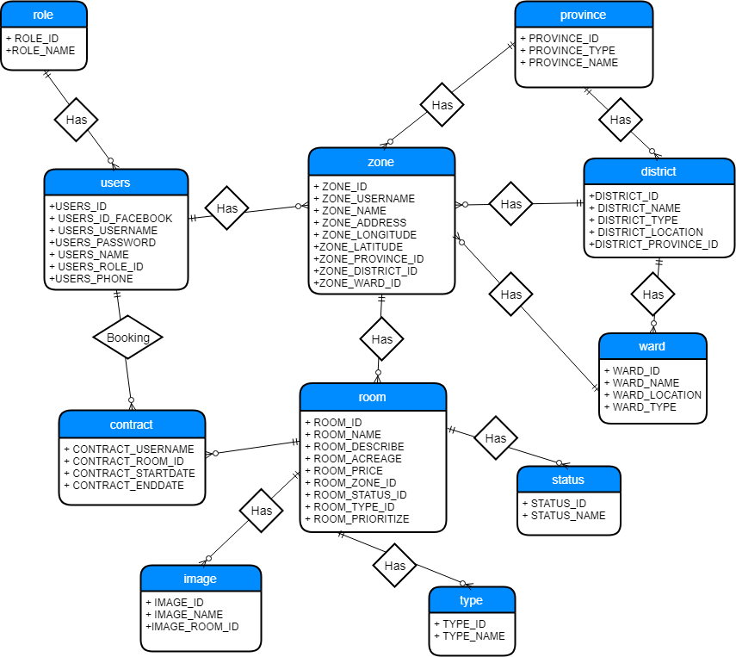

* 1. **Table Relationship Diagram**



* 1. **Detail**
     1. **Role**

**This includes the attribute:**

|  |  |  |  |  |  |
| --- | --- | --- | --- | --- | --- |
| **Attributes** | **Datatype** | **Null** | **Key** | **Default** | **Extra** |
| ROLE_ID | int(11) | not | PK |  | AI |
| ROLE_ID | varchar(30) |  |  |  |  |

* + 1. **User**

**This includes the attribute:**

|  |  |  |  |  |  |
| --- | --- | --- | --- | --- | --- |
| **Attributes** | **Datatype** | **Null** | **Key** | **Default** | **Extra** |
| USERS_ID | int(255) | Not | PK |  | AI |
| USERS_ID_FACEBOOK | int(11) | Not |  |  |  |
| USERS_USERNAME | Varchar(20) | Not |  |  |  |
| USERS_NAME | varchar(50) | Not |  |  |  |
| USERS_PHONE | varchar(11) | not |  |  |  |
| USERS_ROLE_ID | Int(11) | Not | FK |  |  |

* + 1. **Province**

**This includes the attribute:**

|  |  |  |  |  |  |
| --- | --- | --- | --- | --- | --- |
| **Attributes** | **Datatype** | **Null** | **Key** | **Default** | **Extra** |
| PROVINCE_ID | Int(11) | Not | PK |  |  |
| PROVINCE_NAME | varchar(255) |  |  |  |  |
| PROVINCE_TYPE | Varchar(20) |  |  |  |  |

* + 1. **District**

**This includes the attribute:**

|  |  |  |  |  |  |
| --- | --- | --- | --- | --- | --- |
| **Attributes** | **Datatype** | **Null** | **Key** | **Default** | **Extra** |
| DISTRICT_ID | Int(11) | Not | PK |  |  |
| DISTRICT_NAME | varchar(100) |  |  |  |  |
| DISTRICT_TYPE | varchar(50) |  |  |  |  |
| DISTRICT_LOCATION | varchar(200) |  |  |  |  |
| DISTRICT_PROVINCE_ID | int(11) |  | FK |  |  |

* + 1. **Ward**

**This includes the attribute:**

|  |  |  |  |  |  |
| --- | --- | --- | --- | --- | --- |
| **Attributes** | **Datatype** | **Null** | **Key** | **Default** | **Extra** |
| WARD_ID | int(11) | Not | PK |  |  |
| WARD_NAME | Varchar(100) |  |  |  |  |
| WARD_TYPE | Varchar(20) |  |  |  |  |
| WARD_LOCATION | Varchar(255) |  |  |  |  |
| WARD_DISTRICT_ID | Int(11) | not | FK |  |  |

* + 1. **Zone**

**This includes the attribute:**

|  |  |  |  |  |  |
| --- | --- | --- | --- | --- | --- |
| **Attributes** | **Datatype** | **Null** | **Key** | **Default** | **Extra** |
| ZONE_ID | Int(11) | Not | PK |  | AI |
| ZONE_USERNAME | Varchar(20) | Not | FK |  |  |
| ZONE_NAME | Varchar(50) |  |  |  |  |
| ZONE_ADDRESS | Varchar(100) |  |  |  |  |
| ZONE_LOGITUDE | varchar(255) | Not |  |  |  |
| ZONE_LATITUDE | varchar(255) | Not |  |  |  |
| ZONE_PROVIDER_ID | Int(11) | Not | FK |  |  |
| ZONE_DISTRICT_ID | Int(11) | Not | FK |  |  |
| ZONE_WARD_ID | Int(11) | not | FK |  |  |

* + 1. **Room**

**This includes the attribute:**

|  |  |  |  |  |  |
| --- | --- | --- | --- | --- | --- |
| **Attributes** | **Datatype** | **Null** | **Key** | **Default** | **Extra** |
| ROOM_ID | int(11) | Not | PK |  | AI |
| ROOM_NAME | varchar(50) |  |  |  |  |
| ROOM_PRICE | Float |  |  |  |  |
| ROOM_DISCRIBE | varchar(255) |  |  |  |  |
| ROOM_ACREAGE | float |  |  |  |  |
| ROOM_STATUS_ID | Int(11) | not | FK |  |  |
| ROOM_ZONE_ID | Int(11) | Not | FK |  |  |
| ROOM_TYPE_ID | Int(11) | Not | FK |  |  |
| ROOM_PRIORITIZE | Varchar(20) |  |  |  |  |

* + 1. **Image**

**This includes the attribute:**

|  |  |  |  |  |  |
| --- | --- | --- | --- | --- | --- |
| **Attributes** | **Datatype** | **Null** | **Key** | **Default** | **Extra** |
| IMAGE_ID | int(11) | Not | PK |  | AI |
| IMAGE_NAME | varchar(255) |  |  |  |  |
| IMAGE_ROOM_ID | Int | not | FK |  |  |

* + 1. **Status**

**This includes the attribute:**

|  |  |  |  |  |  |
| --- | --- | --- | --- | --- | --- |
| **Attributes** | **Datatype** | **Null** | **Key** | **Default** | **Extra** |
| STATUS_ID | int(11) | Not | PK |  | AI |
| STATUS_NAME | varchar(100) |  |  |  |  |

* + 1. **Type**

**This includes the attribute:**

|  |  |  |  |  |  |
| --- | --- | --- | --- | --- | --- |
| **Attributes** | **Datatype** | **Null** | **Key** | **Default** | **Extra** |
| TYPE_ID | int(11) | Not | PK |  | AI |
| TYPE_NAME | varchar(100) |  |  |  |  |

* + 1. **Contract**

**This includes the attribute:**

|  |  |  |  |  |  |
| --- | --- | --- | --- | --- | --- |
| **Attributes** | **Datatype** | **Null** | **Key** | **Default** | **Extra** |
| CONTRACT_ROOM_ID | int(11) | Not | PK,FK |  | AI |
| CONTRACT_USERS_USERNAME | varchar(20) | Not | PK,FK |  |  |
| CONTRACT_STARTDATE | Date | Not |  |  |  |
| CONTRACT_ENDDATE | Date | Not |  |  |  |
| CONTRACT_PRICE | Float | Not |  |  |  |
| CONTRACT_STATUS | Int(11) |  |  |  |  |

1. **Database for Sprint 3**
   1. **Table Overview**

|  |  |  |
| --- | --- | --- |
| No | Table name | Short Description |
| 1 | users | This table shows all information of user that the system have. |
| 2 | role | This table contains all the role of user in the system. |
| 3 | district | This table shows all the information of district that the system have. |
| 4 | provider | This table shows all the information of provider that the system have. |
| 5 | ward | This table shows all the information of ward that the system have. |
| 6 | zone | This table contains the location information of the landlord accommodation. |
| 7 | room | This table contains the information about the room of landlord that system have. |
| 8 | image | This table contains all the images of the landlord room. |
| 9 | status | This table contains all the status of the room. |
| 10 | type | This table contains all the type of the room. |
| 11 | contract | This table shows all the information of landlord and renter transactions. |
| 12 | report | This table shows all the renter’s comment about room of landlord |

* 1. **Entity Relationship Diagram**

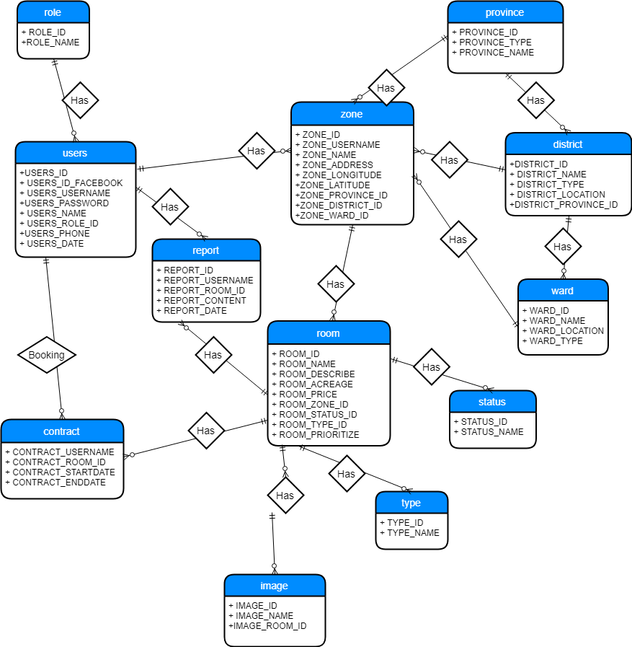

* 1. **Table Relationship Diagram**

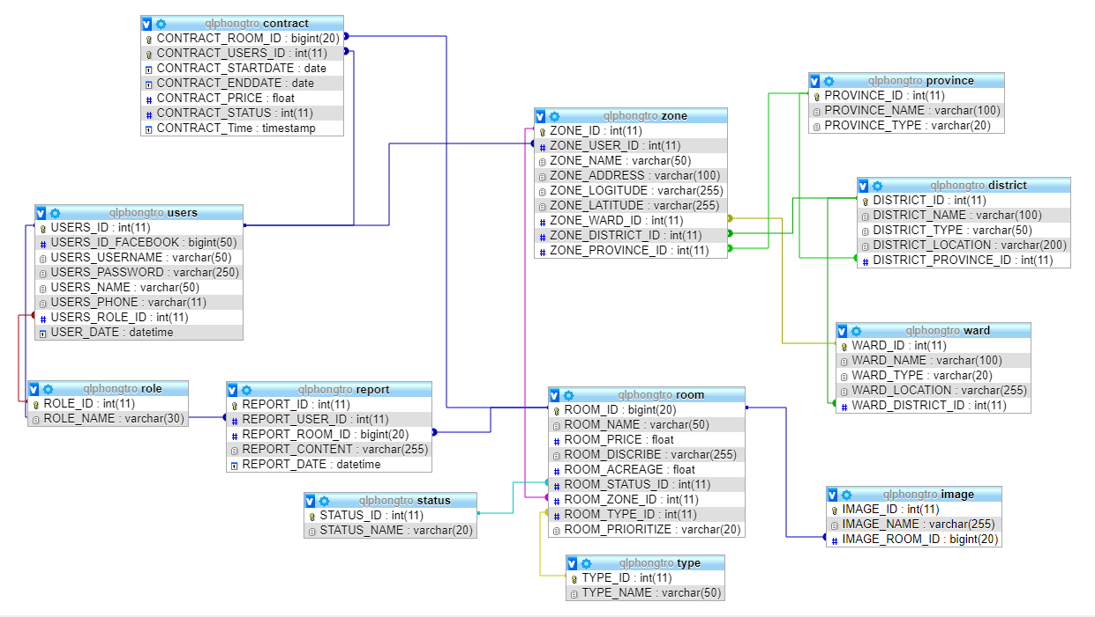

* 1. **Detail**
     1. **Role**

**This includes the attribute:**

|  |  |  |  |  |  |
| --- | --- | --- | --- | --- | --- |
| **Attributes** | **Datatype** | **Null** | **Key** | **Default** | **Extra** |
| ROLE_ID | int(11) | not | PK |  | AI |
| ROLE_ID | varchar(30) |  |  |  |  |

* + 1. **User**

**This includes the attribute:**

|  |  |  |  |  |  |
| --- | --- | --- | --- | --- | --- |
| **Attributes** | **Datatype** | **Null** | **Key** | **Default** | **Extra** |
| USERS_ID | int(11) | Not | PK |  | AI |
| USERS_ID_FACEBOOK | int(50) | not |  |  |  |
| USERS_USERNAME | varchar(20) | Not |  |  |  |
| USERS_NAME | varchar(50) | Not |  |  |  |
| USERS_PHONE | Int(11) | Not | FK |  |  |
| USERS_ROLE_ID | Datetime() | Not |  |  |  |

* + 1. **Province**

**This includes the attribute:**

|  |  |  |  |  |  |
| --- | --- | --- | --- | --- | --- |
| **Attributes** | **Datatype** | **Null** | **Key** | **Default** | **Extra** |
| PROVINCE_ID | Int(11) | Not | PK |  |  |
| PROVINCE_NAME | varchar(255) |  |  |  |  |
| PROVINCE_TYPE | Varchar(20) |  |  |  |  |

* + 1. **District**

**This includes the attribute:**

|  |  |  |  |  |  |
| --- | --- | --- | --- | --- | --- |
| **Attributes** | **Datatype** | **Null** | **Key** | **Default** | **Extra** |
| DISTRICT_ID | Int(11) | Not | PK |  |  |
| DISTRICT_NAME | varchar(100) |  |  |  |  |
| DISTRICT_TYPE | varchar(50) |  |  |  |  |
| DISTRICT_LOCATION | varchar(200) |  |  |  |  |
| DISTRICT_PROVINCE_ID | int(11) |  | FK |  |  |

* + 1. **Ward**

**This includes the attribute:**

|  |  |  |  |  |  |
| --- | --- | --- | --- | --- | --- |
| **Attributes** | **Datatype** | **Null** | **Key** | **Default** | **Extra** |
| WARD_ID | int(11) | Not | PK |  |  |
| WARD_NAME | Varchar(100) |  |  |  |  |
| WARD_TYPE | Varchar(20) |  |  |  |  |
| WARD_LOCATION | Varchar(255) |  |  |  |  |
| WARD_DISTRICT_ID | Int(11) | not | FK |  |  |

* + 1. **Zone**

**This includes the attribute:**

|  |  |  |  |  |  |
| --- | --- | --- | --- | --- | --- |
| **Attributes** | **Datatype** | **Null** | **Key** | **Default** | **Extra** |
| ZONE_ID | Int(11) | Not | PK |  | AI |
| ZONE_USERNAME | Varchar(20) | Not | FK |  |  |
| ZONE_NAME | Varchar(50) |  |  |  |  |
| ZONE_ADDRESS | Varchar(100) |  |  |  |  |
| ZONE_LOGITUDE | varchar(255) | Not |  |  |  |
| ZONE_LATITUDE | varchar(255) | Not |  |  |  |
| ZONE_PROVIDER_ID | Int(11) | Not | FK |  |  |
| ZONE_DISTRICT_ID | Int(11) | Not | FK |  |  |
| ZONE_WARD_ID | Int(11) | not | FK |  |  |

* + 1. **Room**

**This includes the attribute:**

|  |  |  |  |  |  |
| --- | --- | --- | --- | --- | --- |
| **Attributes** | **Datatype** | **Null** | **Key** | **Default** | **Extra** |
| ROOM_ID | int(11) | Not | PK |  | AI |
| ROOM_NAME | varchar(50) |  |  |  |  |
| ROOM_PRICE | Float |  |  |  |  |
| ROOM_DISCRIBE | varchar(255) |  |  |  |  |
| ROOM_ACREAGE | float |  |  |  |  |
| ROOM_STATUS_ID | Int(11) | not | FK |  |  |
| ROOM_ZONE_ID | Int(11) | Not | FK |  |  |
| ROOM_TYPE_ID | Int(11) | Not | FK |  |  |
| ROOM_PRIORITIZE | Varchar(20) |  |  |  |  |

* + 1. **Image**

**This includes the attribute:**

|  |  |  |  |  |  |
| --- | --- | --- | --- | --- | --- |
| **Attributes** | **Datatype** | **Null** | **Key** | **Default** | **Extra** |
| IMAGE_ID | int(11) | Not | PK |  | AI |
| IMAGE_NAME | varchar(255) |  |  |  |  |
| IMAGE_ROOM_ID | Int | not | FK |  |  |

* + 1. **Status**

**This includes the attribute:**

|  |  |  |  |  |  |
| --- | --- | --- | --- | --- | --- |
| **Attributes** | **Datatype** | **Null** | **Key** | **Default** | **Extra** |
| STATUS_ID | int(11) | Not | PK |  | AI |
| STATUS_NAME | varchar(100) |  |  |  |  |

* + 1. **Type**

**This includes the attribute:**

|  |  |  |  |  |  |
| --- | --- | --- | --- | --- | --- |
| **Attributes** | **Datatype** | **Null** | **Key** | **Default** | **Extra** |
| TYPE_ID | int(11) | Not | PK |  | AI |
| TYPE_NAME | varchar(100) |  |  |  |  |

* + 1. **Contract**

**This includes the attribute:**

|  |  |  |  |  |  |
| --- | --- | --- | --- | --- | --- |
| **Attributes** | **Datatype** | **Null** | **Key** | **Default** | **Extra** |
| CONTRACT_ROOM_ID | int(11) | Not | PK,FK |  | AI |
| CONTRACT_USERS_USERNAME | varchar(20) | Not | PK,FK |  |  |
| CONTRACT_STARTDATE | Date | Not |  |  |  |
| CONTRACT_ENDDATE | Date | Not |  |  |  |
| CONTRACT_PRICE | Float | Not |  |  |  |
| CONTRACT_STATUS | Int(11) | Not |  |  |  |
| CONTRACT_TIME | DateTime | Not |  |  |  |

* + 1. **Report**

**This includes the attribute:**

|  |  |  |  |  |  |
| --- | --- | --- | --- | --- | --- |
| **Attributes** | **Datatype** | **Null** | **Key** | **Default** | **Extra** |
| REPORT_ID | int(11) | Not | PK |  | AI |
| REPORT_USERS_USERNAME | Int(11) | Not | FK |  |  |
| ROOM_ID | Int(11) | Not | FK |  |  |
| REPOR_CONTENT | Varchar(255) | Not |  |  |  |