DUY TAN UNIVERSITY

GITHUB REPORT

SOFTWARE CONFIGURATION MANAGE REPORT

Team: LNQT Team

Class: CMU-CS-246-DIS

Subject: APPLICATION DEVELOPMENT PRACTICES

1. ***GitHub***

GitHub is a web-based [Git](https://en.wikipedia.org/wiki/Git) or [version control repository](https://en.wikipedia.org/wiki/Repository_(version_control)) and [Internet hosting service](https://en.wikipedia.org/wiki/Internet_hosting_service). It offers all of the [distributed version control](https://en.wikipedia.org/wiki/Distributed_version_control) and [source code management](https://en.wikipedia.org/wiki/Source_code_management) (SCM) functionality of Git as well as adding its own features. It provides [access control](https://en.wikipedia.org/wiki/Access_control) and several collaboration features such as [bug tracking](https://en.wikipedia.org/wiki/Bug_tracking_system), [feature requests](https://en.wikipedia.org/wiki/Software_feature), [task management](https://en.wikipedia.org/wiki/Task_management), and [wikis](https://en.wikipedia.org/wiki/Wiki) for every project.

GitHub offers both plans for private and free [repositories](https://en.wikipedia.org/wiki/Repository_(version_control)) on the same account which are commonly used to host [open-source](https://en.wikipedia.org/wiki/Open-source) software projects.

1. ***Pros and Cons of github***

**The pros**

* GitHub is a very versatile tool to use. It’s ideal for working on projects of any size and it’s a great tool for web work flows. Firstly you can use it for publishing your work, as a versioning control system and as a collaborative tool.
* With GitHub you can archive your projects and share them with your peers for either inspiration or for them to collaborate on. The beauty of it is that you can have more than one person collaborate remotely on a project, so you’re all on the same page, so to speak.
* It’s ideal for creating a backup of your work instead on saving the code on a desktop or on a corporate server.
* It is also beneficial to use if you’re learning Git. One way to look at it is seeing Git as a preventative maintenance process, where you get into the flow of doing reverts, commits, pulling, pushing, and so forth, as needed.  It can save you a lot of hassle if a problem occurs, or if you need to revert code of any sort. One of the best features is being able to track mistakes, and it’s definitely made easier by using GitHub. Bugs can be opened, and thanks to GitHub, you can add commits to these and associate it with the problem.
* With GitHub pages, you can get started quickly without worrying about setting up hosting or DNS.

***The*** ***Cons***

* If you’re new to GitHub, one of the challenges often talked about is getting to grips with the mental model, which eases with practice and time.
* It may not be the best tool for capturing the creative process or for recording ideas. A good tool for this particular function would be LayerVault or something similar to it. We’d say Git is very good for tracking code, however it’s not the best for tracking design. It can seem a little bit of a grey area when designs are needed to be translated into code or for when you need to export designs to a production setting.
* It depends on the designer, however, some find the GUI a little confusing to use and opt to use its CLI instead. Some developers learnt Git by mostly using commands, which explains why the GUI isn’t always liked by them. With a little practice, the commands are not too difficult to learn. However using Commands everyday can be awkward, especially when tracking project history or resolving conflicts. Then, there are others who’ve preferred the GUI instead of commands,  as the visual representation of previous commits, modified files and diffs can make better sense. As mentioned previously, it can take some getting used to.
* It costs to have a versioning repository on GitHub, however it is worth the investment if you’re working professionall

1. ***Use GitHub Server***

**How to use GitHub Server ?**

* Each member must have a Github account.

• Access https://www.github.com/.

• Click on Sign in .If haven not GibHub account. Click on Create a

new GitHub account then fill in all the information.

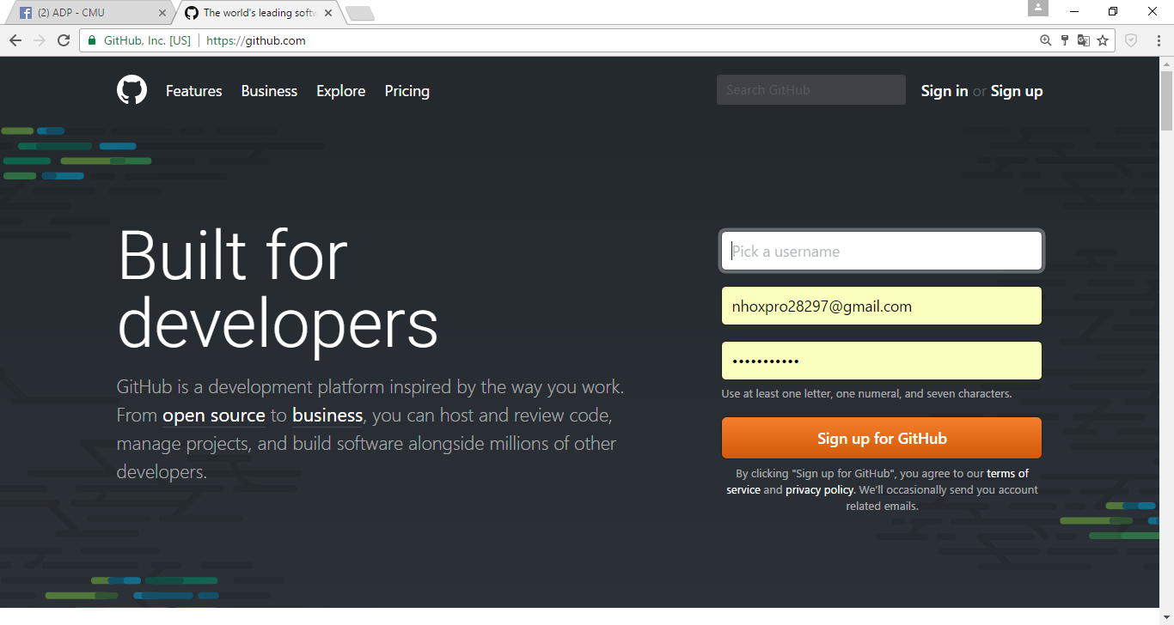

* **How to create new server ?**

1. Click on Start Project

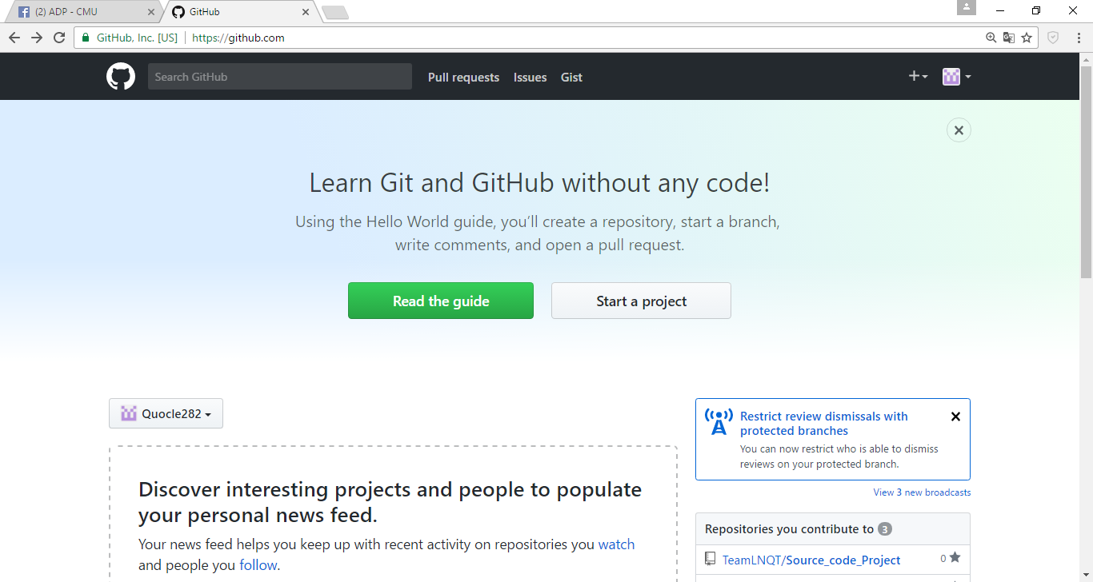

1. Create a new reporsitory

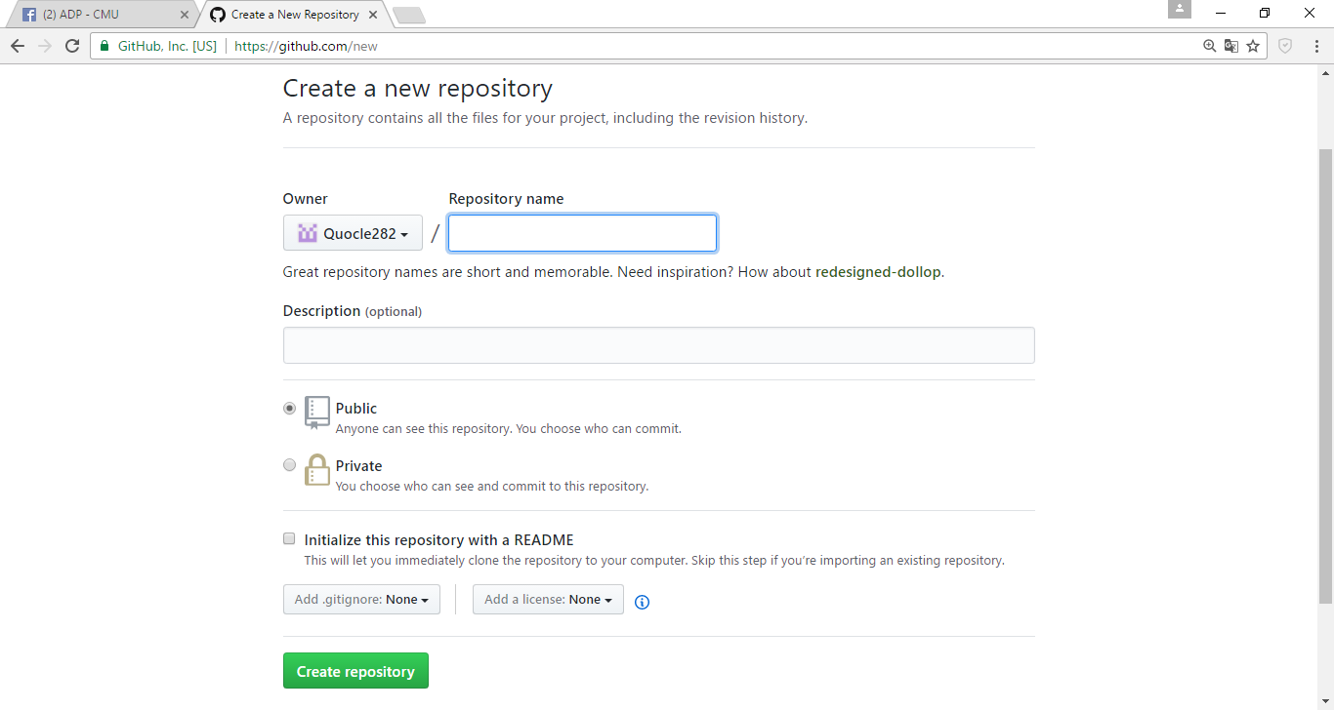

1. Dowload GitHub for Windows

• Access <https://desktop.github.com/>

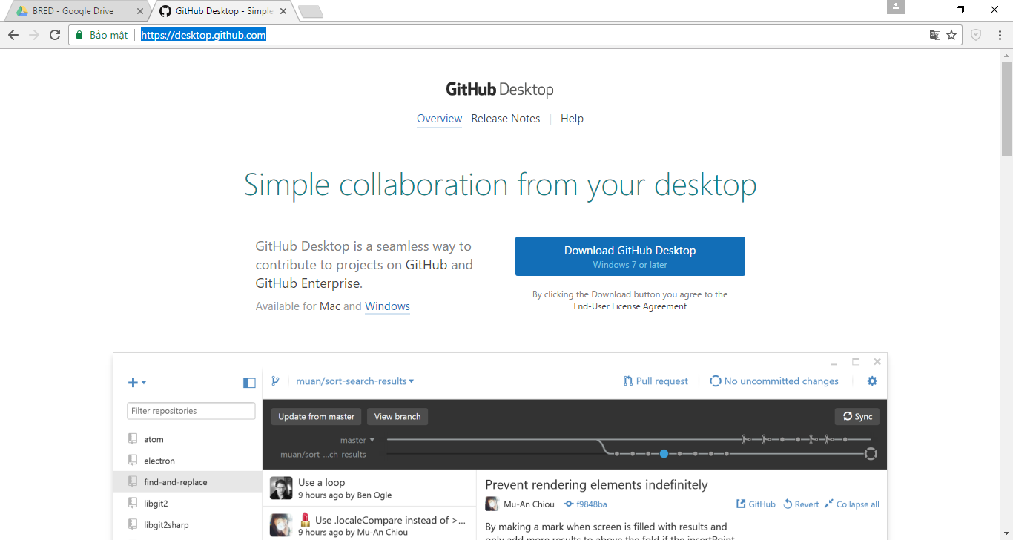

1. Clone or Download

Click Clone or Download to open GitHub on Windowns.

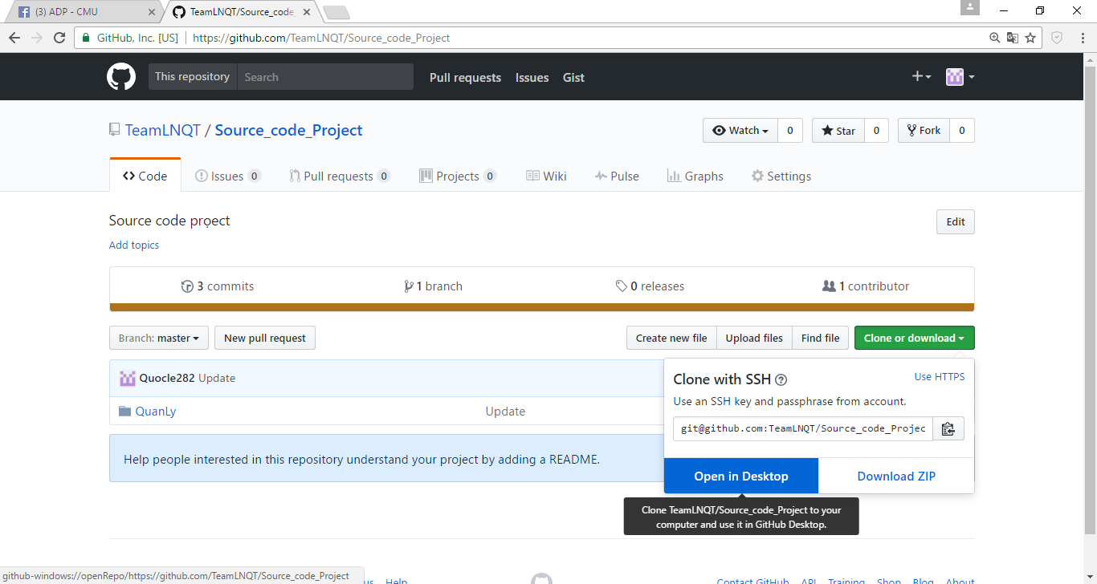

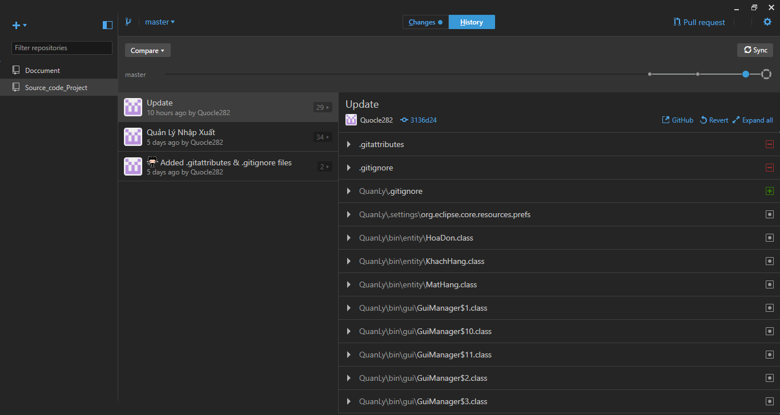

Sign In to clone document on GitHub Web.

***THE END***