

CAPSTONE 1

PROPOSAL DOCUMENT

Version 1.2

Date: Aug 15th, 2018

ROOMY

MENTOR : Phan Van Son

TEAM’S MEMBER : Huynh Quoc Nhat

Le Hoang Quoc

Ho Trung Anh

Huynh Vu Ha Lan

Huynh Thi Thanh Van

Contents

Project Information 3

Proposal Document 4

1 Introduction 6

1.1 Purpose 6

1.2 Scope 6

1.3 Reference 6

2 Project Overview 7

2.1 Project Definition 7

2.2 Business needs/ User needs 7

2.3 Prior art 7

2.4 Proposed solution 8

2.4.1 Project goal 8

2.4.2 System overviews 9

2.4.3 Technical constrains 9

3 Development Process 10

3.1 Reason for selecting process: 10

3.2 Scrum Process 11

3.3 Master plan 12

3.4 Organization management 12

3.4.1 Team information 12

3.4.2 Cost Estimation 13

# Project Information

|  |  |  |  |
| --- | --- | --- | --- |
| Project acronym | Roomy | | |
| Project Tittle | Roomy | | |
| Start Date | 22/8/2018 | End Date | 01/09/2018 |
| Lead Institution | International School, Duy Tan University | | |
| Project Mentor | Phan Van Son | | |
| Product Owner | Huynh Thi Thanh Van | | |
| Scrum Master  & contact details | Huynh Vu Ha Lan  Email: huynhvuhalan.97@gmail.com | | |
| Partner  Organization | Duy Tan university | | |
| Team members | Name | Email | Tel |
| Le Hoang Quoc | quocle28292@gmail.com | 01657708105 |
| Huynh Quoc Nhat | huynhquocnhat97@gmail.com | 0905740256 |
| Ho Trung Anh | hotrunganhht1912@gmail.com | 09055258534 |
| Huynh Thi Thanh Van | thanhvandb97@gmail.com | 01229444661 |
|  | Huynh Vu Ha Lan | huynhvuhalan.97@gmail.com | 01675373265 |

# Proposal Document

|  |  |  |  |
| --- | --- | --- | --- |
| Document Title | Proposal |  |  |
| Reporting Period | August, 2018 |  |  |
| Author(s) | All Members | |  |
| Team Members | Name | Role |  |
| Huynh Vu Ha Lan | Scrum Master |  |
| Huynh Thi Thanh Van | Product Owner |  |
| Huynh Quoc Nhat | Member |  |
| Le Anh Quoc | Member |  |
| Ho Trung Anh | MemBer |  |
| Date | Aug 15, 2018 | Filename | Proposal_v1.1.docx |
| Access | Project and CMU Program | |  |

|  |  |  |  |
| --- | --- | --- | --- |
| Version | Person | Date | Description |
| V1.0 | Team | Aug 22, 2018 | Draft for Document |
| V1.1 | Team | Aug 31, 2018 | Update header page, structure of the document |
| V1.2 | Team | Sep5,2018 | Update header page, structure of the document |

Document Approvals: The following signatures are required for approval of this document.

|  |  |  |  |
| --- | --- | --- | --- |
| Mentor | Phan Van Son | Signature: |  |
|  | Date: |  |
| Product Owner | Huynh Thi Thanh Van | Signature: |  |
|  | Date: |  |
| Scrum Master | Huynh Vu Ha Lan | Signature: |  |
|  | Date: |  |
| DEV Team’s Member | Huynh Quoc Nhat | Signature: |  |
|  | Date: |  |
| Ho Trung Anh | Signature: |  |
|  | Date: |  |
| Le Hoanh Quoc | Signature: |  |
|  | Date: |  |

# Introduction

## Purpose

The purpose of the proposal is to:

* + Define the business need and problem in detail.
  + Provide solutions for business needs and show the overview of system architecture.
  + Provide overview about resources, schedule, solution and budget for the project.

## Scope

This document provides an overview of project will be developed. It includes overview of the product, overview of the process and overview of the project team.

This document provides a plan for each stage of software development process based on Scrum process include: start time, end time and number of working days. This is the general plan and will be updated with detail of the software development process in the next version of document. Proposal includes the introduction of solutions; determine the best way to develop software that we make the total estimated costs, payback period, and breakeven volume for the project.

## Reference

|  |  |  |
| --- | --- | --- |
| No. | References | Document Information |
| 1 | Scrum  Framework | * + - * <https://www.scrum.org/>       * https://www.scrumguides.org |
| 2 | MySQL | - [www.mysql.com](http://www.mysql.com) |
| 3 | Android | - https://www.android.com/ |

# Project Overview

## Project Definition

Developing a accommodation search system, help users location of find them quickly and conveniently. The system helps users locate, display accommodation around the user with informations, images real and display the most favorable path so that users can move conveniently.

## Business needs/ User needs

*User problems:*

* Today, the number of students and workers in large cities is increasing, so finding a accomodation to live is a necessity for them.
* Finding accommodation will be very difficult for first-year students and those from other places come large cities to live.
* Landlords will have difficulty meeting tenants who do not meet their needs.
* Landlords meets the case when the tenant will visits the home but then does not come.
* Accommodation is scarce make the renter difficult in the search process.

*User needs:*

* Show accurate information about their accommodation.
* Renters can contact Landlord quickly.
* Meet the requirements they have set.
* Meet the criteria necessary for them when renting.
* Display realistic images and detailed information about rooms.
* Display accurate rental information.

## Prior art

* Up till, there are many websites that support the search for such as chotot.com, muaban.net, mogi.vn ... Most of them have the main functions are: rental rooms, rental housing, find roommate. Based on that availability, we will create a website for rooms with similar functionality
* However, these websites are mostly single pictures of the place of rental and can not help the tenants know the exact location to where they want it to be.
* To overcome these problems, we want to make a system with high practicality.
* The whole system of program is built in form: Website and Application . So that management and landlord can easily update the latest information about accommodation to renters.
* With the Website, we will create function to display each room, rental house directly on the map together with 360 ° image so that users can easily view the necessary information as well as the panoramic image of the room.
* In addition, there are feature identify the most favorable path so that users can conveniently move.
* With the Application, we will create function locate user and showing rooms for rent around.
* In addition, when user enters detail address, the system will shows accommodations around there.

## Proposed solution

To solve these problems, system can help users locate and show rooms around them with necessary information and visuals.

Our team is based on the requirements and come up with solution and implement project.

### Project goal

The goal of project is to build the website and application with main features that meet business need within budget and deliver on time:

1. **The application determines user's location by GPS**: The system will locate the user on the map via GPS.

2. **Display the road to advantage** : The website will help users see which road is most convenient for them to move easily.

3. **Display information, live images**: The system will help users to see the room information and the actual image on the map.

4. **Display room s around**: The system will show accommodation rooms around when the user enters a specific address

### System overviews

#### System context

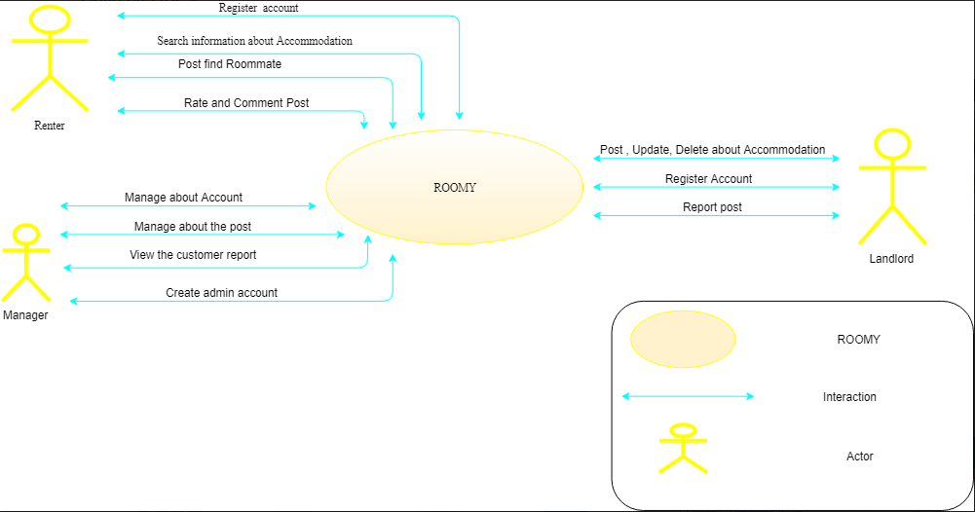

*Figure 1 : Roomy context diagram*

#### System context description

* Renter :

-They can login, logout, register an account.

- Searching information about accommodations based on recommendations of system.

- Search for roommates based on recommendations of system.

- Rating about the quality as well as comment for informations about that room.

* Landlord:

- They can login, logout, register an account.

- Posting, updating, deleting about accommodations.

- Report on post for admin when has trouble during posting.

* Admin:

- Manage about account (find, view, delete).

- Manage about the Post (find, view, delete).

-View the customer report.

- Create account for new admin to manage the system together.

### Technical constrains

Technical to develop

* Language: PHP, HTML, CSS, Java, Android
* Database Management System: MySQL
* Framework: Lavarel
* Develop tool: Sublime Text, Notepad++, Androi studio
* Operating: Multi-platform

Environment

* Web browsers: Internet Explorer, Mozilla Firefox, Apple Safari, Google Chrome, and so on.
* Operation systems: Microsoft Windows, Linux, and Apple Mac OS.

Other Constraints

* Resource: 5 people.
* Budget: Limited.
* Time: The project must be completed within 4 months frame.
* Area: Da Nang city

# Development Process

## Reason for selecting process:

- We use Scrum to do the project Website find the accommodation room. Because Scrum is a process suitable for small and medium software, implementation time short and easy change request Scrum is a process popular in present with the advantages and benefits such as: Timeline Flexibility- can later or earlier than originally planned. Good product quality and reduce production risk, low-cost. Interoperability between clients and developers, among the team members are set to high. The growth rate faster, saving time and errors detected earlier.

## Scrum Process

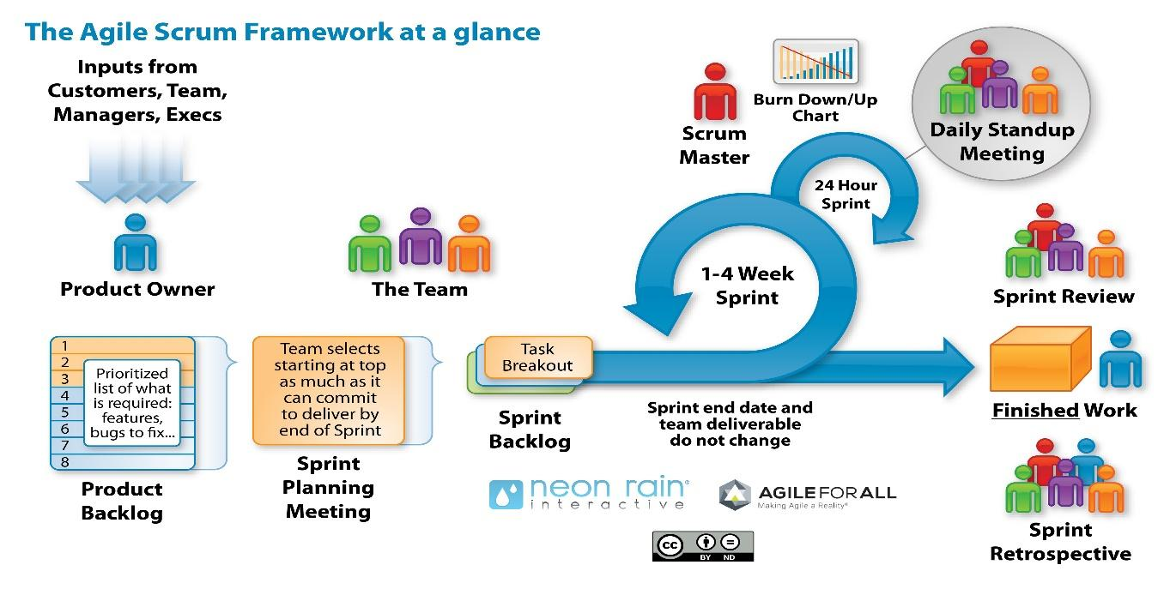

*Figure 2 : The General Scrum process*

* Scrum is an iterative and incremental agile software development framework for managing software projects and product or application development.
* Scrum focuses on project management institutions where it is difficult to plan ahead.
* Mechanisms of empirical process control, where feedback loops that constitute the core management technique are used as opposed to traditional command-and-control management.
* Its approach to planning and managing projects is by bringing decision-making authority to the level of operation properties and certainties.
* Benefit of the methodology:
  + - Project can respond easily to change.
    - Problems are identified early.
    - Customer gets most beneficial work first.
    - Work done will better meet the customer’s needs.
    - Improved productivity.
    - Ability to maintain a predictable schedule for delivery.

## Master plan

|  |  |  |  |  |
| --- | --- | --- | --- | --- |
| NO. | Task Name | Duration | Start | Finish- |
| 1 | Start Up | 7 days | 15/08/2018 | 22/08/2018 |
| 1.1 | Project Kick Off Meeting | 1 day | 24/08/2018 | 24/08/2018 |
| 1.2 | Discuss about project ideal | 3 days | 25/08/2018 | 27/08/2018 |
| 1.3 | Create Proposal document | 3 days | 28/08/2018 | 30/08/2018 |
| 2 | Development | 90 days | 01/09/15 | 05/12/2018 |
| 2.1 | Sprint 0 | 4 days | 01/09/2018 | 04/09/2018 |
| 2.2 | Sprint 1 | 20 days | 05/09/2018 | 25/09/2018 |
| 2.3 | Sprint 2 | 20 days | 26/09/2018 | 15/10/2018 |
| 2.4 | Sprint 3 | 20 days | 16/10/2018 | 05/11/2018 |
| 2.5 | Sprint 4 | 20 days | 6/11/2018 | 26/11/2018 |
| 3 | Sprint 5 | 6 days | 27/11/2018 | 02/12/2018 |
| 4 | Final Release | 1 days | 03/12/2018 | 03/12/2018 |

## Organization management

### Team information

|  |  |  |  |
| --- | --- | --- | --- |
| Full Name | Phone | Email | Position |
| Phan Van Son | 0905151655 | [sonpvs@duytan.edu.vn](mailto:sonpvs@duytan.edu.vn) | Mentor |
| Huynh Vu Ha Lan | 01675373265 | [huynhvuhalan.97@gmail.com](mailto:huynhvuhalan.97@gmail.com) | Scrum Master |
| Huynh Quoc Nhat | 0905740256 | [huynhquocnhat97@gmail.com](mailto:huynhquocnhat97@gmail.com) | Member |
| Le Hoang Quoc | 01657708105 | [quocle28292@gmail.com](mailto:quocle28292@gmail.com) | Member |
| Ho Trung Anh | 09055258534 | [hotrunganhht1912@gmail.com](mailto:hotrunganhht1912@gmail.com) | Member |
| Huynh Thi Thanh Van | 01229444661 | [thanhvandb97@gmail.com](mailto:thanhvandb97@gmail.com) | Product Owner |

### Cost Estimation

#### Cost Person/Hours

|  |  |  |
| --- | --- | --- |
| Full Name | Role | Salary Rate (USD/hour) |
| Huynh Vu Ha Lan | Scrum Master | 1 |
| Huynh Quoc Nhat | Team Member | 1 |
| Le Hoang Quoc | Team Member | 1 |
| Ho Trung Anh | Team Member | 1 |
| Huynh Thi Thanh Van | Product Owner | 1 |

#### Total Cost Estimate

|  |  |  |  |  |
| --- | --- | --- | --- | --- |
| No | Criteria | Price | Amount | Total (USD) |
| 1 | Working hours | 1 | 2946 | 2946 |
| Total cost | | |  | 2946 |

|  |  |  |
| --- | --- | --- |
| Description | Amount | Unit |
| Number of members | 5 | Person |
| Number of working hour per day | 6 | Hour |
| The cost per member per week | 1 | USD |
| The duration of the project | 3 | Month |
| The number of working days | 98 | Day |

Explain:

* + - Amount of working hours = 5 members * 6 hours * 98 days