Guide setup the DFO.Sample project

1. Go to GitHub enpoints: <https://github.com/quocphi/DFOSample>
2. Clone the Repo DFOSample to your local computer
3. Make sure that your computer are allowed to connect the the Nuget site
4. Go the the Root folder:

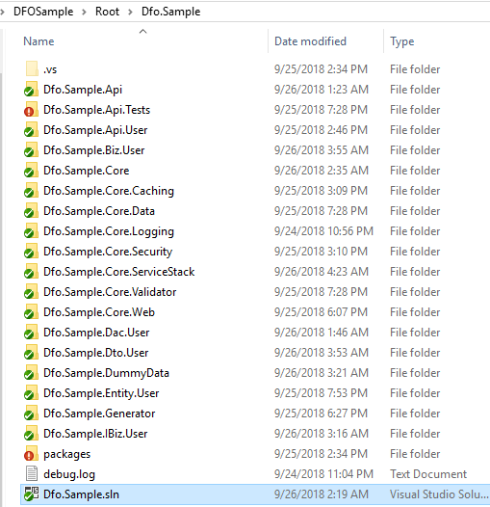

1. Open **Dfo.Sample.sln by Visual Studio Professional 2017**, recommend the version 15.8
2. Make sure you are working on the .**Net Framework 4.6.1** or above.



1. Choose the Rebuild mode to restore all needed nugget packages.
2. F5 or Start Debugging
3. The web page should display as this picture on url: <http://localhost:50966>

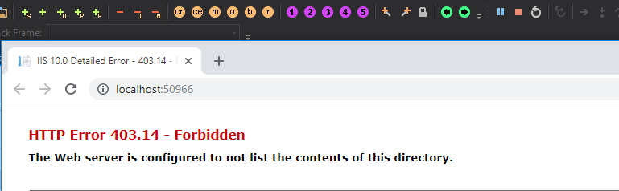

1. To verify the Api please setup the Postman as an extension on Chrome:

<https://chrome.google.com/webstore/detail/postman/fhbjgbiflinjbdggehcddcbncdddomop?hl=en>

1. **Verify the CreateUser:**
   1. Input Data:

|  |
| --- |
| {  "RequestData":  {  "Name":"John", "Age":34, "Address":"Tokyo"  }  } |

* 1. End point: <http://localhost:50966/User/CreateUser>

1. **Verify the UpdateUser**
   1. Input Data:

|  |
| --- |
| {  "RequestData":  {  "Id":9984, "Name":" PhiLBQ", "Age":34, "Address":"HCMC"  }  } |

* 1. End point: <http://localhost:50966/User/UpdateUser>

1. **Verify the GetAllUser**
   1. Input Data:

|  |
| --- |
| {  "RequestData":  {  }  } |

* 1. End point: <http://localhost:50966/User/GetUserById>

1. **Verify the GetUserById**
   1. Input Data:

|  |
| --- |
| {  "RequestData":  {  "Id":9984  }  } |

* 1. End point: <http://localhost:50966/User/GetUserById>