Bài tập tuần 5
Trương Văn Quốc Phong;1150080153;11_ĐH_cnpm2
Bài 1 JAVA + JUNIT 4

: Tạo Project trên eclipse
File → New → Java Project
Project name: Lab5_Junit
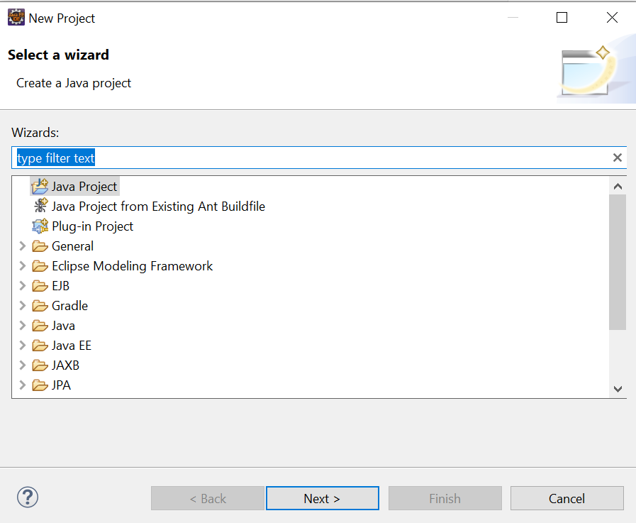
Right click project
> Build Path
> Add Libraries
> JUnit
> JUnit 4
> Finish
Tạo package lab5
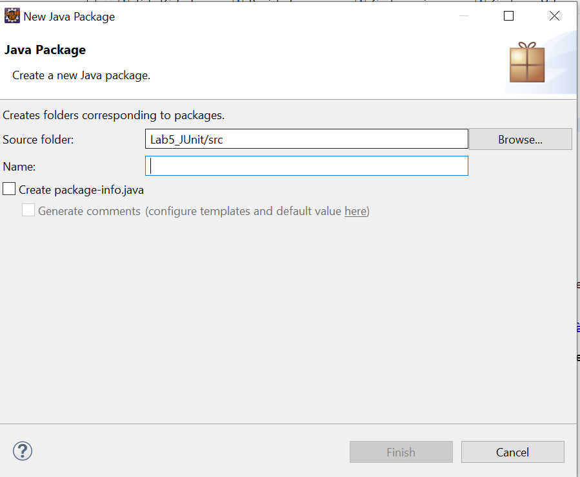
MathFunc.java
package lab5;

public class MathFunc {
public static int calls = 0;

public int factorial(int n) {
calls++;
if (n < 0)
throw new IllegalArgumentException("n must be >= 0");

int result = 1;
for (int i = 1; i <= n; i++)
result *= i;

return result;
}

public int plus(int a, int b) {
calls++;
return a + b;
}
}
MathFuncTest.java
package lab5;

import static org.junit.Assert.*;
import org.junit.*;

public class MathFuncTest {

private MathFunc math;

@Before
public void setUp() {
math = new MathFunc();
MathFunc.calls = 0;
System.out.println("Before test");
}

@After
public void tearDown() {
System.out.println("After test");
}

@Test
public void calls() {
math.plus(1, 2);
math.factorial(3);
assertEquals(2, MathFunc.calls);
}

@Test
public void factorial() {
assertEquals(120, math.factorial(5));
}

@Test(expected = IllegalArgumentException.class)
public void factorialNegative() {
math.factorial(-1);
}

@Ignore("Chưa làm")
@Test
public void todo() {
assertEquals(10, math.plus(4, 6));
}
}
Right click → Run As → JUnit Test
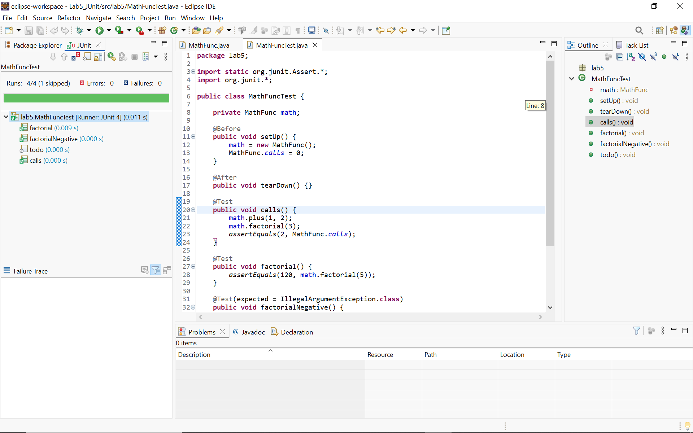
Bài 2: JUNIT TEST SUITE
SuiteTest1.java
package lab5;

import org.junit.Test;

public class SuiteTest1 {
@Test
public void test1() {
System.out.println("Running SuiteTest1");
}
}
SuiteTest2.java
package lab5;

import org.junit.Test;

public class SuiteTest2 {
@Test
public void test2() {
System.out.println("Running SuiteTest2");
}
}
JunitTest.java
package lab5;

import org.junit.runner.RunWith;
import org.junit.runners.Suite;

@RunWith(Suite.class)
@Suite.SuiteClasses({
SuiteTest1.class,
SuiteTest2.class
})
public class JunitTest {
}
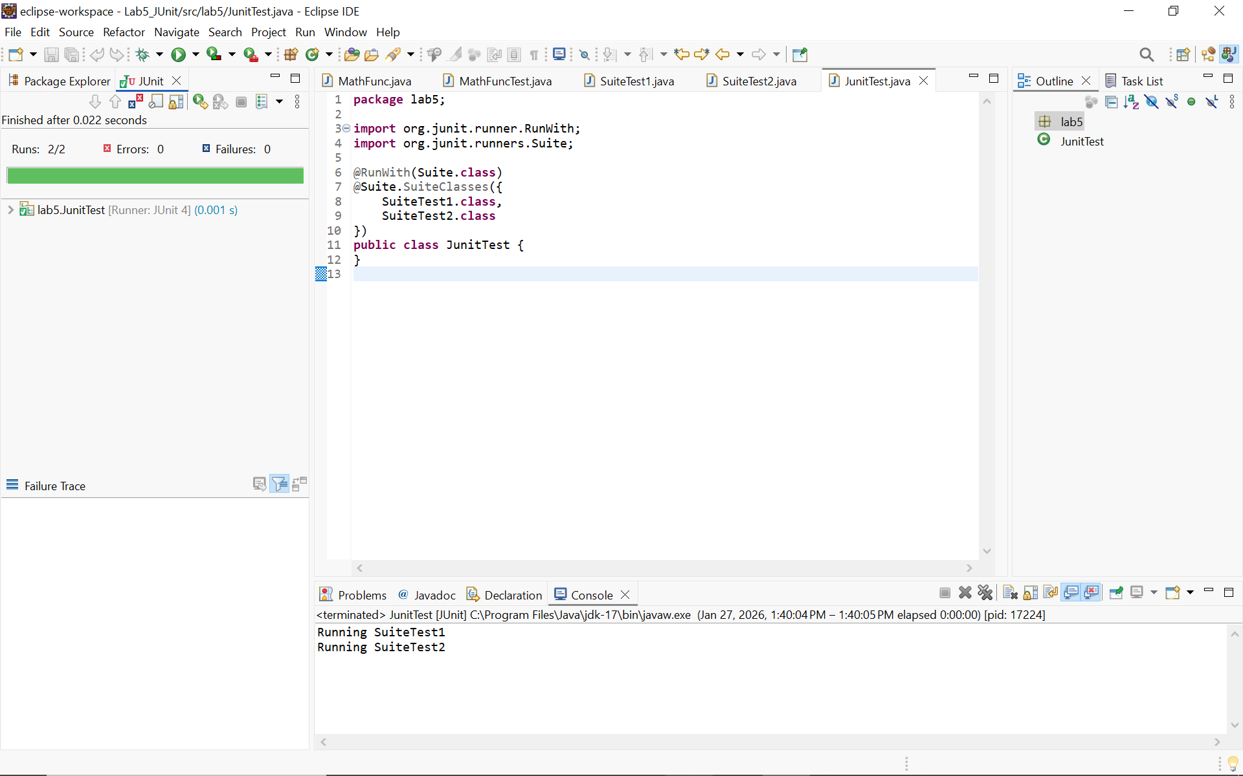
Bài 3: JUNIT ANNOTATIONS
JunitAnnotationsExample.java
package lab5;

import org.junit.*;

public class JunitAnnotationsExample {

@BeforeClass
public static void beforeClass() {
System.out.println("Before Class");
}

@AfterClass
public static void afterClass() {
System.out.println("After Class");
}

@Before
public void before() {
System.out.println("Before Test");
}

@After
public void after() {
System.out.println("After Test");
}

@Test
public void test1() {
System.out.println("Test 1");
}

@Ignore
@Test
public void testIgnored() {
System.out.println("Ignored Test");
}

@Test
public void test2() {
System.out.println("Test 2");
}
}
TestRunner.java
package lab5;

import org.junit.runner.JUnitCore;

public class TestRunner {
public static void main(String[] args) {
JUnitCore.runClasses(JunitAnnotationsExample.class);
}
}
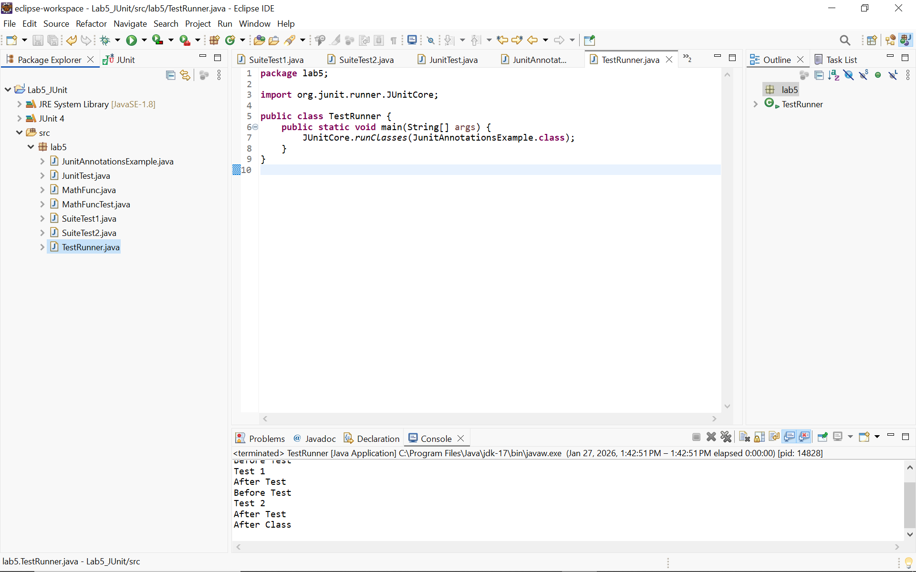
Bài 4. (3.0. điểm). Đặc tả yêu cầu: Cách tính tiền căn cứ vào lứa tuổi như sau:
TicketCalculator
package lab5;

public class TicketCalculator {

public static String calculateFee(int age) {
if (age < 0) {
throw new IllegalArgumentException("Age must be >= 0");
}

if (age <= 5) {
return "Miễn phí";
} else if (age <= 12) {
return "Trẻ em";
} else if (age <= 59) {
return "Người lớn";
} else {
return "Người cao tuổi";
}
}
}
TicketCalculatorTest.java
package lab5;

import static org.junit.Assert.*;
import org.junit.Test;

public class TicketCalculatorTest {

@Test
public void testFreeTicket() {
assertEquals("Miễn phí", TicketCalculator.calculateFee(0));
assertEquals("Miễn phí", TicketCalculator.calculateFee(5));
}

@Test
public void testChildrenTicket() {
assertEquals("Trẻ em", TicketCalculator.calculateFee(6));
assertEquals("Trẻ em", TicketCalculator.calculateFee(12));
}

@Test
public void testAdultTicket() {
assertEquals("Người lớn", TicketCalculator.calculateFee(13));
assertEquals("Người lớn", TicketCalculator.calculateFee(59));
}

@Test
public void testSeniorTicket() {
assertEquals("Người cao tuổi", TicketCalculator.calculateFee(60));
}

@Test(expected = IllegalArgumentException.class)
public void testInvalidAge() {
TicketCalculator.calculateFee(-1);
}
}
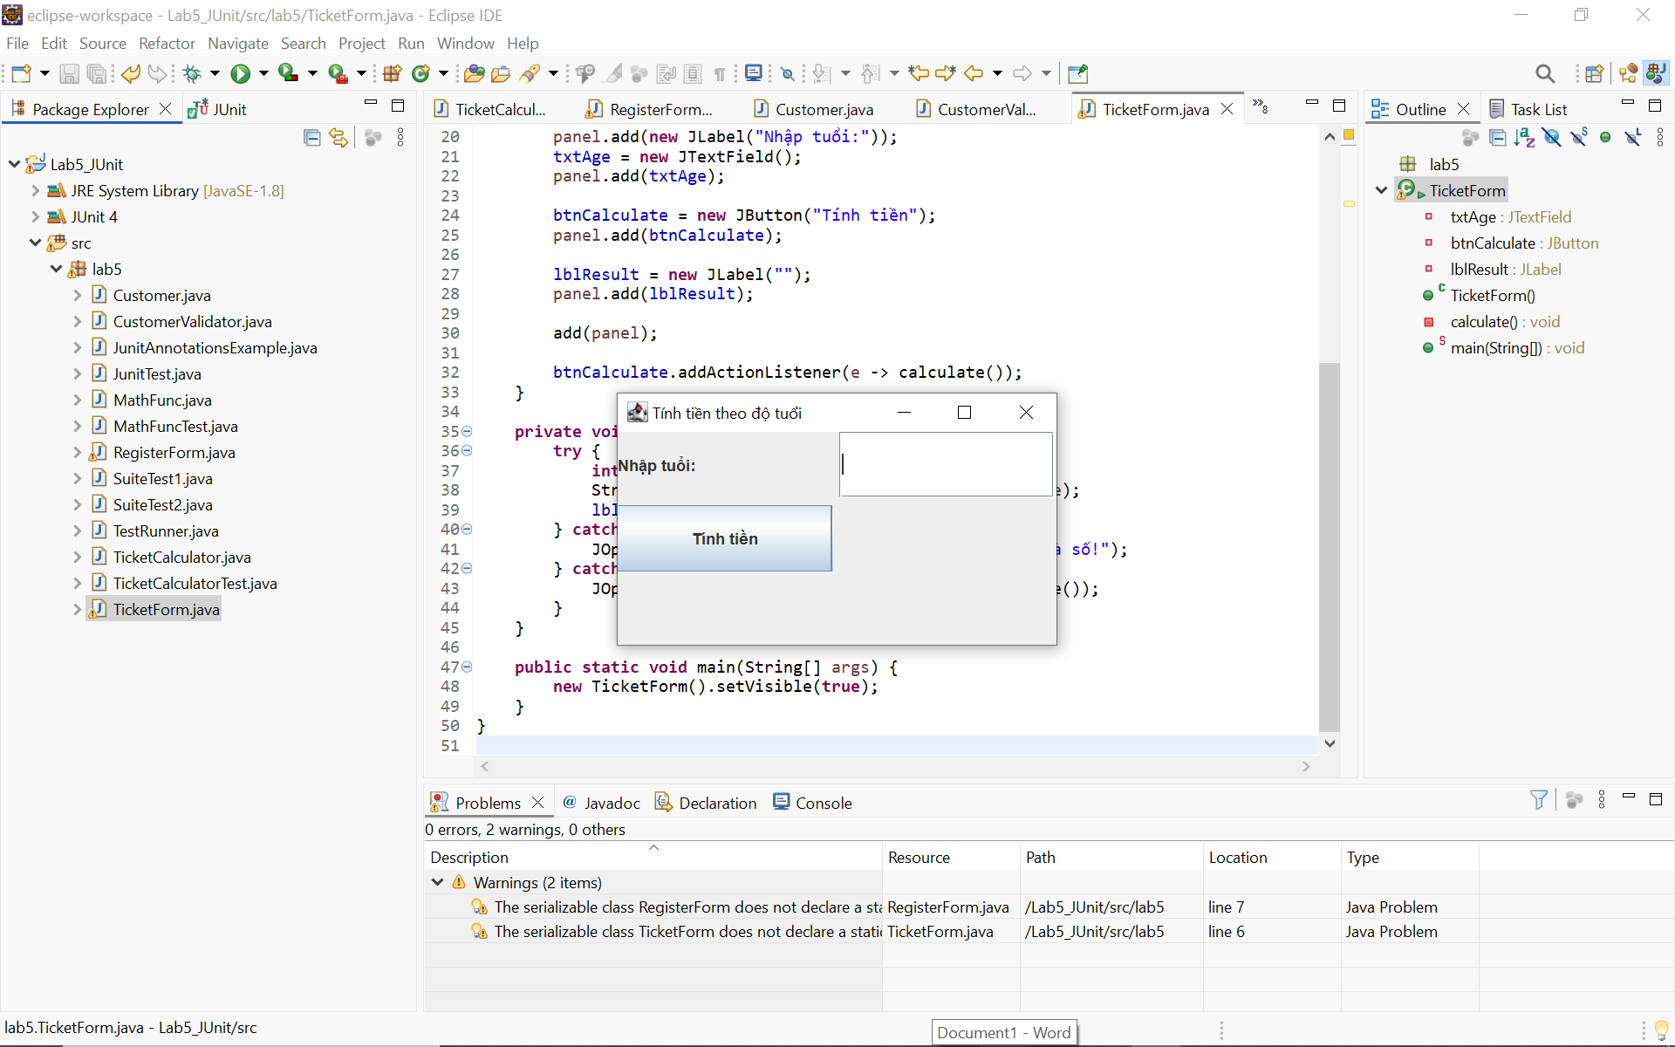
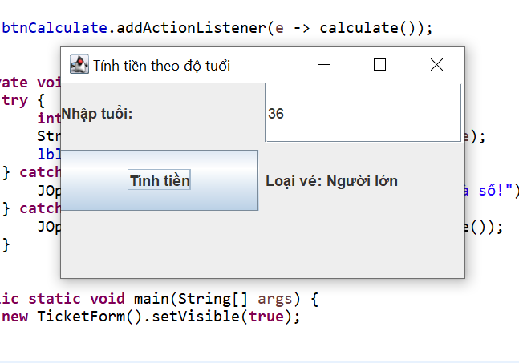
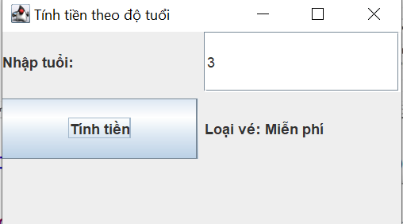
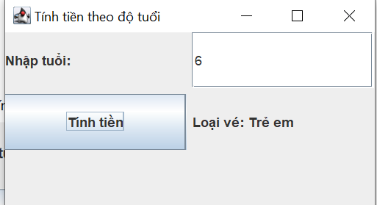
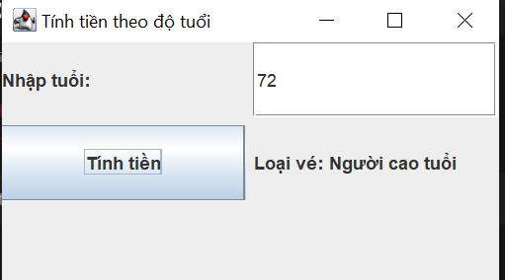
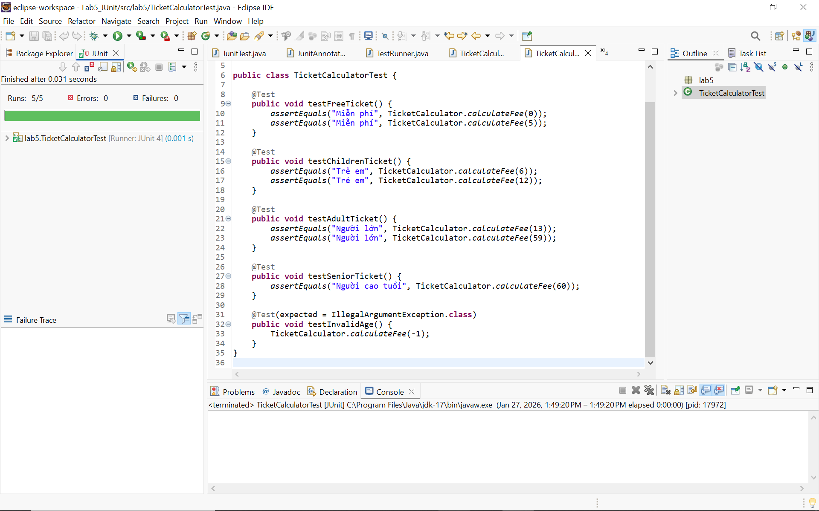
Bài 5: FORM ĐĂNG KÝ + TEST CASE
RegisterForm
package lab5;

import javax.swing.*;
import java.awt.*;
import java.awt.event.*;
import java.time.LocalDate;

public class RegisterForm extends JFrame {

private JTextField txtId, txtName, txtEmail, txtPhone, txtAddress, txtBirth;
private JPasswordField txtPassword, txtConfirm;
private JCheckBox chkTerms;
private JButton btnRegister, btnReset;

public RegisterForm() {
setTitle("Đăng ký tài khoản khách hàng");
setSize(450, 500);
setLocationRelativeTo(null);
setDefaultCloseOperation(JFrame.EXIT_ON_CLOSE);

JPanel panel = new JPanel(new GridLayout(10, 2, 5, 5));

panel.add(new JLabel("Mã khách hàng:"));
txtId = new JTextField();
panel.add(txtId);

panel.add(new JLabel("Họ và tên:"));
txtName = new JTextField();
panel.add(txtName);

panel.add(new JLabel("Email:"));
txtEmail = new JTextField();
panel.add(txtEmail);

panel.add(new JLabel("Số điện thoại:"));
txtPhone = new JTextField();
panel.add(txtPhone);

panel.add(new JLabel("Địa chỉ:"));
txtAddress = new JTextField();
panel.add(txtAddress);

panel.add(new JLabel("Mật khẩu:"));
txtPassword = new JPasswordField();
panel.add(txtPassword);

panel.add(new JLabel("Xác nhận mật khẩu:"));
txtConfirm = new JPasswordField();
panel.add(txtConfirm);

panel.add(new JLabel("Ngày sinh (yyyy-mm-dd):"));
txtBirth = new JTextField();
panel.add(txtBirth);

chkTerms = new JCheckBox("Tôi đồng ý điều khoản dịch vụ");
panel.add(chkTerms);

panel.add(new JLabel(""));

btnRegister = new JButton("Đăng ký");
btnReset = new JButton("Nhập lại");

panel.add(btnRegister);
panel.add(btnReset);

add(panel);

// Sự kiện
btnRegister.addActionListener(e -> register());
btnReset.addActionListener(e -> resetForm());
}

private void register() {
Customer c = new Customer();
c.id = txtId.getText();
c.name = txtName.getText();
c.email = txtEmail.getText();
c.phone = txtPhone.getText();
c.address = txtAddress.getText();
c.password = new String(txtPassword.getPassword());
c.confirmPassword = new String(txtConfirm.getPassword());
c.acceptTerms = chkTerms.isSelected();

if (!txtBirth.getText().isEmpty()) {
try {
c.birthDate = LocalDate.parse(txtBirth.getText());
} catch (Exception ex) {
JOptionPane.showMessageDialog(this, "Ngày sinh không hợp lệ!");
return;
}
}

if (CustomerValidator.validate(c)) {
JOptionPane.showMessageDialog(this, "Đăng ký tài khoản thành công!");
} else {
JOptionPane.showMessageDialog(this, "Dữ liệu không hợp lệ!");
}
}

private void resetForm() {
txtId.setText("");
txtName.setText("");
txtEmail.setText("");
txtPhone.setText("");
txtAddress.setText("");
txtPassword.setText("");
txtConfirm.setText("");
txtBirth.setText("");
chkTerms.setSelected(false);
}

public static void main(String[] args) {
new RegisterForm().setVisible(true);
}
}
TẠO CLASS ĐỐI TƯỢNG

Customer.java
package lab5;

import java.time.LocalDate;

public class Customer {
public String id;
public String name;
public String email;
public String phone;
public String address;
public String password;
public String confirmPassword;
public LocalDate birthDate;
public boolean acceptTerms;
}

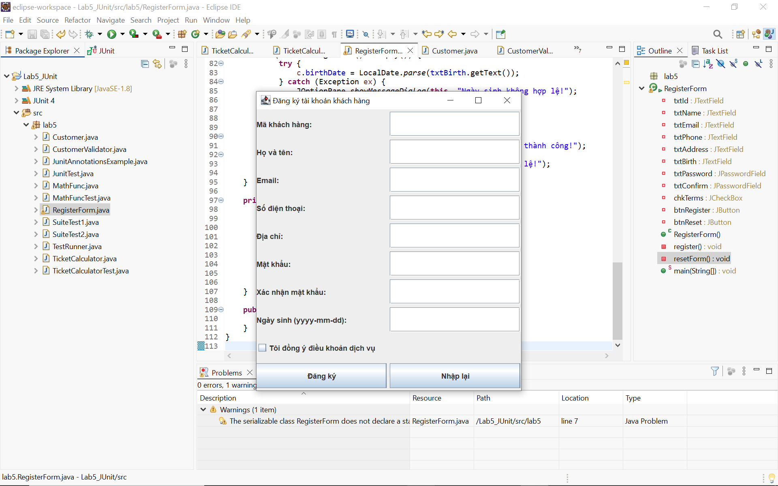
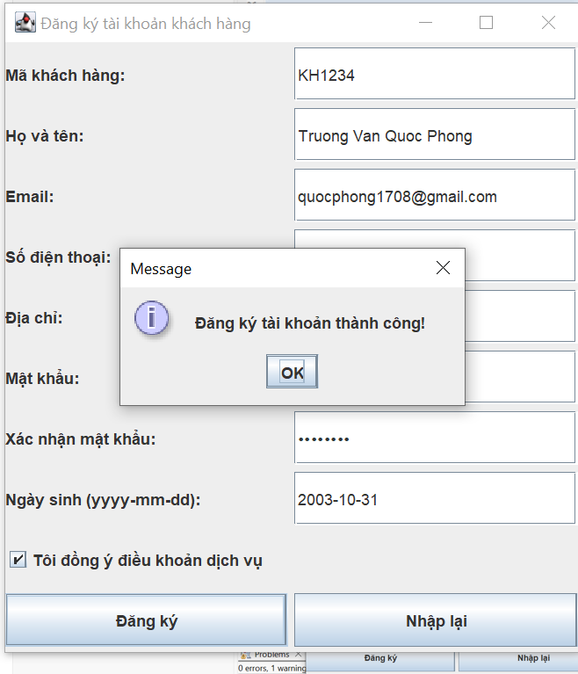
Nếu nhập sai :
