Bài tập tuần 6

Trương Văn Quốc Phong-1150080153-11_ĐH_cnpm2
Bài 1:

Yêu cầu

Tạo class JunitMessage

public class JunitMessage {

public int divide(int a, int b) {

return a / b;

}

}
Tạo class:
JunitMessage → xử lý phép chia
ArithmeticTest → test ngoại lệ
ArithmeticTest
import org.junit.Test;

public class ArithmeticTest {

@Test(expected = ArithmeticException.class)
public void testDivideByZero() {
JunitMessage jm = new JunitMessage();
jm.divide(10, 0);
}
}

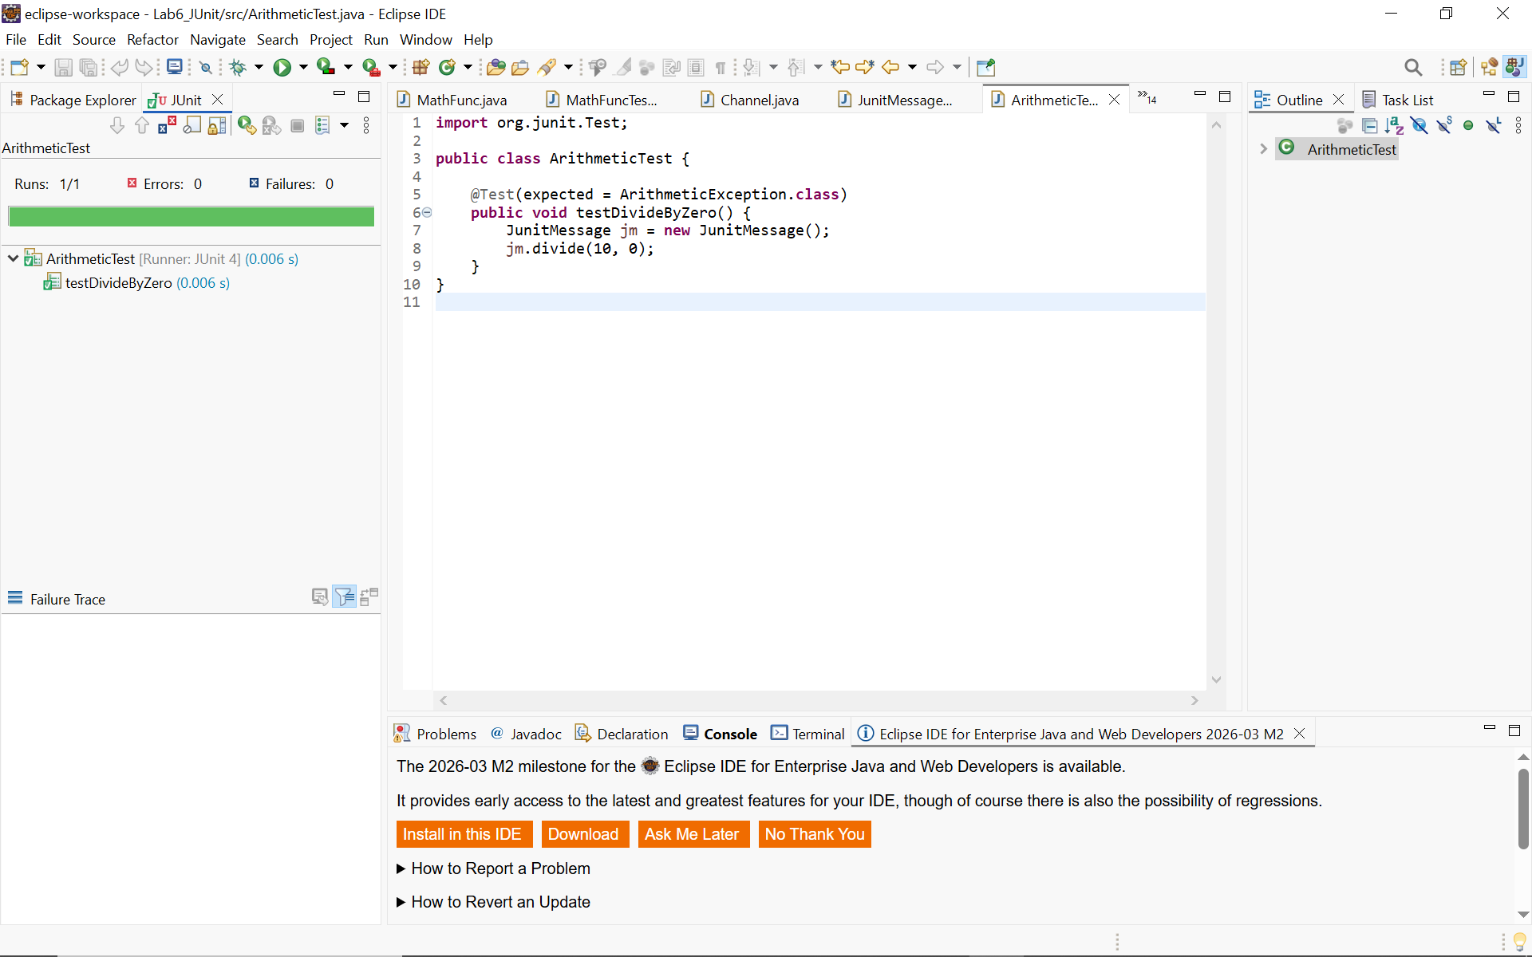

BÀI 2 – Test ngoại lệ Person
Tạo class Person
public class Person {

private String name;
private int age;

public Person(String name, int age) {
if (age < 0) {
throw new IllegalArgumentException("Age cannot be negative");
}

this.name = name;
this.age = age;
}

}
Tạo class: PersonTest
import org.junit.Test;

public class PersonTest {

@Test(expected = IllegalArgumentException.class)
public void testAgeNegative() {
new Person("Phong", -1);
}
}
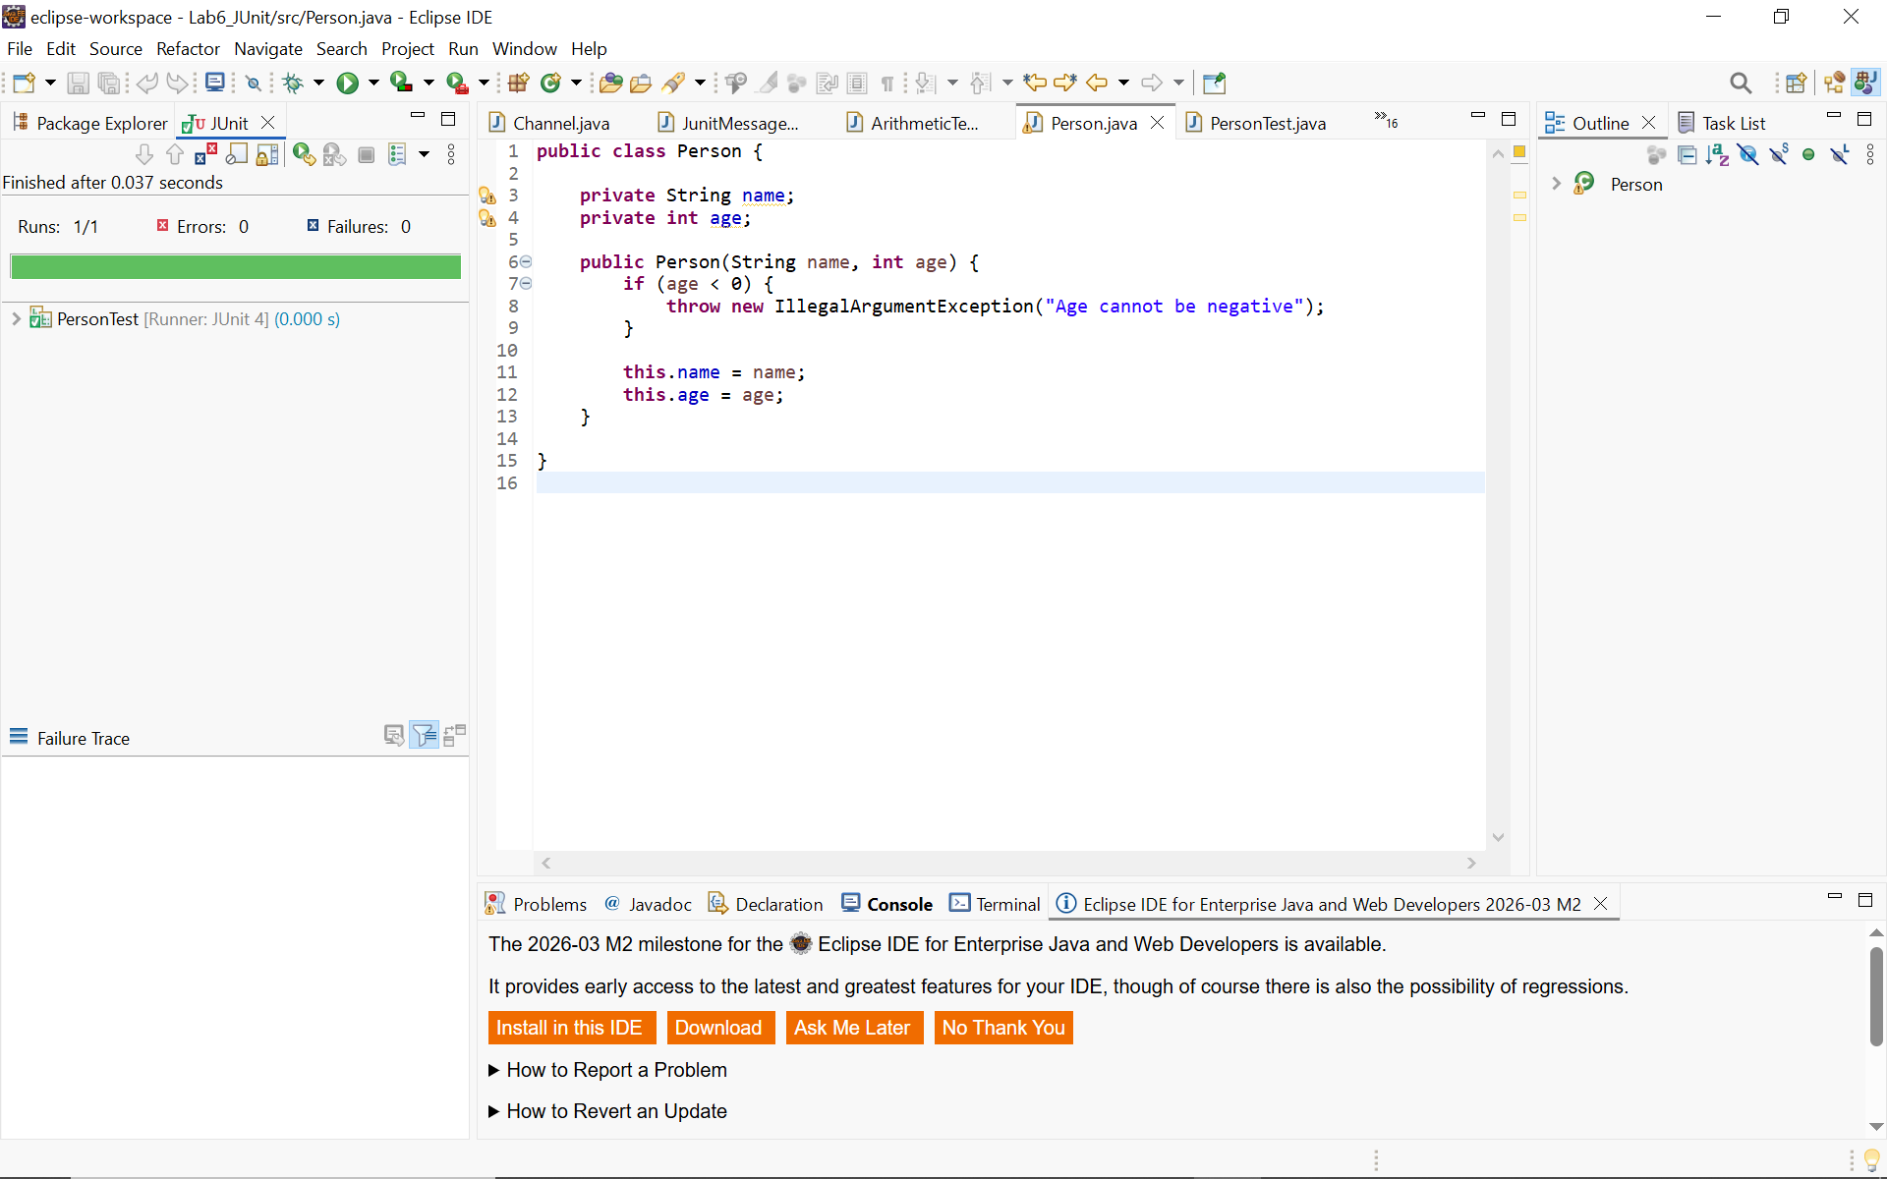
BÀI 3 – ErrorCollector
Tạo class ErrorCollectorExample
import org.junit.Rule;
import org.junit.Test;
import org.junit.rules.ErrorCollector;

public class ErrorCollectorExample {

@Rule
public ErrorCollector collector = new ErrorCollector();

@Test
public void testErrors() {

collector.addError(new Throwable("First Error"));
collector.addError(new Throwable("Second Error"));
collector.addError(new Throwable("Third Error"));

}
}
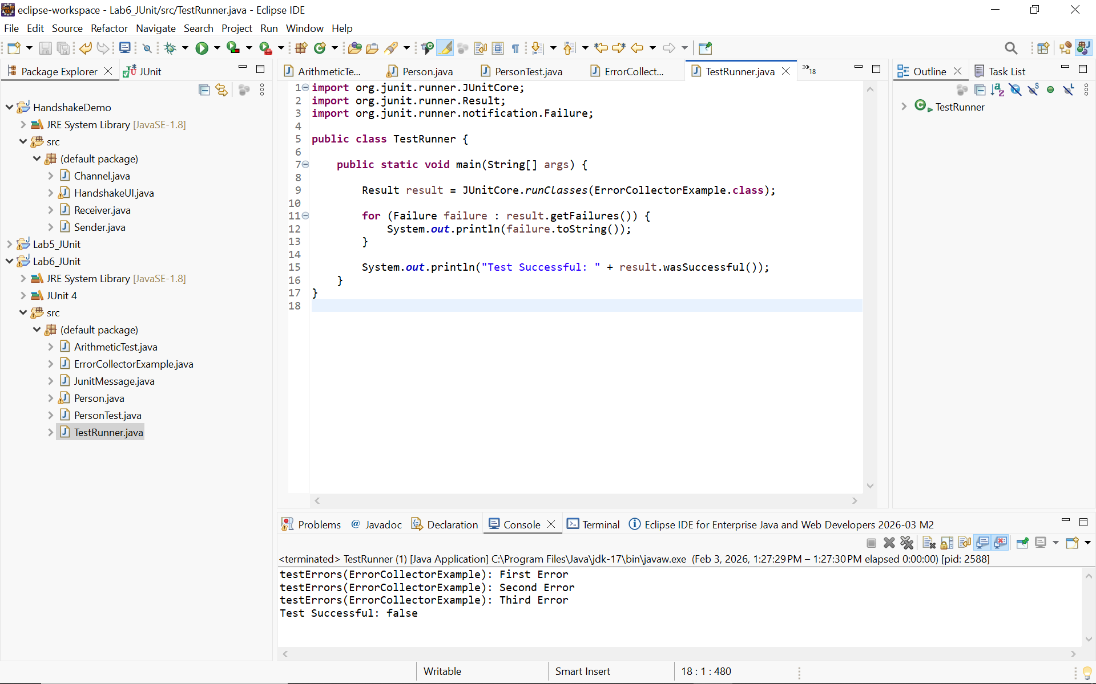
BÀI 4 – Form kết nối database
Tạo class LoginService
import java.sql.Connection;
import java.sql.DriverManager;
import java.sql.ResultSet;
import java.sql.Statement;

public class LoginService {

public boolean login(String username, String password) {

try {
Connection conn = DriverManager.getConnection(
"jdbc:mysql://localhost:3306/testdb",
"root",
"");

Statement st = conn.createStatement();

ResultSet rs = st.executeQuery(
"SELECT * FROM users WHERE username='" +
username + "' AND password='" + password + "'");

return rs.next();

} catch (Exception e) {
return false;
}
}
}
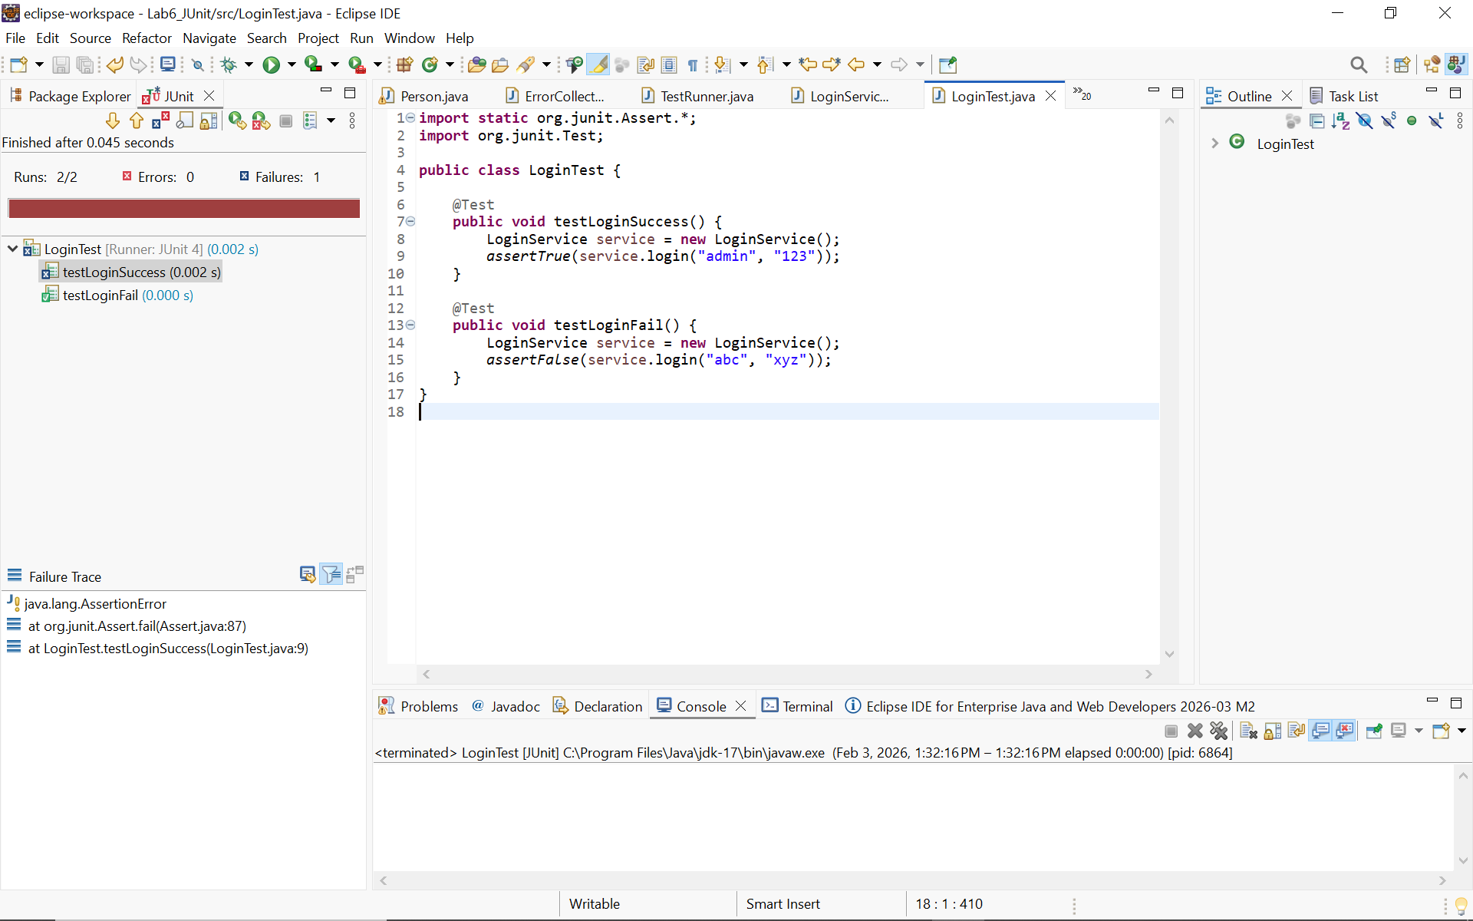
BÀI 5 – Add Job Title Validation
Tạo class JobTitleValidator
public class JobTitleValidator {

public boolean isValidTitle(String title) {
return title != null && title.length() > 0 && title.length() <= 100;
}

public boolean isValidDescription(String desc) {
return desc != null && desc.length() <= 400;
}
}
Test class
import static org.junit.Assert.*;
import org.junit.Test;

public class JobTitleTest {

JobTitleValidator v = new JobTitleValidator();

@Test
public void testValidTitle() {
assertTrue(v.isValidTitle("Developer"));
}

@Test
public void testEmptyTitle() {
assertFalse(v.isValidTitle(""));
}

@Test
public void testLongTitle() {
assertFalse(v.isValidTitle("aaaaaaaaaaaaaaaaaaaaaaaaaaaaaaaaaaaaaaaaaaaaaaaaaaaaaaaaaaaaaaaaaaaaaaaaaaaaaaaaaaaaaaaaaaaaaaaaaaaaaaa"));
}
}
