**ERD:**

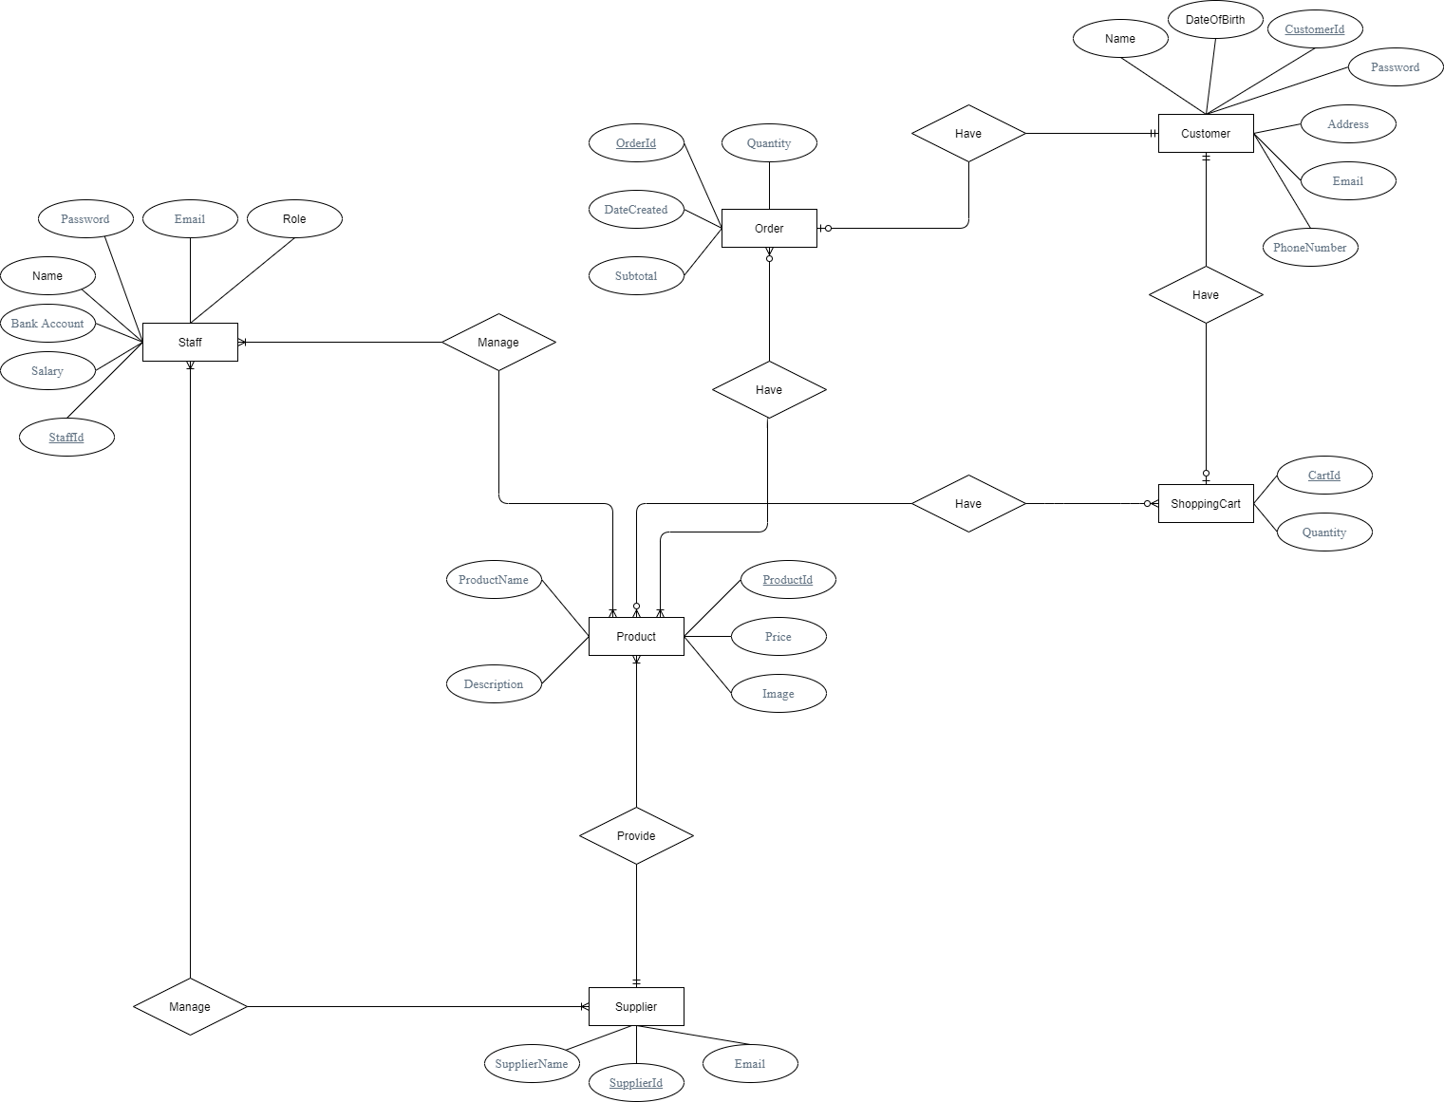

**Mô hình quan hệ:**

Customer(CustomerId,Name,Password,DateOfBirth,Adress,Email,PhoneNumber)

Order(OrderId,DateCreated,Quantity,Subtotal,**CustomerId**)

ShoppingCart(CartId,Quantity,**CustomerId**)

Product(ProductId,ProductName,Description,Price,Image,**SupplierId**)

Supplier(SupplierId,SupplierName,Email)

Staff(StaffId,Name,Password,Email,BankAccount,Salary)

CartItem(**CartID**,**ProductId**)

OrderDetails(**OrderID**,**ProductId)**

ManageProduct(**StaffId,ProductId)**

ManageSupplier(**StaffId,SupplierId)**