**Student name:  Ngô Quốc Thắng**

**Student ID: 20194839**

**Course: Compiler Construction Lab**

Report for Lab02

1. Result of running the scanner project with example2.kpl

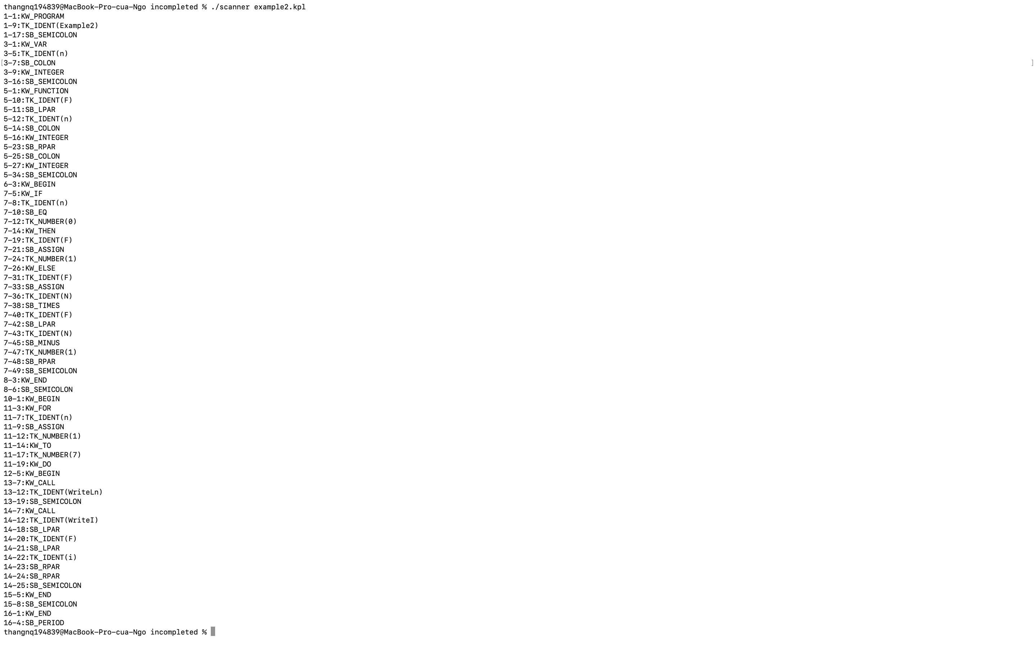

1. Result of running the scanner project with example2.kpl having error ERM_INVALIDSYMBOL



I insert @ before word Example2. Because @ is not a token in KPL so it raises an error here.