**Student name:  Ngô Quốc Thắng**

**Student ID: 20194839**

**Course: Compiler Construction Lab**

Report for Lab03

1. Result of running the scanner project with example3.kpl

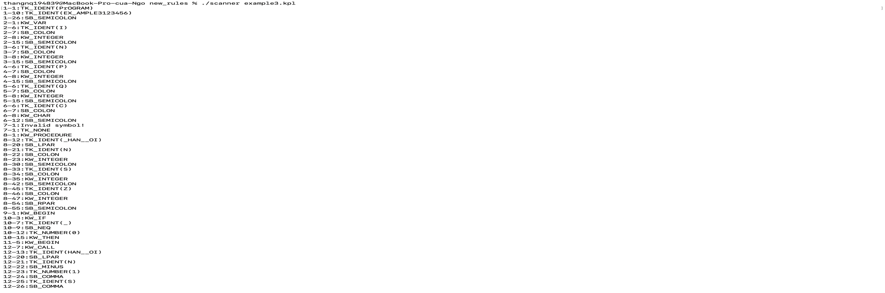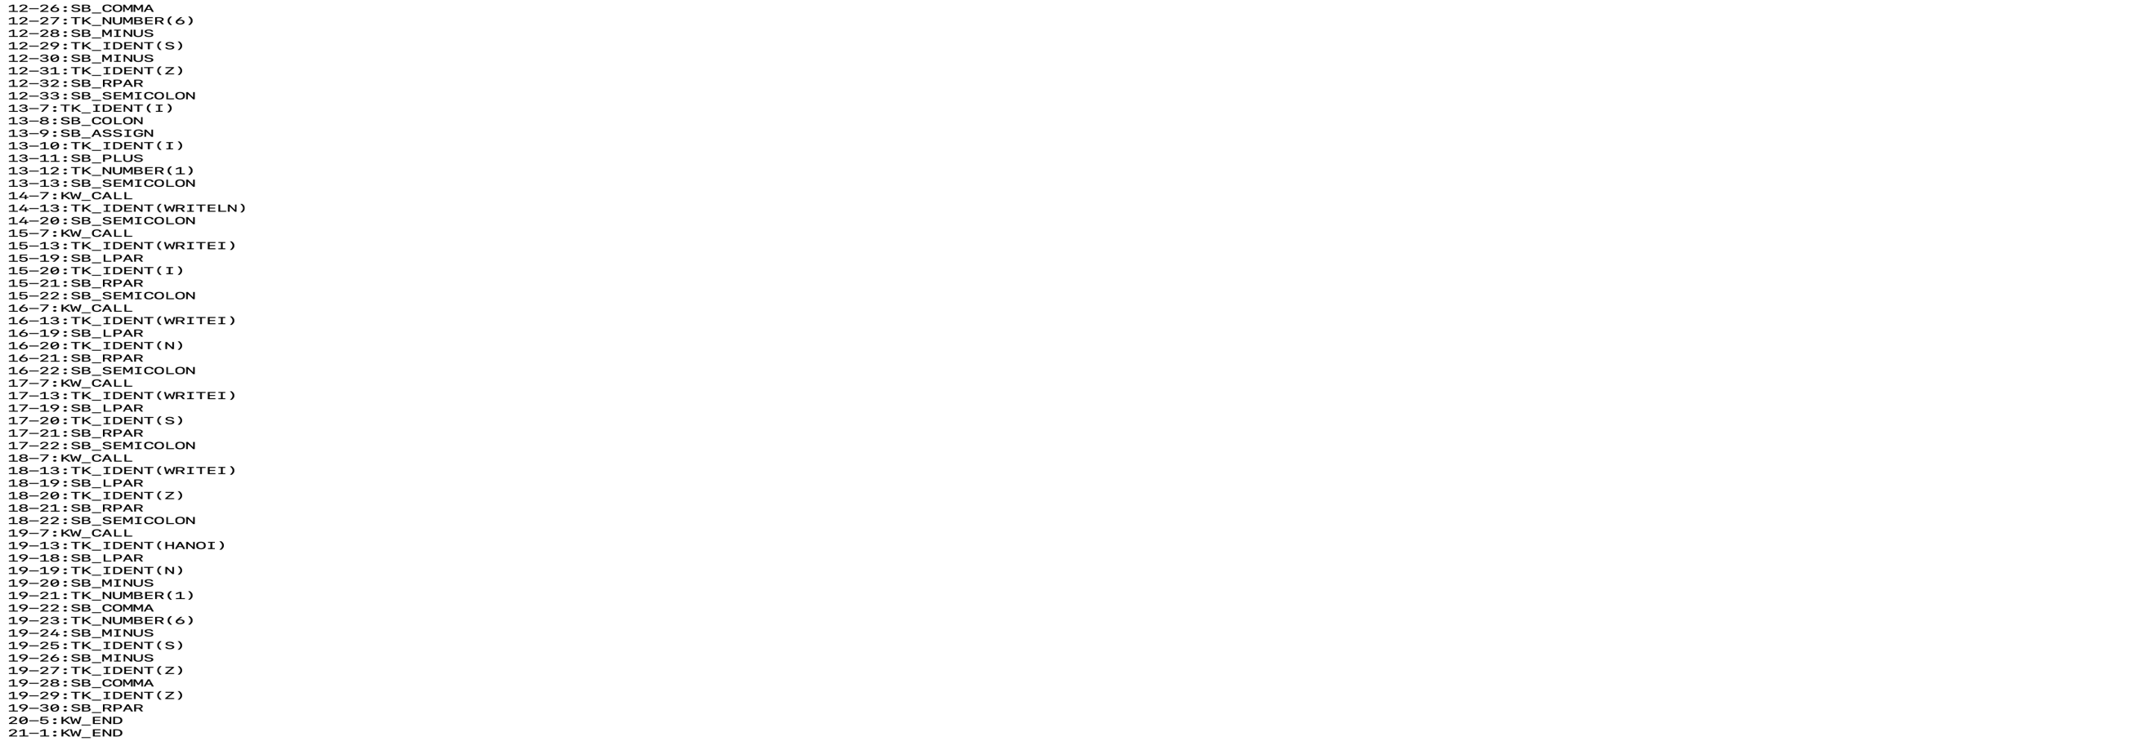

1. 2

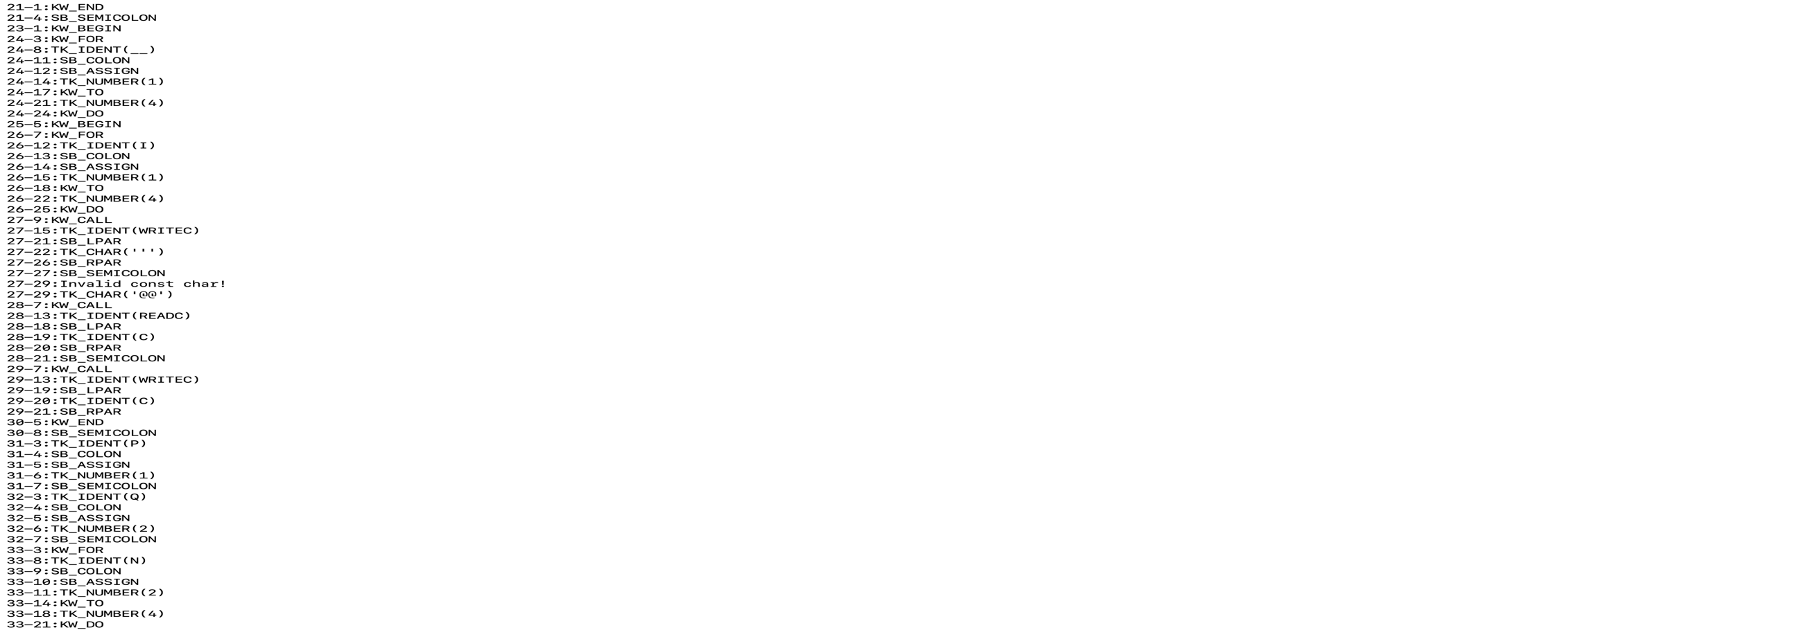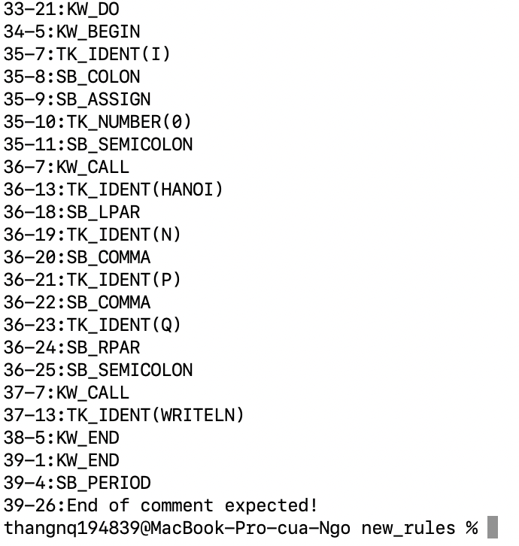

3 4