***Student name: Ngô Quốc Thắng***

***Student ID: 20194839***

REPORT for Assignment 3 CC Lab

***Result of parsing with example3.kpl***

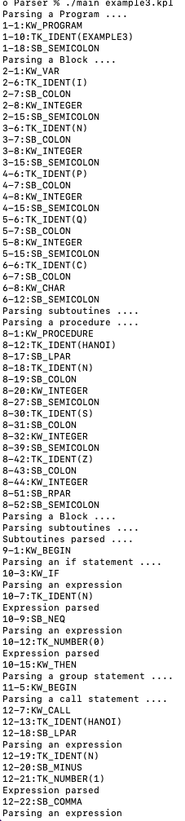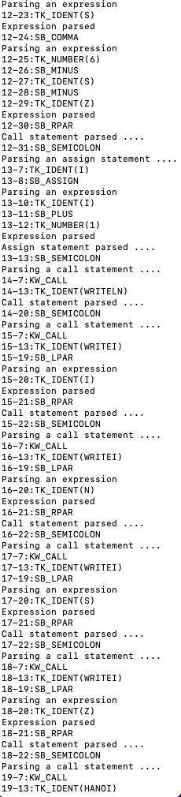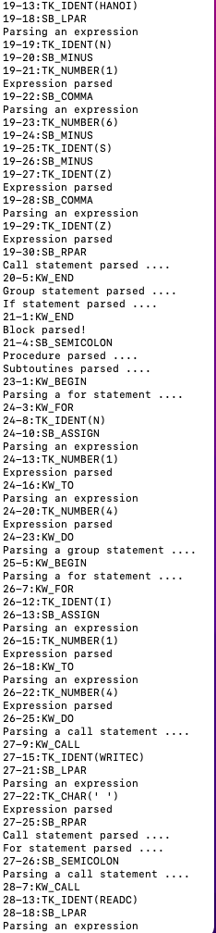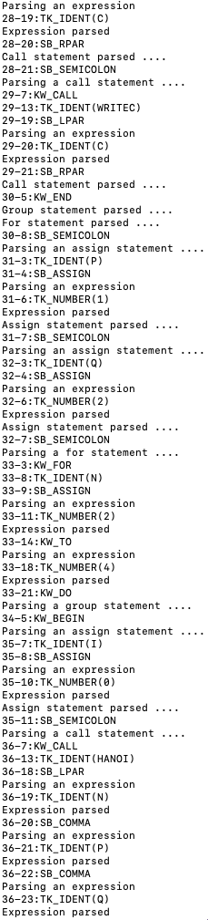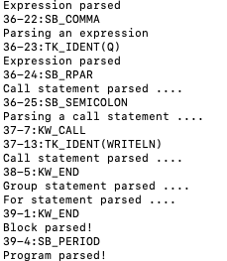

***Result of parsing with example5.kpl***

