*Student name: Ngô Quốc Thắng*

*Student ID: 20194839*

**REPORT SEMANTICS 3**

Before modifying example4.kpl. Screenshot of result.

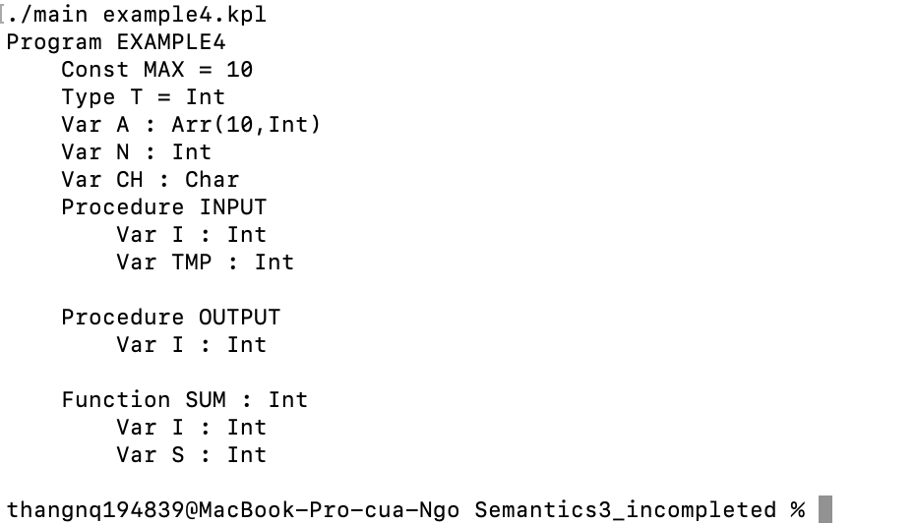

After modifying the Sum function (adding more Function product inside sum function):

FUNCTION SUM : INTEGER;

VAR I: INTEGER;

S : INTEGER;

FUNCTION PRODUCT : INTEGER;

BEGIN

END;

BEGIN

PRODUCT := 0; (* return assignment statement*)

S := 0;

I := 1;

WHILE I <= N DO

BEGIN

S := S + A(.I.);

I := I + 1;

END

END;

