Student name: Ngô Quốc Thắng

Student ID: 20194839

Report for Semantics 4 type checking

1. Result of running example4:

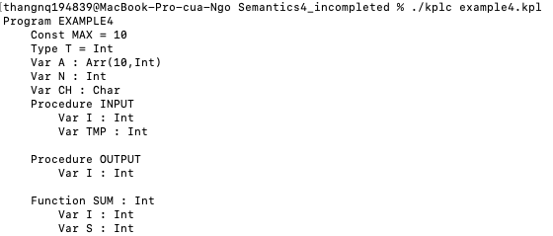

2. Result of running modified example4.kpl so that it causes error "The number of arguments and the number of parameters are inconsistent."



CH := 'y';

WHILE CH = 'y' DO

BEGIN

CALL INPUT(CH);

CALL OUTPUT;

CALL WRITEI(SUM);

CH := READC;

END

I added 1 argument is CH in procedure INPUT which was declared with no param. Because the paramList passed in INPUT is NULL (no param) so that it caused error when seeing one argument.