**UNIVERSITY OF TECHNOLOGY AND EDUCATION**

**FACULTY FOR HIGH QUALITY TRAINING**



**GRADUATION THESIS**

**CONSTRUCT OF LANE DEPARTURE WARNING SYSTEM USING RASPBERRY PI**

**ADVISOR: NGUYEN DANG QUANG, M.S**

**STUDENT:**

1. **NGUYEN TUAN KIET 14110348**
2. **NGUYEN QUOC TINH 14110422**

**ACADEMIC BATCH: 2014 – 2018**

**MAJOR: INFORMATION TECHNOLOGY**

Ho Chi Minh City, May 2018

 **SOCIALIST REPUBLIC OF VIETNAM**

**Independence – Freedom – Happiness**

**----***----**

**Ho Chi Minh City, May 31st 2018**

**MISSION OF THESIS**

Student’s name: Nguyen Tuan Kiet 14110348

Nguyen Quoc Tinh 14110422

Major: Information Technology Class: 14110CL1

Advisor: NGUYEN DANG QUANG, M.S Phone number: 01662218622

Delivery date: 16/01/2018 Submission date: 31/05/2018

1. **Title of thesis:** Construct of lane departure warning system using Raspberry Pi.
2. **The original data, documents:**
3. **Main content:**
4. **Product:**

|  |  |
| --- | --- |
| Program Chair | Advisor |

 **SOCIALIST REPUBLIC OF VIETNAM**

**Independence – Freedom – Happiness**

**----***----**

**ADVISOR’S COMMENT**

Student’s name: Nguyen Tuan Kiet 14110348

Nguyen Quoc Tinh 14110422

Major: Information Technology

Title of thesis: Construct of lane departure warning system using Raspberry Pi.

Advisor’s name: NGUYEN DANG QUANG, M.S.

**COMMENTS**

1. The content of thesis and the workload allocated:

1. Advantages:

1. Improvement point:

1. Project defense approval:

1. Evaluation mark:

1. Grade: (in words: )

|  |  |
| --- | --- |
|  | Ho Chi Minh City, May 31st 2018  Advisor  (*Name & signature*) |

 **SOCIALIST REPUBLIC OF VIETNAM**

**Independence – Freedom – Happiness**

**----***----**

**REVIEWER’S COMMENT**

Student’s name: Nguyen Tuan Kiet 14110348

Nguyen Quoc Tinh 14110422

Major: Information Technology

Title of thesis: Construct of lane departure warning system using Raspberry Pi.

Reviewer’s name:

**COMMENTS**

1. The content of thesis and the workload allocated:

1. Advantages:

1. Improvement point:

1. Project defense approval:

1. Evaluation mark:

1. Grade: (in words: )

|  |  |
| --- | --- |
|  | Ho Chi Minh City, May 31st 2018  Reviewer  (*Name & signature*) |

**TABLE OF CONTENTS**

**ACKNOWLEDGEMENT** i

**ABSTRACT** ii

**LIST OF ABBREVIATIONS** iii

**LIST OF TABLES** iv

**LIST OF FIGURES** v

Chapter 1: INTRODUCTION 1

1.1. Statement of the Problem 1

1.2. Purpose of the Study 1

1.3. Background of the Study 2

1.4. Objectives of the Study 4

1.5. Scope of the Study 5

1.6. Methodology 5

1.7. Structure of the Thesis 5

Chapter 2: FUNDAMENTAL 1

2.1. Canny Edge detection 1

2.2. Hough transform method 1

2.3. OpenCV library 1

2.4. Raspberry Pi 3, Raspbian and Raspberry Pi Camera Module 1

# **ACKNOWLEDGEMENT**

# **ABSTRACT**

The main purpose of this thesis is to develop a Lane Departure Warning System (LDWS). As part of Automatic Driver Assistance System (ADAS), LDWS exist to alert the driver when a car is diverting from its original lane. The LDWS require 3 major operation. First, the captured image is divided into two parts as a road part and a non -road part by using the camera geometry information. Then, inverse perspective mapping is applied to avoid disadvantage of perspective effect. Next, gradient method is used to filter lane marks and Canny edge detection is applied. Additionally, Hough transform method is used for lane marks detection. Finally, driver is warned according to right or left lane departure by using detected lane marks’ angles.

Raspberry Pi is the primary platform that this system will implement on. It has various Input/Output (I/O) ports that allow developer to utilize and many module and component have been design for it, such as the ~~Raspberry Pi~~ Camera Module which will be used for the system purposed.

There are several problem which will be solve by the system. First of all, the road condition such as weather and low light condition that will cause the system not able to detect the lane should be addressed with several image processing technique. Other than that, this system should be portable and compact enough to be installed on the rear of a windshield mirror and implemented on a vehicle.

# **LIST OF ABBREVIATIONS**

LDWS Lane Departure Warning System

ADAS Automatic Driver Assistance System

NHTSA National Highway Traffic Safety Administration

IIHS Insurance Institute for the Safety of the United States Highway

# **LIST OF TABLES**

# **LIST OF FIGURES**

Figure 1.1: Lane Departure Warning 2

Figure 1.2: Technology Lane alert on Chevrolet 4

1. INTRODUCTION
   1. Statement of the Problem

Increase in the number of vehicles and traffic accidents have become a major problem all over the world. According to the World Health Organization (WHO), about 1.2 million people get killed in traffic accidents each year worldwide, while the number of injured is estimated to be between 20 and 50 million. Most of these accidents occur due to driver inattention.

One of the most developed axes of research in automotive solution is passenger's safety. Thus, public research groups, automotive manufacturers and suppliers, as well as other research institutions are developing the next generation of the driver – assistant system that will enable vehicles to have safer reactions and to decrease road injuries and deaths.

Driver warning systems which make the driver realize a dangerous situation are one of the functions of the driver – assistant. The driver is warned against potential hazards which are determined by various sensor systems such as radar and camera.

The system can be divided on a three-step approach. Firstly, the sense and perception of the World are observed. Secondly, the decision on what to do is made based on real-time perception. And finally, the action will be carried out based on the decision made. The most challenging phase of building an automated car is perception and lane detection is definitely the first priority of it.

The system in this thesis is about lane detection and lane departure warning system.

* 1. Purpose of the Study

When people drive, they use their eyes to figure out how fast to go and where the lane lines are and where to turn. A car doesn’t have eyes. But, in a self - driving car, we can use cameras and other sensors to achieve a similar function. So, let’s think about what those cameras are seeing as we drive down the road. The human can easily see where the lane lines are ~~automatically~~ but we need to teach the car how to do that.

People can find lane lines on the road fairly easily, even in a wide variety of conditions. Unless there is snow covering the ground, extremely heavy rainfall, the road is very dirty or in disrepair, we can mostly tell where we are supposed to go, assuming the lines are actually marked. But, computers, on the other hand, do not find this easy. Shadows, glare, small changes in the color of the road, slight obstruction of the line…all things that people can generally ~~still~~ handle, but a computer may struggle mightily with.

The purpose of the study is how to solve that problem and warn the driver of unintended lane departures. OpenCV and Canny Edge detection is one of the most popular computer vision techniques to serve it.

At the end of this thesis, we aim to have a device which use Raspberry Pi 3 and Raspberry Pi Camera Module capable of:

1. Detecting lane markings on the road surface with various weather conditions and different road types.
2. Warning the driver of unintended lane departures.
   1. Background of the Study

In road-transport terminology, a lane departure warning system is a mechanism designed to warn the driver when the vehicle begins to move out of its lane on freeways and arterial roads. These systems are designed to minimize accidents by addressing the main causes of collisions: driver error, distractions, and drowsiness. In 2009 the U.S. National Highway Traffic Safety Administration (NHTSA) began studying whether to mandate lane departure warning systems and frontal collision warning systems on automobiles.

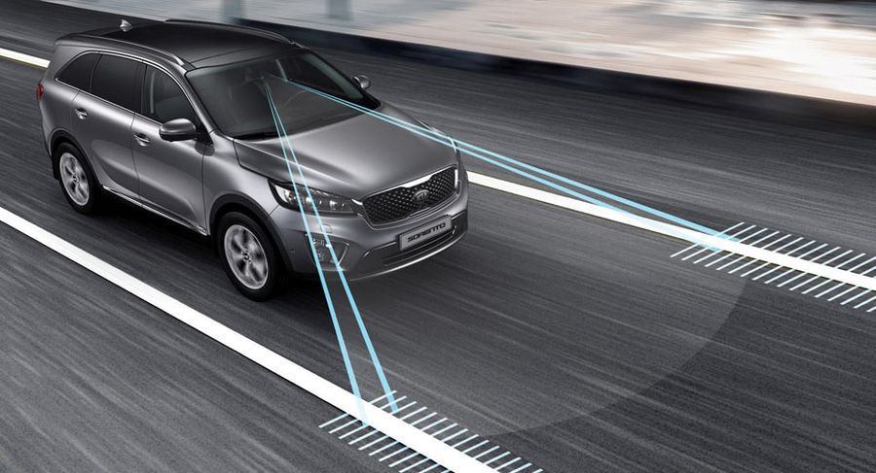

Figure 1.1: Lane Departure Warning

(Source: https://xehay.vn/uploads/images/2017/8/04/xehay-Lane-Departure-Warning-250817-1.jpg)

There are two main types of system:

* The system which warns the driver (Lane departure warning, LDW) if the vehicle is leaving its lane (visual, audible, and/or vibration warnings).
* The system which warns the driver and, if no action is taken, automatically takes steps to ensure the vehicle stay in its lane (lane keeping system, LKS).

The first production lane departure warning system in Europe was developed by the United States company Iteris for Mercedes Actros commercial trucks. The system debuted in 2000 and is now available on most trucks sold in Europe.

In 2002, the Iteris system became available on Freightliner Trucks North American vehicle. In both these system, the driver is warned of unintentional lane departures by an audible rumble strip sound generated on the side of the vehicle drifting out of the lane. No warnings are generated if, before crossing the lane, an active turn signal is given by the driver.

*Abroad:*

The lane departure warning system is one of the most expensive safety features on modern cars. According to the Insurance Institute for the Safety of the United States Highway (IIHS), this feature helps prevent up to 85,000 accidents each year in this country.

IIHS deputy director of research, Jessica Cicchino, recently conducted a study on the effectiveness of the lane departure warning system by analyzing crash date from police reports. And the recorded the numbers are notable.

Research has shown active safety system cars, the rate of self-inflicted injury, accidental stabbing from the hip or craniofacial injury was reduce to 11%. In addition, it reduced the incidence of injuries in accidents by 21%. And most notably, the lane warning system has helped prevent 85,000 accidents and at least 55,000 injuries in 2015.

According to Cicchino, these are the first examples that show us, Lane departure warning or active safety systems are important and they help prevent serious accidents and help save more lives.

According to previous studies, the lane warning system is believed to reduce up to 50% of accidents. However, IIHS argues that the bottom line is that failure to achieve this number is because many US drivers have the habit of turning off the lane warning system, though they know it is a safety feature.

*In the country:*

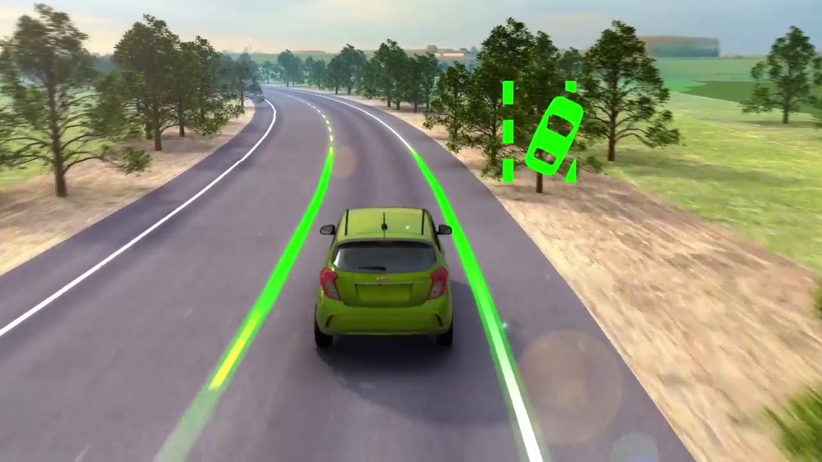

Figure 1.2: Technology Lane alert on Chevrolet

(Source: https://i.ytimg.com/vi/7rfa1rEWLQ8/maxresdefault.jpg)

* 1. Objectives of the Study

To complete this study we have five main objectives:

1. Learn about Raspberry Pi 3 and Raspberry Pi Camera Module
2. Learn about OpenCV library
3. Learn about Canny Edge detection and Hough transform method
4. Detecting lane markings on the road surface base on OpenCV, Canny Edge detection and Hough transform method.
5. Warning driver according to right or left lane departure by using detected lane marks’ angles
   1. Scope of the Study

Subject: single-board computers Raspberry pi, camera and data capture from camera images to detect lane.

Scopy of the study: TPHCM, represented by HCMC University of Technology and Education.

* 1. Methodology

Chapter 2, our team applies the methods of analyzing and synthesizing theories, studying different documents and theories, exploring topics and researches done at home and abroad. Proceed with reference and then select lane detection algorithm and Raspberry Pi apply to the project.

* 1. Structure of the Thesis

Chapter 1: Introduction

Chapter 2: Fundamental

Chapter 3: …

1. FUNDAMENTAL
   1. Canny Edge detection
   2. Hough transform method
   3. OpenCV library
   4. Raspberry Pi 3, Raspbian, and Raspberry Pi Camera Module