**UNIVERSITY OF TECHNOLOGY AND EDUCATION**

**FACULTY FOR HIGH QUALITY TRAINING**



**GRADUATION THESIS**

**CONSTRUCT OF LANE DEPARTURE WARNING SYSTEM USING RASPBERRY PI**

**ADVISOR: NGUYEN DANG QUANG, M.S**

**STUDENT:**

1. **NGUYEN TUAN KIET 14110348**
2. **NGUYEN QUOC TINH 14110422**

**ACADEMIC BATCH: 2014 – 2018**

**MAJOR: INFORMATION TECHNOLOGY**

Ho Chi Minh City, May 2018

 **SOCIALIST REPUBLIC OF VIETNAM**

**Independence – Freedom – Happiness**

**----***----**

**Ho Chi Minh City, May 31st 2018**

**MISSION OF THESIS**

Student’s name: Nguyen Tuan Kiet 14110348

Nguyen Quoc Tinh 14110422

Major: Information Technology Class: 14110CL1

Advisor: NGUYEN DANG QUANG, M.S Phone number: 01662218622

Delivery date: 16/01/2018 Submission date: 31/05/2018

1. **Title of thesis:** Construct of lane departure warning system using Raspberry Pi.
2. **The original data, documents:**
3. **Main content:**
4. **Product:**

|  |  |
| --- | --- |
| Program Chair | Advisor |

 **SOCIALIST REPUBLIC OF VIETNAM**

**Independence – Freedom – Happiness**

**----***----**

**ADVISOR’S COMMENT**

Student’s name: Nguyen Tuan Kiet 14110348

Nguyen Quoc Tinh 14110422

Major: Information Technology

Title of thesis: Construct of lane departure warning system using Raspberry Pi.

Advisor’s name: NGUYEN DANG QUANG, M.S.

**COMMENTS**

1. The content of thesis and the workload allocated:

1. Advantages:

1. Improvement point:

1. Project defense approval:

1. Evaluation mark:

1. Grade: (in words: )

|  |  |
| --- | --- |
|  | Ho Chi Minh City, May 31st 2018  Advisor  (*Name & signature*) |

 **SOCIALIST REPUBLIC OF VIETNAM**

**Independence – Freedom – Happiness**

**----***----**

**REVIEWER’S COMMENT**

Student’s name: Nguyen Tuan Kiet 14110348

Nguyen Quoc Tinh 14110422

Major: Information Technology

Title of thesis: Construct of lane departure warning system using Raspberry Pi.

Reviewer’s name:

**COMMENTS**

1. The content of thesis and the workload allocated:

1. Advantages:

1. Improvement point:

1. Project defense approval:

1. Evaluation mark:

1. Grade: (in words: )

|  |  |
| --- | --- |
|  | Ho Chi Minh City, May 31st 2018  Reviewer  (*Name & signature*) |

# TABLE OF CONTENTS

**ACKNOWLEDGEMENT** i

**ABSTRACT** ii

**LIST OF ABBREVIATIONS** iii

**LIST OF TABLES** iv

**LIST OF FIGURES** v

Chapter 1: INTRODUCTION 1

1.1. Statement of the Problem 1

1.2. Purpose of the Study 1

1.3. Background of the Study 2

1.4. Objectives of the Study 4

1.5. Scope of the Study 5

1.6. Methodology 5

1.7. Structure of the Thesis 5

Chapter 2: FUNDAMENTAL 1

2.1. Canny Edge detection 1

2.2. Hough transform method 1

2.3. OpenCV library 1

2.4. Raspberry Pi 3, Raspbian and Raspberry Pi Camera Module 1

# ACKNOWLEDGEMENT

# ABSTRACT

The main purpose of this thesis is to develop a Lane Departure Warning System (LDWS). As part of Automatic Driver Assistance System (ADAS), LDWS exists to alert the driver when the car is diverting from its original lane. The LDWS requires 3 major operations. First, the captured image is divided into two parts as a road part and a non -road part by using the camera geometry information. Then, the inverse perspective mapping is applied to avoid the disadvantage of perspective effect. Next, a gradient method is used to filter lane marks and Canny edge detection is applied. Additionally, Hough transform method is used for lane marks detection. Finally, the driver is warned according to right or left lane departure by using detected lane marks’ angles.

Raspberry Pi is the primary platform that this system will be implemented on. It has various Input/Output (I/O) ports that allow the developer to utilize to connect peripheral-device and many modules and component have been designed for it, such as the Camera Module which will be used for a various purpose such as capturing live images of our system.

There are several problems which need to be solved by the system. First of all, the road condition such as weather and low light condition that will cause the system not able to detect the lane should be addressed with several image processing technique. Other than that, this system should be portable and compact enough to be installed on the rear of a windshield mirror and implemented on a vehicle.

# LIST OF ABBREVIATIONS

LDWS Lane Departure Warning System

ADAS Automatic Driver Assistance System

NHTSA National Highway Traffic Safety Administration

IIHS Insurance Institute for the Safety of the United States Highway

# LIST OF TABLES

# LIST OF FIGURES

Figure 1.1: Lane Departure Warning 2

Figure 1.2: Technology Lane alert on Chevrolet 4

Figure 2.1: The equation of a straight line in the Cartesian coordinate system. 1

Figure 2.2: Illustration of the parametrisation of a line as used by the Hough transform. 2

Figure 2.4: Their sinusoid in Polar coordinate system 3

Figure 2.3: Five point in Cartesian coordinate system 3

Figure 2.5: Raspberry Pi 3 3

Figure 2.6: Raspbian OS 4

Figure 2.7: Raspberry Pi Camera Module 5

# INTRODUCTION

## Statement of the Problem

The growing number of vehicles on road and consequently, the rising traffic accidents have been noticing recently all over the world. According to the World Health Organization (WHO), about 1.2 million people get killed in traffic accidents each year worldwide, while the number of injured is estimated to be between 20 and 50 million. Most of these accidents occur due to driver inattention.

One of the most developed trends of research in automotive solution is passenger's safety. Thus, public research groups, automotive manufacturers, and suppliers, as well as other research institutions are developing the next generation of the driver – assistant system that enables vehicles to have safer reactions and to decrease road injuries and deaths.

Driver warning systems which make the driver realize a dangerous situation are one of the functions of the driver – assistant. The driver is warned against potential hazards which are determined by various sensor systems such as radar and camera.

The operation of the system can be split into 3 phases. Firstly, the sense and perception of the World are observed. Secondly, the decision on what to do is made based on real-time perception. And finally, the action will be carried out based on the decision made. Among those, the perception and land detection a the most challenging.

The system in this thesis is about lane detection and lane departure warning system.

## Purpose of the Study

When people drive, they use their eyes to figure out how fast to go, where the lane lines are and where to turn. A car doesn’t have eyes. But, in a self - driving car, we can use cameras and other sensors to achieve a similar function. So, let’s think about what those cameras are seeing as it is driven down the road. The human can easily see where the lane lines are but for a self-driven car, it must be taught to do that.

People can find lane lines on the road fairly easily, even in a wide variety of conditions. Unless there is snow covering the ground, extremely heavy rainfall, the road is very dirty or in disrepair, we can mostly tell where we are supposed to go, assuming the lines are actually marked. But, computers, on the other hand, do not find this easy. Shadows, glare, small changes in the color of the road, slight obstruction of the line…all things that people can generally handle, but a computer may struggle mightily with.

The purpose of the study is how to solve that problem and warn the driver of unintended lane departures. OpenCV and Canny Edge detection is one of the most popular computer vision techniques to serve it.

At the end of this thesis, we aim to have a device which uses Raspberry Pi 3 and Raspberry Pi Camera Module capable of:

1. Detecting lane markings on the road surface with various weather conditions and different road types.
2. Warning the driver of unintended lane departures.

Background of the Study

In road-transport terminology, a lane departure warning system is a mechanism designed to warn the driver when the vehicle begins to move out of its lane on freeways and arterial roads. These systems are designed to minimize accidents by addressing the main causes of collisions: driver error, distractions, and drowsiness. In 2009 the U.S. National Highway Traffic Safety Administration (NHTSA) began studying whether to mandate lane departure warning systems and frontal collision warning systems on automobiles.

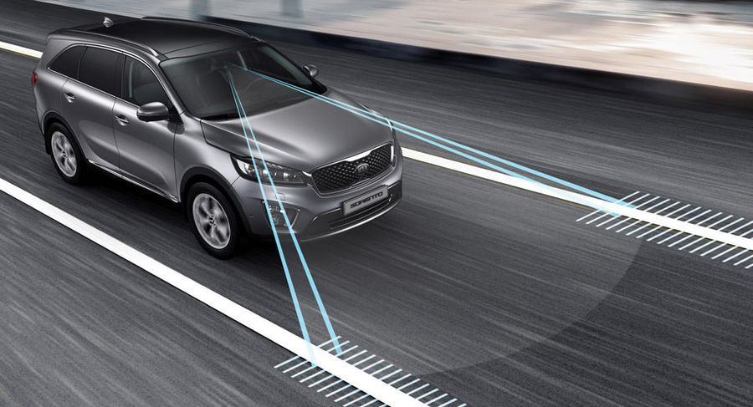

Figure 1.1: Lane Departure Warning

(Source: https://xehay.vn/uploads/images/2017/8/04/xehay-Lane-Departure-Warning-250817-1.jpg)

There are two main types of system:

* The system which warns the driver (Lane departure warning, LDW) if the vehicle is leaving its lane (visual, audible, and/or vibration warnings).
* The system which warns the driver and, if no action is taken, automatically takes steps to ensure the vehicle stay in its lane (lane keeping system, LKS).

The first production lane departure warning system in Europe was developed by the United States company Iteris for Mercedes Actros commercial trucks. The system debuted in 2000 and is now available on most trucks sold in Europe.

In 2002, the Iteris system became available on Freightliner Trucks North American vehicle. In both these system, the driver is warned of unintentional lane departures by an audible rumble strip sound generated on the side of the vehicle drifting out of the lane. No warnings are generated if, before crossing the lane, an active turn signal is given by the driver.

*Abroad:*

The lane departure warning system is one of the most expensive safety features on modern cars. According to the Insurance Institute for the Safety of the United States Highway (IIHS), this feature helps prevent up to 85,000 accidents each year in this country.

IIHS deputy director of research, Jessica Cicchino, recently conducted a study on the effectiveness of the lane departure warning system by analyzing crash date from police reports. And the recorded the numbers are notable.

Research has shown active safety system cars, the rate of self-inflicted injury, accidental stabbing from the hip or craniofacial injury was reduce to 11%. In addition, it reduced the incidence of injuries in accidents by 21%. And most notably, the lane warning system has helped prevent 85,000 accidents and at least 55,000 injuries in 2015.

According to Cicchino, these are the first examples that show us, Lane departure warning or active safety systems are important and they help prevent serious accidents and help save more lives.

According to previous studies, the lane warning system is believed to reduce up to 50% of accidents. However, IIHS argues that the bottom line is that failure to achieve this number is because many US drivers have the habit of turning off the lane warning system, though they know it is a safety feature.

*In the country:*

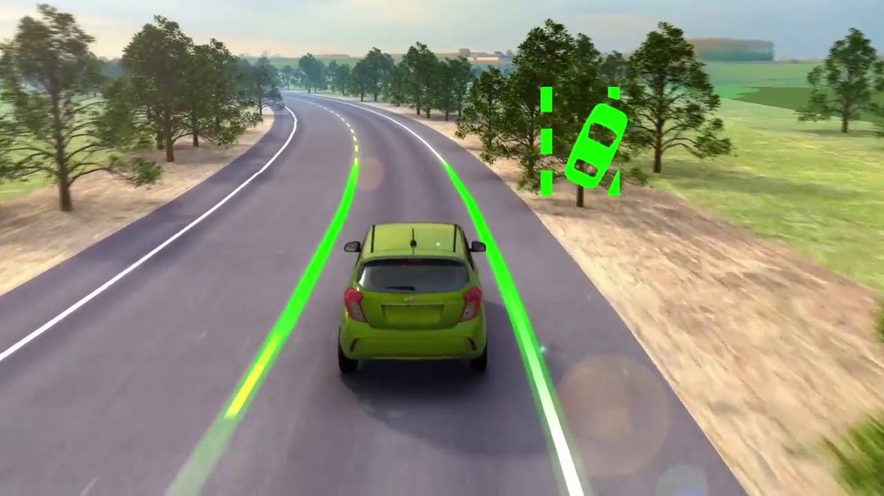

Figure 1.2: Technology Lane alert on Chevrolet

(Source: https://i.ytimg.com/vi/7rfa1rEWLQ8/maxresdefault.jpg)

Objectives of the Study

To complete this study we have five main objectives:

1. Learn about Raspberry Pi 3 and Raspberry Pi Camera Module
2. Learn about OpenCV library
3. Learn about Canny Edge detection and Hough transform method
4. Detecting lane markings on the road surface base on OpenCV, Canny Edge detection and Hough transform method.
5. Warning driver according to right or left lane departure by using detected lane marks’ angles

The scope of the Study

Subject: single-board computers Raspberry Pi, camera, and data capture from camera images to detect lane.

The scope of the study: TPHCM, represented by HCMC University of Technology and Education.

Methodology

Chapter 2, our team applies the methods of analyzing and synthesizing theories, studying different documents and theories, exploring topics and researches done at home and abroad. Proceed with reference and then select lane detection algorithm and Raspberry Pi apply to the project.

Structure of the Thesis

Chapter 1: Introduction

Chapter 2: Fundamental

Chapter 3: …

# FUNDAMENTAL

## Canny Edge detection

There are many methods of edge detection. However, Sobel, Roberts Cross and Prewitt are the most used methods in the edge detection. Prewitt and Sobel are composed of horizontal and vertical directional 3x3 masks. The major limitation of these operators cannot find the edges properly in the high noisy environment. Therefore, a more advanced technique was release - Canny edge detection method, developed by John F. Canny in 1986, become a standard and widely used in many types of research until nowadays.

## Hough transform method

The Hough transform is a feature extraction technique used in image analysis, computer vision, and digital image processing[1]. It can be used to detect lines, circles or, other parametric curves. This technique was developed by Paul Hough in 1962 and it provides an effective approach in determining the boundaries of the object of interest.

The simplest case of Hough transform is detecting straight lines. A straight line can be described in two dimensions coordinate system in many different ways. For example in a Cartesian coordinate system, it is described with (1).

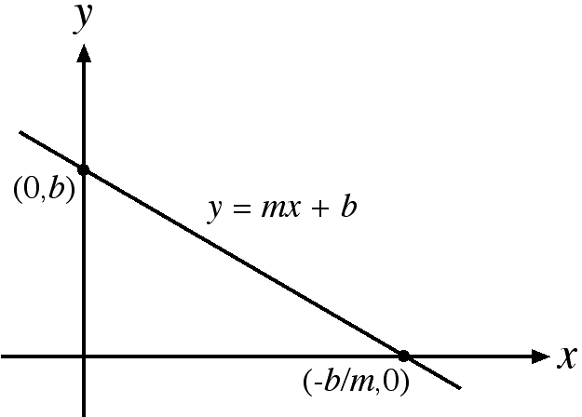

Figure 2.1: The equation of a straight line in the Cartesian coordinate system.

(Source: http://mathsfirst.massey.ac.nz/Algebra/StraightLinesin2D/Int.htm)

|  |  |
| --- | --- |
|  | (1) |

Where m is called the slope and b is called the intercept of the y-axis. However, the Cartesian coordinate system cannot be used in this system in that m in (1) is infinite for vertical lines. The polar coordinate system is more suitable for Hough Transform.

Each point (x, y) in the plane is represented by a pair (ρ, θ) in the polar coordinate system. Similarly, each straight line in the plane can also be represented by a pair (ρ, θ) in the polar coordinates system where ρ is the distance from the quadrant to this line and θ is the angle created by the x-axis with the line perpendicular to it. The Hough line in the Cartesian coordinates system is shown in Figure. 2.2. Conversely, each pair (ρ, θ) in the polar coordinate system also represent a straight line in the plane.

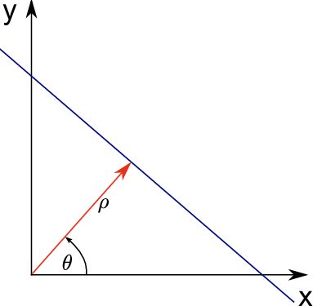

Figure 2.2: Illustration of the parametrisation of a line as used by the Hough transform.

(Source:https://www.researchgate.net/publication/281659541_On_Video_Completion_Line_Scratch_Detection_in_Films_and_Video_Inpainting_of_Complex_Scenes/figures?lo=1)

A straight line can be described with (2) in the polar coordinate system.

|  |  |
| --- | --- |
|  | (2) |

Where ρ is the length of a line perpendicular to this line, starting from the origin and θ is the orientation angle of ρ with respect to the x-axis. The conversion between these two systems can be easily done. Points in a Cartesian coordinate system which corresponds to a sinusoid in the Polar coordinate system is shown in Figure. 2.3 and Figure. 2.4 respectively.

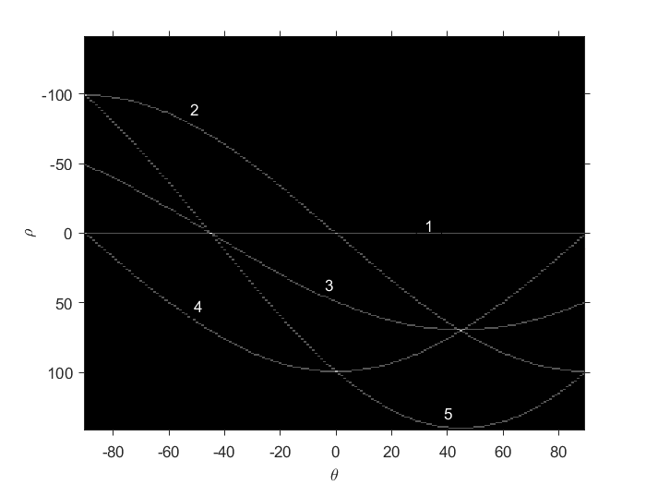

Figure 2.4: Their sinusoid in Polar coordinate system

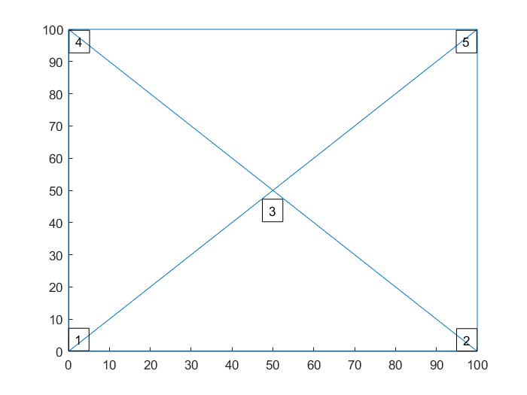

Figure 2.3: Five point in Cartesian coordinate system

## OpenCV library

OpenCV (Open Source Computer Vision Library) is an open source computer vision and machine learning software library. OpenCV was built to provide a common infrastructure for computer vision applications and to accelerate the use of machine perception in the commercial products. Being a BSD-licensed product, OpenCV makes it easy for businesses to utilize and modify the code[2].

## 

## Raspberry Pi 3, Raspbian, and Raspberry Pi Camera Module

* + 1. *Raspberry Pi 3*

The Raspberry Pi is a series of credit card-sized single-board computers developed in the United Kingdom by the Raspberry Pi Foundation with the intention of promoting the teaching of basic computer science in schools and developing countries.

Raspberry Pi is manufactured by 3 OEMs: Sony, Qsida, Egoman. Distributed by: Newark element14 (Premier Farnell), RS Components and Egoman.

On 29 February 2012, the first generation – Raspberry Pi 1 Model B was released with 256MB of RAM, followed by the simpler and cheaper model A. After four years, Raspberry Pi 3 was released with more powerful configurations, more features, many multiple improvement support wifi and Bluetooth available on the board.

Configuration Information Raspberry Pi 3:

* Broadcom BCM2837 chipset running at 1.2 GHz
* 64-bit quad-core ARM Cortex-A53
* 802.11 b/g/n Wireless LAN
* Bluetooth 4.1 (Classic & Low Energy)
* Dual-core Videocore IV® Multimedia co-processor
* 1 GB LPDDR2 memory
* Supports all the latest ARM GNU/Linux distributions and Windows 10 IoT
* MicroUSB connector for 2.5 A power supply
* 1 x 10/100 Ethernet port
* 1 x HDMI video/audio connector
* 1 x RCA video/audio connector
* 4 x USB 2.0 ports
* 40 GPIO pins
* Chip antenna
* DSI display connector
* MicroSD card slot
* Dimensions 85 x 56 x 17 mm

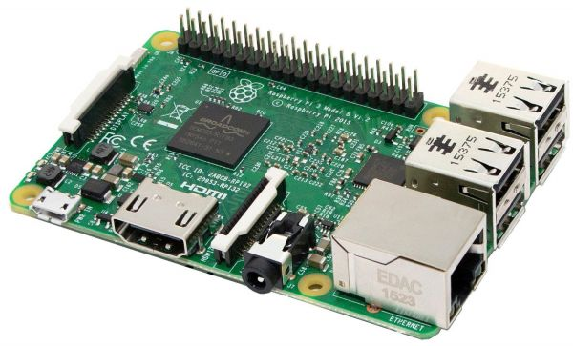

Figure 2.5: Raspberry Pi 3

*(Source:https://cf1.s3.souqcdn.com/item/2016/07/04/11/04/66/79/item_XL_11046679_15157672.jpg)*

* + 1. *Raspbian*

Raspbian is a free operating system based on Debian optimized for the Raspberry Pi hardware. Raspbian comes with over 35,000 packages: pre-compiled software bundles in a nice format for easy installation on your Raspberry Pi.

The Raspbian OS with Raspberry Pi has been updated to support 64-bit computing, with other platforms such as RetroPie and KODI must wait for updates.

Raspbian is a community project active development, with improving the stability and performance.



Figure 2.6: Raspbian OS

*(Source:http://misapuntesde.com/images/raspbian.png)*

* + 1. *Raspberry Pi Camera Module*

Before the camera appears, the developer is used to a webcam plugged into a USB port to add image recognition, video recording and raspberry pi capture. With built-in Logitech Webcams, mjpeg output format will help Raspberry to process faster. However, Logitech webcams are expensive.

Raspberry Pi camera was released in May 2013 and a camera module developed by Raspberry Pi Foundation. The Raspberry Pi camera incorporates a high-sensitivity 5 Megapixel camera, which can capture well in a variety of lighting conditions, indoor and outdoors. The special feature is high-definition shooting during filming. The camera is firmly attached to the CSI socket avoid bandwidth bottlenecks.

In April 2016, the Raspberry Pi Foundation released its second-generation Camera Module with the most significant upgrade being the 8 Megapixel Sony IMX219 sensor, image quality, color fidelity and low-light performance. It supports 1080p30, 720p60 and VGA90 video modes.

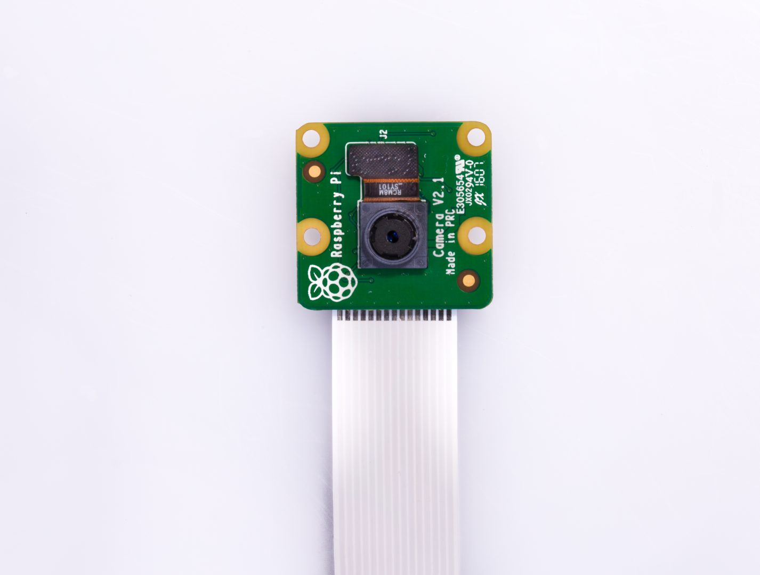

Figure 2.7: Raspberry Pi Camera Module

*(Source:https://www.raspberrypi.org/app/uploads/2017/05/Pi-Camera-front-1-1426x1080.jpg)*

# REFERENCES

1. Shapiro, Linda and Stockman, George. "Computer Vision", Prentice-Hall, Inc. 2001.
2. About OpenCV (https://opencv.org/about.html).