**Practical Examination**   
Subject code: MMA301 – Fall 2023  
Duration : 85 minutes

**Building an application with React Native:**

**1. Create Project (0.5 mark)**

Create a Project with name is FPTUniversity (please avoid using the student's name or ID). Add folders and files:

- data

+ products.json

- App.js

- screens

+ MainScreen.js

+ JsonScreen.js

+ ApiScreen.js

**2. products.json (0.5 mark):** Create 4 objects:

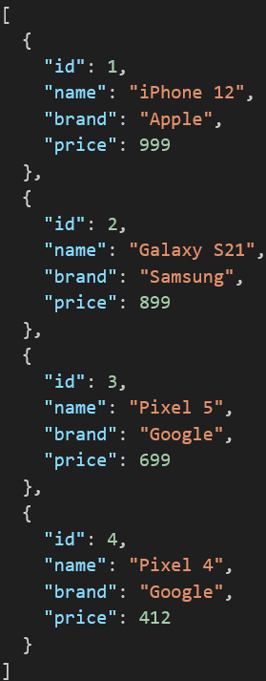

**3. App.js (0.5 mark)**

- Install package react-navigation, use navigator for screens

- Set MainScreen is Launch screen

**4. MainScreen.js (1.5 marks)**

- Design UI: use Styles and Layout

- Click button JSON: open JsonScreen

- Click button API: open ApiScreen

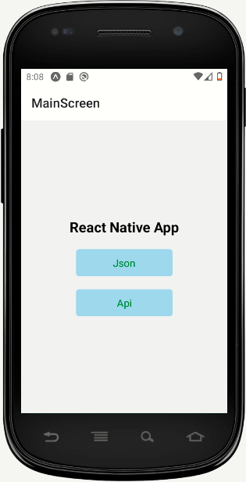

**5. JsonScreen.js (3.5 marks)**

- Design UI: use Styles and Layout

- Display data from the file products.json

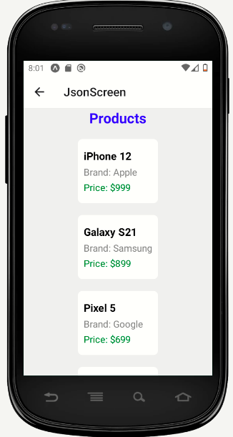

**6. ApiScreen.js (3.5 marks)**

- Design UI: use Styles and Layout

- Display data from the API

<https://jsonplaceholder.typicode.com/photos>

