

International School

Capstone Project 1
CMU-SE 450
C1SE.30

GoodWill VietNam
Submitted by Phong, Le Van Vu Duong, Vo Dinh Loc, Huynh Nhu Trung, Ngo Quoc Bao, Hang Gia Approved by

MSc Huy, Truong Dinh

Capstone Project Review 1:

Name Signature Dat

Capstone Project 1- Mentor:

Name Signature Dat

PROJECT INFORMATION

Project acronym | GWVN
Project Title | GoodWill VietNam
Start Date | 21 Aug 2025 | End Date | 12 Dec 2025
Lead Institution | International School, Duy Tan University
Project Mentor | MSc Huy, Truong Dinh

Scrum master /  Project Leader & contact details | Phong, Le Van Vu  Email: foxnight199@gmail.com  Tel: 0974098009
Partner  Organization | Duy Tan University
Project Web
URL
Team members | Name | Email | Tel
 | Phong, Le Van Vu | foxnight199@gmail.com | 0974098009
 | Duong, Vo Dinh | vodinhduong289@gmail.com | 0964821707
 | Loc, Huynh Nhu | kizzrin123@gmail.com | 0766793958
 | Trung, Ngo Quoc | Quoctrung4real@gmail.com | 0899391923
 | Bao, Hang Gia | hanggiabao2004@gmail.com | 0856096357

DOCUMENT APPROVALS
The following signatures are required for approval of this document.

Phong, Le Van Vu Student ID: 28211301800  Scrum Master | Signature | Date
Duong, Vo Dinh  Student ID: 28211131304  Team Member | Signature | Date
Loc, Huynh Nhu  Student ID: 28211127430  Team Member | Signature | Date
Trung, Ngo Quoc  Student ID: 25211415118  Team Member | Signature | Date
Bao, Hang Gia  Student ID:28211152592  Team member | Signature | Date

REVISION HISTORY

Version | Date | Comments | Author
1.0 | August 21th, 2025 | Initial Release | GWVN Team
1.1 | September 18th, 2025 | Second Release | GWVN Team
1.2 | November 11th, 2025 | Third Release | GWVN Team
1.3 | December 13th, 2025 | Final Release | GWVN Team

Table of Contents
1. Introduction 1
1.1 Purpose Of Document 1
1.2 Project Goal 1
2. Problem Definition 1
2.1 Business need 1
2.2 Solution 1
3. Current Status of Art 2
4. Engineering Approach 2
4.1 System Context Diagram 2
4.2 System Context Description 3
4.3 Technical Constraints 4
5. Task and Deliverables 5
6. Project Management 6
6.1 Cost/Budget For Project 6
6.2 Tentative Schedule 7
6.2.1 Master Plan 7
6.2.2. Scrum Process 7
6.2.3. Risk Management 8
7. Project Team 8
8. Project Constrain 9
9. Conclusion 10
10. References 10
11. Attachment 11

Introduction

Purpose Of Document
- Share the idea and scope of the GoodWill Vietnam project.
- Point out the real problems in how donations and charity goods are managed today.
- Suggest a simple technology solution to make the process of receiving, sorting, pricing, and giving out items more clear and efficient.
- Explain the project’s goals, approach, timeline, and what resources are needed.
- Give everyone involved a clear view so they can review, approve, and follow the
project’s progress.

Project Goal
- Create an online system that manages donations from start to finish: receiving items, sorting them, storing, setting fair prices, and then either giving them to people in need or selling them at low cost.
- Help poor families, homeless people, and low-income groups get access to daily necessities more easily.
- Reduce waste by reusing items that are still in good condition.
- Give project managers tools to keep track of the social and environmental impact of charity activities.
- Build a model of charity work that is more sustainable and can be expanded to other places in Vietnam

Problem Definition

Business need
They need a digital platform that can manage the donation process from giving and sorting the goods to giving away or selling low cost - items. A system would make better about donation goods, reduce waste and sort the item and set the price when they input in to warehouse

Solution
Solution to build the GoodWill VietNam is:
The system to help sorting goos and setting the price. Giving Item topoor people or homeless, selling low price
Administrators to track the social and environmental impact.

Current Status of Art
All over the world, donation and reuse systems are getting more modern and digital. Big organizations like GoodWill in the U.S already run strong platforms that hand donations, second hand sales and even put profit back into community programmes. In Vietnam, things are still more traditional. Most donations happen through charity groups, student clubs, or small local organizations. There effort are meaning but they often face some issues

Engineering Approach

System Context Diagram
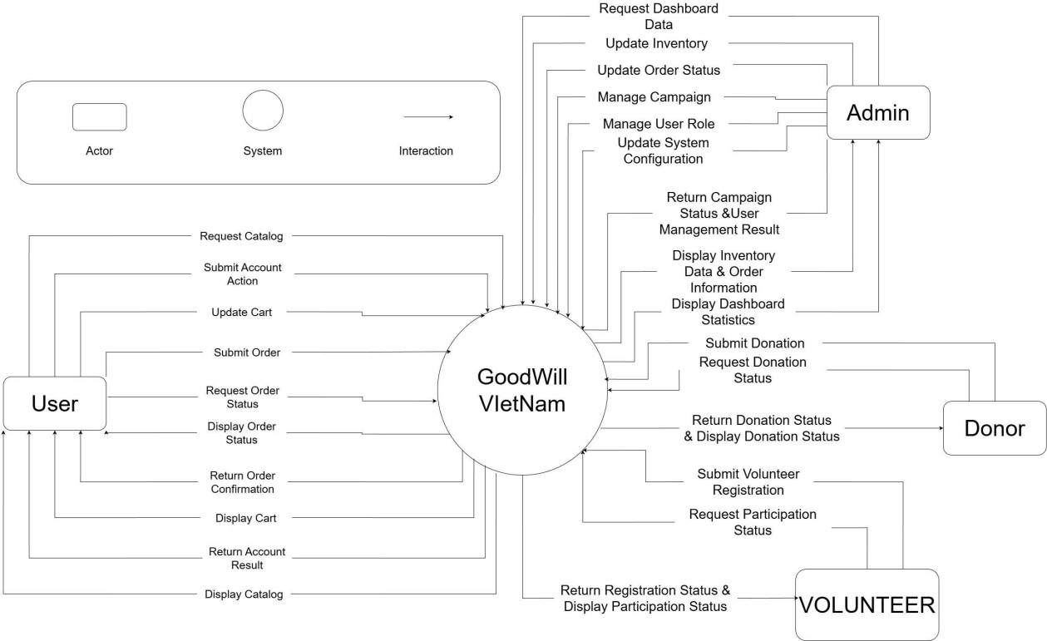
Figure 1. Context Diagram

System Context Description
The GoodWill VietNam system is a centralized web-based donation and volunteer management platform that connects multiple external actors, including User, Donor, Volunteer, and Admin, through a unified system boundary. The system acts as the core processing unit, responsible for handling requests, managing data, and returning results to each actor based on their roles and permissions.
User Interaction
Users interact with the GoodWill VietNam system to browse and purchase items from the catalog, manage their accounts, and track their orders. The system allows users to request the product catalog, submit account-related actions (such as registration or profile updates), manage their shopping cart, and submit orders. After processing these actions, the system returns confirmations, displays order status, account results, cart contents, and updated catalog information to the user.
Donor Interaction
Donors use the system to submit donation requests and monitor the progress of their donations. The GoodWill VietNam system receives donation submissions from donors and processes their donation status through internal validation and administration workflows. The system then returns the donation status and displays detailed donation information back to the donor, ensuring transparency throughout the donation lifecycle.
Volunteer Interaction
Volunteers interact with the system by submitting volunteer registration requests and requesting participation status in campaigns. The system processes volunteer registrations, manages participation records, and returns registration results along with participation status updates. This ensures volunteers can easily track their involvement in charitable activities.
'

Admin Interaction
Administrators have comprehensive control over system operations. The Admin interacts with the system to request dashboard data, manage campaigns, update inventory, update order statuses, manage user roles, and configure system settings. The system processes these administrative actions and returns results such as campaign status updates, user management outcomes, inventory data, order information, and dashboard statistics. This enables effective system monitoring, decision-making, and operational control.
System Boundary and Responsibilities
The GoodWill VietNam system serves as the single point of coordination between all actors. It is responsible for:
- Validating and processing all incoming requests
- Managing business logic related to orders, donations, campaigns, inventory, and participation
- Storing and retrieving data from the underlying database
- Returning accurate and timely information to each actor
By clearly separating external actors from internal system processing, the system context ensures a scalable, secure, and role-based interaction model suitable for a real- world donation management platform.

Technical Constraints
Programming Languages: JavaScript, TypeScript, or Dart (for Flutter).
Frameworks: ReactJS (web), Flutter (mobile), Node.js/Express or ASP.NET Core (backend).
Database: MySQL or PostgreSQL.
Deployment: Docker containers on cloud platforms (Heroku, Azure, or equivalent).
Visualization & Reporting: Chart.js, Power BI integration.

Task and Deliverables
Table 1. Task and Deliverables

No. | Task Name | Duration | Start | Finish | Deliverables
1 | Initial | 6 days | 21/08/2025 | 26/08/2025 | Requirement Analysis,  Project Proposal Document
2 | Start-up | 12 days | 27/08/2025 | 01/09/2025 | Project kick-off report, project plan, initial feasibility documents
2.1 | Project kick-off meeting | 3 days | 27/08/2025 | 27/08/2025 | Kick-off meeting minutes
2.2 | Create Document | 6 days | 27/08/2025 | 01/09/2025 | Project Plan (schedule, resources, scope)
3 | Development | 96 days | 02/09/2025 | 02/12/2025 | Backend & frontend source code, database  schema, API documentation
3.1 | Sprint 1 | 30 days | 02/09/2025 | 01/10/2025 | Core features (user authentication, user management, donation  module)
3.2 | Sprint 2 | 27 days | 02/10/2025 | 28/10/2025 | Inventory management, order processing, admin  dashboard
3.3 | Sprint 3 | 39 days | 29/10/2025 | 06/12/2025 | System integration, KPI reporting, completed web/mobile  application
4 | Project’s  Retrospective Meeting | 1 day | 09/12/2025 | 09/12/2025 | Retrospective meeting minutes, lessons  learned report
5 | Final Release | 3 days | 10/12/2025 | 12/12/2025 | Final system release, User Manual, Final Report & Presentation  Slides

Project Management

Cost/Budget For Project
Table 2. Cost person/hours
Full Name | Role | Salary Rate (USD/hour)
Le Van Vu Phong | Team Leader | 5
Vo Dinh Duong | Team Member | 5
Huynh Nhu Loc | Team Member | 5
Ngo Quoc Trung | Team Member | 5
Hang Gia Bao | Team Member | 5
The following outlines the cost of completing all the identified components for the project.
Table 3. Total cost estimation
No. | Phase | Price (USD) | Total (USD)
1. | Working hours | 5 | 3,295
2. | Other cost | 100 | 500
 |  |  | 3,795
Table 4. Description and Amount

Description | Amount | Unit
Number of member | 5 | Person
Number of working hours per day | 1,6 | Hours
The cost per hour per member | 2 | USD
The number of working days | 82 | Days
Amount of working hours
- Total Working Hours = 5 members × 1.6 hours/day × 82 days = 659 hours
(rounded to 651 hours)
Working hour cost
- 659 hours × 5 USD/hour = 3,295 USD Other costs
- 5 members × 100 USD = 500 USD Total project cost
- 3,295 USD + 500 USD = 3,795 USD

Tentative Schedule

Master Plan
Table 5: Project Schedule
No | Task Name | Duratio n | Start | Finish
1 | Initial | 6 days | 21-Aug-2025 | 26-Aug-2025
2 | Start up | 12 days | 27-Aug-2025 | 01-Sep-2025
2.1 | Project kick-off meeting | 3 days | 27-Aug-2025 | 27-Aug-2025
2.2 | Create Document | 6 day | 27-Aug-2025 | 01-Sep-2025
2 | Development | 96 days | 02-Sep-2025 | 02-Dec-2025
2.1 | Sprint 1 | 30 days | 02-Sep-2025 | 01-Oct-2025
2.2 | Sprint 2 | 27 days | 02-Oct-2025 | 28-Oct-2025
2.3 | Sprint 3 | 39 days | 29-Oct-2025 | 06-Dec-2025
3 | Project’s Retrospective  Meeting | 1 day | 09-Dec-2025 | 09-Dec-2025
4 | Final Release | 3 days | 10-Dec-2025 | 12-Dec-2025

6.2.2. Scrum Process
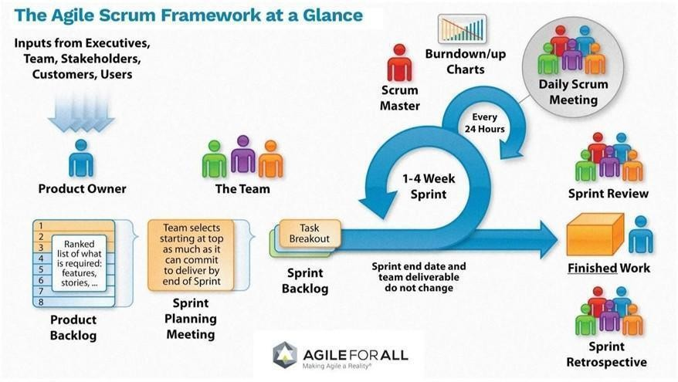
Figure 2. Scrum process
Scrum is an iterative and incremental agile software development framework for managing software projects and product or application development.
Scrum focuses on project management institutions where it is difficult to plan ahead. Mechanisms of empirical process control, where feedback loops that constitute the core management technique is used as opposed to traditional command and control management.
Its approach to planning and managing projects is by bringing decision-making authority to the level of operation properties and certainties.
Benefit of the methodology:
- Project can respond easily to change.
- Problems are identified early.
- Customers get the most beneficial work first.
- The work done will better meet the customer’s needs.
- Improved productivity.
- Ability to maintain a predictable schedule for delivery.

6.2.3. Risk Management
Table 6: Risk Managemet
Risk | Impact | Probability | Mitigation
API failure | High | Medium | Implement fallback & retries
Delay in  development | Medium | Medium | Reassign tasks, buffer time
Data loss | High | Low | Daily backups
Miscommunication | Medium | High | Weekly team meetings
Security breach | High | Low | Apply OWASP practices

Project Team
Table 7: Project Team
Name | Role | Responsibility
Truong Dinh Huy | Project Mentor | Oversees project progress, timeline, and communication
Le Van Vu Phong | Scrum Master | Project management, requirements, work assignment and responsible for backend development and chatbot integration
Huynh Nhu Loc | Backend Developer | Responsible for backend development using PHP.
Vo Dinh Duong | Frontend Developer | Develop the user interface using HTML/CSS.
Hang Gia Bao | Frontend Developer | Develop the user interface using HTML/CSS.
Ngo Quoc Tung | Backend Developer | Responsible for backend development using PHP.

Project Constrain
Table 6. Table Project Constraint
Constraint | Constraints Description | Guidelines for Acceptance
Economic | Since this is a non-profit web-based application, the cost mainly focuses on hosting, cloud services, maintenance, and basic development resources. Funding may come from universities, volunteer clubs, or sponsors. | Ensure low and sustainable costs by using open-source technologies, affordable hosting, and transparent cost reporting.
Environmental | The system encourages reuse of clothes, books, and household items, helping to reduce waste and support the circular economy. | Track the number of donated items, measure reuse rate, and publish reports on environmental impact.
Ethical | Transparency and fairness must be ensured in donation and distribution. Donor and recipient data must be protected. No commercialization of donated goods under the charity label. | Apply privacy and data protection policies; establish clear donation/distribution guidelines.
Public health, safety, and welfare | Only safe items should be distributed. The project also creates training and job opportunities for disadvantaged groups, contributing to community welfare. | Inspect donated goods before distribution; define safety standards for accepted items.
Social and Global | The project promotes community sharing culture and can be scaled to multiple universities, communities, and nationwide. | Acceptance is measured by user satisfaction and the number of organizations adopting the system.
Cultural | The web application should be simple, user-friendly, and suitable for all age groups. It reflects Vietnamese cultural values while beings adaptable internationally. | Usability testing with different user groups; interface designed with cultural inclusivity.

Sustainability | Operated under a social enterprise model: revenue from low-cost resales is reinvested into community support. The system will be updated based on user feedback. | Continuous updates, transparent reinvestment reporting, and regular maintenance schedule.

Conclusion
- The proposed Goodwill Vietnam system addresses a pressing societal need for more transparent, efficient, and sustainable donation management. In Vietnam, donation activities are often spontaneous and fragmented, resulting in limited impact, lack of accountability .By introducing a structured digital platform, this project provides a systematic way to collect, classify, and distribute donated goods while ensuring transparency and traceability.
- Ultimately, Goodwill Vietnam represents a pioneering approach to philanthropy in Vietnam, bridging technology and social responsibility. By digitizing the donation ecosystem, the project lays the foundation for a replicable

References
No. | References | Document Information
1 | Scrum Model | https://en.wikipedia.org/wiki/Scrum_(software_devel opment)
1 | Scrum Model | https://www.atlassian.com/agile/scrum
1 | Scrum Model | https://www.digite.com/agile/scrum-methodology/
1 | Scrum Model | https://www.scrum.org/resources/scrum-guide
2 | Technical | https://www.tensorflow.org/tutorials/quickstart/begi nner?hl=vi
2 | Technical | https://www.flutterclutter.dev/flutter/tutorials/imple menting- edge-detection-in-flutter/2020/1509/
2 | Technical | https://stackoverflow.com/questions/14248571/findin g- properties-of-sloppy-hand-drawn-rectangles
2 | Technical | https://www.tutorialspoint.com/how-to-detect-a- rectangle-and- square-in-an-image-using-opencv- python
2 | Technical | https://platform.openai.com/docs/overview
2 | Technical | https://www.mongodb.com/docs/

 |  | https://pytorch.org/
 |  | https://opencv.org/
 | Standard | https://www.nws.noaa.gov/oh/hrl/developers_docs/G eneral_So ftware_Standards.pdf
 | Standard | https://standards.ieee.org/standard/12208-2017.html

Attachment
Table 7. High-level Functional Requirements

High-level Functional Requirements | 1. Donation Management: Users can register and schedule donations (clothes, books, household items).
High-level Functional Requirements | 2. Beneficiary Access: Disadvantaged individuals can browse and receive items at low cost or free.
High-level Functional Requirements | 3. Inventory & Classification: Admin manages  donated items, categorizes them, and monitors stock levels.
High-level Functional Requirements | 4. Transaction Records: The system logs donation and distribution history for transparency.
High-level Functional Requirements | 5. Reporting Dashboard: Admin can generate reports on number of donations, reuse rate, and beneficiaries.
High-level Functional Requirements | 6. Notification: Email/web notifications for donation events or charity programs.
Table 8. Quality Attributes Requirements
Quality Attributes Requirements  (example related to issues: Ease  Use, Easy to Like, Easy to Learn, Easy to Understand, Easy to Buy / Yes, ...) | 1.Ease of Use
 | 2.Transparency
 | 3.Reliability
 | 4.Scalability
 | 5.Security
 | 6.Performance
 | 7.Accessibility
Table 9. Operation Requirements
Operation Requirements (related to issues: Speed, Accuracy, Performance, Stability, Load Resistance,  Scalability, Safety, ...) | 1. Speed
 | 2. Performance
 | 3. Safety
 | 4. Stability
Table 10. Environment & Operation Requirements
Environment & Operation | 1. The system should run smoothly on cloud
Requirements (related to | environments.
issues: physical impacts on | 2. Optimize performance to reduce hosting and
the environment, | infrastructure costs.

interaction with relevant or existing systems,  conditions for product commercialization, ...) | 3. Ensure compliance with Vietnamese data protection regulations.
Table 11. Requirements for Maintenance & Support
Requirements for Maintenance & Support | 1. Ensure regular system maintenance to ensure stable operation and high performance.
Requirements for Maintenance & Support | 2. Database backup and recovery.
Requirements for Maintenance & Support | 3. Respond promptly and effectively to technical support requests from users.
Requirements for Maintenance & Support | 4. Provide training and documentation for system administrators and volunteers.
Table 12. Security/ Safety Requirements
Security/ Safety | 1. Access Control
Requirements | 2. Data Privacy and Confidentiality
(related to issues: | 3. Incident Response
conditions of use / access to  products, personal freedom, | 4. Regulatory Compliance
inspection, ...)
Table 13. Culture Requirements
Culture Requirements | 1. Default Vietnamese language, extendable to English.
Culture Requirements | 2. Simple interface accessible to all age groups.
Culture Requirements | 3. Promote Vietnamese cultural values of sharing and reuse.

Table 14. Evaluate the complexity of engineering problems
Evaluate the complexity of engineering problems |  | 1. Involving wide-ranging or conflicting technical issues
Evaluate the complexity of engineering problems |  | 2. Having no obvious solution
Evaluate the complexity of engineering problems | ❒ | 3. Addressing problems not encompassed by current standards and codes
Evaluate the complexity of engineering problems | ❒ | 4. Involving diverse groups of stakeholders
Evaluate the complexity of engineering problems | ❒ | 5. Including many component parts or sub- problems (donation, classification, reporting).
Evaluate the complexity of engineering problems | ❒ | 6. Involving multiple disciplines (IT, social enterprise, community).
Evaluate the complexity of engineering problems | ❒ | 7. Having significant consequences in a range of contexts

Table 15. Standard requirements
Standard requirements | ❒ | 1. Code standard. (GNU, Oracle standard for Java,  ..,)
Standard requirements | ❒ | 2. Design standard. (design patterns, object-  oriented analysis and design,…).
Standard requirements | ❒ | 3. IEEE: IEEE 830 (Requirements), IEEE 1016  (Design), IEEE 829 (Testing).
Standard requirements | ❒ | 4. ISO: ISO/IEC 12207 (Lifecycle), ISO/IEC  25010 (Product quality).
Standard requirements | ❒ | 5. National: Vietnam Decree 13/2023/NĐ-CP on data protection.

