Week 6 Learning Activities

Student ID: 105000908

Student name: Tran Hung Quoc Tuan

**1. Concept of Transfer Learning**  
Transfer learning is a machine learning technique where a model developed for one task is reused as the starting point for a model on a second task. Instead of training a model from scratch with random weights, transfer learning leverages pre-trained models (like MobileNetV2, ResNet, or VGG) that have already learned useful features from a large dataset such as ImageNet.  
Difference:

* Training from scratch: all model weights are randomly initialized and trained fully on your dataset, requires a large dataset and lots of computation.
* Transfer learning: starts from pre-trained weights, allowing faster convergence and better performance on smaller datasets.

**2. What is Fine-tuning**  
Fine-tuning means unfreezing some of the pre-trained layers (usually the top few convolutional layers) and training them alongside new classifier layers with a low learning rate. This allows the model to adapt more closely to the new dataset while retaining useful features learned from the base model.  
Why useful: It helps improve accuracy when your dataset is similar but not identical to the pre-training dataset (e.g., new object types but same image styles).

**3. Freezing the Convolutional Base**  
Freezing the convolutional base during feature extraction prevents its pre-trained weights from being updated. This is important because:

* It preserves previously learned low-level features (edges, textures, shapes).
* It reduces computation and prevents overfitting, especially when your dataset is small.  
  Essentially, you’re using the base as a fixed feature extractor.

**4. Why Use Data Augmentation**  
Data augmentation artificially expands your training dataset by applying transformations such as rotation, flipping, zooming, or brightness changes. This helps:

* Reduce overfitting by introducing variation.
* Improve model robustness to unseen data.
* Increase dataset size without collecting new data.

**5. Take a screenshot of the code snippet where the pre-trained MobileNetV2 model is loaded without the top classification layers**

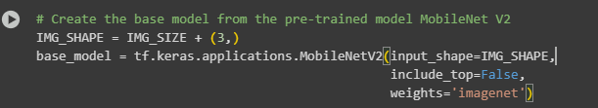

**6. Take a screenshot of the portion of code where the pre-trained model is set to be non-trainable for feature extraction purposes.**



**7. Take a screenshot of the data augmentation layers defined in the model.**

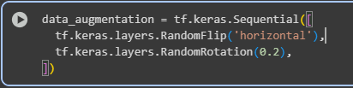

**8. Take a screenshot of the code that shows the addition of the new classifier layers on top of the base model.**

