**Monitoring Tool Web Installation Guide for Window server 2012**

------

Contents

**I.** **Installing IIS 8 on Windows Server 2012** 1

**II.** **Customizing features on IIS 8** 6

**III.** **Internal port 1080:** 10

**IV.** **Deploy Monitoring Web on Window Server 2012** 14

1. **Installing IIS 8 on Windows Server 2012**

Note: IIS 8.0 is only available in Windows Server 2012 and Windows 8.

If server was exist IIS 8.0, you will skip this step.

To install IIS 8, use the following steps:

## Open **Server Manager**.

## Under **Manage** menu, select **Add Roles and Features**:

[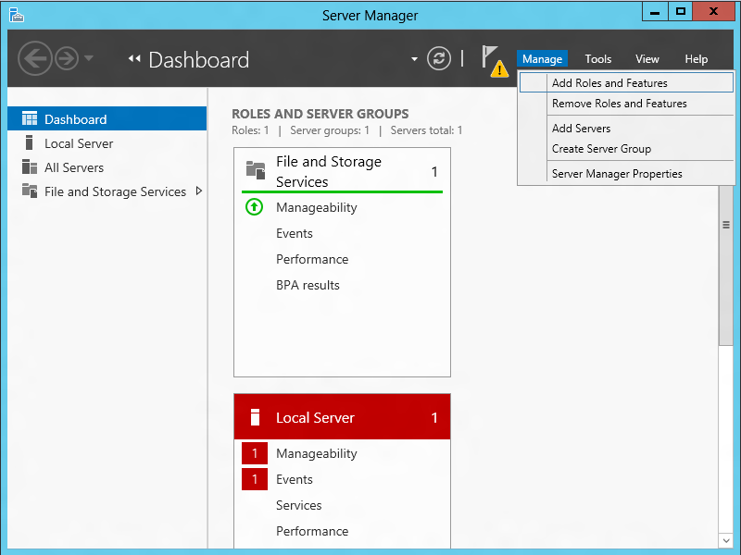](http://i3.iis.net/media/7187674/installing-iis-8-on-windows-server-2012-1088-IMAGE01.png?cdn_id=2013-07-03-001)

## Select **Role-based or Feature-based Installation**:

[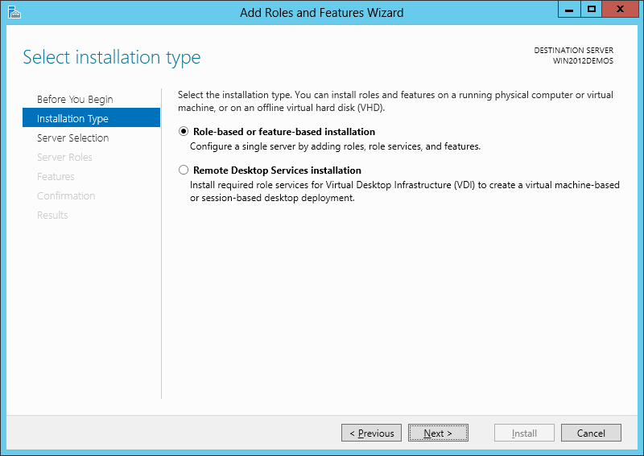](http://i2.iis.net/media/7187668/installing-iis-8-on-windows-server-2012-1088-IMAGE02.png?cdn_id=2013-07-03-001)

## Select the appropriate server (local is selected by default), as shown below:

[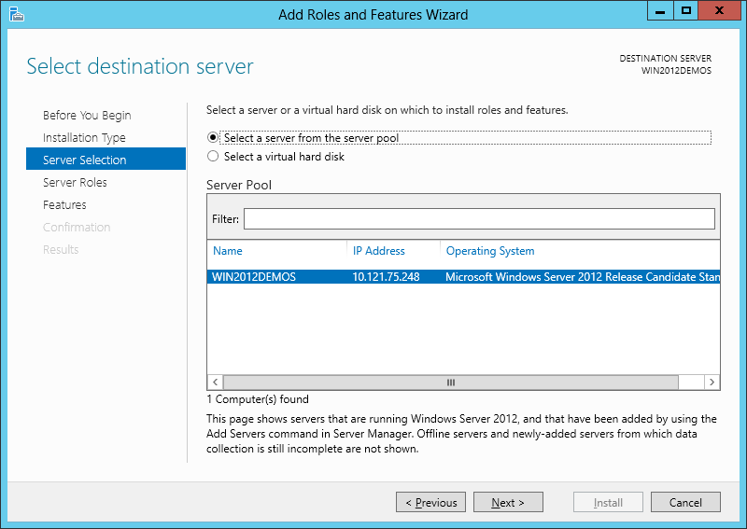](http://i2.iis.net/media/7187662/installing-iis-8-on-windows-server-2012-1088-IMAGE03.png?cdn_id=2013-07-03-001)

## Select **Web Server (IIS)**:

[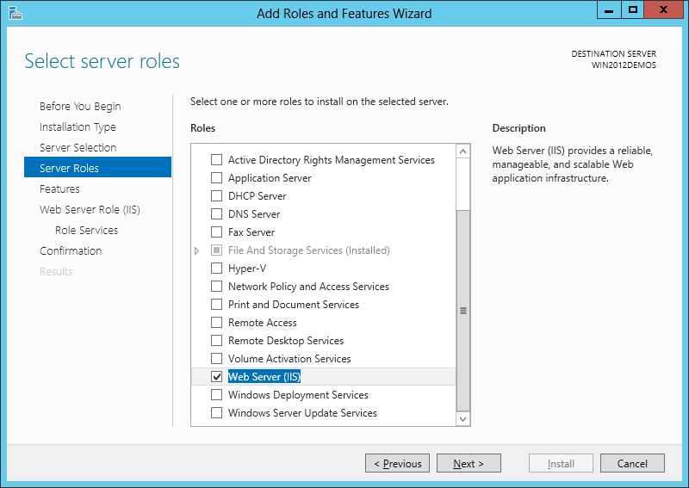](http://i2.iis.net/media/7187656/installing-iis-8-on-windows-server-2012-1088-IMAGE04.png?cdn_id=2013-07-03-001)

## Select features for IIS, so click **Next**:

✓.NET Framework 3.5 Features:

✓..NET Framework 3.5 (includes .NET 2.0 and 3.0)

✓.HTTP Activation

✓.Non-HTTP Activation

✓. .NET Framework 4.5 Features:

✓.NET Framework 4.5

✓.ASP.NET 4.5

✓.WCF Services:

✓.HTTP Activation

✓.Message Queing (MSMQ) Activation

✓.Named Pipe Activation

✓.TCP Activation

✓.TCP Port Sharing

[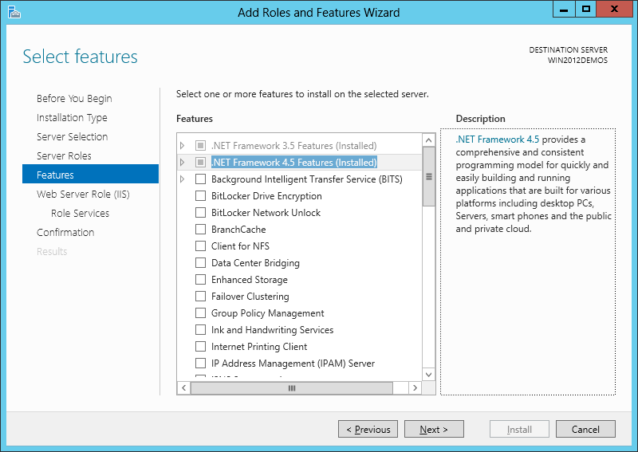](http://i1.iis.net/media/7187650/installing-iis-8-on-windows-server-2012-1088-IMAGE05.png?cdn_id=2013-07-03-001)

## Click **Next**:

[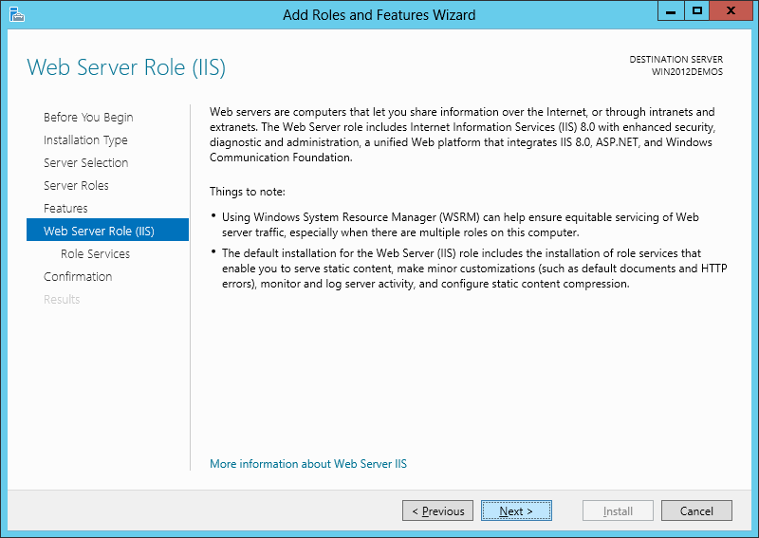](http://i3.iis.net/media/7187644/installing-iis-8-on-windows-server-2012-1088-IMAGE06.png?cdn_id=2013-07-03-001)

## Customize your installation of IIS, or accept the default settings that have already been selected for you and then click **Next**:

[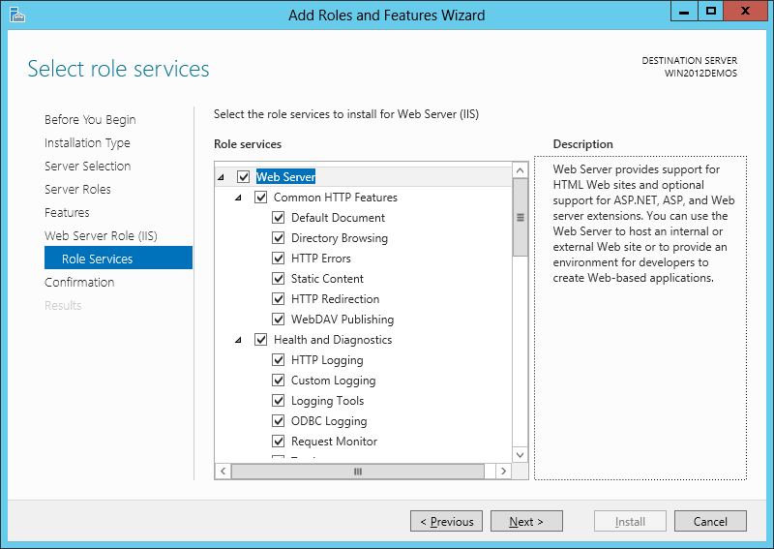](http://i1.iis.net/media/7187638/installing-iis-8-on-windows-server-2012-1088-IMAGE07.png?cdn_id=2013-07-03-001)

## Click **Install**:

[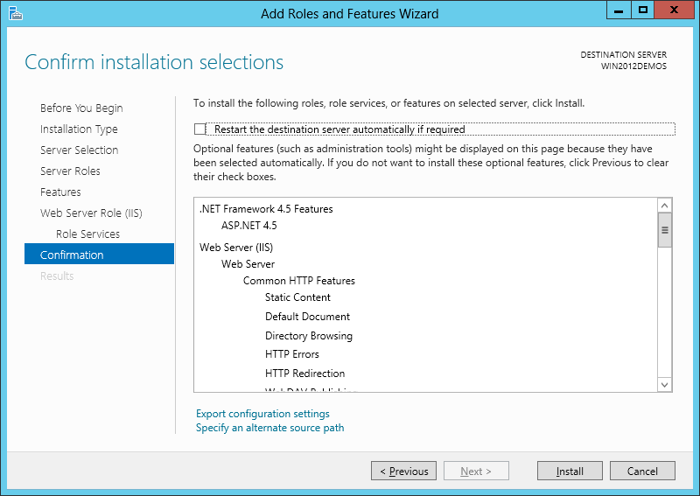](http://i2.iis.net/media/7187632/installing-iis-8-on-windows-server-2012-1088-IMAGE08.png?cdn_id=2013-07-03-001)

## When the IIS installation completes, the wizard reflects the installation status:

[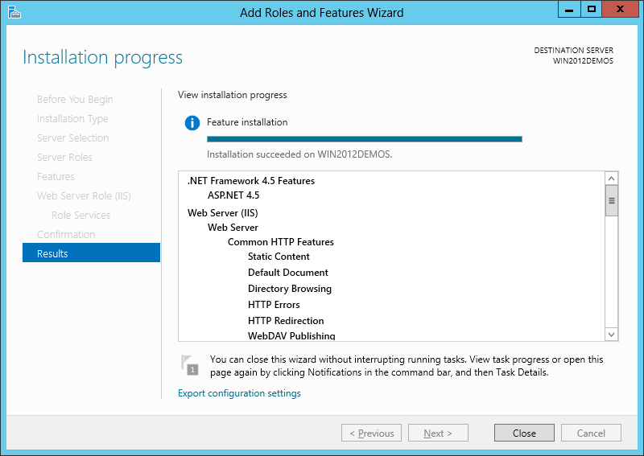](http://i1.iis.net/media/7187626/installing-iis-8-on-windows-server-2012-1088-IMAGE09.png?cdn_id=2013-07-03-001)

## Click **Close** to exit the wizard.

* **Summary:** IIS 8.0 has been installed successfully by using Server Manager in Windows Server 2012.

1. **Customizing features on IIS 8**
   1. Open **Server Manager**
   2. Access to **Local Server** | **Roles and Features** and select **Add Roles and Features** at **TASKS** list.

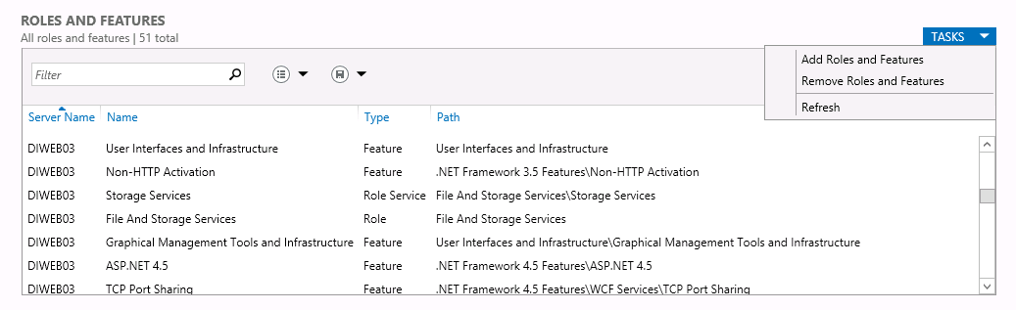

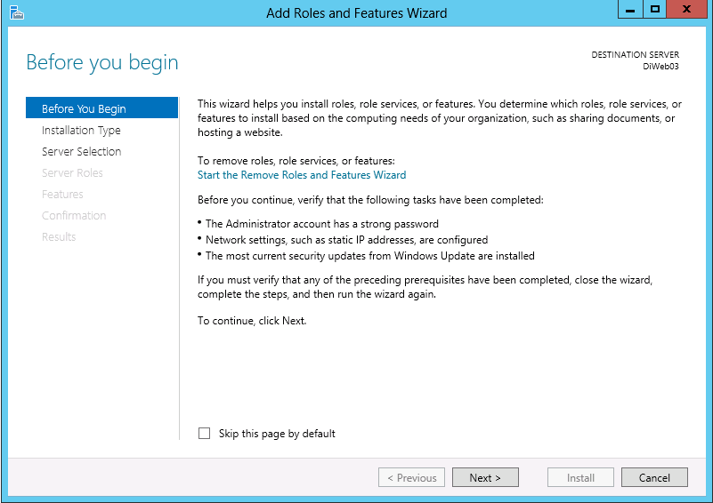

* 1. Select **Role-based or Feature-based Installation**:

[](http://i2.iis.net/media/7187668/installing-iis-8-on-windows-server-2012-1088-IMAGE02.png?cdn_id=2013-07-03-001)

* 1. Select the appropriate server (local is selected by default), as shown below:

[](http://i2.iis.net/media/7187662/installing-iis-8-on-windows-server-2012-1088-IMAGE03.png?cdn_id=2013-07-03-001)

* 1. Select **Web Server (IIS)**:

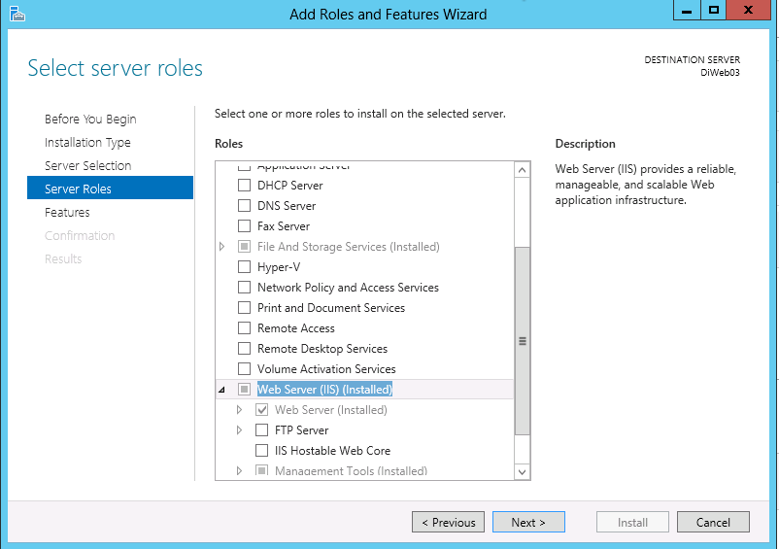

* 1. Customize your installation of IIS and then click **Next**:

Web Server (IIS):

Web Server:

Common HTTP Features:

✓ Default Document

✓ Directory Browsing

✓ HTTP Errors

✓ Static Content

Health and Diagnostic:

✓ HTTP Logging

✓ Request Monitor

Performance:

✓ Static Content Compression

✓ Dynamic Content Compression

Security:

✓ Request Filtering

Application Development:

✓. NET Extensibility 3.5

✓. NET Extensibility 4.5

✓ Application Initialization

✓ ASP

✓ ASP.NET 3.5

✓ ASP.NET 4.5

✓ ISAPI Extension

✓ ISAPI Filters

✓ Server Side Includes

✓ Web Socket Protocol

* 1. Click **Next**:

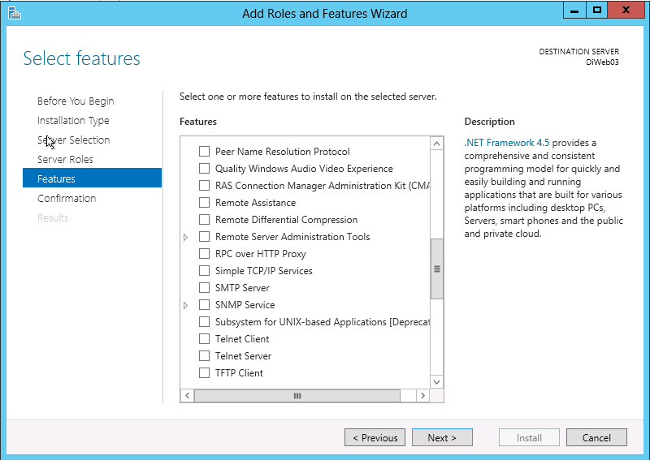

* 1. Click **Install**:

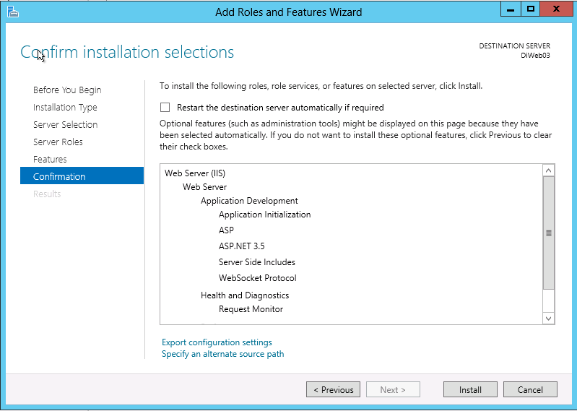

Click **Close** to exit the wizard.

**Summary:** Features has been installed successfully by using Server Manager in Windows Server 2012.

1. **Public port 1080**
2. Open the “windows Firewall with Advanced Security”:

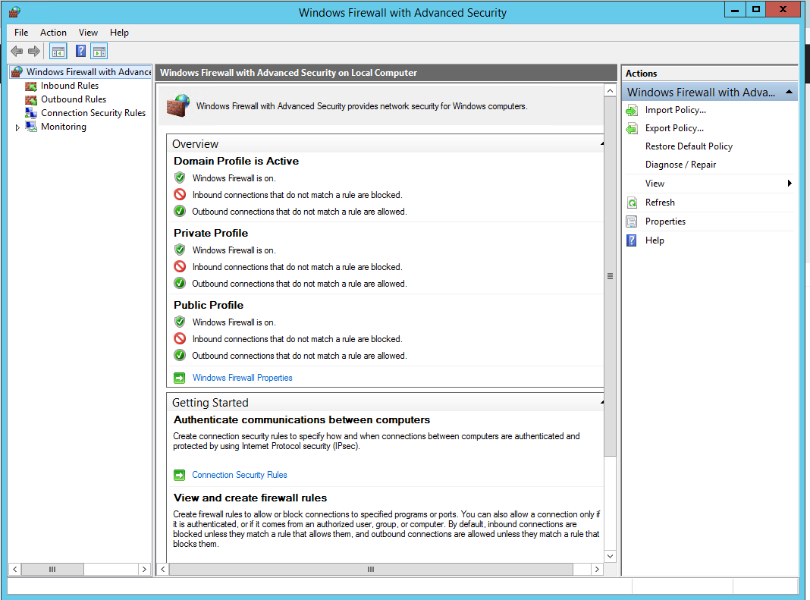

1. Right click to Inbound Rules🡪 New rule…

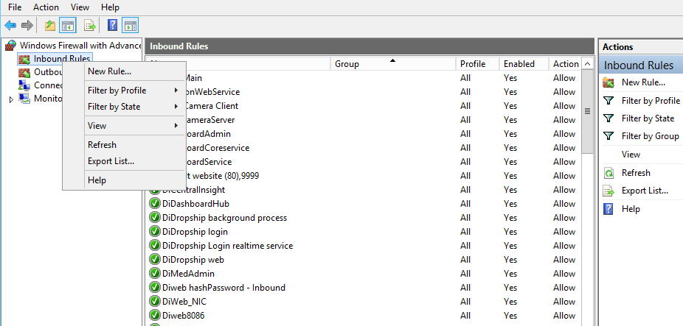

1. Select Port and click Next.

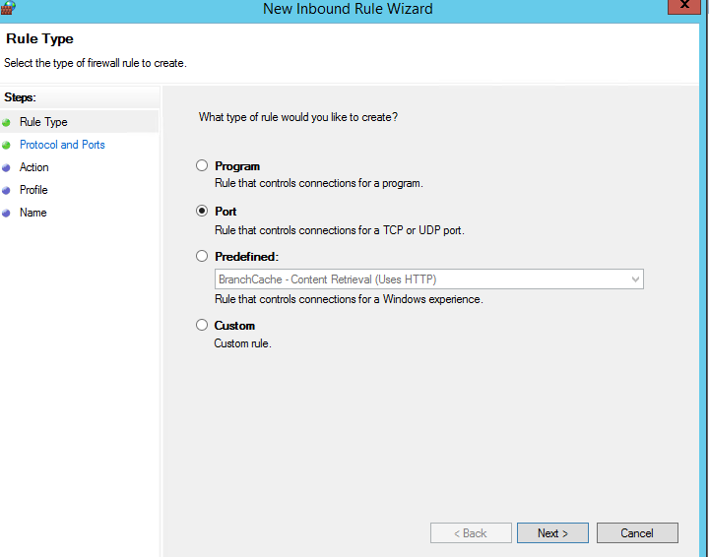

1. Input1080 into Specific local ports. Click Next.

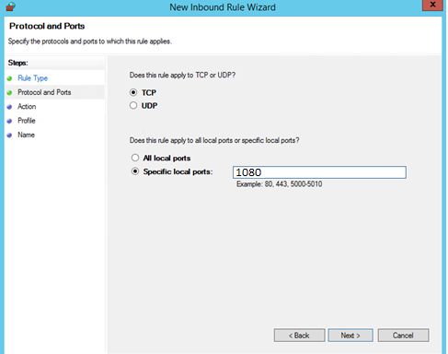

1. Select Allow the connection. Click Next.

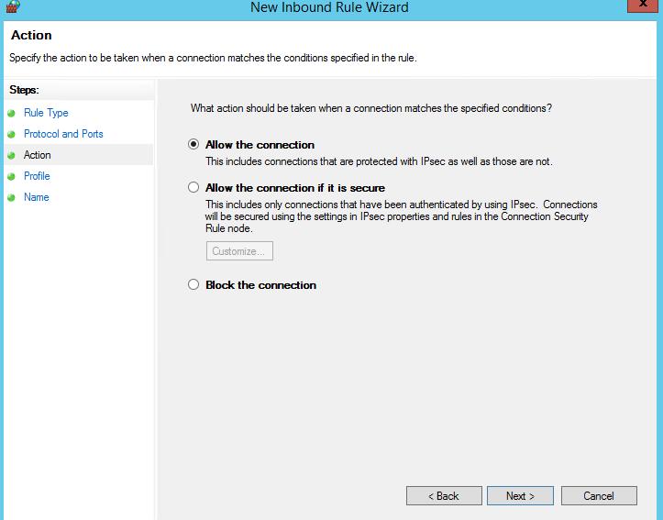

1. Select all(Domain, Private,Public). Click Next.

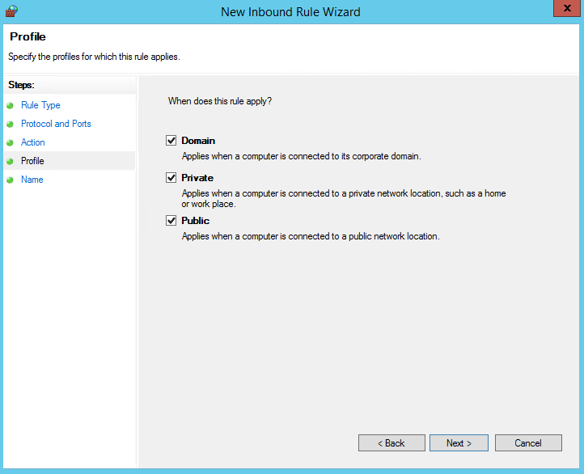

1. Input port name and finish.

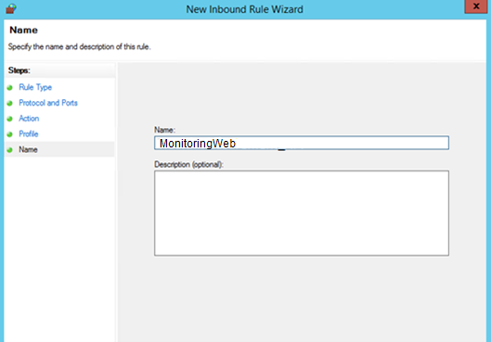

# **Deploy Monitoring Web on Window Server 2012**

1. Create folder to contain source code on server (example: “**MonitoringWeb**”) and copy source code to here.

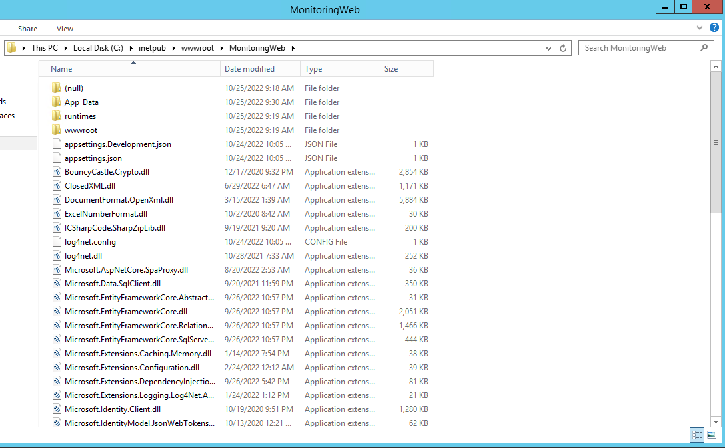

1. Configure IIS: Open **Control Panel** -> **Administrative Tools** -> **Internet Information Services (IIS) Manager**
2. Click **Application Pools** -> select created Application Pool-> click **Advanced Settings…** on Actions right tab to set:

* **Enable 32-bit Applications** = True
* Select “**…**” button at **Identify** properties of **Process Model** section to set:
  + **Built-in account** = LocalSystem
  + **Load User Profile =** False

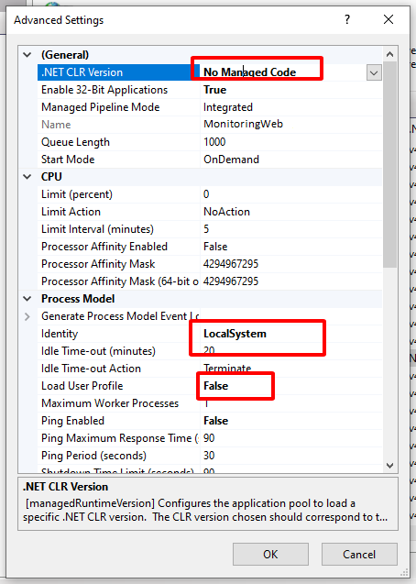

1. Create a Website:

- Right click **Site** -> **Add WebSite** -> Input Alias (this name have to access the website), example: “MonitoringWeb” -> Select **Application Pool** which you were created on above.

- **On physical path**: browse to physical path where it contain your source code “C:\inetpub\wwwroot\MonitoringWeb”.

- On binding:

+ Type: http.

+ Port: 1080

+ Input host name.

~~+ Select the SSL certificate.~~

~~- Click Ok.~~

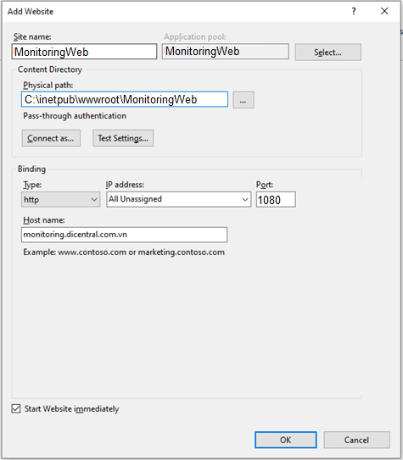

1. Install ASP.Core 6.0 (x86,x64)

**Note**: Check existence Asp .net core 6.0, return if not exists

[Download ASP.NET Core 6.0 Runtime (v6.0.10) - Windows Hosting Bundle Installer (microsoft.com)](https://dotnet.microsoft.com/en-us/download/dotnet/thank-you/runtime-aspnetcore-6.0.10-windows-hosting-bundle-installer)

1. Change **appsettings.json** setting:

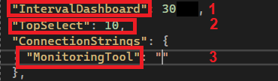

**Notes:**

* **1. IntervalDashboard:** System health dashboard data interval. Unit: second.
* **2. TopSelect:** Number of record select in query get data of system health dashboard order by RequestTime descending.
* **3. MonitoringTool:** Connection string of database

1. Start view **MonitoringWeb** site:

Select **MonitoringWeb** site. It will show website.

