**Monitoring Health Installation Guide for Window server 2012**

------

Contents

**I.** **Installing IIS 8 on Windows Server 2012** 2

**II.** **Customizing features on IIS 8** 6

**III.** **Internal access port 1081:** 10

**IV.** **Deploying Monitoring_wsAddCounters Add Performance Monitor** 17

**V.** **Deloying Service worker Monitoring_wsGetHealth Call data Performance Monitor** 19

1. **Installing IIS 8 on Windows Server 2012**

Note: IIS 8.0 is only available in Windows Server 2012 and Windows 8.

If server was exist IIS 8.0, you will skip this step.

To install IIS 8, use the following steps:

## Open **Server Manager**.

## Under **Manage** menu, select **Add Roles and Features**:

[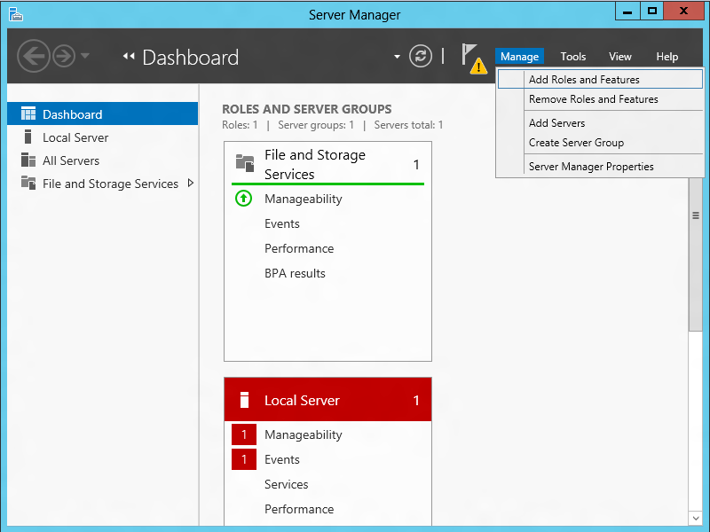](http://i3.iis.net/media/7187674/installing-iis-8-on-windows-server-2012-1088-IMAGE01.png?cdn_id=2013-07-03-001)

## Select **Role-based or Feature-based Installation**:

[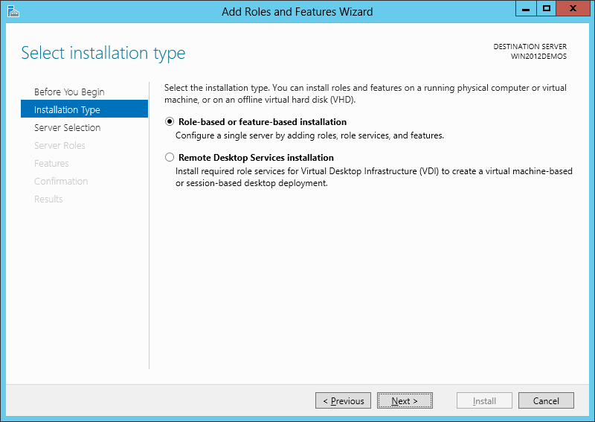](http://i2.iis.net/media/7187668/installing-iis-8-on-windows-server-2012-1088-IMAGE02.png?cdn_id=2013-07-03-001)

## Select the appropriate server (local is selected by default), as shown below:

[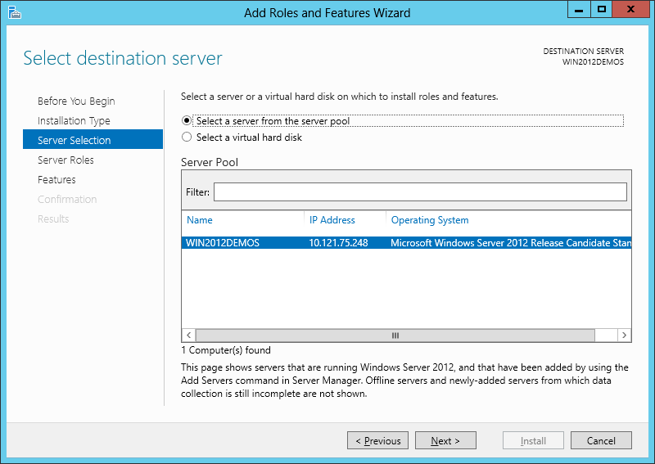](http://i2.iis.net/media/7187662/installing-iis-8-on-windows-server-2012-1088-IMAGE03.png?cdn_id=2013-07-03-001)

## Select **Web Server (IIS)**:

[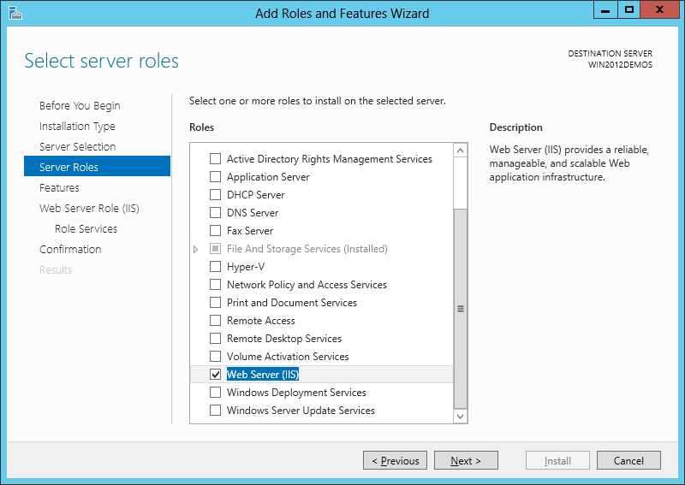](http://i2.iis.net/media/7187656/installing-iis-8-on-windows-server-2012-1088-IMAGE04.png?cdn_id=2013-07-03-001)

## Select features for IIS, so click **Next**:

✓.NET Framework 3.5 Features:

✓..NET Framework 3.5 (includes .NET 2.0 and 3.0)

✓.HTTP Activation

✓.Non-HTTP Activation

✓. .NET Framework 4.5 Features:

✓.NET Framework 4.5

✓.ASP.NET 4.5

✓.WCF Services:

✓.HTTP Activation

✓.Message Queing (MSMQ) Activation

✓.Named Pipe Activation

✓.TCP Activation

✓.TCP Port Sharing

[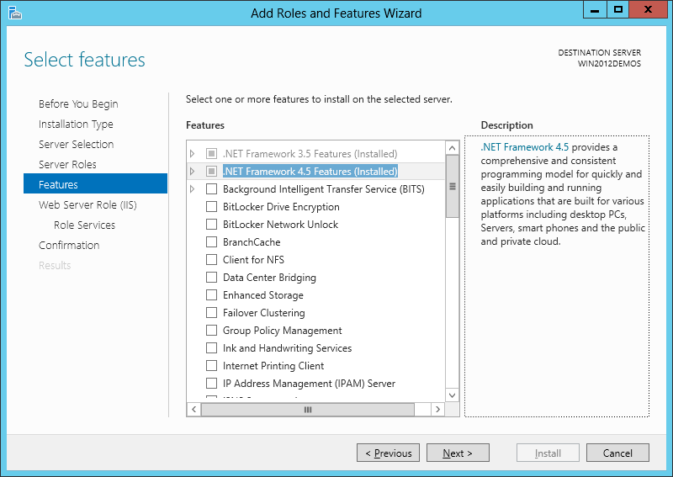](http://i1.iis.net/media/7187650/installing-iis-8-on-windows-server-2012-1088-IMAGE05.png?cdn_id=2013-07-03-001)

## Click **Next**:

[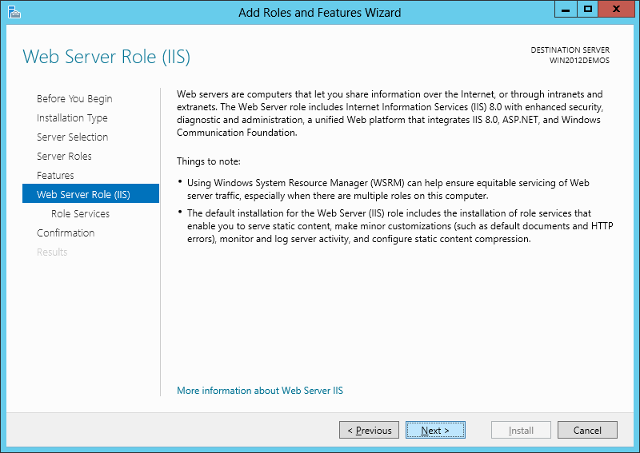](http://i3.iis.net/media/7187644/installing-iis-8-on-windows-server-2012-1088-IMAGE06.png?cdn_id=2013-07-03-001)

## Customize your installation of IIS, or accept the default settings that have already been selected for you and then click **Next**:

[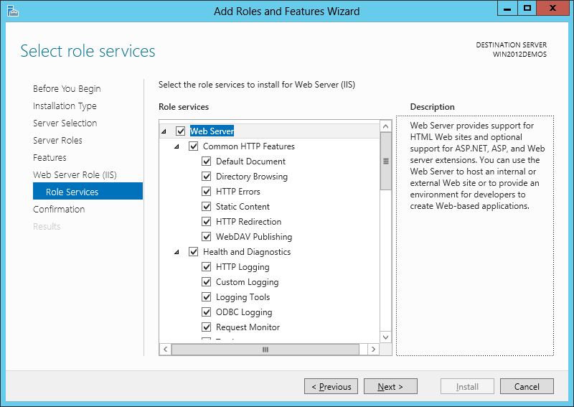](http://i1.iis.net/media/7187638/installing-iis-8-on-windows-server-2012-1088-IMAGE07.png?cdn_id=2013-07-03-001)

## Click **Install**:

[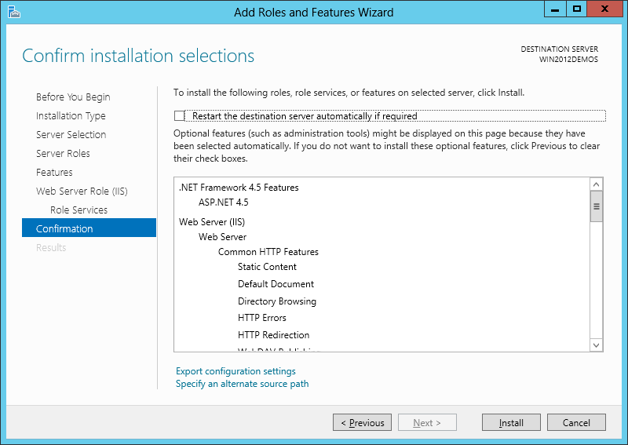](http://i2.iis.net/media/7187632/installing-iis-8-on-windows-server-2012-1088-IMAGE08.png?cdn_id=2013-07-03-001)

## When the IIS installation completes, the wizard reflects the installation status:

[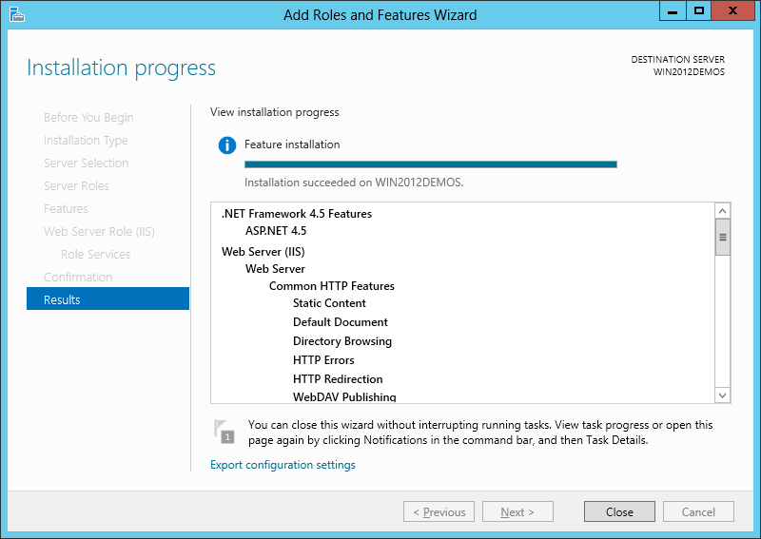](http://i1.iis.net/media/7187626/installing-iis-8-on-windows-server-2012-1088-IMAGE09.png?cdn_id=2013-07-03-001)

## Click **Close** to exit the wizard.

* **Summary:** IIS 8.0 has been installed successfully by using Server Manager in Windows Server 2012.

1. **Customizing features on IIS 8**
   1. Open **Server Manager**
   2. Access to **Local Server** | **Roles and Features** and select **Add Roles and Features** at **TASKS** list.

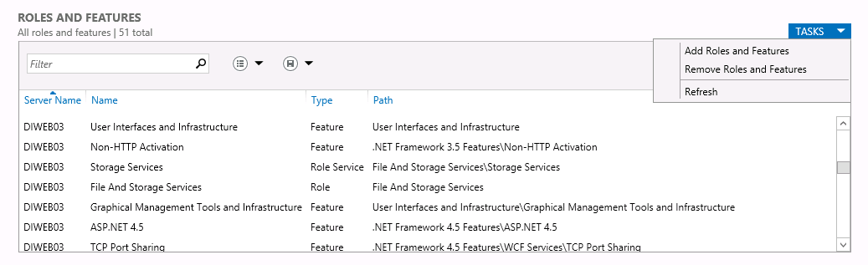

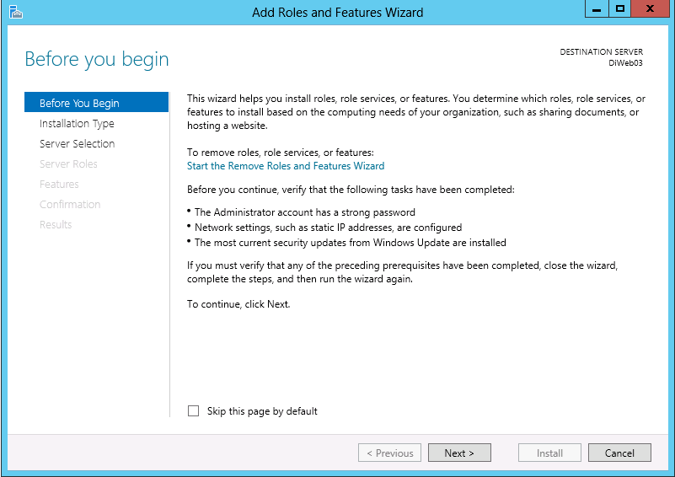

* 1. Select **Role-based or Feature-based Installation**:

[](http://i2.iis.net/media/7187668/installing-iis-8-on-windows-server-2012-1088-IMAGE02.png?cdn_id=2013-07-03-001)

* 1. Select the appropriate server (local is selected by default), as shown below:

[](http://i2.iis.net/media/7187662/installing-iis-8-on-windows-server-2012-1088-IMAGE03.png?cdn_id=2013-07-03-001)

* 1. Select **Web Server (IIS)**:

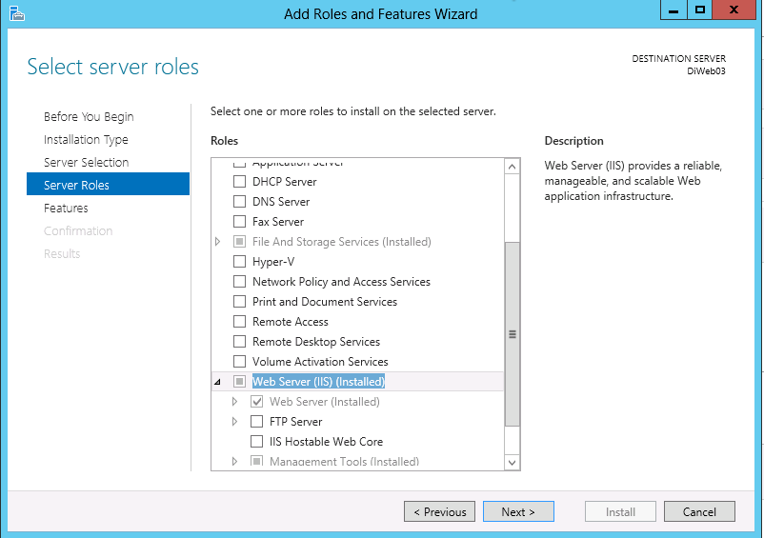

* 1. Customize your installation of IIS and then click **Next**:

Web Server (IIS):

Web Server:

Common HTTP Features:

✓ Default Document

✓ Directory Browsing

✓ HTTP Errors

✓ Static Content

Health and Diagnostic:

✓ HTTP Logging

✓ Request Monitor

Performance:

✓ Static Content Compression

✓ Dynamic Content Compression

Security:

✓ Request Filtering

Application Development:

✓. NET Extensibility 3.5

✓. NET Extensibility 4.5

✓ Application Initialization

✓ ASP

✓ ASP.NET 3.5

✓ ASP.NET 4.5

✓ ISAPI Extension

✓ ISAPI Filters

✓ Server Side Includes

✓ Web Socket Protocol

* 1. Click **Next**:

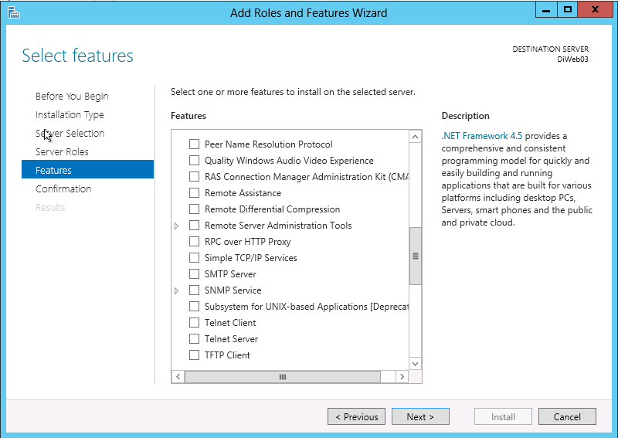

* 1. Click **Install**:

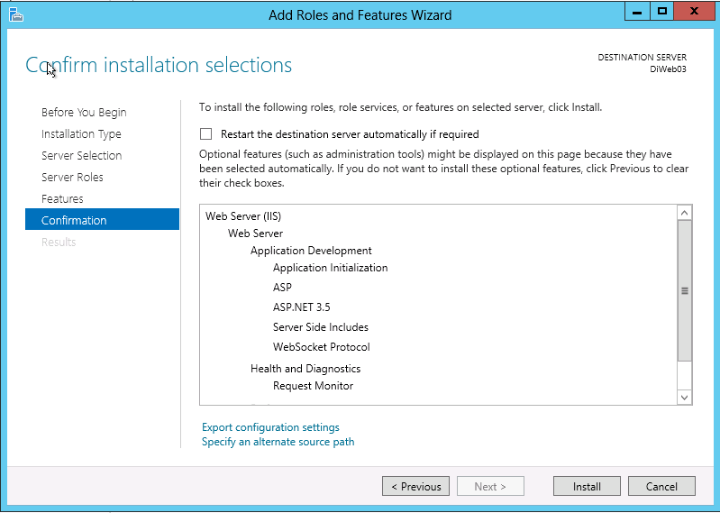

* + - Click **Close** to exit the wizard.**Summary:** Features has been installed successfully by using Server Manager in Windows Server 2012.

1. **Internal access port 1081:**
2. Open the “windows Firewall with Advanced Security”:

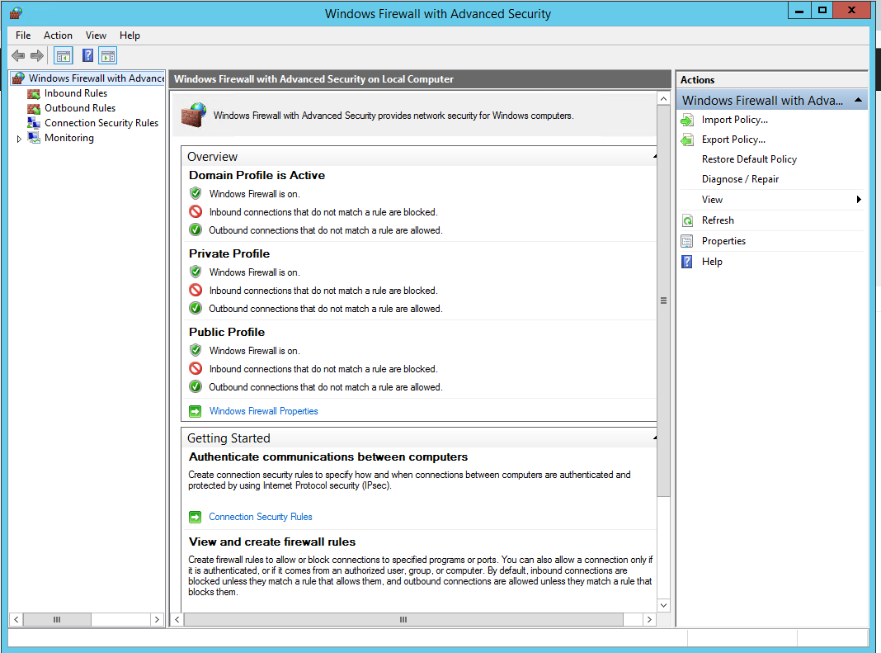

1. Right click to Inbound Rules🡪 New rule…

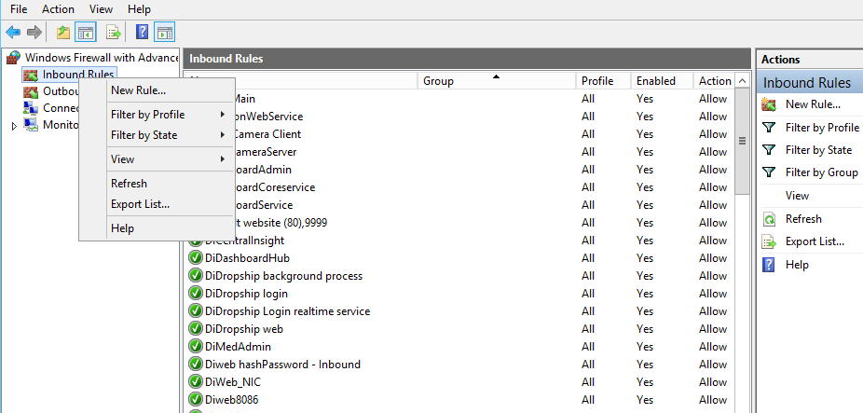

1. Select Port and click Next.

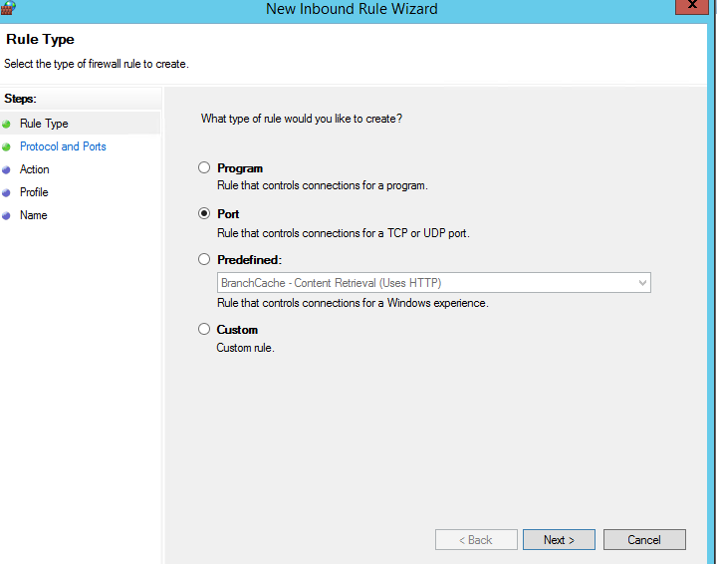

1. Input1081 into Specific local ports. Click Next.

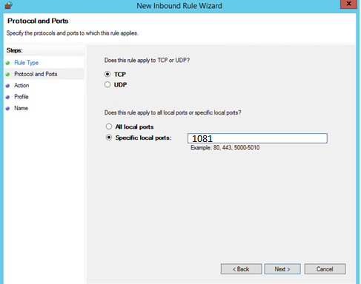

1. Select Allow the connection. Click Next.

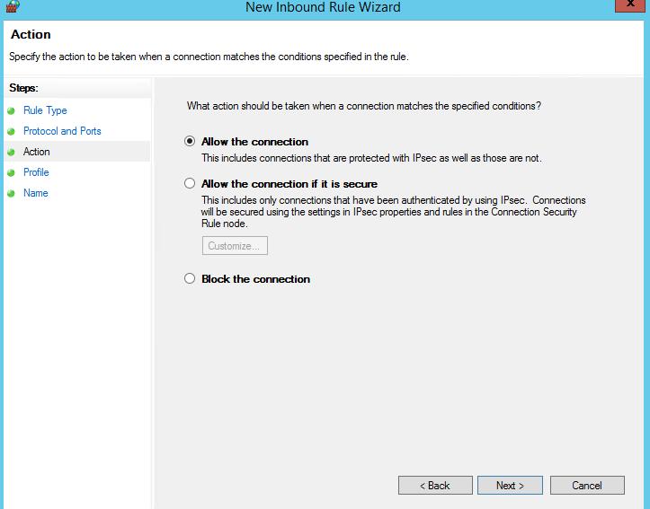Select all(Domain, Private,Public). Click Next.

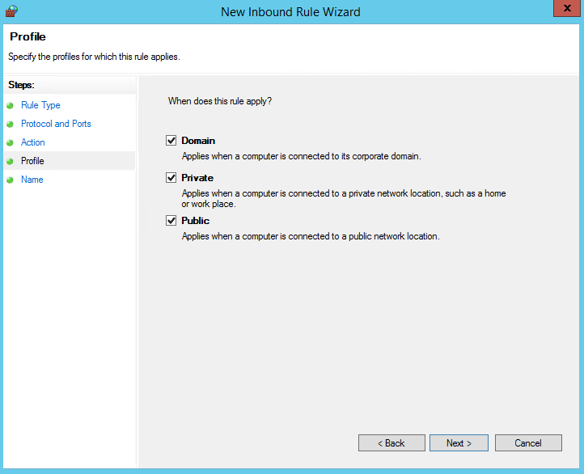

Input port name and finish.

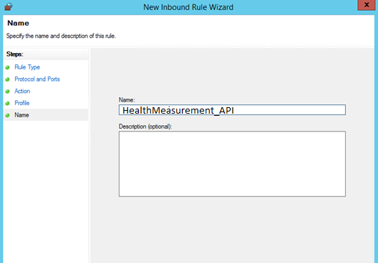**Deploying HealthMeasurement_API on Window Server 2012:**

1. Create folder to contain source code on server (example: “**HealthMeasurement_API**”) and copy HealthMeasurement_API source code to here.

1. Configure IIS: Open **Control Panel** -> **Administrative Tools** -> **Internet Information Services (IIS) Manager**
2. Click **Application Pools** -> select created Application Pool-> click **Advanced Settings…** on Actions right tab to set:

* **Enable 32-bit Applications** = True
* Select “**…**” button at **Identify** properties of **Process Model** section to set:
  + **Built-in account** = LocalSystem
  + **Load User Profile =** False

1. Create a WebSite:

- Right click **Site** -> **Add WebSite** -> Input Alias (this name have to access the website), example: “HealthMeasurement_API” -> Select **Application Pool** which you were created on above.

- **On physical path**: browse to physical path where it contain your source code “C:\Workspace\Publish\HealthMeasurement_API”.

- On binding:

+ Type: http.

+ Port: 1081

+ Input host name.

~~+ Select the SSL certificate.~~

~~- Click Ok.~~

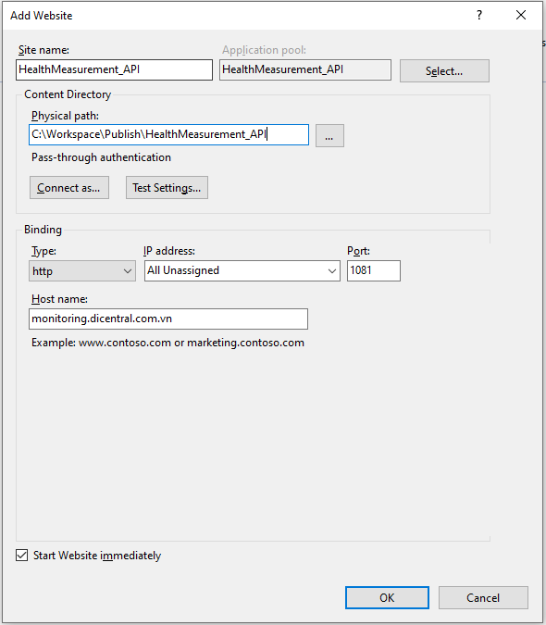

1. Change **appsettings.json** setting:

Change some **appSettings**:

* ProcessList: "explorer"
* ShareFolderCheck: “1” or “0” active/inactive KPI Shared Storage Running Time
* ShareFolderFrom:folder containing measurement files
* ShareFolderTo:destination directory to the measurement files
* EDItoASCII: “1” or “0” active/inactive KPI Process Time EDItoASCII
* EDItoASCIIConfigApp: App config
* EDItoASCIIConfigData: measurement file

1. Add item host

C:\Windows\System32\drivers\etc

172.16.0.109 monitoring.dicentral.com.vn

1. Install ASP Dotnet Core 6.0 (x86, x64)

**Note**: Check existence Asp .net core 6.0, return if not exists

[Download ASP.NET Core 6.0 Runtime (v6.0.10) - Windows Hosting Bundle Installer (microsoft.com)](https://dotnet.microsoft.com/en-us/download/dotnet/thank-you/runtime-aspnetcore-6.0.10-windows-hosting-bundle-installer)

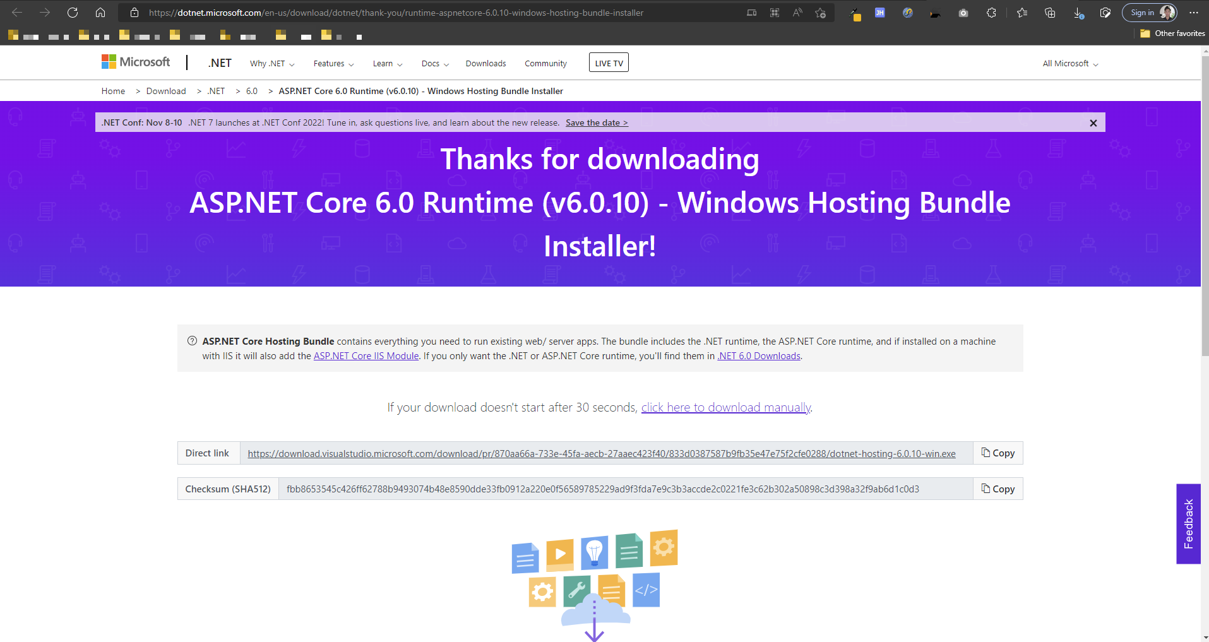

1. Start view HealthMeasurement_API site:

Select HealthMeasurement_API site. It will show login page.

Add key Authorize: <ODC Dev>

http//link URL 1081:/swagger/index.htm

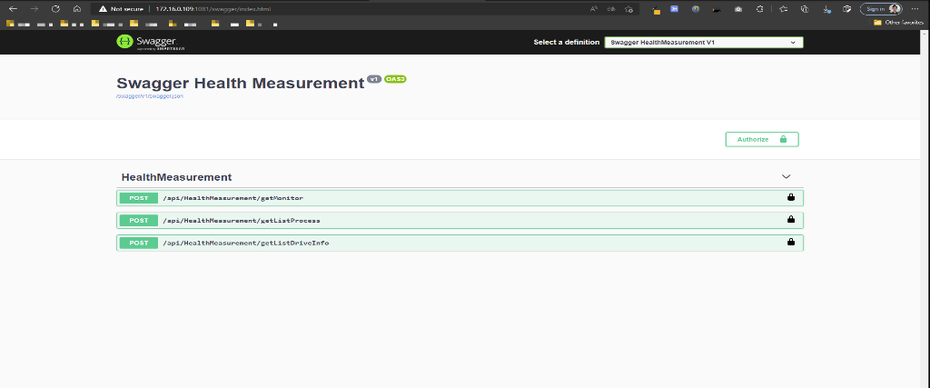

1. **Deploying Monitoring_wsAddCounters Add Performance Monitor**
2. Create folder to contain source code on server (example: “**Monitoring_wsAddCounters**”) and copy **Monitoring_wsAddCounters**source code to here. Graphical user interface, text

   Description automatically generated
3. Change appsettings.json

Ex Multiprocess: explorer;ABC;…

* ProcessList: "explorer"
* ShareFolderCheck: “1” or “0” active/inactive KPI Shared Storage Running Time
* ShareFolderFrom:folder containing measurement files
* ShareFolderTo:destination directory to the measurement files
* EDItoASCII: “1” or “0” active/inactive KPI Process Time EDItoASCII
* EDItoASCIIConfigApp: App config
* EDItoASCIIConfigData: measurement file

change path run file Install_Service.bat (administrator)

1. **Deloying Service worker Monitoring_wsGetHealth Call data Performance Monitor**
2. Create folder to contain source code on server (example: “**Monitoring_** **wsGetHealth**”) and copy **Monitoring_** **wsGetHealth** source code to here.
3. Change appsetting.json Myconfig:ConnectionString

"ConnectionStrings": "Data Source=****;Initial Catalog=Monitoring;User ID=****;Password=****;Connection Timeout=12000;"

1. Run item PROD goto <source path>\ **Monitoring_** **wsGetHealth.exe** file Install_service.bat

1. Check and Start Service

