with MS IdP
Monitoring Project
Version 1.0
Date | Version | Changes | Changed By
Feb 22, 2023 | 1.0 | Initial guideline about  - Application Registration | Thuan Vo

Application Registration
Follow these steps to create the app registration:
- Sign in to the Azure portal (With the role can create the Application).
- If you have access to multiple tenants, use the Directories + subscriptions filter in the top menu to switch to the tenant in which you want to register the application.
- Search for and select Azure Active Directory.
- Under Manage, select App registrations > New registration.
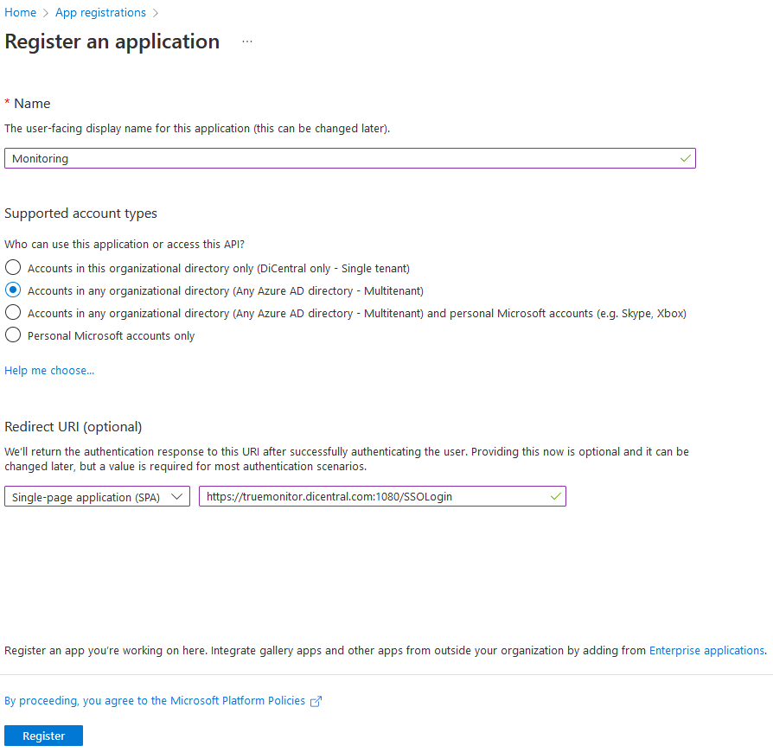
- Enter a display Name for the new application.
- Under Supported account types, select option Accounts in any organization directory (Any Azure AD directly - Multitenant)
- Under Redirect URI, select Web platform and enter redirect URIs provided by True Commerce
Environment | Application | URI
Staging | Monitoring | https://truemonitorv1-staging.dicentral.com:1080/SSOLogin
Production | Monitoring | https://truemonitor.dicentral.com:1080/SSOLogin
Note: URIs can be updated later after the application is registered under Redirect URIs link in Overview panel
- Select Register to complete the initial app registration.
- In Authentication menu, enable Access tokens and ID tokens
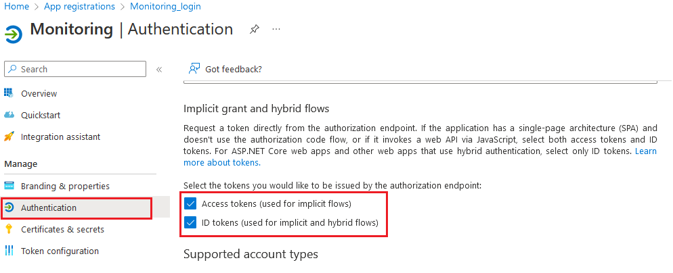
- In Token configuration menu, click Add optional claim, enable ID and click choose the Email. Click Add button.
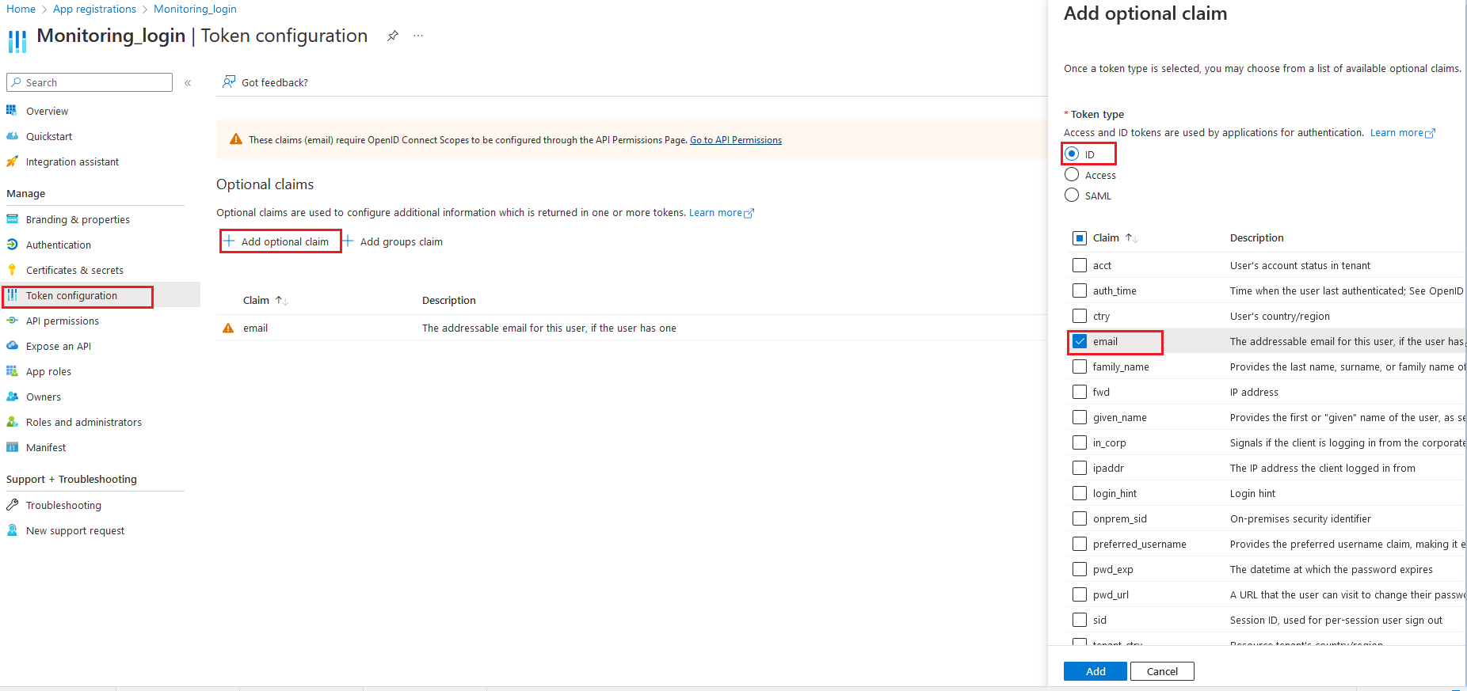
- Press Save to update token settings

Collect Application ID
When registration finishes, the Azure portal displays the app registration's Overview pane. You see the Application (client) ID, also called the client ID. We need to collect & provide Application ID of the new registered application so that we can configure in our system.
