Voltage divider circuit:

24V max => 24/10 = 2.4V => within range

PA0-ADC1-IN0

Battery measurement:

Battery discharge percentage:

at 40% use grid: 11,9V

fully charged: 12.7

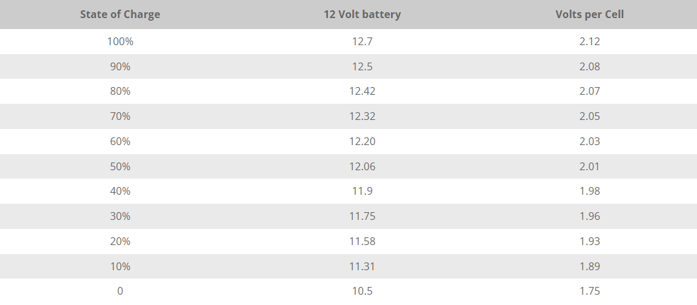

Battery ADC:

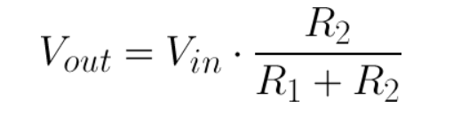

At 100% Vin = 12.7V

At 40% Vin = 11.9V

R1 = 10K. R2 = 1K.

Vout at 100% = 1.155V

Vout at 40% = 1.082V

Use 1250 and 1450 for triggering between grid and solar converter conditions.

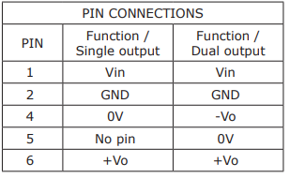

Using dual output:

Pin 4: no pin

Pin 5: ground

Pin 6: output

Will test adc on supply to change code later (Vref might change)