Robotframework常用方法总结
----屈潘

- 自动化环境的搭建

- 自动化中常遇见的错误及解决方法
- 自动化 API

第一篇 自动化环境的搭建

- 驱动下载地址
火狐： https://github.com/mozilla/geckodriver/releases
谷歌： http://chromedriver.storage.googleapis.com/index.html
IE： http://selenium-release.storage.googleapis.com/index.html
注：谷歌的驱动的版本是和浏览器相匹配的，Ie的驱动是和selenium相匹配的，
附上谷歌对照表：
chromedriver版本

v2.37 v65
v2.36 v65
v2.35 v65
v2.34 v61-63
v2.33 v60-62
v2.32 v59-61
v2.31 v58-60
v2.30 v58-60
v2.29 v56-58
v2.28 v55-57
v2.27 v54-56
v2.26 v53-55
v2.25 v53-55
v2.24 v52-54
v2.23 v51-53
v2.22 v49-52
v2.21 v46-50
v2.20 v43-48
v2.19 v43-47
v2.18 v43-46
v2.17 v42-43
v2.13 v42-45
v2.15 v40-43
v2.14 v39-42
v2.13 v38-41
v2.12 v36-40
v2.11 v36-40
v2.10 v33-36
v2.9 v31-34
v2.8 v30-33
v2.7 v30-33
v2.6 v29-32
v2.5 v29-32
v2.4 v29-32

Robot FrameWork环境搭建

Python安装
- 下载Python 2.7.14版本，下载时要注意与系统版本保持一致（32位OR 64位）；
地址：https://www.python.org/downloads/
- 下载完成之后，双击python-2.7.14.amd64.msi进行安装
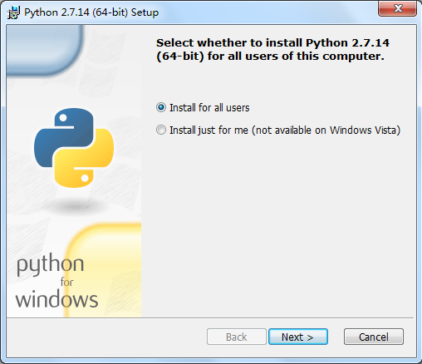
- 点击“Next”，选择安装目录（安装路径最好不要选择有中文或者包含空格的目录，防止后续安装其他库会报错）；
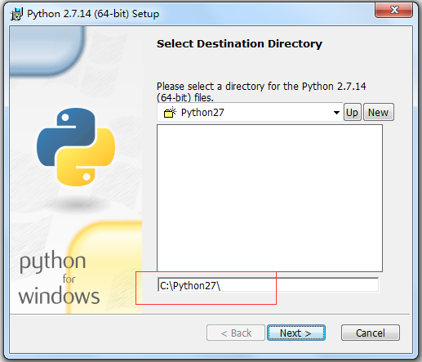
- 在自定义安装界面，选择待安装的功能，将“Add python.exe to Path”设置为“Will be installed on local hard drive”，安装成功之后，自动将Python相关的路径信息配置到系统变量Path中；
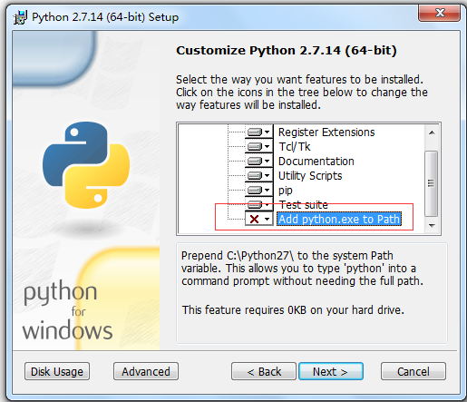
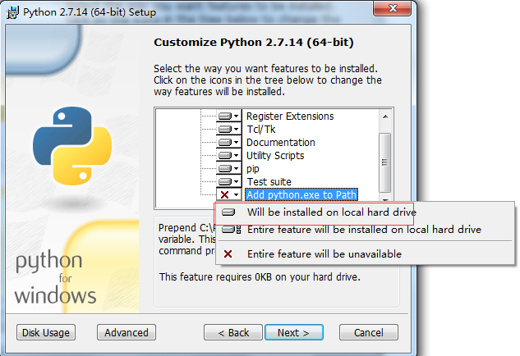
- 点击“Next”直到安装完成，打开cmd命令符，输入python，出现如下信息表示环境配置成功
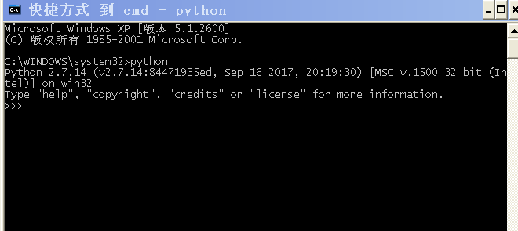

- 如果开始没有勾选自动添加环境变量，需要自己配置，打开系统变量Path，把Python相关信息加到环境变量，用分号隔开（C:\Python27\;C:\Python27\Scripts;）；
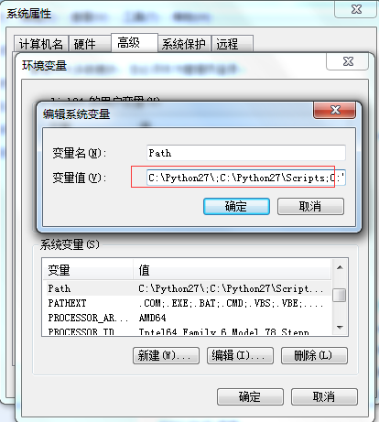

wxPython安装
- 下载wxPython，版本与Python版本要一致（py27是Python2.7系列的），同时要注意与系统版本保持一致（32位OR 64位）；
地址：https://sourceforge.net/projects/wxpython/files/wxPython/2.8.12.1/
- 双击exe，运行安装；
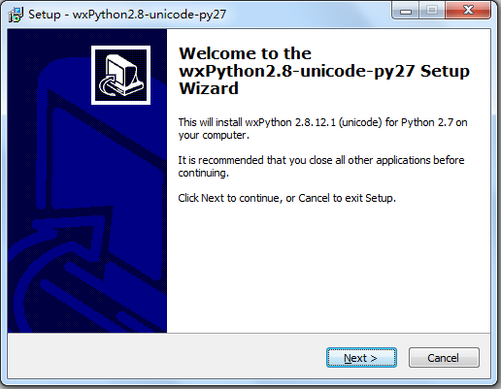
- 点击“Next”按钮，接受相关信息条例；
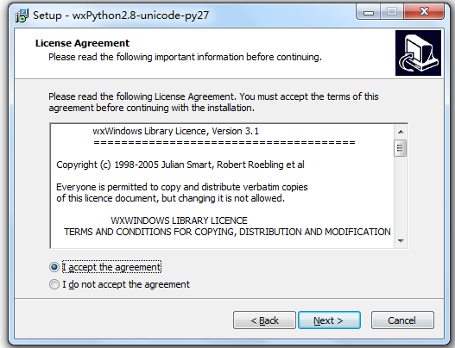
- 选择wxPython安装路径，默认即可；
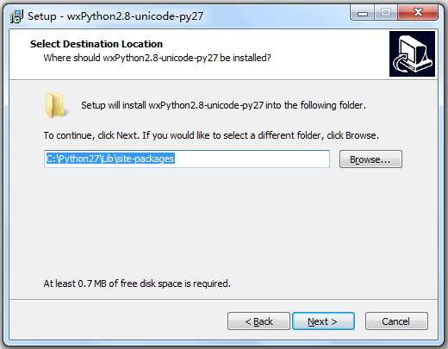
- 点击“Next”按钮直到安装完成即可；

robot Framework安装
Python2.7.11这个版本自带了pip工具，可以使用pip命令安装robotframework、robotframework-ride以及selenium2library，具体安装步骤见各类安装详情。
- “运行—cmd”，打开命令行界面；
- 输入“pip list”，查看已安装的软件及对应的版本；
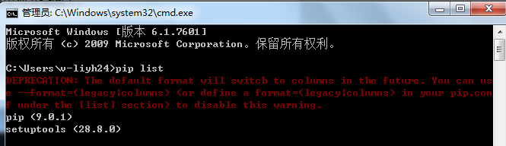
- 输入“pip install robotFramework”，安装Robotframework，当显示“successfully installed robotframework-3.0.2”即表示安装成功；
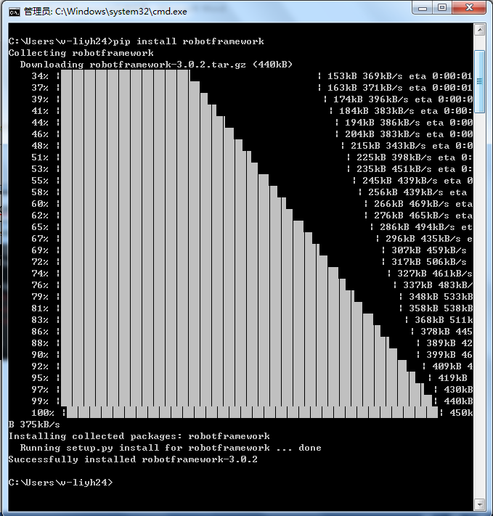

robot Framework—ride安装
- “运行—cmd”，打开命令行界面；
- 输入“pip install robotFramework-ride”，安装robotframework-ride，当显示“Successfully installed robotframework-ride-1.5.2.1”即表示安装成功；
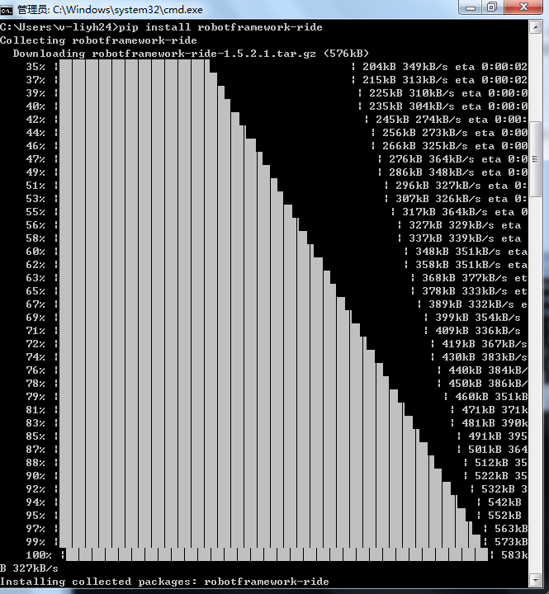
- 输入“ride.py”，验证能否正常打开ride界面；当看到RIDE界面时，表示robotframework-ride安装成功；
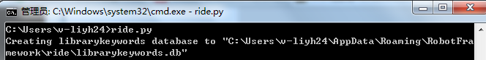
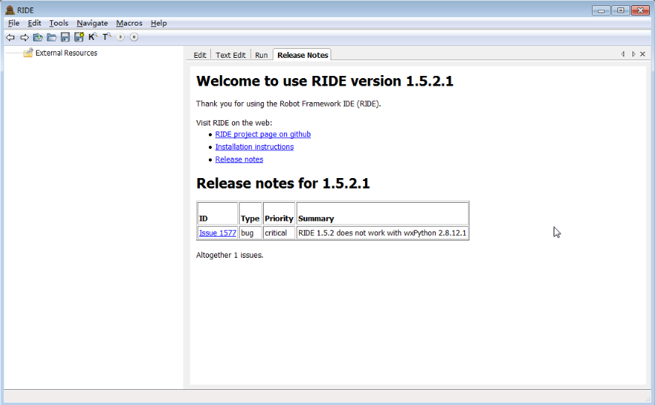

Selenium2Library安装
- “运行—cmd”，打开命令行界面；
- 输入“pip install robotFramework-selenium2library”，安装selenium2library包，当显示“Successfully installed decorator-4.1.2 robotframework-selenium2library-1.8.0 selenium-3.6.0”即表示安装成功；
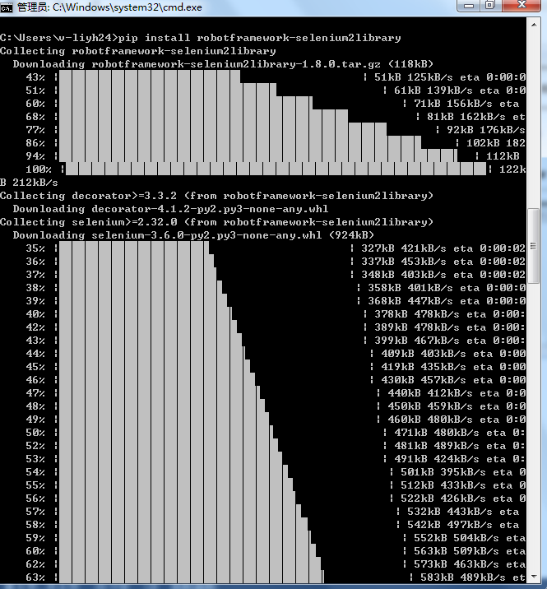
- 查看selenium2library是否安装成功的方法：打开python.exe，输入import Selenium2Library，如果出现命令提示符就 OK；
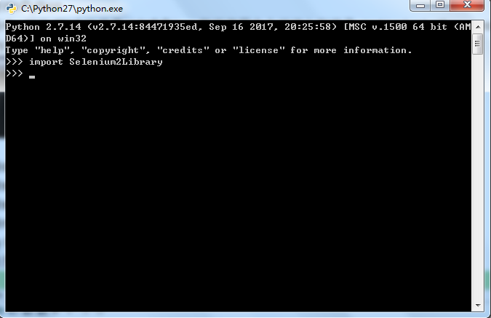

二：驱动及浏览器设置

- 接下来把下载好的IEDriverServer.exe和chromedriver.exe放到python的安装目录：C:\Python27下即可
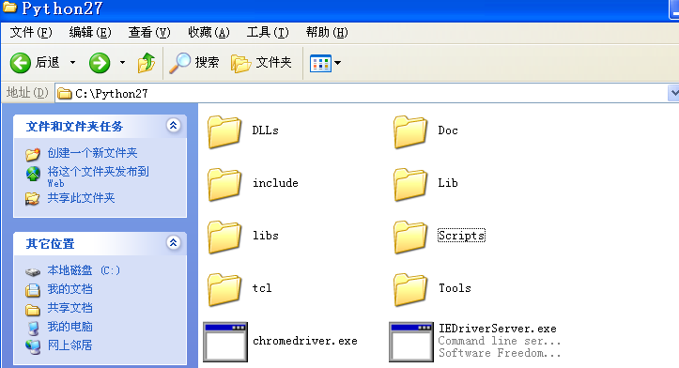
- 打开IE浏览器进行设置
进入：工具》internet选项》安全，左下角取消勾选，四个 都要取消
- 进入：工具》internet选项》高级，勾选三个允许
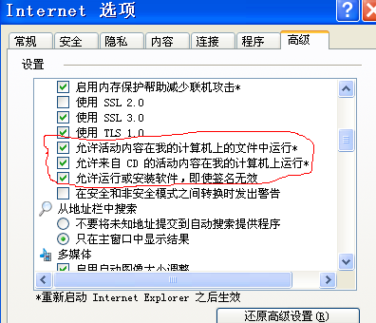
- 继续往下拉，取消两个禁止的勾选
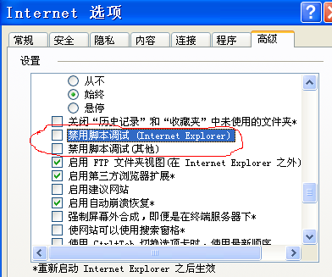

- 最后把浏览器的缩放调到100%

- 谷歌环境
对于谷歌谷歌浏览器：只需下载相对应的驱动放到python的 安装路径即可

第二篇 自动化中常遇见的错误及解决方法

- 使用RIDE运行脚本，第一次成功，第二次不显示日志
原因：第一次运行打开浏览器操作后，驱动没有关闭，
- 新建一个“.bat”文件，
- 内容输入： taskkill /f /im chromedriver.exe
taskkill /f /im IEDriverServer.exe
- 保存后，每次执行完脚本，执行即可

- 在浏览器中打开了新的窗口，切换到新的窗口
- 只有两个窗口时：
select window new ---切换到新窗口
select window main ---回到主窗口
- 有3个或多个窗口时：
@{x} get window handles ---得到所有窗口的句柄
@{x} list windows ---得到所有窗口的句柄
select window ${x[1]}或@{x}[1] ---切换到第二个窗口
select window ${x[2]}或@{x}[2] ---切换到第三个窗口
select widow ${x[0]}或@{x}[0] ---返回第一个窗口

- 要点击的元素是链接
- 使用: click link 新闻
click element link:新闻

- 遇到网页有自动收缩菜单，不能定位到
原因：像这种的收缩菜单，一般是用js或者jquery制作的，使用
Selenium2library中的定位方式不能使用，只能用js或jquery定位。
定位方法如下：
- 使用jquery定位：
Execute javascript “$(‘#input’).click()”
jquery的定位有点像css的定位方式：
Id定位：”$(‘#user’).click()”
Class定位：”$(‘.user’).click()”
其他定位：”$(‘input[type=text]’).click()”
- RIDE输出报告到指定文件夹
- 在robot项目文件加下新建repot文件夹
- 进入RIDE，点击左侧robot项目，进入右方的Run按钮，在Arguments一栏中输入“-d /robot/report”，前面是参数，后面是地址，从项目文件夹开始写
- 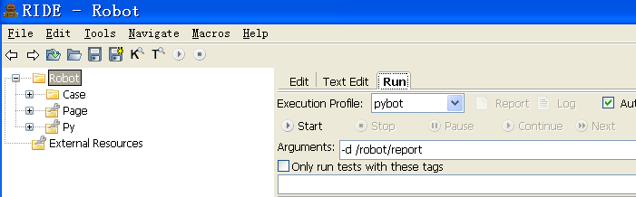

- 使用AutoItLibrary进行下载操作
转自GreenBean：https://www.cnblogs.com/caixiaohong/p/4930921.html

1、下载与安装AutoIt v3 地址链接:http://pan.baidu.com/s/1hqsDFBA，我自己是32位的系统，用这个运行可以
2、安装完成后，如下图所示
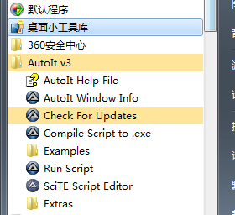
3、 AutoIt Windows Info 用于帮助我们识 Windows 控件信息。
Compile Script to.exe 用于将 AutoIt 生成 exe 执行文件。
Run Script 用于执行 AutoIt 脚本。
SciTE Script Editor 用于编写 AutoIt 脚本
4、上传一个html备用upfile.html
<html><head><meta http-equiv="content-type" content="text/html;charset=utf-8" /><title>upload_file</title><link href="http://cdn.bootcss.com/bootstrap/3.3.0/css/bootstrap.min.css"
rel="stylesheet" /></head><body><div class="row-fluid"><div class="span6 well"><h3>upload_file</h3><input type="file" name="file" /></div></div></body><scriptsrc="http://cdn.bootcss.com/bootstrap/3.3.0/css/bootstrap.min.js"></script></html>
5、 通过浏览器打开upfile.html，效果如下图所示（建议用火狐打开）
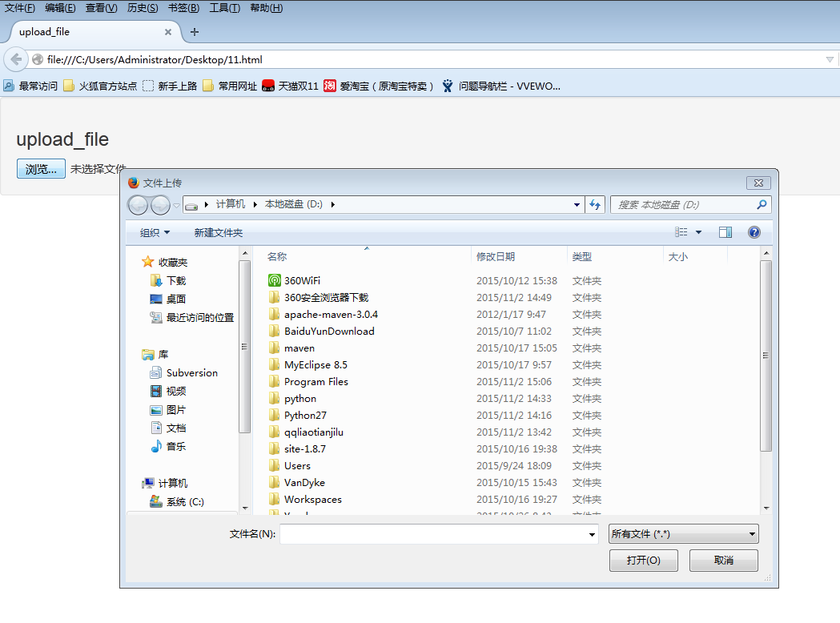
6、 此时打开AutoIt Window Info，鼠标点击 Finder Tool，鼠标将变成一个小风扇形状的图标，按住鼠标左键拖动到需要识别的控件上。
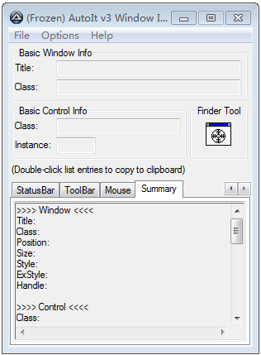
7、首先需要识别的是文本框。
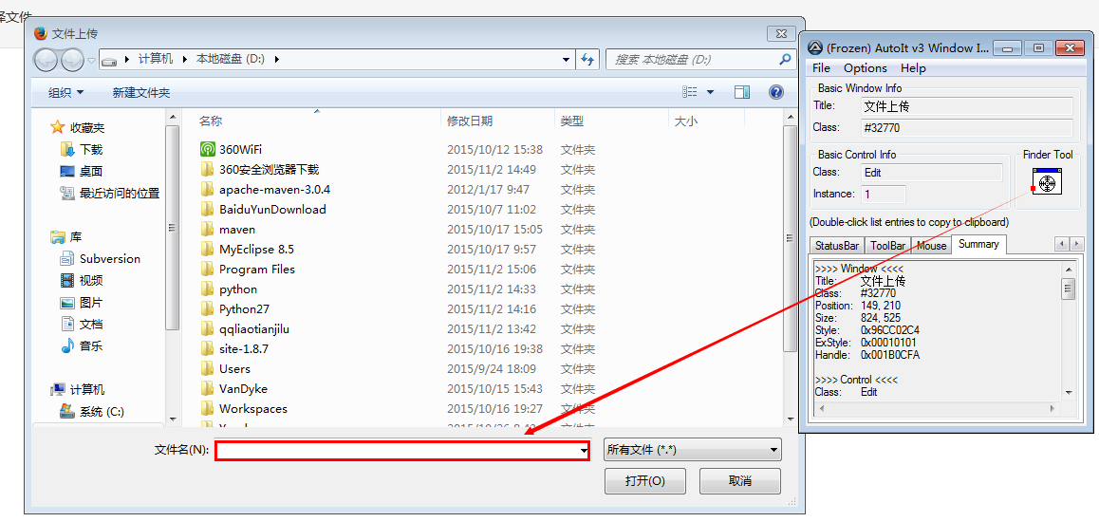
8、识别文本框后，就要在该文本框中输入文件路径，之后就是点击【打开】按钮，所以嘞，待会还要按照步骤7定位下按钮的位置。按照这个思路打开SciTE Script Editor，编辑脚本
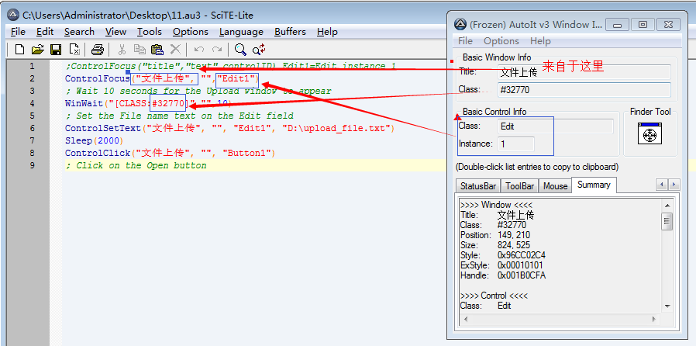
;ControlFocus("title","text",controlID) Edit1=Edit instance 1
ControlFocus("文件上传", "","Edit1")
; Wait 10 seconds for the Upload window to appear
WinWait("[CLASS:#32770]","",10)
; Set the File name text on the Edit field
ControlSetText("文件上传", "", "Edit1", "D:\upload_file.txt")
Sleep(2000)
ControlClick("文件上传", "", "Button1")
; Click on the Open button
9、 将上面的文件保存成11.au3文件
10、将11.au3转化成exe文件，因为exe文件可以直接执行
11、 打开Compile Script to .exe，我是32位的，直接如下图所示就可以了
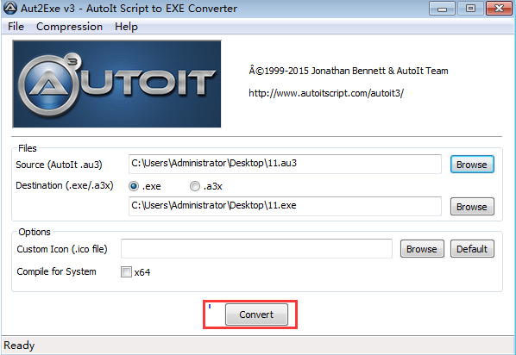
12、 打开ride，直接上代码
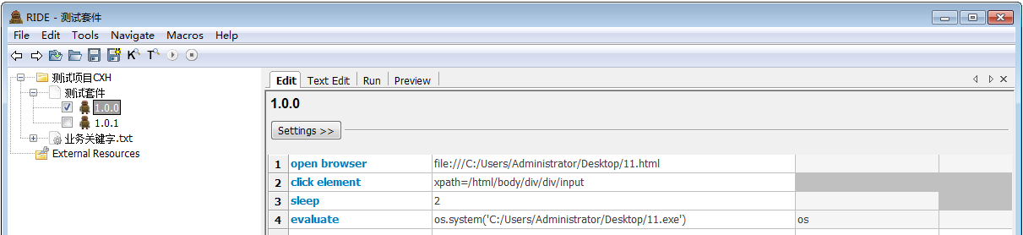
open browser file:///C:/Users/Administrator/Desktop/11.html
click element xpath=/html/body/div/div/input
sleep 2
evaluate os.system('C:/Users/Administrator/Desktop/11.exe') os

第三篇 自动化seleniu2library API

Selenium2Library用户关键字
*** Settings ***
Library Selenium2Library
*** Keywords ***Checkbox应该不被选择
[Arguments] ${locator}
Checkbox Should Not Be Selected ${locator}Frame应该包含文本
[Arguments] ${locator} ${text} ${loglevel}=INFO
Frame Should Contain ${locator} ${text} ${loglevel}List应该无选项
[Arguments] ${locator}
List Should Have No Selections ${locator}List选项应该是
[Arguments] ${locator} @{items}
List Selection Should Be ${locator} @{items}
Radio按钮不应该被选择
[Arguments] ${group_name}
Radio Button Should Not Be Selected ${group_name}
Radio按钮应该被设置成
[Arguments] ${group_name} ${value}
Radio Button Should Be Set To ${group_name} ${value}
Url应该包含
[Arguments] ${expected}
Location Should Contain ${expected}
Xpath应该匹配X次
[Arguments] ${xpath} ${expected_xpath_count} ${msg}= ${loglevel}=INFO
Xpath Should Match X Times ${xpath} ${expected_xpath_count} ${msg} ${loglevel}
checkbox应该被选择
[Arguments] ${locator}
checkbox should be selected ${locator}
url应该是
[Arguments] ${url}
Location Should Be ${url}
下次确认选择取消
Choose Cancel On Next Confirmation
下次确认选择确定
Choose Ok On Next Confirmation
从List中取消选项
[Arguments] ${locator} @{items}
Unselect From List ${locator} @{items}
从List选择选项
[Arguments] ${locator} @{items}
Select From List ${locator} @{items}
偏移拖拽
[Arguments] ${source} ${xoffset} ${yoffset}
Drag And Drop By Offset ${source} ${xoffset} ${yoffset}
元素应该不包含文本
[Arguments] ${locator} ${expected} ${msg}=
Element Should Not Contain ${locator} ${expected} ${msg}
元素应该不可用
[Arguments] ${locator}
Element Should Be Disabled ${locator}
元素应该不可见
[Arguments] ${locator} ${msg}=
Element Should Not Be Visible ${locator} ${msg}
元素应该包含文本
[Arguments] ${locator} ${text}
Element Should Contain ${locator} ${text}
元素应该匹配x次
[Arguments] ${locator} ${count} ${msg}= ${loglevel}=INFO
Locator Should Match X Times ${locator} ${count} ${msg} ${loglevel}
元素应该可用
[Arguments] ${locator}
Element Should Be Enabled ${locator}
元素应该可见
[Arguments] ${locator}
Element Should Be Visible ${locator}
元素文本应该是
[Arguments] ${locator} ${expected} ${msg}=
Element Text Should Be ${locator} ${expected} ${msg}
全选List元素
[Arguments] ${locator}
Select All From List ${locator}
关闭所有浏览器
Close All Browsers
关闭浏览器
Close Browser
关闭窗口
Close Window
切换浏览器
[Arguments] ${index}
Switch Browser ${index}
创建Webdriver
[Arguments] ${driver_name} ${alias}= ${kwargs}={}
Create Webdriver ${driver_name} ${alias} ${kwargs}
删除Cookie
[Arguments] ${name}
Delete Cookie ${name}
删除所有Cookie
Delete All Cookies
删除本地策略
[Arguments] ${strategy_name}
Remove Location Strategy ${strategy_name}
刷新页面
Reload Page
双击元素
[Arguments] ${locator}
Double Click Element ${locator}
取消选择Checkbox
[Arguments] ${locator}
Unselect Checkbox ${locator}
取消选择Frame
Unselect Frame
回退
Go Back
在图片上按下鼠标左键
[Arguments] ${locator}
Mouse Down On Image ${locator}
在连接上按下鼠标左键
[Arguments] ${locator}
Mouse Down On Link ${locator}
应该出现警告弹窗
[Arguments] ${text}=
Alert Should Be Present ${text}
当前Frame不应该包含
[Arguments] ${text} ${loglvl}=INFO
Current Frame Should Not Contain ${text} ${loglvl}
当前Frame包含
[Arguments] ${text} ${loglevel}=INFO
Current Frame Contains ${text} ${loglevel}
截屏
[Arguments] @{filename}
Capture Page Screenshot @{filename}
打开浏览器
[Arguments] ${url} ${browser}=chrome @{args}
Open Browser ${url} ${browser} @{args}
打开菜单
[Arguments] ${locator}
Open Context Menu ${locator}
执行js
[Arguments] ${code}
Execute Javascript ${code}
执行异步js
[Arguments] ${code}
Execute Async Javascript ${code}
拖拽元素
[Arguments] ${source} ${target}
Drag And Drop ${source} ${target}
按下鼠标左键
[Arguments] ${locator}
Mouse Down ${locator}
按键
[Arguments] ${locator} ${key}
[Documentation] 按键 \ \ text_field \ \ q
...
... 按键 \ \ login_button \ \\13 \ \ #ASCII Code for enter Key
Press Key ${locator} ${key}
提交表单
[Arguments] ${locator}=
Submit Form ${locator}
文本区值应该是
[Arguments] ${locator} ${expected} ${msg}=
Textarea Value Should Be ${locator} ${expected} ${msg}
文本区应该包含
[Arguments] ${locator} ${expected} ${msg}=
Textarea Should Contain ${locator} ${expected} ${msg}
文本框值应该是
[Arguments] ${locator} ${expected} ${msg}=
Textfield Value Should Be ${locator} ${expected} ${msg}
文本框应该包含
[Arguments] ${locator} ${expected} ${msg}=
Textfield Should Contain ${locator} ${expected} ${msg}
最大化
Maximize Browser Window
标题应该是
[Arguments] ${title}
Title Should Be ${title}
根据Index从List中取消选项
[Arguments] ${locator} @{indexes}
Unselect From List By Index ${locator} @{indexes}
根据Index从List选择
[Arguments] ${locator} @{indexes}
Select From List By Index ${locator} @{indexes}
根据Label从List中取消选项
[Arguments] ${locator} @{Labels}
Unselect From List By Label ${locator} @{Labels}
根据Label从List选择
[Arguments] ${locator} @{labels}
Select From List By Label ${locator} @{labels}
根据Value从List中取消选项
[Arguments] ${locator} @{values}
Unselect From List By Value ${locator} @{values}
根据Value从List选择
[Arguments] ${locator} @{values}
Select From List By Value ${locator} @{values}
根据值选择列表元素
[Arguments] ${locator} ${value}
Select From List By Value ${locator} ${value}
模拟
[Arguments] ${locator} ${event}
Simulate ${locator} ${event}
注册失败后运行的关键字
[Arguments] ${kwd}
Register Keyword To Run On Failure ${kwd}
添加cookie
[Arguments] ${name} ${value} ${path}= ${domain}= ${secure}= ${expiry}=
添加本地策略
[Arguments] ${strategy_name} ${strategy_keyword} ${persist}=False
Add Location Strategy ${strategy_name} ${strategy_keyword} ${persist}
清除元素文本
[Arguments] ${locator}
Clear Element Text ${locator}
点击元素
[Arguments] ${path}
Click Element ${path}
点击元素坐标
[Arguments] ${locator} ${xoffset} ${yoffset}
Click Element At Coordinates ${locator} ${xoffset} ${yoffset}
点击图片
[Arguments] ${locator}
Click Image ${locator}
点击按钮
[Arguments] ${path}
Click Button ${path}
点击链接
[Arguments] ${locator}
Click Link ${locator}
睡眠
[Arguments] ${time}
Sleep ${time}
确认
Confirm Action
窗口列表
@{list} List Windows
[Return] @{list}
等待元素不包含文本
[Arguments] ${locator} ${text} ${timeout}= ${error}=
Wait Until Element Does Not Contain ${locator} ${text} ${timeout} ${error}
等待元素不可见
[Arguments] ${locator} ${timeout}= ${error}=
Wait Until Element Is Not Visible ${locator} ${timeout} ${error}
等待元素包含文本
[Arguments] ${locator} ${text} ${timeout}= ${error}=
Wait Until Element Contains ${locator} ${text} ${timeout} ${error}
等待元素可用
[Arguments] ${locator} ${timeout}= ${error}=
Wait Until Element Is Enabled ${locator} ${timeout} ${error}
等待元素可见
[Arguments] ${locator} ${timeout}=30
Wait Until Element Is Visible ${locator} ${timeout}
等待执行成功
[Arguments] ${timeout} ${retry} ${keyword} @{args}
Wait Until Keyword Succeeds ${timeout} minutes ${retry} sec ${keyword} @{args}
等待条件成立
[Arguments] ${condition} ${timeout}= ${error}=
Wait For Condition ${condition} ${timeout} ${error}
等待页面不包含元素
[Arguments] ${locator} ${timeout}= ${error}=
Wait Until Page Does Not Contain Element ${locator} ${timeout} ${error}
等待页面包含元素
[Arguments] ${locator} ${timeout}= ${error}=
Wait Until Page Contains Element ${locator} ${timeout} ${error}
等待页面包含文本
[Arguments] ${text} ${timeout}= ${error}=
Wait Until Page Contains ${text} ${timeout} ${error}
给元素分配ID
[Arguments] ${locator} ${id}
Assign Id To Element ${locator} ${id}
获取Cookie值
[Arguments] ${name}
${value} Get Cookie Value ${name}
[Return] ${value}
获取List元素
[Arguments] ${locator}
@{items} Get List Items ${locator}
获取List多个选定值
[Arguments] ${locator}
@{values} Get Selected List Values ${locator}
[Return] @{values}
获取List多个选定标签
[Arguments] ${locator}
@{labels} Get Selected List Labels ${locator}
[Return] @{labels}
获取List选定值
[Arguments] ${locator}
${value} Get Selected List Value ${locator}
[Return] ${value}
获取List选定标签
[Arguments] ${locator}
${label} Get Selected List Label ${locator}
[Return] ${label}
获取Selenium等待时间
${sec} Get Selenium Implicit Wait
[Return] ${sec}
获取Selenium超时
${timeout} Get Selenium Timeout
[Return] ${timeout}
获取Selenium速率
${res} Get Selenium Speed
[Return] ${res}
获取xpath匹配次数
[Arguments] ${xpath}
${count} Get Matching Xpath Count ${xpath}
[Return] ${count}
获取元素值
[Arguments] ${locator}
${value} Get Value ${locator}
[Return] ${value}
获取元素属性
[Arguments] ${attribute_locator}
Get Element Attribute ${attribute_locator}
获取元素文本
[Arguments] ${locator}
${text} Get Text ${locator}
[Return] ${text}
获取坐标
${location} Get Location
[Return] ${location}
获取垂直坐标
[Arguments] ${locator}
${vertical} Get Vertical Position ${locator}
[Return] ${vertical}
获取当前Url
${url} Log Location
[Return] ${url}
获取当前页面标题
${title} Log Title
[Return] ${title}
获取所有Cookie
@{cookies} Get Cookies
[Return] @{cookies}
获取所有连接
@{links} Get All Links
[Return] @{links}
获取文本
[Arguments] ${path}
${text} get text ${path}
[Return] ${text}
获取标题
${title} get title
[Return] ${title}
获取水平坐标
[Arguments] ${locator}
@{position} Get Horizontal Position ${locator}
[Return] @{position}
获取焦点
[Arguments] ${locator}
Focus ${locator}
获取窗口名字
@{names} Get Window Names
[Return] @{names}
获取窗口坐标
${x} ${y}= Get Window Position
[Return] ${x} ${y}
获取窗口大小
${width} ${higth}= GET Window Size
[Return] ${width} ${higth}
获取窗口标识
@{windows} Get Window Identifiers
[Return] @{windows}
获取窗口标题
@{titles} Get Window Titles
[Return] @{titles}
获取表格内容
[Arguments] ${table_locator} ${row} ${column} ${loglevel}=INFO
${cell} Get Table Cell ${table_locator} ${row} ${column} ${loglevel}
[Return] ${cell}
获取警告信息
${msg} Get Alert Message
[Return] ${msg}
获取资源
${source} Get Source
[Return] ${source}
获取页面元素
[Arguments] ${locator}
@{elements} Get Webelements ${locator}
[Return] @{elements}
获取页面标题
${title} Get Title
[Return] ${title}
获取页面资源
[Arguments] ${loglevel}=INFO
${source} Log Source ${loglevel}
[Return] ${source}
表头应该包含
[Arguments] ${table_locator} ${expected} ${loglevel}=INFO
table header should contain ${table_locator} ${expected} ${loglevel}
表头应该包含文本
[Arguments] ${table_locator} ${expected} ${loglevel}=INFO
Table Header Should Contain ${table_locator} ${expected} ${loglevel}
表应该包含文本
[Arguments] ${table_locator} ${expected} ${loglevel}=INFO
Table Should Contain ${table_locator} ${expected} ${loglevel}
表格Footer应该包含文本
[Arguments] ${table_locator} ${expected} ${loglevel}
Table Footer Should Contain ${table_locator} ${expected} ${loglevel}
表格列应该包含文本
[Arguments] ${table_locator} ${col} ${expected} ${loglevel}=INFO
Table Column Should Contain ${table_locator} ${col} ${expected} ${loglevel}
表格应该包含
[Arguments] ${table_locator} ${row} ${column} ${expected}
table cell should contain ${table_locator} ${row} ${column} ${expected}
表格应该包含文本
[Arguments] ${table_locator} ${row} ${column} ${expected} ${loglevel}=INFO
Table Cell Should Contain ${table_locator} ${row} ${column} ${expected} ${loglevel}
表格行应该包含文本
[Arguments] ${table_locator} ${row} ${expected} ${loglvl}=INFO
Table Row Should Contain ${table_locator} ${row} ${expected} ${loglvl}
设置Selenium等待
[Arguments] ${seconds}
${return} Set Selenium Implicit Wait ${seconds}
[Return] ${return}
设置Selenium超时
[Arguments] ${seconds}
Set Selenium Timeout ${seconds}
设置Selenium速率
[Arguments] ${speed}
Set Selenium Speed ${speed} seconds
设置浏览器等待时间
[Arguments] ${seconds}
Set Browser Implicit Wait ${seconds}
设置窗口坐标
[Arguments] ${x} ${y}
Set Window Position ${x} ${y}
设置窗口大小
[Arguments] ${width} ${higth}
Set Window Size ${width} ${higth}
跳转
[Arguments] ${url}
Go To ${url}
跳转到
[Arguments] ${url}
go to ${url}
输入密码
[Arguments] ${path} ${passwd}
Input password ${path} ${passwd}
输入文本
[Arguments] ${path} ${str}
Input Text ${path} ${str}
选择Checkbox
[Arguments] ${locator}
Select Checkbox ${locator}
选择Frame
[Arguments] ${locator}
Select Frame ${locator}
选择Radio按钮
[Arguments] ${group_name} ${value}
Select Radio Button ${group_name} ${value}
选择文件
[Arguments] ${locator} ${file_path}
Choose File ${locator} ${file_path}
选择窗口
[Arguments] ${locator}=
Select Window ${locator}
页面应该不包含Checkbox
[Arguments] ${locator} ${msg}= ${loglevel}=INFO
Page Should Not Contain Checkbox ${locator} ${msg} ${loglevel}
页面应该不包含Link
[Arguments] ${locator} ${msg}= ${loglevel}=INFO
Page Should Not Contain Link ${locator} ${msg} ${loglevel}
页面应该不包含List
[Arguments] ${locator} ${msg}= ${loglevel}=INFO
Page Should Not Contain List ${locator} ${msg} ${loglevel}
页面应该不包含Radio按钮
[Arguments] ${locator} ${msg}= ${loglevel}=INFO
Page Should Not Contain Radio Button ${locator} ${msg} ${loglevel}
页面应该不包含元素
[Arguments] ${locator} ${msg}= ${loglevel}=INFO
Page Should Not Contain Element ${locator} ${msg} ${loglevel}
页面应该不包含图片
[Arguments] ${locator} ${msg}= ${loglevel}=INFO
Page Should Not Contain Image ${locator} ${msg} ${loglevel}
页面应该不包含按钮
[Arguments] ${locator} ${msg}= ${loglevel}=INFO
Page Should Not Contain Button ${locator} ${msg} ${loglevel}
页面应该不包含文本
[Arguments] ${text} ${lvl}=INFO
Page Should Not Contain ${text} ${lvl}
页面应该不包含文本框
[Arguments] ${locator} ${msg}= ${loglevel}=INFO
Page Should Not Contain Textfield ${locator} ${msg} ${loglevel}
页面应该包含Checkbox
[Arguments] ${locator} ${msg}= ${loglevel}=INFO
Page Should Contain Checkbox ${locator} ${msg} ${loglevel}
页面应该包含Link
[Arguments] ${locator} ${msg}= ${loglevel}=INFO
Page Should Contain Link ${locator} ${msg} ${loglevel}
页面应该包含List
[Arguments] ${locator} ${msg}= ${loglevel}=INFO
Page Should Contain List ${locator} ${msg} ${loglevel}
页面应该包含Radio按钮
[Arguments] ${locator} ${msg}= ${loglevel}=INFO
Page Should Contain Radio Button ${locator} ${msg} ${loglevel}
页面应该包含元素
[Arguments] ${locator} ${msg}= ${loglevel}=INFO
Page Should Contain Element ${locator} ${msg} ${loglevel}
页面应该包含图片
[Arguments] ${locator} ${msg}= ${loglevel}=INFO
Page Should Contain Image ${locator} ${msg} ${loglevel}
页面应该包含按钮
[Arguments] ${locator} ${msg}= ${loglevel}=INFO
Page Should Contain Button ${locator} ${msg} ${loglevel}
页面应该包含文本
[Arguments] ${text} ${loglevel}=INFO
Page Should Contain ${text} ${loglevel}
页面应该包含文本框
[Arguments] ${locator} ${msg}= ${loglevel}=INFO
Page Should Contain Textfield ${locator} ${msg} ${loglevel}
鼠标悬停
[Arguments] ${locator}
Mouse Over ${locator}
鼠标移出
[Arguments] ${locator}
Mouse Out ${locator}
鼠标释放
[Arguments] ${locator}
Mouse Up ${locator}

