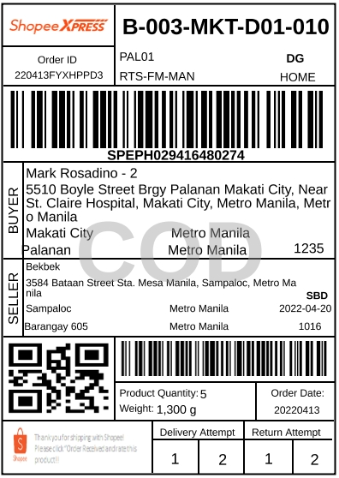

NO.**1** ORDER ID:**220413FYXHPPD3**

|  |  |  |  |
| --- | --- | --- | --- |
| **SKU/NAME** | **VARIATION** | **U PRICE** | **QTY** |
| **[1] Hotdog Pillowcase Canad...** | **Adventure monstera,(L)Hotdo...** | **Php79** | **1** |
| **[2] Bargain Murang Bedsheet...** | **Cat yarn,1pc pillowcase** | **Php45** | **3** |
| **[3] Bargain Murang Bedsheet...** | **Cat yarn,Single bedsheet** | **Php130** | **1** |

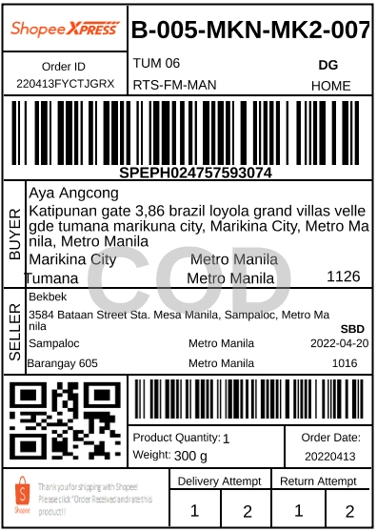

NO.**2** ORDER ID:**220413FYCTJGRX**

|  |  |  |  |
| --- | --- | --- | --- |
| **SKU/NAME** | **VARIATION** | **U PRICE** | **QTY** |
| **[1] Bargain Murang Single B...** | **Victorian violet,Single Bed...** | **Php130** | **1** |

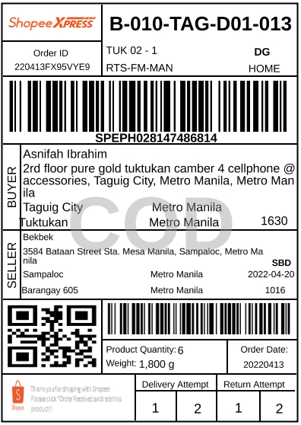

NO.**3** ORDER ID:**220413FX95VYE9**

|  |  |  |  |
| --- | --- | --- | --- |
| **SKU/NAME** | **VARIATION** | **U PRICE** | **QTY** |
| **[1] Bargain Murang Single B...** | **Victorian violet,1pc pillow...** | **Php45** | **2** |
| **[2] Bargain Murang Single B...** | **Victorian violet,Single Bed...** | **Php130** | **1** |
| **[3] Bargain Murang Single B...** | **Victorian brown,1pc pillowcase** | **Php45** | **2** |
| **[4] Bargain Murang Single B...** | **Victorian brown,Single Beds...** | **Php135** | **1** |

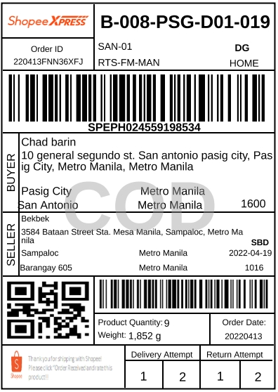

NO.**4** ORDER ID:**220413FNN36XFJ**

|  |  |  |  |
| --- | --- | --- | --- |
| **SKU/NAME** | **VARIATION** | **U PRICE** | **QTY** |
| **[1] Baby Prints Pillowcase ...** | **Peppa pig** | **Php40** | **1** |
| **[2] Baby Prints Pillowcase ...** | **Toy story** | **Php35** | **1** |
| **[3] Bargain Pillowcase with...** | **Shorty Blue lines,16x26** | **Php35** | **3** |
| **[4] Bargain Pillowcase with...** | **Jasmine Blue,16x26** | **Php35** | **2** |
| **[5] Bargain Murang Single B...** | **Sampague blue,Single Bedsheet** | **Php135** | **1** |
| **[6] Bargain Murang Bedsheet...** | **Blue gold triangle,Single b...** | **Php125** | **1** |

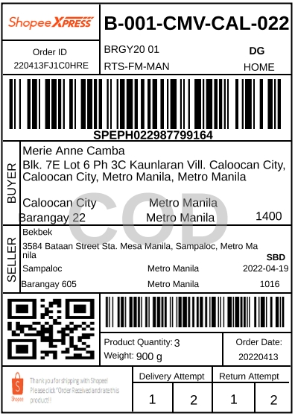

NO.**5** ORDER ID:**220413FJ1C0HRE**

|  |  |  |  |
| --- | --- | --- | --- |
| **SKU/NAME** | **VARIATION** | **U PRICE** | **QTY** |
| **[1] Bargain Murang Bedsheet...** | **Happy rabbit,Single bedsheet** | **Php130** | **1** |
| **[2] Bargain Murang Bedsheet...** | **Happy rabbit,1pc pillowcase** | **Php45** | **2** |

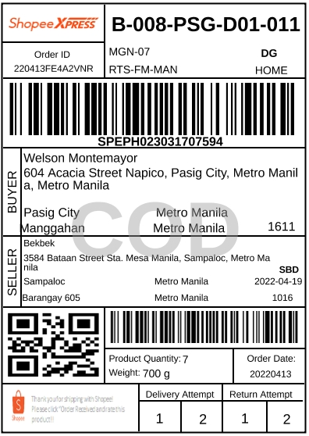

NO.**6** ORDER ID:**220413FE4A2VNR**

|  |  |  |  |
| --- | --- | --- | --- |
| **SKU/NAME** | **VARIATION** | **U PRICE** | **QTY** |
| **[1] Shorts Pambahay for Men...** | **Mens Stripes** | **Php37** | **7** |



NO.**7** ORDER ID:**220413FD6S7BXS**

|  |  |  |  |
| --- | --- | --- | --- |
| **SKU/NAME** | **VARIATION** | **U PRICE** | **QTY** |
| **[1] Lababo Curtain / Kitche...** | **Moroccan blue,Lababo Curtai...** | **Php55** | **2** |

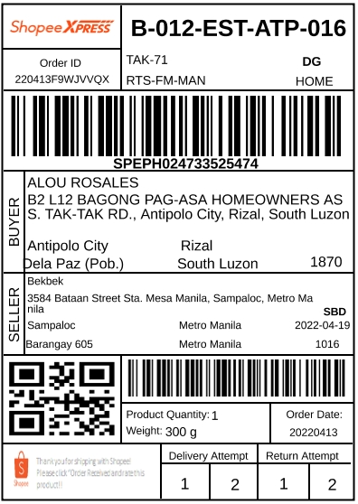

NO.**8** ORDER ID:**220413F9WJVVQX**

|  |  |  |  |
| --- | --- | --- | --- |
| **SKU/NAME** | **VARIATION** | **U PRICE** | **QTY** |
| **[1] Bargain Murang Bedsheet...** | **Silver feather,Single bedsheet** | **Php130** | **1** |



NO.**9** ORDER ID:**220413F2EQSY5B**

|  |  |  |  |
| --- | --- | --- | --- |
| **SKU/NAME** | **VARIATION** | **U PRICE** | **QTY** |
| **[1] Lababo Curtain / Kitche...** | **Sunflower black,Lababo Curt...** | **Php55** | **3** |

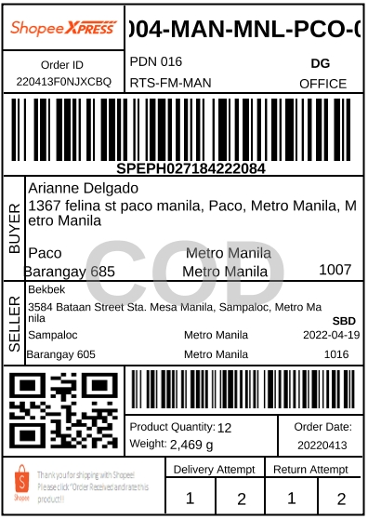

NO.**10** ORDER ID:**220413F0NJXCBQ**

|  |  |  |  |
| --- | --- | --- | --- |
| **SKU/NAME** | **VARIATION** | **U PRICE** | **QTY** |
| **[1] Bargain Pillowcase with...** | **Hanji,16x26** | **Php35** | **6** |
| **[2] Bargain Murang Single B...** | **Granite green dots,Single B...** | **Php135** | **6** |

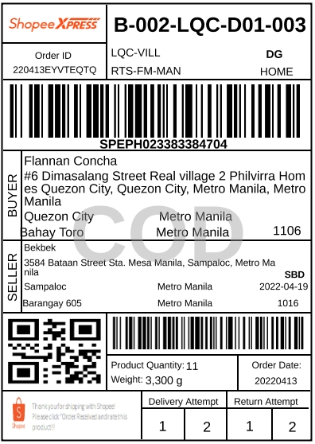

NO.**11** ORDER ID:**220413EYVTEQTQ**

|  |  |  |  |
| --- | --- | --- | --- |
| **SKU/NAME** | **VARIATION** | **U PRICE** | **QTY** |
| **[1] Bargain Murang Single B...** | **Second ocean,Single Bedsheet** | **Php135** | **1** |
| **[2] Bargain Murang Single B...** | **Lemon tree,Single Bedsheet** | **Php135** | **1** |
| **[3] Bargain Murang Single B...** | **1 pink laurel,Single Bedsheet** | **Php135** | **1** |
| **[4] Bargain Murang Single B...** | **Blue gold triangles,Single ...** | **Php135** | **1** |
| **[5] Bargain Murang Single B...** | **Silver feather,Single Bedsheet** | **Php135** | **1** |
| **[6] Bargain Murang Single B...** | **Blue flamingo,Single Bedsheet** | **Php135** | **1** |
| **[7] Bargain Murang Single B...** | **Colorful fences,Single Beds...** | **Php135** | **1** |
| **[8] Bargain Murang Single B...** | **Sage and brown,Single Bedsheet** | **Php135** | **1** |
| **[9] Bargain Murang Single B...** | **Lyrebird,Single Bedsheet** | **Php135** | **1** |
| **[10] Bargain Murang Bedshee...** | **Peach banana leaf,Single be...** | **Php125** | **1** |
| **[11] Bargain Murang Bedshee...** | **Tiger lily blue,Single beds...** | **Php125** | **1** |



NO.**12** ORDER ID:**220413EXTX31GA**

|  |  |  |  |
| --- | --- | --- | --- |
| **SKU/NAME** | **VARIATION** | **U PRICE** | **QTY** |
| **[1] Lababo Curtain / Kitche...** | **Lily gray,Lababo Curtain (55)** | **Php55** | **1** |
| **[2] Lababo Curtain / Kitche...** | **Lily red,Lababo Curtain (55)** | **Php55** | **1** |



NO.**13** ORDER ID:**220413EUXU0ES3**

|  |  |  |  |
| --- | --- | --- | --- |
| **SKU/NAME** | **VARIATION** | **U PRICE** | **QTY** |
| **[1] Large to XL Pillowcase ...** | **Secret garden** | **Php45** | **2** |
| **[2] Large to XL Pillowcase ...** | **Feather white** | **Php55** | **1** |
| **[3] Large to XL Pillowcase ...** | **Lunar party** | **Php45** | **2** |
| **[4] Random Bargain Pillow c...** | **18x28** | **Php25** | **8** |
| **[5] Hugger Body Pillow Pill...** | **Seller Picks Design,1x Hugg...** | **Php80** | **1** |
| **[6] Bargain Murang Bedsheet...** | **Nacho,Single bedsheet** | **Php125** | **1** |
| **[7] Bargain Murang Bedsheet...** | **Tiger lily blue,Single beds...** | **Php125** | **1** |
| **[8] Bargain Murang Bedsheet...** | **White circles n dots,Single...** | **Php125** | **1** |



NO.**14** ORDER ID:**220413EUEYU84V**

|  |  |  |  |
| --- | --- | --- | --- |
| **SKU/NAME** | **VARIATION** | **U PRICE** | **QTY** |
| **[1] Bargain Murang Single B...** | **Green keep,Single Bedsheet** | **Php135** | **1** |

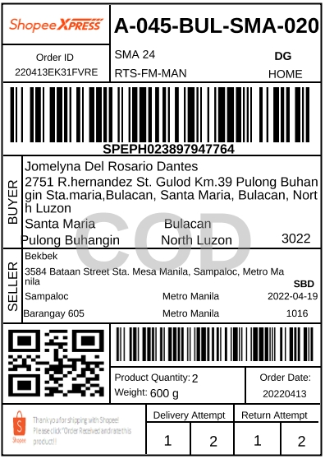

NO.**15** ORDER ID:**220413EK31FVRE**

|  |  |  |  |
| --- | --- | --- | --- |
| **SKU/NAME** | **VARIATION** | **U PRICE** | **QTY** |
| **[1] Bargain Murang Single B...** | **Silver feather,Single Bedsheet** | **Php135** | **2** |

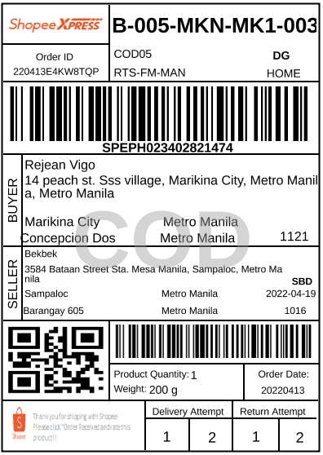

NO.**16** ORDER ID:**220413E4KW8TQP**

|  |  |  |  |
| --- | --- | --- | --- |
| **SKU/NAME** | **VARIATION** | **U PRICE** | **QTY** |
| **[1] Bargain Lababo Curtain ...** | **Lilac pine leaves,Kitchen C...** | **Php40** | **1** |

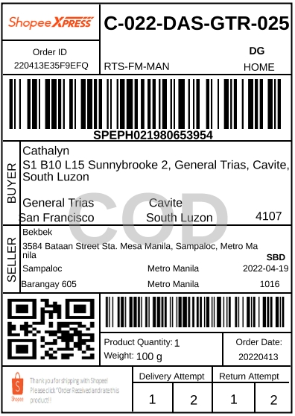

NO.**17** ORDER ID:**220413E35F9EFQ**

|  |  |  |  |
| --- | --- | --- | --- |
| **SKU/NAME** | **VARIATION** | **U PRICE** | **QTY** |
| **[1] Lababo Curtain / Kitche...** | **Lily blue,Lababo Curtain (55)** | **Php55** | **1** |

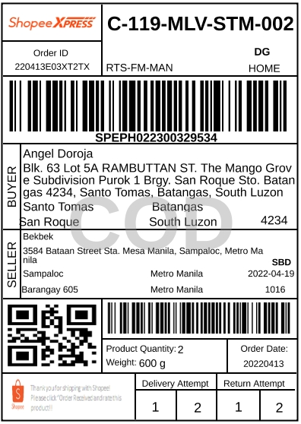

NO.**18** ORDER ID:**220413E03XT2TX**

|  |  |  |  |
| --- | --- | --- | --- |
| **SKU/NAME** | **VARIATION** | **U PRICE** | **QTY** |
| **[1] Bargain Murang Single B...** | **Blue flamingo,Single Bedsheet** | **Php130** | **1** |
| **[2] Bargain Murang Single B...** | **Boston green gold,Single Be...** | **Php130** | **1** |

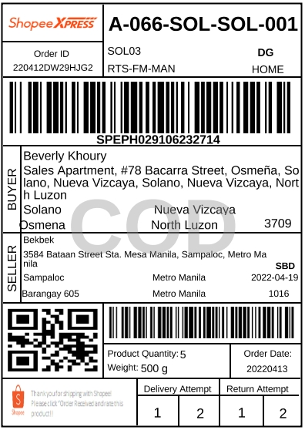

NO.**19** ORDER ID:**220412DW29HJG2**

|  |  |  |  |
| --- | --- | --- | --- |
| **SKU/NAME** | **VARIATION** | **U PRICE** | **QTY** |
| **[1] Pambahay Shorts for men...** | **Shorts - Stripes** | **Php42** | **2** |
| **[2] Cotton Pambahay Shorts ...** | **Cotton Shorts 45** | **Php45** | **3** |



NO.**20** ORDER ID:**220412DUCH5P6S**

|  |  |  |  |
| --- | --- | --- | --- |
| **SKU/NAME** | **VARIATION** | **U PRICE** | **QTY** |
| **[1] Cotton Pambahay Shorts ...** | **Cotton Shorts 45** | **Php45** | **6** |

**BUYER'S COMMENT:*Hello po. Madamk nadin po ako naorder sa shop nyo in the past few years. Sana po new tela yung magamit dito sa orders ko para po di same same lahat ng shorts ni mister. Pakipack din po ng maayos and pakidouble check na maayos po yung tahi.***

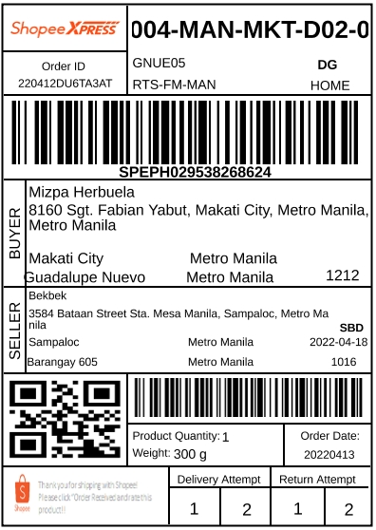

NO.**21** ORDER ID:**220412DU6TA3AT**

|  |  |  |  |
| --- | --- | --- | --- |
| **SKU/NAME** | **VARIATION** | **U PRICE** | **QTY** |
| **[1] Bargain Murang Bedsheet...** | **Candy flowers,Single bedsheet** | **Php130** | **1** |

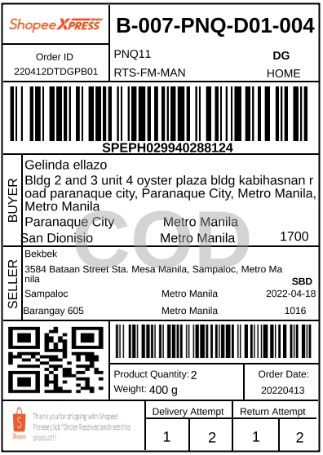

NO.**22** ORDER ID:**220412DTDGPB01**

|  |  |  |  |
| --- | --- | --- | --- |
| **SKU/NAME** | **VARIATION** | **U PRICE** | **QTY** |
| **[1] Bargain Lababo Curtain ...** | **Diamond bnw,Kitchen Curtain** | **Php40** | **2** |

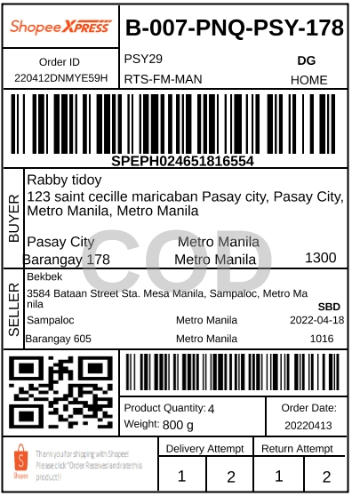

NO.**23** ORDER ID:**220412DNMYE59H**

|  |  |  |  |
| --- | --- | --- | --- |
| **SKU/NAME** | **VARIATION** | **U PRICE** | **QTY** |
| **[1] Bargain Lababo Curtain ...** | **Paint splash,Kitchen Curtain** | **Php40** | **4** |



NO.**24** ORDER ID:**220412DN1XD9NB**

|  |  |  |  |
| --- | --- | --- | --- |
| **SKU/NAME** | **VARIATION** | **U PRICE** | **QTY** |
| **[1] Bargain Murang Bedsheet...** | **Blue gray slant,Single beds...** | **Php120** | **1** |
| **[2] Bargain Murang Bedsheet...** | **Blue gray slant,1pc pillowcase** | **Php35** | **2** |



NO.**25** ORDER ID:**220412DMDUP5EV**

|  |  |  |  |
| --- | --- | --- | --- |
| **SKU/NAME** | **VARIATION** | **U PRICE** | **QTY** |
| **[1] Bargain Murang Single B...** | **Doraemon,Single Bedsheet** | **Php130** | **1** |
| **[2] Bargain Murang Single B...** | **Mighty pups,Single Bedsheet** | **Php120** | **1** |

**SELLER'S NOTE:*Sana po maayos at wala pong damage ☺️***

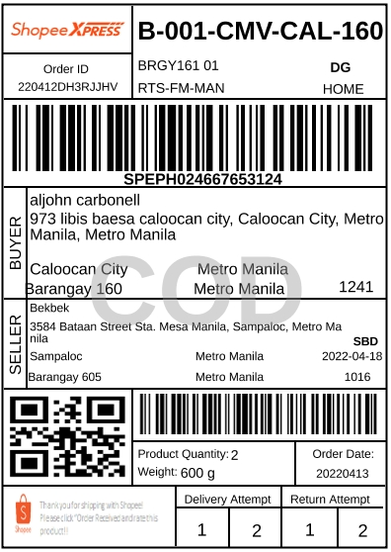

NO.**26** ORDER ID:**220412DH3RJJHV**

|  |  |  |  |
| --- | --- | --- | --- |
| **SKU/NAME** | **VARIATION** | **U PRICE** | **QTY** |
| **[1] Bargain Murang Bedsheet...** | **Blue gold triangle,Single b...** | **Php120** | **1** |
| **[2] Bargain Murang Bedsheet...** | **Tiger lily blue,Single beds...** | **Php120** | **1** |

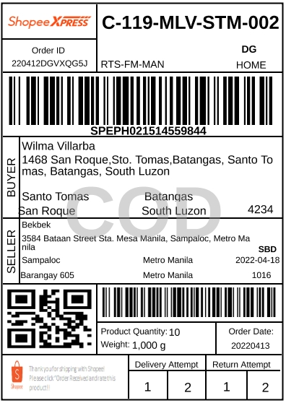

NO.**27** ORDER ID:**220412DGVXQG5J**

|  |  |  |  |
| --- | --- | --- | --- |
| **SKU/NAME** | **VARIATION** | **U PRICE** | **QTY** |
| **[1] Lababo Curtain / Kitche...** | **Moroccan green,Lababo Curta...** | **Php55** | **10** |

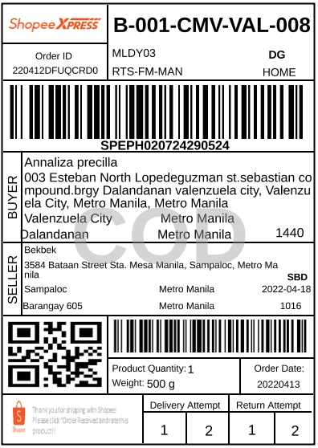

NO.**28** ORDER ID:**220412DFUQCRD0**

|  |  |  |  |
| --- | --- | --- | --- |
| **SKU/NAME** | **VARIATION** | **U PRICE** | **QTY** |
| **[1] Bargain Murang Queen Be...** | **Notre dame,Queen 60x75** | **Php225** | **1** |