Most common/top places in Toronto for Tourist attraction

Haris A. Qureshi

March 4th, 2020

1. INTRODUCTION

1.1 Background
It is no doubt that any tourist when comes to a new country is puzzled with the thought of where to proceed and where to go from the airport, or what places must be visited on their visit to a new country. It is very difficult for them to get in touch with the locals and get suggestions from them because their suggestion may be limited to their taste.

1.2 Problem statement and solution
Due to this, the problem for tourist place visits is solved using Foursquare API to provide them with the data of top places for them to visit. The scope of this project is limited to Toronto.

2. DATA

The data to be used is places in Toronto, including Beaches, Parks, Cafes, etc. The dataset to be used is from the Wikipedia page which was redirected in the course module of week 3.

3. METHODOLOGY

Pandas library was used head to head to clean and structure the dataset which was collected from the Wiki page. Then after structuring the data in a Pandas DataFrame, Foursquare API was used to get the data about reviews and visits on certain places in a specified radius of 500 meters from the Toronto.

The categories of places were then used to further specify which of them have famous places among them. The categories are shown as below;

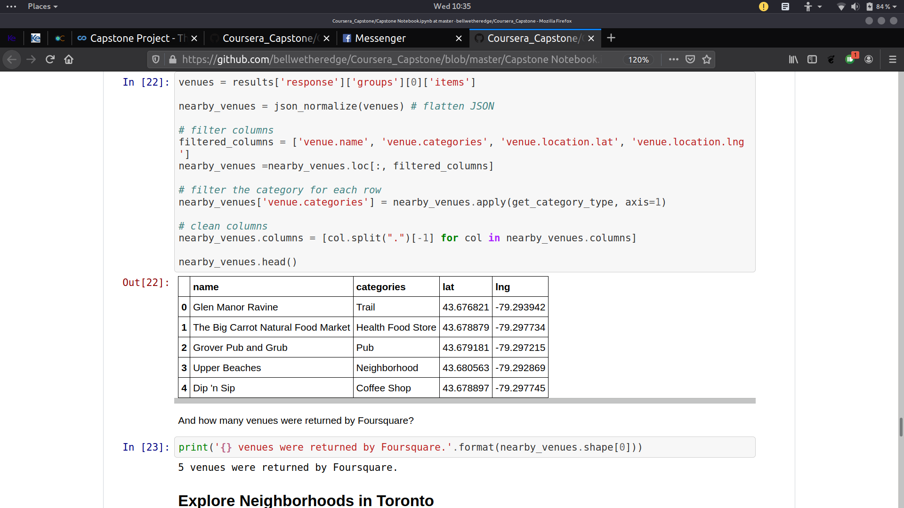

Neighborhoods were then explored in these categories to see which places are in those neighborhoods. After finding the neighborhoods, frequency was calculated to measure certain score for a specific place.

4. RESULTS

The top 5 venues were calculated from the given categories;
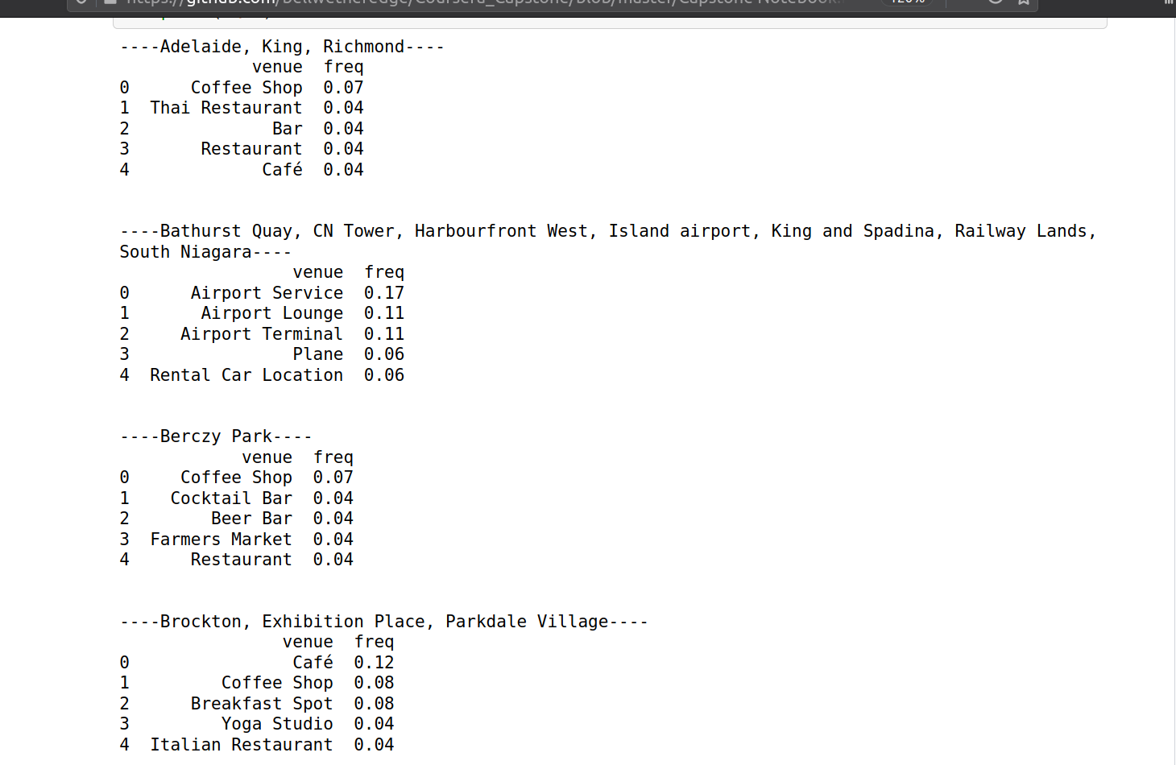

Then they were structured in a proper dataframe with the most common one first in that neighborhood;

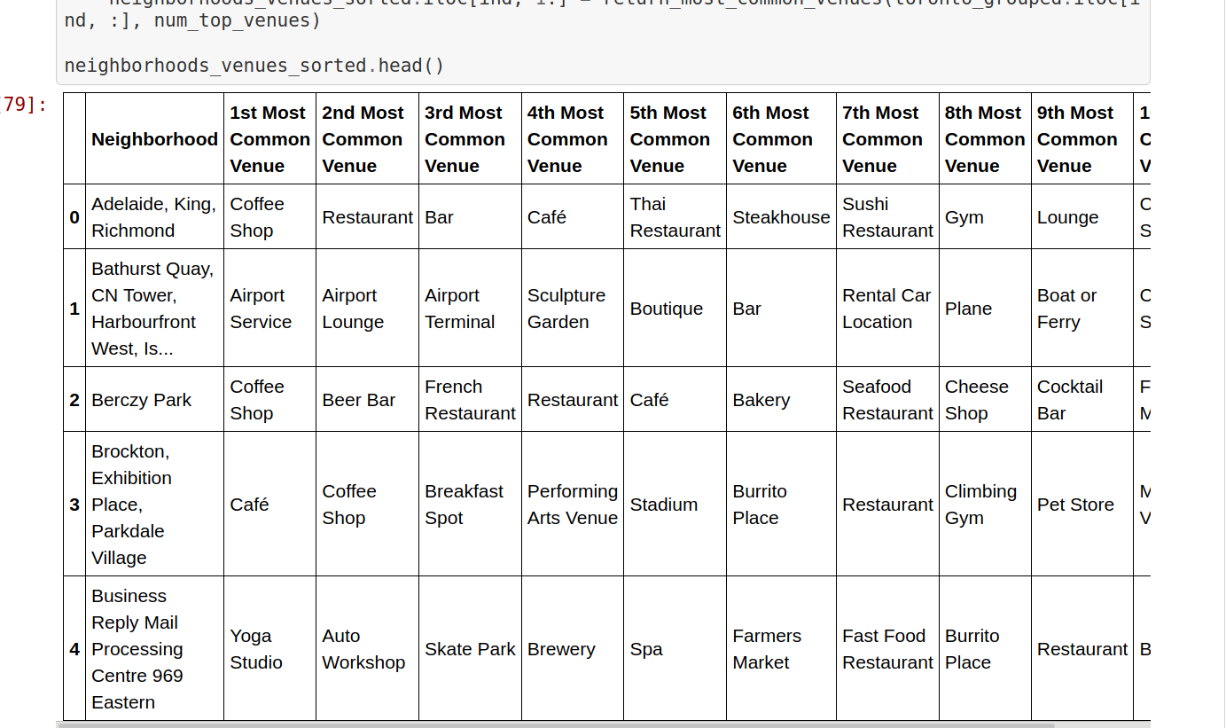

5. DISCUSSION

The scope of this project was limited to the Toronto, and further machine learning techniques could be used to find more insights on the relationships between certain places.

6. CONCLUSION

It can be concluded that certain areas and most of them had Cafes and Coffee shops as the most common place for attraction. Tourists may tend to visit them to grab a cup of coffee and snacks on their long run.

