## Introduction to Information and Communication Technology

**CSL-110**

# Bahria Logo

Project Report

**Kaif Qureshi | 02-235222-013**

**Bilal Masroor | 02-235222-034**

**Zonish Ahmed | 02-235222-022**

## DEPARTMENT OF COMPUTER SCIENCE

BAHRIA UNIVERSITY KARACHI, PAKISTAN

**BAHRIA UNIVERSITY KARACHI CAMPUS**

**Department Of Computer Science**

### Table of Contents

|  |  |  |
| --- | --- | --- |
| **No.** | **Project Report** | **Page no.** |
| 1 | Introduction | 3 |
| 2 | System Design | 5 |
| 3 | Hardware and software requirements | 6 |
| 4 | Implementing tools for the project | 7 |
| 5 | Project Model view | 8 |
| 6 | Conclusion & Future Enhancement | 10 |

#### **Introduction**

##### Overview

The front-end website for buying laptops is a platform that allows users to browse and purchase laptops online. The website has a clean and user-friendly design, making it easy for users to navigate and find the information they need. The website features a homepage that includes a section for the most popular brands, and a section for the most watched reviews. The product page includes detailed information about the laptop, including specifications, images. There is also an "Add to cart" button for easy purchasing, and a back button for easy navigation. The website also has a contact page which includes a contact form for customers to reach out to the business. The website is built using HTML, CSS. The website is fully functional and has been tested on multiple devices and browsers to ensure that it works as intended.

##### Background Study

E-commerce offers several benefits for both consumers and businesses. For consumers, shopping for laptops online provides convenience and a wider selection of options. They can easily compare prices and features of different laptops, and can make a purchase from the comfort of their own home. For businesses, e-commerce through a website allows for a wider reach of customers, as the website can be accessed by anyone with an internet connection. It also allows for a more efficient sales process and can save on overhead costs associated with maintaining a physical store. Overall, e-commerce provides a mutually beneficial solution for both consumers and businesses. It offers convenience, selection, and cost savings for consumers and a wider reach, efficient sales process and data-driven decision making for businesses

##### Project Planning

Project planning is a crucial step in the project management process. It involves defining the objectives, scope, and deliverables of a project, as well as outlining the resources, timelines, and budgets required to achieve them. Project planning is essential for ensuring that a project is completed on time, within budget, and to the satisfaction of stakeholders. A well-designed project plan serves as a roadmap for the project team and stakeholders, providing a clear understanding of the project's goals, milestones, and deliverables. It is also used to identify potential risks and to develop strategies for justifying them.

##### Purpose

The purpose of creating a front-end website for laptops is to provide customers with an easy and convenient way to browse, research, and purchase laptops online. The website will aim to provide a seamless and user-friendly interface that allows customers to quickly find the laptops that meet their needs and preferences, such as brand, model, and price range. The website will also be designed to provide detailed information on the laptops' specifications and features, to help customers make informed purchasing decisions. The website will also provide a contact form for customers to get support and assistance in case of any issues. Overall, the purpose of the website is to provide a one-stop-shop for customers to buy laptops online, making the process of buying laptops easy and efficient.

* 1. **Objectives**
* To provide customers with an easy-to-use and visually appealing interface for browsing and researching laptops.
* To offer a wide range of laptops from different brands and manufacturers, with detailed information on each product's specifications and features.
* To enable customers to easily compare prices and features of different laptops to make informed purchasing decisions.
* To offer a customer service channel for customers to get support and assistance with their purchases.
* To regularly update and maintain the website to ensure that all information is accurate, up-to-date, and secure.
* To use the website as a marketing channel to promote new products, sales, and discounts.
* To increase brand awareness and customer loyalty.
* To increase online sales revenue and market share.

#### **System Design**

* 1. **Design**

This website is divided into four parts that includes a Home Page, About Page, Contact Page, and Product Page.

###### Website Information

This website is an E commerce store where users can place orders online. The website has the following advantages:

* User friendly interface
* Easy navigation
* Fast access to website

###### Website Analysis

Website analysis is an important aspect of any website development project, as it helps to identify the strengths and weaknesses of the current website and provides valuable insights into how it can be improved. A comprehensive website analysis should include several key elements, including:

* User experience (UX) analysis
* Technical analysis
* Content analysis
  1. **Feasibility Analysis**

Feasibility analysis is an important step in evaluating the potential success of a website development project. A feasibility analysis should consider several key factors, including technical feasibility.

* 1. **Technical Feasibility**

The website we designed is technically feasible as there will be no difficulty in getting required resources for the development and maintaining the website as well. All the resources needed for the development of the website as well as the maintenance are feasible.

**Hardware and Software Requirement**

##### Hardware Required

##### Processor: Pentium IV or Above

##### RAM : 1GB or above

##### Hard Disk: 32GB or above

##### Input Devices: Keyboard, Mouse

##### Output Devices: Monitor

##### Software Required

##### Operating System: Mac, Windows XP, 7, 8, 8.1, 10, 11

##### Frontend: HTML, CSS.

##### Backend: N/A.

##### Local host: N/A.

### Implementing Tools for the Project

##### Tools

* + - HTML
    - CSS

##### HTML

Every webpage you look at is written in a language called HTML. You can think of HTML as the structure of every website. In this course, we'll use HTML to add paragraphs, headings, images and links to a webpage.

HTML is a fundamental building block of the World Wide Web and is used in conjunction with other technologies such as CSS and JavaScript to create interactive and dynamic web pages. It's also a simple and easy to learn language that makes it a great choice for beginners to start learning web development.

##### CSS

CSS (Cascading Style Sheets) is a language used to control the presentation and layout of web pages. It is used in conjunction with HTML to create visually appealing and well-designed web pages. With CSS, developers can control the colors, fonts, spacing, and overall layout of web pages, creating a consistent look and feel across a website.

CSS uses selectors and rules to apply styles to HTML elements. Selectors are used to target specific HTML elements and rules define the styles that should be applied to those elements. For example, a rule could be written to change the background color of all headings on a web page, or to increase the font size of all links.

### Project Model View

##### Home Page

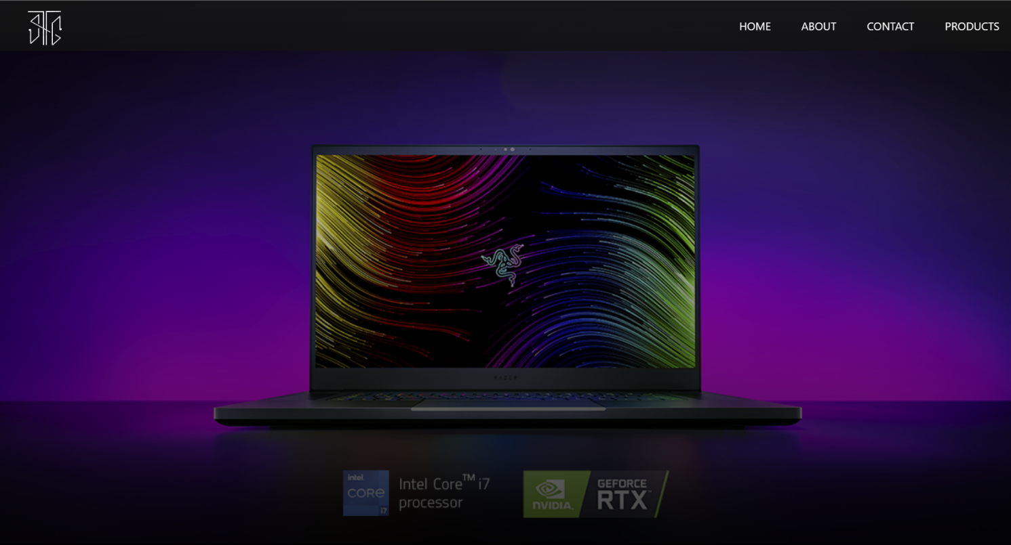

* 1. **Product Page**

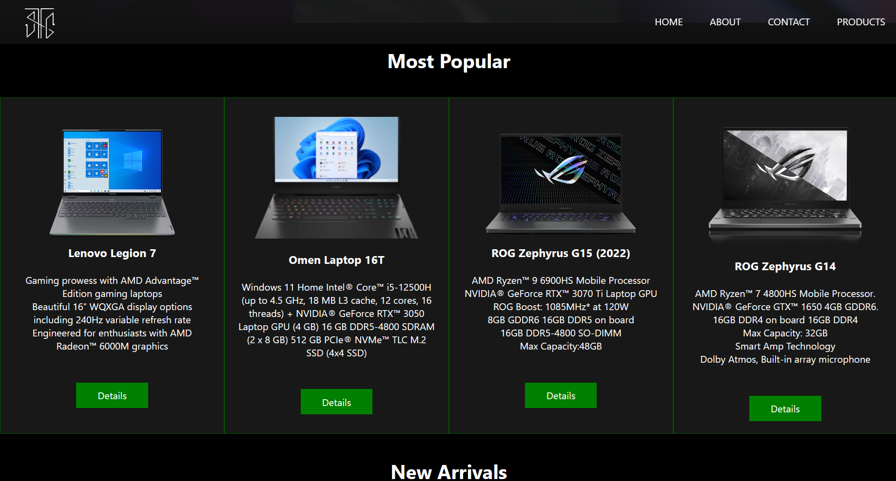

* 1. **About page**

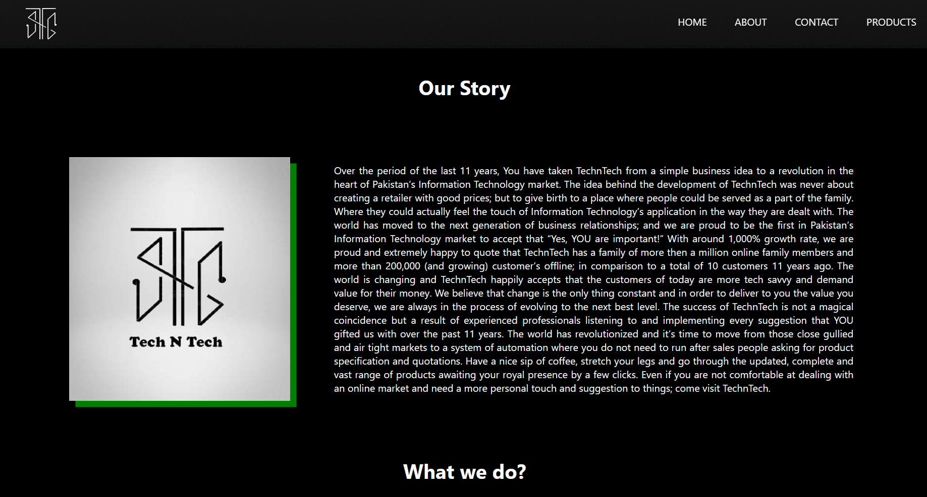

* 1. **Contact page**

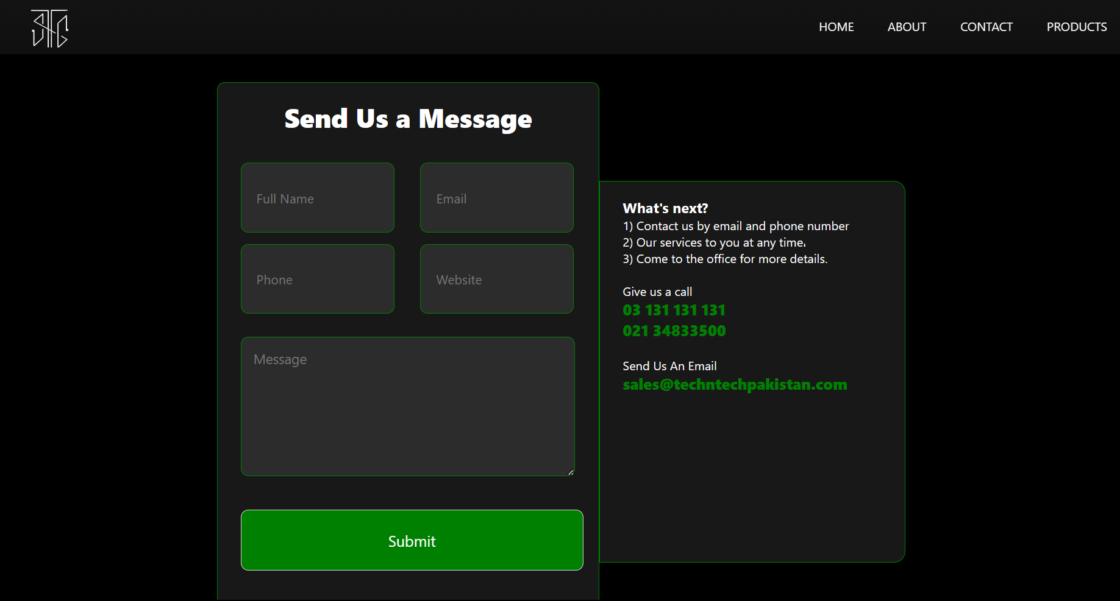

### Conclusion & Future Enhancement

##### Conclusion

In conclusion, this website is a comprehensive platform that allows users to easily browse and purchase laptops online. It has a clean and user-friendly design, making it easy for users to navigate and find the information they need. It features a homepage, product page, about page, and contact page that provide a seamless and efficient shopping experience for the users. The website's design is optimized for easy navigation and the layout is simple and easy to understand. The website is built using HTML and CSS. In summary our website is user-friendly that provides an efficient shopping experience for the users. It's ready to be deployed for the business to use, and can be expected to improve the customer's shopping experience and increase sales.

##### Future aspect

The project has a very vast scope in future. The project can be implemented on internet using a hosting and a domain. In future, this project can be updated to improve its performance and to improve its efficiency.

The following are the future scope for the project.

* Should be added payment gateway so that users can pay directly through the website
* Website can be made responsive using JavaScript functions and JQuery.
* Should be added a Login Management System so users can create their own profile.
* Should be added multilingual support to the site
* And many features can be added this project to make it more robust.