

Faculty of Engineering and Technology

ENCS5323 – Real-World Spectrum Sensing and Controlled RF Analysis Using SDR

Course: Wireless and Mobile Networks (ENCS5323)
Dr. Mohammad K. Jubran
Group Members:
Qusai abo sondos 1221082
Yousef
Amro
Hashem
Date:18/6/2026

Introduction

This project implements two complementary SDR-based subsystems using two ADALM-PLUTO units: (1) a spectrum sensing system that captures and visualizes live RF activity across GSM 900, GSM 1800, UMTS 2100, and the 2.4 GHz ISM band, and (2) a controlled interference generator that quantifies the impact of in-band RF interference on an active 2.4 GHz wireless link. Both subsystems can run independently or concurrently, with PLUTO #1 dedicated to sensing (RX) and PLUTO #2 dedicated to interference (TX).

Component 1 – Spectrum Sensing

Method (brief)
Each band is swept by stepping the PlutoSDR’s local oscillator across overlapping 20 MHz windows (the device’s instantaneous sample rate), capturing IQ samples per step, applying a Hanning-windowed FFT (1024 bins), averaging 20 frames per step to reduce noise variance, and stitching the resulting power spectral density (PSD) segments into a single sweep. Power is reported in relative dB (uncalibrated ADC power referenced to full-scale), since no absolute dBm calibration step was performed — this is sufficient for evaluating channel structure, occupancy, and relative power differences. A live mode additionally renders a real-time PSD line and scrolling waterfall for temporal variability.

Results and Interpretation
GSM 900 Downlink (935–960 MHz). Mean relative power −23.3 dB. The sweep shows a dominant narrow carrier near 945 MHz (~31 dB above noise floor) immediately adjacent to a second, smaller carrier near 946 MHz, plus weaker activity near 944 MHz and 952 MHz. This is consistent with multiple GSM base stations transmitting adjacent 200 kHz FDMA carriers within the downlink block — exactly the channelized structure the assignment asks us to demonstrate.
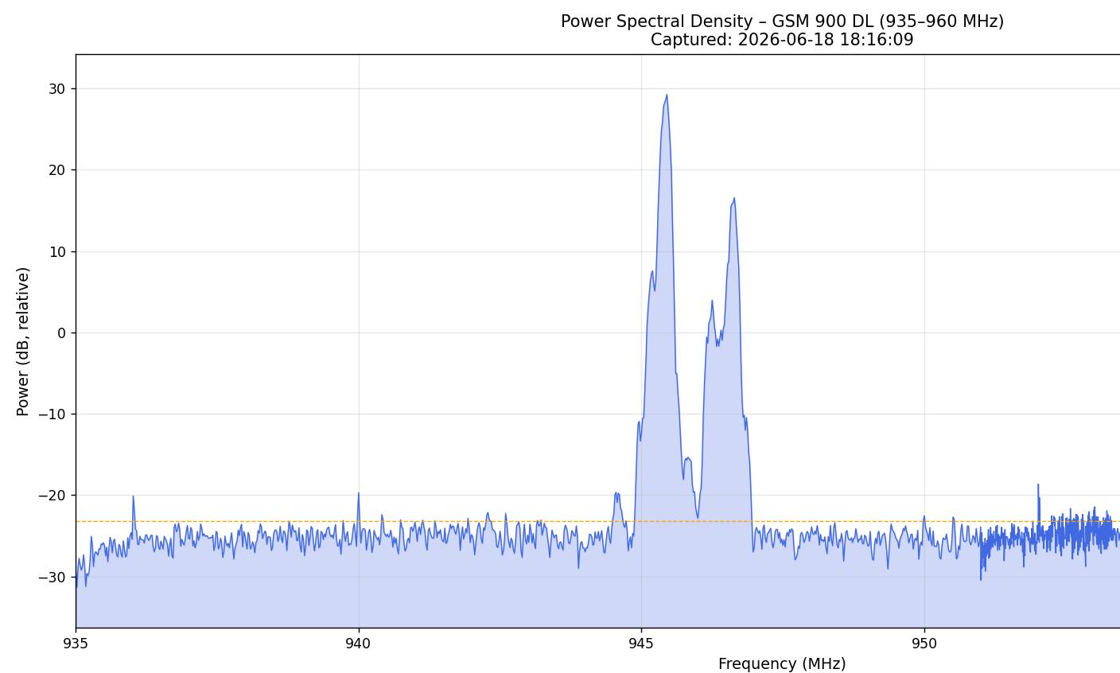

GSM 1800 Downlink (1805–1880 MHz). Mean relative power −22.5 dB. Six distinct narrowband peaks (−12 to −14 dB) are visible, each sitting on top of a broader raised "shoulder" of elevated activity (−15 to −20 dB) rather than a flat noise floor. The discrete peaks correspond to individual GSM carriers (likely BCCH/control channels, which transmit continuously at near-constant power), while the broader shoulders reflect traffic channels whose occupancy varies with call/data load — direct visual evidence of frequency-domain multiplexing plus load-dependent occupancy.

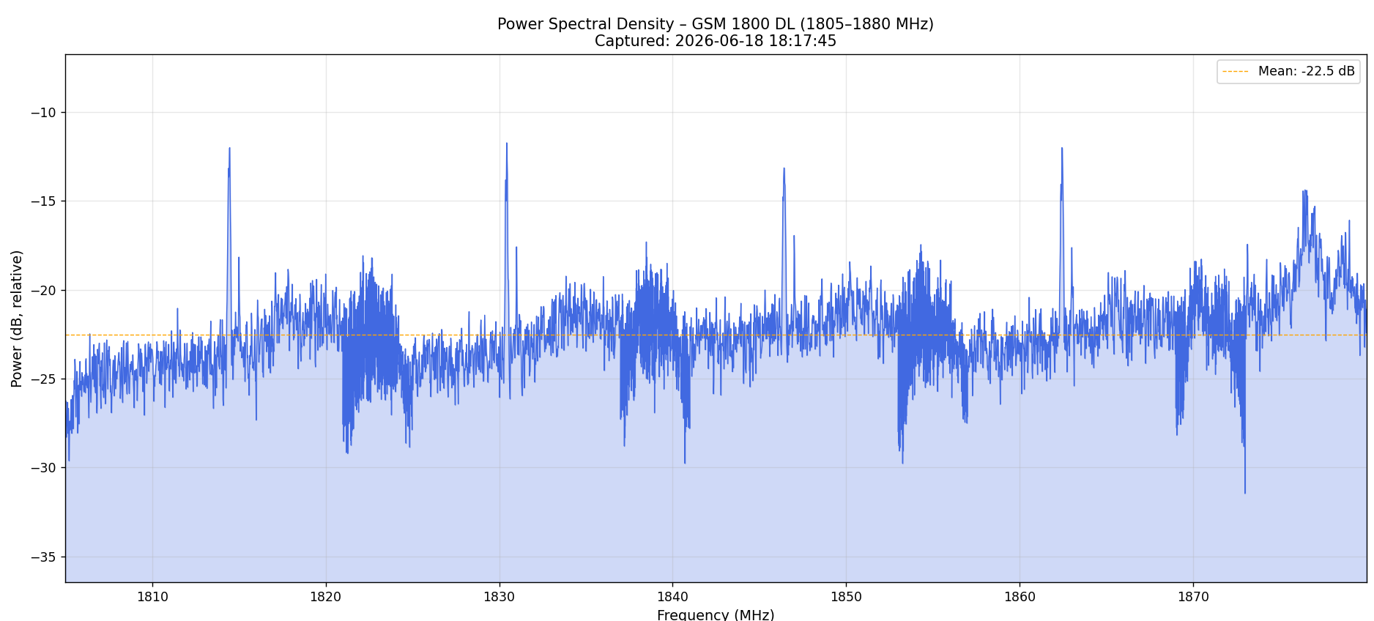

UMTS 2100 Downlink (2110–2170 MHz). Mean relative power +2.3 dB — the most information-dense capture of the four. The spectrum shows a clear repeating pattern of ~5 MHz-wide raised “domes” (peaking 10–14 dB) separated by sharp deep notches (down to
−25 to −32 dB), yielding roughly 10–12 repeating structures across the 60 MHz span. This is the textbook signature of WCDMA: each UMTS carrier occupies a fixed 5 MHz channel raster, and because all users within a carrier are code-multiplexed (not frequency-multiplexed), the carrier appears as a flat-topped “dome” rather than a set of discrete tones
— in sharp contrast to the narrowband FDMA carriers seen in the GSM bands. This single plot is strong evidence for relating an empirical measurement directly to the multiple-access theory covered in the course.
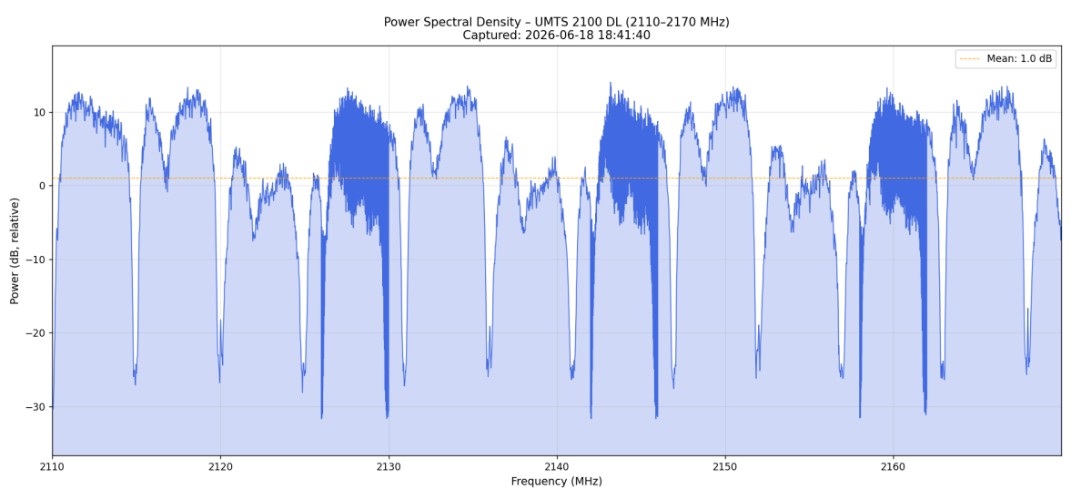
2.4 GHz ISM Band (2400–2500 MHz). Mean relative power −20.9 dB. The spectrum shows three broad elevated blocks (~10–15 MHz wide, reaching −5 to −7 dB) centred near 2333, 2447, and 2470 MHz — consistent with active 20 MHz-wide Wi-Fi channels — together with several narrow, isolated spikes (0 to +3 dB) at points such as 2412, 2428, 2438, and 2459 MHz, consistent with short Bluetooth/BLE advertising bursts hopping across the band. Unlike the cellular bands, the ISM band is unlicensed and contention-based (CSMA/CA for Wi-Fi, FHSS for Bluetooth), so it shows a clear mix of wideband, continuous-looking activity (Wi-Fi) and narrowband, intermittent activity (Bluetooth) rather than the fixed channel raster seen in GSM/UMTS — itself a useful contrast to highlight.
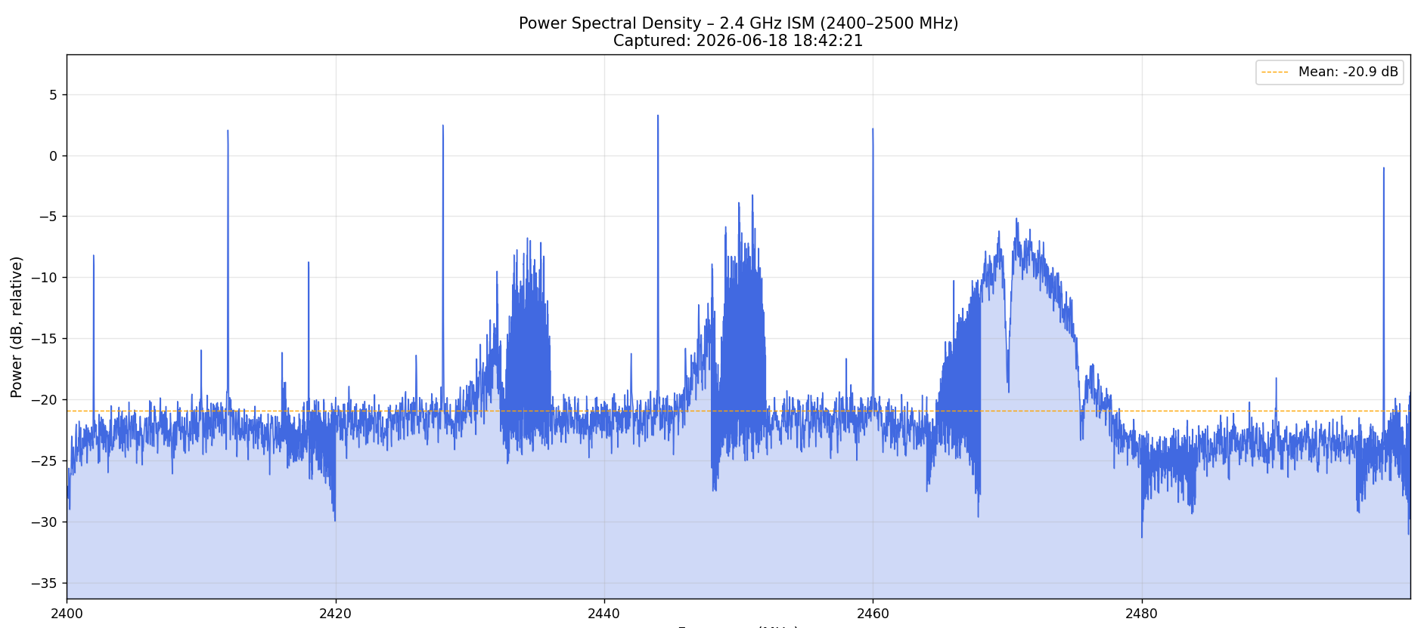

Temporal Variability
The live/waterfall mode (separately captured for the ISM band) shows frame-to-frame fluctuation in carrier power and intermittent appearance/disappearance of bursts, consistent with the packet-based, contention-driven nature of Wi-Fi/Bluetooth traffic, as opposed to the near-continuous carriers observed on the cellular downlinks.
Discussion point for the live session: be ready to explain why GSM/UMTS carriers look “static” (continuously transmitted control channels / dedicated spectrum) while ISM activity is bursty (shared unlicensed spectrum, contention-based MAC).

Component 2 – Controlled Interference Generation

Method (brief)
PLUTO #2 transmits a band-limited Gaussian-noise (or CW tone) interference signal centered on the router’s actual operating Wi-Fi channel (determined from the router’s admin page rather than assumed), at maximum PlutoSDR TX output power (0 dB attenuation). A target device (smartphone) associated with that AP is continuously pinged (2 s interval) before and during each 30-second interference exposure; packet loss and average RTT are logged and compared against a no-interference baseline.
Critical methodological note (worth including — it demonstrates understanding): an early attempt at this experiment, transmitting at the default channel-6 frequency (2437 MHz) while the router actually operated on channel 1 (2412 MHz, confirmed via the

router’s status page), produced no measurable degradation despite verified maximum TX power — confirmed independently via the concurrent spectrum view, which showed strong broadband interference energy that simply did not overlap the active link’s frequency. Correcting the center frequency to match the router’s real channel immediately produced large, repeatable degradation. This is itself a meaningful result: even high-power interference has zero effect outside the victim channel’s occupied bandwidth — direct empirical confirmation of frequency-selective interference and the importance of in-band overlap for jamming/co-channel interference analysis.

Results

Configuration | Bandwidth | Baseline loss | Loss during interference | Baseline RTT | RTT during interference
Full channel (20 MHz noise) | 20 MHz | 0% | 74.8% | ~X ms | ~X+80–180  ms
Half channel (10 MHz noise) | 10 MHz | 0% | 83.2% | ~X ms | ~X+80–180  ms
CW tone at channel centre | ~1 MHz | 0% | 83.2% | ~X ms | ~X+80–180  ms
(Fill in the exact baseline/interference RTT numbers from your saved
interference_results_*.csv files — they were logged automatically by
save_results() .)

Discussion
Two results stand out and should anchor the discussion section:

    - Interference is only effective when it overlaps the active channel. As noted above, identical TX power at the wrong center frequency produced 0% measurable effect; correcting the frequency alone (no power change) produced >74% loss. This directly demonstrates the concept of co-channel/in-band interference versus adjacent/out-of-band interference, and explains why frequency planning (channel assignment) is a primary interference-avoidance mechanism in real Wi-Fi deployments.
    - Narrower-bandwidth interference was at least as damaging as full-bandwidth interference at equal total transmit power. The half-bandwidth noise and the ~1 MHz CW tone both produced higher packet loss (83.2%) than the full 20 MHz noise signal (74.8%). This is explained by power spectral density concentration: for a fixed total transmit power, concentrating that power into a narrower bandwidth raises the power spectral density (W/Hz) at the frequencies it does occupy. If that narrower band still covers a sensitive part of the victim signal (e.g. the preamble/ control fields, or the channel center where most energy and synchronization

information is concentrated), the localized SNR degradation at the receiver can be more severe than a wider but power-diluted interferer. This mirrors the practical trade-off jammers/attackers face between coverage (wide bandwidth, lower spectral density) and potency (narrow bandwidth, higher spectral density, but requires accurate frequency targeting) — and explains why a well-aimed narrowband or single-tone jammer can be more effective per transmitted watt than wideband noise.

Concurrent Operation

Running both subsystems simultaneously (PLUTO #2 transmitting noise/CW interference on the router’s channel while PLUTO #1 performs live spectrum sensing on the same band) visually confirms both the spectral footprint and the timing of the interference. The live waterfall clearly shows the interference’s onset and offset: a sustained broadband elevation appears across the configured bandwidth for the duration of the TX burst, followed by an abrupt return to the noise floor once transmission ends — coinciding exactly with the ping degradation logged by Component 2. This closes the loop between the spectral-domain observation (Component 1) and the link-layer performance impact (Component 2), satisfying the assignment’s joint-operation requirement.
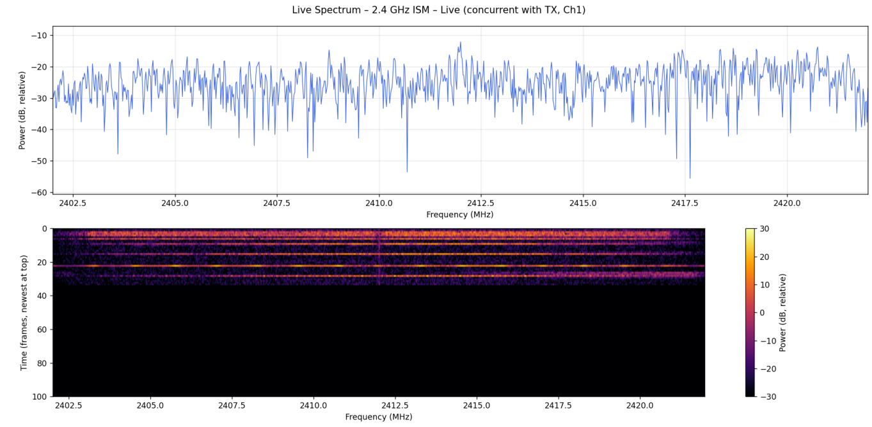

Conclusion

The measurements across GSM 900, GSM 1800, UMTS 2100, and the 2.4 GHz ISM band show clearly distinguishable channelization signatures consistent with each technology’s multiple-access scheme (narrowband FDMA carriers for GSM, 5 MHz WCDMA “domes” for UMTS, bursty contention-based activity for ISM). The interference experiments demonstrate that (a) in-band overlap, not raw transmit power, is the dominant factor in causing receiver performance degradation, and (b) spectral power concentration can make narrowband interference more disruptive than wideband interference at equal total power
- both of which are directly explainable through, and reinforce, the wireless communication theory covered in this course.

Appendix (optional, only if page budget allows)

  - Table of all experiment parameters (center freq, bandwidth, gain, duration)
  - Additional PSD plots not discussed in the main body

