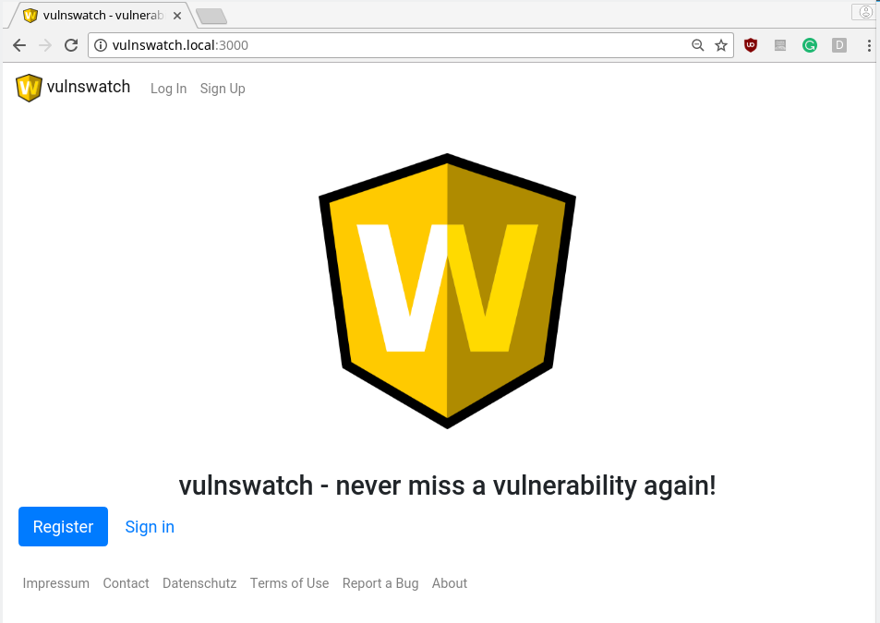

Vulnswatch lets you track the known and published vulnerabilities in third party components of your system. It works as a website for you.

Once you register, you have to provide a short description of your system under monitoring.
This description is called a project.
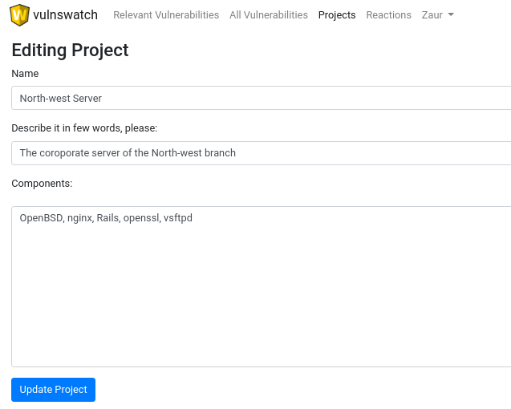

After the description is provided vulnswatch searches the database with CVEs and presents you with the findings.

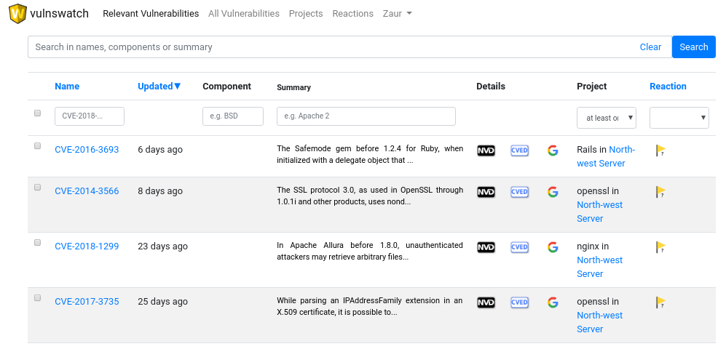
Next the user can research the vulnerabilities reading their summary or clicking one of the three icons in the Details column: NVD page, Cve Details page or google search about the CVE will show up.

Managing the findings comes next. In the Reaction column the user can specify what happens with the findings. This column tells if the findings are false positives, present a problem, are in an unknown, not yet researched state, Or indicate that the problem has been solved already.

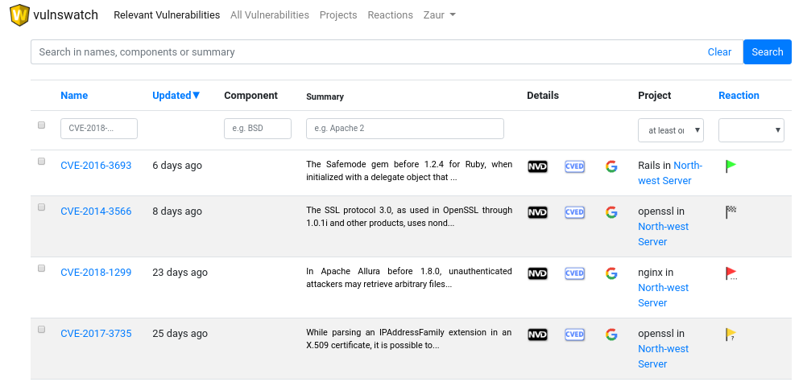

Like this we achieve the management of known and big vulnerabilities in third-party components of a system.
What is it good for?

- It can be used with any system: a server, a software project, a whole network of an organization…
- It allows management and tracking of vulnerabilities
- It does not require any coding skills or installing anything, e.g. Dependency Check is more precise, but is targeted for developers
- It allows for exchange between people on findings.

How to start using it?

- Vulnswatch is an open-source Ruby-on-Rails app
- Get it from my github including installation instructions for your organization:
https://github.com/qutorial/vulnswatch

