

**CCNA**

640-802

**Internetworking**



Revision no.: PPT/2K804/04

|  |
| --- |
| **© CMS INSTITUTE, 2004**. All rights reserved. No part of this material may be reproduced, stored or emailed without the prior permission. |

Revision no.: PPT/2K804/04

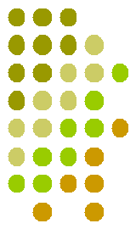

**Internetworking Basics**

* Breaking up a larger network into a number of smaller ones is called network segmentation, and it’s accomplished using routers, switches, and bridges.
* Possible causes of LAN traffic congestion are:
  + Too many hosts in a broadcast domain
  + Broadcast storms
  + Multicasting
  + Low bandwidth



|  |
| --- |
| **© CMS INSTITUTE, 2004**. All rights reserved. No part of this material may be reproduced, stored or emailed without the prior permission. |

Revision no.: PPT/2K804/04



**Internetworking Models**

* In 1977, the International Organization for standardization (ISO) created the Open Systems Interconnection (OSI) Reference Model.
* OSI Layer is meant for Networking manufacturers and developers to provide them a standard based on which they can make their products.
* All OSI Layers are independent from each other, which makes introducing changes easier as no other layers are effected.



|  |
| --- |
| **© CMS INSTITUTE, 2004**. All rights reserved. No part of this material may be reproduced, stored or emailed without the prior permission. |

Revision no.: PPT/2K804/04



**The Layered Approach**

* A reference model is a conceptual blueprint of how communications should take place. It addresses all the processes required for effective communication and divides these processes into logical groupings called layers
* When a communication system is designed in this manner, it’s known as layered architecture.



|  |
| --- |
| **© CMS INSTITUTE, 2004**. All rights reserved. No part of this material may be reproduced, stored or emailed without the prior permission. |

Revision no.: PPT/2K804/04



**Advantages of Reference Models**

* Advantages of using the OSI layered model include, but are not limited to, the following:
  + Allows multiple-vendor development through standardization of network components.
  + Allows various types of network hardware and software to communicate.
  + Prevents changes in one layer from affecting other layers, so it does not hamper development.



|  |
| --- |
| **© CMS INSTITUTE, 2004**. All rights reserved. No part of this material may be reproduced, stored or emailed without the prior permission. |

Revision no.: PPT/2K804/04



**The OSI Reference Model**

* The Seven Layers of OSI
  + Application Layer
  + Presentation Layer
  + Session Layer
  + Transport Layer
  + Network Layer
  + Datalink Layer
  + Physical Layer



|  |
| --- |
| **© CMS INSTITUTE, 2004**. All rights reserved. No part of this material may be reproduced, stored or emailed without the prior permission. |

Revision no.: PPT/2K804/04



**Application Layer**

* This is where users communicate to the computer.
* This is where communication between two users are established.
* This is a point where user or application interfaces with the protocols to gain access to the network.
* Examples are WWW, Telnet, FTP, TFTP, E-mail, SNMP, DNS



|  |
| --- |
| **© CMS INSTITUTE, 2004**. All rights reserved. No part of this material may be reproduced, stored or emailed without the prior permission. |

Revision no.: PPT/2K804/04



**Presentation Layer**

* Tasks like Translation, Encryption, decryption, compression, decompression are associated with this layer.
* It receives the data in native format & converts in standard format or receives data in standard format and converts in native format, i.e.. EBCDIC to ASCII.
* It is mainly responsible for how the data is to be presented to the Application Layer.
* Examples are PICT, TIFF, JPEG, MIDI, MPEG, GIFF etc.



|  |
| --- |
| **© CMS INSTITUTE, 2004**. All rights reserved. No part of this material may be reproduced, stored or emailed without the prior permission. |

Revision no.: PPT/2K804/04



**Presentation Layer (contd.)**

* Translation at Presentation Layer :
  + Bit - How many bits
  + Byte - Little Indent to Big Indent
  + Character - ASCII to EBCDIC
  + File Syntax - LFN to SFN
* Encryption at Presentation Layer
* Encryption means scrambling bits in order to provide security to data sent over the Network.
* Different Technology which is used for encryption are:
  + RSA
  + DSA



|  |
| --- |
| **© CMS INSTITUTE, 2004**. All rights reserved. No part of this material may be reproduced, stored or emailed without the prior permission. |

Revision no.: PPT/2K804/04



**Session Layer**

* The Session layer is responsible for setting up, managing, and then tearing down sessions between Presentation layer entities.
* It coordinates communication between systems, and serves to organize their communication by offering three different modes: simplex, half duplex, and full duplex.
* The Session layer basically keeps different applications’ data separate from other applications’ data.
* RPC, SQL, NFS and NetBIOS are examples of Session Layer.



|  |
| --- |
| **© CMS INSTITUTE, 2004**. All rights reserved. No part of this material may be reproduced, stored or emailed without the prior permission. |

Revision no.: PPT/2K804/04



**Transport Layer**

* Transport Layer never actually transports the data but only prepares for transporting.
* Uses Socket to define the services running on a particular node, the data is associated with.
* Responsible for the following :
  + Segmentation
  + End-to-end Communication
  + Flow Control
  + Error Control
  + Multiplexing of Applications
* TCP, UDP and SPX work at this layer



|  |
| --- |
| **© CMS INSTITUTE, 2004**. All rights reserved. No part of this material may be reproduced, stored or emailed without the prior permission. |

Revision no.: PPT/2K804/04



**Socket**

* Socket is a software component and points to a particular service running on a particular node.
* Structure of a socket
  + IP Address + Port Address
    - Each service has a unique Port address
    - Max. Port Addresses can be 65,536
    - Port address 1-1023 is reserved for specific Services like

|  |  |  |
| --- | --- | --- |
| • WWW | - | 80 |
| • FTP | - | 21 |
| • SMTP | - | 25 |

* Port Addresses are reserved for standardization purpose.



|  |
| --- |
| **© CMS INSTITUTE, 2004**. All rights reserved. No part of this material may be reproduced, stored or emailed without the prior permission. |

Revision no.: PPT/2K804/04



**Segmentation**

* This is a mechanism wherein the data is divided into multiple segments and sent over the network.
* By doing this different segments can use different links for traveling across the network.
* If one segment is lost the only segment is required to be re-sent and not the entire data.
* Once all segments reach to the destination the received segments have to be sequenced back, which is also done at this layer.



|  |
| --- |
| **© CMS INSTITUTE, 2004**. All rights reserved. No part of this material may be reproduced, stored or emailed without the prior permission. |

Revision no.: PPT/2K804/04



**End-to-End Communication**

* Connection Less Transmission
  + UDP is used
  + Not reliable
  + Faster
* Connection Oriented Transmission
  + TCP or SPX is used
  + Reliable
  + Slower



|  |
| --- |
| **© CMS INSTITUTE, 2004**. All rights reserved. No part of this material may be reproduced, stored or emailed without the prior permission. |

Revision no.: PPT/2K804/04



**Connection Oriented Protocol**

* 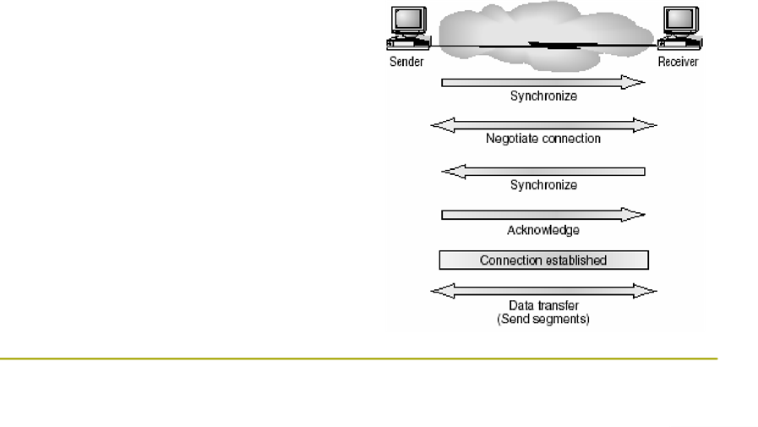These protocols relies on Acknowledgement.
* Positive acknowledgement means data has been received.
* Negative acknowledgement means data is lost no further data is sent till positive acknowledgement is received.
* It is slow but Reliable.
* E.g.. TCP and SPX



|  |
| --- |
| **© CMS INSTITUTE, 2004**. All rights reserved. No part of this material may be reproduced, stored or emailed without the prior permission. |

Revision no.: PPT/2K804/04



**Connection Less Protocol**

* They do not provide acknowledgement neither sequence numbers.
* It is faster but not reliable
* E.g.. UDP and IPX



|  |
| --- |
| **© CMS INSTITUTE, 2004**. All rights reserved. No part of this material may be reproduced, stored or emailed without the prior permission. |

Revision no.: PPT/2K804/04



**Flow Control**

* Used while connection oriented communication
* It helps to have a control on over flow of Buffer.
* Advantages are:
  + The segments delivered are acknowledged if received
  + Any segment not acknowledged are retransmitted
  + segments are sequenced back upon their arrival
  + Congestion, Overloading and data loss are avoided
* To achieve all this it uses the technique of Sliding window or Windowing

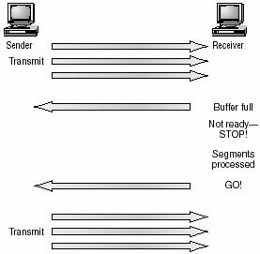

|  |
| --- |
| **© CMS INSTITUTE, 2004**. All rights reserved. No part of this material may be reproduced, stored or emailed without the prior permission. |

Revision no.: PPT/2K804/04



**Windowing**

* This mechanism is used to overcome the problem of data loss due to buffer overflowing.
* A “WAIT” signal is sent by the receiver, when buffer is full and “YES” signal is sent when it is ready to receive.
* This approach is call “Sliding Window” method.
* In this mechanism it auto adjusts the number of segments that it is going to send before receiving the acknowledgement.
* If sender does not receive the acknowledgement after sending the pre-defined number of segments, it stops transmission till it receives the positive signal.

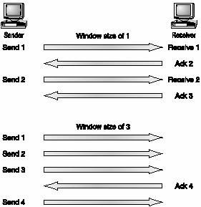

|  |
| --- |
| **© CMS INSTITUTE, 2004**. All rights reserved. No part of this material may be reproduced, stored or emailed without the prior permission. |

Revision no.: PPT/2K804/04



**Acknowledgments**

* Reliable data delivery ensures the integrity of a stream of data sent from one machine to the other through a fully functional data link.
* It guarantees that the data won’t be duplicated or lost.
* This is achieved through something called positive acknowledgment with retransmission-a technique that requires a receiving machine to communicate with the transmitting source by sending an acknowledgment message back to the sender when it receives data.
* When it sends a segment, the transmitting machine starts a timer and retransmits if it expires before an acknowledgment is returned from the receiving end.



|  |
| --- |
| **© CMS INSTITUTE, 2004**. All rights reserved. No part of this material may be reproduced, stored or emailed without the prior permission. |

Revision no.: PPT/2K804/04



**Network Layer**

* It is responsible for communicating Networks
* It recognizes Networks with the help of Network Addresses
  + Network Address is a logical address like IP Address or IPX Address
  + It is common for a group of computers
* It works only with Network IDs and has got nothing to do with host Ids.
* Path determination or Routing is performed at this layer.
* Router works at this layer.



|  |
| --- |
| **© CMS INSTITUTE, 2004**. All rights reserved. No part of this material may be reproduced, stored or emailed without the prior permission. |

Revision no.: PPT/2K804/04



**Data Link Layer**

* It uniquely identifies each device in the Network.
* It translates data from Network Layer into bits for the Physical layer to transmit.
* It formats the messages into Data Frames
* Adds a customized header containing Source and Destination hardware address
* This layer works with Frames
* This layer is logically divided in two sub-layers:
  + LLC (Logical Link Control)
  + MAC (Media Access Control)



|  |
| --- |
| **© CMS INSTITUTE, 2004**. All rights reserved. No part of this material may be reproduced, stored or emailed without the prior permission. |

Revision no.: PPT/2K804/04



**Devices at Data Link Layer**

* Devices that works at this layer are
  + LAN Card
  + Switches
  + Bridges etc.



|  |
| --- |
| **© CMS INSTITUTE, 2004**. All rights reserved. No part of this material may be reproduced, stored or emailed without the prior permission. |

Revision no.: PPT/2K804/04



**Logical Link Control**

* It identifies Network Layer Protocols and encapsulates them.
* With the help of LLC header it determines what to do once the frame is received.
* It also provides
  + Error Control
  + Flow Control
  + Sequencing of Bits
* It also creates
  + DSAP (Destination Service Access Pointer)
  + SSAP (Source Service Access Pointer)
* 802.2 Frame Type



|  |
| --- |
| **© CMS INSTITUTE, 2004**. All rights reserved. No part of this material may be reproduced, stored or emailed without the prior permission. |

Revision no.: PPT/2K804/04



**Media Access Control (MAC)**

* The MAC Sublayer maintains addresses that enable messages to be sent and received by particular devices across a network.
* These addresses, called physical device addresses, data-link addresses, hardware addresses, or MAC Addresses, are unique addresses associated with the networking hardware in a computer.
* The address is burned into the Network Interface Card (NIC) at the time of manufacturing



|  |
| --- |
| **© CMS INSTITUTE, 2004**. All rights reserved. No part of this material may be reproduced, stored or emailed without the prior permission. |

Revision no.: PPT/2K804/04



**Physical Layer**

* Electrical and Mechanical settings are provided at this layer.
* Transmits data in the form of bits.
* This layer communicates directly with actual communication media.
* At this layer DCE & DTE are identified
  + DCE (Data Circuit-Terminating Equipment)
    - Located at Service Provider’s side
  + DTE (Data Terminal Equipment)
    - The attached device at customer’ Place eg. Modem
  + Services available to a DTE is most often accessed via a Modem or Channel Service Unit (CSU) Data Service Unit (DSU).
* Hubs & REPEATERS are working at this layer.
* Max. troubleshooting occurs at this layer



|  |
| --- |
| **© CMS INSTITUTE, 2004**. All rights reserved. No part of this material may be reproduced, stored or emailed without the prior permission. |

Revision no.: PPT/2K804/04



**The Ethernet Networking**

* Ethernet is a methodology for accessing a media
* It allows all hosts on a network to share the same bandwidth of a link.
* It is popular because :
  + It is easy to implement & Troubleshoot
  + It is easy to add new technologies like Fast Ethernet and Gigabit Ethernet to existing infrastructure.
* Ethernet uses Data Link Layer and Physical Layer Specification
* It uses something called CSMA/CD



|  |
| --- |
| **© CMS INSTITUTE, 2004**. All rights reserved. No part of this material may be reproduced, stored or emailed without the prior permission. |

Revision no.: PPT/2K804/04



**CSMA/CD**

* CSMA/CD stands for Carrier Sense Multiple Access / Collision Detect.
* It is used by all NICs in Ethernet Networking
* In this method all NICs first sense whether the cable is free or not.
* If it is free the request is sent otherwise it waits.



|  |
| --- |
| **© CMS INSTITUTE, 2004**. All rights reserved. No part of this material may be reproduced, stored or emailed without the prior permission. |

Revision no.: PPT/2K804/04



**Collision Domain**

* All the computers which are physically connected together and can collide with each other are part of a single Collision Domain.
* To reduce collision increase collision domain
* Reducing Collision Domain will increase collision.



|  |
| --- |
| **© CMS INSTITUTE, 2004**. All rights reserved. No part of this material may be reproduced, stored or emailed without the prior permission. |

Revision no.: PPT/2K804/04



**Half Duplex Ethernet**

* It is defined in 802.3 Ethernet specifications
* It uses only one wire pair for signals running in both direction.
* CSMA/CD is used to prevent collision.
* Half Duplex typically 10base T is 50-60 % efficient. (In CISCO views)
* In a large 10 base T network you only get 3 to 4 MBPS at most.



|  |
| --- |
| **© CMS INSTITUTE, 2004**. All rights reserved. No part of this material may be reproduced, stored or emailed without the prior permission. |

Revision no.: PPT/2K804/04



**Full Duplex**

* Full Duplex Ethernet uses two pairs of wires.
* It uses Point-to-Point connection
* There is no collision in Full Duplex
* Full Duplex is suppose to offer 100% efficiency in both direction
* Means you can get 20 MBPS in 10 MBPS or 200 MBPS in Fast Ethernet running Full Duplex.



|  |
| --- |
| **© CMS INSTITUTE, 2004**. All rights reserved. No part of this material may be reproduced, stored or emailed without the prior permission. |

Revision no.: PPT/2K804/04



**Auto Detect Mechanism**

* When a Full Duplex port is powered on, it first checks with remote end and decides whether it can run on 10 or 100 MBPS.
* Then it checks to see whether it can run Full duplex or half duplex.
* This is called Auto Detect Mechanism.



|  |
| --- |
| **© CMS INSTITUTE, 2004**. All rights reserved. No part of this material may be reproduced, stored or emailed without the prior permission. |

Revision no.: PPT/2K804/04



**Ethernet @ Datalink Layer**

* At Datalink Layer Ethernet is responsible for :
  + Ethernet / Hardware / MAC Addressing
  + Framing Packets received from Network Layer
* Frame Types available are :
  + Ethernet_II
  + IEEE 802.3
  + IEEE 802.2
  + SNAP



|  |
| --- |
| **© CMS INSTITUTE, 2004**. All rights reserved. No part of this material may be reproduced, stored or emailed without the prior permission. |

Revision no.: PPT/2K804/04



**Ethernet Addressing**

* Ethernet Addressing uses MAC Address
  + MAC addresses are burned on every NIC
  + It is a 48-bit address
  + It is written in the same format even if different LAN Technologies are used.

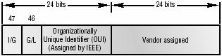

|  |
| --- |
| **© CMS INSTITUTE, 2004**. All rights reserved. No part of this material may be reproduced, stored or emailed without the prior permission. |

Revision no.: PPT/2K804/04



**Ethernet Frames**

* Frames are used at the Data Link Layer to encapsulate packets coming down for transmission on a type of Media Access
* There are three types of Media Access
  + Contention (Ethernet)
  + Token Passing (Token Ring or FDDI)
  + Polling (IBM Mainframes)
* We will be covering only “Contention”, as rest all are beyond the scope of our course.



Revision no.: PPT/2K804/04

|  |
| --- |
| **© CMS INSTITUTE, 2004**. All rights reserved. No part of this material may be reproduced, stored or emailed without the prior permission. |

**802.3 & Ethernet Frame Formats**

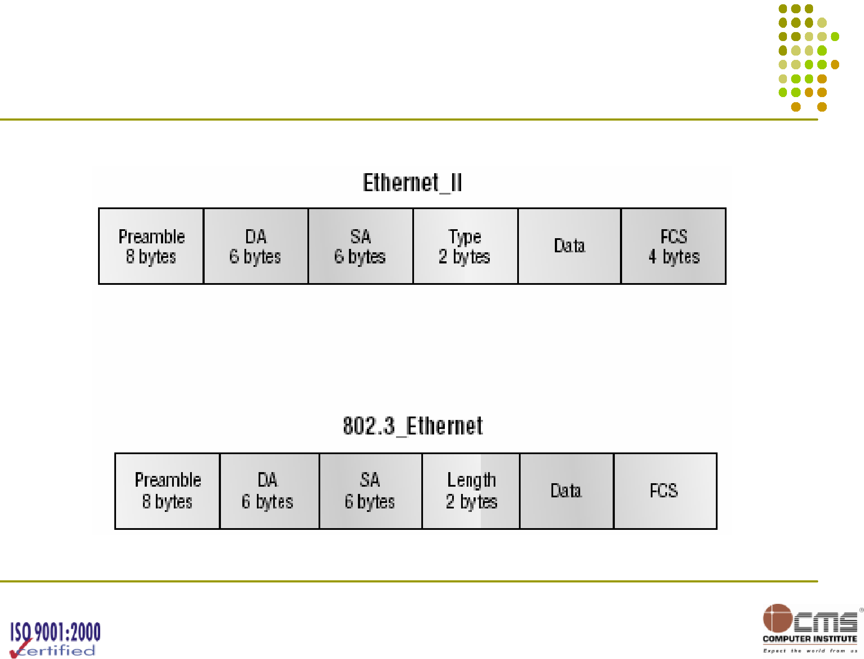

|  |
| --- |
| **© CMS INSTITUTE, 2004**. All rights reserved. No part of this material may be reproduced, stored or emailed without the prior permission. |

Revision no.: PPT/2K804/04



**Ethernet Frame Format (contd.)**

* Preamble
  + An alternating 1,0 pattern provides a 5 MHz clock at the start of each packet.
  + It allows the receiving devices to lock the incoming bit stream.
  + The Peamble uses either an SFD or synch field to indicate to the receiving station that the data portion of the message will follow.
* Start Frame Delimiter (SFD)/Synch
  + SFD is 1,0,1,0,1,0 etc.
  + The synch field is all 1s
  + The Preamble or Synch fields are 64 bits long



|  |
| --- |
| **© CMS INSTITUTE, 2004**. All rights reserved. No part of this material may be reproduced, stored or emailed without the prior permission. |

Revision no.: PPT/2K804/04



**Ethernet Frame Format (contd.)**

* Destination Address (DA)
  + DA is used by receiving stations to determine if an incoming packet is addressed to a particular node.
  + Uses LSB (Least Significant Bit) first
  + Destination can be individual, multicast or broadcast
  + Broadcast will be all 1s or Fs and will be sent to all.
  + Multicast will be sent to the specific subnet
* Source Address (SA)
  + SA is a 48 bit MAC Address supplied by the transmitting device.
  + Broadcast and Multicast address formats are illegal within the SA fields.
  + It uses LSB (Least significant bit first)



|  |
| --- |
| **© CMS INSTITUTE, 2004**. All rights reserved. No part of this material may be reproduced, stored or emailed without the prior permission. |

Revision no.: PPT/2K804/04



**Ethernet Frame Format (contd.)**

* Length or Type Field
  + 802.3 uses length field where as Ethernet frame uses type field to identify the network layer protocol.
  + 802.3 can not identify upper-layer protocol and must be used with a proprietary LAN, for example IPX.
* Data
  + This is the packet sent down to the Data Link Layer from the Network layer.
  + The size can vary from 46-1500 bytes.
* Frame Check Sequence (FCS)
  + FCS is a field at the end of the frame that is used to store the cyclic redundancy check.



Revision no.: PPT/2K804/04

|  |
| --- |
| **© CMS INSTITUTE, 2004**. All rights reserved. No part of this material may be reproduced, stored or emailed without the prior permission. |

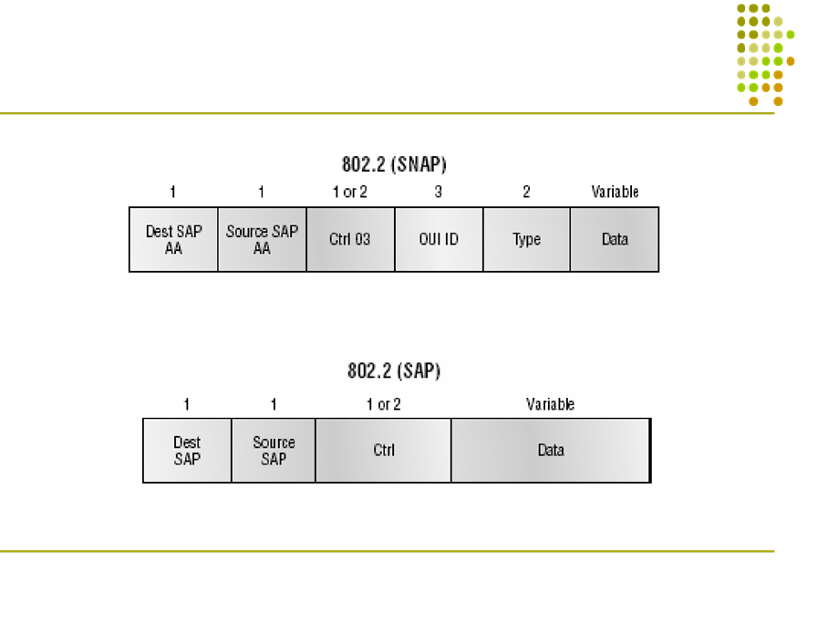

**802.2 & SNAP Frame Formats**

|  |
| --- |
| **© CMS INSTITUTE, 2004**. All rights reserved. No part of this material may be reproduced, stored or emailed without the prior permission. |

Revision no.: PPT/2K804/04



**802.2 Frame**

* 802.2 Frame has two new fields
  + DSAP (Destination Service Access Pointer)
  + SSAP (Source Service Access Pointer)
* 802.2 frame type is nothing but 802.3 frame with LLC information
* Because of the LLC information we know what upper layer protocol is.



|  |
| --- |
| **© CMS INSTITUTE, 2004**. All rights reserved. No part of this material may be reproduced, stored or emailed without the prior permission. |

Revision no.: PPT/2K804/04



**SNAP Frame**

* The SNAP Frame has its own protocol field to identify the upper layer protocol.
* This is really a way to use Ethernet_II frame type in 802.3 frame.
* To Identify SNAP Frame:
  + DSAP and SSAP fields are always AA
  + Command field is always 3
* CISCO uses SNAP frame with their proprietary protocol CDP (CISCO Discovery Protocol)



|  |
| --- |
| **© CMS INSTITUTE, 2004**. All rights reserved. No part of this material may be reproduced, stored or emailed without the prior permission. |

Revision no.: PPT/2K804/04



**Ethernet @ Physical Layer**

* Ethernet uses Bus Topology
  + means signal must run from one end to the other end of the segment.
* Ethernet has also defined Baseband Technology.
  + Means that whenever transmission takes place it uses the entire bandwidth on the wire and does not share it.

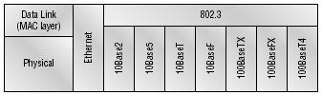

|  |
| --- |
| **© CMS INSTITUTE, 2004**. All rights reserved. No part of this material may be reproduced, stored or emailed without the prior permission. |

Revision no.: PPT/2K804/04



**Cable Specification**

|  |  |  |  |  |
| --- | --- | --- | --- | --- |
| **Cables** | **Distance** | **Throughput** | **Ethernet** | **Connectors** |
|  |  |  | **Standard** |  |
| Co-axial | 185 Mtrs. | 10 MBPS | 10Base2 | T-connector |
| Thinnet |  |  |  |  |
| Co-axial | 500 Mtrs. | 100 MBPS | 10Base5 | AUI |
| Thicknet |  |  |  |  |
| Category 3 | 100 Mtrs. | 10 MBPS | 10BaseT | RJ-45 |
| Category 5 | 100 Mtrs. | 100 MBPS | 10BaseX / | RJ-45 |
|  |  |  | Fast Ethernet |  |



|  |
| --- |
| **© CMS INSTITUTE, 2004**. All rights reserved. No part of this material may be reproduced, stored or emailed without the prior permission. |

Revision no.: PPT/2K804/04



**Ethernet Cabling**

* Ethernet cabling is an important discussion, especially if you are planning on taking the Cisco CCNA exam. The types of Ethernet cables available are:
  + Straight-through cable
  + Crossover cable
  + Rolled cable



|  |
| --- |
| **© CMS INSTITUTE, 2004**. All rights reserved. No part of this material may be reproduced, stored or emailed without the prior permission. |

Revision no.: PPT/2K804/04



**Straight-Through Cable**

* The *straight-through* cable is used to connect:
  + Host to switch or hub
  + Router to switch or hub

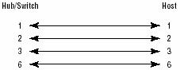

|  |
| --- |
| **© CMS INSTITUTE, 2004**. All rights reserved. No part of this material may be reproduced, stored or emailed without the prior permission. |

Revision no.: PPT/2K804/04



**Crossover Cable**

* The *crossover* cable can be used to connect:
  + Switch to switch
  + Hub to hub
  + Host to host
  + Hub to switch
  + Router direct to host

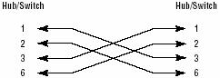

|  |
| --- |
| **© CMS INSTITUTE, 2004**. All rights reserved. No part of this material may be reproduced, stored or emailed without the prior permission. |

Revision no.: PPT/2K804/04



**Rolled Cable**

* Although *rolled* cable isn’t used to connect any Ethernet connections together, you can use a rolled Ethernet cable to connect a host to a router console serial communication (com) port.

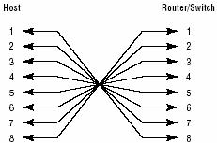

|  |
| --- |
| **© CMS INSTITUTE, 2004**. All rights reserved. No part of this material may be reproduced, stored or emailed without the prior permission. |

Revision no.: PPT/2K804/04



**Wireless Networking**

* Narrowband Wireless LANs
* Personal Communication Services (PCS)
* Narrowband PCS
* Broadband PCS
* Satellite
* Infrared Wireless LAN’s
* Spread Spectrum Wireless LAN’s

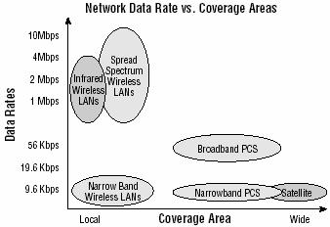

**© CMS INSTITUTE, 2004**. All rights reserved. No part of this material may be reproduced, stored or emailed without the prior permission.

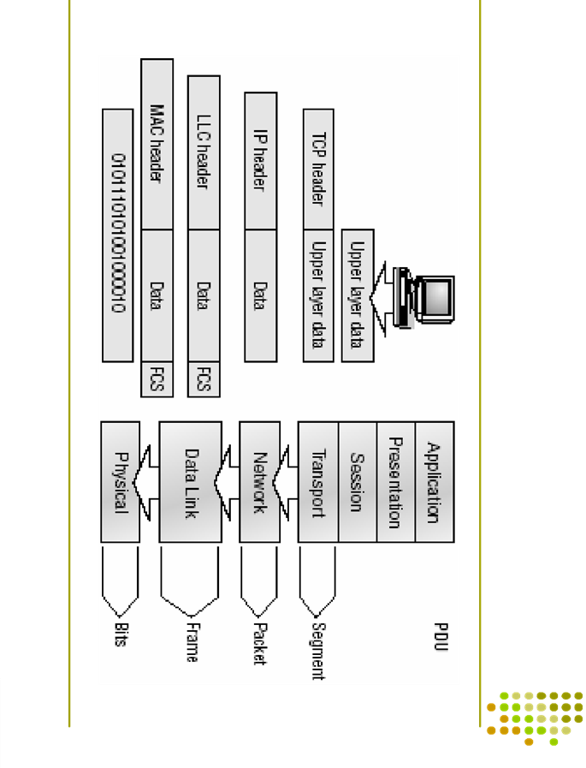

|  |
| --- |
| **Data Encapsulation** |

|  |
| --- |
| Revision no.: PPT/2K804/04 |

|  |
| --- |
| **© CMS INSTITUTE, 2004**. All rights reserved. No part of this material may be reproduced, stored or emailed without the prior permission. |

Revision no.: PPT/2K804/04



**The Cisco Three Layer Hierarchy Model**

* If implemented properly
  + It makes network more predictable
  + it helps us defining at which level of hierarchy we should perform certain functions
  + Example is Access List that should be used at certain levels but at certain level it should be avoided.
  + In large networks which is complicated with multiple protocols, detailed configurations and diverse technologies, hierarchy helps us to summarize a complex collection of details in to an understandable model.



Revision no.: PPT/2K804/04

|  |
| --- |
| **© CMS INSTITUTE, 2004**. All rights reserved. No part of this material may be reproduced, stored or emailed without the prior permission. |

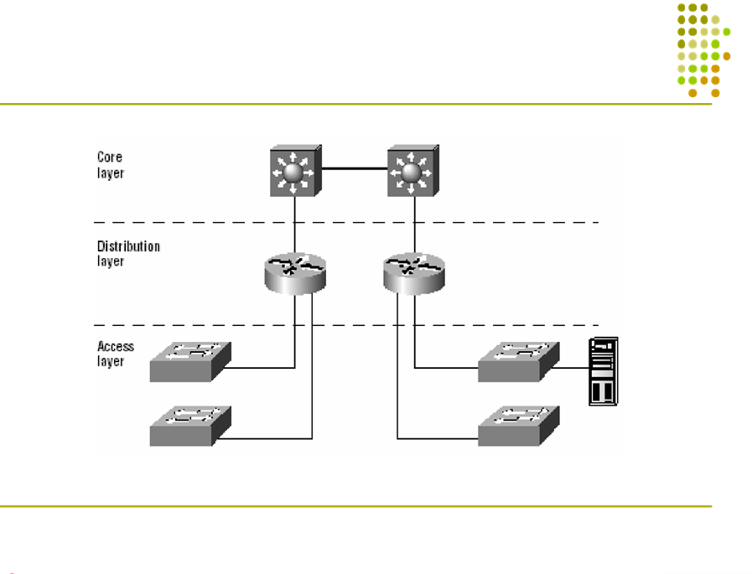

**The Cisco hierarchical model**

|  |
| --- |
| **© CMS INSTITUTE, 2004**. All rights reserved. No part of this material may be reproduced, stored or emailed without the prior permission. |

Revision no.: PPT/2K804/04



**Core Layer**

* Core Layer is actually the core of the network.
* It is responsible for transporting large amount of traffic reliably and quickly.
* Core Layer failure affects each individual user, hence fault tolerance becomes an issue at this layer.
* Core layer is likely to see large volume of traffic, hence speed and latency is the driving concerns.
* There are few thing we do not want to do at core layer but few things are recommended to do at this layer.



|  |
| --- |
| **© CMS INSTITUTE, 2004**. All rights reserved. No part of this material may be reproduced, stored or emailed without the prior permission. |

Revision no.: PPT/2K804/04



**Core Layer (contd.)**

* Few Things we do not want to do as we design the CORE:
  + Don’t do anything to slow down traffic, like using access lists, routing between VLANs and packet filtering.
  + Don’t support workgroup access here.
  + Give preference to upgrades over expansion and avoid expansion.
* Few Things we do not want to do as we design the CORE:
  + Design the core for high reliability.
  + Consider data-link technologies that facilitate both speed and redundancy, like FDDI, Fast Ethernet or ATM etc.
  + Design with speed in mind. The core should have very little latency.
  + Select routing protocols with lower convergence time.



|  |
| --- |
| **© CMS INSTITUTE, 2004**. All rights reserved. No part of this material may be reproduced, stored or emailed without the prior permission. |

Revision no.: PPT/2K804/04



**Distribution Layer**

* It is sometimes also referred as workgroup layer.
* It is communication point between Access Layer and Core Layer.
* Routing, Filtering & WAN Access is the Primary function of the distribution layer.
* Network policies are implemented at Distribution Layer.
* Best path is determined and request are forwarded to Core Layer.



|  |
| --- |
| **© CMS INSTITUTE, 2004**. All rights reserved. No part of this material may be reproduced, stored or emailed without the prior permission. |

Revision no.: PPT/2K804/04



**Distribution Layer (contd.)**

* We do the following:
  + Implementation of tools like access lists, packet filtering etc.
  + Implementation of security and network policies like address translation and firewalls
  + Redistribution between routing protocols, including static routing
  + Routing between VLANs
  + Definition of Broadcast and Multicast Domains



|  |
| --- |
| **© CMS INSTITUTE, 2004**. All rights reserved. No part of this material may be reproduced, stored or emailed without the prior permission. |

Revision no.: PPT/2K804/04



**The Access Layer**

* Access Layer controls users and workgroup access to network resources.
* This layer is also referred to as Desktop Layer.
* Continues access control and policies from distribution layer
* Creation of separate collision domains (segmentation)
* Workgroup connectivity into the distribution layer



Revision no.: PPT/2K804/04

|  |
| --- |
| **© CMS INSTITUTE, 2004**. All rights reserved. No part of this material may be reproduced, stored or emailed without the prior permission. |

