

## CCNA

640-802

**Network Address Translation (NAT)**



    



    



Revision no.: PPT/2K804/04

Revision no.: PPT/2K804/04



# When Do We Use NAT?

* Similar to Classless Inter-Domain Routing (CIDR), the original intention for NAT was to slow the depletion of available IP address space by allowing many private IP addresses to be represented by some smaller number of public IP addresses.



### Here’s a list of situations when it’s best to have NAT on your side:

* You need to connect to the Internet and your hosts don’t have globally unique IP addresses.
* You change to a new ISP that requires you to renumber your network.
* You need to merge two intranets with duplicate addresses.







Revision no.: PPT/2K804/04

**You typically use NAT on a border router.**

For an illustration of this, see Figure

When to Configuring NAT

 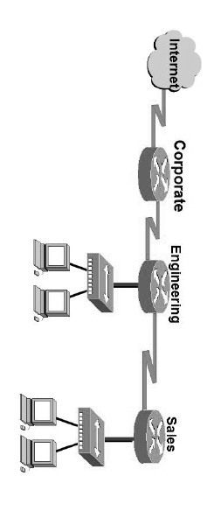

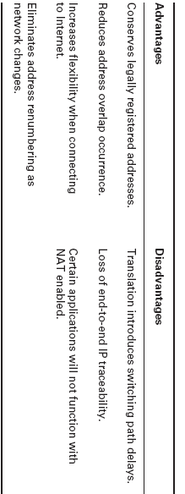



Revision no.: PPT/2K804/04

Advantages & Disadvantages of Implementing NAT



# Types of Network Address Translation



### Static NAT

* This type of NAT is designed to allow one-to-one mapping between local and global addresses.
* Keep in mind that the static version requires you to have one real Internet IP address for every host on your network.





 

### Dynamic NAT

* This version gives you the ability to map an unregistered IP address to a registered IP address from out of a pool of registered IP addresses.
* You don’t have to statically configure your router to map an inside to an outside address as you would using static NAT, but you do have to have enough real, bona-fide IP addresses for everyone who’s going to be sending packets to and receiving them from the Internet.





 

### Overloading

* This is the most popular type of NAT configuration. Understand that overloading really is a form of dynamic NAT that maps multiple unregistered IP addresses to a single registered IP address—many-to-one—by using different ports.
* It is also known as *Port Address Translation (PAT),* and by using PAT (NAT verload), you get to have thousands of users connect to the Internet using only one real global IP address.
* NAT Overload is the real reason we haven’t run out of valid IP address on the Internet.







Revision no.: PPT/2K804/04

**NAT Names**

NAT Terms

 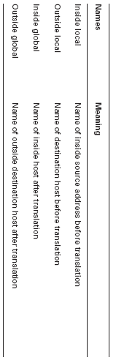





Revision no.: PPT/2K804/04

**How NAT Works**

Figure to describe the basic translation of NAT

 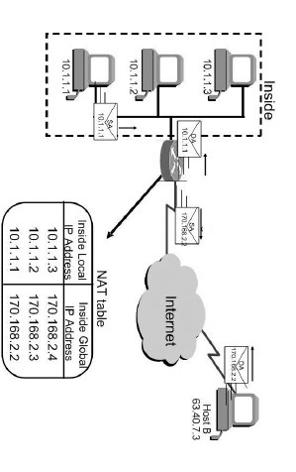



 

* In the example shown in Figure host 10.1.1.1 sends an outbound packet to the border router configured with NAT.
* The router identifies the IP address as an inside local IP address destined for an outside network, translates the address, and documents the translation in the NAT table.
* The packet is sent to the outside interface with the new translated source address.
* The external host returns the packet to the destination host and the NAT router translates the inside global IP address back to the inside local IP address using the NAT table.





 

* Figure to demonstrate how PAT works.
* With overloading, all inside hosts get translated to one single IP address, hence the term *Overloading* .
* Take a look at the NAT table in Figure again. In addition to the inside local IP address and outside global IP address, we now have port numbers.
* These port numbers help the router identify which host should receive the return traffic.





 

NAT overloading example (PAT)

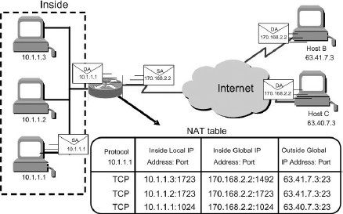

PAT allows us to use the Transport layer to identify the hosts, which in turn allows us to use (theoretically) up to 65,000 hosts with one real IP address





**Static NAT Configuration**



Let’s take a look at a simple basic static NAT configuration: ip nat inside source static 10.1.1.1 170.46.2.2

!

interface Ethernet0

ip address 10.1.1.10 255.255.255.0

ip nat inside

!

interface Serial0

ip address 170.46.2.1 255.255.255.0

ip nat outside

!





 

* In the preceding router output, the **ip nat inside source**

command identifies which IP addresses will be translated.

* In this configuration example, the ip nat inside source command configures a static translation between the inside local IP address

10.1.1.1 to the outside global IP address 170.46.2.2.

* The **ip nat inside** command identifies that interface as the inside interface.
* The **ip nat outside** command identifies that interface as the outside interface.





# Dynamic NAT Configuration



Here is a sample output of a dynamic NAT configuration: ip nat pool todd 170.168.2.2 170.168.2.254

netmask 255.255.255.0

ip nat inside source list 1 pool todd

!

interface Ethernet0

ip address 10.1.1.10 255.255.255.0

ip nat inside

!

interface Serial0

ip address 170.168.2.1 255.255.255.0

ip nat outside

!

access-list 1 permit 10.1.1.0 0.0.0.255

!





 

* The **ip nat inside source list 1 pool todd** command tells the router to translate IP addresses that match access-list 1 to an address found in the IP NAT pool named
* Todd.
* The **access list** is being used in this case to select or designate what we often call interesting traffic.
* When interesting traffic has been matched with the access list, it is pulled into the NAT process to be translated.
* The **ip nat pool todd 170.168.2.2 192.168.2.254** command creates a pool of addresses that will be distributed to those hosts that require NAT.





# PAT (Overloading) Configuration



Here is a sample output of a PAT configuration: ip nat pool globalnet 170.168.2.1 170.168.2.1

netmask 255.255.255.0

ip nat inside source list 1 pool globalnet overload

!

interface Ethernet0/0

ip address 10.1.1.10 255.255.255.0

ip nat inside

!

interface Serial0/0

ip address 170.168.2.1 255.255.255.0

ip nat outside

!

access-list 1 permit 10.1.1.0 0.0.0.255





 

* The nice thing about PAT is that the only differences between this configuration and the previous dynamic NAT configuration is that our pool of addresses has shrunk to only one IP address and at the end of our ip nat inside source command we included the overload command.





# Simple Verification of NAT



* To see basic IP address translation information, use the following command:

Router#show ip nat translation

* You can verify your NAT configuration with the debug ip nat command.
* This output will show the sending address, the translation, and the destination address on each debug line:

Router#debug ip nat

* To clear your NAT entries from the translation table:

Router#clear ip nat translation

* To clear all entries from the NAT table, use an asterisk (*) at the end of the command.





 

* Testing and Troubleshooting NAT
* Check the dynamic pools—are they composed of the right scope of addresses?
* Check to see if any dynamic pools overlap.
* Check to see if the addresses used for static mapping and those in the dynamic pools overlap.
* Ensure that your access lists specify the correct addresses for translation.
* Make sure there aren’t any addresses left out that need to be there, and ensure none are included that shouldn’t be.
* Check to make sure that you’ve got both the inside and outside interfaces delimited properly.

**We can configure NAT by Using SDM**



Revision no.: PPT/2K804/04

permission.

prior the

without

emailed or

stored d,

reproduce be

may

material

this of

part No

reserved.

rights All

.

**2004**

**INSTITUTE, CMS**

**©**



**Design & Published by:**