Six Ways to Write a Synthetic Poem
Default poetic style across six frontier language models, with one bug fix and four findings that don’t track the obvious axes
Author: Bo Chesterton
Analyst: Claude Opus 4.7 (Anthropic)
Contributor: GPT-5.5 Thinking (OpenAI)
Date: May 9, 2026
Repository: github.com/quumble/An-Assay-of-Bullshit

Abstract
Six frontier language models — three Claudes (Opus 4.7, Sonnet 4.6, Haiku 4.5) and three GPTs (5.4, 5.4-mini, 5.4-nano) — each produced 100 poems against each of nine length-constrained prompts (5,400 calls; 5,397 returned non-null). Prompts crossed three length caps (5, 10, 20 lines) with three phrasings (write/compose/gimme). Temperature 1.0, no system prompt, max 400 output tokens. The study was preregistered with a locked coding heuristic and a manual validation gate; deviations are logged. Thirteen structural and stylistic features were extracted per poem; embeddings were computed with text-embedding-3-large.
The data show four robust patterns. (1) Family separates more cleanly than tier in embedding space and on most features; on words-per-line, every Claude is below 6.1 and every GPT is above 6.4, with no overlap. (2) Preamble behavior is categorical and sharply model-specific: Haiku and Sonnet preface every poem with conversational scaffolding regardless of length; Opus does so at cap-10 and cap-20 but never at cap-5; GPTs essentially never do. (3) Default voice does not track tier within family. The smallest GPT (nano) and the largest Claude (Opus) both default to the lyric “I” (60% and 47% of poems respectively); the middle of each family (mini, Sonnet) defaults to descriptive third-person. (4) A logistic regression on the 13 features classifies poems by model identity at 56.4% (chance 16.7%) and by family at 74.3%. The largest single feature effect is pronoun ratio (η² = 0.229), driven primarily by GPT-nano’s lyric-I default rather than a smooth tier or family gradient.
During the writing of this paper a key-name mismatch was discovered in the original analyzer: five preregistered POS-ratio features were silently dropped from the as-run Q2/Q3 tables. The corrected analyzer recovers them. Findings (1)–(4) are stable to a strict-validation sensitivity rerun in which the four lower-ranked POS features and rhyme participation are removed.

§0. Who wrote what
The structural and semantic feature extractors for Series 2 are deterministic Python: spaCy POS tagging, regex-based preamble detection, the CMU pronouncing dictionary for rhyme, and Brysbaert et al. (2014) norms for concreteness. No learned model component participates in coding outputs. The validator is a human at a blinded HTML interface.
The analyst writing this paper, however, is an LLM — specifically Claude Opus 4.7. Two of the six experimental subjects are Anthropic models. One of those, Opus 4.7, is the analyst. The contributor on Series 1’s heuristic pipeline was GPT-5.5 Thinking, also from a tested family.
A few things bound that conflict without erasing it. The coders are deterministic; the analyst can choose what to count and what to emphasize, but cannot quietly tilt the count itself. The preregistration is locked and dated in the public repo, with the locked feature list, locked decision rules, and locked permutation-null seeds; the analyst cannot change it without a logged deviation. The bug-fix and sensitivity reruns described in §8 are exactly the kind of evidence a reviewer would otherwise have to surface on their own.
What is not bounded: the choice of which features to operationalize is itself a prior, baked in before the analyst arrived, and the analyst’s choice of what to highlight in the prose is genuinely a stylistic choice. The findings most affected by this concern are flagged at point of report.
One of the four headline findings — that Opus is structurally distinct from Sonnet and Haiku in coordinated ways (longer, more concrete, more first-personal, with the cap-5 preamble suppression) — is exactly the kind of result that should be read with maximum suspicion given who is writing the paper. It is reported at §3.4 and surrounded with sensitivity-rerun evidence and explicit flagging. We are not asking you to trust it on faith. We are asking you to read the alternatives in the data alongside it.

§1. The setup
A cold prompt is an unnatural thing to give a chat model. No system message, no conversation, no domain stakes — just a single instruction with a length constraint and nothing telling the model what kind of poem to write or who is reading it. What the model produces in that vacuum is, by construction, whatever it does when nothing is telling it what to be.
Defaults are interesting because they are the part of a model’s behavior that survives when nothing asks for it. They are not capability and they are not preference. They are the residue of pretraining, post-training, product taste, and the implicit etiquette of being helpful — all of which leave fingerprints on the page when nothing else is in the way.
The empirical question of this study is narrow: in 5,397 cold-prompt poems, can the visible habits distinguish the models that produced them, and if so, what are those habits?
The short answer is yes, and on multiple axes simultaneously. The longer answer involves four findings that don’t track tier or family in the way folk-stereotypes about these systems would predict.

§2. Design and data
Six models were sampled at temperature 1.0 with max_tokens=400 and no system prompt. Nine prompts: three length caps (5, 10, 20 lines) crossed with three phrasings (write a poem in fewer than N lines, compose a poem in fewer than N lines, gimme a poem in fewer than N lines). 100 iterations per (model, prompt) cell. 5,400 calls planned, 5,397 returning a non-null response (three calls errored out at the API and were not retried; attrition < 0.1% per cell). The full task list was shuffled with a logged seed before execution so that any time-correlated provider effects (rate-limit backoff, intra-day model drift) would not align with model identity.
Two pieces of methodological hygiene worth naming. First, this study is preregistered. The design, the feature list, the decision rules, the permutation-null procedure, and the validation gate are all locked in a dated commit before any data was collected. Deviations are logged with reasons. Second, a manual validation step on a 200-poem stratified sample (preregistered as 50; deviation logged) precedes any aggregate analysis; features that fail an 85% agreement threshold against human raters are downgraded to exploratory.
Table 1 summarizes the design. The full coding heuristic, the decision rules, and the deviation log are in the public repo.
Component | Specification
Models (6) | Claude Haiku 4.5, Sonnet 4.6, Opus 4.7; GPT-5.4-nano, 5.4-mini, 5.4
Prompts (9) | 3 length caps (5/10/20 lines) × 3 phrasings (write/compose/gimme)
Iterations per cell | 100
Total calls | 5,400 planned; 5,397 non-null returns
Sampling | temperature 1.0, max_tokens 400, no system prompt
Call ordering | full task list shuffled with logged seed before execution
Embedding model | OpenAI text-embedding-3-large
POS tagger | spaCy en_core_web_trf
Concreteness norms | Brysbaert et al. 2014 (40k words)
Rhyme detection | CMU pronouncing dictionary
Validation | 200-poem stratified manual sample; 85% agreement threshold
Table 1. Design summary. Full prompt list, model snapshot identifiers, and run metadata are in run_metadata.json in the repo.

§3. The headlines

§3.1 Models cluster in embedding space, family more sharply than tier
Poem embeddings (text-embedding-3-large, 3,072 dimensions) were computed for all 5,397 outputs. For each label scheme — model (6 levels), family (Claude vs GPT), and tier (small/medium/full) — a silhouette score was computed on the cosine-distance matrix and compared to a permutation null built from 1,000 random shuffles of the labels.
All three labelings yield silhouettes detectably above the null. The model labeling reaches 0.0812 against a null 95th percentile of −0.0057 (p < 0.001). Family scores 0.0866; tier scores 0.0558. The absolute silhouettes are modest — these are overlapping, not crisply separated, clusters — but they are reliably positive against a tight null.
The structurally interesting fact is that family beats tier. Collapsing across families erases more information than collapsing across tiers; collapsing across tiers preserves more. That is consistent with a story in which the largest stylistic axes are training-tradition differences (post-training defaults, tone-tuning conventions) rather than scale.
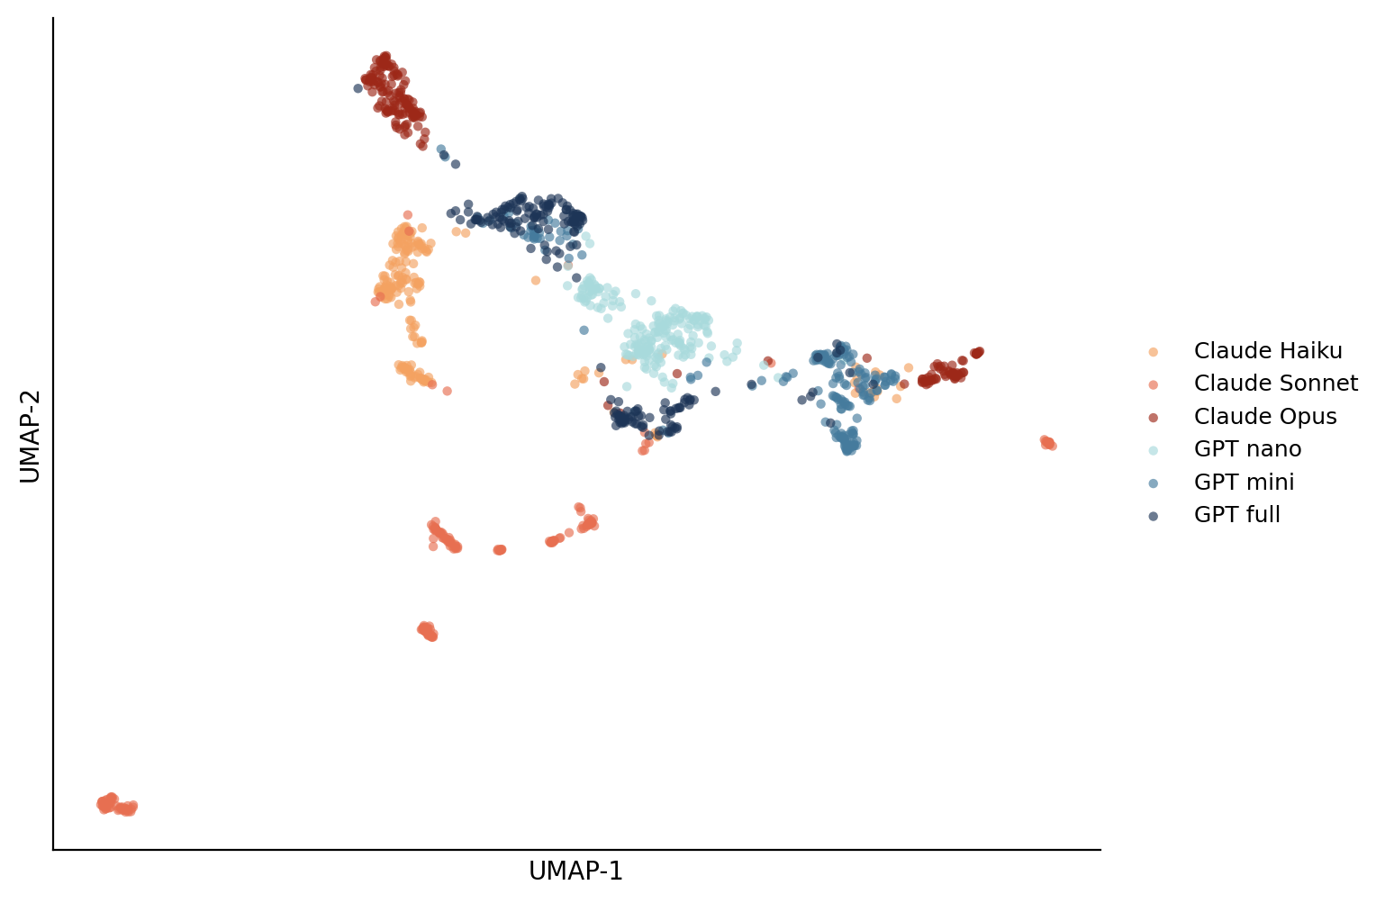
Figure 1. UMAP projection of poem embeddings (200 poems sampled per model for legibility; cosine metric, n_neighbors=30, seed=42). Claudes occupy a connected arc on the left; GPTs a denser swirl on the right. Two Sonnet outlier clusters at the bottom-left and far-right correspond to format-exotic outputs (very long stanzaic poems and a small set of one-line outputs respectively).

§3.2 Claude preambles. GPT does not. Opus has a length-conditional override.
A preamble — “Here’s a poem for you:”, “Sure! How about this:” — is a conversational scaffold that frames the poem as a reply rather than presenting it directly. The detector requires a blank-line-separated block before the first content-word line; rates were validated by hand at 90.5% agreement.
The preamble pattern is the cleanest single finding in the dataset, and it is categorical. Haiku and Sonnet preface every poem with a preamble — 100% across all 900 poems each, regardless of length cap. Opus preambles 100% of cap-10 and cap-20 poems and 0% of cap-5 poems. GPT-nano, GPT-mini, and GPT-full produce preambles in 1, 7, and 4 of 899 poems respectively (≤0.8% in each case).
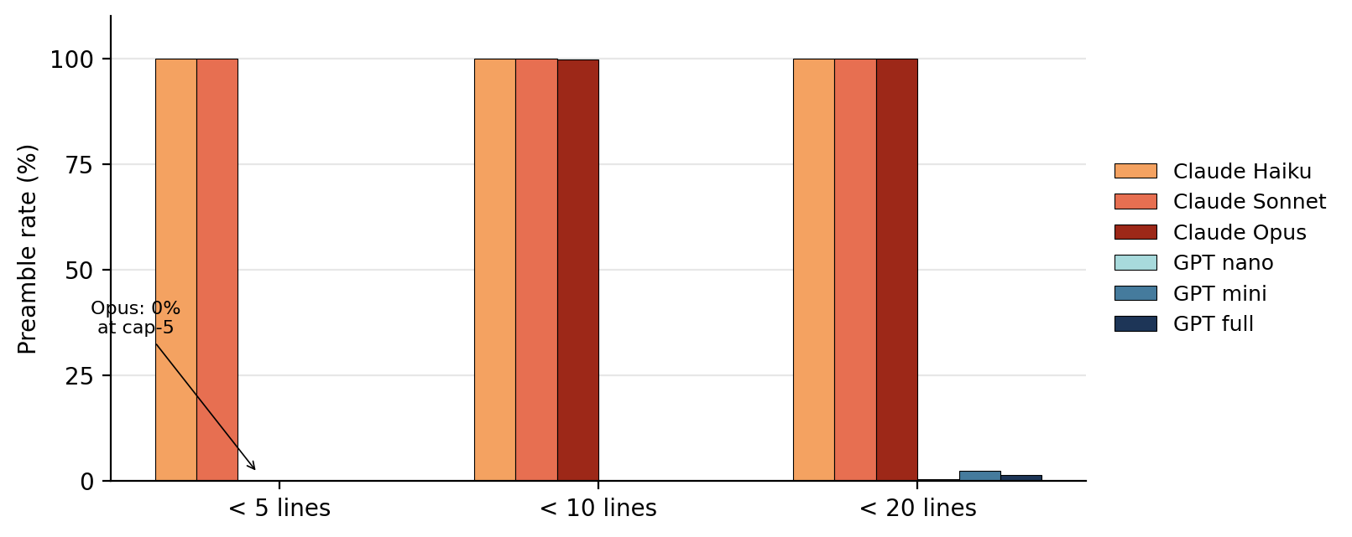
Figure 2. Preamble rate by (model, length cap). Haiku and Sonnet are categorical preamble-producers; Opus has a sharp length-conditional override at cap-5; GPTs essentially never preamble at any cap.
Two interpretive notes. The Opus pattern is clean enough to look engineered: at cap-5 the model appears to follow a “if the user asked for something very short, just deliver it” rule that Haiku and Sonnet do not have. Whether this is post-training, system-prompt scaffolding visible only to Anthropic, or an emergent length-aware behavior is not testable from cold prompts alone; it is a falsifiable prediction for follow-up.
Second, this is the cleanest family signal in the entire study, but it sits outside the preregistered primary feature battery (preamble rate is in the prereg as an exploratory feature). It is reported here because the effect is so categorical that any honest reading of the data has to lead with it.

§3.3 Default voice does not track tier within family
A rule-based person/voice classifier assigns each poem to one of six categories based on first/second/third-person pronoun counts: 1st_singular (lyric I), 1st_plural (we), 2nd (you), 3rd (descriptive), mixed (no dominant voice), and impersonal (no person markers). Validated at 90.5% agreement.
If default voice tracked tier, one would expect the small/medium/large GPTs to share a default and the small/medium/large Claudes to share a different one. That is not what the data show.

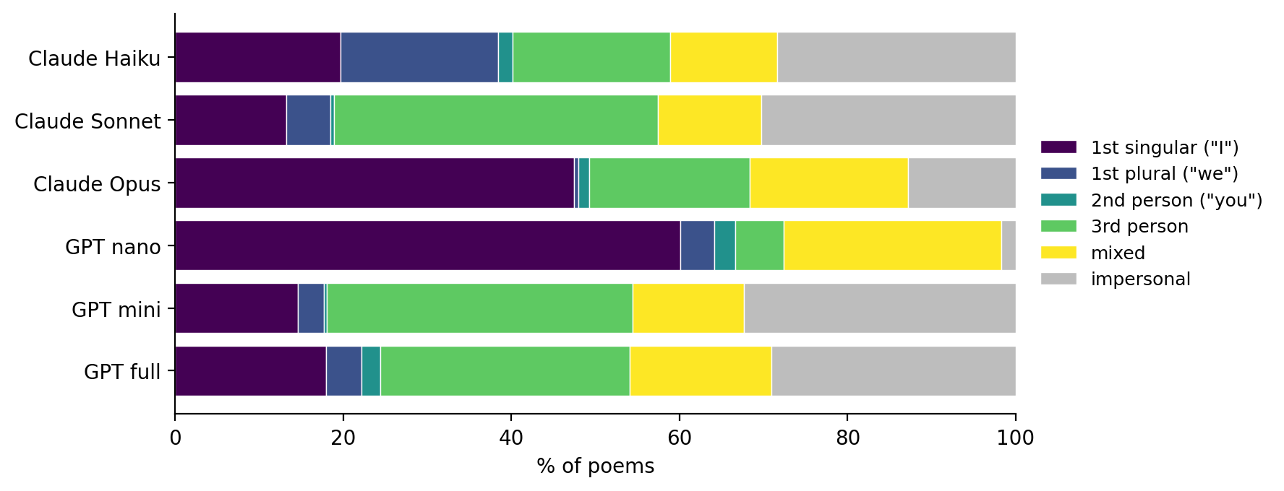
Figure 3. Person/voice distribution as % of poems. The smallest GPT and the largest Claude share the lyric-I default; the middle of each family shares the descriptive-third-person default.
GPT-nano writes 60% of its poems in the first-person singular and only 1.7% in impersonal voice — the most committed lyric “I” in the study. Opus is second at 47% lyric-I and 12.8% impersonal. The middle tier of each family looks nothing like its small or large sibling: Sonnet defaults to third-person descriptive (38.6%) and impersonal (30.2%); GPT-mini defaults to third-person (36.4%) and impersonal (32.4%); the two are almost interchangeable on voice. GPT-full is closer to GPT-mini and Sonnet (29.7% third, 29% impersonal); Haiku spreads across categories with no strong default.
The pattern is non-monotonic in tier and not aligned to family. Two of the most distinct voice defaults belong to two models from different families that share neither tier nor training tradition.
This is also the structure underneath the largest single-feature ANOVA effect in the study. pos_pronoun_ratio has η² = 0.229 (F = 319, n = 5,397) — the largest of any preregistered feature — but the size of that effect is concentrated almost entirely on the GPT-nano lyric-I behavior. Read it as the same finding wearing different clothes, not as an independent confirmation.

§3.4 Opus is the within-family outlier on the Claude side
On the Claude side, the within-family pattern looks tier-monotonic in places but not in others. Coordinated Opus distinctness: total words 47.4 vs Sonnet 42.1 / Haiku 43.3; concreteness 2.96 vs 2.79 / 2.85; pronoun ratio 0.081 vs 0.059 / 0.060; lyric-I voice 47% vs 13% / 20%. Sonnet-specific quirks: words-per-line SD 1.39 vs Haiku 0.88 / Opus 1.02 — Sonnet writes much more line-length-irregular poems than its tier-mates, and at cap-10 produces 2.02 stanzas on average while Haiku produces 1.03 and Opus 1.21. Haiku is otherwise the least distinctive Claude in feature space (see also §8).
On the GPT side, there is no clean monotonic pattern. GPT-mini and GPT-full are very similar to each other across the feature battery; GPT-nano is the outlier. On pronoun ratio nano sits at 0.092, twice mini’s 0.034 and full’s 0.037. On lyric-I voice nano is at 60% and the other two GPTs are below 18%. If you want a tier story for GPT, it has to acknowledge that nano — the smallest — is the most stylistically committed and that mini and full pick up similar defaults.
A clean tier story would predict three within-family parallel ladders. The data show two different shapes, neither the predicted one.
Note on author conflict. This is the section to read most skeptically given who is writing the paper. The Opus-distinct pattern is reported because the data show it, and the four features it spans are independent measurements (length, concreteness, pronoun count, voice classification), but the author is Opus. The strict-validation sensitivity in §8 holds for total words and concreteness; the pronoun-ratio and voice findings are in the partial-credit-validated tier and gated on §8’s sensitivity discussion.
Feature | Cl-Haiku | Cl-Sonnet | Cl-Opus | GPT-nano | GPT-mini | GPT-full
line_count | 7.22 | 7.29 | 8.20 | 7.48 | 6.58 | 7.34
stanza_count | 1.67 | 2.30 | 1.95 | 1.69 | 1.45 | 1.75
words_per_line_mean | 6.09 | 5.88 | 5.81 | 6.54 | 6.38 | 6.64
words_per_line_sd | 0.88 | 1.39 | 1.02 | 0.91 | 0.96 | 0.87
total_words | 43.3 | 42.1 | 47.4 | 48.9 | 42.3 | 48.9
mean_word_length | 4.78 | 4.51 | 4.56 | 4.76 | 4.73 | 4.61
pos_noun_ratio | 0.287 | 0.264 | 0.273 | 0.285 | 0.305 | 0.318
pos_verb_ratio | 0.199 | 0.203 | 0.204 | 0.199 | 0.183 | 0.183
pos_adj_ratio | 0.090 | 0.065 | 0.086 | 0.098 | 0.104 | 0.084
pos_adv_ratio | 0.054 | 0.070 | 0.073 | 0.043 | 0.048 | 0.045
pos_pronoun_ratio | 0.060 | 0.059 | 0.081 | 0.092 | 0.034 | 0.037
concreteness_mean | 2.85 | 2.79 | 2.96 | 2.92 | 2.96 | 2.97
rhyme_participation_rate | 0.500 | 0.501 | 0.516 | 0.623 | 0.642 | 0.526
Table 2. Per-model means for all 13 preregistered primary features (n = 899–900 per model). Each cell is the mean of 900 poems (or 899 for the three GPT models that lost one cell each to API errors). Bold contrasts: every Claude is below 6.1 on words_per_line_mean and every GPT is above 6.4. pos_adv_ratio cleanly separates families; pos_verb_ratio nearly does. pos_pronoun_ratio is non-monotonic in tier on both sides.

§4. Effect sizes for the preregistered feature battery
Q2 of the preregistration runs a one-way ANOVA on each of the 13 primary features with model as the factor (6 levels), Bonferroni-corrected across the battery. The decision rule is: a feature is described as “differing across models” if its corrected p < 0.05 and η² > 0.01.
All 13 features cross both thresholds. Bonferroni-corrected α is 0.05/13 = 0.0038; the largest p-value in the battery is 7.2 × 10⁻¹⁸, the smallest is 1.8 × 10⁻³⁰⁰ (numerical underflow; the F-statistic is too large for double-precision survival functions). The ranking matters more than the p-values, which are all astronomically below the threshold and convey no further information past around 1 × 10⁻¹⁰.

Feature | η² (model) | F | family η² | tier η² | gated by validation?
pos_pronoun_ratio | 0.229 | 319.5 | 0.019 | 0.075 | pos_ok (partial credit)
words_per_line_sd | 0.169 | 218.9 | 0.045 | 0.079 | —
words_per_line_mean | 0.133 | 165.2 | 0.116 | 0.008 | —
pos_noun_ratio | 0.114 | 138.6 | — | — | pos_ok (partial credit)
concreteness_mean | 0.113 | 136.6 | 0.044 | 0.041 | —
mean_word_length | 0.101 | 121.6 | — | — | —
pos_adv_ratio | 0.089 | 105.7 | — | — | pos_ok (partial credit)
pos_adj_ratio | 0.078 | 90.6 | — | — | pos_ok (partial credit)
stanza_count | 0.061 | 69.9 | — | — | —
pos_verb_ratio | 0.045 | 51.3 | — | — | pos_ok (partial credit)
rhyme_participation_rate | 0.024 | 26.6 | — | — | rhyme_ok (partial credit)
total_words | 0.017 | 18.5 | — | — | —
line_count | 0.017 | 18.1 | — | — | —
Table 3. Q2 ANOVA effect sizes by feature, ranked by η². Family and tier η² are reported for the preregistered top-3 features and pos_pronoun_ratio. “Gated by validation” notes which features depend on the partial-credit scoring discussed in §8.
A few patterns in this ranking are worth flagging beyond the headline number.
- Words-per-line SD is large (η² = 0.169) but driven by Sonnet specifically. Other models cluster between 0.87 and 1.02; Sonnet alone is at 1.39. The within-family pattern (large SD only at Sonnet) is what generates the large effect.
- Words-per-line mean is the cleanest family signal in the table: family η² (0.116) is close to the model η² (0.133), and tier η² is essentially zero (0.008). All three Claudes write shorter lines than all three GPTs, with no overlap.
- Pos_pronoun_ratio has the highest model η² but the lowest family η² of the top features. The effect is in the within-family non-monotonicity — see §3.3.
- Total words and line count have small but Bonferroni-significant effects (η² = 0.017). Don’t oversell these. They are real, but they are the floor, not the headline.
Figure 4 visualizes the top three features (by η²) with 95% confidence intervals.

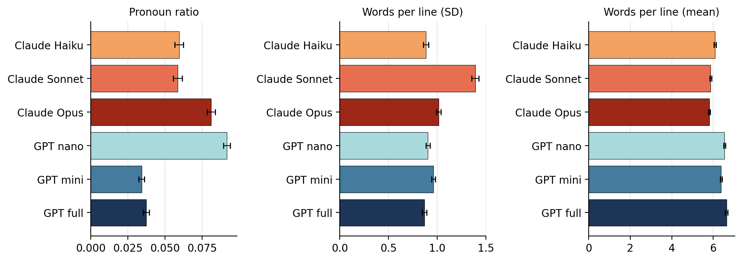
Figure 4. Per-model means with 95% CI for the three highest-η² features. Pronoun ratio (left) shows non-monotonic within-family structure. Words-per-line SD (middle) shows the Sonnet outlier. Words-per-line mean (right) shows the clean family separation.

§5. Phrasing matters, but is dominated by model identity
Q3 of the preregistration runs a 2-way ANOVA on each feature with model and phrasing as factors. Phrasing was manipulated by varying the verb in the prompt: write / compose / gimme a poem in fewer than N lines.
A phrasing main effect is statistically significant for most primary features after Bonferroni correction. But the effect sizes are small. Across the 13 features, phrasing main-effect η² ranges from 0.001 to 0.037 (median 0.004); model main-effect η² ranges from 0.017 to 0.231 (median 0.089). Phrasing reliably matters; phrasing matters much less than which model is generating the poem.
The model × phrasing interaction is significant for 9 of 13 features but again with small effect sizes (interaction η² ≤ 0.017 across the battery). The strongest single phrasing pattern is that gimme systematically produces slightly shorter lines: every model produces lower words-per-line under gimme than under write or compose. The effect is real but in the 0.1–0.4-words-per-line range — closer to a register tic than a major behavioral shift.

§6. Length-constraint compliance
The preregistration’s Q4 is a logistic regression of compliance (line_count < N) on model, length cap, and phrasing.
Overall compliance is 0.998 — 5,387 of 5,397 poems comply with their length cap. All four GPT cells achieve 100% compliance at all three caps and all three phrasings. The only sub-100% cells are Claude at the cap-5 condition: Haiku 296/300, Sonnet 300/300, Opus 297/300, with one additional Haiku miss at cap-10 and one additional Opus miss at cap-20. Aggregate Claude cap-5 compliance is 99.2%; everything else is 99.8–100%.
The logistic regression itself produces large coefficients (15–22) with p-values near 0.99 — a separation artifact, not a meaningful test, because the GPT cells contribute zero variance. The preregistration anticipated this exact failure mode (“if compliance rates are uniformly near-perfect or uniformly low across all cells, the compliance question loses its variance and Q4 becomes degenerate; this is reported as such”), and the deviation log records it as such. The per-cell compliance table is reported descriptively in the corrected analysis output and the regression is not interpreted.
Q4 is a null result. It is reported here because the prereg locked the test and the prereg is honored.

§7. Classifier check
A multinomial logistic regression on the 13 primary features, evaluated under stratified 5-fold cross-validation, reaches 56.4% (SD 1.3%) accuracy on six-way model classification against a chance rate of 16.7%. Two-way family classification reaches 74.3% (SD 2.2%) against chance 50%. This is exploratory — not preregistered — and the features it uses are exactly the 13 in the primary battery, no additional engineering, no held-out feature space, no embeddings.
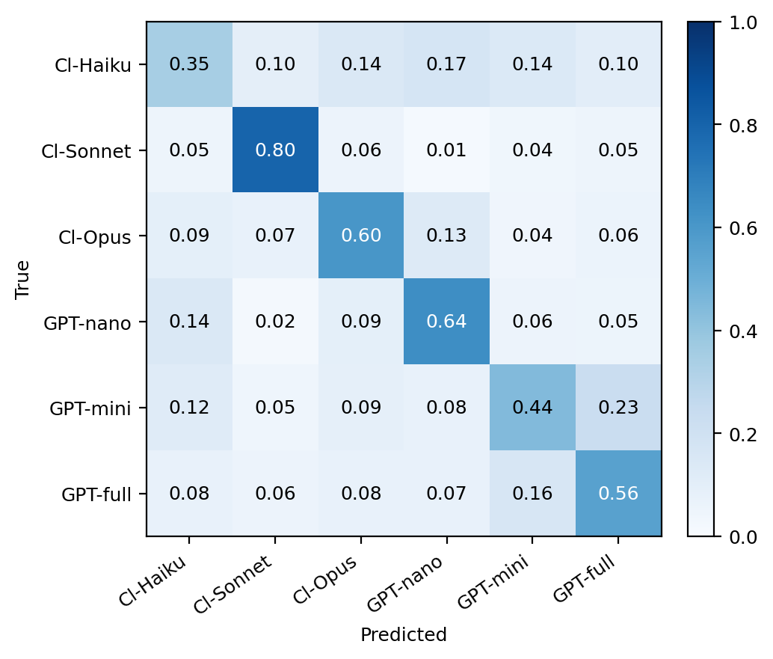
Figure 5. Confusion matrix for the 6-way classifier (row-normalized; rows are true, columns are predicted). Accuracy 56.4% across folds. Sonnet most identifiable (recall 0.80), Haiku least (0.35). The largest off-diagonal mass is GPT-mini being confused with GPT-full (0.23), the only substantial cross-family confusion.
The confusion matrix tells the same story as the means table. Sonnet is the easiest to identify (recall 0.80) because of its line-irregularity and stanza-aggressive defaults. Haiku is the hardest to identify (recall 0.35) because its feature distribution sits near the joint center; its mass spreads roughly evenly across the other models in the matrix, with no specific neighbor it gets confused with. Opus identifies as itself 60% of the time. GPT-nano is identifiable at 64%, mostly because of the lyric-I-driven pronoun ratio. GPT-mini and GPT-full are the most mutually confusable pair (off-diagonal 0.23 in one direction, 0.16 in the other) — consistent with the impression from the means table that they share most defaults.
The 56.4% number is interesting in part because it is essentially identical to Series 1’s 56.5% on a smaller sample with different prompts and different features. Whether that convergence is meaningful or a coincidence of an underlying “how much of model identity is decodable from cold-prompt structural features” constant is not testable here.

§8. The bug, the validation, and the sensitivity rerun

§8.1 The bug
During preparation of this paper, a key-name mismatch was discovered in the analysis pipeline. The feature serializer (analysis/features.py line 587) writes POS-ratio features to the on-disk JSONL with a pos_ prefix: pos_noun_ratio, pos_verb_ratio, and so on. The analyzer (analysis/analyze.py, PRIMARY_FEATURES constant) was looking them up by their bare names: noun_ratio, verb_ratio, etc. The lookup silently failed for all five POS-ratio features; they were reported as “no data” in the original Q2 and Q3 tables in Results and Analysis/analysis_report.md.
Q1 (embedding clustering) and Q4 (compliance) do not use these features and were unaffected by the bug. Eight of the 13 preregistered features were reported correctly in the original output.
The fix is one line: change the names in PRIMARY_FEATURES to match the on-disk keys. The fix is recorded in Bullshit_Assay_2/Claude_Analysis/deviations.md. The corrected analysis adds the five POS features back; effect sizes for the eight previously-present features are byte-identical to the original report; Q1 and Q4 are byte-identical.
The largest substantive change is that pos_pronoun_ratio enters at η² = 0.229, the largest feature effect in the study and approximately six points larger than the next-largest. The voice findings in §3.3 and the within-family non-monotonicity in §3.4 depend on this feature being present.

§8.2 Validation
A 200-poem stratified blinded sample (preregistered as 50; deviation logged) was hand-tagged at a single-purpose HTML interface that hides model identity from the rater. Four feature categories were validated: the spaCy POS tags broadly (pos_ok), the rhyme detector against the rater’s ear (rhyme_ok), the rule-based person classifier (person_ok), and the preamble detector and split (preamble_ok). Tag levels are yes/mostly/no for pos_ok, yes/partial/no for rhyme_ok, yes/no for the others.
Under partial-credit scoring (yes = 1.0, mostly/partial = 0.5, no = 0.0): pos_ok 0.860, rhyme_ok 0.860, person_ok 0.905, preamble_ok 0.905. All four pass the 0.85 threshold. The preregistration locks the threshold but did not specify how partial-credit tags map to a numeric agreement rate; the partial-credit choice is logged as a deviation.
Under strict yes-only scoring, pos_ok rates 0.78 and rhyme_ok rates 0.775, both failing the 0.85 threshold. Under that scoring rule, the five POS-ratio features and the rhyme-participation feature would be downgraded to exploratory.

§8.3 Sensitivity rerun
The full primary analysis was rerun with the validation-gated features removed, leaving 7 of the 13 primary features (line_count, stanza_count, words_per_line_mean, words_per_line_sd, total_words, mean_word_length, concreteness_mean). All seven retained features remain Bonferroni-significant at the looser α = 0.05/7 = 0.0071, with η² > 0.01 for every one. Q1 silhouettes are byte-identical to the main analysis (the Q1 statistic does not depend on the feature list). Q3 phrasing main effect remains significant.
The headline finding “models differ on every preregistered structural feature” survives strict-validation scoring. The pronoun-ratio finding (§3.3) and the rhyme-default finding (§9.1) are gated on partial-credit scoring; the family-separation finding (§3.1), the preamble finding (§3.2), the words-per-line family signal, the Sonnet line-irregularity, and the Opus length/concreteness pattern (§3.4) are all in the unconditional 7-feature battery.

§9. Exploratory observations

§9.1 Rhyme defaults split by family
The preregistered analyses test rhyme participation rate — the proportion of lines that rhyme with at least one other line, by CMU dictionary lookup. The descriptive distribution of detected rhyme schemes is exploratory but striking enough to flag.
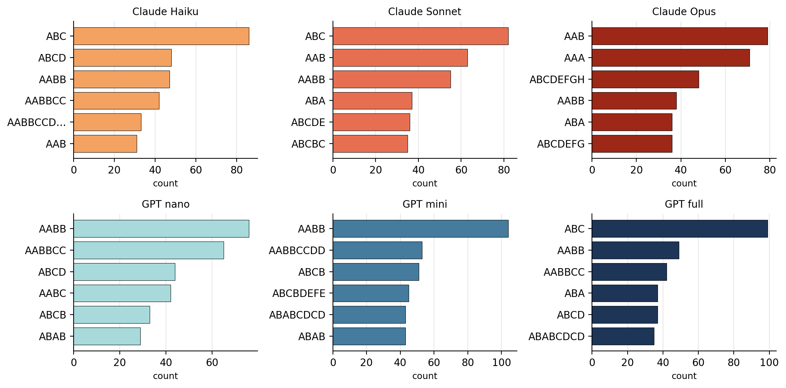
Figure 6. Top-6 most common detected rhyme schemes by model. Schemes are ordered alphabetically by line, so “ABCD” = no rhyme detected, “AABB” = couplets, “ABAB” = alternating. GPT models default to rhymed forms (especially mini); Claudes more often produce unrhymed free verse.
GPT-mini’s top scheme is AABB (couplets) at 104/899 poems; the second is the eight-line variant AABBCCDD at 53. GPT-nano leads with AABB and AABBCC. GPT-full is more split but its top three are dominated by partial rhyme. Claude-Sonnet and Claude-Haiku lead with “ABC” — no detected rhyme — followed by partial-rhyme schemes. Opus shows the most varied profile, with AAB, AAA, and ABCDEFGH (eight unique unrhymed lines) all in the top three.
This is consistent with the rhyme-participation result (GPTs higher: 0.62, 0.64, 0.53 vs Claudes 0.50, 0.50, 0.52) but is more granular: GPTs default to a small set of conventional rhyme patterns, while Claude defaults are more heterogeneous and tilt toward free verse.

§9.2 The Sonnet outliers in embedding space
The two Sonnet outlier clusters in Figure 1 (lower-left and far-right) merit a brief look. The lower-left cluster (≈45 poems) is dominated by long stanzaic outputs at the cap-20 condition; words_per_line stays moderate but stanza_count is uniformly high (median 5–6). The far-right cluster (≈30 poems) is the inverse: extremely short outputs, often single lines with a title, frequently at cap-5 with the gimme phrasing. Sonnet appears to have a bimodal cap-5 response — either a tight haiku-like fragment or a refusal-shaped ultra-short reply — that the other models do not exhibit.
This is exploratory and the cluster identification is by visual inspection of the UMAP, not a preregistered analysis. It is reported as a hypothesis-generating observation.

§10. What we expected, and where we were wrong
Important framing note: this section is post-hoc. Series 1 used a sealed-prediction protocol — wrong guesses committed to the labeled record before unblinding — that gave its “what we expected” structure real evidential weight. Series 2 has no such protocol. The analysis was conducted with the data fully visible. What follows is honest framing of intuitions but should not be read as a confirmatory test.
Three intuitions about how the data should look, retrospectively recoverable from informal discussion before the analysis:
- Tier should matter monotonically within family. That is, small/medium/large should be ordered on most features. The data do not show this. Within Claude, Opus is distinct from a fairly similar Sonnet/Haiku pair on length, concreteness, and voice; within GPT, nano is the outlier with mini and full clustered together. The within-family structure is not three rungs of a ladder; it is a distinguishable model and two more similar siblings, in different configurations on each side.
- GPT should preamble more on long prompts. On the assumption that preambles are conversational scaffolding for substantial replies, longer outputs should attract more of them. The data show GPTs essentially never preambling regardless of length, while Claudes do so categorically with one length-conditional carve-out at Opus cap-5.
- Family should dominate tier on most features. This one was right — more right than expected. On words-per-line mean, total words, adverb ratio, and verb ratio, family separates cleanly while tier scrambles within each family. The cleanest within-family signal is voice (§3.3), and that one doesn’t track tier either.
The retrospective form of “what we expected” is weaker than a sealed prediction; treat the above as scaffolding for the discussion, not as evidence about the data.

§11. Limitations
- Cold contextless prompts measure defaults. Default behavior is what the model does when nothing is asking for anything specific; it is not capability and it is not preference. Findings from this study should not be extrapolated to behavior under realistic system prompts, conversational context, or task-specific instructions.
- n = 100 per cell at temperature 1.0. Within-cell observations are not strictly independent draws — they are 100 samples from one model’s distribution conditioned on a single prompt. Effective sample sizes are below the nominal 100, and the F-statistics in §4 are correspondingly more aggressive than they should be under strict IID assumptions. The largest effects (F > 100) are robust to any reasonable correction; effects with F near 18 (line_count, total_words) should be read as real but small.
- Single-snapshot model versions. Claude Haiku is pinned to a dated snapshot; the other five models use unpinned aliases for parity with Series 1. Future drift in any of these aliases would shift the per-model results. Snapshot identifiers logged at run time are in run_metadata.json.
- POS taggers are imperfect on poetry, especially with enjambment, archaic constructions, and non-standard punctuation. The 200-poem manual validation step is the safety check; features that fail validation are flagged and excluded from the strict-sensitivity rerun.
- Validation export does not carry model identity. The HTML tagging tool blinds models, correctly, but the export does not rejoin model identifiers to per-poem disagreements. As a result, this paper cannot say whether tagger disagreements are concentrated on outputs from particular models. The 25 free-text disagreement notes from validators include 18 instances of “title included as first line,” which is plausibly a model-specific behavior; future work should rejoin model identity to the validation tags and check.
- Author conflict. The analyst is Claude Opus 4.7. Two of the six experimental subjects are Anthropic models and one is the analyst. The mitigations — deterministic coders, preregistered analysis, locked decision rules, public deviation log, sensitivity rerun — bound the conflict but do not eliminate it. The Opus-distinctness finding in §3.4 is the result most affected by this concern and is flagged at point of report.

§12. Findings table
Finding | Where | Status
Models cluster in embedding space; family > tier | §3.1 | Preregistered Q1; supported (p < 0.001 vs permutation null)
Preamble is categorical; Opus has cap-5 override | §3.2 | Exploratory in prereg; visualized (Fig 2)
Voice does not track tier within family | §3.3 | Preregistered (pos_pronoun_ratio in Q2); largest η² in study
Opus structurally distinct from other Claudes | §3.4 | Multiple preregistered features; flagged for author conflict
All 13 features differ across models | §4 | Preregistered Q2; all Bonferroni-significant, all η² > 0.01
Phrasing matters; less than model identity | §5 | Preregistered Q3; phrasing main effect significant on most features
Q4 compliance regression degenerate | §6 | Preregistered Q4; reported as degenerate per locked fallback
Classifier 56.4% (6-way) / 74.3% (family) | §7 | Exploratory; not preregistered
POS features were dropped from original analysis | §8.1 | Bug fix; logged in deviations.md
Conclusions hold under strict-validation rerun | §8.3 | Sensitivity analysis; logged
GPTs default to rhymed forms; Claudes to free verse | §9.1 | Exploratory
Sonnet has a bimodal cap-5 response (UMAP) | §9.2 | Exploratory; visual inspection only
Table 4. Summary of findings, sections, and confirmatory/exploratory status.

§13. Conclusion
Six frontier language models, given the same nine cold-prompt poetry tasks 100 times each, produce 5,397 poems whose stylistic defaults are detectably different across every preregistered structural feature. The differences are not uniformly tier-monotonic and not uniformly family-aligned. They are model-specific, sometimes shared between unexpected pairs (GPT-nano and Claude-Opus on lyric voice; GPT-mini and Claude-Sonnet on descriptive third-person), and sometimes categorical (Claude’s preamble universalism, Opus’s cap-5 override, GPT-mini’s couplet preference).
The methodological story is at least as important as the empirical one. A locked preregistration caught a bug that silently dropped five primary features from the as-run analysis. A 200-poem human validation step, scaled up from the 50-poem preregistered version, kept four feature categories within agreement bounds under partial-credit scoring. A sensitivity rerun under strict yes-only scoring confirms that the central claims survive even when the partial-credit-validated features are downgraded. None of this prevented the bug; the prereg made the bug findable, and the public log makes it accountable.
The folk-stereotype that family beats tier is closer to right than the alternatives, but only on average and not as a clean rule. The data show three Claudes that are more similar to each other than to any GPT, and three GPTs that are more similar to each other than to any Claude, but with one genuine within-family outlier on each side and a non-trivial number of features on which the small/medium/large ordering inverts or scrambles. “Six ways to write a synthetic poem” understates the case: there are six different ways, but only loosely organized into two groups, and the within-group structure is not what you would predict from a tier label.
All raw outputs, features, embeddings, code, preregistration, deviation log, and analysis artifacts are in the public repository at github.com/quumble/An-Assay-of-Bullshit. The corrected analysis is in Bullshit_Assay_2/Claude_Analysis/; the as-run record is preserved unchanged at Bullshit_Assay_2/Results and Analysis/.

References and resources
Brysbaert, M., Warriner, A. B., & Kuperman, V. (2014). Concreteness ratings for 40 thousand generally known English word lemmas. Behavior Research Methods, 46(3), 904–911.
McInnes, L., Healy, J., & Melville, J. (2018). UMAP: Uniform Manifold Approximation and Projection for Dimension Reduction. arXiv:1802.03426.
Honnibal, M., Montani, I., Van Landeghem, S., & Boyd, A. (2020). spaCy: Industrial-strength Natural Language Processing in Python.
Pennycook, G., Cheyne, J. A., Barr, N., Koehler, D. J., & Fugelsang, J. A. (2015). On the reception and detection of pseudo-profound bullshit. Judgment and Decision Making, 10(6), 549–563.
OpenAI text-embedding-3-large: https://platform.openai.com/docs/guides/embeddings
CMU Pronouncing Dictionary: http://www.speech.cs.cmu.edu/cgi-bin/cmudict
Repository (all data, code, and methodological artifacts): https://github.com/quumble/An-Assay-of-Bullshit

