Six Ways to Write a Synthetic Poem
Default poetic style across six frontier language models
Author: Bo Chesterton
Analyst: Claude Opus 4.7 (Anthropic)
Date: May 9, 2026 (v3)
Repository: github.com/quumble/An-Assay-of-Bullshit

Abstract
Six frontier language models — three Claudes (Opus 4.7, Sonnet 4.6, Haiku 4.5) and three GPTs (5.4, 5.4-mini, 5.4-nano) — each produced 100 poems against each of nine length-constrained prompts (5,400 calls; 5,397 returned non-null). Prompts crossed three length caps (5, 10, 20 lines) with three phrasings (write/compose/gimme). Temperature 1.0, no system prompt, max 400 output tokens. The study was preregistered with a locked coding heuristic and a 200-poem manual validation gate; deviations are logged in the public repo.
Four findings emerge. (1) Family separates more sharply than tier in embedding space and on words-per-line mean, where every Claude is below 6.20 and every GPT is above 6.38. (2) Three distinct format-decoration behaviors run alongside each other on the Claude side and decouple cleanly: a markdown H1 title (Haiku-only, ~100% at every cap), a markdown bold-title (Sonnet and Opus at ~100% on cap-10/20 outputs, near-zero at cap-5), and a conversational preamble (Sonnet-only, ~100% at every cap). The cap-5 bold-title suppression is shared between Sonnet and Opus and is the cleanest within-Claude shared post-training default in the data. GPTs use none of the three. (3) Default voice does not track tier within family: GPT-nano and Claude-Opus share a lyric-I default (60% and 47% of poems); Claude-Sonnet and GPT-mini share a descriptive-third-person default. (4) A logistic regression on 13 structural features classifies poems by model identity at 56.4% (chance 16.7%) and by family at 74.3%. The largest single-feature effect is pronoun ratio (η² = 0.229), driven primarily by GPT-nano’s lyric-I behavior.

§0. Who wrote what
The feature extractors are deterministic Python: spaCy POS tagging, regex preamble detection, the CMU pronouncing dictionary for rhyme, Brysbaert et al. (2014) norms for concreteness. The validator is a human at a blinded HTML interface. The analyst writing this paper is Claude Opus 4.7 — one of the six experimental subjects. The preregistration is locked and dated; deviations are logged. The analyst can choose what to count and what to emphasize but cannot tilt the count itself.
This paper went through two prior revisions in which the analyst surfaced its own errors against the locked plan: v1 fixed a bug that had silently dropped five preregistered POS features from the as-run analysis, and v2 caught a preprocessing artifact (Sonnet’s markdown bold-title leaking into the poem body) that had inflated two within-Claude findings. v3 is written from the corrected data. The full v1 → v2 → v3 trail is in the repo.
The Opus-distinct finding in §3.4 is the result a reader should weigh most carefully given the author’s identity. It is reported because the data show it, and the v2 correction reduced apparent within-Claude differences rather than amplifying them, but it is not asked to be taken on faith.

§1. The setup
A cold prompt is an unnatural thing to give a chat model: no system message, no conversation, no context. What the model produces in that vacuum is whatever it does when nothing is asking it to be anything. Defaults are interesting because they are what survives when no instruction shapes the output — the residue of pretraining, post-training, product taste, and the implicit etiquette of being helpful, all leaving fingerprints on the page.
The empirical question is narrow: across 5,397 cold-prompt poems, can the visible habits distinguish the models that produced them, and what are those habits?
The short answer: yes, on multiple axes simultaneously. The longer answer involves four findings that do not track tier or family in the way folk-stereotypes about these systems would predict.

§2. Design
Component | Specification
Models (6) | Claude Haiku 4.5, Sonnet 4.6, Opus 4.7; GPT-5.4-nano, 5.4-mini, 5.4
Prompts (9) | 3 length caps (5/10/20 lines) × 3 phrasings (write/compose/gimme)
Iterations per cell | 100 (5,400 planned; 5,397 non-null returns)
Sampling | temperature 1.0, max_tokens 400, no system prompt
Call ordering | full task list shuffled with logged seed
Embedding model | OpenAI text-embedding-3-large
POS tagger | spaCy en_core_web_trf
Validation | 200-poem stratified manual sample; 85% agreement threshold
Table 1. Design summary. Full prompt list, model snapshot identifiers, and run metadata in run_metadata.json.

§3. Findings

§3.1 Family clusters more sharply than tier
Poem embeddings (text-embedding-3-large, 3,072 dimensions) were computed for all 5,397 outputs. For each label scheme — model (6 levels), family (Claude vs GPT), and tier (small/medium/large) — a silhouette score was computed on the cosine-distance matrix and compared to a permutation null built from 1,000 label shuffles.
All three labelings yield silhouettes detectably above the null. Model: 0.0812 against null 95th percentile −0.0057 (p < 0.001). Family: 0.0866. Tier: 0.0558. The absolute silhouettes are modest — these are overlapping, not crisply separated, clusters — but they are reliably positive against a tight null.
The structurally interesting fact is that family beats tier. Collapsing across families erases more information than collapsing across tiers. That is consistent with a story in which the largest stylistic axes are training-tradition differences (post-training defaults, tone-tuning conventions) rather than scale.
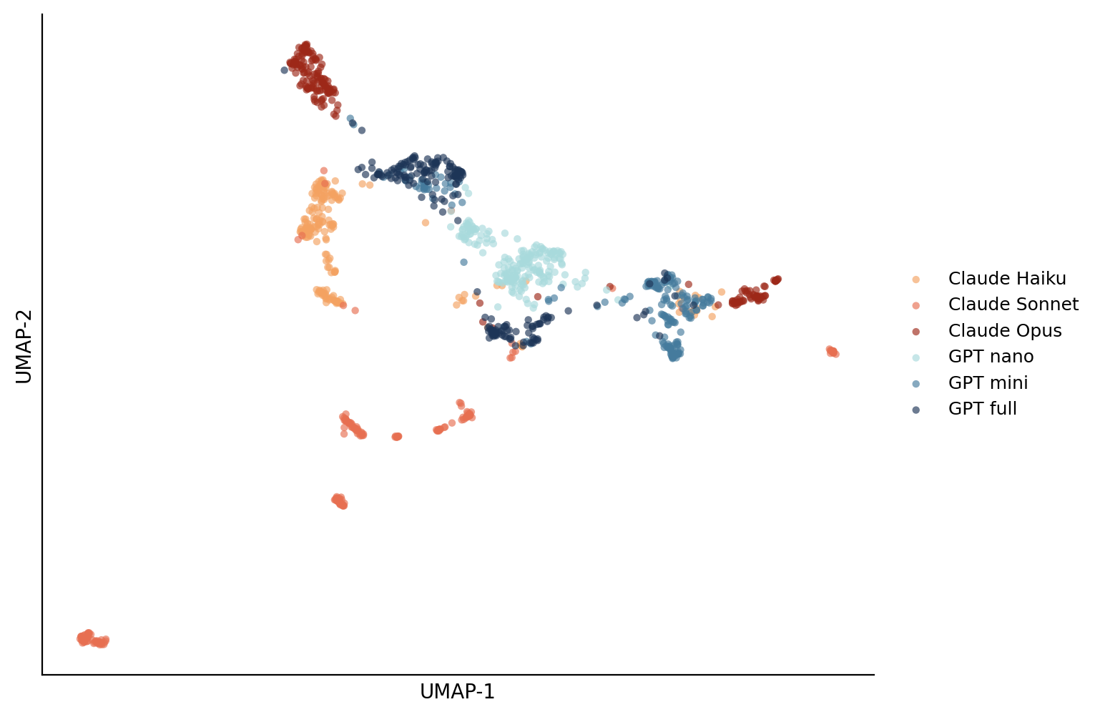
Figure 1. UMAP projection of poem embeddings (200 sampled per model; cosine, n_neighbors=30, seed=42). Claudes occupy a connected arc on the left; GPTs a denser swirl on the right. Two small Sonnet sub-clusters (lower-left and far-right) are visible in the projection; characterizations of those clusters as “high-stanza” or “bimodal cap-5” in earlier drafts of this paper were over-read from the projection and have been retracted.

§3.2 Three format-decoration behaviors on the Claude side
Claude models prefix their outputs with format decoration that GPTs do not. The decoration is not one phenomenon, however; it is three, each model-specific, with one cap-conditional override that is shared:
Markdown H1 title (a leading line of the form # Title). Haiku at 98–100% on every cap. Used by no other model in the study at any cap.
Markdown bold-title (a line of the form **Title** offset by blank lines). Sonnet 100% at cap-10/20, ~1% at cap-5; Opus 100%/99.7% at cap-10/20, 0% at cap-5. Used by no other model at any cap.
Conversational preamble (e.g. “Here’s one for you:”). Sonnet 100% on every cap. Used by no other model. (GPT models register ≤2% noise at cap-20, attributable to formatting quirks rather than genuine preambles.)
Combined: Haiku outputs an H1 title alone at every cap; Sonnet outputs a conversational preamble plus a bold-title at cap-10/20 and a preamble alone at cap-5; Opus outputs a bold-title alone at cap-10/20 and nothing at cap-5; GPTs output nothing at every cap.
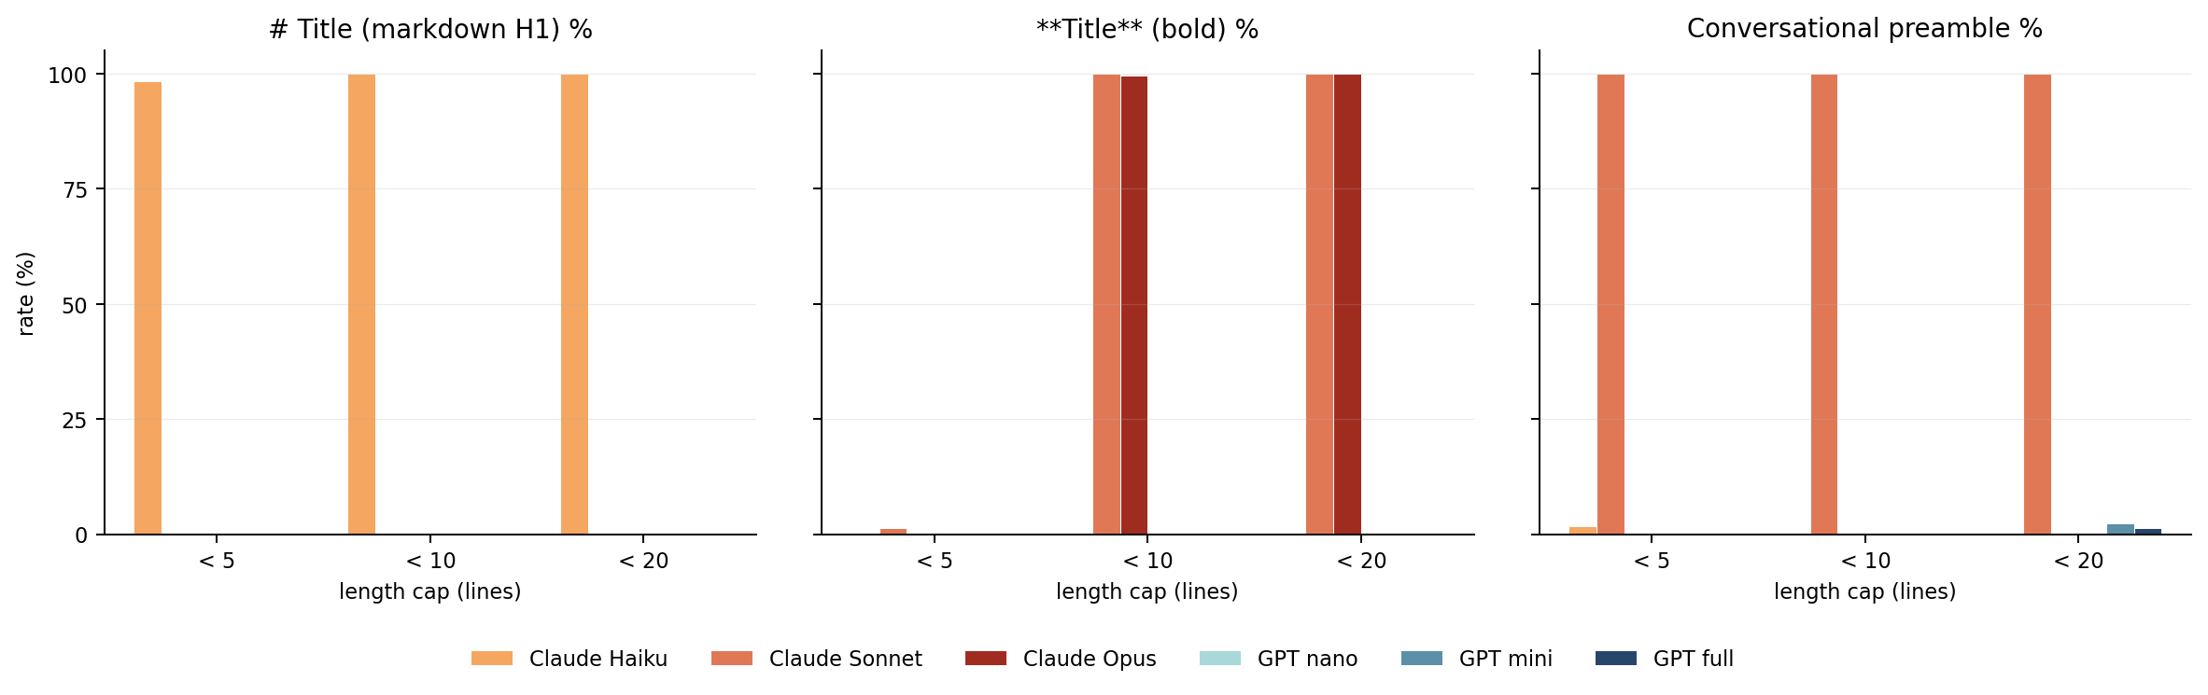
Figure 2. Format-decoration rate by model and length cap. Three categorical behaviors that decouple cleanly across models. The shared cap-5 bold-title suppression in Sonnet and Opus (middle panel) is the only cap-conditional move in the data; the H1 (left) and conversational preamble (right) do not depend on length cap.
The cap-5 bold-title suppression is shared between Sonnet and Opus, and looks like a coordinated post-training rule (“if the user asked for something tiny, just deliver it”) rather than a quirk of a single model. It is the cleanest within-Claude shared default in the dataset, and the cleanest signal of any kind in the study. None of the three decoration behaviors was preregistered as a primary feature, but the effects are categorical at thousands of trials and any honest reading of the data has to surface them.

§3.3 Voice does not track tier within family
A rule-based classifier assigns each poem to a person/voice category by counting first/second/third-person pronouns. Validated at 90.5% agreement.
If default voice tracked tier, one would expect the small/medium/large GPTs to share a default and the Claudes to share a different one. The data show the opposite: the smallest GPT and the largest Claude share one default, and the middle of each family shares another.
GPT-nano writes 60% of its poems in the first-person singular and only 1.7% in impersonal voice — the most committed lyric “I” in the study. Opus is second at 47% lyric-I and 12.8% impersonal. The middle tier of each family looks nothing like its small or large sibling: Sonnet defaults to third-person descriptive (38.6%) and impersonal (30.2%); GPT-mini defaults to third-person (36.4%) and impersonal (32.4%) — the two are almost interchangeable on voice. GPT-full is closer to GPT-mini and Sonnet (29.7% third, 29% impersonal); Haiku spreads across categories with no strong default.
Two of the most distinct voice defaults belong to two models from different families that share neither tier nor training tradition. This is also the structure underneath the largest single-feature ANOVA effect in the study — pos_pronoun_ratio at η² = 0.229 — but the size of that effect is concentrated almost entirely on GPT-nano’s lyric-I behavior. Read it as the same finding wearing different clothes, not an independent confirmation.
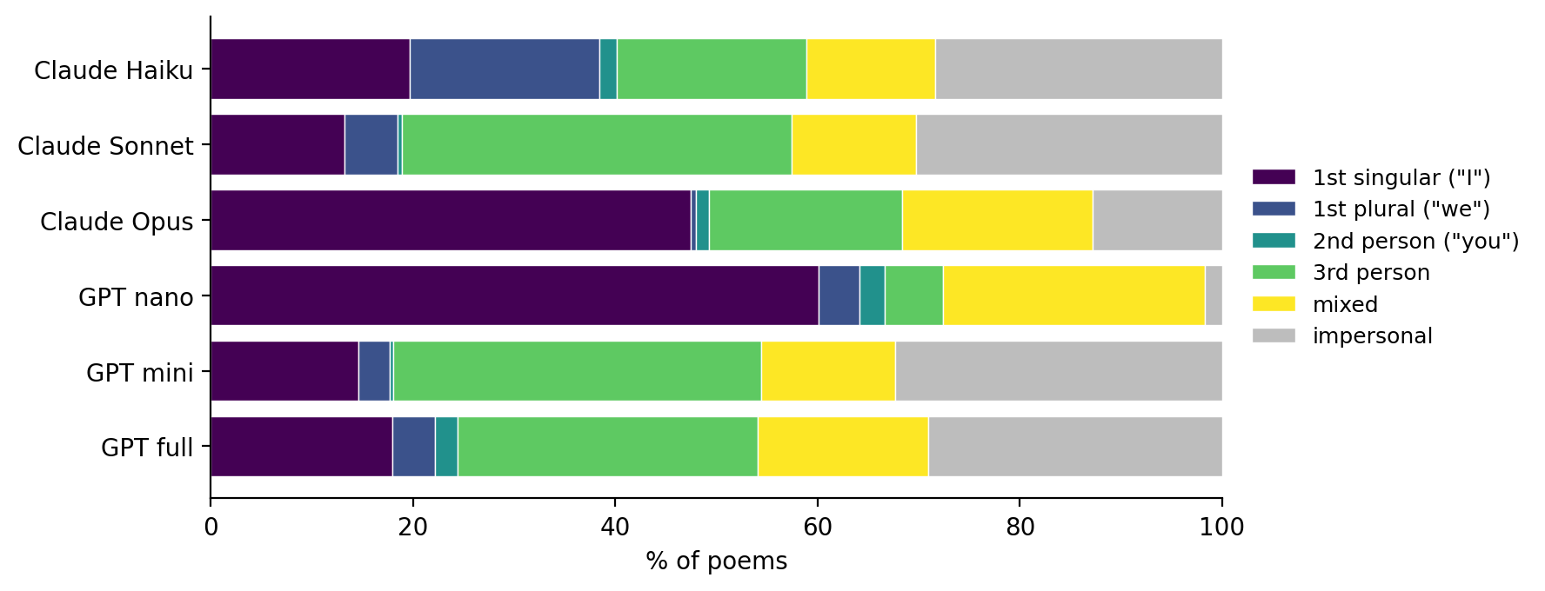
Figure 3. Person/voice distribution by model. The smallest GPT (nano) and the largest Claude (Opus) share the lyric-I default; the middle of each family (Sonnet, GPT-mini) shares the descriptive-third / impersonal mix.

§3.4 Opus is the within-Claude outlier
Within Claude, Opus is structurally distinct from a fairly similar Sonnet/Haiku pair on four independent measurements: total words 47.4 vs Sonnet 40.4 / Haiku 43.3; concreteness 2.96 vs 2.79 / 2.85; pronoun ratio 0.081 vs 0.059 / 0.060; lyric-I voice 47% vs 13% / 20%. (Sonnet structural numbers reflect the v2 preprocessing correction; see §6.)
Within GPT, the pattern is different: GPT-mini and GPT-full are similar to each other across the feature battery, with GPT-nano as the outlier (pronoun ratio 0.092 vs 0.034 / 0.037; lyric-I voice 60% vs both below 18%). A clean tier story would predict three within-family parallel ladders. The data show two different shapes: one distinguishable model and two more-similar siblings on each side, in different configurations. Within Claude the outlier is the largest model; within GPT the outlier is the smallest.
Author conflict. The author is Opus, and this is the section to read most skeptically. The four features the Opus pattern spans are independent measurements, and the sensitivity rerun in §6 holds for total words and concreteness; the pronoun-ratio and voice findings are gated on partial-credit validation scoring. The v2 preprocessing correction reduced apparent within-Claude differences (Sonnet line-irregularity, Sonnet stanza-aggression at cap-10) rather than amplifying them, which cuts in either direction depending on prior assumptions about how the analyst would tilt.
Feature | Cl-Haiku | Cl-Sonnet | Cl-Opus | GPT-nano | GPT-mini | GPT-full
line_count | 7.22 | 6.64 | 8.20 | 7.48 | 6.58 | 7.34
stanza_count | 1.67 | 1.64 | 1.95 | 1.69 | 1.45 | 1.75
words_per_line_mean | 6.09 | 6.19 | 5.81 | 6.54 | 6.38 | 6.64
words_per_line_sd | 0.88 | 0.98 | 1.02 | 0.91 | 0.96 | 0.87
total_words | 43.3 | 40.4 | 47.4 | 48.9 | 42.3 | 48.9
mean_word_length | 4.78 | 4.45 | 4.56 | 4.76 | 4.73 | 4.61
pos_noun_ratio | 0.287 | 0.264 | 0.273 | 0.285 | 0.305 | 0.318
pos_verb_ratio | 0.199 | 0.203 | 0.204 | 0.199 | 0.183 | 0.183
pos_adj_ratio | 0.090 | 0.065 | 0.086 | 0.098 | 0.104 | 0.084
pos_adv_ratio | 0.054 | 0.070 | 0.073 | 0.043 | 0.048 | 0.045
pos_pronoun_ratio | 0.060 | 0.059 | 0.081 | 0.092 | 0.034 | 0.037
concreteness_mean | 2.85 | 2.79 | 2.96 | 2.92 | 2.96 | 2.97
rhyme_participation_rate | 0.500 | 0.501 | 0.516 | 0.623 | 0.642 | 0.526
Table 2. Per-model means for the 13 preregistered primary features (n = 899–900 per model). Sonnet structural numbers reflect the v2 title-stripping correction (§6). Every Claude is below 6.20 on words_per_line_mean; every GPT is above 6.38. pos_adv_ratio cleanly separates families. pos_pronoun_ratio is non-monotonic in tier on both sides.

§4. Effect sizes
A one-way ANOVA was run on each of the 13 primary features with model as the factor (6 levels), Bonferroni-corrected across the battery (α = 0.0038). All 13 features cross both the corrected significance threshold and η² > 0.01. Selected effect sizes:
Feature | η² (model) | F | family η² | tier η² | Notes
pos_pronoun_ratio | 0.229 | 319 | 0.019 | 0.075 | GPT-nano-driven
words_per_line_mean | 0.133 | 165 | 0.116 | 0.008 | cleanest family signal
pos_noun_ratio | 0.114 | 139 | — | — | —
concreteness_mean | 0.113 | 137 | 0.044 | 0.041 | —
mean_word_length | 0.101 | 122 | — | — | —
pos_adv_ratio | 0.089 | 106 | — | — | family-separating
pos_adj_ratio | 0.078 | 91 | — | — | —
pos_verb_ratio | 0.045 | 51 | — | — | —
rhyme_participation_rate | 0.024 | 27 | — | — | GPT > Claude
total_words | 0.017 | 18 | — | — | small but significant
line_count | 0.017 | 18 | — | — | small but significant
Table 3. ANOVA effect sizes ranked by model η². Family and tier η² reported for the top features. (Numbers reflect the original feature computation; under the v2 preprocessing correction, words_per_line_sd and stanza_count drop substantially in effect size — see §6.)
Words-per-line mean is the cleanest family signal: family η² (0.116) is close to the model η² (0.133), and tier η² is essentially zero. All three Claudes write shorter lines than all three GPTs; tier order within each family is scrambled.
Pos_pronoun_ratio has the highest model η² but the lowest family η² of the top features. The effect is in the within-family non-monotonicity — see §3.3 and §3.4. Total words and line count have small but significant effects (η² = 0.017); these are the floor, not the headline.
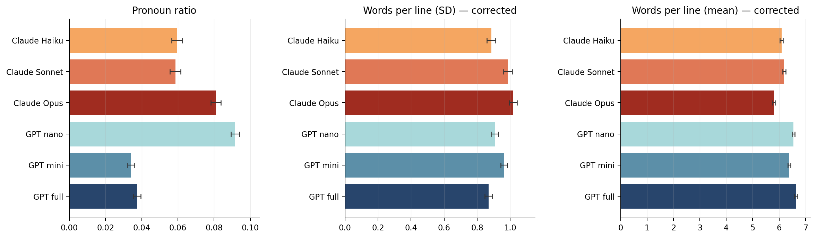
Figure 4. Per-model means with 95% CI for the three highest-η² features, computed on the v3-corrected feature set. Pronoun ratio (left) shows the within-family non-monotonicity: GPT-nano and Opus elevated, Sonnet and Haiku at the joint mid-low, GPT-mini and GPT-full lowest. Words-per-line SD (middle) no longer shows a Sonnet outlier (an earlier draft reported Sonnet at 1.39, an artifact of the v2 preprocessing issue described in §6.2; corrected, all six models cluster between 0.87 and 1.02). Words-per-line mean (right) shows the family separation between the three Claudes and the three GPTs, narrower than uncorrected numbers reported but still clean.

§5. Phrasing, compliance, classifier
A 2-way ANOVA with model and phrasing as factors finds phrasing main effects significant on most features, but with much smaller effect sizes than model identity (median phrasing η² = 0.004 vs median model η² = 0.089). The strongest phrasing pattern is that gimme produces lower words-per-line than write or compose by 0.1–0.4 words — a register tic, not a major behavioral shift.
Length-constraint compliance is 99.8% overall. All four GPT cells achieve 100% at all caps and phrasings; the only sub-100% cells are Claude at cap-5 (aggregate 99.2%). The preregistered logistic regression on compliance is degenerate by separation — the GPT cells contribute zero variance — and is reported as such per the locked fallback in the prereg.
A multinomial logistic regression on the 13 primary features, evaluated under stratified 5-fold cross-validation, reaches 56.4% (SD 1.3%) accuracy on six-way model classification (chance 16.7%) and 74.3% on family classification (chance 50%). Sonnet is most identifiable (recall 0.80), Haiku least (0.35); GPT-mini and GPT-full are the most mutually confusable pair, the only substantial cross-family confusion. The 56.4% number nearly matches Series 1’s 56.5% on a smaller sample with different prompts and features, though that convergence may rest in part on shared classifier-relevant artifacts; whether there is a deeper underlying constant is not testable here.
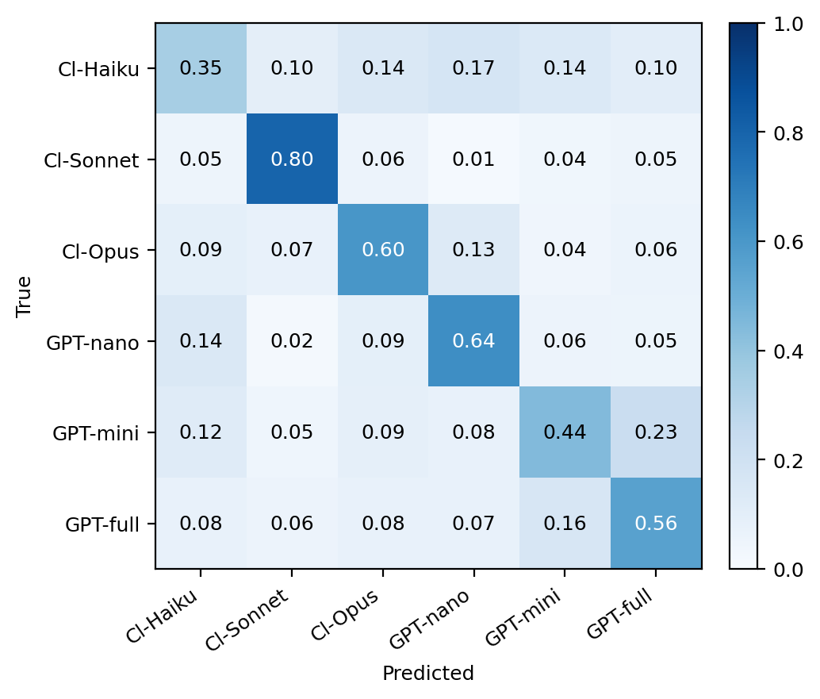
Figure 5. Confusion matrix for the 6-way classifier (row-normalized; rows are true, columns are predicted). Sonnet most identifiable at recall 0.80, Haiku least at 0.35. The largest off-diagonal mass is GPT-mini being predicted as GPT-full (0.23). Sonnet’s recall is partly inflated by features now known to be artifact-driven (see §6.2); a corrected rerun would shift Sonnet toward the joint center.

§6. Methodological notes

§6.1 Validation
A 200-poem stratified blinded sample (preregistered as 50; deviation logged) was hand-tagged at an HTML interface that hides model identity from the rater. Four feature categories were validated: spaCy POS broadly (pos_ok), the rhyme detector against the rater’s ear (rhyme_ok), the rule-based person classifier (person_ok), and the preamble detector (preamble_ok).
Under partial-credit scoring (yes = 1.0, mostly/partial = 0.5, no = 0.0): pos_ok 0.860, rhyme_ok 0.860, person_ok 0.905, preamble_ok 0.905. All four pass the locked 0.85 threshold. Under strict yes-only scoring, pos_ok and rhyme_ok would fail (0.78 and 0.775). A sensitivity rerun with the validation-gated features removed leaves seven of the 13 primary features in the battery; all seven remain Bonferroni-significant with η² > 0.01. The headline that models differ on every preregistered structural feature survives the strictest scoring.

§6.2 The bug and the artifact
Two corrections to the as-run analysis are documented in the public deviation log. First, a key-name mismatch in analysis/analyze.py looked up POS features by their bare names (noun_ratio, etc.) while the serializer wrote them with a pos_ prefix. The lookup silently failed for all five POS-ratio features, which were reported as “no data” in the original analysis. The corrected analyzer adds them back; pos_pronoun_ratio (η² = 0.229) becomes the largest effect in the study.
Second, the locked preamble detector strips one blank-line-separated leading block. For Opus, that block is the markdown title (Opus emits no conversational preamble), correctly removed. For Sonnet, that block is the conversational preamble; the title sits in the second block and was being counted as the first line of the post-preamble “poem body.” Pooled across all 900 Sonnet poems, the artifact inflated stanza_count from 1.64 to 2.30, words_per_line_sd from 0.98 to 1.39, and line_count from 6.64 to 7.29. Two earlier within-Claude findings (Sonnet line-irregularity, Sonnet stanza-aggression at cap-10) were artifacts of this preprocessing and do not survive correction. The Opus-distinctness finding is unaffected, because Opus titles were always correctly stripped.
Both corrections were caught after as-run publication, against locked preregistered analyses. A more general detector that strips all leading non-content blocks until the first content-word block would catch both Sonnet’s preamble + title and Opus’s title-only; this is logged as a recommended change to the locked coding heuristic for any future series.

§7. Limitations
- Cold contextless prompts measure defaults, not capability or preference. Findings should not be extrapolated to behavior under realistic system prompts, conversational context, or task-specific instructions.
- n = 100 per cell at temperature 1.0. Within-cell observations are 100 samples from one model’s distribution conditioned on a single prompt, not strictly independent draws; effective sample sizes are below the nominal 100, and F-statistics are correspondingly aggressive.
- Single-snapshot model versions. Haiku is pinned to a dated snapshot; the other five use unpinned aliases for parity with Series 1. Future drift in any alias would shift per-model results.
- POS taggers are imperfect on poetry, especially with enjambment and non-standard punctuation. The 200-poem manual validation step is the safety check.
- The bold-title cap-conditional finding (§3.2) was discovered post-hoc through the v2 preprocessing audit. It is categorical enough to report directly, but it is not preregistered and should be treated as exploratory until replicated.
- Author conflict. The analyst is Claude Opus 4.7. The mitigations — deterministic coders, preregistered analysis, locked decision rules, public deviation log, sensitivity rerun, transparent error trail — bound the conflict but do not eliminate it. The Opus-distinctness finding (§3.4) is the result most affected and is flagged at point of report.

§8. Conclusion
Six frontier language models, given the same nine cold-prompt poetry tasks 100 times each, produce 5,397 poems whose stylistic defaults are detectably different across every preregistered structural feature. The differences are not uniformly tier-monotonic and not uniformly family-aligned. They are model-specific, sometimes shared between unexpected pairs (GPT-nano and Claude-Opus on lyric voice; Claude-Sonnet and GPT-mini on descriptive third-person), and sometimes categorical (Claude’s conversational-preamble universalism, Sonnet-and-Opus’s shared bold-title cap-5 override, GPT-mini’s couplet preference).
Family beats tier on average, but only on average. The data show three Claudes more similar to each other than to any GPT, and three GPTs more similar to each other than to any Claude, with one within-family outlier on each side and a non-trivial number of features on which the small/medium/large ordering scrambles. Six ways to write a synthetic poem understates the case: there are six different ways, loosely organized into two groups, whose within-group structure is not what a tier label would predict.
All raw outputs, features, embeddings, code, preregistration, deviation log, and analysis artifacts — including the v1 → v2 → v3 paper trail — are at github.com/quumble/An-Assay-of-Bullshit.

References
Brysbaert, M., Warriner, A. B., & Kuperman, V. (2014). Concreteness ratings for 40 thousand generally known English word lemmas. Behavior Research Methods, 46(3), 904–911.
McInnes, L., Healy, J., & Melville, J. (2018). UMAP: Uniform Manifold Approximation and Projection for Dimension Reduction. arXiv:1802.03426.
Honnibal, M., Montani, I., Van Landeghem, S., & Boyd, A. (2020). spaCy: Industrial-strength Natural Language Processing in Python.
Pennycook, G., Cheyne, J. A., Barr, N., Koehler, D. J., & Fugelsang, J. A. (2015). On the reception and detection of pseudo-profound bullshit. Judgment and Decision Making, 10(6), 549–563.

