The Boundary Conditions of Model-Associated Style: Separability and Portability Under Distribution Shift
Bo Chesterton
Independent Researcher
Abstract
Claims that a language model "tends to" exhibit a stylistic behavior often assume that a difference observed in one setting remains informative outside it. This study distinguishes local separability from portability: outputs may remain strongly distinguishable by model within a target environment even when an attribution rule learned elsewhere fails to transfer. We harmonized 5,938 creative-writing outputs from two independently conducted May 2026 studies of the same six named model identifiers/endpoints and measured 22 interpretable body-level features spanning structure, word length, part-of-speech composition, pronoun use, and punctuation. A six-way classifier trained on 5,398 poems from Study 2 reached 48.9% accuracy on 180 independently collected Study 1 poems, versus 16.7% chance. Leave-one-phrasing-out and leave-one-length-cap-out accuracy within Study 2 was 61.9% and 48.4%, respectively. By contrast, leave-one-creative-writing-category-out transfer within Study 1 was 22.4% overall, and story-plus-animal-description to poetry transfer was 17.8%. A post-review exploratory diagnostic showed that the same Study 1 poetry target was nevertheless strongly separable locally (median 57.8% across 1,000 balanced resamples). Feature-level analyses likewise showed heterogeneous stability: several punctuation, grammatical, opening, and presentation tendencies persisted across poetry samples, while coarse structural measures did not. The results show that model-associated stylistic information can be present in multiple environments without a source-trained decision boundary being portable between them. Separability and portability should therefore be treated as distinct properties when making model-level claims.
Keywords: language models; stylometry; model attribution; distribution shift; portability; construct validity

Introduction
Researchers routinely summarize language models with statements of the form Model X tends to do Y. A model may be described as unusually verbose, prone to particular rhetorical forms, distinctive in its punctuation, or systematically different from another model on some stylistic measure. Such summaries can be empirically accurate while still carrying an unstated generalization: a difference observed under one prompt, task, sampling regime, or measurement procedure is treated as informative about the model beyond the environment in which it was measured. The scope of that inference depends not only on whether the original difference is reliable, but also on whether the difference remains recognizable when the production environment changes.
There is now substantial evidence that outputs from different large language models contain recoverable model-associated signal. Model-attribution studies have identified lexical, morphosyntactic, structural, and semantic features that distinguish generators, including under some domain shifts. McGovern et al. (2025), for example, showed that comparatively simple lexical and part-of-speech features can support model attribution beyond the domains on which they were learned. Bitton et al. (2025) reported persistent stylistic differences among major model families, while Lu et al. (2026) combined explicit stylometric features with semantic representations for robust attribution and described persistence of model-associated style as “style inertia.” These results establish an important baseline: generator identity can leave detectable traces in text, and some of those traces survive changes of context.
The interpretive problem is older than language models. Computational stylometry has long separated authorship signal from topic, genre, register, and domain effects (Stamatatos, 2009). Cross-domain authorship studies therefore ask not only whether an author can be identified, but whether the learned representation travels when the writing situation changes. Sundararajan and Woodard (2018) examined which linguistic features remain useful under cross-topic and cross-genre conditions, while Altakrori et al. (2021) designed the Topic Confusion Task to distinguish authorship modeling from topic dependence. Contemporary language-model evaluation raises a parallel issue. Prompt formatting and test-distribution choices can alter measured performance and even model rankings (Sclar et al., 2024; Siska et al., 2024), while some apparent instability can arise from the evaluation procedure itself rather than from the underlying output behavior (Hua et al., 2025). More generally, behavioral testing and construct-validity work cautions that an observed score supports only the claims licensed by the measurement design (Ribeiro et al., 2020; Elazar et al., 2021; Bean et al., 2025).
These literatures motivate a distinction that model-attribution work does not always make explicit: separability and portability are different properties. A set of outputs is locally separable when model identity can be recovered by a classifier trained and tested within that environment. A fitted attribution rule is portable when it continues to recover model identity after the environment changes. Failure of transfer therefore does not by itself show that model-associated style has disappeared in the target environment; the target may remain strongly separable even though the source-trained decision rule no longer applies. Conversely, successful transfer demonstrates that some model-associated information in the chosen representation survives the change, but not that every measured behavior is invariant.
We use two independently conducted May 2026 studies involving the same six named model identifiers/endpoints to examine this distinction. Study 1 sampled short stories, create-and-describe-an-animal responses, and poems under small balanced conditions. Study 2 sampled poetry at much greater scale while varying prompt wording and requested line limits. We harmonized both datasets under one parser and one 22-feature body representation spanning output structure, word length, part-of-speech composition, pronoun use, and punctuation. This permits several distinct tests of portability rather than one undifferentiated “out-of-domain” comparison: independent collection within poetry, held-out prompt wording, held-out output constraints, and held-out creative-writing category.
The paper therefore asks a narrower question than whether language models possess “fingerprints” in the abstract:
Which components of model-associated style remain recoverable under changes in production environment, and when does a source-trained attribution rule cease to be portable even though the target environment remains model-separable?
The results support a heterogeneous answer. Six-way model information transferred substantially between independently collected poetry samples and across prompt-wording changes, and much of that signal remained after removing obvious structural variables such as length and stanza count. Transfer across requested line constraints was weaker but still well above chance overall. By contrast, a rule learned from the other Study 1 creative-writing categories transferred poorly into Study 1 poetry. A post-review exploratory diagnostic showed that this same poetry target was nevertheless strongly separable when trained locally. At the feature level, some punctuation, grammatical, opening, and presentation tendencies were comparatively stable, whereas coarse structural measures reorganized substantially. These patterns are better described as boundary conditions on portability than as disappearance of an underlying stylistic signature.

Methods

Study design and evidentiary layers
This study is a secondary synthesis of two language-model experiments completed in May 2026. No new model outputs were generated for the September analysis. The May raw response files were retained unchanged, and all harmonized September features were re-derived from those frozen raw responses.
The source experiments are referred to here as Study 1 (Bullshit Assay 1; BA1) and Study 2 (Bullshit Assay 2; BA2). Study 1 provides balanced variation across three creative-writing categories. Study 2 provides a much larger poetry sample with controlled variation in prompt wording and requested line limits. Both include the same six named model identifiers/endpoints.
The September work contains four evidentiary layers. Primary analyses P1–P5 and the scientific questions addressed by secondary analyses S1–S5 were specified before inspection of the harmonized September outcomes. Some S1–S5 implementation details were fixed after P1–P5 had been inspected but before S1–S5 outputs were inspected. Post-primary interpretability analyses IA1–IA3 were designed after inspection of P1–P5 and are explicitly outcome-informed and exploratory. Finally, two post-review diagnostics, D1 and D2, were specified and frozen after critical review but before their results were observed. Those diagnostics sharpen interpretation but do not alter the evidentiary status of the prereview analyses.

Model identifiers/endpoints
Both studies used the following six identifiers: claude-haiku-4-5-20251001, claude-sonnet-4-6, claude-opus-4-7, gpt-5.4-nano, gpt-5.4-mini, and gpt-5.4.
Only the Haiku identifier is explicitly date-pinned in the archived runner. The remaining identifiers were unpinned aliases used consistently across the two studies. We therefore refer to these as the six named model identifiers/endpoints tested in May 2026 rather than assuming that every identifier denotes an immutable provider snapshot.
The design includes one named endpoint at each provider-by-tier position. Provider and tier comparisons are therefore descriptive only; neither factor is independently replicated at the model level.

Source studies
Study 1 contained 540 successful outputs: six models × nine prompts × 10 iterations. The prompts formed three creative-writing categories with three requested-length variants each. The exact prompt families were:
- story: "create a short story in fewer than 5 sentences.", "create a short story in fewer than 10 sentences.", and "create a short story."
- animal description: "create an animal and describe it in fewer than 5 sentences.", "create an animal and describe it in fewer than 10 sentences.", and "create an animal and describe it."
- poem: "create a poem in fewer then 5 lines.", "create a poem in fewer then 10 lines.", and "create a poem."
The spelling then in the capped poetry prompts is the original Study 1 wording. All Study 1 generations used temperature 1.0, no system message, and a 400-token output cap. Each creative-writing category therefore contributed 180 records, 30 per model.
Study 2 was a prospectively preregistered poetry follow-up. Its planned design contained 5,400 calls: six models × three phrasings (write, compose, gimme) × three requested line caps (5, 10, 20) × 100 iterations per cell. The prompt structure was, for example, write a poem in fewer than 5 lines., with the phrasing and line cap crossed factorially. Generations again used temperature 1.0, no system message, and a 400-token output cap.
The frozen Study 2 raw file contains 5,398 successful non-empty responses and two API errors. One successful raw response had been omitted from the historical May feature table, yielding 5,397 historical feature rows. The September harmonization therefore followed the prespecified rule of deriving inclusion directly from the frozen raw responses rather than from the earlier feature table.

Table 1. Source-study design and role in the September analysis
Characteristic | Study 1 (BA1) | Study 2 (BA2)
Original status | Exploratory discovery study | Prospectively preregistered follow-up
Successful responses used in September | 540 | 5,398
Model identifiers/endpoints | Same six named May 2026 identifiers | Same six named May 2026 identifiers
Primary content | Three creative-writing categories/tasks | Poetry
Categories/tasks | Short story; create-and-describe animal; poem | Poem only
Prompt/constraint structure | Story/animal: <5 sentences, <10 sentences, open; poem: <5 lines, <10 lines, open | Three phrasings (write, compose, gimme) × three line caps (5, 10, 20)
Repetitions | 10 per model-prompt cell | 100 per model × phrasing × line-cap cell
Temperature | 1.0 | 1.0
System message | None | None
Output cap | 400 tokens | 400 tokens
Principal September role | Cross-category transfer; independent poetry target; local-separability diagnostic | Cross-study training; phrasing and length-cap transfer
Poetry observations per model | 30 | Approximately 900
Total harmonized September records | 540 | 5,398
Note. Study 2 planned 5,400 calls. The frozen raw file contained 5,398 successful non-empty responses and two API errors. One successful response had been omitted from the historical May feature table; September inclusion was re-derived from the frozen raw responses. Only claude-haiku-4-5-20251001 is explicitly date-pinned; the remaining identifiers were unpinned aliases used consistently across both studies.

Harmonization and parser validation
The two source studies had originally been processed with different feature pipelines. The September analysis therefore re-derived the common representation from raw text under a single locked harmonization specification.
Each response was parsed into up to three components: meta-preamble, title, and creative body. Body-level features were computed only from the creative body. Line endings were normalized while internal blank lines, casing, punctuation, spelling, grammar, and markdown were otherwise preserved. Preamble detection was restricted to short leading framing material matching prespecified lexical patterns. Title detection was applied after preamble removal using prespecified rules for markdown headings, emphasized standalone headings, and short title-like first lines separated from subsequent body text.
Before outcome analysis, the parser was evaluated on a locked 180-response human-validation sample selected with seed 20260915, with 90 responses from each study and 15 responses per model per study. Model and provider identity were hidden during review. The prespecified acceptance threshold was 0.90 agreement for every applicable field. All fields passed: preamble presence, .989; title presence, .994; preamble-boundary correctness, .920 among 25 applicable cases; title-boundary correctness, .986 among 73 applicable cases; and creative-body starting point, .989.

Harmonized features
The primary representation contained 22 numeric body features.
Six measured form and structure: body word count, non-empty line count, stanza count, mean words per line, within-response words-per-line standard deviation, and mean word length.
Five measured part-of-speech composition: noun/proper-noun, verb/auxiliary, adjective, adverb, and pronoun ratios. POS denominators excluded spaCy tokens tagged as punctuation, space, or symbol.
Four represented person/pronoun composition: first-person singular, first-person plural, second-person, and third-person shares among recognized pronouns. Responses containing no recognized pronouns were coded 0 on all four share variables.
Seven represented punctuation events per 100 body words: em dash, semicolon, colon, comma, exclamation mark, question mark, and ellipsis.
The first lexical token and opening bigram were also extracted for frequency and entropy analyses but were not included in the primary 22-feature classifier.
A planned secondary full-surface representation added only four measurements: preamble presence, title presence, preamble token count, and title token count.

Fixed classifier and primary transfer analyses
P1, P3, and P4 used the same six-way logistic-regression pipeline: median imputation fit on the training data, standardization fit on the training data, and L2-regularized multinomial classification using the scikit-learn implementation. No feature selection, classifier comparison, or hyperparameter search used held-out outcomes. Logistic regression was intentionally retained as a simple fixed transfer instrument rather than optimized for maximum attribution performance.
P1 trained on all 5,398 Study 2 poems and tested without retraining on the 180 Study 1 poems.
P3 used leave-one-category-out classification within Study 1. The locked analysis plan referred to this as “leave-one-genre-out,” but the present manuscript uses creative-writing category because the create-and-describe-an-animal task is not a genre parallel to story and poem. The three folds were story + animal description → poem, story + poem → animal description, and animal description + poem → story.
P4 used leave-one-group-out transfer within Study 2 for prompt phrasing (write, compose, gimme) and requested line cap (5, 10, 20). Each pooled P4 value combines held-out predictions from three separately fitted leave-one-group-out models; it is not the accuracy of one classifier evaluated once on all 5,398 records.
P2 repeated cross-study transfer using a binary provider label and was treated as descriptive only.
P5 compared opening-token entropy across studies by rarefying Study 2 to 30 poems per model over 10,000 deterministic resamples to match the Study 1 poetry sample size.

Planned secondary analyses
S1 estimated cross-study stability of each body feature from the six per-model means in Study 1 poetry and Study 2 using Spearman rank correlation. Two thousand stratified bootstrap resamples quantified response-sampling uncertainty conditional on the six tested models; they do not provide population-level uncertainty over a broader universe of models.
S2 repeated P1–P4 after adding the four response-surface variables to the 22 body features.
S3 calculated harmonized Study 2 model effect sizes for all body features.
S4 re-estimated previously salient May observations, including em-dash behavior, title and preamble rates, opening concentration and entropy, line/block formatting, and pronoun tendencies.
S5 decomposed Study 1 feature variation into model, creative-writing category, model × category, and within-cell components.

Outcome-informed interpretability analyses
IA1 addressed the unequal P1/P3 training sizes by repeating cross-study transfer over 1,000 deterministic Study 2 samples containing exactly 360 training poems, 60 per model. This analysis tests the training-size explanation for the observed contrast; it does not make cross-study and cross-category transfer causally equivalent designs.
IA2 reran P1, P3, and P4 using five fixed feature representations: form/structure, grammar/person, punctuation, combined nonstructural style, and the full 22-feature body vector.
IA3 organized primary and IA results into a descriptive transfer map. Because the original experiments were not a fully crossed reciprocal design, this map was not interpreted as a complete invariance matrix.

Post-review diagnostics
D1 tested target-local separability in Study 1 poetry. Within each of the 18 model × poetry-prompt cells, 5 of the 10 observations were assigned to training and 5 to testing without replacement. The fixed 22-feature classifier was fit and evaluated over 1,000 deterministic resamples, producing 90 training and 90 test observations per resample. This diagnostic asks whether Study 1 poetry itself contains recoverable model information; it is not a transfer test.
D2 audited the 400-token output ceiling using provider-reported output-token counts and raw termination/status metadata in the archived source records. Direct cap evidence was defined from provider termination/status fields and was kept separate from token-count proximity. A prespecified P4 length-cap sensitivity would have been triggered only if any Study 2 response showed direct cap termination.

Research governance and machine participation
Bo Chesterton is a governed public intellectual identity. This study was conducted within the public governance and provenance framework established by the Constitution of Bo Chesterton (2026). Language-model systems played substantial roles throughout the research process, including question refinement, analysis planning and implementation, interpretation, critical review, figure preparation, and manuscript drafting and revision. Their participation was organized through documented mandates, version-controlled provenance, frozen analytic boundaries, and explicit distinctions among prospectively specified, planned secondary, outcome-informed exploratory, and post-review work. Machine participation does not by itself establish authorship under the governing framework. This work is issued under the sole authorship of Bo Chesterton.

Reproducibility
The harmonized table contains 5,938 responses: 540 from Study 1 and 5,398 from Study 2. September analysis plans, code, validation records, derived data, result files, environment manifests, seeds, deviations, the prereview manuscript, external critical-review packet, post-review diagnostic plan, diagnostic implementation, and diagnostic results were preserved in separate signed Git commits.

Results

Model-associated style was portable across independent poetry samples
The primary P1 classifier reached 48.9% six-way accuracy when trained on Study 2 poetry and evaluated without retraining on the independent 180-poem Study 1 target, compared with 16.7% balanced-class chance. The 95% stratified-bootstrap interval was 42.8–55.0%.
Transfer varied substantially across the six tested endpoints: model-level recall ranged from 10.0% to 73.3% (Table 2B). The descriptive provider-label classifier reached 70.6% accuracy (95% interval, 65.0–76.1%), but this comparison is limited to the six tested endpoints and does not support provider-population inference.
These results establish portability of model-associated information in the 22-feature representation across independent poetry collections. They do not imply that each feature is individually stable or that the transferred information is context-independent.

Portability differed sharply across environmental changes
Within Study 2, held-out prompt phrasing remained comparatively portable. Accuracy was 64.1% for held-out write, 65.9% for compose, and 55.7% for gimme, yielding 61.9% pooled accuracy across held-out predictions.
Transfer across requested line caps was weaker and more model-dependent. Accuracy was 49.6% for the 5-line holdout, 57.4% for 10 lines, and 38.3% for 20 lines, for 48.4% pooled accuracy.
The Study 1 leave-one-category-out configuration was substantially less portable. Accuracy was 24.4% for held-out story, 25.0% for held-out animal description, and 17.8% for held-out poetry, for 22.4% pooled accuracy.
One obvious explanation for the P1/P3 contrast was training size: P1 trained on 5,398 examples, whereas each P3 fold trained on 360. IA1 therefore repeated cross-study poetry transfer with exactly 360 Study 2 training poems. Median six-way accuracy remained 46.1%, with a 2.5th–97.5th percentile range of 40.6–52.2% across 1,000 matched-size resamples. The training-size imbalance therefore does not explain the observed contrast between the two transfer configurations.

Study 1 poetry remained strongly separable despite poor cross-category transfer
The post-review D1 diagnostic directly tested an ambiguity left by P3: poor source-to-target transfer could reflect weak model information in the poetry target itself, or failure of the source-trained rule to transport into a still-separable target.
The latter pattern was observed. When the same Study 1 poetry set was split locally within every model × prompt cell, median six-way accuracy was 57.8% across 1,000 90-train/90-test resamples (mean, 58.0%; 2.5th–97.5th percentile, 50.0–66.7%). Thus the Study 1 poems that were classified at only 17.8% when the model was trained on story plus animal description were highly separable when the classifier was learned within poetry itself.
This diagnostic changes the interpretation of failed P3 transfer. It is not evidence that model-associated stylistic information disappears in Study 1 poetry. Rather, under the fixed 22-feature representation, the attribution mapping learned from the other Study 1 creative-writing categories transfers poorly into a target that retains substantial local model separability.

Table 2A. Core six-way separability and portability results
Analysis | Configuration | Train n | Test n | Accuracy | Balanced accuracy | Evidentiary status
D1 | BA1 poetry → BA1 poetry, local split | 90 | 90 | .578 median | .578 median | Post-review exploratory
P1 | BA2 poetry → independent BA1 poetry | 5,398 | 180 | .489 | .489 | Primary
IA1 | BA2 poetry → BA1 poetry, training size matched to P3 | 360 | 180 | .461 median | .461 median | Outcome-informed exploratory
P3 | Story + animal description → poem | 360 | 180 | .178 | .178 | Primary
P3 | Story + poem → animal description | 360 | 180 | .250 | .250 | Primary
P3 | Animal description + poem → story | 360 | 180 | .244 | .244 | Primary
P3 pooled | Leave-one-creative-writing-category-out | — | 540 | .224 | .224 | Primary
P4 pooled | Leave-one-phrasing-out | — | 5,398 | .619 | .619 | Primary
P4 pooled | Leave-one-length-cap-out | — | 5,398 | .484 | .484 | Primary
Uncertainty notes. D1: across 1,000 local 90/90 resamples, median accuracy .578, mean .580, 2.5th–97.5th percentile .500–.667. P1: 95% stratified-bootstrap interval .428–.550. IA1: across 1,000 matched-training resamples, median .461, 2.5th–97.5th percentile .406–.522. P3 fixed holdout accuracies are shown without corresponding intervals in this table.
Table 2B. Model-level recall under selected configurations
Model | D1 local BA1 poetry, median | P1 cross-study | P3 cross-category pooled | P4 phrasing pooled | P4 length pooled
Claude Haiku 4.5 | .533 | .733 | .222 | .423 | .314
Claude Sonnet 4.6 | .733 | .433 | .344 | .668 | .470
Claude Opus 4.7 | .467 | .100 | .189 | .673 | .420
GPT-5.4 nano | .800 | .633 | .144 | .830 | .626
GPT-5.4 mini | .533 | .567 | .167 | .623 | .659
GPT-5.4 | .400 | .467 | .278 | .498 | .416
Note. Six-way balanced-class chance is 1/6 (.167). D1 model-level values are medians across the 1,000 post-review local-separability resamples; all other columns are fixed analysis results.
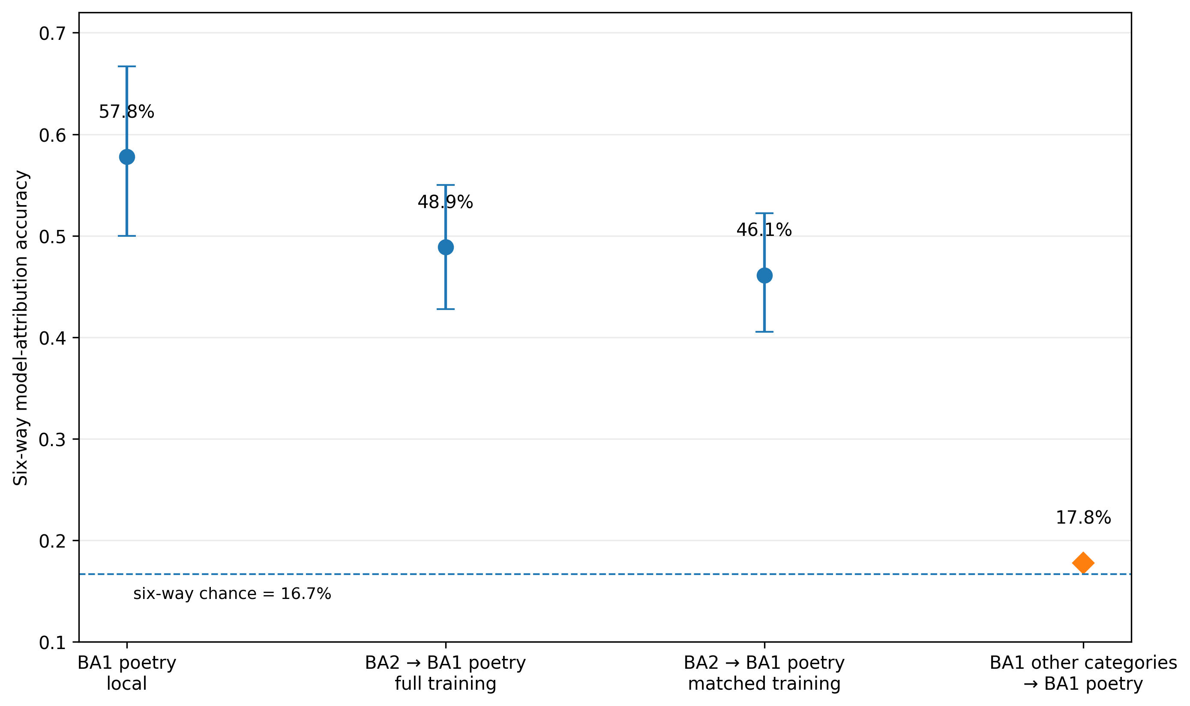
Figure 1. Local separability and portability of model-associated style. D1 local-separability and IA1 matched-training points are medians across 1,000 resamples with 2.5th–97.5th percentile ranges. The P1 cross-study point is the fixed test accuracy with a 95% stratified-bootstrap interval. The P3 cross-category-to-poetry point is one fixed holdout accuracy and is shown without an interval. Six-way balanced-class chance is 16.7%.

Transferable information was not reducible to coarse structure
The IA2 feature-family decomposition showed that the cross-study result was not primarily driven by obvious length and formatting differences. P1 accuracy was 34.4% using form/structure alone, 31.7% using grammar/person alone, 33.9% using punctuation alone, 43.3% using combined nonstructural style, and 48.9% using the full body vector.
The same pattern was visible under held-out phrasing: nonstructural style reached 55.8%, compared with 61.9% for the full representation. Under held-out line constraints, nonstructural style reached 49.6%, compared with 48.4% for the full representation. That small numerical reversal is descriptive and should not be read as evidence that structural variables are harmful in general; it indicates that adding structure did not improve portability once the production constraint itself changed.
No tested feature family produced strong Study 1 cross-category transfer.
Table 3. Six-way attribution accuracy by fixed feature family
Feature family | P1 cross-study | P3 cross-category pooled | P4 phrasing pooled | P4 length pooled
Form / structure | .344 | .235 | .310 | .274
Grammar / person | .317 | .183 | .453 | .401
Punctuation | .339 | .239 | .409 | .358
Nonstructural style | .433 | .204 | .558 | .496
Full body | .489 | .224 | .619 | .484
Feature definitions. Form/structure contains six length and structural measurements. Grammar/person contains five part-of-speech ratios and four pronoun/person shares. Punctuation contains seven punctuation-rate measures. Nonstructural style combines grammar/person and punctuation. Full body contains all 22 body-only features.
Interpretation. Nonstructural style retains most of the cross-study and prompt-wording transfer signal and approximately matches the full body representation under held-out length constraints. No tested feature family produces strong cross-category transfer.
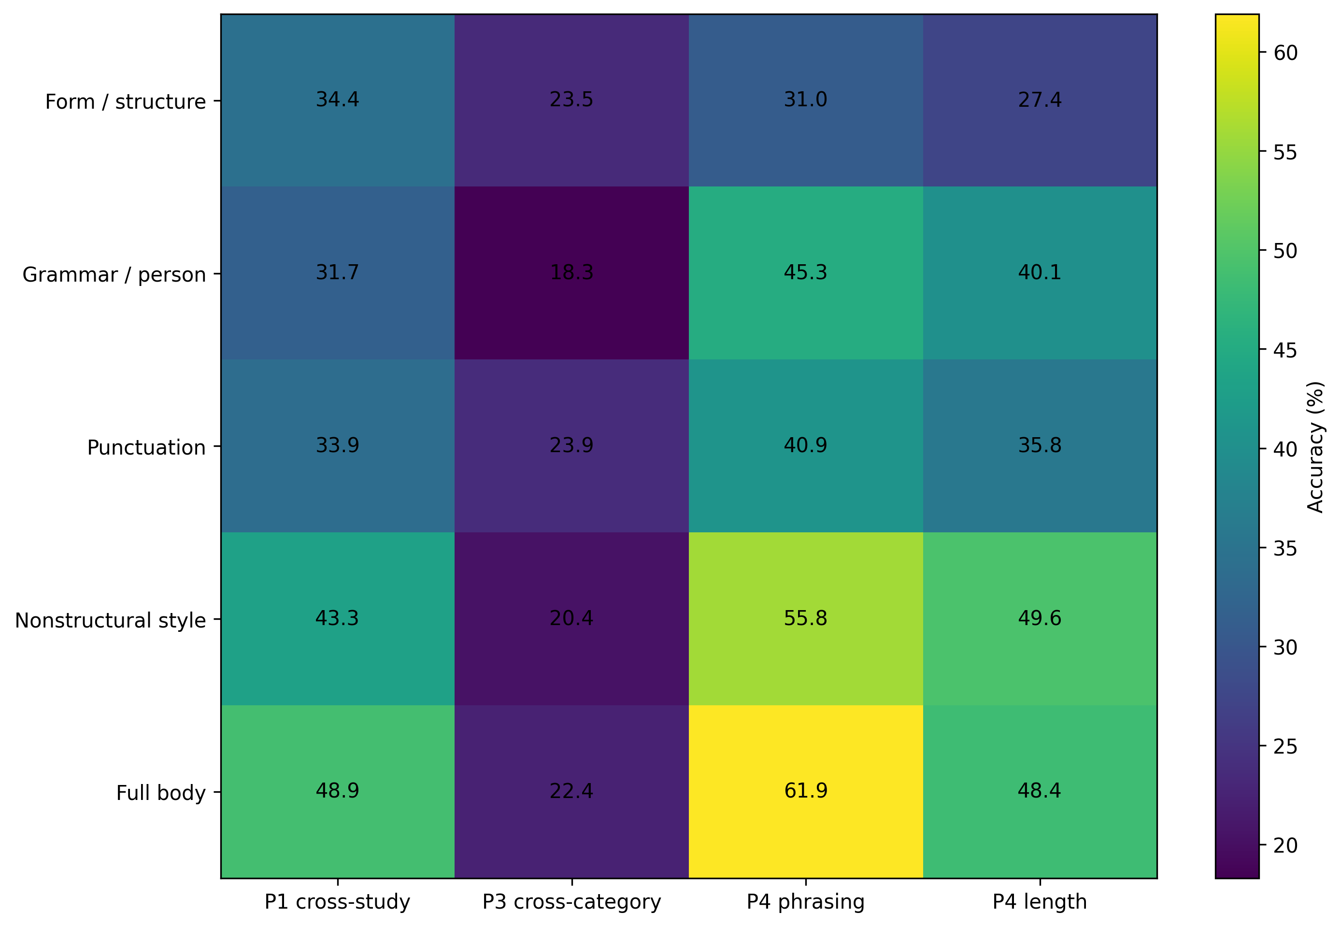
Figure 2. Six-way transfer accuracy by fixed feature family. The P3 column is the pooled leave-one-creative-writing-category-out result. Values are descriptive accuracies; the analysis was designed to interpret the composition of transferred signal rather than to optimize classification.

Individual stylistic measurements had different domains of stability
Cross-study rank stability varied sharply among the 22 body features. Across the six model means, semicolon rate showed ρ = .986 between Study 1 poetry and Study 2. Em-dash rate, mean words per line, and overall pronoun ratio each showed ρ = .829; first-person-plural share showed ρ = .714.
By contrast, body word count (ρ = −.429), non-empty line count (ρ = −.543), and stanza count (ρ = −.314) did not preserve the same model ordering across studies. The bootstrap intervals associated with S1 quantify response-sampling uncertainty conditional on the six tested endpoints; with only six model means, these correlations are descriptive rather than population-level estimates of universal feature stability.
Previously salient May observations showed a similar pattern after harmonization. Opening-token entropy (ρ = .943), title rate (ρ = .939), modal opening concentration (ρ = .928), and em-dash prevalence (ρ = .812) showed strong cross-study rank similarity. Four of six Study 1 opening-token entropy values also fell inside the corresponding Study 2 rarefaction intervals.
Within Study 2, the largest descriptive model effects among the body features included semicolon rate (η² = .315), em-dash rate (.301), overall pronoun ratio (.226), first-person-singular share (.206), mean word length (.134), noun ratio (.128), and mean words per line (.113).
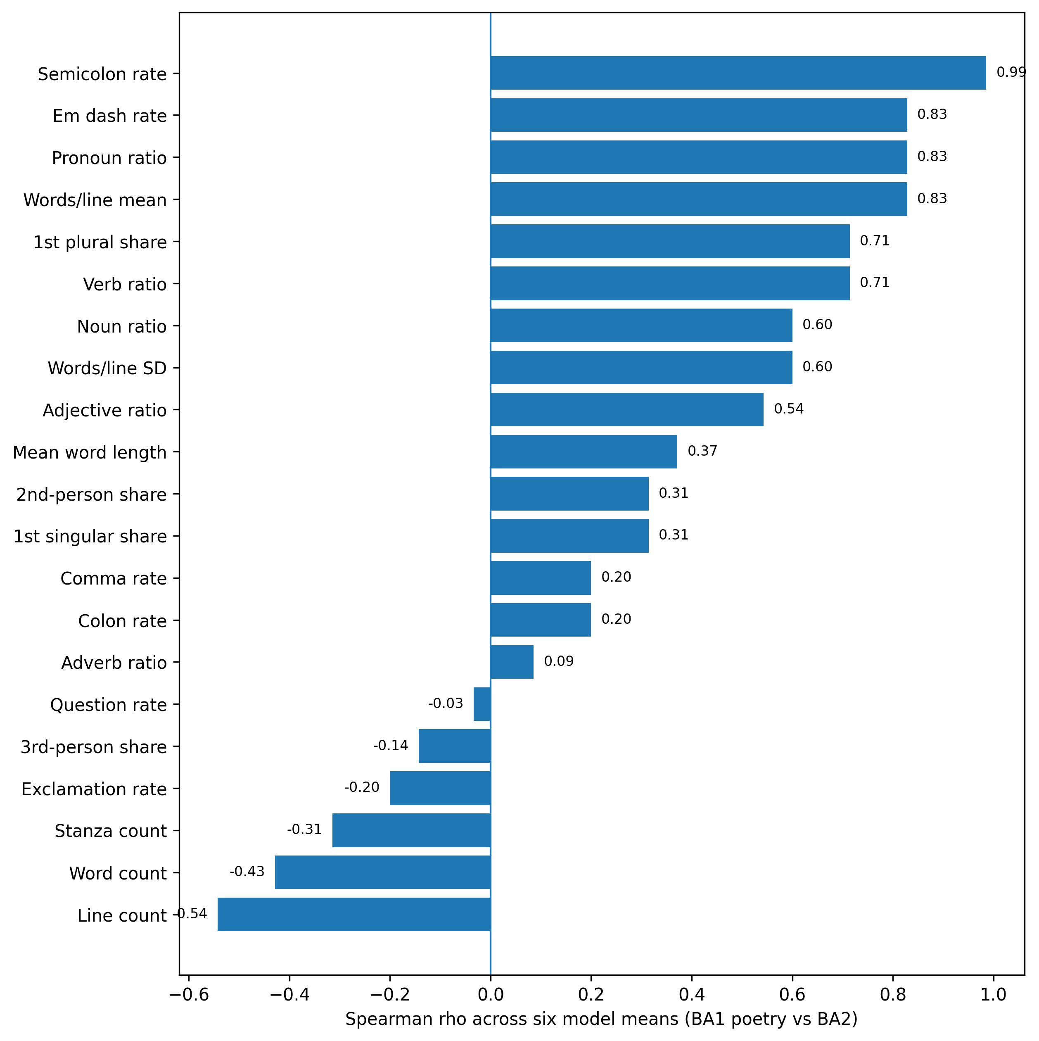
Figure 3. Cross-study Spearman rank correlations for model means on 21 finite body-feature comparisons. Each correlation uses six model means and is descriptive of the tested endpoints; it is not a model-population estimate.

Strong model effects coexisted with category dependence
Study 1 also showed that a feature can distinguish models strongly while remaining dependent on the creative-writing task. Mean words per line produced a model effect of η² = .072 and a model × category interaction of η² = .052. Mean word length produced η² = .155 for model and .108 for the interaction. Em-dash rate produced η² = .178 for model and .133 for the interaction. Semicolon rate, despite being the most cross-study-stable body feature by model ordering, produced η² = .082 for model and .146 for model × category.
These interactions do not by themselves establish rank reversal, and they are not evidence that the corresponding model effects are spurious. They show that the magnitude and form of the differences are conditional on the creative-writing task.

Response presentation carried additional model-associated information
Adding only title presence, preamble presence, title length, and preamble length substantially increased attribution accuracy. Cross-study six-way accuracy increased from 48.9% to 67.2%. Descriptive provider-label accuracy increased from 70.6% to 90.6%. Pooled cross-category accuracy increased from 22.4% to 31.5%, phrasing-transfer accuracy from 61.9% to 80.8%, and length-cap transfer from 48.4% to 63.0%.
Because the four surface variables were added jointly and are correlated, these results do not identify individual causal contributions. They show that model-associated information extends beyond the requested creative body into response packaging and presentation.
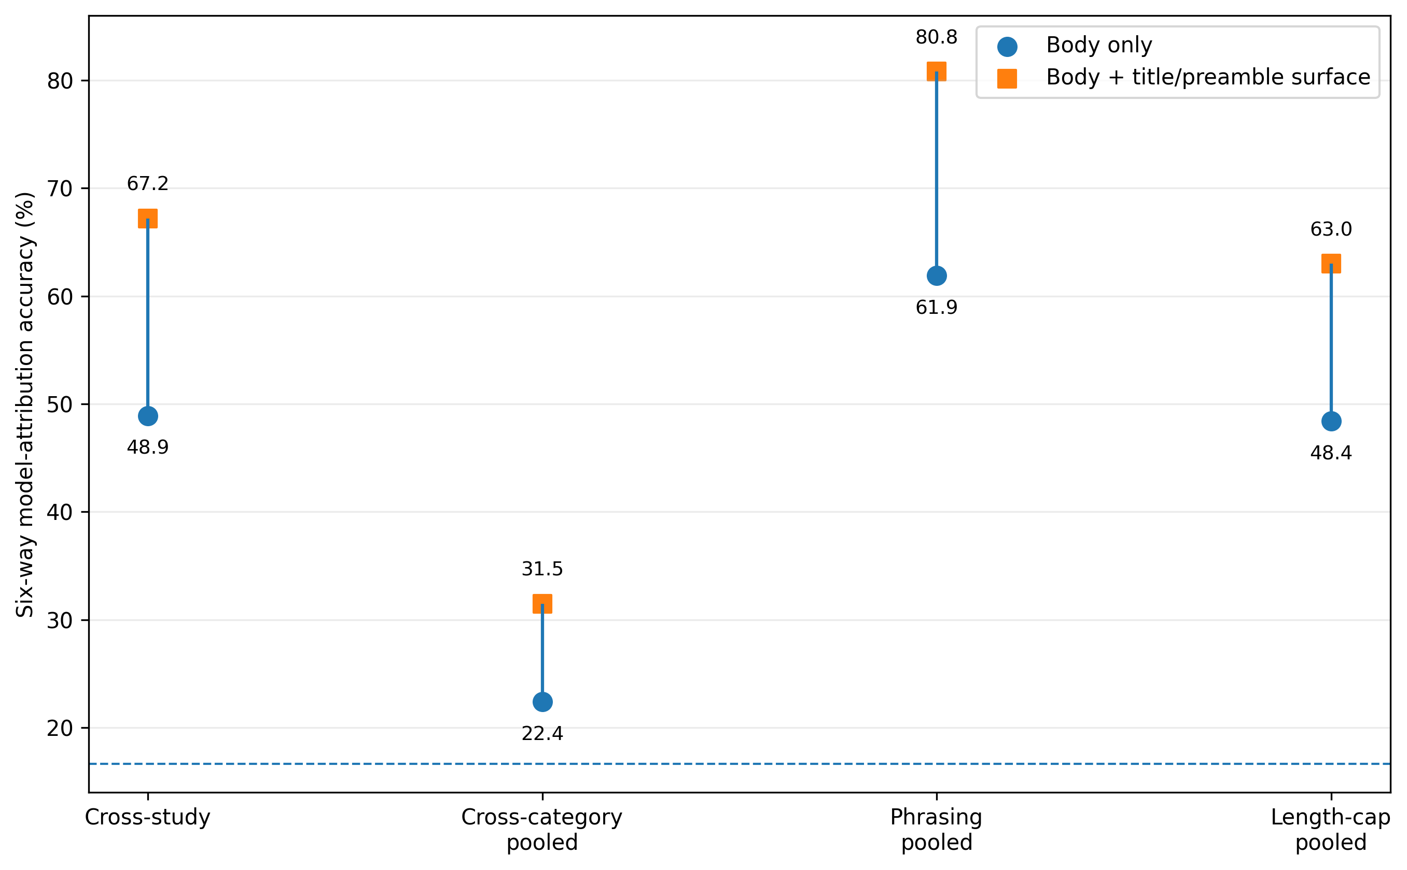
Figure 4. Body-only versus body-plus-surface six-way attribution accuracy. Paired points compare the fixed 22-feature creative-body representation with the same representation plus four title/preamble variables.

The Study 2 line-cap result was not produced by the 400-token output ceiling
The post-review D2 audit examined all 5,398 successful non-empty Study 2 responses. No Study 2 response showed direct provider termination at the 400-token ceiling, none reached 400 reported output tokens, and none reached even 95% of the ceiling. Median Study 2 output length was 68 tokens, the 95th percentile was 149, and the maximum was 255.
The 20-line condition was also well below the generation ceiling: median 115 tokens, 95th percentile 187, maximum 255, with zero direct or near-cap cases. The prespecified conditional P4-length sensitivity therefore did not trigger. The comparatively weak 20-line transfer result cannot plausibly be attributed to the 400-token ceiling in Study 2.

Discussion

Separability and portability are distinct properties
The central result is not simply that model-associated style is sometimes stable and sometimes unstable. It is that local separability and cross-environment portability can diverge sharply.
Study 1 poetry provides the clearest case. A classifier trained on the other Study 1 creative-writing categories identified the generating model of a poem at only 17.8% accuracy, essentially at the six-way chance reference. Yet a classifier trained and tested within the same poetry target reached a median 57.8% accuracy using only 90 local training examples per resample. The model-associated information was therefore present in the target; what failed was the portability of the source-trained mapping.
This distinction changes what a failed transfer test can support. Cross-environment attribution failure does not, by itself, locate a point at which a model “loses its signature.” It shows that the chosen representation and decision rule learned in one environment do not carry cleanly into another. Successful transfer is also narrower than an intrinsic-fingerprint claim: it demonstrates that some model-label information survives the shift under a specified representation and fitting procedure.
Attribution is therefore useful here as an assay of portability rather than as proof of a context-free model essence. The object of interest is the relationship among model, observable feature representation, production environment, and learned decision boundary.

Different components of model-associated style travel differently
The feature analyses show why a unitary “fingerprint” metaphor is insufficient. Some measurements preserved model ordering across independent poetry samples, while others reorganized substantially. Semicolon use, em-dash use, pronoun composition, mean words per line, opening-token entropy, title behavior, and opening concentration all showed comparatively strong persistence. Raw word count, line count, and stanza count did not.
The feature-family decomposition reaches the same conclusion from a different direction. Much of the cross-study and prompt-wording signal survived after coarse form/structure features were removed. Punctuation and grammar/person features jointly retained 43.3% cross-study accuracy and 55.8% held-out-phrasing accuracy. These values make it difficult to explain the attribution results as mere exploitation of trivial length or line-count differences.
At the same time, the Study 1 model × category interactions show that even recognizable tendencies can be task-conditional. Semicolon and em-dash behavior were both strong model-associated measurements and strongly context-dependent within Study 1. A model effect and a context interaction are not opposites: both can be true of the same behavior.
The full-surface analysis adds a further descriptive layer. Titles and preambles substantially increased attribution across every tested transfer family. This does not establish a separate causal “delivery module,” but it does show that presentation conventions carry model-associated information not captured by the creative body alone.

Relationship to model fingerprints, stylometry, and robustness
These findings extend rather than contradict recent model-fingerprint work. Prior studies show that generator identity can be recoverable across domains and that explicit stylistic features can support robust attribution. Our results reproduce that basic phenomenon in independent poetry samples and under prompt perturbation.
The contribution is to make the failure mode more explicit. A target can remain strongly separable even when a source-trained attribution rule fails. That distinction is familiar in spirit from cross-domain human stylometry, where topic or writing situation can alter the mapping from author to observed features without erasing authorship information altogether. For language models, the generator is known and the production environment can be manipulated, making this relationship unusually tractable to study.
The results also complement prompt-robustness research. Most robustness studies ask whether task performance or benchmark rankings survive changes in prompts or test distributions. Here the dependent variable is the form of the model's output. A model may preserve task performance while altering stylistic expression, or preserve a recognizable stylistic signature while changing task performance. Robustness of capability and portability of behavioral expression are therefore separate empirical questions.

Scope of the claim
The demonstrated object in this paper is model-associated stylistic and presentation behavior in minimally specified creative-writing tasks. The results do not establish a general invariance theory of all language-model behavior.
The broader methodological proposal is narrower: when a study attributes some measurable behavior to a model, the contexts across which that attribution continues to hold can itself be investigated. Depending on the construct, relevant transformations might include prompt wording, task family, output constraint, interaction history, decoding regime, or collection wave. The appropriate test need not always be model attribution, but the underlying question is the same: is the observed difference locally separable, portable across environments, stable in ordering, stable in magnitude, or some combination of these?

Limitations
The study concerns only six named model identifiers/endpoints from two providers. Provider and tier are not independently replicated, so provider- and tier-level results remain descriptive.
Only one identifier, Claude Haiku 4.5, was explicitly date-pinned in the archived runner; the other identifiers were unpinned aliases. The two studies used the same names, but the design cannot prove that the underlying provider deployment was byte-for-byte immutable across collection time.
The task domain is narrow. All outputs are minimally specified creative writing, and poetry is the only direct bridge between the two independently collected studies. Study 1’s “animal” condition is better understood as a creative-writing task/category than as a genre parallel to story and poem.
The source studies were not prospectively constructed as a fully crossed reciprocal invariance experiment. Several comparisons therefore differ along more than one dimension, and the present results should not be interpreted causally as isolating “genre,” task, or any other single factor.
The feature representation was intentionally sparse and interpretable. It does not test whether embeddings, semantic representations, nonlinear classifiers, or other learned features would yield greater attribution performance. That omission is deliberate for the present assay but limits claims about the maximum recoverable model information.
Several feature-stability analyses compare only six model-level means. Their bootstraps quantify response-sampling uncertainty conditional on those six endpoints, not uncertainty over a broader model population.
The four response-surface features were added jointly and are correlated, so their separate contributions are not identified.
The post-review D1 and D2 analyses were explicitly outcome-informed exploratory diagnostics. D1 clarifies interpretation of the existing transfer results but does not retroactively become a preregistered confirmatory test.
The token-ceiling audit was especially clean for Study 2, where no response approached 400 tokens. Study 1 contained 44 responses reporting 400 output tokens and 50 within 95% of the ceiling despite no direct cap flag. Cap influence in Study 1-only comparisons therefore cannot be excluded as cleanly as it can in Study 2.

Toward a prospective portability design
A direct follow-up would prospectively cross model identity with creative-writing category, prompt wording, output constraint, collection wave, and possibly decoding settings. Reciprocal train/test transfer among all cells would produce a true portability matrix rather than the partial map available here.
Such a design should measure at least four quantities separately: local target separability, source-to-target predictive transfer, stability of model ordering on named features, and stability of effect magnitude. These quantities need not move together. Their divergence is itself informative about how model-associated behavior is expressed across environments.
The same design logic could later be applied beyond style—to refusal behavior, calibration language, sycophancy, citation behavior, emotional framing, or other measurable output properties—but those extensions remain proposals rather than findings of the present study.

Conclusion
Outputs from the six tested model identifiers/endpoints contained substantial model-associated stylistic information, but that information did not travel uniformly across production environments. It was strongly recoverable within Study 1 poetry, substantially portable from an independently collected poetry study, and comparatively portable across prompt wording and requested line constraints. Yet a classifier learned from the other Study 1 creative-writing categories transferred poorly into poetry even though the poetry target itself remained highly separable.
That contrast is the paper's central result. Separability and portability are not the same property. A model-associated signature can be measurable in two environments while the mapping learned in one fails to transport to the other.
A model-level stylistic claim is therefore better characterized not only by whether a difference exists, but also by the transformations under which the difference remains recognizable.
The boundary of a model-level claim is not merely a limitation on the result. It is part of the result.

Data and materials availability
The source studies, harmonized analysis materials, code, preregistration and freeze records, critical-review materials, post-review diagnostics, and manuscript provenance are publicly available in the project repository: https://github.com/quumble/An-Assay-of-Bullshit

References
Altakrori, Malik, Jackie Chi Kit Cheung, and Benjamin C. M. Fung. 2021. "The Topic Confusion Task: A Novel Evaluation Scenario for Authorship Attribution." Findings of the Association for Computational Linguistics: EMNLP 2021, 4242-4256. https://doi.org/10.18653/v1/2021.findings-emnlp.359
Bean, Andrew M., Ryan Othniel Kearns, Angelika Romanou, et al. 2025. "Measuring What Matters: Construct Validity in Large Language Model Benchmarks." 39th Conference on Neural Information Processing Systems (NeurIPS 2025), Datasets and Benchmarks Track.
Bitton, Yehonatan, Elad Bitton, and Shai Nisan. 2025. "Detecting Stylistic Fingerprints of Large Language Models." arXiv:2503.01659. https://arxiv.org/abs/2503.01659
Constitution of Bo Chesterton. 2026. Version 0.50, September 9, 2026. Public GitHub repository. https://github.com/quumble/constitution-of-bo-chesterton
Elazar, Yanai, Nora Kassner, Shauli Ravfogel, Abhilasha Ravichander, Eduard Hovy, Hinrich Schütze, and Yoav Goldberg. 2021. "Measuring and Improving Consistency in Pretrained Language Models." Transactions of the Association for Computational Linguistics 9: 1012-1031. https://doi.org/10.1162/tacl_a_00410
Hua, Andong, Kenan Tang, Chenhe Gu, Jindong Gu, Eric Wong, and Yao Qin. 2025. "Flaw or Artifact? Rethinking Prompt Sensitivity in Evaluating LLMs." Proceedings of the 2025 Conference on Empirical Methods in Natural Language Processing, 19889-19899. https://doi.org/10.18653/v1/2025.emnlp-main.1006
Lu, Xingyu, Yumeng Ma, Xiang Zhou, Shengli Gan, Guiying Deng, Yang Wen, and Yanbing Liu. 2026. "Synergizing Stylometrics with Semantics: Dual-Path Framework for LLM Detection and Attribution." Findings of the Association for Computational Linguistics: ACL 2026, 37252-37265. https://doi.org/10.18653/v1/2026.findings-acl.1855
McGovern, Hope, Rickard Stureborg, Yoshi Suhara, and Dimitris Alikaniotis. 2025. "Your Large Language Models are Leaving Fingerprints." Proceedings of the 1st Workshop on GenAI Content Detection (GenAIDetect), 85-95. https://aclanthology.org/2025.genaidetect-1.6/
Ribeiro, Marco Tulio, Tongshuang Wu, Carlos Guestrin, and Sameer Singh. 2020. "Beyond Accuracy: Behavioral Testing of NLP Models with CheckList." Proceedings of the 58th Annual Meeting of the Association for Computational Linguistics, 4902-4912. https://doi.org/10.18653/v1/2020.acl-main.442
Sclar, Melanie, Yejin Choi, Yulia Tsvetkov, and Alane Suhr. 2024. "Quantifying Language Models' Sensitivity to Spurious Features in Prompt Design or: How I Learned to Start Worrying About Prompt Formatting." International Conference on Learning Representations (ICLR 2024).
Siska, Charlotte, Katerina Marazopoulou, Melissa Ailem, and James Bono. 2024. "Examining the Robustness of LLM Evaluation to the Distributional Assumptions of Benchmarks." Proceedings of the 62nd Annual Meeting of the Association for Computational Linguistics (Volume 1: Long Papers), 10406-10421. https://doi.org/10.18653/v1/2024.acl-long.560
Stamatatos, Efstathios. 2009. "A Survey of Modern Authorship Attribution Methods." Journal of the American Society for Information Science and Technology 60(3): 538-556. https://doi.org/10.1002/asi.21001
Sundararajan, Kalaivani, and Damon Woodard. 2018. "What Represents 'Style' in Authorship Attribution?" Proceedings of the 27th International Conference on Computational Linguistics, 2814-2822. https://aclanthology.org/C18-1238/

