What Models Do When Nobody's Watching
  - Registered measures, unregistered priors, and stylistic defaults in six LLMs under cold prompts
Author: Bo Chesterton
Coder authorship: structural heuristic by claude-opus-4-7; semantic heuristic by GPT-5.5 Thinking
Version: v5 clean final (synthesized from v2, v3, and the v4 audit version); May 8, 2026
Repository: https://github.com/quumble/An-Assay-of-Bullshit

Abstract. Six contemporary chat models - three from the GPT family and three from the Claude family - were each given the same nine cold creative-writing prompts ten times. There was no system message, no conversation history, temperature was 1.0, and max_tokens was fixed at 400, yielding 540 successful outputs. Two deterministic machine-authored heuristic coders, one semantic and one structural, processed the outputs blind before de-blinding. The cleanest registered result is opening-word concentration: all three Claude models begin with "the" in roughly 62-67% of outputs, with first-word entropies around 1.2-1.5 bits, while the three GPT models have much more dispersed openings around 2.9-3.0 bits. The most vivid exploratory results reverse two folk stereotypes: em-dashes localize to GPT 5.4 Nano rather than Claude, and assistant-style preambles localize to Claude Sonnet 4.6 rather than GPT, only under specific prompt conditions. Formatting habits also separate the models sharply, but not as a simple family split: Sonnet and Haiku are format-rigid, GPT 5.4 and GPT Nano are format-minimal, and Opus and GPT Mini are more adaptive. The paper is descriptive, not normative. It does not test quality, capability, or normal product behavior. Its methodological claim is stricter than earlier drafts: public exploratory methods logs are useful, but they are not sealed preregistrations; machine-authored coders count reproducibly, but they still choose what to count; and exploratory reversals should not be laundered into confirmatory hypotheses.

At a glance
Finding | Evidence status | Bottom line
Opening-word concentration | Registered exploratory measure | Strongest family-level result.
Em-dash reversal | Exploratory / unregistered prior reversal | GPT 5.4 Nano is the spike, not Claude.
Preamble reversal | Exploratory / conditional | Sonnet, not GPT, and only in constrained poems/stories.
Format fingerprint | Exploratory structural pattern | Model-specific; not reducible to GPT vs Claude.
Output-cap hits | Planned reporting, refined interpretation | Censoring/confound, not failure.

0. Evidence hierarchy: what v5 keeps, demotes, and makes visual
The central change in this version is not numerical. It is evidentiary. Earlier drafts made the most entertaining story - two wrong folk predictions - feel like the strongest piece of the protocol. v5 keeps that drama, but labels it correctly. The repository records an exploratory design and several planned descriptive measures. It does not seal a confirmatory prediction that em-dashes would be Claude or that assistant-style preambles would be GPT. Those were analyst priors, not preregistered hypotheses.
The evidentiary order used below is therefore: registered exploratory design; registered exploratory measures; public deviations and methods log; unregistered analyst priors; and post hoc or added analyses. Opening-word concentration sits on the strongest footing. Em-dashes, preambles, format-rigidity, and classifier checks are useful and vivid, but exploratory.
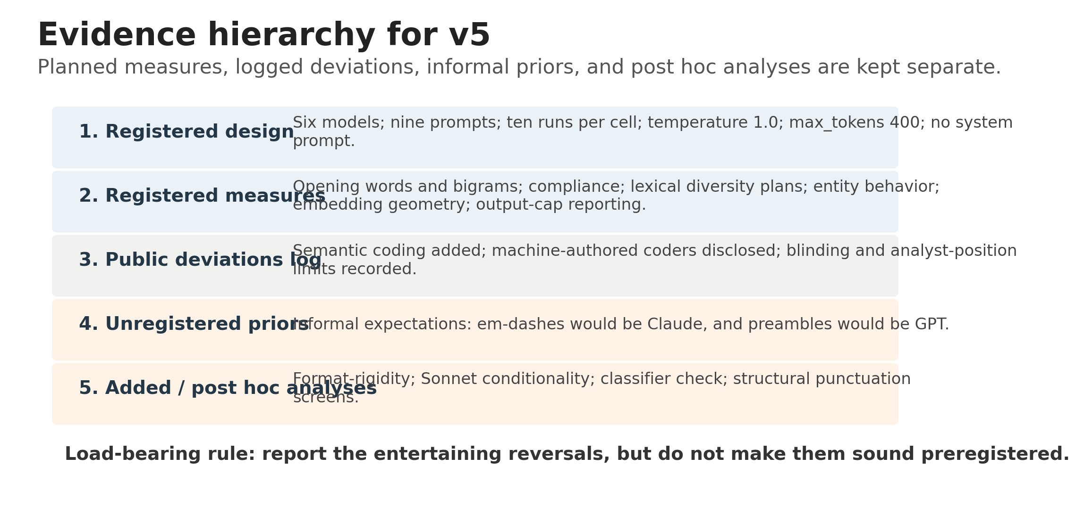
Figure 1. v5 makes the evidence hierarchy part of the paper design, not an afterthought. The most memorable findings are not automatically the most confirmatory findings.

1. Introduction
A cold prompt is an unnatural thing to give a chat model. There is no system message, no conversation history, no user context, and no domain stakes. The model is simply asked to make a small invented object - a story, an animal, or a poem - and it still has to do something. What it does in that vacuum is the object of this study.
Defaults are interesting because they survive the removal of context. They are not a model's best behavior, and they are not capability scores. They are residue: pretraining, post-training, product taste, implicit helpfulness etiquette, hidden provider defaults, and whatever else makes a model feel like itself when nothing else is asking it to become something specific.
The question is narrow: in 540 cold-prompt creative outputs, are there visible habits that distinguish six contemporary models? The answer is yes. The stricter question is: which habits were planned measures, which were logged deviations, which were informal priors, and which were discovered after the fact? v5 answers both questions together.

2. Design and data
The experiment compared six models: GPT 5.4, GPT 5.4 Mini, GPT 5.4 Nano, Claude Opus 4.7, Claude Sonnet 4.6, and Claude Haiku 4.5. The prompt grid crossed three categories - story, animal, poem - with three length conditions: fewer than 5, fewer than 10, and open length. Each of the 54 model-prompt cells was sampled ten times, for 540 total outputs.
All calls used temperature = 1.0, max_tokens = 400, and no system prompt. The runner wrote one JSONL record per call. The prompt file contains a typo in the poem prompts - "fewer then 5 lines" and "fewer then 10 lines" - preserved because the study was first-take and the typo applied equally across models.
Two deterministic heuristic coders were used. The semantic coder labeled content-like features: setting, mood, tense, person, imagery, plot arc, animal/entity candidates, opening word and bigram, formulaicness, and type-token ratio. The structural coder labeled surface form: sentence and paragraph structure, line counts, title lines, meta-preambles, punctuation, sentence rhythm, repetition, hedges, intensifiers, and endings.
The coders were blind to model identity and used independent blind label schemes. After de-blinding, the crosswalk was exact: M1/Model A = GPT 5.4; M2/Model B = GPT 5.4 Nano; M3/Model C = Claude Opus 4.7; M4/Model D = Claude Sonnet 4.6; M5/Model E = GPT 5.4 Mini; M6/Model F = Claude Haiku 4.5.

3. Results

3.1 Registered result: opening-word concentration
Opening-token concentration is the cleanest registered family-level result. Across all three Claude models, the first word is overwhelmingly "the": 60/90 for Opus, 56/90 for Sonnet, and 60/90 for Haiku. First-word entropy is correspondingly low. The GPT models are much more dispersed, with first-word entropies around 2.9-3.0 bits.
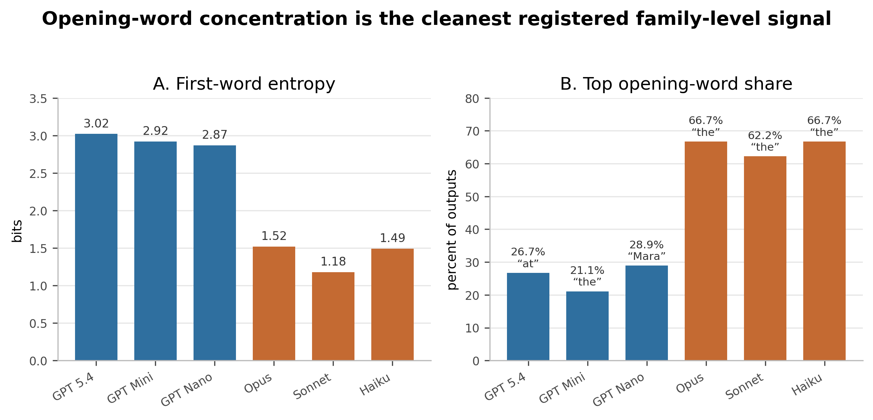
Figure 2. Claude models repeatedly start with the same word; GPT models scatter their openings. GPT 5.4 Nano has its own local basin: 26 of 90 outputs begin with the proper name "Mara."

3.2 Exploratory reversal: em-dashes are not a Claude tell here
The em-dash result is not preregistered. It is an exploratory structural screen, and it reverses a familiar folk stereotype. In this dataset, the em-dash signal localizes to GPT 5.4 Nano. Nano averages 1.62 em-dashes per response, more than twice any other model, and its median em-dash count is 1 while every other model has median 0.

3.3 Exploratory reversal: the preamble is Sonnet, not GPT
The assistant-style preamble result is also exploratory. Across 270 GPT outputs, there are zero structural meta-preambles. Across 90 Sonnet outputs, there are 34. Opus has one; Haiku has none. This is not a Claude-family habit. It is a Sonnet habit under specific prompt conditions.
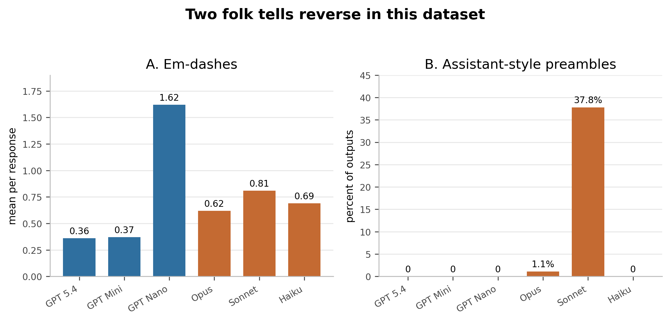
Figure 3. Two folk tells reverse in this dataset. The figure is intentionally paired: both results are vivid, but both should be read as exploratory reversals of informal priors, not as preregistered hypothesis tests.

3.4 Conditionality: Sonnet frames constrained artifacts
Within Sonnet, preambles appear on length-constrained poems and stories: 10/10 on poem_lt5, 10/10 on poem_lt10, 10/10 on story_lt5, and 4/10 on story_lt10. They disappear on open prompts and on animal prompts. The behavior looks like a deliverable-frame reflex: when asked for a constrained poem or story, Sonnet announces the artifact before giving it.
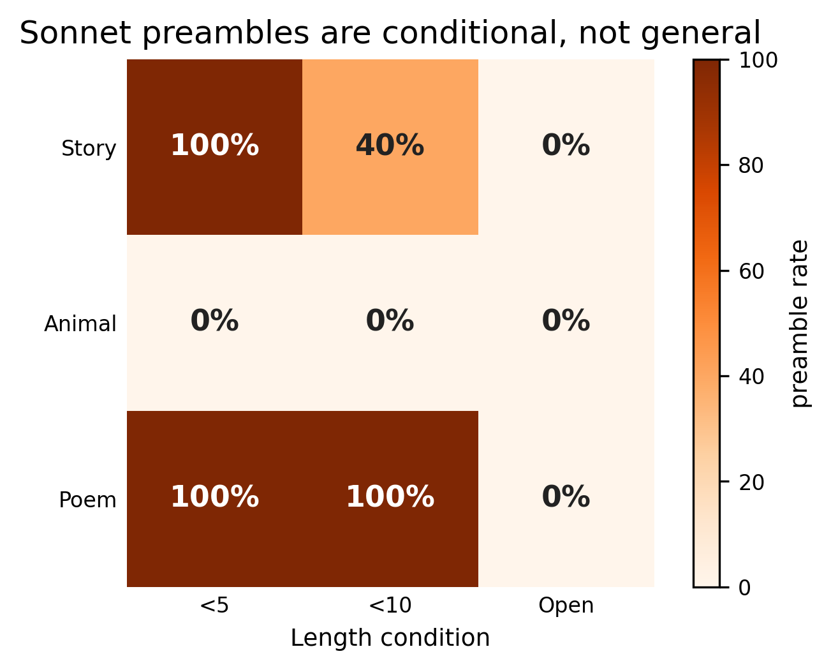
Figure 4. Sonnet's preamble is conditional on prompt form. It is not a general politeness habit and not a provider-family signature.

3.5 Exploratory structural signature: format fingerprint
Titles and single-block prose separate the six models dramatically, but not as a simple Claude-vs-GPT binary. A family summary is true but too smooth: GPT-family outputs are usually single-block; Claude-family outputs are usually titled. The individual profiles are more informative. Sonnet and Haiku are format-rigid. GPT 5.4 and GPT Nano are format-minimal. Opus and GPT Mini are more adaptive.
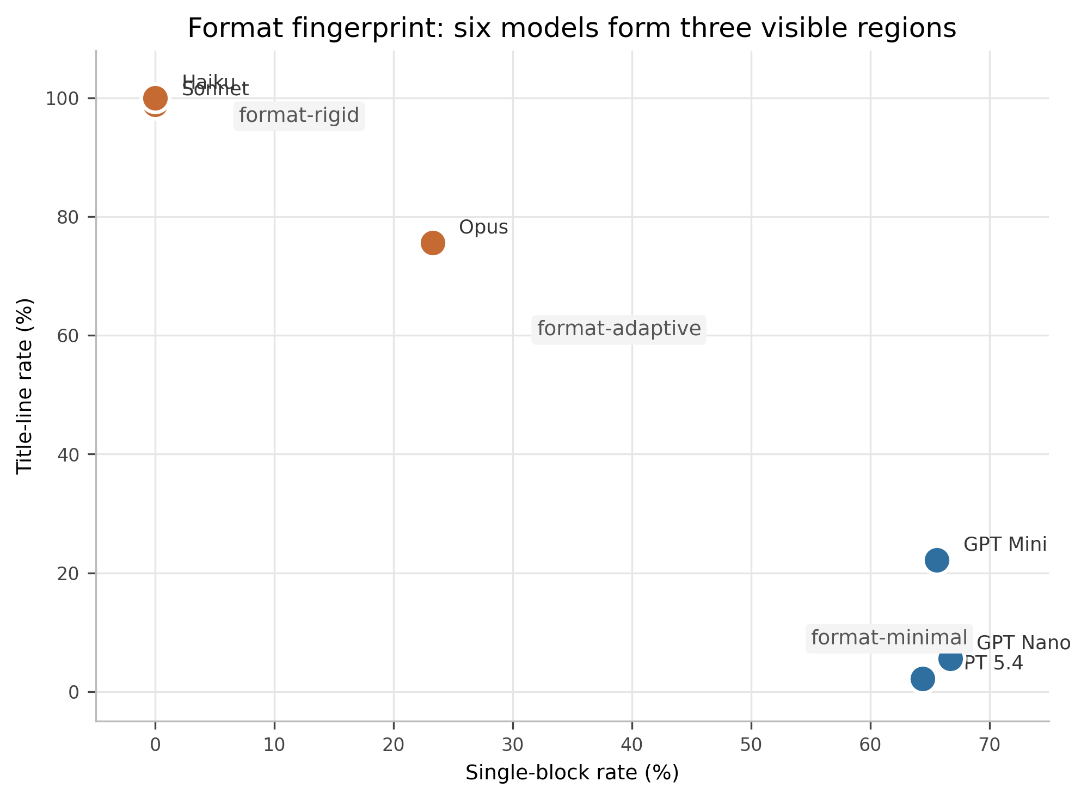
Figure 5. The format space is a model fingerprint. The region labels are interpretive; the underlying rates are the load-bearing part.

3.6 Output-cap hits: Opus had more to say
The variable formerly treated as truncation is better named an output-cap hit. With max_tokens fixed at 400, a cap hit is a censoring event imposed by the harness. It does not mean the model failed; it means the model attempted to continue beyond the response budget. Every cap hit in the dataset occurs in an open-length prompt. Opus hits the cap on 100% of open stories and 100% of open animal descriptions; Sonnet never hits the cap.
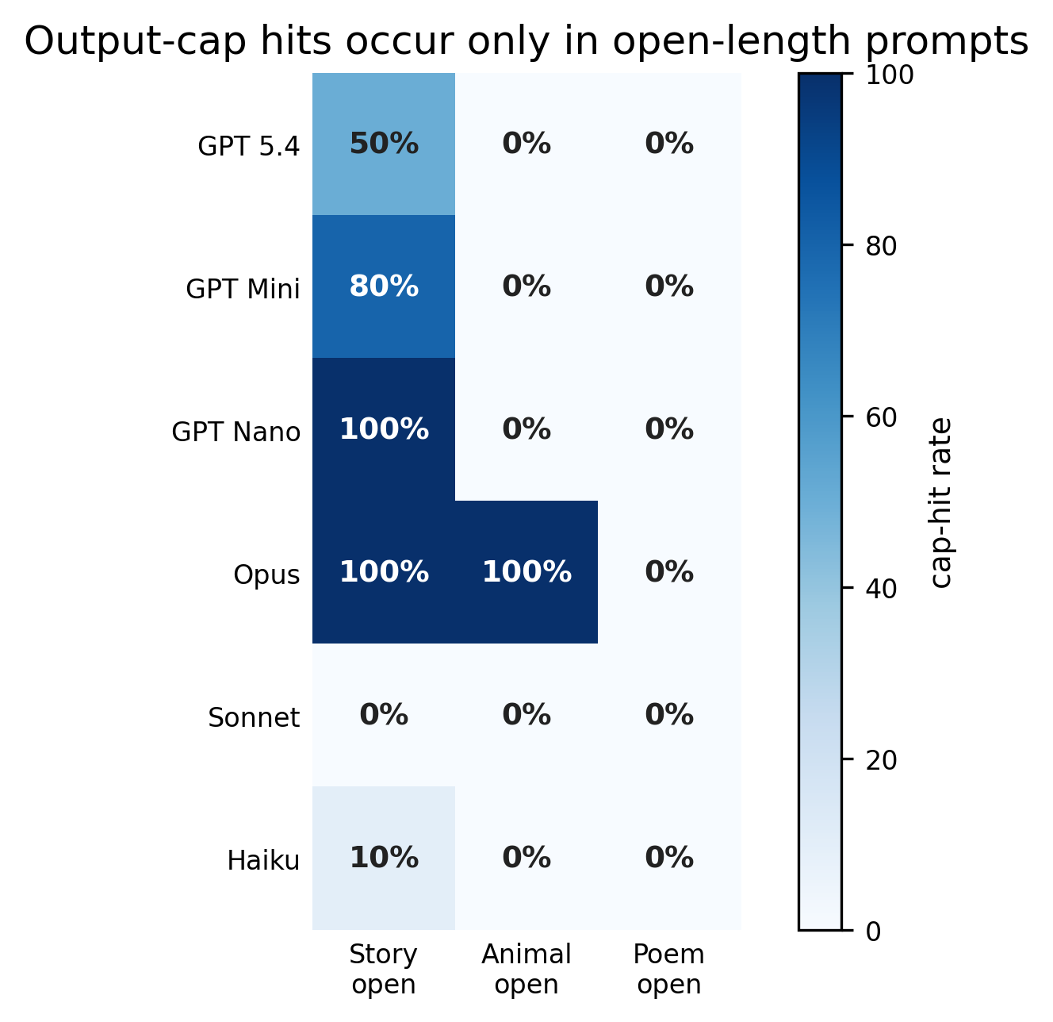
Figure 6. Output-cap hits are a censoring confound for open prompts, especially Opus story and animal completions. They should not be converted into quality judgments.

3.7 Compliance and the sentence boundary
Length compliance was high. Under the semantic coder, failures were sparse: Haiku animal_lt5 = 1, Haiku story_lt5 = 5, Opus story_lt5 = 2, and Sonnet story_lt10 = 1. Under the structural coder, the same pattern appears except Haiku story_lt5 rises to 8 because the structural sentence splitter counted five sentences where the semantic splitter counted four. The two coders agreed on compliance for 537 of 540 outputs; the three disagreements are all Haiku story_lt5 rows sitting exactly on the four-vs-five sentence boundary.

3.8 Classifier sanity check
The classifier check is exploratory and not the preregistered embedding-nearest-neighbor analysis. Using surface-style features only, excluding model labels, family labels, prompt labels, compliance labels, text, and output-cap hits, validation was leave-one-prompt-condition-out. With the v4 feature set, logistic regression reaches 55.6% six-way accuracy and random forest reaches 58.5%, against 16.7% chance. The confusion is uneven: Haiku is easiest, Sonnet is relatively visible, GPT models are harder and often confused with one another, and Opus is frequently confused with Haiku.
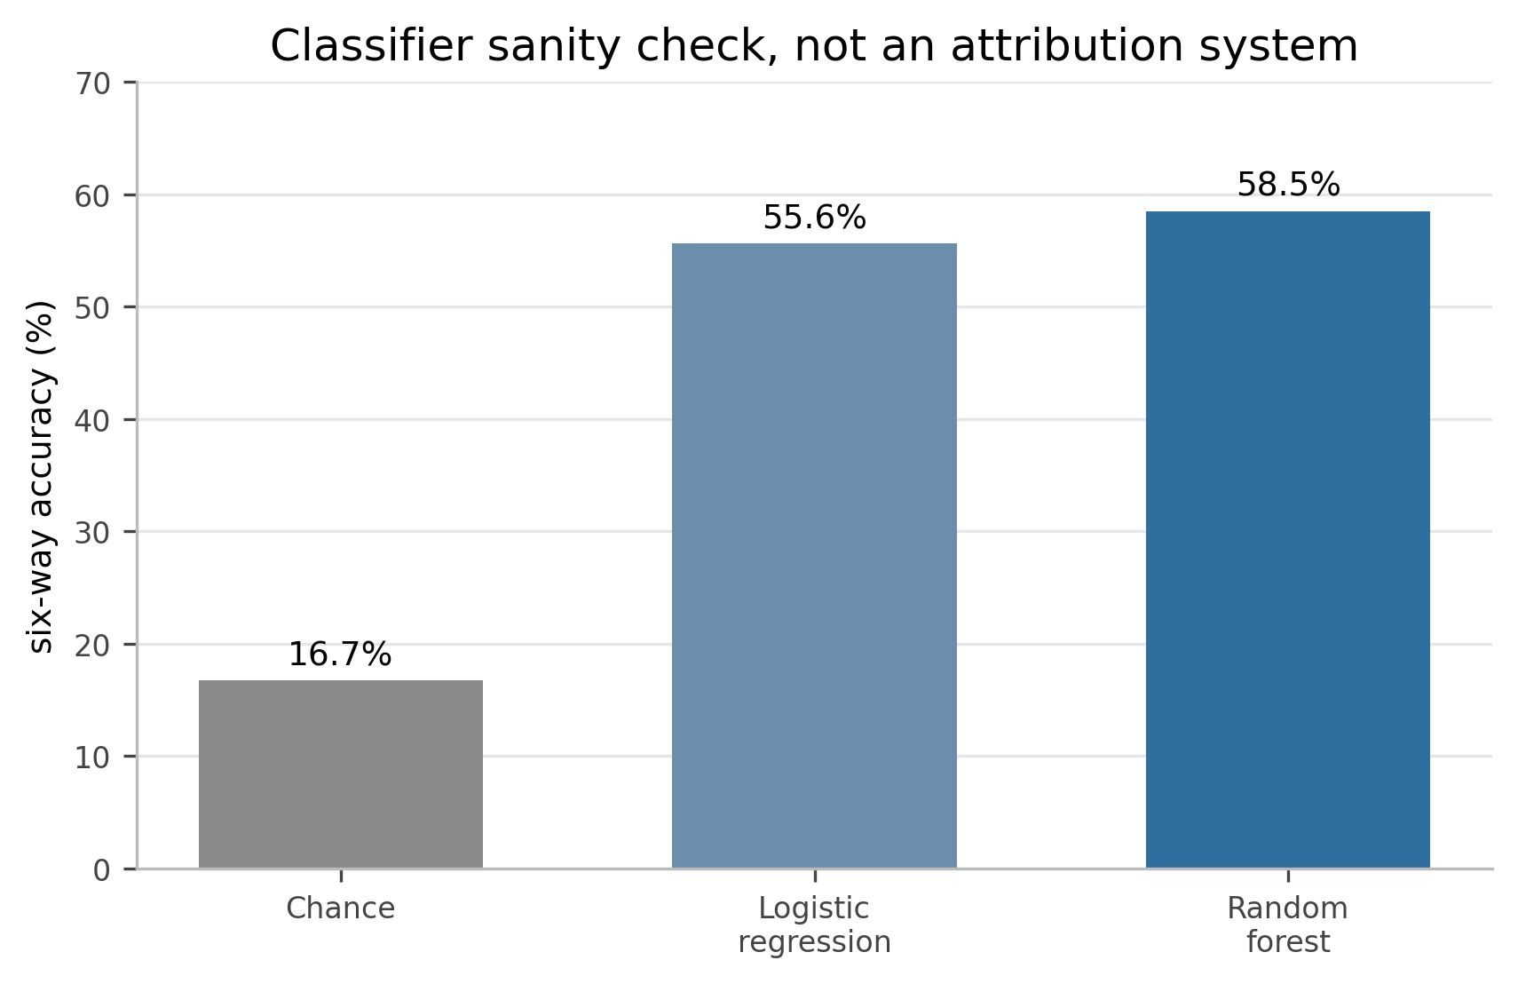
Figure 7. The classifier is a sanity check that surface-style defaults survive prompt variation. It is not a production attribution system.

4. Why semantic features were quieter
The semantic coder produced weaker separations than the structural coder. That does not prove the models are semantically similar. It proves only that these short cold-prompt outputs, coded with these coarse semantic bins, separated less strongly by content than by visible form.
There are several plausible reasons. The prompts may naturally pull frontier-style models toward similar semantic material: natural settings, serene moods, third-person present-tense narration, gentle transformations, small creatures, starlight, forests, rivers, and memory. The bins may also be too coarse. A model can differ in metaphor texture, cliché handling, tonal pressure, or narrative pacing without changing a label such as dominant mood = serene. Finally, the 400-token cap censors the very outputs where longer semantic arcs might have developed.
The defensible claim is therefore narrow: structural features discriminated models more strongly than the available semantic heuristics. The paper should not claim that models differ in form but not in meaning. Formulaicness is especially delicate: it appears in the semantic heuristic, not in the original registered MTLD plan, so it should be treated as an exploratory proxy rather than a completed preregistered lexical-diversity result.

5. Discussion: what the audit changes
The main empirical result remains: models have recognizable defaults. They do not all behave the same way when context is stripped away. But v5 changes the paper's center of gravity. The older center was: blind analysis reversed two folk beliefs. The new center is: an exploratory design and several planned descriptive measures were publicly logged; the strongest registered signal is opening-token concentration; and many of the most entertaining findings are exploratory reversals of informal priors.
That is not a downgrade. It is a better paper. It prevents a public methods ledger from being rhetorically inflated into a sealed preregistration. It preserves the weirdness without laundering it. It lets the strongest claim stand on the correct footing: under cold creative-writing prompts, models exhibit measurable default styles. Some planned measures, especially opening-token concentration, show clean family-level structure. Many vivid signatures - em-dashes, preambles, format-rigidity, and output-budget pressure - are exploratory and model-specific.
The machine-authored-coder problem is not a footnote. Claude Opus wrote the structural heuristic; GPT-5.5 Thinking wrote the semantic heuristic; later model-assisted passes helped rewrite the paper. Determinism bounds the act of counting, but it does not bound the choice of what to count. The human author is not an invisible gold-standard judge; the human role is closer to producer, curator, editor, and taste function. That does not invalidate the counts. It makes the choice of features part of the object under study.

6. Limitations and deviations
- The preregistration was in-progress and public, not a conventional sealed prospective preregistration. All findings remain exploratory.
- No confirmatory hypotheses were preregistered. The registered questions were descriptive and exploratory.
- Several registered analyses are incomplete or only partially represented here: full MTLD, full named-entity inventory, embedding geometry, and embedding nearest-neighbor confusion matrices.
- Some of the strongest narrative findings - em-dashes, preambles, format-rigidity, and classifier identification - are exploratory post hoc analyses or unregistered-prior reversals.
- The classifier check is trained and tested within one prompt grid, one temperature, one day, and one set of model identifiers. It is not a production attribution system.
- The sample is small: ten runs per model-prompt cell.
- The prompts are cold and contextless. They measure defaults in a vacuum-chamber regime, not normal chat behavior.
- The 400-token output cap censors open-prompt outputs, especially Opus story and animal completions.
- Sentence-count heuristics disagree on 105 of 540 rows, especially open stories and animals. Compliance is robust except at a few boundary cases.
- Both heuristic coders were machine-authored, including by models from the families under study. Determinism bounds counting; it does not bound feature selection.
- Five of six model identifiers are not pinned to dated snapshots. Behavior may shift if provider-side deployments change.
- One prompt contains a typo: "fewer then" instead of "fewer than." It applies equally across models, but it remains an instruction hazard.
- Stylistic signatures are not quality judgments and should not be generalized to coding, reasoning, retrieval, summarization, dialogue, or tool use.

7. Conclusion
The cleanest registered result is that Claude models begin the same way. Not morally, not intelligently, not better - just literally. They start with "the" at striking rates. The GPT models, by contrast, scatter their openings.
The funniest exploratory result is that two folk stereotypes fail here. Em-dashes are not Claude in this dataset; they are GPT 5.4 Nano. Preambles are not GPT; they are Sonnet, and only in particular prompt conditions. The most visually obvious result is that formatting habits are model-specific. The most analytically important correction is that output-cap hits mean a model had more to say than the harness allowed, not that it failed.
The methodological result may be the most durable one. A public exploratory methods ledger is useful, but it is not a sealed preregistration. Machine-authored coders can count reproducibly, but they still choose what to count. Blind labels reduce some expectancy effects, but style itself leaks identity. The protocol does not purify the study. It gives the weirdness somewhere to stand.
There are truths in the average bullshittings of machines. v5 adds a stricter rule: say which truths were looked for, which were found by accident, and which were only expected by the people - human and otherwise - doing the looking.

Appendix A. Registered-but-incomplete measures
Registered measure | v5 status | Consequence
Opening words/bigrams | Reported, with entropy and top-word concentration | Strongest registered result
Sentence-count compliance | Reported with two coders and boundary cases | Robust except at boundary cases
Line-count metrics for poems | Partly present, not fully emphasized | Expand if poem compliance matters
Lexical diversity / MTLD | Not completed as preregistered; proxies only | Do not treat formulaicness as registered MTLD
Named-entity inventory for animal prompts | Partly approximated by semantic candidates | Label exploratory/partial
Embedding geometry | Not completed in this version | Cannot claim within/between embedding structure yet
Embedding nearest-neighbor confusion matrix | Not completed; classifier matrix is different | Keep distinct

References and source record
- Project repository: https://github.com/quumble/An-Assay-of-Bullshit
- Repository README, design summary: six models, nine prompts, ten runs per cell, 540 calls, temperature = 1.0, max_tokens = 400, no system prompt.
- Bullshit_Assay_1/PREREGISTRATION.md: exploratory preregistration / design lock-in and planned analyses.
- Bullshit_Assay_1/model_comparison_preregistration.md: in-progress preregistration; no confirmatory hypotheses preregistered.
- deviations_md.md: public running log and deviations record, including preregistration timing clarification, semantic-coding exploratory addition, heuristic-pipeline provenance, and analyst-position note.
- Bullshit_Assay_1/run_experiment.py: exact model list, prompts, typo-preserved poem prompts, temperature, max-token setting, and no-system-prompt runner behavior.
- In-session coded outputs and blind maps: coded_outputs_semantic(2).csv, coded_outputs_structural(2).csv, blind_model_map_PRIVATE_semantic.json, and blind_model_map_PRIVATE_structural.json.
- Uploaded manuscript sources used for v5: what_models_do_when_nobody_watching_v2.docx, average_bullshittings_v3.docx, and Average Bullshittings Empirical Paper V1-1.docx.

