The Average Bullshittings of Machines

Stylistic Fingerprints in Cold LLM Creative Output
A v1.1 empirical write-up from An Assay of Bullshit
Author: Bo Chesterton
Primary analyst and semantic heuristic designer: GPT-5.5 Thinking / Extended
Structural heuristic designer: Claude Opus 4.7
Human role: experimental author, curator, producer, and taste-maker
Repository: https://github.com/quumble/An-Assay-of-Bullshit
Date: May 7, 2026

Version note: what changed in v1.1
Version 1.0 treated the semantic and structural coders mostly as instruments. Version 1.1 says the stranger thing plainly: the instruments were themselves made by machines. The structural heuristic came from Claude Opus 4.7, one of the assayed models. The semantic heuristic came from GPT-5.5 Thinking / Extended, the primary analyst of this write-up. The human author did not pretend to be a neutral measuring device. The human role was closer to Rick Rubin than court stenographer: choose the room, invite the players, listen for what matters, and say when the take has heat.
That does not invalidate the assay. It clarifies what kind of assay it is: machine outputs, machine-coded by two rival machine sensibilities, then human-curated into an empirical story. The result is not “human truth extracted from machine noise.” It is more recursive and more interesting: machines leave fingerprints not only in the text they generate, but also in the measurements they design to read that text.

Abstract
Bullshit is usually treated as the waste product of large language models: content generated without stakes, context, or commitment. This experiment treats that waste product as an empirical signal. In a blind creative-writing assay, six models answered the same nine cold prompts across three genres and three length conditions, with ten runs per cell. The resulting 540 responses were coded with parallel semantic and structural heuristics.
The central result is that model identity is visible less in what the models write about than in how they habitually arrange what they write. Title lines, block structure, preambles, paragraphing, punctuation, and output-budget pressure form stable stylistic fingerprints. Provider family matters: GPT-family outputs were usually single-block prose, while Claude-family outputs were much more often titled and formatted. But that family story is too blunt. The sharper result is model-specific: Sonnet, Haiku, Opus, GPT 5.4, GPT 5.4 Mini, and GPT 5.4 Nano each leave a different trail in the average bullshit they produce.
A prompt-blocked classifier using only surface-style features identified the six individual models at 49.8% accuracy, compared with 16.7% chance. This is not a production classifier and not a claim about intrinsic quality. It is a sign that the models have recognizable defaults. Even when prompted to do the same arbitrary thing, they do not bullshit in the same way.
Version 1.1 adds a necessary reflexive claim: both major coding systems were machine-designed. Claude Opus 4.7 designed the structural heuristic; GPT-5.5 Thinking / Extended designed the semantic heuristic and served as primary analyst. This makes the study an assay not only of generated style, but of machine-made measurement. The finding remains empirical, but the epistemology changes: the truth here is triangulated through competing machine habits, not purified of them.

1. Introduction: nonsense as instrument
A cold prompt is not a natural habitat for intelligence. It is closer to a vacuum chamber. Remove conversation, task history, domain stakes, and user personality, and the model still has to do something. That something is easy to dismiss as mere filler: a short story, an animal description, a poem, a few charming sentences arranged around no real need.
But filler has form. Defaults are not nothing. When machines are asked to improvise without context, they expose the little grooves cut into them by pretraining, post-training, product taste, instruction following, and whatever invisible etiquette has been made to feel “helpful.” The outputs may be bullshit in the Frankfurt-adjacent sense: indifferent to external truth conditions, not necessarily false, but unmoored. Yet across hundreds of such unmoored outputs, patterns appear.
The empirical question is therefore modest and strange: can the average bullshittings of machines reveal stable model signatures?
The answer in this dataset is yes. The strongest signatures are not deep semantic themes. They are manners: whether the model gives the thing a title, whether it writes in a single prose block, whether it prefaces the artifact with meta-commentary, whether it uses em dashes, whether it keeps elaborating until the experimental harness cuts it off. These are not grand cognitive truths. They are behavioral fingerprints.
Version 1.1 adds a second question: what happens when the bullshit is also coded by machines? The answer is not that the coding becomes worthless. The answer is that the measurement system gains provenance. Claude’s structural eye and GPT’s semantic eye do not stand outside the experiment like laboratory glassware. They stand beside the models under study. They are part of the scene.

2. Design and data
The public repository describes an exploratory comparison of creative-writing defaults across Claude and OpenAI model tiers under cold, contextless prompts. The design used six models, nine prompts, ten runs per model-prompt cell, temperature 1.0, max_tokens=400, and no system prompt, for 540 total calls.
The six de-blinded models were:
- gpt-5.4
- gpt-5.4-mini
- gpt-5.4-nano
- claude-opus-4-7
- claude-sonnet-4-6
- claude-haiku-4-5-20251001
The prompt grid crossed three categories with three length conditions:
- category: story, animal, poem
- length condition: fewer than 5 sentences, fewer than 10 sentences, open-ended
Two coded-output tables were analyzed. One contained semantic/content heuristics; the other contained structural/form heuristics. Rows were joined by output_id. The joined dataset contained 540 aligned outputs, with no duplicate output IDs and no row mismatches across shared source fields.
The analysis was originally blind. After blind coding, private label maps were supplied and used to de-blind the six model labels. The resulting structural-to-semantic crosswalk was exact:
Structural label | Semantic label | Model
M1 | Model A | gpt-5.4
M2 | Model B | gpt-5.4-nano
M3 | Model C | claude-opus-4-7
M4 | Model D | claude-sonnet-4-6
M5 | Model E | gpt-5.4-mini
M6 | Model F | claude-haiku-4-5-20251001

2.1 Analytic provenance: two machine coders and one human producer
The coding architecture matters. It is not a neutral afterthought.
Layer | Agent | Role in the assay
Experiment framing | Bo Chesterton | Chose the problem, prompt regime, repository, interpretive stakes, and final taste constraints
Structural heuristic | Claude Opus 4.7 | Designed a form-oriented coder emphasizing layout, sentence/paragraph shape, punctuation, line structure, titles, and preambles
Semantic heuristic | GPT-5.5 Thinking / Extended | Designed a content-oriented coder emphasizing mood, setting, imagery, plot arc, tense/person, entities, formulaicness, and lexical variety
Statistical synthesis and write-up | GPT-5.5 Thinking / Extended, directed by Bo Chesterton | Joined the codings, de-blinded labels after private maps were supplied, computed descriptive and screening statistics, and drafted the empirical narrative
This provenance changes the study’s posture. There is no claim that a human-coded gold standard silently adjudicates the machines from above. Instead, the paper treats the two heuristic systems as machine-made lenses. The interesting point is not that either lens is final. It is that two independently designed machine lenses converge on the same large result: surface style carries model identity.
The human contribution is not reducible to a script. It is taste, suspicion, pacing, and refusal. It is noticing that “truncation” was the wrong word for output-cap hits. It is rejecting the lazy provider-family headline. It is hearing that “truths in the average bullshittings of machines” is not just a joke but the paper’s thesis.

3. Measures
The analysis used two families of variables.
Structural features captured the visible shape of the response: word and character counts, sentence count, paragraph count, line count, single-block formatting, title-line presence, meta-preamble presence, punctuation counts, sentence-length measures, line starts, repeated openings, and related surface cues.
Semantic features captured coarser content patterns: dominant setting, mood, plot arc, imagery categories, ending valence, tense, person, pronoun counts, animal/entity detection, formulaicness, and type-token ratio.
The distinction matters. Structural variables are mechanically legible and often sharply separated the models. Semantic variables are more interpretive and may be underpowered here. A weak semantic result could mean that the models were semantically similar under these prompts, that the semantic heuristic was too coarse to see richer differences, or that GPT’s semantic lens simply noticed different things than Claude’s structural lens.
The variable is_truncated_400ish is described here as an output-cap hit, not as natural truncation. It indicates that a response reached the experiment’s fixed response budget and was cut off by the harness. It is therefore a censoring variable and a measure of latent elaboration pressure, not a failure to complete.

4. Results

4.1 Model-level descriptive profile
The model profiles are immediately distinct.
Model | Family | Words mean | Title | Single block | Preamble | Cap hit | Compliance
GPT 5.4 | GPT | 109.7 | 2.2% | 64.4% | 0.0% | 5.6% | 100.0%
GPT 5.4 Nano | GPT | 119.4 | 5.6% | 66.7% | 0.0% | 11.1% | 100.0%
GPT 5.4 Mini | GPT | 116.7 | 22.2% | 65.6% | 0.0% | 8.9% | 100.0%
Claude Opus 4.7 | Claude | 108.6 | 75.6% | 23.3% | 1.1% | 22.2% | 96.7%
Claude Sonnet 4.6 | Claude | 112.2 | 98.9% | 0.0% | 37.8% | 0.0% | 98.3%
Claude Haiku 4.5 | Claude | 119.1 | 100.0% | 0.0% | 0.0% | 1.1% | 90.0%
The most visible contrast is the title/block axis. GPT-family models usually produced single-block prose and rarely used titles. Claude-family models, especially Sonnet and Haiku, usually produced titled, line-broken artifacts. Yet the individual models matter more than a simple family slogan permits. Opus was less rigidly formatted than Sonnet or Haiku. GPT 5.4 Mini was more title-prone than the other GPT models. Haiku’s compliance weakness was local and sentence-threshold dependent, not a Claude-family universal.
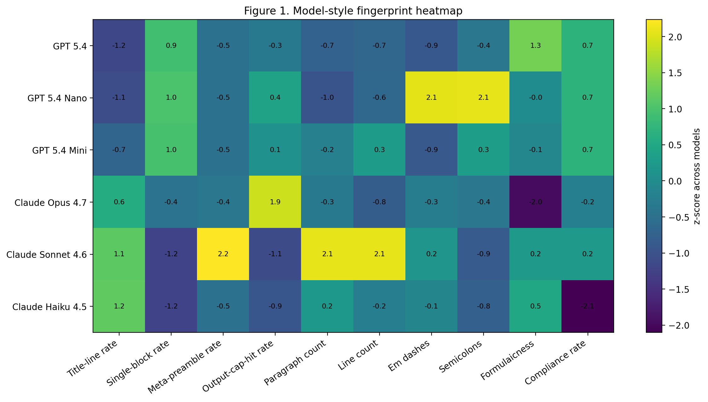
Figure 1. Model-style fingerprint heatmap
Figure 1 standardizes key stylistic features across models. The result is not a single family gradient. It is a fingerprint panel.

4.2 The title/block axis
The clearest two-variable view is title-line rate against single-block rate.
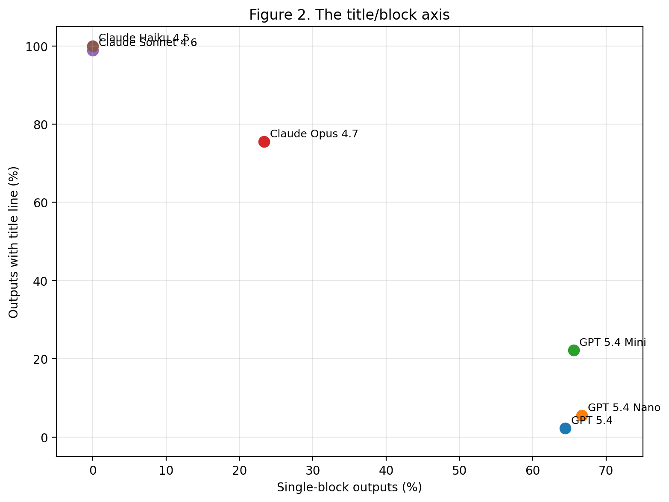
Figure 2. The title/block axis
This figure explains why a family-level interpretation is tempting. GPT models cluster toward high single-block and low title-line use. Sonnet and Haiku sit at the opposite pole. But the exceptions are the interesting part. Opus is not Sonnet. GPT Mini is not GPT 5.4. The family labels describe the broad geography; the individual models are the terrain.

4.3 Strongest statistical discriminators
Categorical structural variables produced very large model-level differences.
Feature | p | Cramér V
Title-line rate | 4.52e-80 | 0.84
Single-block rate | 4.92e-43 | 0.62
Meta-preamble rate | 7.38e-36 | 0.57
Output-cap-hit rate | 1.73e-07 | 0.27
Continuous variables also differed by model, especially paragraphing and punctuation.
Feature | p | ε²
Paragraph count | 6.76e-17 | 0.15
Semicolon count | 4.78e-13 | 0.12
Em-dash count | 9.76e-12 | 0.10
Colon count | 0.007 | 0.02
Type-token ratio | 0.007 | 0.02
Formulaicness | 0.068 | 0.01
These p-values should be read as screening statistics, not final inferential proof. The rows are not fully independent: each model answered the same prompt grid. The effect sizes and visual separations are more important than the exact p-values.

4.4 Output-cap hits: Opus had more to say
The output-cap variable needs special care. A cap-hit response did not “choose” to stop badly. It was stopped by the experiment. Therefore the strongest interpretation is not that Opus failed more often; it is that Opus more often tried to continue beyond the fixed response budget.
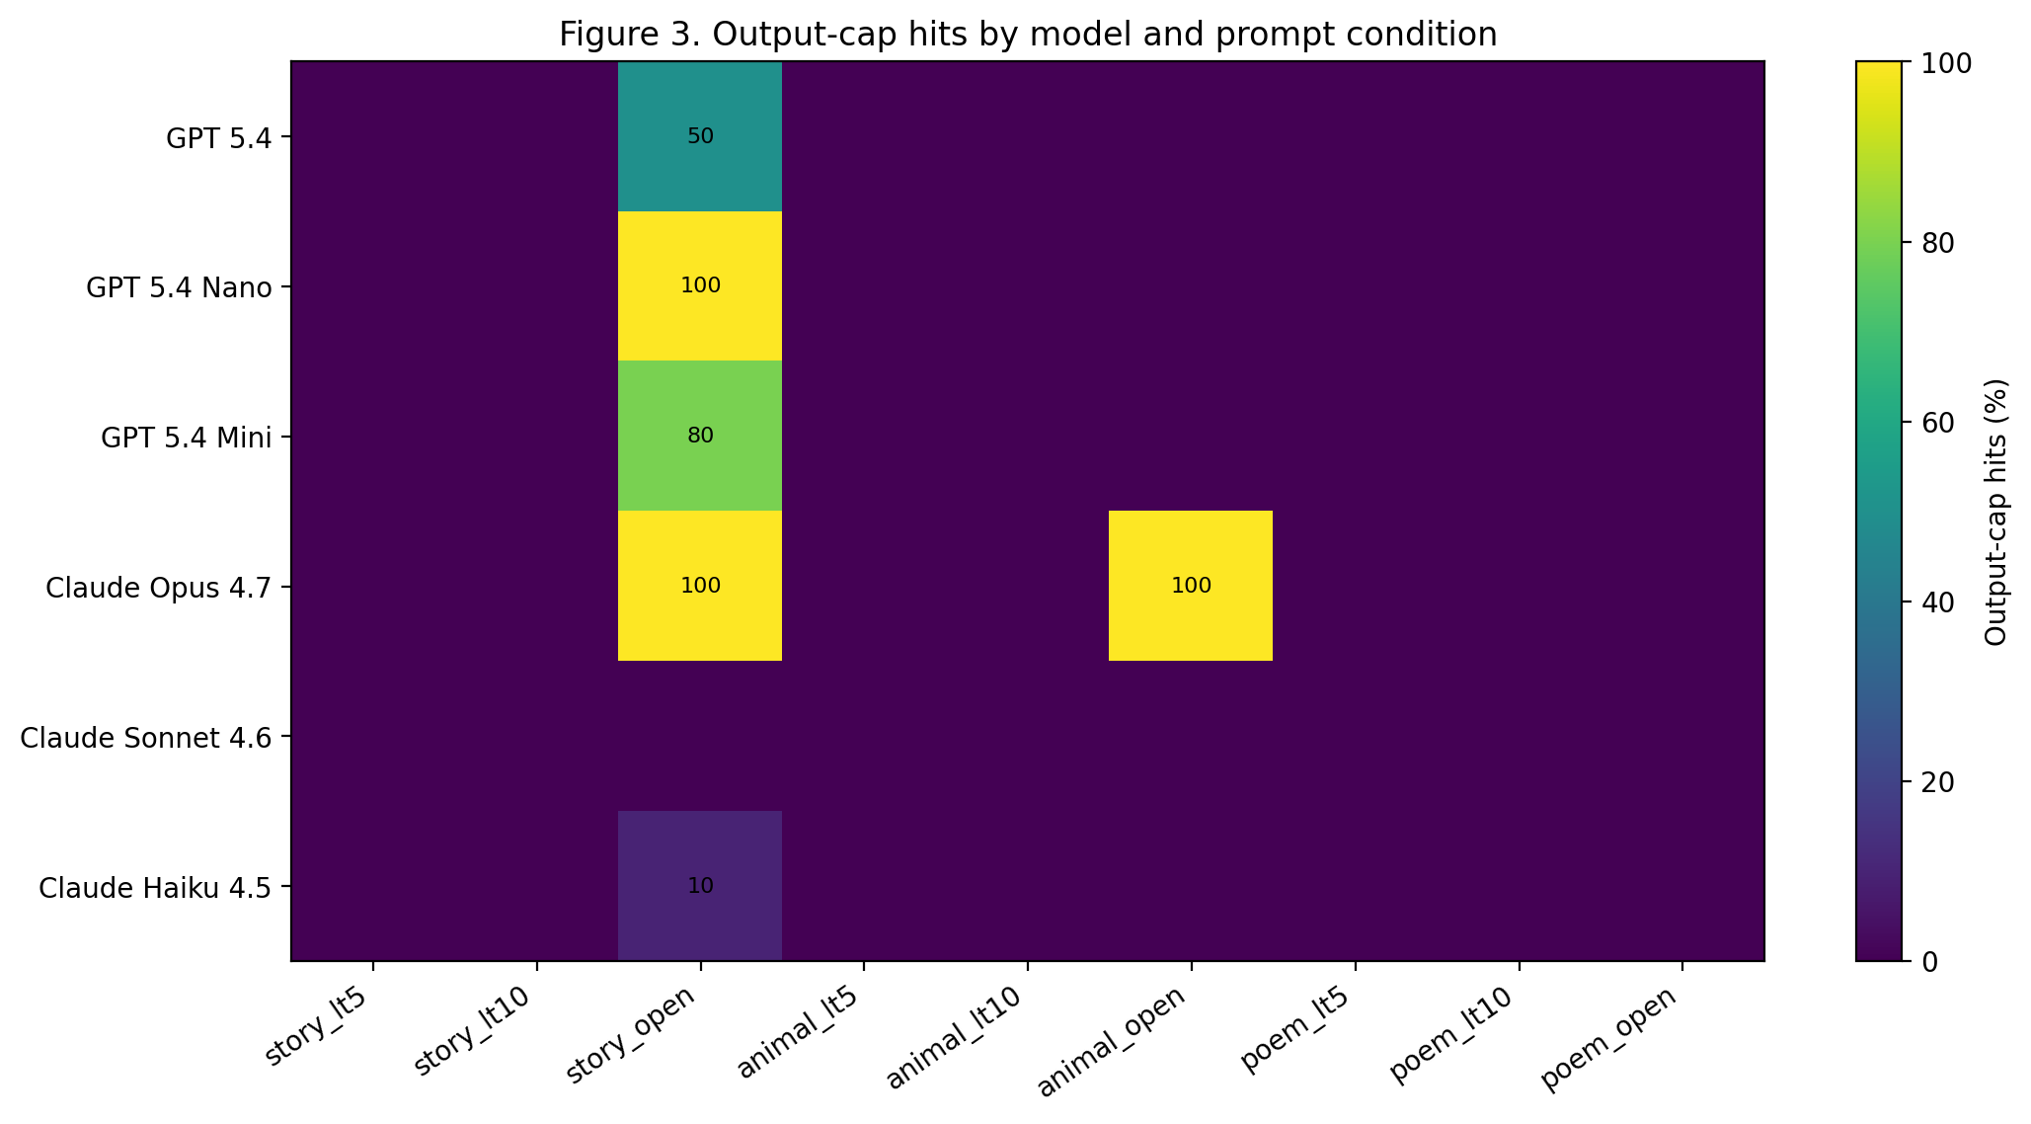
Figure 3. Output-cap hits by model and prompt condition
Open-ended conditions carried most of the output-cap hits.
Model | story_open | animal_open | poem_open
GPT 5.4 | 50.0 | 0.0 | 0.0
GPT 5.4 Nano | 100.0 | 0.0 | 0.0
GPT 5.4 Mini | 80.0 | 0.0 | 0.0
Claude Opus 4.7 | 100.0 | 100.0 | 0.0
Claude Sonnet 4.6 | 0.0 | 0.0 | 0.0
Claude Haiku 4.5 | 10.0 | 0.0 | 0.0
claude-opus-4-7 had the highest overall cap-hit rate at 22.2%. In this design, that means Opus most often had more to say than the harness allowed. This matters analytically because cap-hit rows contaminate downstream features involving endings, plot resolution, final sentence structure, and compliance. They are informative, but they are censored observations.

4.5 Individual signatures are not reducible to family signatures
A family summary is useful but dangerous. GPT-family outputs had a 10.0% title-line rate and a 65.6% single-block rate. Claude-family outputs had a 91.5% title-line rate and a 7.8% single-block rate. That is real. It is also incomplete.
The more interesting evidence is the shape of the individual model fingerprints. In a standardized feature space built from style variables, some same-family models are farther apart than some cross-family pairs.
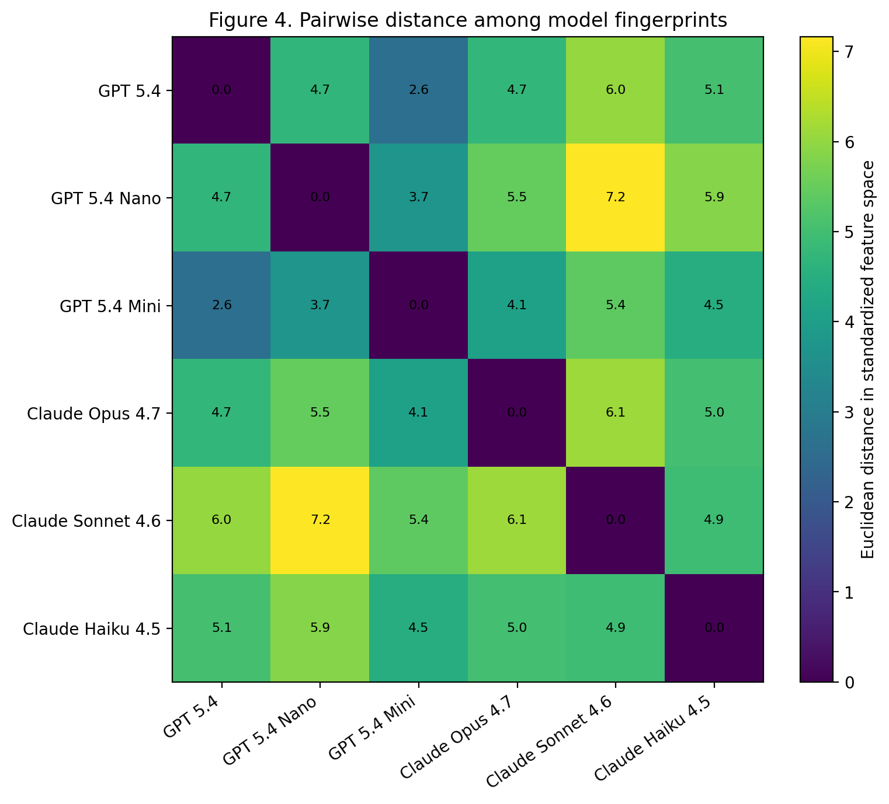
Figure 4. Pairwise distance among model fingerprints
Nearest fingerprint pairs:
Model 1 | Model 2 | Relation | Distance
GPT 5.4 | GPT 5.4 Mini | same family | 2.61
GPT 5.4 Nano | GPT 5.4 Mini | same family | 3.73
GPT 5.4 Mini | Claude Opus 4.7 | different families | 4.10
GPT 5.4 Mini | Claude Haiku 4.5 | different families | 4.48
GPT 5.4 | GPT 5.4 Nano | same family | 4.72
GPT 5.4 | Claude Opus 4.7 | different families | 4.74
Farthest fingerprint pairs:
Model 1 | Model 2 | Relation | Distance
GPT 5.4 Nano | Claude Haiku 4.5 | different families | 5.86
GPT 5.4 | Claude Sonnet 4.6 | different families | 6.04
Claude Opus 4.7 | Claude Sonnet 4.6 | same family | 6.10
GPT 5.4 Nano | Claude Sonnet 4.6 | different families | 7.17
The distance matrix makes the main point: family is a visible axis, but it is not the whole structure. Opus can be closer to GPT-style profiles than to Sonnet on some features, while Sonnet and Haiku share title-heavy formatting but diverge in preambles, compliance, and cap-hit behavior.
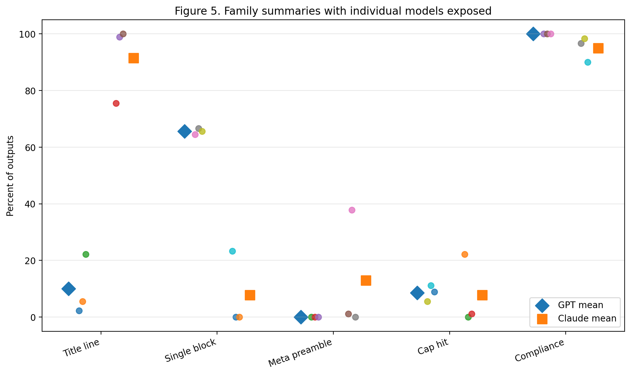
Figure 5. Family summaries with individual models exposed
The family means are not false. They are simply too smooth.

4.6 A prompt-blocked classifier sanity check
To test whether the stylistic fingerprints survive prompt variation, I trained simple classifiers on surface-style features only, excluding model labels, family labels, prompt labels, and the output-cap indicator. Validation was leave-one-prompt-id-out: train on eight prompt conditions, test on the ninth.
Classifier | Validation | Six-way accuracy | Chance
Logistic regression | leave-one-prompt-id-out | 42.6% | 16.7%
Random forest | leave-one-prompt-id-out | 49.8% | 16.7%
Chance performance for six-way model identification is 16.7%. The random forest reached 49.8%; logistic regression reached 42.6%. This is not offered as a serious attribution system. It is a sanity check. If a small pile of surface features can identify the model far above chance on an unseen prompt condition, then the style signal is real enough to survive the prompt grid.

4.7 Semantic features were quieter, but the quietness is itself situated
The semantic features did not separate models as dramatically as structural variables. Formulaicness differed descriptively: claude-opus-4-7 had the lowest mean formulaicness score, while gpt-5.4 had the highest. But the model-level test for formulaicness was weaker than for paragraph count, title use, preambles, em dashes, or semicolons.
This should not be overread. It does not prove that the models are semantically alike. It may simply mean that the semantic coder is too blunt for the thing we want to know. Mood labels, imagery buckets, and plot-arc categories are high-level bins. A model may differ in metaphor texture, cliché handling, narrative tempo, or conceptual surprise without moving these heuristics much.
In v1.1, this point becomes sharper because the semantic coder is not an abstract coding regime. It is a GPT-designed heuristic. Its quietness may reflect something real about the outputs, or something real about GPT’s own analytic taste: perhaps it is better at naming broad content buckets than at hearing minute tonal differences. Claude’s structural heuristic, by contrast, found loud separations in the manners of the page. This does not make Claude right and GPT wrong. It means the two machine coders discovered different signal-to-noise ratios.
The first clean conclusion remains structural: model identity is easier to see in manners than in meanings. The v1.1 refinement is that the measuring instruments have manners too.

4.8 Compliance and sentence-count fragility
Compliance was high overall. GPT-family models were fully compliant under the semantic heuristic on constrained prompts. Claude-family compliance was lower, but this was not a clean family effect. The weakest compliance rate was concentrated in claude-haiku-4-5-20251001, especially around story_lt5.
This is also where coder fragility matters. Sentence-count coders disagreed on 105 of 540 rows, mostly in open-ended stories and animal descriptions. Compliance coders disagreed on only three rows, all claude-haiku-4-5-20251001 on story_lt5, where one sentence-count heuristic yielded compliance and the other did not. In other words, the compliance finding exists, but it is local, mechanical, and partly definition-sensitive.
The sentence-count disagreements are not merely nuisance errors. They are a reminder that even apparently simple facts - how many sentences are in this generated text? - can become slippery when prose, list-like formatting, titles, poem lines, fragments, and model house style collide.

5. Discussion: finding truths in average bullshit
The joke is also the result. Ask the machines to make something up, ask them again and again, then average the visible habits. Truth appears not in the propositions but in the posture.
The models are not merely sampling content. They are sampling manners. A title is a habit. A preamble is a habit. A refusal to put everything in one block is a habit. An em dash is a habit. So is the urge to keep elaborating until the budget cuts you off. None of these features alone is profound. Together they form a behavioral signature.
The major finding is therefore not “Claude versus GPT,” although that contrast is visible. The stronger finding is:
Individual models leave stylistic fingerprints that survive prompt variation.
Provider family is one layer of explanation. Product tier, post-training taste, instruction-following style, default helpfulness rituals, and model-specific generation preferences are probably entangled with it. This experiment cannot separate those causes. But it can show the consequence: the average output is not neutral.
The phrase “average bullshit” matters because these prompts do not ask for expertise. They ask for improvisation. The resulting text is not useless because it lacks a real-world task. It is useful precisely because the stakes are low. Low-stakes generation exposes defaults that high-stakes instruction may conceal.
Version 1.1 adds that the coding process is itself part of the artwork and the instrument. Claude made one lens. GPT made another. The human author arranged the session and refused the boring takes. That arrangement is not a contamination to be hidden; it is a condition to be disclosed.
The best analogy is not a microscope. It is a studio. The models play. The machine coders place microphones in different parts of the room. The human producer says: that sound, there - keep that.

6. Limitations
This is a v1.1 exploratory analysis, and its claims should stay proportional.
First, the sample is small: 10 runs per model-prompt cell. The effects are large enough to see, but replication is needed.
Second, the task regime is narrow. These are creative-writing prompts under cold contextless conditions, not coding, reasoning, retrieval, summarization, dialogue, or tool use.
Third, model names are dated product labels. The repository itself notes that dated snapshots are important for long-term reproducibility.
Fourth, rows are not fully independent because every model answered the same prompt grid. Statistical tests are best treated as descriptive screens. A paper-grade follow-up should use prompt-blocked or mixed-effects models.
Fifth, output-cap hits are censored observations. They should not be interpreted as natural failures or completion defects. They show pressure against the imposed response budget.
Sixth, structural and semantic features are heuristic, and both heuristic systems were machine-designed. The structural coder disclosed that its script was authored by claude-opus-4-7, one of the experimental subjects. The semantic heuristic was designed by GPT-5.5 Thinking / Extended, which also served as primary analyst. This is not a fatal flaw, but it is not invisible. It means the assay has two machine-made coding sensibilities rather than one neutral human gold standard.
Seventh, the convergence between the two coders is more reassuring for direct, mechanically countable variables than for interpretive variables. A title line, line count, or block format is less vulnerable to coder taste than a mood, plot arc, or formulaicness label. But no coding category is taste-free.
Finally, stylistic fingerprints are not quality judgments. A title-heavy model is not better or worse than a prose-block model. A model that has more to say is not necessarily wiser. The assay measures defaults, not virtue.

7. Conclusion
The experiment began with disposable prompts and ended with durable signatures. The models were asked for small invented things: stories, animals, poems. They obliged. But in obliging, they revealed preferences. Some boxed the artifact with a title. Some flowed in prose. Some prefaced. Some punctuated. Some kept going until the cap fell.
The finding is not that machines bullshit. Everyone knew that. The finding is that they bullshit differently, and consistently enough to be measured.
Version 1.1 adds a second finding: machines also measure differently. Claude’s structural heuristic and GPT’s semantic heuristic stand alongside the outputs they code. The human author is not the hidden oracle; he is the producer who hears the take and decides that the average bullshit is worth listening to.
A v1.1 headline:
Model identity is more visible in style than in semantics. Family matters, but the individual model leaves the fingerprint - and the coders leave fingerprints too.
Or, less politely:
There are truths in the average bullshittings of machines, including in the machines that do the averaging.

References
- Bo Chesterton / quumble, An-Assay-of-Bullshit, GitHub repository: https://github.com/quumble/An-Assay-of-Bullshit
- Analysis files supplied in-session: structural coded outputs, semantic coded outputs, summary tables, private blind-model maps, and machine-designed coding heuristics.

