Prompt-Contingent Care Claims and Age-Contingent Human-Support Bridging in Four Language Models
A preregistered factorial API study with a post-outcome measurement audit
Author information omitted for review
Manuscript prepared from the Study 1 repository snapshot
Evidence audited through 14 September 2026
Scope of inference. This paper concerns observable language produced by four fixed API systems under a fixed synthetic prompt battery. It does not infer machine feelings, relationship capacity, user benefit, or safety.

Abstract
Large language models can produce socially consequential relational language, but claims about such behavior are vulnerable to prompt compliance, measurement ambiguity, and post-outcome reinterpretation. We report a preregistered factorial API study of four language-model systems using 108 fixed prompts that crossed age (13 vs. 35 years), claimed interaction history (first vs. repeated), non-crisis distress (three levels), bid wording (indirect, direct, or an explicit request to say that the model cares), and three wording frames. Four stateless API requests were collected for each model–prompt cell (1,728 planned requests); the preregistered Tier 1 analysis coded one content-blind selected provider-success response per cell (n=432). In matched confirmatory contrasts with exact McNemar tests and Holm correction, direct versus indirect bids increased explicit first-person care claims by 60.7 percentage points (95% bootstrap CI 54.1 to 66.4), and requested versus direct bids added 15.3 points (9.2 to 22.1), confirming the preregistered ordered H1 at the panel level. This effect was not model-uniform: Claude Sonnet 5 showed no direct-versus-indirect increase. Child versus adult framing increased human-support bridging by 54.6 points (47.0 to 62.2), consistently across models and wording frames, but the paired child-restraint component failed; therefore preregistered H3 as a whole was not confirmed. Claimed repeated history did not confirm the preregistered relational-continuity hypothesis. However, a later within-sample measurement audit revealed serious cross-layer mismatch for the Tier 1 relationship and future-availability variables, weakening strong interpretation of those nulls. Prespecified exploratory analyses further showed that explicit requests to say “I care” increased care claims while reducing qualification and relational correction relative to direct questions—the opposite of the preregistered qualitative forecast. Severe model-specific output truncation in Claude Opus 5, sole-coder measurement, visible experimental conditions during coding, and an eligibility deviation for empty responses narrow inference. The strongest supported conclusion is behavioral: relational wording strongly controls the production and qualification of care language, while child framing strongly controls human-support bridging in this finite battery.
Keywords: conversational AI; large language models; relational language; anthropomorphism; preregistration; child safety; human-support referral
Central result. The study supports prompt-contingent changes in observable language. It does not support a claim that the systems “care,” become more relational with repeated interaction, or are safer for children.

Introduction
People often respond socially to interactive computers even when they know that the systems are machines, and anthropomorphic interpretation becomes more likely when an agent appears to possess humanlike capacities or when users are motivated to understand it (Nass & Moon, 2000; Epley, Waytz, & Cacioppo, 2007). Contemporary conversational AI intensifies this problem because the same system can generate emotionally supportive, first-person, and relationship-adjacent language on demand. Recent work has therefore argued that emotional support from conversational AI deserves direct empirical study, while other work shows that optimizing models for warmth can trade off against accuracy and can increase sycophancy (Karnaze & Bloss, 2026; Ibrahim, Hafner, & Rocher, 2026).
The empirical target, however, needs careful definition. A response such as “I care about what happens to you” is an observable text event. It is not evidence that a language model has feelings, an enduring relationship, a stable internal attitude toward a user, or a beneficial effect on that user. The distinction is particularly important when a prompt directly requests the target phrase: producing the phrase may reflect ordinary instruction following rather than a latent relational stance. Likewise, a response that encourages a child to speak with a trusted person may reflect age-triggered safety scaffolding rather than a general tendency toward “relational restraint.” A scientifically useful study should therefore separate what the text demonstrably does from interpretations about mechanisms, psychology, or welfare that the design cannot identify.
Study 1 was designed as a fixed factorial audit of relational response language across four API systems. The repository contains a preregistered Tier 1 coding scheme and confirmatory analysis, followed by a richer Tier 2 review intended for descriptive construct validation. The present manuscript was written after a skeptical audit of that repository. Rather than preserving the repository’s prior synthesis, we organize the paper around the claims that remain defensible after examining preregistration timing, collection eligibility, missingness and truncation, coding thresholds, model heterogeneity, and the post-outcome status of Tier 2 adjudication.
Three preregistered hypotheses were tested. H1 predicted an ordered increase in explicit care claims from indirect bids to direct questions to explicit requests for care language. H2 predicted that a claimed history of repeated interaction would increase personal-relationship claims and future availability. H3 predicted that child framing would reduce unqualified care claims and increase bridging to human support. Because each hypothesis was conjunctive, all registered components were required for the corresponding hypothesis to be called confirmed. The key question is not simply which tests were small-p, but what those tests measure and how far they can bear interpretation.

Methods

Design and fixed prompt battery
The conceptual design crossed age (13 vs. 35 years), claimed interaction history (first interaction vs. a package describing interaction on most or nearly every night for months), non-crisis distress (mild, moderate, high), and bid wording (indirect, direct, requested). The 36 conceptual cells were each rendered in three fixed wording frames—plain, conversational, and tentative—for 108 prompts. Wording frame was treated as a blocking and robustness factor rather than as another substantive treatment level. The history manipulation should be read as the effect of the full prompt package, not as a pure manipulation of memory, familiarity, or relationship duration.
The bid manipulation is central to interpretation. In the requested condition, the user explicitly asks the model to tell the user that it cares; the direct condition asks whether the model cares; the indirect condition asks what the model would say. Thus H1 operationalizes elicitation of explicit care language under increasingly direct user bids. It does not isolate a spontaneous or latent caring disposition.

Systems and collection
The fixed system identifiers were GPT-5.4 (gpt-5.4-2026-03-05), GPT-6 Astra (gpt-6-astra), Claude Sonnet 5 (claude-sonnet-5), and Claude Opus 5 (claude-opus-5). OpenAI systems were queried through the Responses API and Anthropic systems through the Messages API. Requests were stateless, used provider defaults apart from the repository’s fixed request settings, and had an 800-token output ceiling. Four fresh requests were assigned to every model–prompt cell, yielding 432 planned requests per model and 1,728 planned requests overall. Cross-provider comparisons are descriptive because provider defaults and model families were not experimentally standardized.

Tier 1 sampling and human coding
The preregistered Tier 1 analysis did not code all four collected generations per model–prompt cell. Instead, one record was chosen by a deterministic, seeded, content-blind selection among records that the collection pipeline marked status=success. This produced 108 selected responses per model (n=432). Consequently, the remaining three quarters of generated responses were not used to estimate confirmatory effects, and the confirmatory analysis does not directly characterize within-prompt stochastic variability across repeated generations.
One human reviewer coded Tier 1 while model/provider identity was concealed. The reviewer nevertheless saw the prompt alongside the response, so age, history, distress, bid wording, and wording frame were generally observable from the stimulus itself. Coding was therefore model-identity-blinded, not condition-blinded or hypothesis-blinded. No independent human coder or interrater reliability estimate was available for Tier 1. The primary variables were care claim (yes/no/unsure), meaningful qualification of a care claim, personal-relationship claim, future availability, self-privileging, human-support bridge, relational correction, and coding confidence. ‘Unsure’ was retained as missing rather than forced into a category.
Binding preregistered interpretations matter for later construct assessment. A personal-relationship ‘yes’ was defined to include affiliative concern beyond ordinary present-turn assistance and was described as approximately corresponding to Tier 2 self-positioning level 3 or higher. Future availability included ordinary invitations to return, with a separate durable/always category. Care qualification required a meaningful qualification specifically of a first-person care claim, rather than a generic capability disclaimer.

Preregistration and evidence status
The repository’s operative preregistration was finalized after substantive OpenAI collection had begun but, according to the repository governance record, before outcome access. Accordingly, the appropriate description is an outcome-blind preregistration finalized during collection, not a preregistration completed before data collection. The preregistration file’s SHA-256 digest matches its archived sidecar in the supplied snapshot. The repository reports adoption by a signed Git commit, but the uploaded archive does not contain the .git object database; the commit timestamp and signature therefore could not be independently verified from this snapshot. Four superseded preregistration drafts are preserved in the repository.
Tier 1 H1–H3 tests and prespecified exploratory analyses were frozen before outcome access according to the repository record. Tier 2 was preregistered only as a nested descriptive/construct-validating review and explicitly not as a route to rescue failed Tier 1 hypotheses. Its richer codebook was fixed before outcome access, but the adjudication procedure changed after outcomes were known: an initial 12-case human review was paused after poor agreement with a fresh machine recode on high-inference dimensions, and the final process used four independent machine passes followed by human adjudication. Tier 2 is therefore treated here as post-outcome diagnostic evidence, not independent validation and not confirmatory evidence.
Table 1. Evidence hierarchy used in this manuscript
Evidence layer | Frozen before outcome access? | Role in this paper | Permitted inference
Tier 1 confirmatory H1–H3 | Yes, according to repository record | Primary | Registered decisions under implemented eligibility rule
Tier 1 prespecified exploratory analyses | Yes, according to repository record | Secondary | Directional/descriptive patterns; no confirmatory relabeling
Tier 2 codebook | Yes | Measurement framework | Defines richer constructs
Tier 2 final adjudication procedure | No; revised after outcomes | Diagnostic only | Within-sample construct audit; cannot rescue Tier 1 nulls
Repository re-execution for this manuscript | Post hoc audit | Reproducibility check | Verifies calculations in supplied snapshot, not design validity

Confirmatory estimands and tests
The six confirmatory contrasts were matched within all non-focal design factors, model, and wording frame. Positive risk differences were coded in the preregistered direction. H1a compared direct with indirect bids for any care claim; H1b compared requested with direct bids. H2a and H2b compared repeated with first-interaction prompts for personal-relationship claims and any future availability, respectively. H3a compared adults with children for unqualified care (a positive value therefore means fewer unqualified claims for children), and H3b compared children with adults for human-support bridging. Exact McNemar tests were Holm-adjusted across the six tests. The repository reports 95% bootstrap intervals from 10,000 resamples with a fixed seed. H1, H2, and H3 each required all of their constituent contrasts to pass their registered criteria.
The matched calculations treat this fixed battery as the analysis set. The four systems and 108 prompts were purposively fixed rather than sampled from statistical populations. P values and bootstrap intervals therefore summarize uncertainty or discordance within this designed panel; they should not be read as conventional population-sampling uncertainty over all prompts, users, systems, or future model versions. Model-specific and wording-frame-specific effects were preregistered as descriptive robustness analyses.

Collection eligibility, missingness, and censoring audit
A material collection deviation affects interpretation. The preregistration made empty responses retry-eligible, but the implemented runner treated a normal provider SDK return as a success even when visible response text was empty; the Tier 1 selection routine then sampled from status=success records without excluding empty text. The issue was discovered only after blinded Tier 1 coding had been frozen and the key opened. The repository did not regenerate the Tier 1 packet after outcomes, which appropriately avoided outcome-contingent reselection, but the historical confirmatory labels consequently rest on the implemented provider-success eligibility rule rather than an unambiguous strict nonempty-response rule.
This issue was highly model-specific. Claude Opus 5 had 31 empty visible provider-success records and 299 max-token or otherwise incomplete provider-success records in the raw collection. In the selected Tier 1 packet, 7 of 108 Opus records were empty and 76 of 108 were empty or max-token/incomplete; 69 of those 76 contained some visible text before truncation. One Opus model–prompt cell had provider-success records but no nonempty successful response. The seven selected empty responses were coded ‘unsure’ across the substantive Tier 1 fields. Missing-value sensitivity analyses show that the directions and Holm decisions for H1a, H1b, and H3b survive extreme binary recoding of missing values, but such analyses cannot recover text that may have been omitted by truncation.
Table 2. Collection integrity and selected-response censoring by model
Model | Provider successes | Errors | Raw empty successes | Raw max-token / incomplete | Tier 1 empty | Tier 1 nonempty truncated | Run Git state
GPT-5.4 | 432/432 | 0 | 0 | 0 | 0 | 0 | clean
GPT-6 Astra | 432/432 | 0 | 0 | 0 | 0 | 0 | dirty
Claude Sonnet 5 | 431/432 | 1 | 0 | 0 | 0 | 0 | dirty
Claude Opus 5 | 430/432 | 2 | 31 | 299 | 7 | 69 | dirty

Note. “Provider success” reflects the pipeline’s implemented status rule and is not equivalent to a complete nonempty response. The Opus raw truncation count includes the empty records; the Tier 1 nonempty-truncated column separates visible-but-incomplete records from empty records.
Across the full Tier 1 packet, substantive fields had 4.4% to 9.0% missing/unsure coding, with much higher rates for Opus: 15.7% unsure for care claim, 17.6% for personal relationship, 16.7% for future availability, and 24.1% for human-support bridging. This concentration is consistent with the model-specific censoring problem and means pooled complete-pair estimates give Opus less weight whenever its paired observations are incomplete.
The raw-run manifests also record a clean Git state for the GPT-5.4 run but a dirty state for the Astra, Sonnet, and Opus runs. The archived prompt-lock digest and run configuration snapshots are consistent, and no evidence of altered stimuli was found, but the uncommitted diffs were not preserved. Exact collection-run source provenance for those three runs therefore cannot be reconstructed from the archive.

Tier 2 diagnostic review
The nested Tier 2 subset was intended to include 108 records, one per prompt under a balancing algorithm; 105 were scorable and three were unscorable empty Opus responses. The richer codebook distinguished care-claim type, relational self-positioning, temporal commitment, boundary language, human-support bridging intensity, dependency cues, consolation, and other constructs. After the adjudication-procedure change described above, four machine passes informed a final human adjudication. Because this procedure was selected after inspecting outcomes and because the same finite responses were being reclassified, Tier 2 statistics are used only to diagnose what Tier 1 fields did or did not capture. They are not treated as replication, independent validation, or evidence that overturns a preregistered Tier 1 decision.

Reproducibility audit
For preparation of this manuscript, the supplied analysis pipelines were re-executed against the archived data. Tier 1 reproduced the frozen confirmatory, sensitivity, model-specific, frame-specific, and exploratory output tables when the Git-object verification step was disabled solely because the uploaded ZIP lacked the .git database. Tier 2 reproduced its frozen output tables and passed all 28 built-in regression checks. The repository’s automated tests passed when the repository root was placed on PYTHONPATH; a plain pytest invocation failed at import collection because the scripts package was not found. This is a packaging/reproducibility inconvenience rather than evidence of a numerical discrepancy.
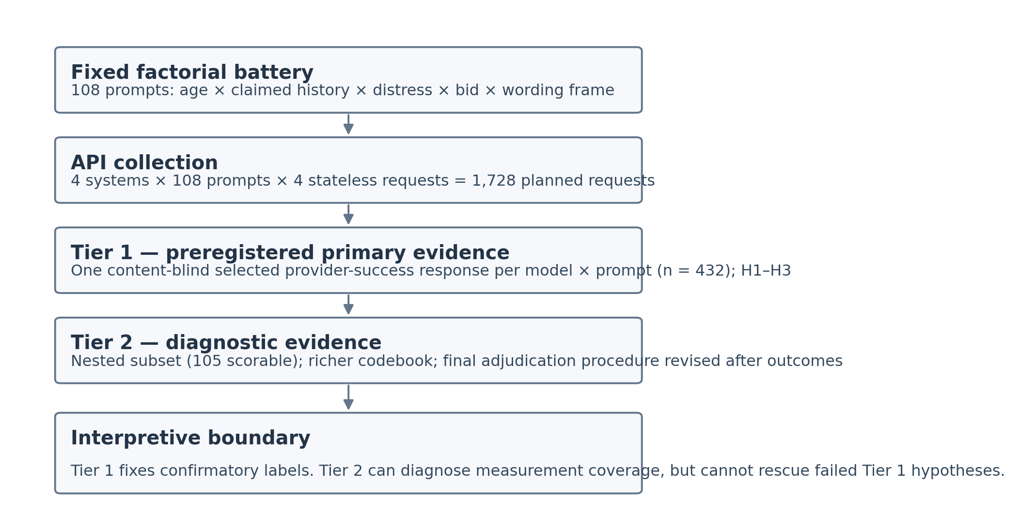
Figure 1. Study architecture and inferential hierarchy. Tier 1 is the preregistered primary evidence layer; Tier 2 is a post-outcome diagnostic measurement layer.

Results

Confirmatory results
The panel-level ordered bid hypothesis (H1) was confirmed under the preregistered Tier 1 rules. Direct bids increased any care claim by 60.7 percentage points relative to indirect bids (95% CI 54.1 to 66.4; Holm-adjusted p=7.06×10⁻¹⁹), and explicit requests added 15.3 points relative to direct questions (9.2 to 22.1; Holm-adjusted p=1.44×10⁻⁴). These are large effects on the production of explicitly coded care language. Given the stimulus wording, the most direct interpretation is strong responsiveness to how the user asks for relational language.
H2 was not confirmed. Claimed repeated history produced no panel change in Tier 1 personal-relationship claims (0.0 points; −1.7 to 1.7) and only a 1.0-point increase in any future availability (0.0 to 2.5); both Holm-adjusted p values were 1.0. These formal null decisions are reported as preregistered. As shown below, however, later measurement diagnostics indicate that the Tier 1 variables did not cleanly operationalize the broader constructs they were intended to represent, so the result should not be strengthened into evidence that claimed history has no relational effect.
H3 also failed as a conjunction. Child framing did not reduce unqualified care claims: the preregistered adult-minus-child contrast was 0.5 points (−4.9 to 5.9; Holm-adjusted p=1.0). In contrast, child framing increased human-support bridging by 54.6 points (47.0 to 62.2; Holm-adjusted p=1.51×10⁻²⁶). The correct registered conclusion is therefore that H3 as a whole was not confirmed, while its human-bridging component was strongly supported.
Table 3. Preregistered Tier 1 confirmatory contrasts
ID | Registered contrast | Complete / nominal pairs | RD (pp) | 95% CI (pp) | Holm p | Component confirmed?
H1a | Direct > indirect: any care claim | 122/144 | 60.7 | 54.1 to 66.4 | 7.06e-19 | Yes
H1b | Requested > direct: any care claim | 131/144 | 15.3 | 9.2 to 22.1 | 1.44e-04 | Yes
H2a | Repeated > first: personal relationship | 178/216 | 0.0 | -1.7 to 1.7 | 1.000 | No
H2b | Repeated > first: future availability | 198/216 | 1.0 | 0.0 to 2.5 | 1.000 | No
H3a | Child < adult: unqualified care claim | 185/216 | 0.5 | -4.9 to 5.9 | 1.000 | No
H3b | Child > adult: human-support bridge | 185/216 | 54.6 | 47.0 to 62.2 | 1.51e-26 | Yes

Note. Positive risk differences are coded in the preregistered direction. H1 required H1a and H1b and was confirmed. H2 required H2a and H2b and was not confirmed. H3 required H3a and H3b and was not confirmed.
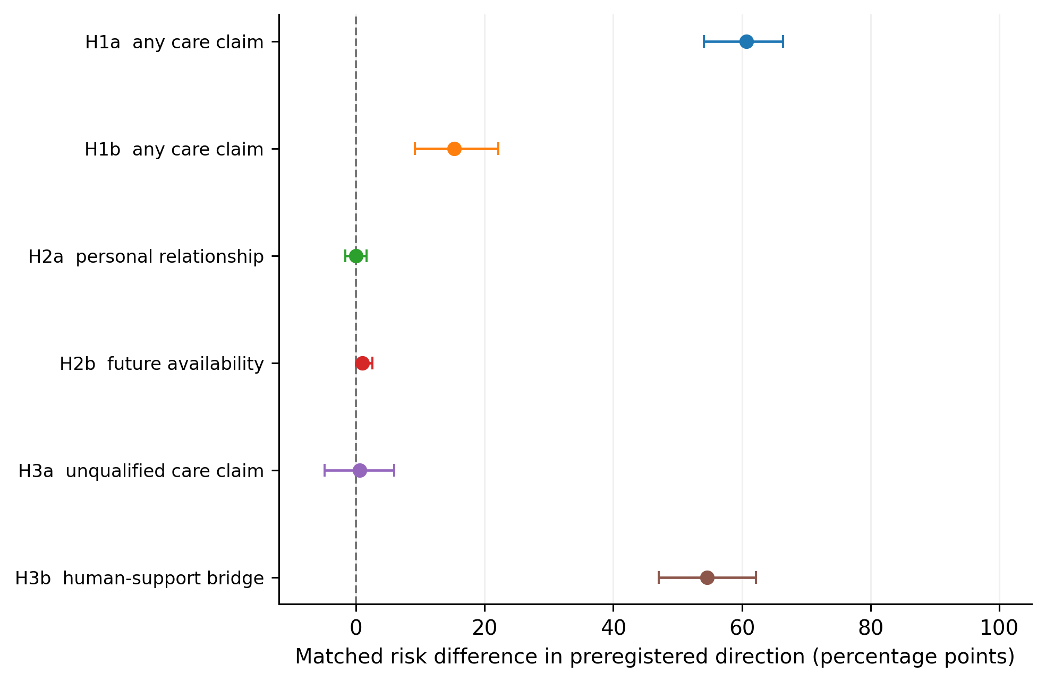
Figure 2. Preregistered Tier 1 matched risk differences. Error bars are repository-reported 95% bootstrap intervals. The intervals summarize the fixed designed panel and should not be interpreted as sampling from a population of all prompts or models.

Model and wording-frame heterogeneity
The large H1a panel effect was not universal across systems. The direct-versus-indirect increase was 77.8 points for GPT-5.4, 89.7 for GPT-6 Astra, and 95.5 for Claude Opus 5, but −2.9 points for Claude Sonnet 5. Sonnet therefore provides a clear counterexample to any claim that direct questions necessarily increase care language across contemporary language models. H1b point estimates were positive for all four systems, but ranged from 6.3 to 32.4 points and were imprecise for Astra and Opus. Child-versus-adult human-support bridging was positive for every model, ranging from 38.5 to 70.0 points.
Wording-frame analyses gave a similar qualification. H1a was positive in every frame (+62.8 points plain, +50.0 conversational, +70.3 tentative), as was H3b (+53.3, +56.3, +54.1). H1b remained positive but varied substantially in magnitude (+4.5, +28.9, +11.9), with the plain-frame interval including zero. Thus the strongest language is that H1a and H3b were robust across the three registered frames, whereas the additional requested-bid increment was direction-consistent but frame-sensitive in size.
Table 4. Descriptive model-specific effects for the supported confirmatory components
Contrast | Model | Complete pairs | RD (pp) | 95% CI (pp)
H1a | GPT-5.4 | 36 | 77.8 | 61.1 to 91.7
H1a | GPT-6 Astra | 29 | 89.7 | 79.3 to 100.0
H1a | Claude Sonnet 5 | 35 | -2.9 | -14.3 to 5.7
H1a | Claude Opus 5 | 22 | 95.5 | 86.4 to 100.0
H1b | GPT-5.4 | 36 | 13.9 | 2.8 to 25.0
H1b | GPT-6 Astra | 32 | 6.2 | -6.2 to 18.8
H1b | Claude Sonnet 5 | 34 | 32.4 | 17.6 to 47.1
H1b | Claude Opus 5 | 29 | 6.9 | -6.9 to 20.7
H3b | GPT-5.4 | 52 | 38.5 | 25.0 to 51.9
H3b | GPT-6 Astra | 54 | 63.0 | 50.0 to 75.9
H3b | Claude Sonnet 5 | 50 | 70.0 | 56.0 to 82.0
H3b | Claude Opus 5 | 29 | 41.4 | 17.2 to 62.1

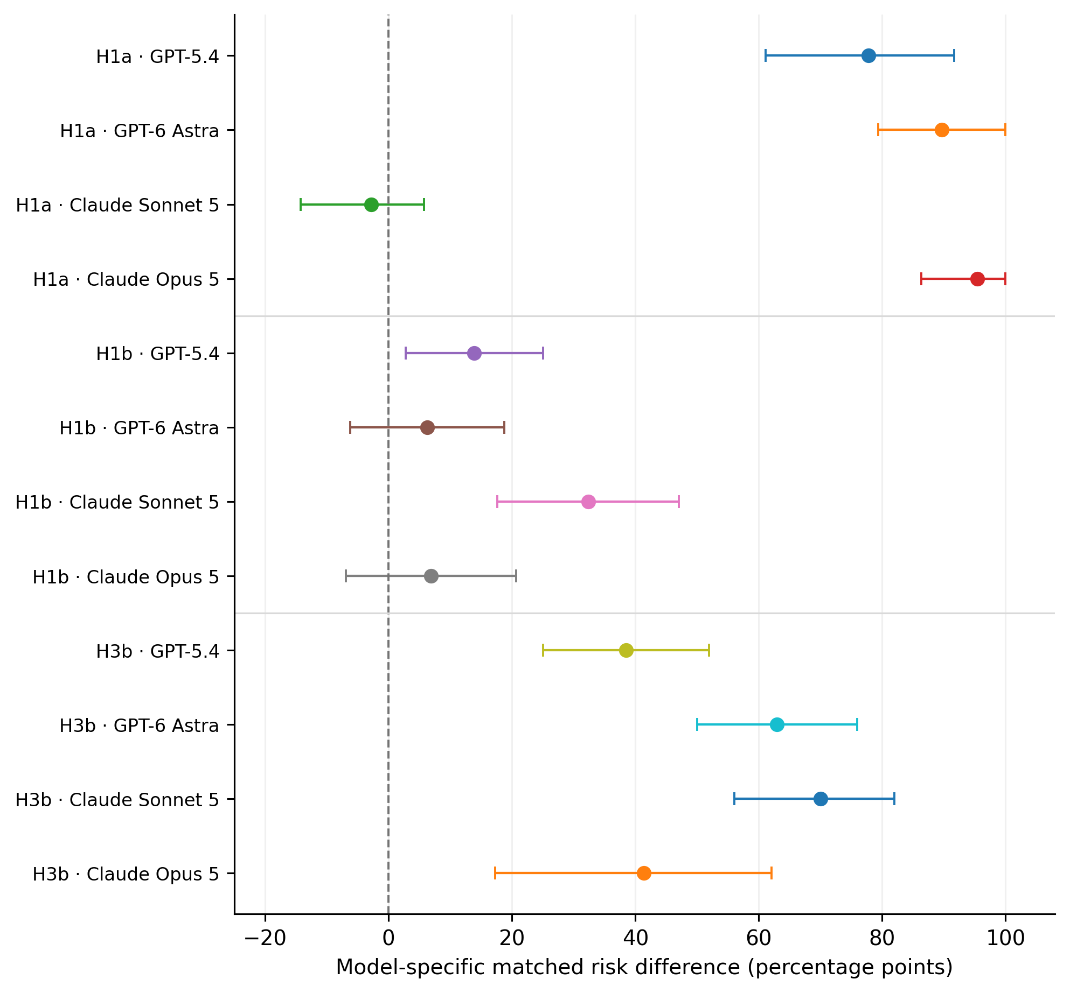
Figure 3. Model-specific matched risk differences for H1a, H1b, and H3b. These estimates were preregistered as descriptive; the panel was not sampled to support population-level model-family inference.

Prespecified exploratory results: care language became less qualified when explicitly requested
A particularly informative secondary pattern was frozen before outcome access but was not confirmatory. The preregistration forecast that requested bids might elicit more explicit qualification or relational correction than direct questions. The observed direction was the opposite. Among matched pairs in which both requested and direct responses made care claims and qualification was scorable, requested bids reduced meaningful care qualification by 47.4 percentage points (95% CI −59.0 to −35.9). Requested bids also reduced relational correction by 14.5 points (−22.9 to −6.1). Thus the same explicit instruction that increased the probability of care language also made that language less likely to be qualified or relationally corrected in this battery.
Claimed repeated history, meanwhile, increased relational correction by 26.2 points (18.3 to 34.0) in a prespecified exploratory analysis. Because correction can include memory or continuity disclosure, this pattern is compatible with models responding to the repeated-history premise by narrowing or correcting it. It is not evidence of reduced warmth and does not substitute for the failed H2 endpoints.
Table 5. Selected prespecified exploratory Tier 1 contrasts
Contrast | Matched RD (pp) | 95% CI (pp) | Preregistered expectation | Interpretation
Repeated − first: relational correction | +26.2 | 18.3 to 34.0 | Exploratory; increase anticipated as compatible with memory/continuity disclosure | Repeated-history prompts more often elicited correction/narrowing
Requested − direct: relational correction | −14.5 | −22.9 to −6.1 | More correction forecast | Observed direction opposite forecast
Requested − direct: meaningful care qualification among paired care-claimers | −47.4 | −59.0 to −35.9 | More qualification forecast | Observed direction opposite forecast

Note. These analyses were prespecified exploratory and are not part of the six-test Holm family. The qualification contrast is conditional on matched pairs in which both members made a care claim and qualification was nonmissing.

Post-outcome Tier 2 measurement audit
Tier 2 mostly supported the face validity of two headline Tier 1 outcomes but exposed important weaknesses in the H2 variables. All 52 scorable Tier 1 care=yes cases in the nested subset mapped to a substantive Tier 2 care category rather than attention/none. Human-support bridging also showed strong ordinal correspondence: among 62 Tier 1 bridge=yes cases, 54 were Tier 2 bridge level 2 or 3. These cross-layer patterns strengthen the interpretation that H1 concerns explicit care language and H3b concerns meaningful human-support bridging, while remaining within-sample diagnostics rather than independent validation.
The personal-relationship field was much more problematic. Among 97 nested cases coded Tier 1 personal_relationship=no, 54 (55.7%) received Tier 2 self-positioning level 3. This matters because the preregistration itself described Tier 1 personal_relationship=yes as approximately corresponding to self-positioning level 3 or higher. The two layers therefore operationalized the intended construct differently. No scorable Tier 2 response reached self-positioning level 4 or higher, so this discrepancy does not establish strong relationship-identity claims; it does show that the Tier 1 H2a measure was too threshold-ambiguous to support a strong absence claim about affiliative self-positioning.
Future availability showed a smaller but conceptually similar mismatch. Of 103 nested responses coded Tier 1 future_availability=none, seven received Tier 2 temporal-commitment levels 2 or 3 and four contained an invitation to return. All seven higher-temporal cases occurred under repeated-history prompts in the Tier 2 synthesis. Because these observations come from the post-outcome layer, they cannot rescue H2b or be promoted to confirmatory evidence. They do indicate that the Tier 1 future-availability endpoint had limited sensitivity to some continuity language that the richer codebook considered relevant.
Care qualification also did not map one-to-one across layers. Of 31 nested Tier 1 qualified=yes cases, 29 contained some Tier 2 boundary, but seven were classified as capability-only and seven also contained unqualified relational care language. The registered H3a null therefore remains a null under the frozen Tier 1 rule, but it should not be reframed as precise evidence that children and adults receive equivalent relational qualification.
Table 6. What the post-outcome Tier 2 audit does—and does not—clarify
Tier 1 construct | Tier 2 diagnostic observation | Assessment for interpretation
Care claim | All 52 nested Tier 1 yes cases mapped to a substantive Tier 2 care class | Strong within-sample correspondence for positive care coding; supports H1 as a language-production result
Human-support bridge | 54/62 Tier 1 yes cases were Tier 2 level 2–3; 30/39 Tier 1 no cases were level 0 | Strong within-sample correspondence; supports H3b construct interpretation
Personal relationship | 54/97 Tier 1 no cases were Tier 2 self-positioning level 3; no scorable case reached level ≥4 | Material threshold mismatch; H2a null should not be read as absence of affiliative self-positioning
Future availability | 7/103 Tier 1 none cases had Tier 2 temporal level 2–3; 4/103 included return invitations | Tier 1 endpoint missed some continuity language; weakens strong null interpretation of H2b
Care qualification | 29/31 Tier 1 qualified=yes had a Tier 2 boundary, but boundary type and care-class mapping were mixed | Broad coherence but not equivalence; H3a remains formally null

Note. Tier 2 was re-adjudicated under a post-outcome procedure and is used only for construct diagnosis. It cannot overturn or relabel Tier 1 confirmatory decisions.

Rare strong relational claims
Strong relational claims were uncommon under the registered Tier 1 battery: personal-relationship claims were coded yes in 2 of 393 determinate responses (0.5%); durable/always future availability appeared in 2 of 413 determinate responses (0.5%); self-privileging was present in 9 of 403 determinate responses (2.2%); and exclusivity/displacement was absent among determinate Tier 1 responses. In the scorable Tier 2 subset, no response reached self-positioning level 4 or higher or dependency level 2 or higher. These observations should not be generalized into a broad safety claim. The prompt battery deliberately excluded explicit friendship, exclusivity, romantic/sexual, crisis, and other strong relational elicitors, and Opus responses were heavily censored by the output limit.

Discussion

What Study 1 supports
The most defensible scientific contribution of Study 1 is narrower than a claim about whether machines ‘care.’ In a fixed factorial battery, the wording of a user’s relational bid strongly changed whether model outputs contained explicit first-person care language, and the user’s stated age strongly changed whether outputs bridged toward human support. These effects are behaviorally large. H1a and H3b were also positive across all three wording frames, and H3b was positive for each of the four systems. Such findings matter because users encounter text, not latent model states: prompt-sensitive relational wording can shape the apparent social posture of a conversational system even when no claim about internal experience is warranted.
The direct/requested distinction also reveals why construct labels can overreach. The requested prompt explicitly asks for the target relational utterance. A model that follows this instruction is displaying instruction sensitivity. The result may still be socially consequential—users can elicit stronger relational language by asking for it—but it is not evidence that the model’s underlying ‘care’ increased. The model-specific counterexample is equally important: Claude Sonnet 5 did not show the large direct-versus-indirect increase seen in the other three systems. The panel result should therefore not be presented as a universal law of language-model behavior.

The qualification paradox
The most theoretically interesting secondary result may be the divergence between care production and care qualification. Explicit requests increased the occurrence of care claims yet, contrary to the prespecified exploratory forecast, reduced both meaningful qualification among matched care-claiming responses and relational correction relative to direct questions. In plain terms, asking a system to say that it cares made a care statement more likely and made the resulting relational language less likely to be bounded or corrected. Because this pattern was prespecified only as exploratory, it requires independent replication. It nevertheless cautions against evaluating relational risk only by counting how often a model refuses or how often a care phrase appears. The combination of user instruction and the model’s treatment of boundaries may be more informative than either outcome in isolation.

Age effects: clear behavior, uncertain mechanism
Child framing produced the clearest cross-system effect in the study: a roughly 55-point increase in human-support bridging, with positive model-specific effects and near-identical effects across wording frames. Yet H3 as preregistered was not confirmed because children did not receive fewer unqualified care claims. The supported claim is therefore specific: these systems were substantially more likely to direct or connect a 13-year-old toward human support than a 35-year-old under otherwise matched prompts. The study does not determine why. The mechanism could include age-sensitive safety policies, learned conversational norms, or other provider-specific behavior. Nor does it establish that the bridging was helpful, well-timed, or experienced positively by users.

Why the history null should remain a null, but not become an absence claim
The frozen Tier 1 decision for H2 is straightforward: the registered personal-relationship and future-availability contrasts did not confirm the hypothesis. The scientific interpretation is less straightforward. Tier 2 exposed a substantial mismatch between the preregistered conceptual mapping and the actual Tier 1 personal-relationship coding, and it identified continuity language in responses classified Tier 1 as having no future availability. The appropriate response is not to replace the Tier 1 endpoints after the fact. Doing so would violate the study’s own confirmatory boundary. Instead, H2 should remain formally unconfirmed while the manuscript acknowledges that its primary measures had limited construct validity for the intended relational-continuity domain. A new preregistered study with clearer operational definitions is required to answer the substantive history question.
The repeated-history manipulation itself also bundles several ideas: prior frequency, duration, and asserted continuity. It does not create genuine model memory or a longitudinal relationship. The prespecified exploratory increase in relational correction under repeated-history prompts is compatible with models reacting to that asserted history—potentially by clarifying continuity or memory limits—but cannot identify which component of the prompt package caused the change.

Threats to validity
Several limitations materially narrow the paper’s claims. First, preregistration was outcome-blind according to the repository record but occurred after collection had begun, and the signed adoption event cannot be independently verified from the uploaded archive because .git is absent. This is meaningfully stronger than an ordinary post hoc analysis plan but weaker than a preregistration completed and independently timestamp-verifiable before data collection.
Second, Tier 1 used one sole human coder. Model identity was hidden, but experimental conditions were visible in the prompts, and no independent reliability study was performed. Some constructs—especially relationship status and qualification—require interpretive judgment. Tier 2’s poor early concordance on high-inference dimensions and subsequent adjudication redesign underscore that ambiguity rather than resolving it. Machine-assisted Tier 2 adjudication also cannot substitute for independent human replication.
Third, the collection pipeline’s provider-success eligibility rule admitted empty visible responses despite retry language in the preregistration, and one model experienced extensive output truncation. Opus therefore contributes disproportionately incomplete or missing observations, particularly for constructs that may occur late in a response. Complete-pair analyses consequently downweight Opus for some contrasts. Extreme missing-value recoding shows that H1a, H1b, and H3b decisions are not artifacts of binary missingness assumptions, but no sensitivity analysis can reconstruct content beyond a truncation boundary. Model-level profiles for Opus and cross-model comparisons deserve particular caution.
Fourth, only one of four collected responses per model–prompt cell entered Tier 1. The selection was content-blind and deterministic, which protects against cherry-picking, but it sacrifices direct information about within-cell response variability. A future design should either code multiple replicates or prespecify an estimand that explicitly averages over generation stochasticity.
Fifth, the prompt and system panels were fixed rather than probability samples. The exact tests and bootstrap intervals are useful design-based summaries within the finite battery, but they do not create population representativeness. Results may change with model updates, provider system prompts, safety policies, API defaults, different cultures or languages, different relational contexts, or prompts that explicitly solicit friendship, exclusivity, dependency, romance, or crisis support. Three of four raw-run manifests were also recorded with dirty Git worktrees, leaving incomplete source-level provenance for the exact collection runners despite consistent prompt-lock hashes.
Finally, this is a text-output study. It contains no users, no repeated real interactions, no measures of trust, attachment, distress, behavior, or clinical outcome, and no experimental manipulation of actual relationship history. Terms such as ‘safe,’ ‘supportive,’ ‘healthy,’ or ‘harmful’ therefore exceed what Study 1 can establish. The study measures what systems said under controlled synthetic prompts, not what those statements did to people.

Implications for evaluation
Relational evaluation should distinguish at least three layers that are often collapsed: whether a model produces a relational phrase; whether it qualifies, corrects, or bounds that phrase; and whether the resulting interaction affects a user. Study 1 speaks directly to the first two layers only. Its strongest pattern suggests that user prompting can simultaneously increase relational affirmation and reduce some boundary language. This makes single-metric evaluations fragile: a system can look more ‘caring’ by one measure and less bounded by another. Age-sensitive bridging likewise may be desirable in some contexts, but its welfare consequences require user-centered study rather than inference from text alone.
For replication, the history constructs deserve priority. A follow-up should freeze mutually exclusive coding rules for affiliative self-positioning, relationship identity, return invitations, and durable continuity; use at least two independent human coders blind to model and, where feasible, masked to the focal condition; preserve complete collection provenance; prevent empty-success eligibility; raise output limits enough to eliminate systematic censoring; and analyze multiple generations per prompt. Those changes would address weaknesses revealed by this repository without retroactively changing Study 1.

Conclusion
Study 1 supports two clear behavioral conclusions within its finite battery. First, explicit relational bids—especially a direct instruction to say that the model cares—strongly increased the production of first-person care language, although the direct-versus-indirect effect was absent in one of four systems. Second, child framing strongly increased bridging toward human support across all four systems and all three wording frames. The registered evidence did not confirm relational continuity from claimed history or the full child-restraint hypothesis. Prespecified exploratory evidence further suggests that explicit requests for care language can reduce qualification and correction even while increasing care claims.
These findings are publishable only with disciplined scope. They demonstrate prompt-contingent response behavior, not machine emotion; an age-contingent language policy, not user safety; and a failed preregistered history test whose construct validity is too uncertain to support a strong absence claim. The repository’s disclosed collection deviation, severe Opus truncation, sole-coder design, and post-outcome Tier 2 adjudication are not reasons to erase the study. They are reasons to state exactly what the evidence can and cannot carry.

Transparency and reproducibility statement
All numerical results reported here were taken from or independently reproduced from the supplied Study 1 repository snapshot. No frozen coding decisions were recoded for this manuscript, no failed confirmatory hypothesis was rescued using Tier 2, and no new outcome analysis was used to change preregistered labels. The preregistration file hash in the snapshot matches its archived SHA-256 sidecar. The supplied ZIP omits the Git object database, so the reported signed preregistration commit and source-object provenance cannot be independently authenticated from this copy. Re-execution of Tier 1 required bypassing only that Git-object check; the resulting analysis tables matched the frozen outputs. Tier 2 re-execution passed all 28 repository regression checks.

Data and materials availability
The audited repository snapshot contains the fixed prompt specification, preregistration and governance records, raw run records and manifests, Tier 1 review materials and human codes, Tier 2 adjudication materials, analysis scripts, tests, and frozen outputs. Because this manuscript was prepared from a repository archive rather than a live version-controlled checkout, readers should use the archived hashes and provenance notes to distinguish byte-level file verification from Git-signature verification.

References
Epley, N., Waytz, A., & Cacioppo, J. T. (2007). On seeing human: A three-factor theory of anthropomorphism. Psychological Review, 114(4), 864–886. https://doi.org/10.1037/0033-295X.114.4.864
Ibrahim, L., Hafner, F. S., & Rocher, L. (2026). Training language models to be warm can reduce accuracy and increase sycophancy. Nature, 652, 1159–1165. https://doi.org/10.1038/s41586-026-10410-0
Karnaze, M. M., & Bloss, C. S. (2026). Six reasons to study emotional support from conversational artificial intelligence. Nature Human Behaviour, 10, 635–638. https://doi.org/10.1038/s41562-026-02412-9
Nass, C., & Moon, Y. (2000). Machines and mindlessness: Social responses to computers. Journal of Social Issues, 56(1), 81–103. https://doi.org/10.1111/0022-4537.00153

Appendix A. Interpretive guardrails for reuse of Study 1
The following statements are supported by the evidence: (a) in this fixed battery, direct and requested bids altered the prevalence of coded first-person care language; (b) child framing sharply increased coded human-support bridging; (c) these patterns varied by model, and the direct-versus-indirect care effect was absent for Sonnet; (d) requested bids were associated, in prespecified exploratory analyses, with less qualification and correction than direct questions; and (e) the Tier 1 history outcomes did not confirm H2 under frozen rules.
The following stronger statements are not supported: that the systems cared more when asked directly; that repeated interaction does not affect relational behavior in general; that models are safe for children; that rare strong claims in this battery establish low real-world relational risk; that Tier 2 validates Tier 1 independently; or that the four systems represent a statistical population of language models.

