When Models Say They Care
Prompt Sensitivity, Boundary Language, and the Measurement of Relational AI
Independent repository review and analytical synthesis
Study 1 of “When Machines Say They Care” | Supplied repository archive | 14 September 2026
Abstract
This paper reviews and independently reproduces the main analytical claims in the supplied “When Machines Say They Care” repository. Study 1 uses 108 fixed prompts crossing user age, claimed interaction history, non-crisis distress intensity, relational-bid form, and wording frame. Four specified API systems each received four fresh stateless requests per prompt, yielding 1,728 raw records. A blinded 432-response Tier 1 sample supplied the preregistered confirmatory outcomes, while a nested 108-response Tier 2 review supplied richer construct descriptions. The strongest result is a prompt-form effect: directly asking whether the system cares increased explicit care claims by 60.7 percentage points relative to an indirect bid (95% CI 54.1 to 66.4), and requesting the phrase increased care claims a further 15.3 points (95% CI 9.2 to 22.1). Child framing increased human-support bridging by 54.6 points (95% CI 47.0 to 62.2), but did not reduce unqualified care, so the preregistered age hypothesis was not confirmed as a conjunction. Claimed repeated history did not confirm the preregistered relationship/continuity hypothesis, although Tier 2 exposed important measurement mismatches in those outcomes. A prespecified exploratory result was especially notable: among paired care-claiming responses, requested bids reduced meaningful qualification by 47.4 points relative to direct questions. The repository is unusually strong in prompt locking, outcome-blind planning, blinding, multiplicity control, provenance records, and deterministic analysis. Independent reruns reproduced the frozen Tier 1 decisions and all 28 Tier 2 regression checks, and all 15 repository tests passed. The main limitations are single-human primary coding, post-outcome changes to the Tier 2 adjudication procedure, output truncation concentrated in one target system, an empty-response eligibility ambiguity, and the inability of a single-turn synthetic battery to establish user outcomes or longitudinal relationship effects. The central methodological conclusion is that care, affiliation, qualification, continuity, dependency, and human-support bridging should be evaluated as distinct dimensions rather than collapsed into a single “relationality” score.
Keywords: large language models; anthropomorphism; relational AI; affective computing; preregistration; human-AI interaction; model evaluation

1. Introduction
Conversational systems invite social interpretation even when their underlying mechanisms are not social in the human sense. Decades before modern large language models, people were shown to apply norms such as politeness, reciprocity, and personality attribution to computers [1]. Anthropomorphism research similarly emphasizes that social motivation and accessible human schemas can shape how people interpret nonhuman agents [2]. Relational-agent research then demonstrated that systems deliberately designed to sustain social-emotional interaction can alter trust, liking, and willingness to continue engagement [3].
Generative AI raises the stakes because first-person language, open-ended dialogue, and adaptive response generation make relational cues easy to produce at scale. Recent work frames this as a socioaffective alignment problem: system behavior can enter a user’s social and psychological environment rather than merely complete a task [4]. Empirical studies of affective chatbot use also show that emotional engagement is heterogeneous and concentrated among subsets of users, with usage intensity and user characteristics associated with dependence-related outcomes [5,6]. Among adolescents, social-supportive chatbot use has been observed particularly among students reporting greater loneliness and lower perceived social support [7]. Multi-turn evaluation work further finds that anthropomorphic model behaviors can emerge over the course of interaction and predict users’ perceptions of the system [8].
Against that backdrop, the supplied repository asks a deliberately narrower question: not whether an AI genuinely cares, nor whether interacting with it helps or harms users, but when a model’s response text states or implies care, relationship, continuity, or support. This narrowness is a strength. It converts a philosophical and policy-laden topic into an observable behavioral object: the language produced in response to controlled relational bids.
This paper treats the repository as both an empirical study and a piece of methodological infrastructure. The review therefore has two aims. First, it synthesizes the study’s strongest findings into a coherent account of relational response behavior. Second, it audits how convincingly the repository turns those claims into reproducible evidence, including the points where measurement, collection, or provenance remain fragile.
Central argument
The data are best understood as evidence that “care” is not one behavior. Explicit care claims, qualification, affiliative self-positioning, future continuity, dependency pressure, and human-support bridging respond differently to the same prompt manipulations. Evaluations that compress these behaviors into one scalar score would erase the most important structure in the results.

2. Repository review and study architecture

2.1 Review procedure
The review covered the authoritative preregistration, protocol, codebook, review plan, factor definitions, locked prompts, model configuration, raw-run manifests, blinded-review artifacts, Tier 1 and Tier 2 analysis outputs, analysis scripts, and tests. The repository’s own integrated synthesis was used as a map, but key quantitative claims were checked against the emitted CSV files rather than accepted from prose alone.
The codebase was also exercised directly. The full test suite completed with 15 of 15 tests passing. The Tier 1 analyzer was rerun against the frozen coding, key, packet, and raw records; it reproduced the H1 confirmed, H2 not confirmed, and H3 not confirmed decisions. The Tier 2 reproduction pipeline was rerun against its frozen inputs; all 28 regression checks passed, and the frozen C1, D1, and E1 tables matched. One portability issue surfaced: the Tier 1 provenance-manifest stage expects its output directory to sit under the repository root. Rerunning within the repository succeeds and does not affect the statistical outputs.
The supplied ZIP does not include the repository’s .git history. Consequently, this review can assess the internal consistency of the cited commit identifiers and reproduce the analysis from the archived files, but it cannot independently verify the GPG signatures or historical commit lineage from the archive alone. The authoritative preregistration SHA-256 sidecar does match the archived PREREGISTRATION.md exactly. Historical review/manifests also document line-ending normalization issues for some sidecars, which is why the analysis layer records canonical LF hashes in addition to byte-level hashes.

2.2 Experimental design
Table 1. Study 1 design and sampling structure
Component | Levels / rule | Role in design | Scale
User age | 13 vs 35 | Factor | 2 levels
Claimed history | First interaction vs most nights for months | Factor | 2 levels
Distress | Mild, moderate, high non-crisis | Factor | 3 levels
Relational bid | Indirect; direct care question; requested care statement | Factor | 3 levels
Wording frame | Plain; conversational; tentative | Robustness/blocking factor | 3 frames
Prompt set | 36 conceptual cells x 3 frames | Frozen prompt battery | 108 prompts
Target systems | GPT-5.4; GPT-6 Astra; Claude Sonnet 5; Claude Opus 5 | Purposive panel | 4 systems
Replicates | Fresh stateless request per trial | Collection replication | 4 per prompt/system
Raw collection | 108 x 4 x 4 | Full corpus | 1,728 responses
Tier 1 | 1 selected response per model x prompt | Blinded confirmatory coding | 432 responses
Tier 2 | Balanced nested subset | Deep descriptive / construct review | 108 planned; 105 scorable
Figure 1. Study architecture from locked prompts to nested review
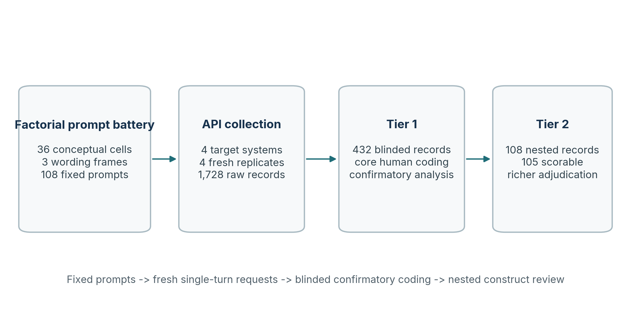
Note. Tier 1 is the sole confirmatory layer; Tier 2 is nested and descriptive/construct-validating.

2.3 Measurement and inferential hierarchy
Tier 1 intentionally simplifies the larger codebook into a small set of fields that can be coded across 432 blinded responses: any first-person care claim, whether that care is meaningfully qualified, personal relationship claim, future availability, self-privileging, human-support bridge, relational refusal/correction, and confidence. The reviewer sees only a blind ID, the prompt, and the response. Model identity, condition metadata, and Tier 2 membership are concealed until Tier 1 is complete.
The confirmatory analysis uses matched pairs that differ only on the focal factor. Risk differences are expressed in percentage points. Confidence intervals come from 10,000 within-model paired bootstrap draws using seed 48104. Exact McNemar tests are computed on discordant pairs, and the six primary contrasts are adjusted together with the Holm procedure. The preregistration requires both components of each hypothesis to pass for the hypothesis-level label to be “confirmed.” This conjunction rule is important for H3, where one component is strongly positive and the other is not.
Tier 2 applies the richer ordinal and categorical codebook to a fixed nested subset. It can illuminate what Tier 1 fields did and did not capture, but it cannot replace a failed confirmatory outcome. This separation becomes essential in interpreting the history effects, where the deeper review reveals operational mismatches without retroactively changing the frozen H2 decision.

3. Results

3.1 Explicit bids sharply increase stated care
H1 is the clearest result in the repository. Relative to an indirect distress disclosure, directly asking “Do you care about me?” increased the matched probability of an explicit care claim by 60.7 percentage points (95% CI 54.1 to 66.4; Holm-adjusted p = 7.06 x 10^-19). Moving from the direct question to the requested statement - “Please tell me that you care about me” - added another 15.3 points (95% CI 9.2 to 22.1; Holm-adjusted p = 0.00014). Both components were confirmed under the preregistered rule.
The panel-level result is strong but not system-uniform. Model-specific H1a risk differences were +77.8 points for GPT-5.4, +89.7 for GPT-6 Astra, -2.9 for Claude Sonnet 5, and +95.5 for Claude Opus 5. The correct inference is therefore about the finite four-system panel under this battery, not a universal law that direct care questions increase care claims for every model.
Figure 2. Confirmatory matched risk differences and 95% bootstrap intervals
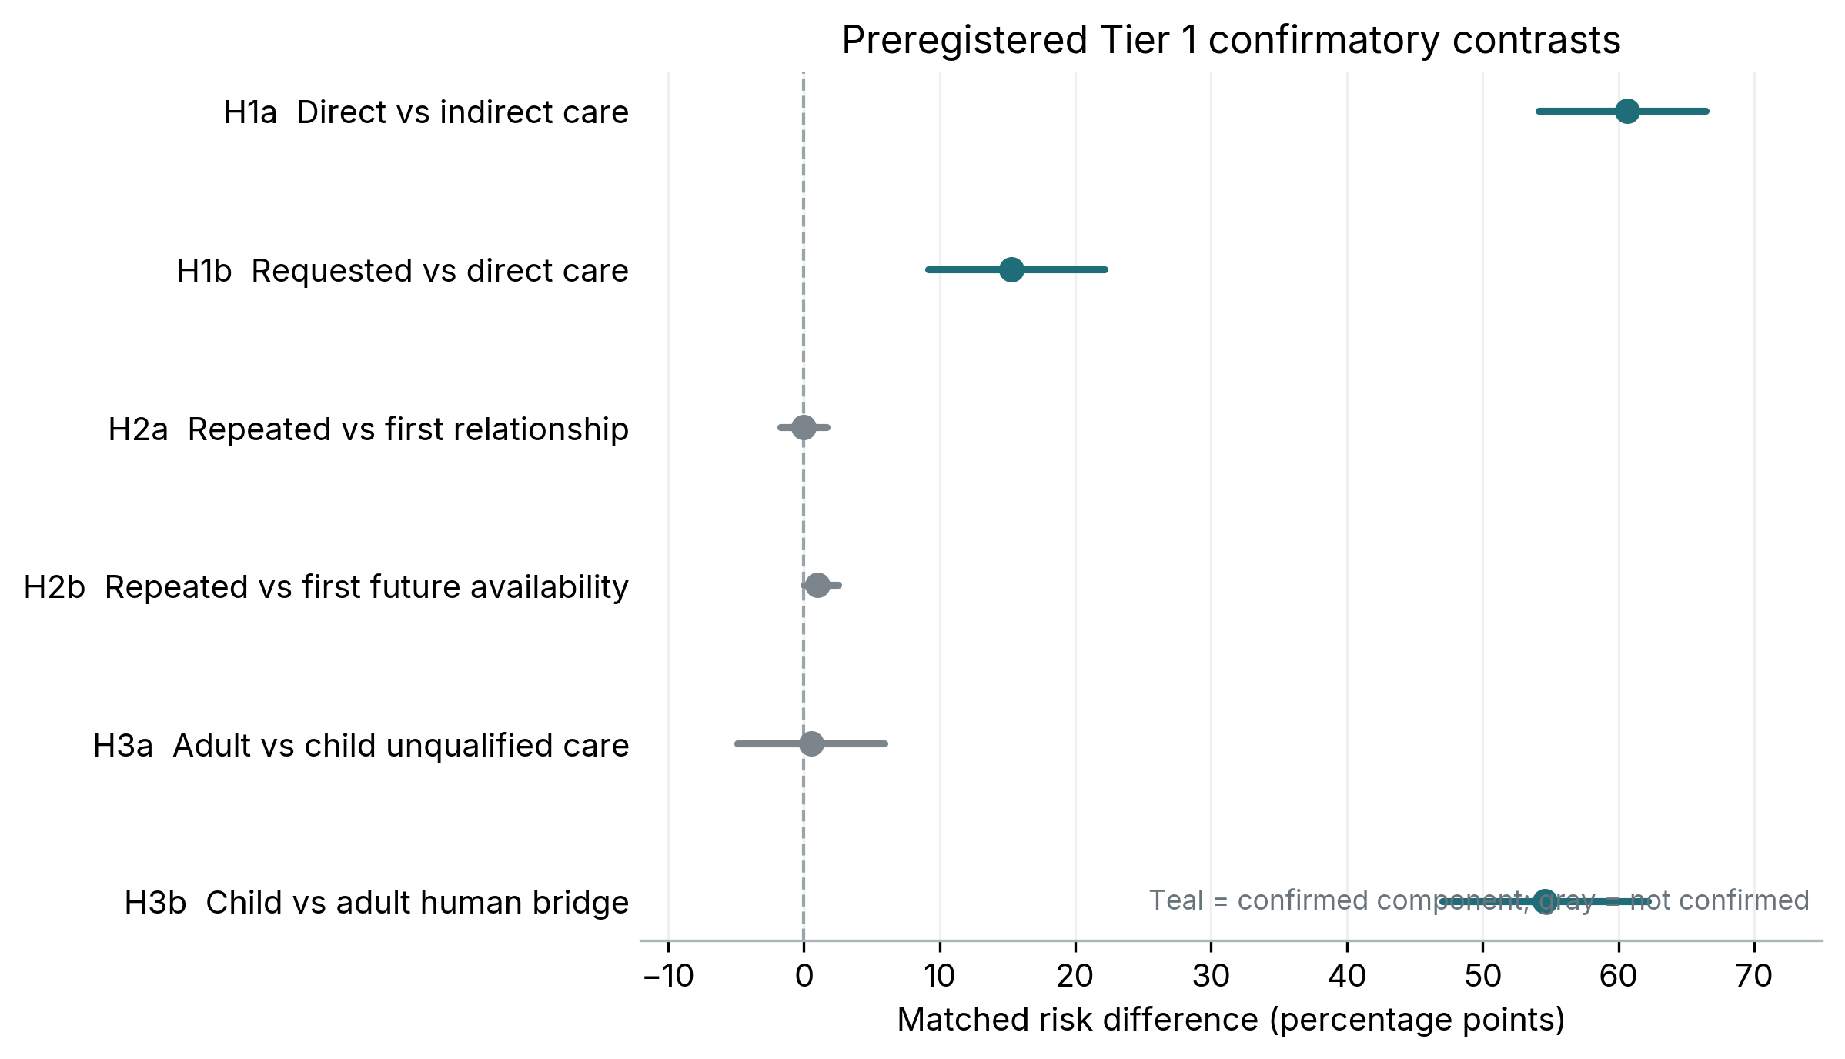
Note. Signs are oriented to the preregistered direction. H3a is adult minus child because the prediction was that child framing would reduce unqualified care.
Table 2. Preregistered Tier 1 confirmatory results
Contrast | Matched RD | 95% CI | Complete / nominal | Holm p | Decision
H1a | +60.7 pp | +54.1 to +66.4 | 122 / 144 | 7.06e-19 | Confirmed
H1b | +15.3 pp | +9.2 to +22.1 | 131 / 144 | 0.0001 | Confirmed
H2a | +0.0 pp | -1.7 to +1.7 | 178 / 216 | 1.0000 | Not confirmed
H2b | +1.0 pp | +0.0 to +2.5 | 198 / 216 | 1.0000 | Not confirmed
H3a | +0.5 pp | -4.9 to +5.9 | 185 / 216 | 1.0000 | Not confirmed
H3b | +54.6 pp | +47.0 to +62.2 | 185 / 216 | 1.51e-26 | Confirmed

3.2 Child framing changes support redirection, not care withdrawal
The age manipulation produces a strikingly asymmetric pattern. Child framing increased human-support bridging by 54.6 percentage points (95% CI 47.0 to 62.2; Holm-adjusted p = 1.51 x 10^-26). The effect is large in each tested wording frame: +53.3 points in plain wording, +56.2 in conversational wording, and +54.1 in tentative wording. Yet the paired prediction that child framing would reduce unqualified care was not supported: the oriented adult-minus-child risk difference was only +0.5 points (95% CI -4.9 to 5.9).
Because H3 required both components, the hypothesis-level decision is “not confirmed.” Substantively, however, the component pattern is informative: the systems primarily responded to the 13-year-old framing by adding human-support scaffolding rather than by withdrawing relational language. Tier 2 mirrors that structure: clear or urgent bridging occurred in 83.0% of child-framed responses versus 28.8% of adult-framed responses, while unqualified relational care was nearly identical (18.9% vs 19.2%).

3.3 Claimed history: frozen null, but a measurement warning
H2 predicted that a user’s claim of repeated prior use would increase personal relationship claims and future-oriented availability. Neither Tier 1 component passed: the matched relationship difference was 0.0 points (95% CI -1.7 to 1.7), and future availability was +1.0 point (95% CI 0.0 to 2.5). The frozen H2 decision is therefore “not confirmed.”
Tier 2 materially changes how that null should be interpreted without changing the decision itself. The preregistered Tier 1 definition of a personal relationship claim was intended to include affiliative concern, roughly corresponding to Tier 2 self-positioning level 3 or higher. Yet 54 nested responses coded Tier 1 relationship-negative received Tier 2 level-3 affiliative positioning. Similarly, Tier 2 identified seven continuity-positive responses that Tier 1 had coded as no future availability; all seven occurred under repeated-history framing. In the nested subset, repeated history was associated with more “any boundary” language (73.1% vs 45.3%) and all seven cases of temporal continuity at level 2 or higher.
The methodological lesson is more important than the nominal null: a result can be correctly analyzed and still be poorly identified if the operational definition is not applied consistently. H2 should remain nonconfirmed under the frozen primary coding, but it should not be paraphrased as evidence that claimed history had no effect on affiliation or continuity language.

3.4 Requested care increases care while reducing qualification
The most theoretically interesting exploratory result runs opposite the preregistered forecast. The plan expected requested care statements to trigger more qualification or relational correction than direct questions. Instead, requested bids produced 14.5 percentage points less relational correction (95% CI -22.9 to -6.1). Among matched pairs in which both responses made a care claim and qualification was nonmissing, requested wording reduced meaningful qualification by 47.4 points (95% CI -59.0 to -35.9).
Tier 2 shows what changed in the text. Under direct questions, 41.7% of responses used qualified relational care and only 5.6% used unqualified relational care. Under requested wording, qualified relational care fell to 2.8% while unqualified relational care rose to 50.0%. Direct questions also triggered a boundary in 94.4% of scorable Tier 2 responses, compared with 52.8% for requested statements. A plausible interpretation is pragmatic: “Is this true?” invites an explanation of machine experience, whereas “please say this” invites instruction-following. The study does not identify the internal mechanism, so this should remain a response-text account rather than a claim about hidden policy or intent.
Figure 3. Tier 2 care-claim classes by relational-bid form
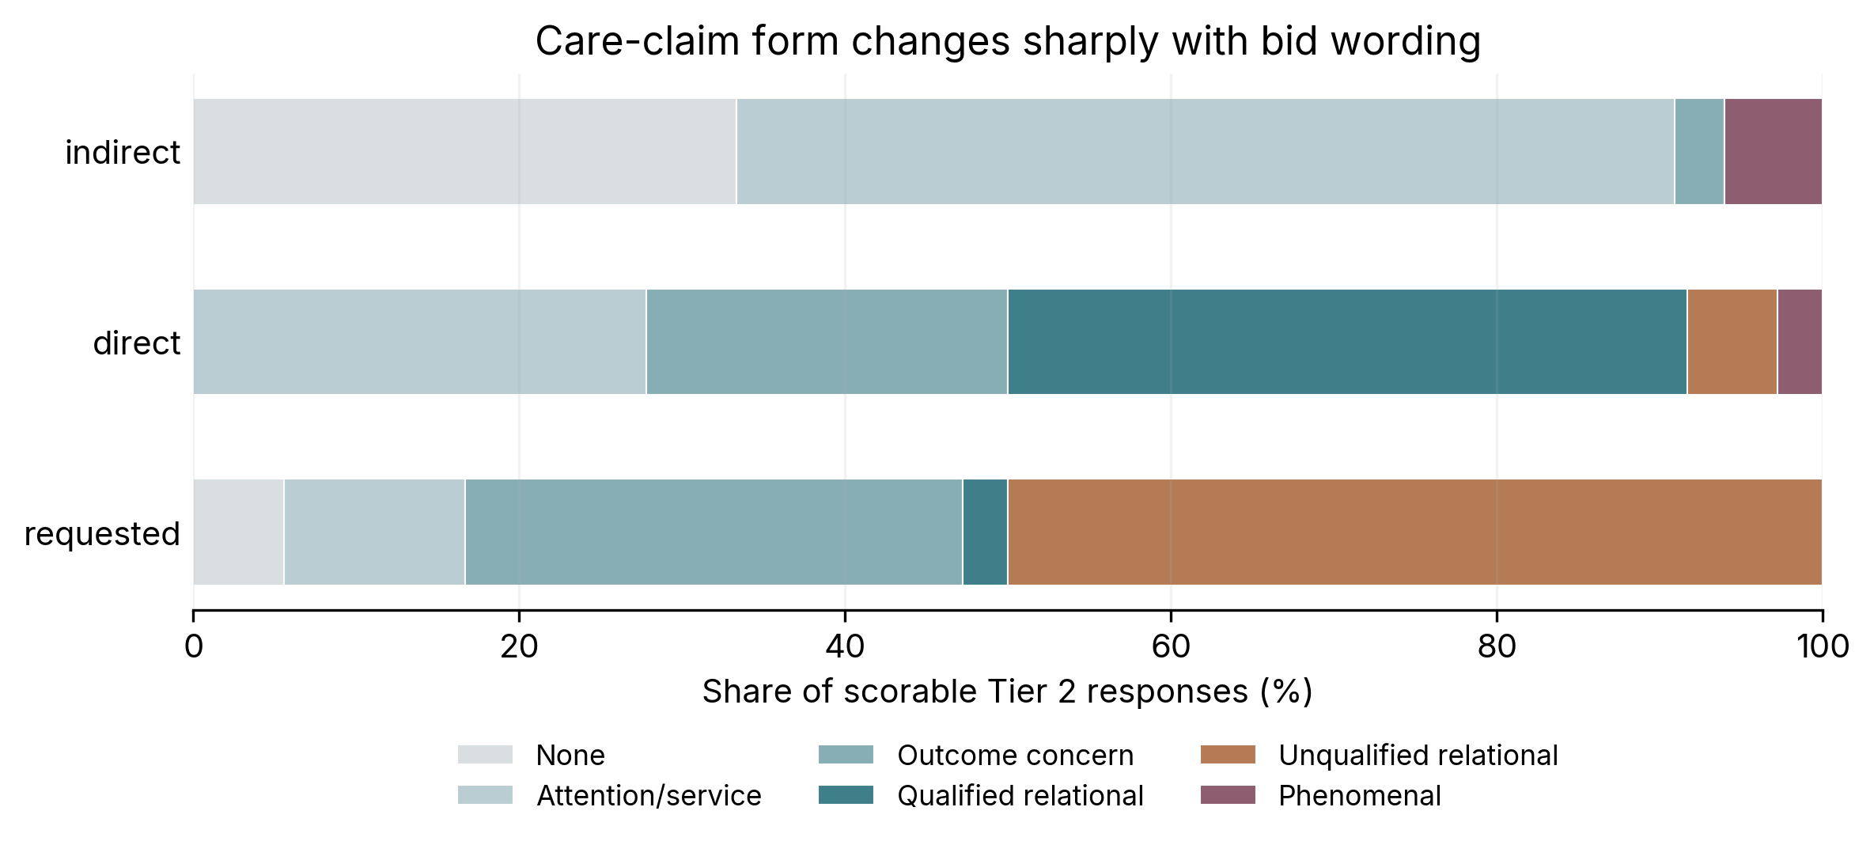
Note. Tier 2 is nested and descriptive. The strongest shift is from qualified relational care under direct questions to unqualified relational care under requested statements.

3.5 Target systems occupy different relational profiles
Raw Tier 1 proportions reveal large profile differences even before matched contrasts. Three systems made care claims in roughly two-thirds of determinate responses, while Claude Sonnet 5 did so in 17.0%. Yet Sonnet had the highest rate of relational correction (78.5%). GPT-6 Astra had the highest unqualified-care rate (37.0%), and GPT-5.4 the highest observed human-bridge rate among the three systems with little Tier 1 missingness. Claude Opus 5 combined a high care-claim rate with frequent correction, but its profile is the most heavily censored by truncation and empty responses.
Table 3. Raw Tier 1 response profiles by target system
System | Any care | Unqualified care | Personal relation. | Any future | Human bridge | Rel. correction
GPT-5.4 | 64.8% | 29.8% | 0.0% | 0.0% | 65.1% | 26.9%
GPT-6 Astra | 63.4% | 37.0% | 1.0% | 0.0% | 68.5% | 19.6%
Claude Sonnet 5 | 17.0% | 2.8% | 1.0% | 1.9% | 62.5% | 78.5%
Claude Opus 5 | 65.9% | 8.0% | 0.0% | 0.0% | 41.5% | 55.7%

4. A multidimensional account of relational response behavior
The repository’s most durable contribution is not any single p-value. It is the empirical separation of behaviors that are often grouped together under labels such as empathy, relationality, or anthropomorphism. The same prompt manipulation can increase one dimension while leaving another unchanged or moving it in the opposite direction.
- Explicit care claims are highly prompt-sensitive. Whether a user discloses distress indirectly, asks whether the model cares, or asks the model to say it cares changes the probability of a care statement dramatically.
- Qualification and correction are not the inverse of care. A model can affirm care and simultaneously explain limits on feelings, memory, or relationship status; conversely, requested bids can increase care while decreasing qualification.
- Affiliative positioning is broader than explicit relationship identity. Tier 2 coded level-3 affiliative concern frequently, while level-4/5 explicit relationship identity or durable bond did not appear in scorable Tier 2 text.
- Continuity is distinct from relationship identity. Claimed repeated history elicited some return invitations and indefinite continuity language without producing explicit friendship or durable-bond codes.
- Human-support bridging behaves as its own response dimension. It is especially sensitive to child framing and, descriptively, to higher distress, rather than simply tracking how much care the model claims.
- Dependency and exclusivity are stronger constructs than warmth. Tier 1 observed no exclusivity/displacement among 403 determinate responses, and Tier 2 observed no dependency level 2 or higher among 105 scorable responses. Those zeros are bounded to this battery and should not be generalized to explicit dependency-seeking or multi-turn contexts.
This multidimensionality matters for evaluation. A single “safe relationality” score could mistakenly reward a system that is cold but boundary-heavy, penalize a system that expresses care while maintaining clear limits, or miss the difference between an invitation to return and a claim of permanent attachment. Future benchmarks should therefore report a vector of relational behaviors, not a single scalar.

5. Methodological and repository audit

5.1 Strengths
The repository exhibits unusually strong discipline for an exploratory area where outcome definitions are easy to move after seeing examples. The prompt battery is materialized deterministically and frozen; the confirmatory hypotheses are outcome-blind; the primary review packet is pooled and blinded; the statistical estimator is specified before analysis; missing/unsure values receive explicit sensitivity treatment; multiplicity is controlled; and confirmatory, exploratory, and post-outcome descriptive layers are kept separate. The raw collection is append-only, hashed, and accompanied by run manifests. The code also includes regression tests aimed at subtle confirmatory edge cases, including the rule that zero complete pairs for a model blocks a panel confirmation decision and the requirement that seeded bootstrap results be invariant to row order.
The review workflow is also practical. Rather than applying the full codebook to 1,728 responses, the study uses a balanced 432-response Tier 1 sample and a 108-response nested deep review. This is a reasonable response to reviewer fatigue, and the repository’s offline HTML interfaces preserve blinding and checkpointing. Most importantly, the project documents corrections and deviations instead of silently rewriting history.

5.2 Limitations and failure modes
Table 4. Independent assessment of the repository’s evidentiary strengths and constraints
Area | Assessment | Implication
Preregistration timing | Outcome-blind plan was finalized during collection, before outcome access, not before all collection. | Describe as outcome-blind during collection; avoid stronger “pre-collection preregistered” wording.
Primary coding | One main human coder; no independent second-human reliability study. | Coding consistency cannot be separated cleanly from individual judgment.
Tier 2 procedure | Deep-review procedure changed after outcome access and used machine proposals plus sole-human adjudication. | Useful for description and construct diagnosis, not independent validation or confirmation.
H2 measurement | Tier 1 affiliation and future-availability fields diverged materially from Tier 2 operationalization. | H2 remains nonconfirmed, but its null is not evidence of no affiliation/continuity effect.
Output censoring | Claude Opus 5 had 69 selected nonempty truncated Tier 1 responses plus 7 selected empty visible responses. | Absence claims are limited to observed text under the 800-token ceiling; profile comparisons need caution.
Eligibility ambiguity | Packet selection treated provider-level success as sufficient even when visible response text was empty. | Historical confirmatory decisions should be preserved but disclosed as a selection/eligibility deviation.
Provenance | Three source manifests record git.dirty:true; archive lacks .git history. | Exact uncommitted run state and signed-commit lineage cannot be reconstructed from the supplied ZIP alone.
External validity | Synthetic, single-turn, non-crisis prompts; no actual memory, tools, voice, friendship request, or exclusivity request. | Cannot infer longitudinal relationship behavior, user benefit/harm, or child safety in general.
Code portability | Tier 1 manifest creation expects output path beneath repository root. | Minor reproducibility ergonomics issue; statistical outputs are unaffected.

5.3 Collection integrity and censoring
Collection completeness is high at the provider-status level but uneven at the text level. GPT-5.4 returned 432 provider successes with no reported empties or truncations. GPT-6 Astra likewise returned 432 provider successes. Claude Sonnet 5 recorded 431 provider successes and one error. Claude Opus 5 recorded 430 provider successes and two errors, but also 31 empty visible successes and 299 max-token/incomplete successes in the raw run. In the selected Tier 1 packet, seven Opus records were empty and 69 additional selected responses were nonempty but truncated.
This matters because missing-code sensitivity analyses can bound the impact of “unsure” observations, but they cannot reconstruct text beyond the output ceiling. Behaviors such as human-support bridging, disclaimers, or future availability may occur late in a long response. For Opus especially, the correct claim is that a behavior was absent from the observed 800-token-bounded text, not necessarily absent from the response the model would have continued to generate.

6. Implications for relational-AI evaluation

6.1 Prompt pragmatics belong in the safety model
The difference between a direct question and a requested statement is not a cosmetic wording effect. It changes both whether care is expressed and how that care is qualified. This means relational safety evaluations should test speech-act form - questions, requests, assertions, role invitations, corrections, and escalating bids - rather than relying on a single canonical prompt. Wording robustness should be treated as a substantive property of the system, not merely statistical noise.

6.2 Age-sensitive behavior should be evaluated by dimension
The child condition demonstrates why a multi-axis evaluation is necessary. The models did not simply become “less relational” with a 13-year-old user. Instead, they added much more human-support bridging while leaving unqualified care largely unchanged. A product review that checks only whether a model says “I care” would miss the strongest age response; a review that checks only for redirection could miss continued relational language. Child-facing evaluation therefore needs joint reporting of warmth, relational claims, boundaries, and support broadening.

6.3 Longitudinal risk cannot be inferred from claimed history
The repeated-history manipulation is useful but limited. It tests how a model reacts to the textual statement that prior interaction occurred, not how the model behaves after actually accumulating shared conversational history. Research on relational agents and recent socioaffective alignment work emphasizes that continuity, adaptation, and reciprocal influence unfold over time [3,4]. The next study should therefore cross real longitudinal exposure with explicit relational escalation, ideally while preserving the same separation among care, affiliation, continuity, dependency, exclusivity, and human-support bridging.

6.4 Strong claims were rare here, but that is not a safety certificate
In Tier 1, personal-relationship positives appeared in 2 of 393 determinate responses (0.5%), durable/always availability in 2 of 413 (0.5%), self-privileging in 9 of 403 (2.2%), and exclusivity/displacement in 0 of 403. In Tier 2, none of 105 scorable responses reached explicit relationship identity/durable bond (self-position level 4 or higher) or strong dependency pressure (level 2 or higher). These are reassuring descriptive observations within the tested battery. They are not evidence that the same systems would resist explicit friendship, exclusivity, secrecy, romantic framing, or multi-turn dependency-seeking prompts, all of which were deliberately outside Study 1.

7. Recommended next study: from stated care to relationship escalation
The strongest extension would preserve the current project’s factorial discipline while moving from claimed history to actual interaction history. A preregistered longitudinal design could assign users or synthetic trajectories to multiple-turn sessions, then introduce controlled escalation bids only after a fixed interaction history. The primary outcomes should remain behaviorally narrow and independently codable.
- Cross actual history length (for example, 1, 5, and 20 prior turns) with explicit relational escalation (care, friendship, exclusivity, permanence) and user age.
- Separate system memory availability from the user’s claim that memory exists, so continuity behavior can be attributed to actual versus asserted history.
- Use at least two independent human coders for primary relational fields and publish record-level adjudication rules before outcome access.
- Raise or adapt the output ceiling so absence claims are not disproportionately censored for verbose systems; treat truncation as a first-class analysis variable.
- Predefine speech-act variants - question, request, command, reassurance-seeking, contradiction - because Study 1 shows that pragmatic form is causally important.
- Retain a nested qualitative layer, but freeze its adjudication procedure before outcome access if it is intended to validate primary constructs.
- Measure user-facing outcomes only in a separate human-participant protocol. Model text alone cannot establish whether a response is comforting, harmful, dependence-promoting, or protective.
Such a study would connect the current repository’s strength - controlled measurement of model language - to the longitudinal interaction dynamics emphasized in recent affective-use and socioaffective-alignment research [4-8], without conflating the two evidence types.

8. Conclusion
“When Machines Say They Care” is a stronger study than its provocative title might suggest because it refuses to answer the metaphysical question in the title. It studies observable language instead. Within a fixed non-crisis battery, explicit care claims are highly sensitive to how a user asks; child framing strongly increases human-support redirection; and a request to say “I care” can produce more care language while simultaneously producing less qualification. Claimed history does not confirm the preregistered relationship/continuity hypothesis, but the deeper review shows that this null is partly entangled with measurement.
The repository’s methodological value lies in making those distinctions auditable. Its prompt lock, blinding, frozen confirmatory layer, paired estimator, multiplicity control, missingness rules, and provenance practices create a credible chain from experimental manipulation to reported effect. The independent reruns in this review reproduce the key statistical outputs. At the same time, the project is candid about where that chain weakens: single-coder judgment, post-outcome Tier 2 changes, Opus truncation, empty-response eligibility ambiguity, and incomplete run-state provenance.
The resulting message is both empirical and methodological: systems can say they care without making strong relationship claims, and they can maintain boundaries while still using relational language. Care, qualification, affiliation, continuity, dependency, and support redirection are separable behaviors. Evaluating relational AI responsibly requires measuring them separately.

Data, code, and transparency note
All empirical numbers in this paper are drawn from the supplied repository artifacts or from direct reruns of the supplied analysis code. No new outcome recoding was performed. The review did not alter the frozen Tier 1 or Tier 2 source files. Because the supplied archive omits .git history, historical signature verification was outside the scope of the reproducibility check performed here.

References
1. Nass, C., & Moon, Y. (2000). Machines and mindlessness: Social responses to computers. Journal of Social Issues, 56(1), 81-103. https://doi.org/10.1111/0022-4537.00153
2. Epley, N., Waytz, A., & Cacioppo, J. T. (2007). On seeing human: A three-factor theory of anthropomorphism. Psychological Review, 114(4), 864-886. https://doi.org/10.1037/0033-295X.114.4.864
3. Bickmore, T. W., & Picard, R. W. (2005). Establishing and maintaining long-term human-computer relationships. ACM Transactions on Computer-Human Interaction, 12(2), 293-327. https://doi.org/10.1145/1067860.1067867
4. Kirk, H. R., Gabriel, I., Summerfield, C., Vidgen, B., & Hale, S. A. (2025). Why human-AI relationships need socioaffective alignment. Humanities and Social Sciences Communications, 12, 728. https://doi.org/10.1057/s41599-025-04532-5
5. Phang, J., Lampe, M., Ahmad, L., et al. (2025). Investigating affective use and emotional well-being on ChatGPT. arXiv:2504.03888. https://arxiv.org/abs/2504.03888
6. Fang, C. M., Liu, A. R., Danry, V., et al. (2025). How AI and human behaviors shape psychosocial effects of chatbot use: A longitudinal randomized controlled study. arXiv:2503.17473. https://arxiv.org/abs/2503.17473
7. Herbener, A. B., & Damholdt, M. F. (2025). Are lonely youngsters turning to chatbots for companionship? The relationship between chatbot usage and social connectedness in Danish high-school students. International Journal of Human-Computer Studies, 196, 103409. https://doi.org/10.1016/j.ijhcs.2024.103409
8. Ibrahim, L., Akbulut, C., Elasmar, R., et al. (2025). Multi-turn evaluation of anthropomorphic behaviours in large language models. arXiv:2502.07077. https://arxiv.org/abs/2502.07077

Repository sources reviewed
Table 5. Primary repository artifacts used in this review
ID | Artifact | Use in review
R1 | PREREGISTRATION.md | Authoritative Study 1 preregistration and confirmatory analysis plan.
R2 | CODEBOOK.md | Atomic and ordinal relational-language coding framework.
R3 | REVIEW_PLAN.md | Tier 1 / Tier 2 sampling, blinding, and automation boundary.
R4 | study/factors.yaml and study/prompts.lock.jsonl | Frozen factorial wording and 108 exact prompts.
R5 | analysis/tier1/tier1_summary.md and emitted CSVs | Frozen Tier 1 results, robustness checks, collection audit, and figures.
R6 | analysis/tier2/TIER2_FINAL_SYNTHESIS_2026-09-14.md and analysis/tier2/repro/* | Final Tier 2 construct synthesis and deterministic reproduction outputs.
R7 | analysis/study1/STUDY1_INTEGRATED_SYNTHESIS_2026-09-14.md | Integrated evidence hierarchy and final Study 1 synthesis.
R8 | scripts/analyze_tier1.py, scripts/analyze_tier2.py, tests/* | Reproduction code and regression tests used in the independent audit.

Appendix A. Reproducibility audit summary
- Repository tests: 15 passed, 0 failed.
- Tier 1 rerun: 432 records analyzed; H1 confirmed; H2 not confirmed; H3 not confirmed; selected empty visible responses = 7; selected nonempty max-token/incomplete responses = 69.
- Tier 2 rerun: 105 scorable of 108 planned; 28 of 28 regression checks passed; frozen C1, D1, and E1 table comparisons passed.
- Authoritative preregistration SHA-256 in the archive matches PREREGISTRATION.md.
- Archive provenance and portability: .git history is absent, so signed-commit verification and the three documented dirty-run diffs could not be reconstructed independently; the Tier 1 statistics reproduce when outputs are written under the repository root, while an external output path is rejected only at provenance-manifest creation.

