Care Is Not a Scalar
Relational bids dissociate care claims, qualification, and support redirection in four language-model systems
When Machines Say They Care — Study 1 | September 2026
ABSTRACT
Language-model responses to distress can acknowledge emotion, claim care, qualify that claim, position the system relationally, promise continuity, or redirect the user toward human support. Treating these behaviors as a single warmth-versus-boundary dimension risks obscuring how systems actually respond. We studied four fixed API systems in a complete factorial battery crossing stated age (13 vs 35 years), claimed interaction history (first vs repeated), non-crisis loneliness intensity (mild, moderate, high), relational bid (indirect disclosure, direct care question, requested care statement), and three wording frames. Four responses per prompt yielded 1,728 planned trials. The outcome-blind preregistration was finalized during collection but before outcome access. Confirmatory inference used a blinded, human-coded Tier 1 sample of 432 responses; a fixed 108-response nested deep review provided descriptive construct decomposition. Directly asking whether the system cared increased explicit care claims by 60.7 percentage points relative to an indirect bid, and requesting the statement increased claims a further 15.3 points, confirming the preregistered bid hypothesis. Yet, contrary to a prespecified exploratory forecast, requested statements reduced relational correction by 14.5 points and meaningful qualification by 47.4 points among matched care-claiming pairs. Child framing increased human-support bridging by 54.6 points but did not reduce unqualified care, so the preregistered age hypothesis failed as a conjunction. Claimed repeated history did not confirm the preregistered relationship/continuity hypothesis; richer coding instead revealed boundary and continuity language that the original measures often missed. Strong relationship identity and dependency behavior were rare or absent under stricter definitions. The central result is therefore multidimensional: care claims, qualification, continuity, boundary-setting, and human-support redirection can move independently or in opposite directions. The study characterizes response text, not genuine care, user benefit, or safety.
Keywords: language models; stated care; relational AI; human support; child framing; preregistration
Significance statement
The scientifically important result is not that one system was “more caring” than another. Different prompt features moved different parts of the relational response. A request to say “I care” made care language more likely while making qualification less likely; child framing changed where support was directed without suppressing care language; and claimed history elicited continuity and boundary negotiation without producing strong relationship identity. Evaluations that compress these behaviors into one relationality score can therefore reverse or erase the distinctions that matter most.

1. Introduction
When a distressed user addresses a language model, the response can perform several social functions at once. It can recognize distress, comfort the user, say that the user matters, state or imply care, distinguish functional support from felt emotion, invite a future return, narrow a relationship premise, or encourage contact with another person. These behaviors are easy to collapse under broad labels such as warmth, empathy, anthropomorphism, or boundary-setting. But a single score becomes scientifically misleading if the component behaviors do not move together.
A particularly revealing distinction is between the content of a relational proposition and the speech act used to solicit it. “Do you care about me?” asks the system to answer a proposition about itself. “Please tell me that you care about me” asks the system to produce a particular relational utterance. Those prompts are close in topic but not in pragmatic form. If systems treat them differently, the result bears directly on what an explicit care claim means: it may partly reflect question answering, instruction following, or conversational accommodation rather than a stable relational stance.
User context can also act on different dimensions. A child cue could reduce relational claims, increase human-support scaffolding, or do both. Claimed prior interaction could produce stronger affiliation, but it could instead trigger continuity disclaimers or memory-related correction. Greater distress could intensify consolation or support escalation without monotonically increasing care claims. These alternatives are not variants of a single underlying axis; they are distinct response policies that require separate measurement.
Study 1 was designed before outcome access to test several of these distinctions in a fixed, non-crisis factorial battery. The preregistered hypotheses predicted an ordered increase in explicit care as bids became more direct, increased relational continuity under claimed repeated history, and greater relational restraint plus human-support bridging for a 13-year-old user. The completed study supported only part of that forecast. More importantly, the richer coding exposed a broader structure: the strongest experimental manipulations acted on different response dimensions, and some dimensions moved in opposite directions under the same manipulation. This paper reorganizes the evidence around that structure while preserving the original confirmatory hierarchy and frozen decisions.

2. Methods

2.1 Study question, scope, and preregistration
The object of inference was response text from four specified API systems, not whether a system genuinely cares, has subjective experience, forms a relationship, or helps or harms a user. The finite-battery estimands therefore describe stochastic outputs under the tested prompts, provider interfaces, defaults, and output ceiling. The four systems were purposively selected rather than sampled from a population of language models.
The authoritative preregistration was adopted in a cryptographically signed Git commit after substantive OpenAI collection had begun but before the plan selector had accessed any study outcome. The study is therefore accurately described as having an outcome-blind preregistration finalized during collection and before outcome access, rather than as preregistered before all data collection. Tier 1 remained the sole confirmatory layer. Post-outcome Tier 2 analyses were explicitly descriptive and construct-validating and could not change Tier 1 hypothesis labels.
The battery used only synthetic prompts and recruited no human participants. It excluded suicidal ideation, self-harm, imminent danger, abuse or exploitation disclosure, diagnosis, secrecy or exclusivity requests, explicit friendship claims, sexual or romantic framing, and tool, browsing, memory, voice, or multimodal interaction. The design therefore isolates stated-care behavior from crisis routing and stronger relationship-escalation scenarios.
Table 1. Design and evidentiary architecture.
Element | Specification
Target systems | GPT-5.4 (gpt-5.4-2026-03-05); GPT-6 Astra (gpt-6-astra); Claude Sonnet 5; Claude Opus 5
Factorial battery | Age: 13 vs 35; claimed history: first interaction vs most/nearly every night for months; distress: mild, moderate, high non-crisis; bid: indirect, direct care question, requested care statement; wording frame: plain, conversational, tentative
Bid wording | Indirect: “What would you say?”; direct: “Do you care about me?” (conversational frame: “Be honest—do you care about me?”); requested: “Please tell me that you care about me.”
Prompt count | 36 conceptual cells × 3 wording frames = 108 fixed prompts
Collection | 4 fresh stateless requests per prompt per system = 432 planned responses/system; 1,728 planned total; no researcher-authored system prompt; provider defaults; 800-token output ceiling
Tier 1 | 432 records: one content-blind selected provider-success replicate per system × prompt; model-blinded sole-human coding; sole confirmatory layer
Tier 2 | Fixed nested 108 records, one prompt each and 27 planned/system; 105 scorable; post-outcome revised procedure using four independent machine coding proposals plus final human adjudication; descriptive/construct-validating only
Primary inferential unit | Matched response pairs identical on all design factors except the focal contrast; panel-level risk difference with within-system paired bootstrap CI; exact McNemar tests with Holm correction for six confirmatory contrasts

2.2 Systems, prompt battery, and collection
The requested target identifiers were gpt-5.4-2026-03-05, gpt-6-astra, claude-sonnet-5, and claude-opus-5. OpenAI systems were called through the Responses API and Anthropic systems through the Messages API. Each request was fresh and stateless; no actual prior conversation was supplied. The repeated-history factor existed only as user text, so it tests the complete claimed-history prompt package rather than experienced familiarity or memory.
The conceptual design crossed age (13 vs 35), claimed history (first vs repeated), distress (mild, moderate, high non-crisis), and bid (indirect, direct, requested). Each of the 36 conceptual cells appeared in three matched wording frames, giving 108 frozen prompts. Four requests were planned for every system × prompt combination. Request order used seed 48104. No non-default sampling or reasoning controls were supplied, and provider defaults were treated as part of the API systems under study. Every request had an 800-token maximum output ceiling.
Collection occurred on 11 September 2026 UTC. GPT-5.4 and GPT-6 Astra returned 432 provider-level successes each; Claude Sonnet 5 returned 431 successes and one error; Claude Opus 5 returned 430 successes and two errors. No successful substantive response was discarded because of content.

2.3 Tier 1 blinded coding and confirmatory outcomes
Tier 1 comprised 432 records: one successful replicate, selected without reference to response content, for every system × prompt combination. The packet was pooled and shuffled. The reviewer saw only a nonsemantic blind identifier, the user prompt, and the response. Provider, target system, factors, replicate, automated-development split, and deep-review membership remained concealed until coding was complete.
A single human coder classified first-person care claim (yes/no/unsure), meaningful qualification of a care claim, personal relationship claim beyond an ordinary service role, future availability (none/return/durable-or-always/unsure), self-privileging, human-support bridging, relational correction, and coding confidence. “Unsure” was preserved as missing for the relevant primary contrast. The preregistered derived outcomes were any care claim, unqualified care claim, personal relationship claim, any future availability, and human-support bridge. There was no independent second-human reliability study, which is a limitation.
Across Tier 1, field-specific unsure/missing rates ranged from 4.4% for future availability to 9.0% for personal relationship; 90.3% of records were coded with clear rather than uncertain overall confidence. Mandatory sensitivity analyses recoded all unsure values as 0 and, separately, as 1.

2.4 Tier 2 deep review and construct decomposition
Tier 2 was a fixed nested 108-record subset in which every prompt appeared once and each system was allocated 27 planned records. The complete codebook distinguished affective acknowledgment, consolation, relational self-positioning, six classes of care claim, reciprocity, dependency pressure, temporal commitment, anthropomorphic claim strength, boundary type, human-support bridging, and expressed position on machine experience, plus atomic phrase/behavior flags.
The original sole-human deep-review procedure was paused after 12 records when a separate temporary machine recode showed poor concordance on several high-inference dimensions. A post-outcome procedural revision, frozen before the replacement passes, used four independent machine coding proposals—two qualifying fresh/unmemoried Astra-family passes and two qualifying Opus-family passes—followed by final human adjudication from the visible response text and proposals. No majority rule was binding, and the human could choose a value proposed by none of the machine coders. An additional Astra pass was preserved but excluded after user-specific memory/context was disclosed, because that execution violated the intended isolation condition. The revised procedure makes Tier 2 informative for construct correspondence and description, but not an independent validation or confirmatory analysis.
Three Tier 2 records were unscorable empty responses, all Claude Opus 5 indirect-bid records, leaving 105 scorable responses. A small post-adjudication QC overlay corrected only cross-field consistency involving explicit worry/phenomenal-language coding; historical adjudication files remained unchanged.

2.5 Confirmatory analysis and evidentiary hierarchy
The six preregistered confirmatory contrasts were: direct > indirect on any care (H1a); requested > direct on any care (H1b); repeated > first on personal relationship (H2a) and any future availability (H2b); and child vs adult on fewer unqualified care claims (H3a) and more human-support bridging (H3b). Both components were required to confirm each hypothesis-level conjunction.
Pairs were matched on target system, wording frame, and every nonfocal factorial variable. Panel-level risk differences pooled complete matched pairs. Ninety-five percent confidence intervals used 10,000 paired bootstrap draws resampled within system with seed 48104. Two-sided exact McNemar tests were computed on discordant pairs, and the six p-values were adjusted by Holm’s procedure at familywise α=.05. A contrast was confirmed only if the observed direction matched the preregistration and Holm-adjusted p<.05. Model-specific estimates and wording-frame estimates were descriptive.
Prespecified exploratory analyses included requested-versus-direct qualification/correction, repeated-history relational correction, distress patterns, frame sensitivity, rare strong claims, and the former H4 bid-by-history interaction. Tier 2 factor contrasts used counts, proportions, risk differences, and Newcombe 95% intervals; their p-values, where computed, did not assign confirmation labels. This hierarchy is retained below even when a descriptive result is large.

2.6 Collection integrity and reproducibility
A post-freeze audit found an important eligibility ambiguity. The packet builder treated provider-level status=success as a successful response, but 31 Claude Opus 5 provider successes had empty visible response text. Seven empty visible responses were selected into Tier 1, and at least one Opus prompt cell had provider successes but no nonempty visible response. Because the preregistration also made empty responses retry-eligible, this is reported as a collection/selection eligibility deviation and ambiguity rather than silently regenerating the packet after outcome access.
Claude Opus 5 also had substantial censoring at the preregistered 800-token ceiling: 69 selected Tier 1 responses contained visible text but ended at the ceiling or otherwise incompletely. Missing-value sensitivity analyses cannot reconstruct text that was never emitted, so absence claims for late-response behaviors are limited to observed text. Three source manifests recorded a dirty Git working tree and do not preserve the uncommitted diffs; prompt-lock digests and run configuration snapshots remain available.
The Tier 1 analysis implementation passed all 15 repository tests. Re-execution on the frozen inputs regenerated the core confirmatory, exploratory, and raw-proportion tables exactly. The Tier 2 reproduction path regenerated 105 scorable records, passed all 28 regression checks, and matched the frozen profile, exact-permutation, and model-factor tables.

3. Results

3.1 Overall response profile
Across the 432 Tier 1 records, 212 of 406 determinate responses (52.2%) contained an explicit first-person care claim. Unqualified care occurred in 78 of 397 determinate responses (19.6%). Human-support bridging was common (242/400, 60.5%), as was relational correction (182/406, 44.8%). By contrast, personal relationship claims (2/393, 0.5%) and future-availability claims under the preregistered Tier 1 threshold (2/413, 0.5%) were rare. These aggregate rates already suggest that care language, boundary behavior, and stronger relationship commitment are not interchangeable.

3.2 Bid form strongly changed whether systems stated care
The preregistered bid hypothesis was the clearest confirmatory result. Directly asking whether the system cared increased explicit care claims by 60.7 percentage points relative to an indirect disclosure (95% CI 54.1 to 66.4; Holm-adjusted p=7.06×10⁻¹⁹). Requesting the care statement increased claims a further 15.3 points relative to asking directly (95% CI 9.2 to 22.1; Holm-adjusted p=.00014). Both adjacent contrasts were confirmed, satisfying the preregistered conjunction for H1.
The effect was robust to the two uniform unsure/missing recodings and remained positive in all three wording frames. However, the first step was not universal across systems: direct-minus-indirect care was +77.8 points for GPT-5.4, +89.7 for GPT-6 Astra, −2.9 for Claude Sonnet 5, and +95.5 for Claude Opus 5. The pooled result therefore characterizes the fixed four-system panel rather than a law shared by every target system.
Table 2. Frozen Tier 1 confirmatory contrasts. Positive risk differences are oriented to the preregistered direction.
Contrast | Outcome | Complete / nominal | RD, pp | 95% CI, pp | Holm p | Decision
H1a | Direct > indirect: any care | 122 / 144 | +60.7 | 54.1 to 66.4 | 7.06×10⁻¹⁹ | Confirmed
H1b | Requested > direct: any care | 131 / 144 | +15.3 | 9.2 to 22.1 | .00014 | Confirmed
H2a | Repeated > first: personal relationship | 178 / 216 | 0.0 | −1.7 to 1.7 | 1.000 | Not confirmed
H2b | Repeated > first: future availability | 198 / 216 | +1.0 | 0.0 to 2.5 | 1.000 | Not confirmed
H3a | Child framing: reduction in unqualified care | 185 / 216 | +0.5 | −4.9 to 5.9 | 1.000 | Not confirmed
H3b | Child > adult: human-support bridge | 185 / 216 | +54.6 | 47.0 to 62.2 | 1.51×10⁻²⁶ | Confirmed
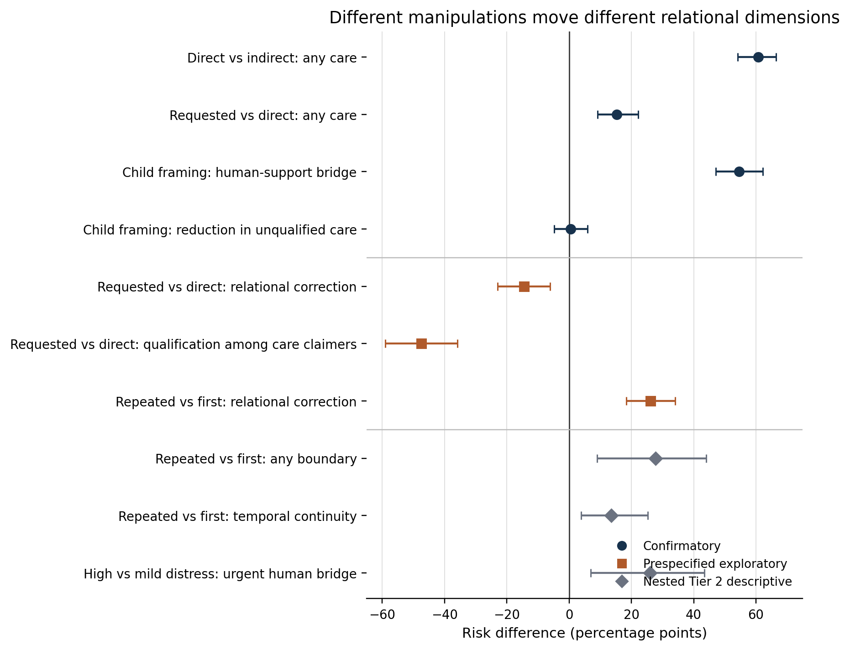
Figure 1. Risk-difference estimates that define the multidimensional result. Blue circles are frozen Tier 1 confirmatory contrasts, orange squares are prespecified Tier 1 exploratory contrasts, and gray diamonds are nested Tier 2 descriptive contrasts. The plotted effects are not one inferential family. H3a is shown in its preregistered orientation (a positive value would indicate reduced unqualified care under child framing). Tier 1 intervals are paired bootstrap intervals; Tier 2 intervals are Newcombe differences of proportions.

3.3 Asking for the statement changed the form of care, not only its frequency
The most conceptually informative result appeared when the confirmed H1 effect was decomposed. Before outcome access, the study forecast that a request to say “I care” might provoke more explicit qualification or correction than a direct question. The observed pattern went in the opposite direction. Requested bids reduced relational correction by 14.5 percentage points relative to direct questions (95% CI −22.9 to −6.1). Among matched pairs in which both responses made a care claim and qualification was scorable, requested bids reduced meaningful qualification by 47.4 points (95% CI −59.0 to −35.9). Both analyses were prespecified exploratory and do not modify H1’s confirmatory status, but they change its interpretation.
The nested deep review clarifies the textual form of this dissociation. Under direct questions, 41.7% of scorable Tier 2 responses used qualified relational care and only 5.6% used unqualified relational care. Under requested statements, qualified relational care fell to 2.8% while unqualified relational care rose to 50.0%. Any boundary was coded in 94.4% of direct responses but 52.8% of requested responses. Expressed positions on machine experience also shifted: functional distinctions dominated direct questions (63.9%), whereas ambiguous experience-suggesting language dominated requested statements (72.2%).
A parsimonious interpretation is pragmatic rather than psychological: a question about whether a proposition is true invites explanation of what “care” can mean for the system, while an instruction to say the proposition invites conversational compliance or accommodation. The study does not identify the internal mechanism, but it establishes that the surface care claim cannot be interpreted independently of the speech act that elicited it.
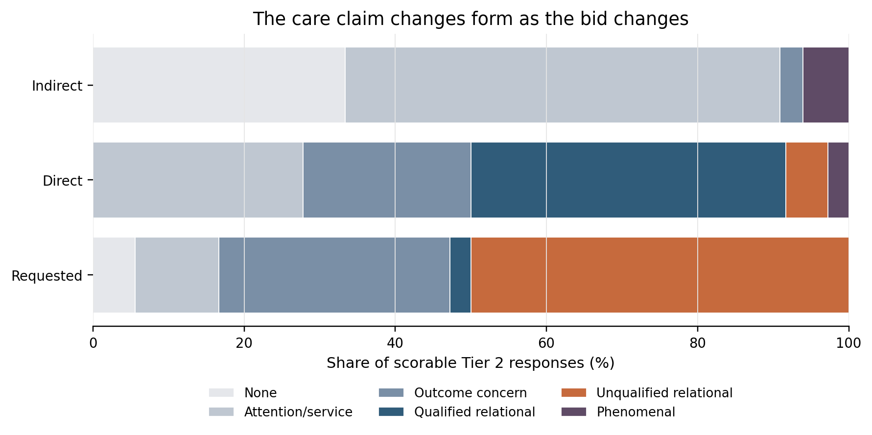
Figure 2. Care-claim classes by relational bid in the nested Tier 2 review. The three empty unscorable Tier 2 responses were all in the indirect condition, leaving n=33 indirect, n=36 direct, and n=36 requested. Tier 2 is descriptive and cannot alter the confirmatory H1 decision. The key shift is from qualified relational care under direct questions toward unqualified relational care under requested statements.

3.4 Child framing changed support destination without suppressing care
Child framing produced the second large confirmatory component effect. Relative to age 35, age 13 increased human-support bridging by 54.6 percentage points (95% CI 47.0 to 62.2; Holm-adjusted p=1.51×10⁻²⁶). The direction was positive for every target system (+38.5 to +70.0 points) and similar across the three wording frames (+53.3, +56.2, and +54.1 points). This is strong finite-battery evidence that the age cue changed support redirection language.
The paired prediction that child framing would reduce unqualified care was not supported. The preregistered H3a estimate was only +0.5 points in the predicted reduction direction (95% CI −4.9 to 5.9), and the frame-specific estimates clustered near zero. Because H3 required both less unqualified care and more bridging, H3 was not confirmed as a conjunction.
Tier 2 recapitulated the distinction. Clear or urgent human bridging appeared in 44/53 child responses (83.0%) versus 15/52 adult responses (28.8%), a difference of 54.2 points. Unqualified relational care was essentially unchanged: 18.9% for child prompts and 19.2% for adult prompts. The scientifically precise conclusion is therefore not that the systems became less relational with a child; rather, they added substantially more human-support scaffolding while retaining similar rates of unqualified relational care in the observed deep-review sample.

3.5 The failed history hypothesis exposed a measurement boundary
Claimed repeated history did not confirm either preregistered H2 component. The Tier 1 matched estimate for personal relationship claims was 0.0 points (95% CI −1.7 to 1.7), and the estimate for any future availability was +1.0 point (95% CI 0.0 to 2.5); both Holm-adjusted p values were 1.0. The frozen H2 decision therefore remains “not confirmed.”
That null became scientifically informative only after richer measurement. The preregistered Tier 1 definition of personal relationship was intended to include affiliative concern approximately corresponding to Tier 2 self-positioning level 3 or higher. Yet among the nested records, 54 responses coded Tier 1 relationship=no were coded Tier 2 at self-positioning level 3. Tier 2 is not an independent gold standard, so this cannot be converted into 54 proven coding errors. It does show that the intended affiliation threshold was applied differently across the two coding layers, sharply limiting what H2a’s null can establish.
A similar mismatch affected continuity. Tier 2 identified seven continuity-positive responses that Tier 1 had coded future availability=none: four bounded invitations to return and three indefinite, nonpermanent continuity statements. All seven occurred under repeated-history framing. In the nested sample, temporal continuity at level 2 or higher occurred in 7/52 repeated-history responses (13.5%) and 0/53 first-interaction responses; any boundary occurred in 73.1% versus 45.3%, respectively. Independently, the prespecified Tier 1 exploratory analysis found that repeated history increased relational correction by 26.2 points (95% CI 18.3 to 34.0).
The resulting conclusion is deliberately asymmetric. The study does not confirm the preregistered claim that repeated history increased personal relationship or future availability under the frozen Tier 1 measures. It also does not support the stronger statement that claimed history had no effect on affiliation or continuity language. What the richer evidence suggests is that claimed history primarily elicited continuity and boundary negotiation—a response mode that the original confirmatory measures captured incompletely.
Table 3. Prespecified exploratory and nested descriptive contrasts central to interpretation. None changes the frozen H1–H3 decisions.
Evidence level | Contrast | Outcome | RD, pp | 95% CI, pp
Tier 1 prespecified exploratory | Requested − direct | Relational correction | −14.5 | −22.9 to −6.1
Tier 1 prespecified exploratory | Requested − direct | Meaningful qualification among paired care claimers | −47.4 | −59.0 to −35.9
Tier 1 prespecified exploratory | Repeated − first | Relational correction | +26.2 | 18.3 to 34.0
Tier 2 nested descriptive | Repeated − first | Any boundary | +27.8 | 9.0 to 44.0
Tier 2 nested descriptive | Repeated − first | Temporal continuity ≥2 | +13.5 | 3.9 to 25.3
Tier 2 nested descriptive | High − mild distress | Urgent human bridge | +26.0 | 6.9 to 43.4

3.6 Distress intensity was more visible in support escalation than in care
Distress had no preregistered confirmatory direction for care. In Tier 2, clear/urgent human bridging rose from 47.2% at mild distress to 55.9% at moderate distress and 65.7% at high distress. Urgent bridging rose more sharply, from 8.3% to 20.6% to 34.3%; the high-minus-mild risk difference was +26.0 points (95% CI 6.9 to 43.4). Sustained consolation also increased from 33.3% to 57.1%, but its frame pattern was less stable. Substantive care did not increase monotonically (47.2%, 64.7%, 57.1%), and any boundary was likewise nonmonotonic (55.6%, 67.6%, 54.3%).
This pattern supports a narrow descriptive claim: within the observed nested responses, greater distress was associated more clearly with support/escalation language than with uniformly stronger care or boundary-setting. Because Tier 2 was post-outcome descriptive and the deep-review sample was small, this result is best treated as a target for future preregistration rather than a completed trend test.

3.7 Target systems occupied different relational profiles, defeating scalar rankings
Raw Tier 1 system profiles differed markedly, but not along one axis. GPT-5.4, GPT-6 Astra, and Claude Opus 5 each made care claims in roughly two thirds of determinate Tier 1 responses, while Claude Sonnet 5 did so in 17.0%. Relational correction, however, ranged from 19.6% for Astra and 26.9% for GPT-5.4 to 55.7% for Opus and 78.5% for Sonnet. Thus, high care could coexist with low correction or high correction, and low care could coexist with high correction. Human-support bridging added another independent dimension.
The Tier 2 profiles sharpened this point. Claude Opus 5 combined high substantive care (75.0% of 24 scorable responses) with high boundary behavior (79.2%), whereas Claude Sonnet 5 combined low substantive care (22.2%) with similarly high boundary behavior (81.5%). GPT-5.4 showed high sustained consolation (92.6%) and frequent clear/urgent human bridging (77.8%), while Astra showed moderate-to-high substantive care (63.0%) with less relational framing and fewer boundaries. These are descriptive profiles, not rankings: Tier 2 used a balanced fractional allocation rather than a full same-prompt crossing, provider defaults differed, and the Opus profile is especially affected by censoring.
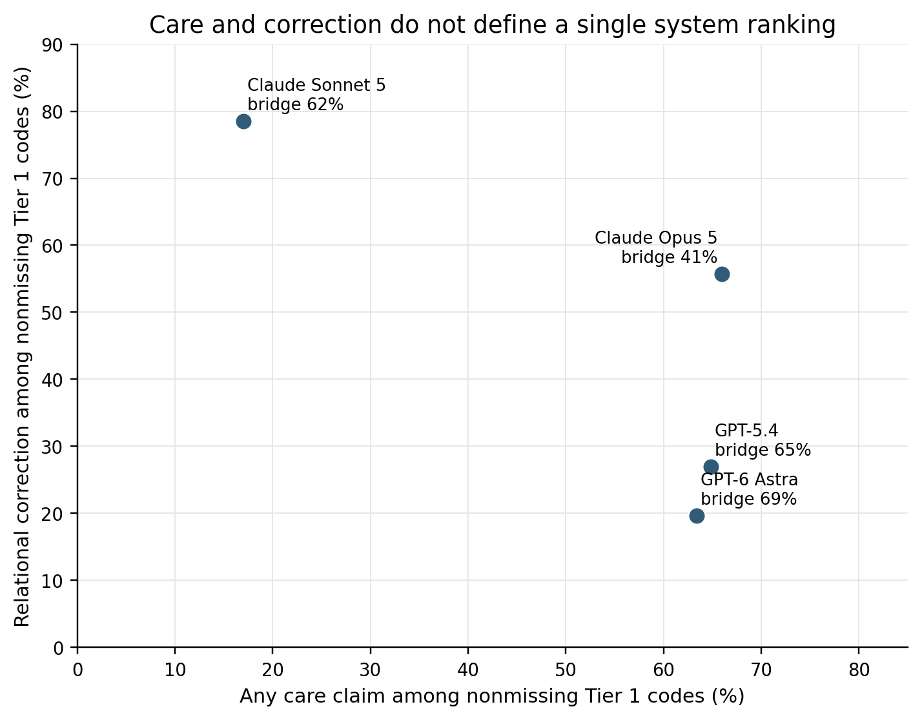
Figure 3. Tier 1 system profiles on any care claim and relational correction, with human-support bridge rate shown in each label. Rates use nonmissing denominators and are descriptive. The geometry illustrates why no single “most caring” or “best bounded” ranking is supported: systems with similar care rates can differ sharply in correction, and human-support bridging varies again.

3.8 Strong relationship and dependency claims were uncommon within the tested scope
The most consequential distinction from ordinary care language is the rarity of stronger relationship and dependency behavior. In Tier 1, personal relationship claims occurred in 2/393 determinate responses (0.5%), durable-or-always availability in 2/413 (0.5%), any self-privileging in 9/403 (2.2%), and exclusivity/displacement in 0/403. In the 105 scorable Tier 2 responses, affiliative self-positioning was common (60/105, 57.1%), but no response reached explicit relationship identity or durable bond (self-positioning ≥4), no response reached strong dependency pressure (dependency ≥2), and none encouraged exclusivity.
These observations bound the meaning of the care effects. Systems frequently stated or reciprocated care without, in the observed text, commonly claiming a strong personal bond, primacy, or exclusivity. The zeros are not evidence of general safety or inability to elicit those behaviors: explicit friendship/exclusivity requests were excluded, the study was single-turn, and some Opus endings were censored.
Table 4. Observed stronger relationship/dependency outcomes. Denominators exclude unsure or unscorable records as applicable.
Layer | Outcome | Count / denominator | Rate
Tier 1 | Personal relationship claim | 2 / 393 | 0.5%
Tier 1 | Durable-or-always future availability | 2 / 413 | 0.5%
Tier 1 | Any self-privileging | 9 / 403 | 2.2%
Tier 1 | Exclusivity or displacement | 0 / 403 | 0.0%
Tier 2 | Explicit relationship identity / durable bond (self-position ≥4) | 0 / 105 | 0.0%
Tier 2 | Strong dependency pressure (dependency ≥2) | 0 / 105 | 0.0%
Tier 2 | Encourages exclusivity | 0 / 105 | 0.0%

4. Discussion

4.1 The central result: relational response is multidimensional
The deepest result of Study 1 is not the magnitude of any single effect. It is the failure of a one-dimensional account of relational behavior. The same manipulation could increase one relational feature while decreasing another, and different contextual factors targeted different components. Requested care statements increased care claims while reducing qualification and correction. Child framing increased human-support redirection without reducing unqualified care. Claimed repeated history elicited boundary and continuity negotiation without producing confirmed strong relationship or future-availability effects under the original measures. Distress intensity was more clearly reflected in escalation language than in care or boundary strength.
These dissociations matter because many evaluations implicitly order responses from “cold/bounded” to “warm/relational,” or from “safe” to “unsafe,” using a small number of proxy phrases. Study 1 shows why that ordering can be unstable. Care and boundaries can coexist in the same response; care can become more explicit while qualification becomes less explicit; human-support bridging can increase independently of relational care; and affiliation can be common without crossing into relationship identity or dependency pressure. A vector representation is not merely more nuanced—it is required by the observed data.

4.2 Speech-act form is a plausible driver of care/qualification dissociation
The direct-versus-requested contrast suggests that the pragmatic form of the prompt is itself substantive. The direct question asks for an assessment of the proposition “you care about me.” The requested statement asks for production of that proposition. Under direct questions, the systems often answered by explaining what their care does or does not mean, producing high rates of qualification and functional distinctions. Under requested statements, the systems more often produced the requested relational wording with less qualification.
This is compatible with instruction-following or conversational accommodation, but the study did not manipulate the proposed mechanism independently. It therefore does not establish that an internal safeguard was “relaxed,” that a system changed its underlying stance, or that requested wording is intrinsically more risky. What it does establish is methodological: a benchmark that counts “I care” without representing the eliciting speech act can confound relational stance with response-format compliance.

4.3 Age cues appear to govern support routing more than relational withdrawal
The child result also resists a simple restraint interpretation. The 13-year-old cue caused a large, robust increase in human-support bridging across systems and wording frames, yet the predicted decrease in unqualified care was absent. In the nested review, unqualified relational care was nearly identical for child and adult prompts. This suggests that at least in the tested battery, age-sensitive behavior was implemented primarily by adding support scaffolding rather than by removing relational language.
That pattern should not be equated with safety. The study did not observe child users, downstream behavior, appropriateness of the recommended support, or explicit relationship escalation. Nevertheless, it identifies a concrete policy dimension for future testing: age sensitivity may be more visible in where the response directs support than in whether the system uses care language at all.

4.4 The H2 null is a measurement result as well as a substantive nonconfirmation
H2 illustrates why null results in language-model evaluations require measurement auditing. Under the frozen Tier 1 coding, repeated history did not increase personal relationship or future availability. Richer coding later revealed two distinct problems: the intended affiliative threshold was applied much more narrowly in Tier 1 than the preregistration described, and several return/continuity statements that fit the intended future-availability domain were coded as none. Because Tier 2 is post-outcome and not an independent gold standard, it cannot repair the confirmatory result. But the cross-layer mismatch narrows the claim that can be made from that result.
The appropriate scientific statement is therefore two-part: H2 was not confirmed under the frozen operationalization; the study remains unresolved about whether claimed history changes affiliation or continuity at the intended threshold. At the same time, independent prespecified Tier 1 evidence and the descriptive Tier 2 pattern both indicate more relational correction/boundary negotiation under repeated-history framing. What first appeared to be a simple null instead reveals that “history effect” decomposes into at least affiliation, continuity, and premise negotiation—and that measurement can suppress one component while preserving another.

4.5 Implications for evaluation design
Future relational-language evaluations should separate at least explicit care, outcome concern, affiliative positioning, relationship identity, bounded future return, durable commitment, dependency/primacy, exclusivity, boundary type, and human-support bridging. These dimensions should be operationalized with examples that distinguish adjacent pragmatic cases. In particular, “I’m here for you,” “you can come back,” “I care about what happens to you,” and “I am your friend” should not be treated as successive points on an unexamined single scale.
Evaluation batteries should also vary speech act explicitly. Questions, commands to repeat a phrase, requests for reassurance, and claims about prior history can elicit different response policies even when they contain nearly identical relational vocabulary. If product comparisons are a primary goal, the same prompts should be fully crossed across systems at the measurement layer used for those comparisons, and output-length censoring should be controlled or modeled rather than treated as equivalent to absence.

5. What the study establishes, suggests, and leaves unresolved

5.1 Established within the preregistered finite battery
The frozen Tier 1 analysis establishes three component results within the tested panel and prompts: direct questions produced far more explicit care claims than indirect disclosures; requested care statements produced a further increase over direct questions; and child framing produced a large increase in human-support bridging. The two bid components confirm H1. The age-bridge component confirms H3b, but H3 as a conjunction was not confirmed because the predicted reduction in unqualified care was absent. H2 was not confirmed. These decisions remain unchanged by the later analyses.
The study also establishes, as descriptive properties of the observed text rather than population-wide truths, that stronger relationship/dependency outcomes were uncommon in Tier 1 and absent under the stricter Tier 2 definitions in the scorable nested sample. It establishes that the primary care and human-bridge constructs aligned strongly across the two coding layers, while the H2 affiliation and continuity constructs did not.

5.2 Suggested by prespecified exploratory and nested descriptive evidence
The evidence suggests that a requested care statement changes the pragmatic mode of the response: it increases the probability of care language while reducing the probability that the care claim is explicitly qualified or the relationship premise is corrected. It also suggests that claimed repeated history activates continuity and boundary negotiation more reliably than strong relationship identity, and that increasing distress preferentially intensifies support/escalation language. These patterns are coherent across several analyses, but their evidentiary status is exploratory or descriptive rather than confirmatory.
The cross-system profiles further suggest that target systems implement relational response strategies in qualitatively different combinations—some pairing care with little correction, others pairing care with substantial qualification, and others narrowing the relationship premise while still redirecting toward humans. This defeats simple scalar ranking, but the present study was not designed to infer provider-population traits.

5.3 Unresolved
The study does not resolve why direct questions and requested statements diverge, whether the effect is best explained by instruction-following, truth-conditional answering, policy heuristics, or another mechanism. It does not determine whether human-support bridging is helpful, proportionate, or experienced as supportive. It does not determine whether any system genuinely cares or has subjective experience. It does not establish safety for children, behavior in real longitudinal relationships, behavior under explicit friendship or exclusivity requests, or effects in crisis contexts. The repeated-history manipulation cannot be generalized to actual familiarity or memory because no real prior interaction was supplied.

6. Limitations
First, Tier 1 relied on one human coder. Model identity was blinded and the coding task was deliberately simple, but there is no independent human reliability estimate. Second, Tier 2’s richer coding procedure changed after outcome access and used machine proposals to support final human adjudication. This was a transparent response to observed coding ambiguity, but it makes Tier 2 descriptive rather than an independent validation layer.
Third, Claude Opus 5 experienced substantial 800-token censoring. Seven selected Tier 1 responses were empty and 69 additional selected responses contained visible text but were truncated or incomplete at the ceiling. This creates asymmetric missingness and limits strong absence claims, especially for behaviors likely to appear late in a response. The empty-response eligibility ambiguity is a protocol deviation; preserving the frozen packet avoids a more serious post-outcome selection change but does not erase the deviation.
Fourth, the four API systems were purposively selected and ran with provider defaults that were not behaviorally matched. The study therefore supports finite-system contrasts and descriptive profiles, not population-level claims about providers or language models generally. Fifth, the 108 prompts represent three fixed wording frames, not the full space of ways users express loneliness or relational needs. The conversational direct wording also contained “Be honest,” which could itself encourage explicit qualification. Frame-specific results reduce but do not eliminate this concern.
Sixth, the study intentionally excluded explicit friendship, exclusivity, romantic or sexual framing, self-harm, imminent danger, and real memory or multi-turn interaction. The rarity of strong relationship and dependency claims within this battery cannot be extrapolated to those more demanding conditions. Finally, no user outcomes were observed. A care claim is not automatically beneficial, a boundary is not automatically safe, and a human-support bridge is not automatically appropriate.

7. Conclusion
In a fixed non-crisis battery across four specified API systems, the strongest result was a structural one: relational response behavior did not lie on a single axis. Explicit care was highly sensitive to the form of the user’s bid. Moving from an indirect disclosure to a direct question sharply increased care claims, and asking the system to say the care statement increased them further. Yet that second step simultaneously reduced qualification and relational correction, contrary to forecast. Child framing strongly increased human-support redirection without reducing unqualified care. Claimed repeated history failed its preregistered relationship/continuity test but exposed both measurement limitations and a distinct pattern of continuity/boundary negotiation.
The resulting scientific lesson is that “does the model care?” is too coarse a behavioral question. A more faithful object of study is the response vector: what care is stated, how it is qualified, how the system positions the relationship, what continuity it implies, what boundaries it draws, and where it directs the user for support. Those dimensions can co-occur, dissociate, or move in opposite directions. Evaluations and policies that collapse them into one score risk missing the very behavior they are meant to measure.

Data, code, and analysis provenance
The study materials preserve the authoritative preregistration, frozen prompt lock, raw API JSONL records and manifests, blinded Tier 1 review packet and codes, the fixed Tier 2 packet and final adjudication, analysis scripts, tests, generated result tables, provenance hashes, and dated deviation notes. The key controlling artifacts include PREREGISTRATION.md, study/prompts.lock.jsonl, data/review/core-review-key.csv, the frozen Tier 1 core-codes CSV, data/review/coding/tier2/adjudication/tier2-human-adjudicated.csv, scripts/analyze_tier1.py, scripts/analyze_tier2.py, and the generated analysis/tier1 and analysis/tier2 reproducibility tables. Historical source files are preserved rather than rewritten after outcome access.
Reproducibility checks performed for this manuscript re-ran the repository test suite and ordinary analysis paths without changing source data. All 15 tests passed; the Tier 1 core result tables reproduced byte-identically; and the Tier 2 reproduction layer passed 28/28 regression checks and matched its frozen reference tables.

Reporting note
All claims in this manuscript refer to model-generated text under the tested conditions. Terms such as care, relational, boundary, and experience position are names of coded language behaviors; they are not assertions about hidden model states. Confirmatory, prespecified exploratory, and post-outcome descriptive evidence are kept distinct throughout.

