变量筛选
- 单因素分析
研究独立变量对结局的影响，首先进行单因素分析，并剔除单因素分析表中p值都大于0.1的因子为：T2,L1,WBC,Neut,Mono,PT,TT,Ddimer,GLB,UCB,UA,D1,D2,Bloodloss,H1,H2,Fracture_side,Hypertension,Diabetes,Osteoporosis,Osteoarthritis,Atrial_fibrillation,Thyroid_disorder。其单因素分析表参见附件1。
- Lasso回归筛选
最小均方误差的λ为0.009,对应模型的变量选择为:'Age','BMI','HB','FIB','ALT','AST','BUN','Cr','Sex','Cerebral_infarction','COPD','Dementia','DVT','ASA','Anaesthesia','Bloodtransfusion'。
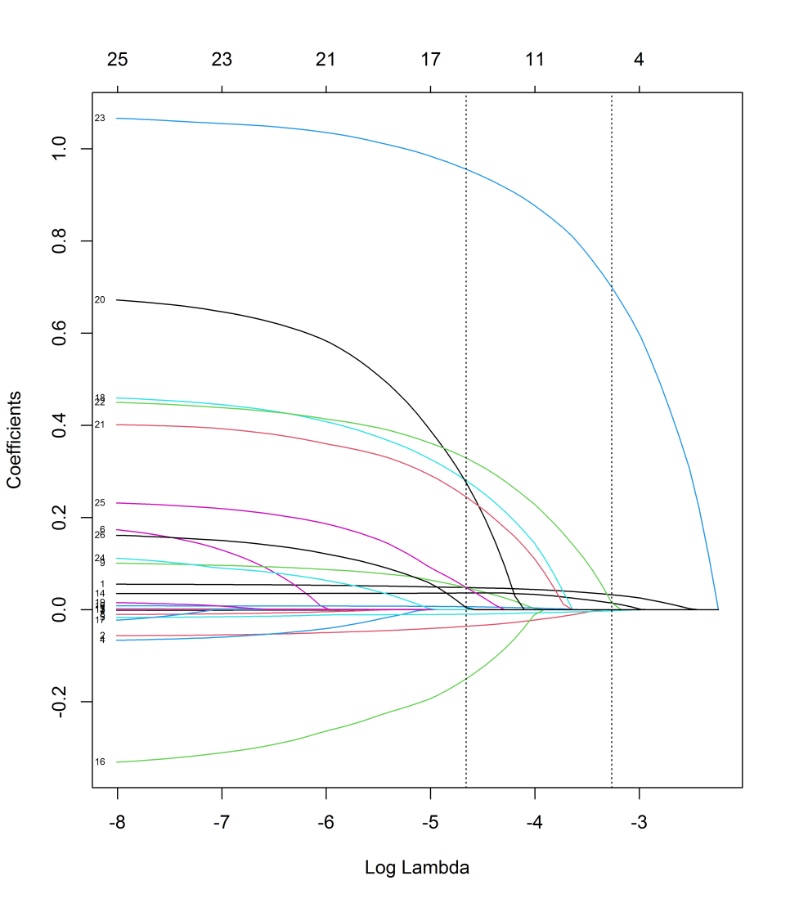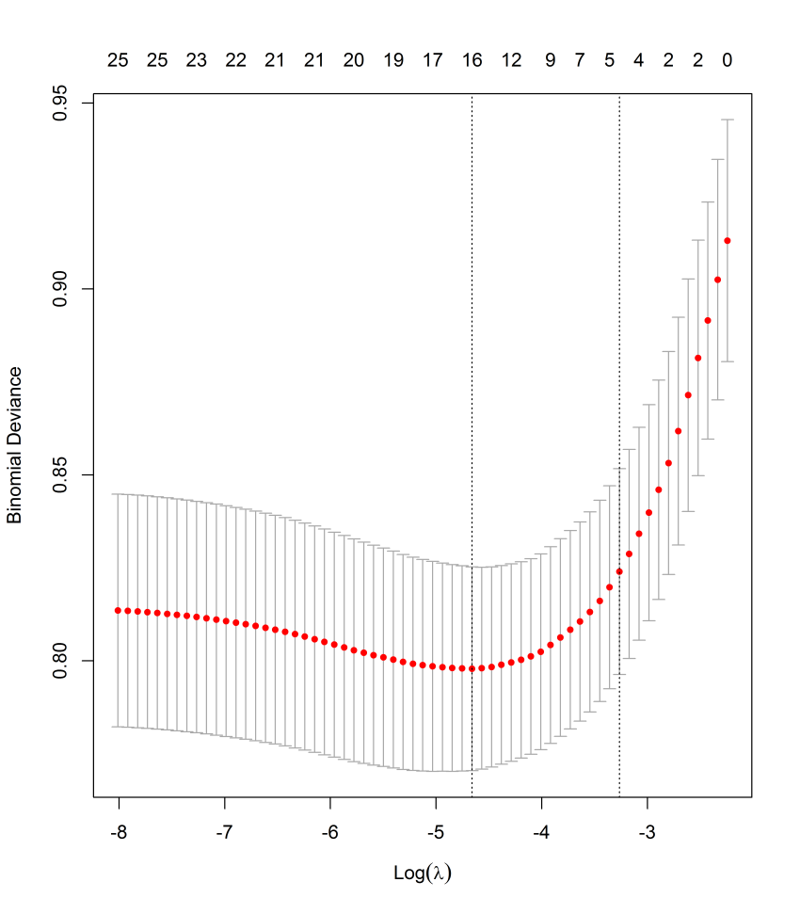
- XGBoost重要度排序
采用极端梯度提升树(XGBOOST)进行变量重要度分析，其重要度最高的16个变量（由高到低）分别为：'BUN', 'Age', 'ASA', 'BMI', 'FDP', 'RBC', 'Lymph', 'CB', 'Cr', 'HB', 'APTT', 'ALB', 'ALT', 'FIB', 'AST', 'T1'。
Variable | Total Gain | Total Cover | Gain | Cover | Weight Importance
BUN | 159.234 | 2169.025 | 1.154 | 15.718 | 138.000
Age | 156.418 | 2255.643 | 1.955 | 28.196 | 80.000
ASA | 141.941 | 1875.443 | 3.735 | 49.354 | 38.000
BMI | 141.891 | 3115.784 | 1.144 | 25.127 | 124.000
FDP | 104.207 | 1577.517 | 1.032 | 15.619 | 101.000
RBC | 102.738 | 1797.409 | 1.007 | 17.622 | 102.000
Lymph | 86.785 | 1299.287 | 0.914 | 13.677 | 95.000
CB | 86.326 | 1159.459 | 0.838 | 11.257 | 103.000
Cr | 83.558 | 1822.791 | 0.880 | 19.187 | 95.000
HB | 82.466 | 1141.624 | 1.085 | 15.021 | 76.000
APTT | 82.125 | 1699.909 | 0.679 | 14.049 | 121.000
ALB | 74.010 | 1541.179 | 0.832 | 17.317 | 89.000
ALT | 71.305 | 1634.909 | 0.820 | 18.792 | 87.000
FIB | 65.403 | 791.748 | 0.838 | 10.151 | 78.000
AST | 44.574 | 945.176 | 0.686 | 14.541 | 65.000
T1 | 43.751 | 1081.730 | 0.781 | 19.317 | 56.000

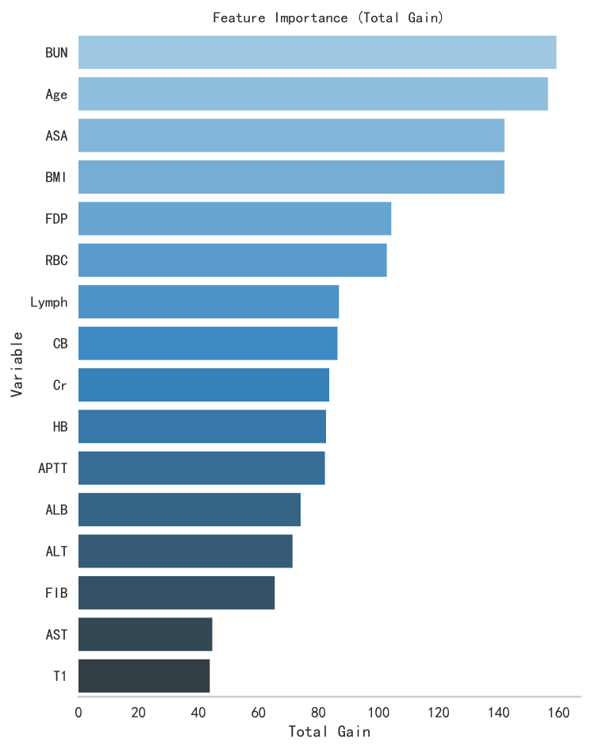
- RF重要度排序
采用Random Forrest Classifier（RF）进行变量重要度分析，其重要度最高的18个变量（由高到低）分别为：'BMI', 'Age', 'Lymph', 'Cr', 'BUN', 'RBC', 'ASA', 'ALB', 'HB', 'CB', 'APTT', 'FIB', 'FDP', 'ALT', 'AST', 'T1'。
Variable | Weight Importance
BMI | 0.078
Age | 0.074
Lymph | 0.066
Cr | 0.063
BUN | 0.061
RBC | 0.059
ASA | 0.057
ALB | 0.055
HB | 0.055
CB | 0.054
APTT | 0.053
FIB | 0.052
FDP | 0.051
ALT | 0.047
AST | 0.045
T1 | 0.036

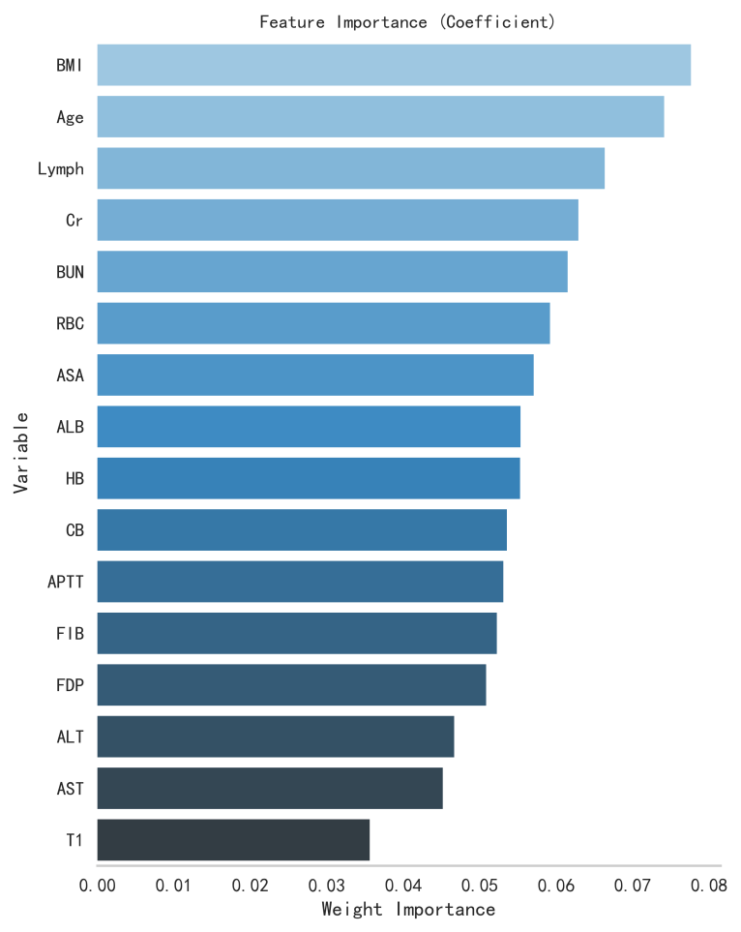

- 韦恩图
通过韦恩图获取3个方法（Lasso、XGBoost、RF）所共有的特征：'Age','AST','FIB','Cr','BMI','HB','ALT','ASA','BUN'。
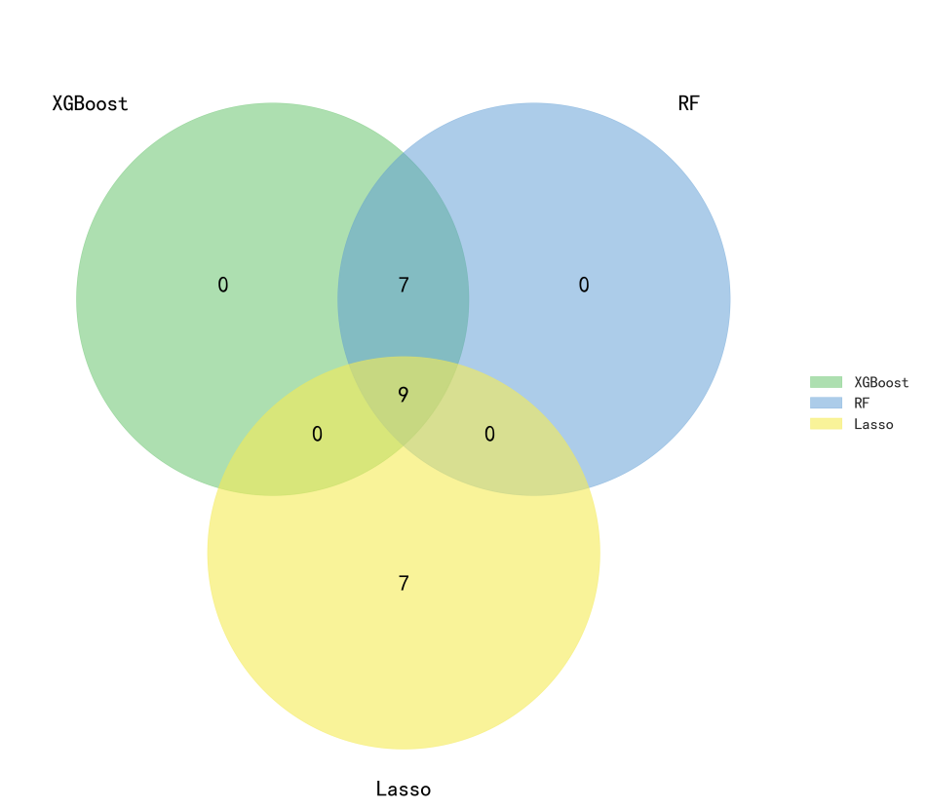

模型选择
将最终剩余的9个变量作为输入变量，训练集中用80%的数据用于训练，20%的数据用于验证并重采样5次观察在不同模型（XGBoost, AdaBoost, RF, GBDT, GNB, CNB, Logistic, SL(其第一层模型由上述的GBoost、RF、AdaBoost、GBDT、GNB、CNB、Logistic构成，元学习器由上述的Logistic)）中的表现，并比较模型间的AUC，选出最优模型，其分析的相关结果如下。

训练集各项指标：

分类模型 | AUC(95%CI) | cutoff(95%CI) | 准确度(95%CI) | 灵敏度(95%CI) | 特异度(95%CI) | 阳性预测值(95%CI) | 阴性预测值(95%CI) | F1分数(95%CI) | Kappa(95%CI)
XGBoost | 0.771 (0.730-0.811) | 0.18(0.161-0.200) | 0.698(0.661-0.735) | 0.733(0.678-0.788) | 0.692(0.636-0.747) | 0.332(0.307-0.357) | 0.925(0.916-0.934) | 0.455(0.440-0.469) | 0.285(0.259-0.310)
AdaBoost | 0.726 (0.686-0.766) | 0.23(0.204-0.257) | 0.747(0.642-0.852) | 0.808(0.791-0.824) | 0.555(0.518-0.592) | 0.45(0.312-0.587) | 0.883(0.844-0.922) | 0.564(0.444-0.685) | 0.214(0.208-0.220)
RF | 0.724 (0.679-0.769) | 0.192(0.179-0.204) | 0.775(0.691-0.860) | 0.608(0.503-0.713) | 0.745(0.644-0.846) | 0.425(0.352-0.499) | 0.884(0.863-0.906) | 0.486(0.454-0.519) | 0.275(0.245-0.304)
GBDT | 0.769 (0.729-0.809) | 0.183(0.176-0.191) | 0.692(0.653-0.730) | 0.739(0.682-0.796) | 0.677(0.618-0.735) | 0.323(0.303-0.342) | 0.92(0.910-0.931) | 0.448(0.436-0.460) | 0.269(0.250-0.288)
GNB | 0.710 (0.666-0.754) | 0.031(0.007-0.055) | 0.665(0.657-0.673) | 0.688(0.666-0.710) | 0.662(0.652-0.671) | 0.294(0.288-0.300) | 0.909(0.899-0.919) | 0.412(0.408-0.416) | 0.225(0.215-0.235)
CNB | 0.651 (0.601-0.702) | 0.301(-0.012-0.614) | 0.645(0.555-0.735) | 0.592(0.447-0.737) | 0.656(0.518-0.793) | 0.275(0.239-0.312) | 0.888(0.876-0.899) | 0.363(0.354-0.372) | 0.168(0.138-0.198)
logistic | 0.734 (0.687-0.782) | 0.197(0.184-0.210) | 0.714(0.692-0.737) | 0.651(0.635-0.667) | 0.728(0.699-0.758) | 0.331(0.315-0.346) | 0.908(0.903-0.913) | 0.438(0.426-0.451) | 0.271(0.250-0.292)
SL | 0.777 (0.736-0.818) | 0.151(0.140-0.162) | 0.667(0.630-0.704) | 0.798(0.743-0.853) | 0.64(0.584-0.696) | 0.316(0.296-0.336) | 0.938(0.931-0.945) | 0.451(0.436-0.466) | 0.271(0.247-0.294)

验证集各项指标：
分类模型 | AUC(95%CI) | cutoff(95%CI) | 准确度(95%CI) | 灵敏度(95%CI) | 特异度(95%CI) | 阳性预测值(95%CI) | 阴性预测值(95%CI) | F1分数(95%CI) | Kappa(95%CI)
XGBoost | 0.719 (0.623-0.815) | 0.18(0.161-0.200) | 0.652(0.619-0.686) | 0.696(0.661-0.730) | 0.713(0.652-0.774) | 0.278(0.232-0.325) | 0.914(0.885-0.943) | 0.394(0.351-0.436) | 0.209(0.176-0.243)
AdaBoost | 0.700 (0.612-0.789) | 0.23(0.204-0.257) | 0.748(0.620-0.875) | 0.794(0.745-0.843) | 0.525(0.441-0.608) | 0.47(0.300-0.640) | 0.883(0.846-0.920) | 0.573(0.423-0.722) | 0.202(0.170-0.233)
RF | 0.687 (0.592-0.783) | 0.192(0.179-0.204) | 0.754(0.676-0.833) | 0.666(0.435-0.897) | 0.622(0.441-0.803) | 0.349(0.241-0.458) | 0.872(0.830-0.914) | 0.416(0.312-0.520) | 0.184(0.143-0.226)
GBDT | 0.681 (0.582-0.780) | 0.183(0.176-0.191) | 0.635(0.582-0.687) | 0.71(0.615-0.804) | 0.623(0.512-0.735) | 0.255(0.201-0.310) | 0.895(0.871-0.918) | 0.371(0.314-0.428) | 0.164(0.119-0.209)
GNB | 0.699 (0.607-0.791) | 0.031(0.007-0.055) | 0.642(0.611-0.672) | 0.709(0.585-0.833) | 0.658(0.530-0.786) | 0.261(0.245-0.278) | 0.902(0.864-0.940) | 0.379(0.351-0.407) | 0.181(0.148-0.214)
CNB | 0.649 (0.539-0.758) | 0.301(-0.012-0.614) | 0.597(0.503-0.691) | 0.601(0.430-0.773) | 0.708(0.551-0.864) | 0.23(0.173-0.288) | 0.876(0.842-0.910) | 0.316(0.269-0.362) | 0.11(0.072-0.148)
logistic | 0.708 (0.603-0.813) | 0.197(0.184-0.210) | 0.703(0.682-0.724) | 0.644(0.533-0.755) | 0.744(0.648-0.841) | 0.303(0.277-0.330) | 0.908(0.878-0.938) | 0.408(0.384-0.432) | 0.242(0.218-0.266)
SL | 0.743 (0.646-0.841) | 0.151(0.140-0.162) | 0.64(0.606-0.673) | 0.728(0.684-0.772) | 0.712(0.620-0.803) | 0.278(0.228-0.329) | 0.922(0.896-0.948) | 0.398(0.351-0.445) | 0.215(0.174-0.255)

Delong检验P值表
 | XGBoost | AdaBoost | RF | GBDT | GNB | CNB | Logistic | SL
XGBoost | NA | 0.546 | 0.392 | 0.431 | 0.542 | 0.221 | 0.298 | 0.496
AdaBoost | 0.546 | NA | 0.549 | 0.444 | 0.639 | 0.482 | 0.415 | 0.276
RF | 0.392 | 0.549 | NA | 0.425 | 0.480 | 0.365 | 0.511 | 0.203
GBDT | 0.431 | 0.444 | 0.425 | NA | 0.489 | 0.475 | 0.437 | 0.121
GNB | 0.542 | 0.639 | 0.480 | 0.489 | NA | 0.346 | 0.377 | 0.296
CNB | 0.221 | 0.482 | 0.365 | 0.475 | 0.346 | NA | 0.309 | 0.069
Logistic | 0.298 | 0.415 | 0.511 | 0.437 | 0.377 | 0.309 | NA | 0.343
SL | 0.496 | 0.276 | 0.203 | 0.121 | 0.296 | 0.069 | 0.343 | NA

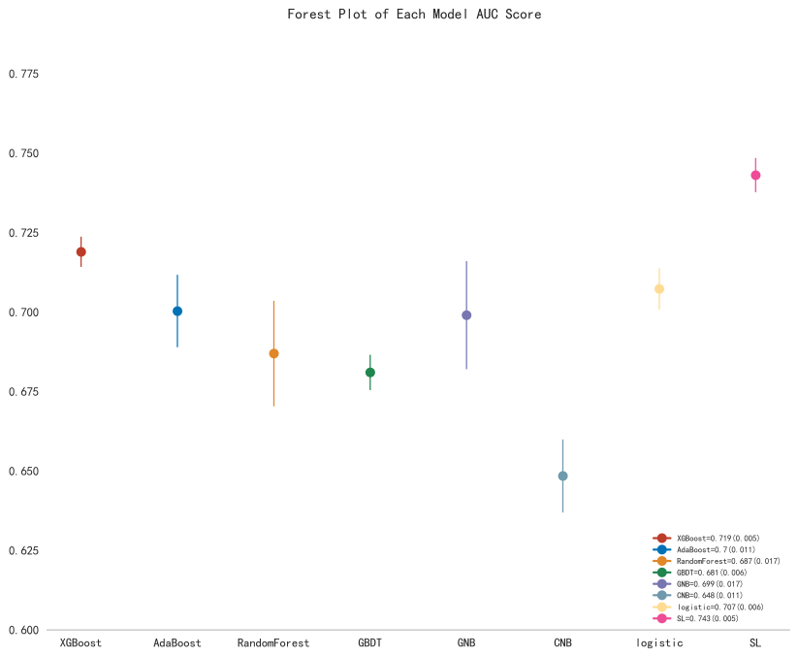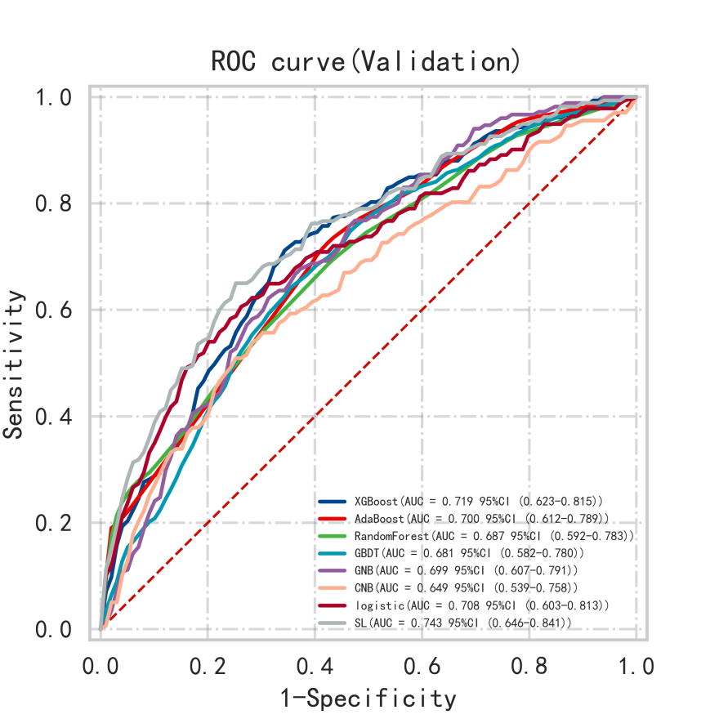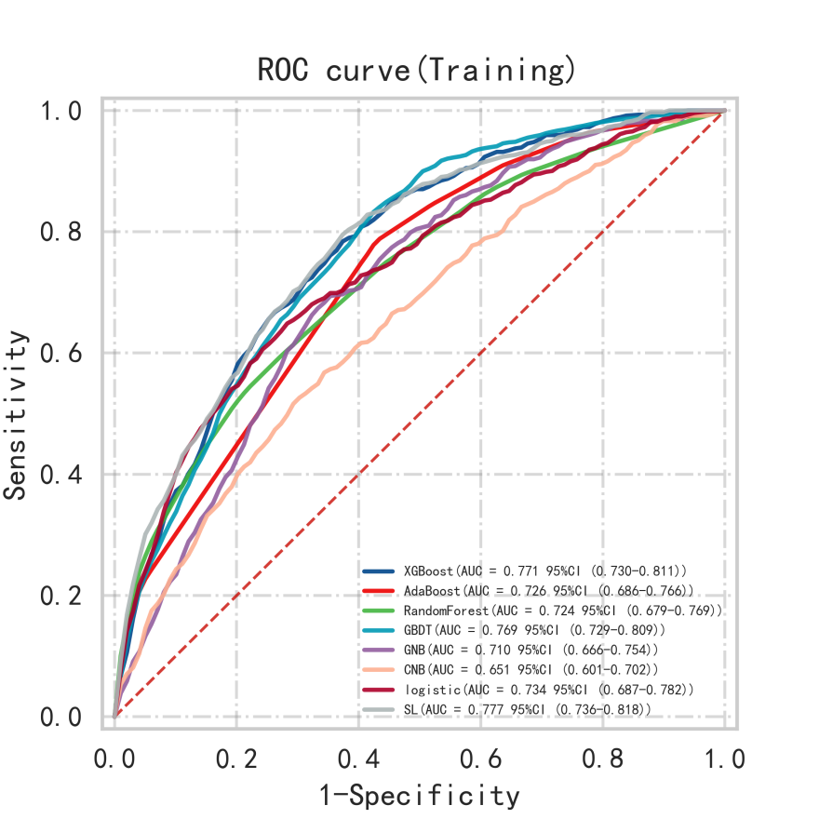

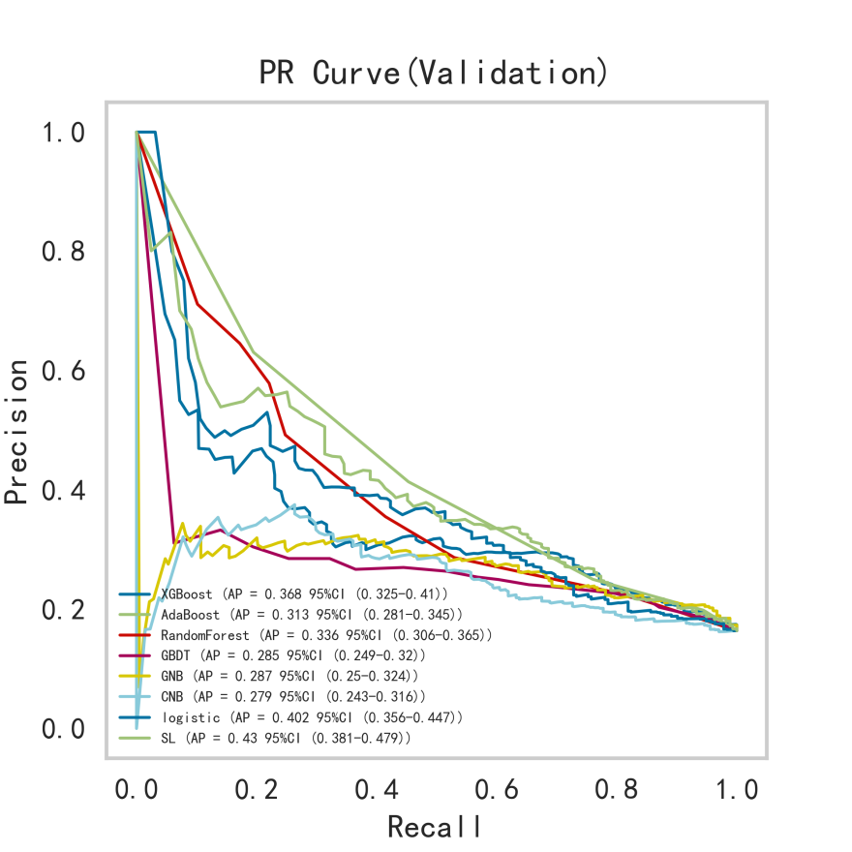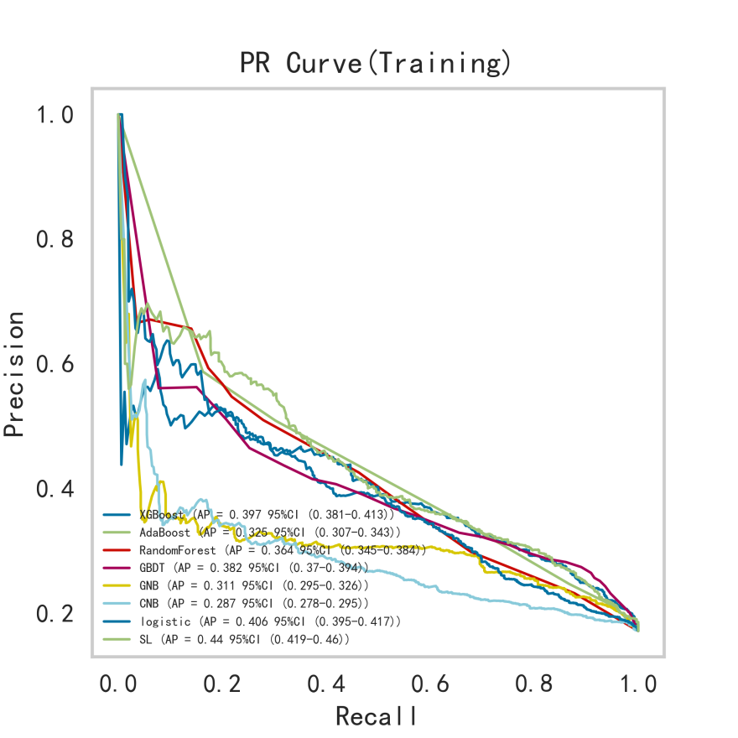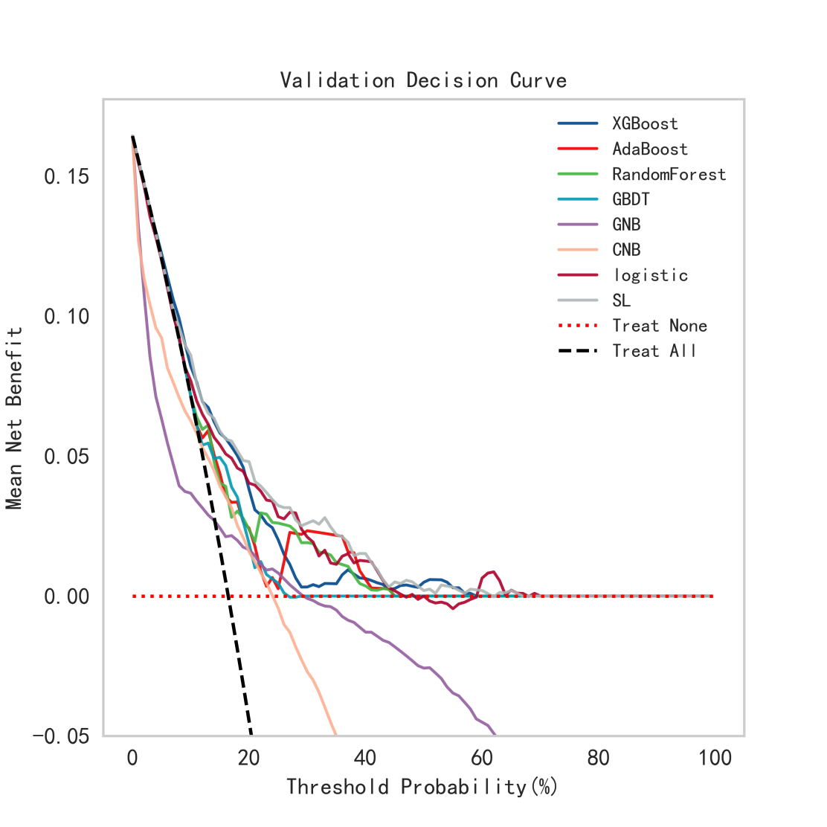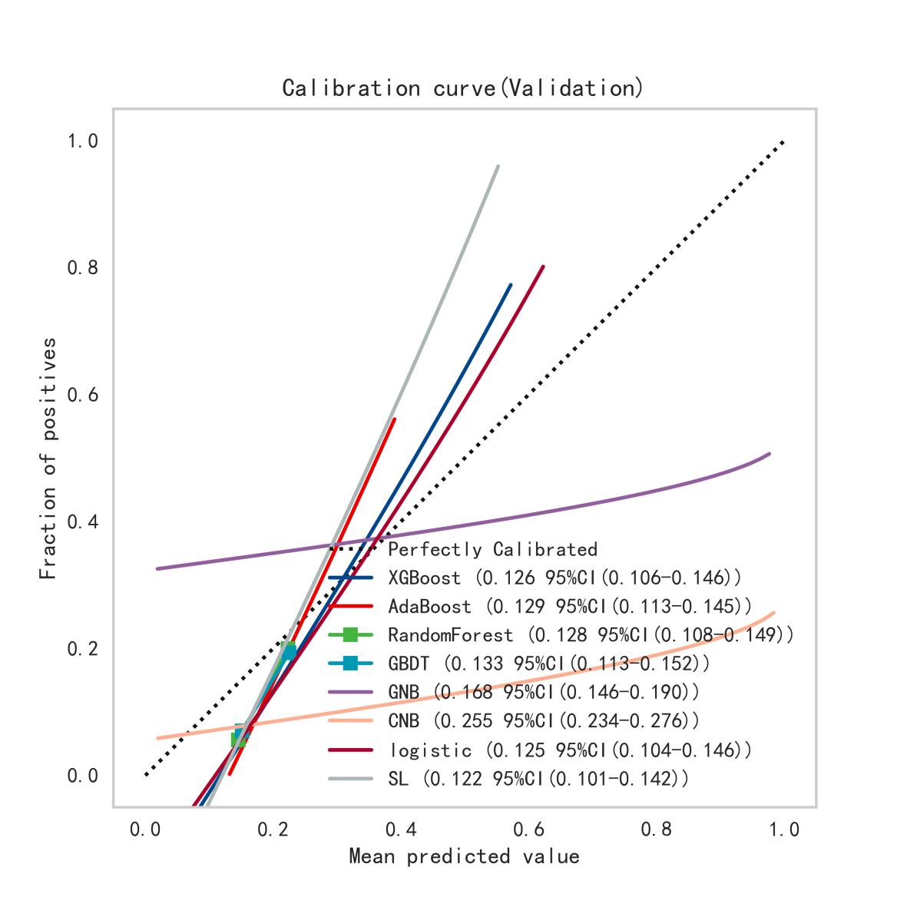

可以看出SL不管在训练集还是在验证集中表现最好，且模型稳定性也较优，最终选择的模型为SL。

最优模型
进一步研究结局和9个变量直接的关系，并进行5折交叉验证，并观察模型在测试集中的表现，构建SuperLearner机器学习方法进行分类，分类变量为Outcome，模型中的变量包括Age、AST、FIB、Cr、BMI、HB、ALT、ASA、BUN。
数据集样本数总计N=1263例，分类变量中包含的类别信息为：
类别(0)：N=1051例
类别(1)：N=212例
其中在总体样本中根据标签1为1划分为总体测试集，其余标签归为训练集。其中测试集N=253例(20.03%)，剩余样本作为训练集进行5折交叉验证，并在验证集中得到AUC=0.7358(0.6446-0.8269)。
最终模型在测试集中的AUC=0.6494，准确度=0.6522。
模型在训练集各项指标如下：
 | AUC(95%CI) | cutoff(95%CI) | 准确度(95%CI) | 灵敏度(95%CI) | 特异度(95%CI) | 阳性预测值(95%CI) | 阴性预测值(95%CI) | F1分数(95%CI)
SL | 0.776(0.734-0.817) | 0.163(0.144-0.181) | 0.711(0.671-0.752) | 0.721(0.650-0.792) | 0.711(0.648-0.774) | 0.342(0.309-0.376) | 0.925(0.914-0.936) | 0.460(0.448-0.473)

模型在验证集各项指标如下：

 | AUC(95%CI) | cutoff(95%CI) | 准确度(95%CI) | 灵敏度(95%CI) | 特异度(95%CI) | 阳性预测值(95%CI) | 阴性预测值(95%CI) | F1分数(95%CI)
SL | 0.736(0.645-0.827) | 0.163(0.144-0.181) | 0.683(0.656-0.711) | 0.681(0.644-0.717) | 0.708(0.651-0.765) | 0.304(0.287-0.320) | 0.910(0.893-0.926) | 0.419(0.402-0.437)
模型在测试集各项指标如下：

AUC | cutoff | 准确度 | 灵敏度 | 特异度 | 阳性预测值 | 阴性预测值 | F1分数
0.649 | 0.162 | 0.652 | 0.525 | 0.746 | 0.239 | 0.888 | 0.329
图形如下：
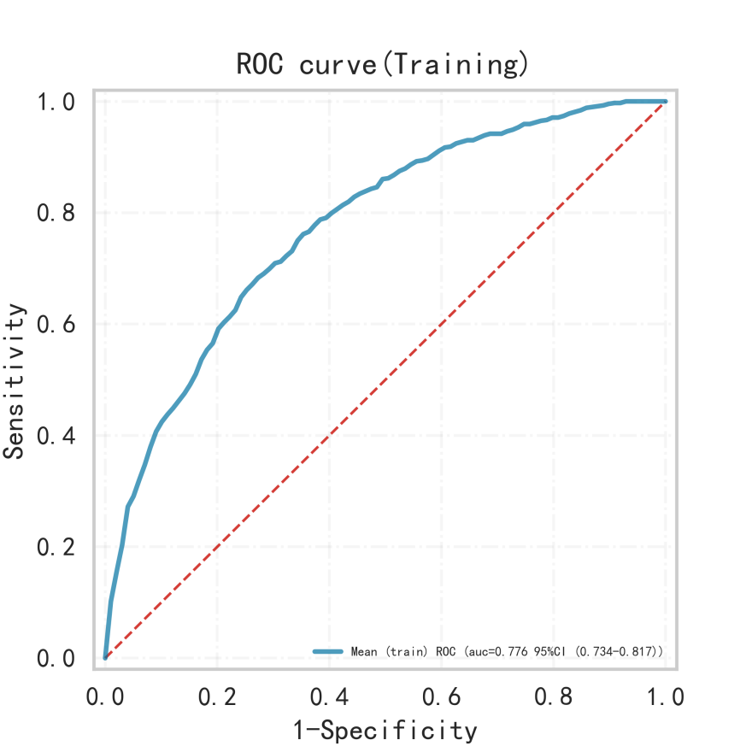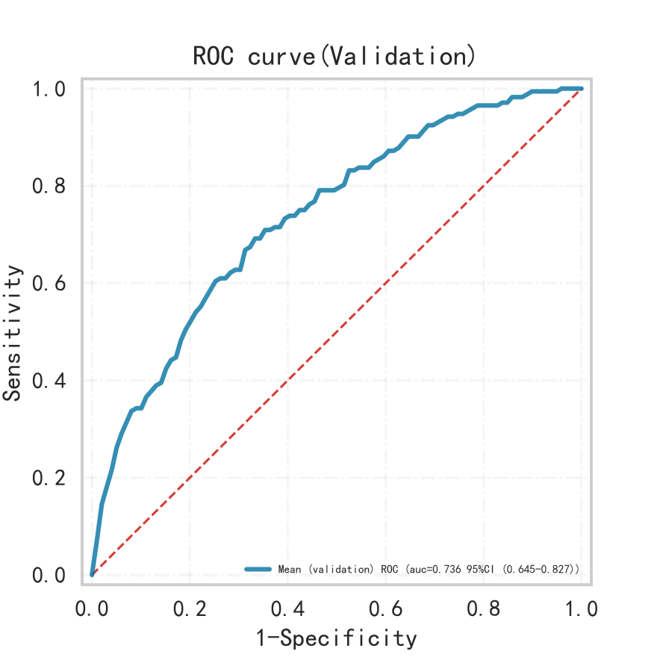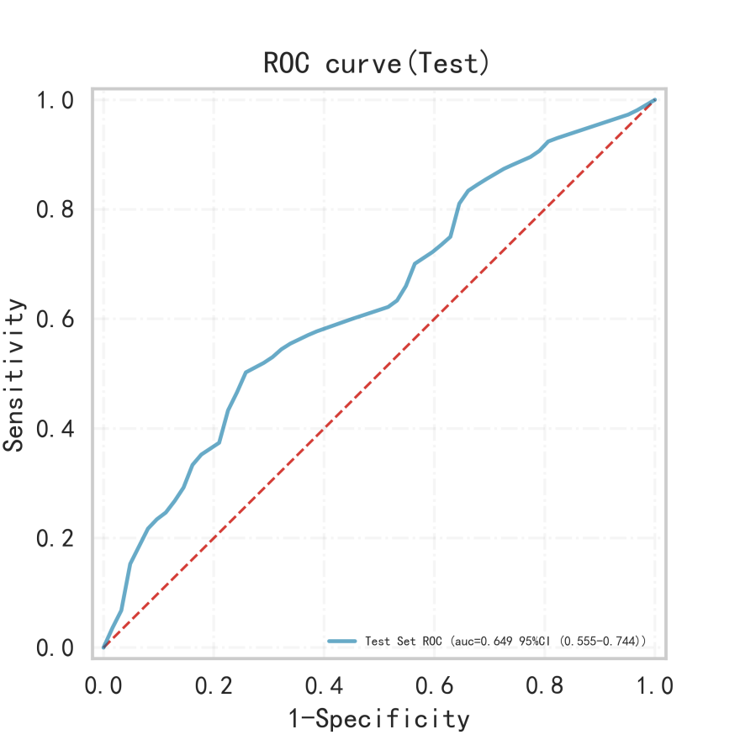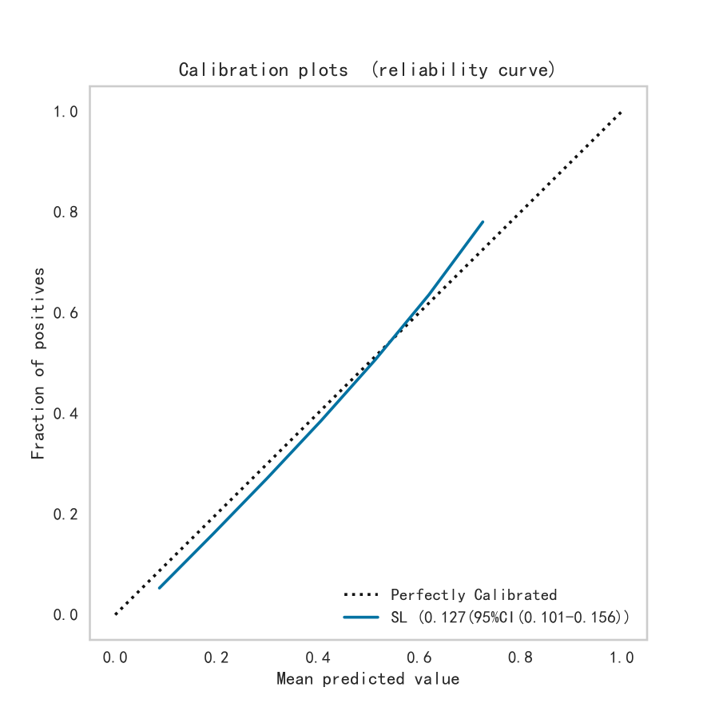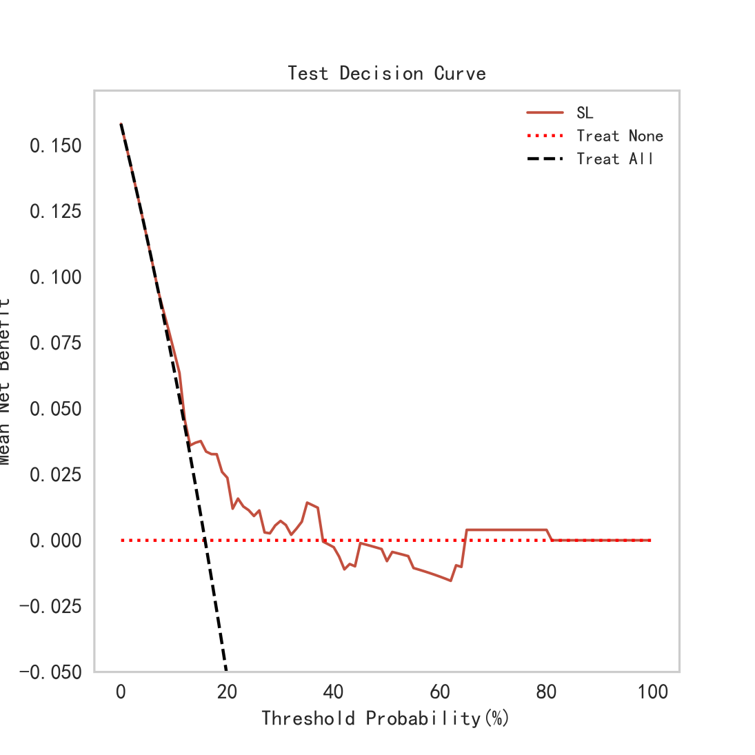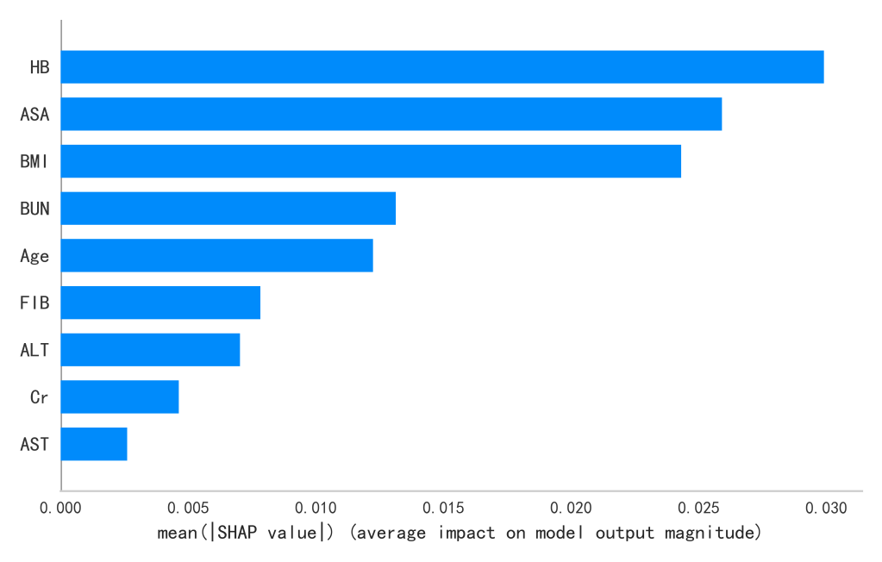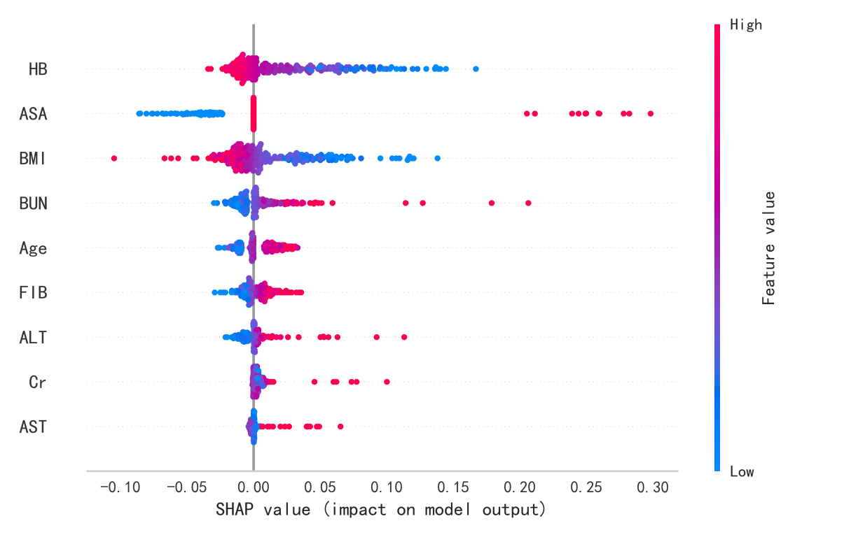

【下面是第二种方法，手动写代码的结果】

手动建立SL模型

具体建立流程如下：第一层模型包括：，XGBoost, AdaBoost, RF, GBDT, GNB, CNB, Logistic，数据集样本数总计1263 例，其中
类别(0)：N=1051例
类别(1)：N=212例
训练集样本数总计1010 例，其中
类别(0)：N=838例
类别(1)：N=172例
第二层通过第一层的5折交叉验证训练出5个弱分类器，并对验证集进行预测，再采用logistic模型对其进行训练建模，其在测试集中的: AUC=0.651，最终建立的SL模型在测试集中的AUC值为：0.651
其分析的相关结果如下。
训练集各项指标：

分类模型 | AUC(95%CI) | cutoff(95%CI) | 准确度(95%CI) | 灵敏度(95%CI) | 特异度(95%CI) | 阳性预测值(95%CI) | 阴性预测值(95%CI) | F1分数(95%CI) | Kappa(95%CI)
XGBoost | 0.770 (0.729-0.811) | 0.170 (0.159-0.181) | 0.681 (0.658-0.704) | 0.762 (0.722-0.802) | 0.666 (0.630-0.703) | 0.318 (0.305-0.330) | 0.930 (0.922-0.937) | 0.447 (0.442-0.453) | 0.271 (0.258-0.285)
AdaBoost | 0.625 (0.588-0.663) | 0.434 (0.237-0.631) | 0.831 (0.829-0.833) | 0.433 (0.143-0.723) | 0.795 (0.576-1.013) | 0.527 (NaN-NaN) | 0.838 (0.827-0.849) | 0.633 (NaN-NaN) | 0.078 (-0.016-0.172)
RF | 0.707 (0.663-0.752) | 0.185 (0.176-0.195) | 0.787 (0.706-0.869) | 0.681 (0.554-0.809) | 0.642 (0.511-0.772) | 0.471 (0.354-0.587) | 0.874 (0.849-0.899) | 0.537 (0.458-0.617) | 0.242 (0.213-0.271)
GBDT | 0.731 (0.688-0.773) | 0.177 (0.172-0.183) | 0.738 (0.667-0.809) | 0.733 (0.594-0.871) | 0.635 (0.518-0.753) | 0.355 (0.303-0.406) | 0.894 (0.871-0.918) | 0.467 (0.429-0.506) | 0.258 (0.223-0.292)
GNB | 0.712 (0.668-0.756) | 0.033 (0.003-0.064) | 0.651 (0.626-0.676) | 0.703 (0.671-0.736) | 0.642 (0.606-0.678) | 0.286 (0.274-0.299) | 0.912 (0.906-0.917) | 0.406 (0.395-0.418) | 0.216 (0.197-0.235)
CNB | 0.655 (0.605-0.705) | 0.344 (0.097-0.591) | 0.671 (0.631-0.711) | 0.551 (0.462-0.640) | 0.697 (0.631-0.764) | 0.273 (0.254-0.292) | 0.883 (0.873-0.893) | 0.360 (0.348-0.373) | 0.172 (0.160-0.184)
Logistic | 0.733 (0.685-0.781) | 0.211 (0.176-0.245) | 0.729 (0.686-0.772) | 0.622 (0.558-0.687) | 0.753 (0.688-0.818) | 0.347 (0.303-0.392) | 0.906 (0.899-0.913) | 0.440 (0.424-0.457) | 0.281 (0.246-0.317)

验证集各项指标：
分类模型 | AUC(95%CI) | cutoff(95%CI) | 准确度(95%CI) | 灵敏度(95%CI) | 特异度(95%CI) | 阳性预测值(95%CI) | 阴性预测值(95%CI) | F1分数(95%CI) | Kappa(95%CI)
XGBoost | 0.725 (0.636-0.814) | 0.170 (0.159-0.181) | 0.665 (0.638-0.692) | 0.756 (0.695-0.818) | 0.652 (0.598-0.705) | 0.297 (0.278-0.315) | 0.914 (0.907-0.921) | 0.426 (0.402-0.449) | 0.232 (0.203-0.261)
AdaBoost | 0.607 (0.531-0.682) | 0.434 (0.237-0.631) | 0.841 (0.829-0.852) | 0.391 (0.107-0.675) | 0.782 (0.565-0.999) | 0.759 (NaN-NaN) | 0.843 (0.829-0.856) | 0.750 (NaN-NaN) | 0.118 (-0.026-0.262)
RF | 0.669 (0.579-0.759) | 0.185 (0.176-0.195) | 0.791 (0.729-0.853) | 0.729 (0.566-0.891) | 0.553 (0.387-0.719) | 0.433 (0.288-0.579) | 0.870 (0.838-0.902) | 0.510 (0.436-0.583) | 0.212 (0.132-0.293)
GBDT | 0.628 (0.535-0.720) | 0.177 (0.172-0.183) | 0.689 (0.628-0.750) | 0.756 (0.665-0.846) | 0.493 (0.464-0.522) | 0.242 (0.209-0.274) | 0.861 (0.831-0.891) | 0.365 (0.321-0.408) | 0.103 (0.056-0.151)
GNB | 0.685 (0.593-0.777) | 0.033 (0.003-0.064) | 0.641 (0.626-0.656) | 0.743 (0.642-0.844) | 0.614 (0.508-0.721) | 0.272 (0.243-0.300) | 0.904 (0.876-0.933) | 0.396 (0.357-0.436) | 0.191 (0.133-0.248)
CNB | 0.644 (0.545-0.743) | 0.344 (0.097-0.591) | 0.658 (0.595-0.722) | 0.663 (0.449-0.877) | 0.611 (0.417-0.805) | 0.262 (0.215-0.308) | 0.873 (0.855-0.891) | 0.368 (0.305-0.430) | 0.147 (0.086-0.208)
Logistic | 0.713 (0.613-0.812) | 0.211 (0.176-0.245) | 0.715 (0.664-0.766) | 0.651 (0.580-0.722) | 0.740 (0.678-0.801) | 0.328 (0.278-0.378) | 0.896 (0.888-0.903) | 0.433 (0.387-0.479) | 0.245 (0.210-0.280)

模型在测试集各项指标如下：

AUC | cutoff | 准确度 | 灵敏度 | 特异度 | 阳性预测值 | 阴性预测值 | F1分数 | Kappa
0.651 | 0.156 | 0.625 | 0.600 | 0.634 | 0.228 | 0.888 | 0.330 | 0.129
SL模型在训练集各项指标如下：
 | AUC(95%CI) | cutoff(95%CI) | 准确度(95%CI) | 灵敏度(95%CI) | 特异度(95%CI) | 阳性预测值(95%CI) | 阴性预测值(95%CI) | F1分数(95%CI)
SL | 0.776(0.734-0.818) | 0.156(0.139-0.173) | 0.692(0.648-0.736) | 0.759(0.695-0.823) | 0.680(0.614-0.745) | 0.330(0.301-0.359) | 0.931(0.920-0.942) | 0.457(0.439-0.475)

SL模型在验证集各项指标如下：

 | AUC(95%CI) | cutoff(95%CI) | 准确度(95%CI) | 灵敏度(95%CI) | 特异度(95%CI) | 阳性预测值(95%CI) | 阴性预测值(95%CI) | F1分数(95%CI)
SL | 0.744(0.653-0.834) | 0.152(0.131-0.173) | 0.673(0.602-0.745) | 0.768(0.718-0.818) | 0.660(0.572-0.748) | 0.320(0.254-0.387) | 0.924(0.908-0.940) | 0.447(0.386-0.509)

模型权重表
模型 | 权重系数
XGBoost | 2.169
AdaBoost | 1.350
RF | 1.558
GBDT | -0.018
GNB | -0.100
CNB | 0.286
Logistic | 1.932
图形如下：
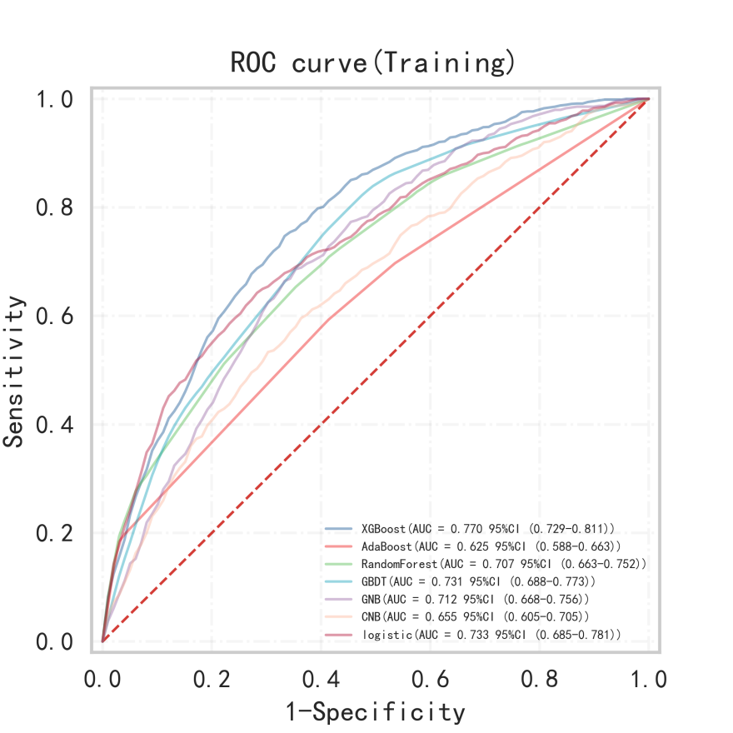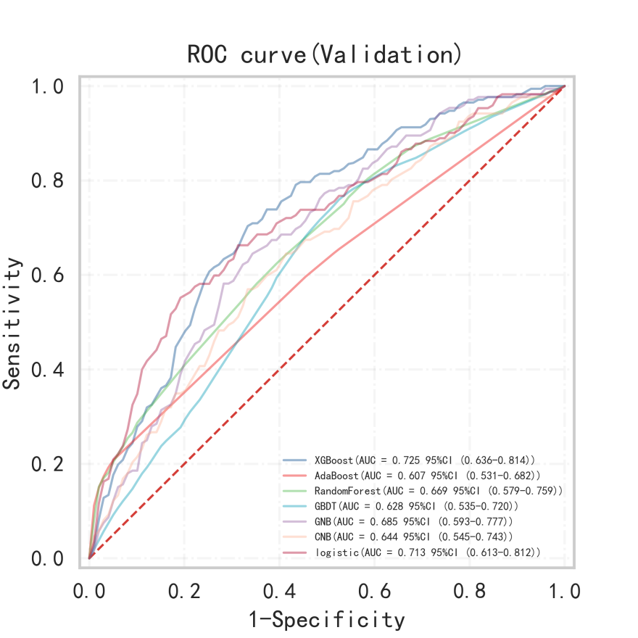
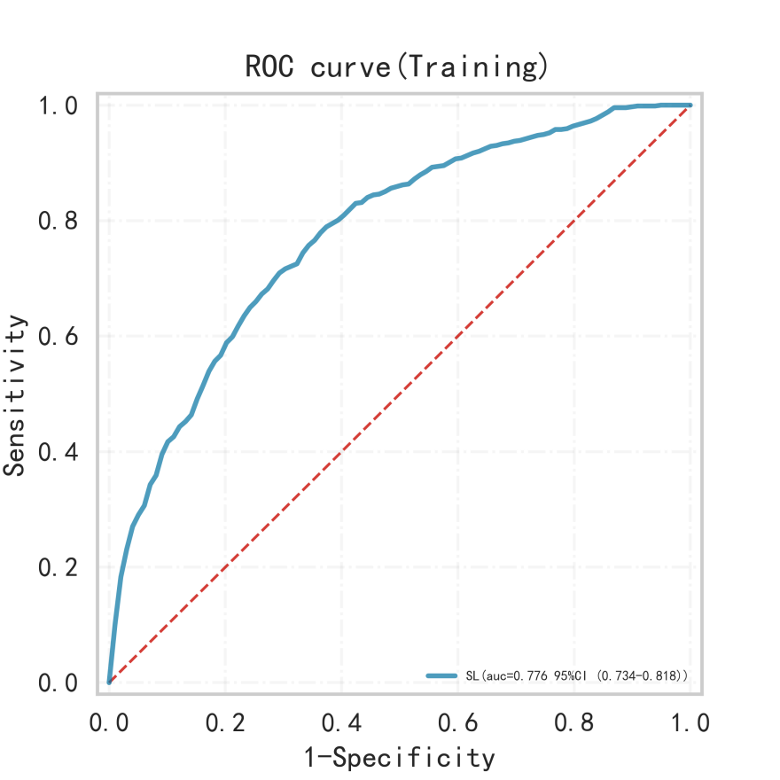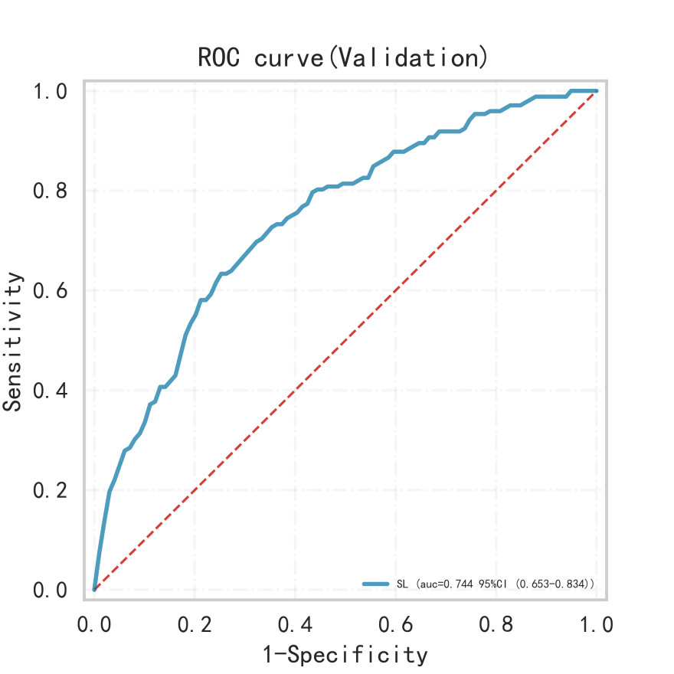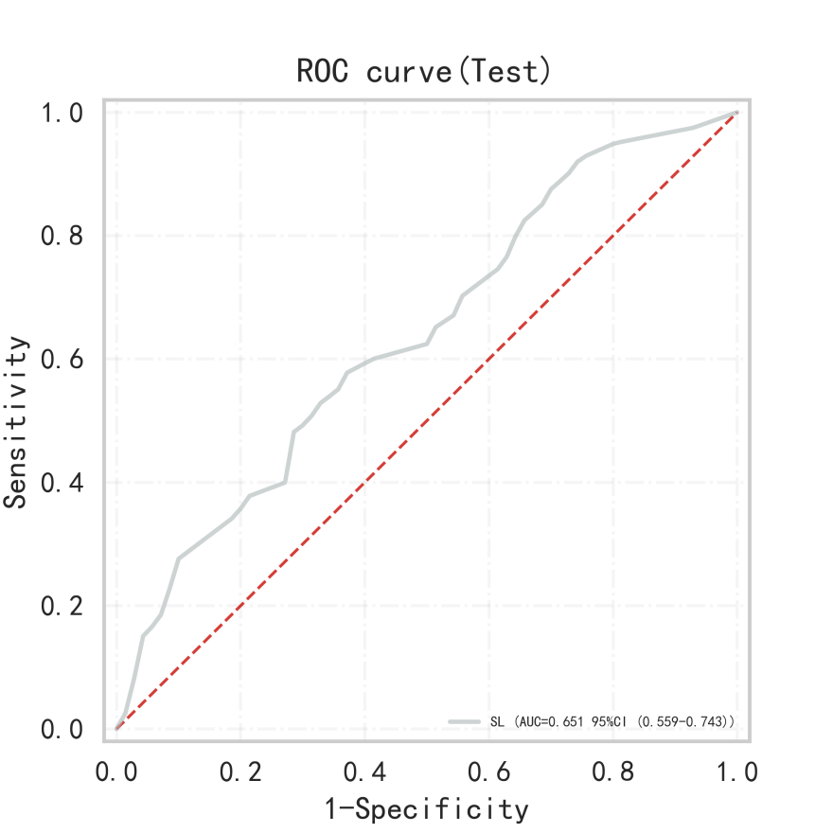
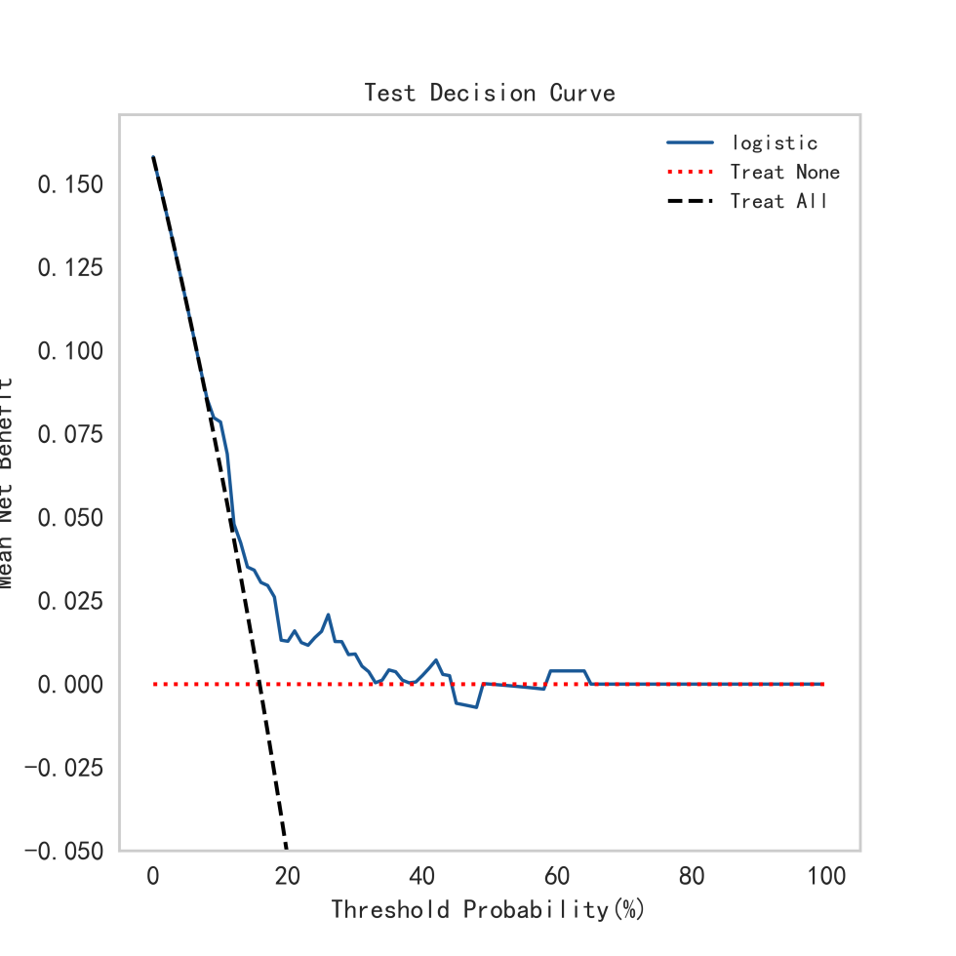

附件1：单因素分析表
name | N | OR | 95%CI | P-value
Age | 1263 | 1.098 | [1.074,1.123] | 0.000
BMI | 1263 | 0.929 | [0.89,0.97] | 0.001
T1 | 1263 | 1.002 | [1.0,1.003] | 0.015
T2 | 1263 | 1.001 | [0.998,1.004] | 0.666
L1 | 1263 | 0.993 | [0.945,1.043] | 0.772
WBC | 1263 | 1.003 | [0.951,1.057] | 0.924
Neut | 1263 | 1.028 | [0.973,1.087] | 0.320
Lymph | 1263 | 0.677 | [0.498,0.92] | 0.013
Mono | 1263 | 1.477 | [0.861,2.535] | 0.157
HB | 1263 | 0.980 | [0.973,0.988] | 0.000
RBC | 1263 | 0.624 | [0.501,0.779] | 0.000
FDP | 1263 | 0.996 | [0.991,1.0] | 0.079
PT | 1263 | 1.007 | [0.913,1.11] | 0.895
APTT | 1263 | 1.033 | [1.012,1.056] | 0.003
FIB | 1263 | 1.238 | [1.091,1.406] | 0.001
TT | 1263 | 0.984 | [0.914,1.058] | 0.662
Ddimer | 1263 | 0.991 | [0.979,1.003] | 0.141
ALT | 1263 | 1.007 | [0.999,1.015] | 0.096
AST | 1263 | 1.010 | [0.999,1.021] | 0.082
GLB | 1263 | 1.006 | [0.975,1.038] | 0.707
ALB | 1263 | 0.925 | [0.895,0.955] | 0.000
CB | 1263 | 1.041 | [1.01,1.074] | 0.009
UCB | 1263 | 0.999 | [0.979,1.018] | 0.895
BUN | 1263 | 1.102 | [1.062,1.144] | 0.000
Cr | 1263 | 1.003 | [1.001,1.006] | 0.006
UA | 1263 | 1.000 | [0.998,1.002] | 0.891
D1 | 1263 | 0.998 | [0.994,1.001] | 0.249
D2 | 1263 | 1.000 | [0.998,1.003] | 0.897
Bloodloss | 1263 | 0.999 | [0.999,1.0] | 0.179
Sex
1 | 430
2 | 833 | 0.664 | [0.491,0.898] | 0.008
H1
0 | 1191
1 | 72 | 1.450 | [0.815,2.581] | 0.206
H2
0 | 1234
1 | 29 | 1.923 | [0.840,4.402] | 0.122
Fracture_type
1 | 700
2 | 360 | 1.640 | [1.182,2.276] | 0.003
3 | 203 | 1.151 | [0.750,1.767] | 0.519
Fracture_side
1 | 662
2 | 601 | 0.958 | [0.713,1.288] | 0.777
Hypertension
0 | 625
1 | 638 | 1.068 | [0.795,1.435] | 0.661
Diabetes
0 | 1015
1 | 248 | 1.165 | [0.812,1.671] | 0.408
Osteoporosis
0 | 608
1 | 655 | 1.048 | [0.780,1.408] | 0.757
Osteoarthritis
0 | 1203
1 | 60 | 1.119 | [0.572,2.190] | 0.742
Atrial_fibrillation
0 | 1189
1 | 74 | 1.398 | [0.787,2.482] | 0.253
Cerebral_infarction
0 | 1055
1 | 208 | 1.744 | [1.218,2.499] | 0.002
CAD
0 | 1003
1 | 260 | 1.402 | [0.993,1.978] | 0.055
COPD
0 | 1236
1 | 27 | 2.544 | [1.127,5.743] | 0.025
Thyroid_disorder
0 | 1246
1 | 17 | 1.536 | [0.496,4.756] | 0.457
Dementia
0 | 1213
1 | 50 | 2.689 | [1.469,4.924] | 0.001
DVT
0 | 808
1 | 455 | 1.920 | [1.425,2.588] | 0.000
ASA
2 | 481
3 | 715 | 3.258 | [2.197,4.832] | 0.000
4 | 67 | 15.268 | [8.434,27.638] | 0.000
Type_of_surgery
1 | 618
2 | 204 | 0.323 | [0.184,0.566] | 0.000
3 | 441 | 0.833 | [0.606,1.145] | 0.260
Anaesthesia
1 | 796
2 | 467 | 1.319 | [0.977,1.780] | 0.071
Bloodtransfusion
0 | 972
1 | 291 | 1.526 | [1.098,2.121] | 0.012

