PRACTICAL EXAMINATION 01
Subject code: FER202 - SPRING 2026
Duration: 85 minutes
You are required to build a Student Feedback & Course Review web application where a user must first log in, and then can add, edit, delete course feedback, view average ratings, and filter feedback by course name. You must use ReactJS (functional components), React Router, Redux Toolkit, Hooks, Bootstrap or React Bootstrap, Axios, and JSON Server to design the UI according to the given requirements.
Note:
- Students are allowed to use resources stored on their computers but are not allowed to use the Internet during the test (except for submitting the exam).
- If identical test results are detected, the students’ work will receive a score of zero.
- If the code does not run or does not use db.json in Given folder, the students’ work will receive a score of zero.
- Students will receive fully 10 marks if they use Redux Toolkit or useContext combined with useReducer; otherwise they get 9 marks.
- Submit a folder containing your project (excluding node_modules) and a readme.txt (listing installed packages and how to run, if applicable).
Questions
- Create a React application named fer202-01
- Setup JSON Server (1 mark)
- Copy a file named db.json in Given folder to initialize a virtual server using JSON Server
- Project structure (0.5 mark)
- Organize the source into meaningful folders: components, pages, contexts, services, routes…
- Authentication (2.5 marks)
- /login page with username and password fields (0.5 mark).

DE190984 Nguyễn Đào Văn Quý

Validate that both fields are not empty (0.25 mark).
Display an error message (e.g., "Email and password are required") if the user tries to submit an empty form (0.25 mark)
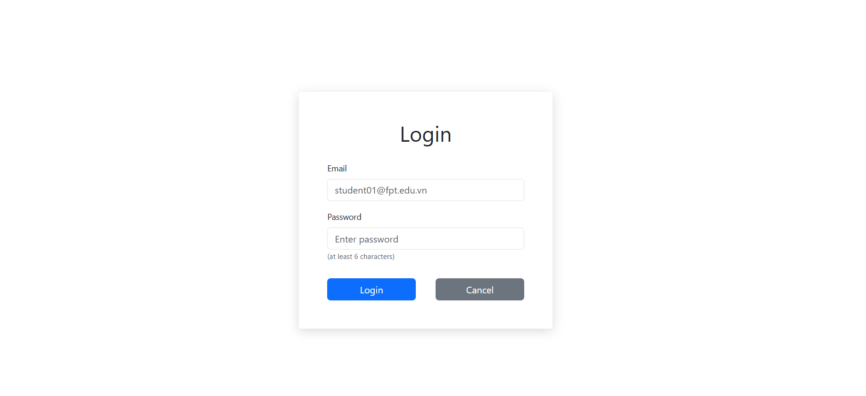
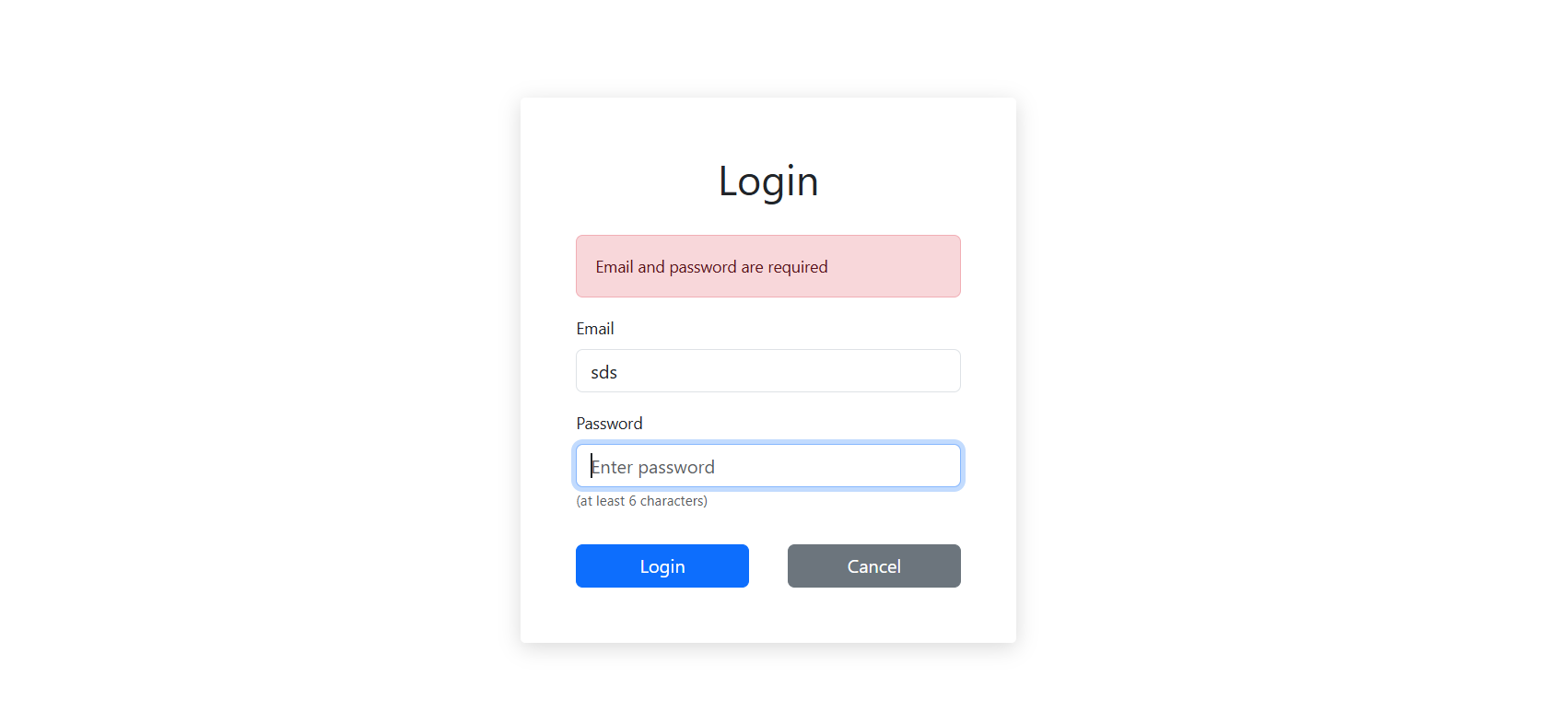
Optionally, Email must has ‘@’ (e.g., student01@fpt.edu.vn) (0.5 mark)
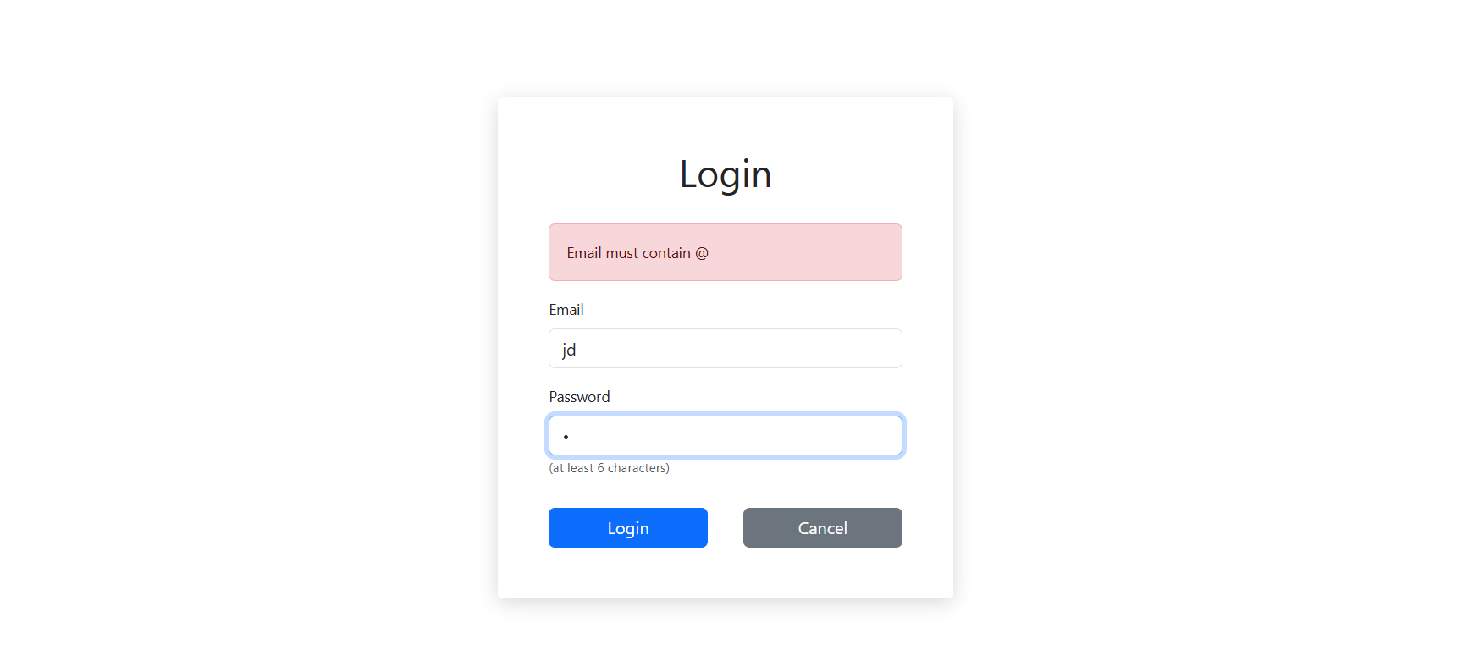
- On success: redirect to /home (1 mark)
- Call router successfully: /home (0.5 mark)
- Feedback Dashboard (6 marks)
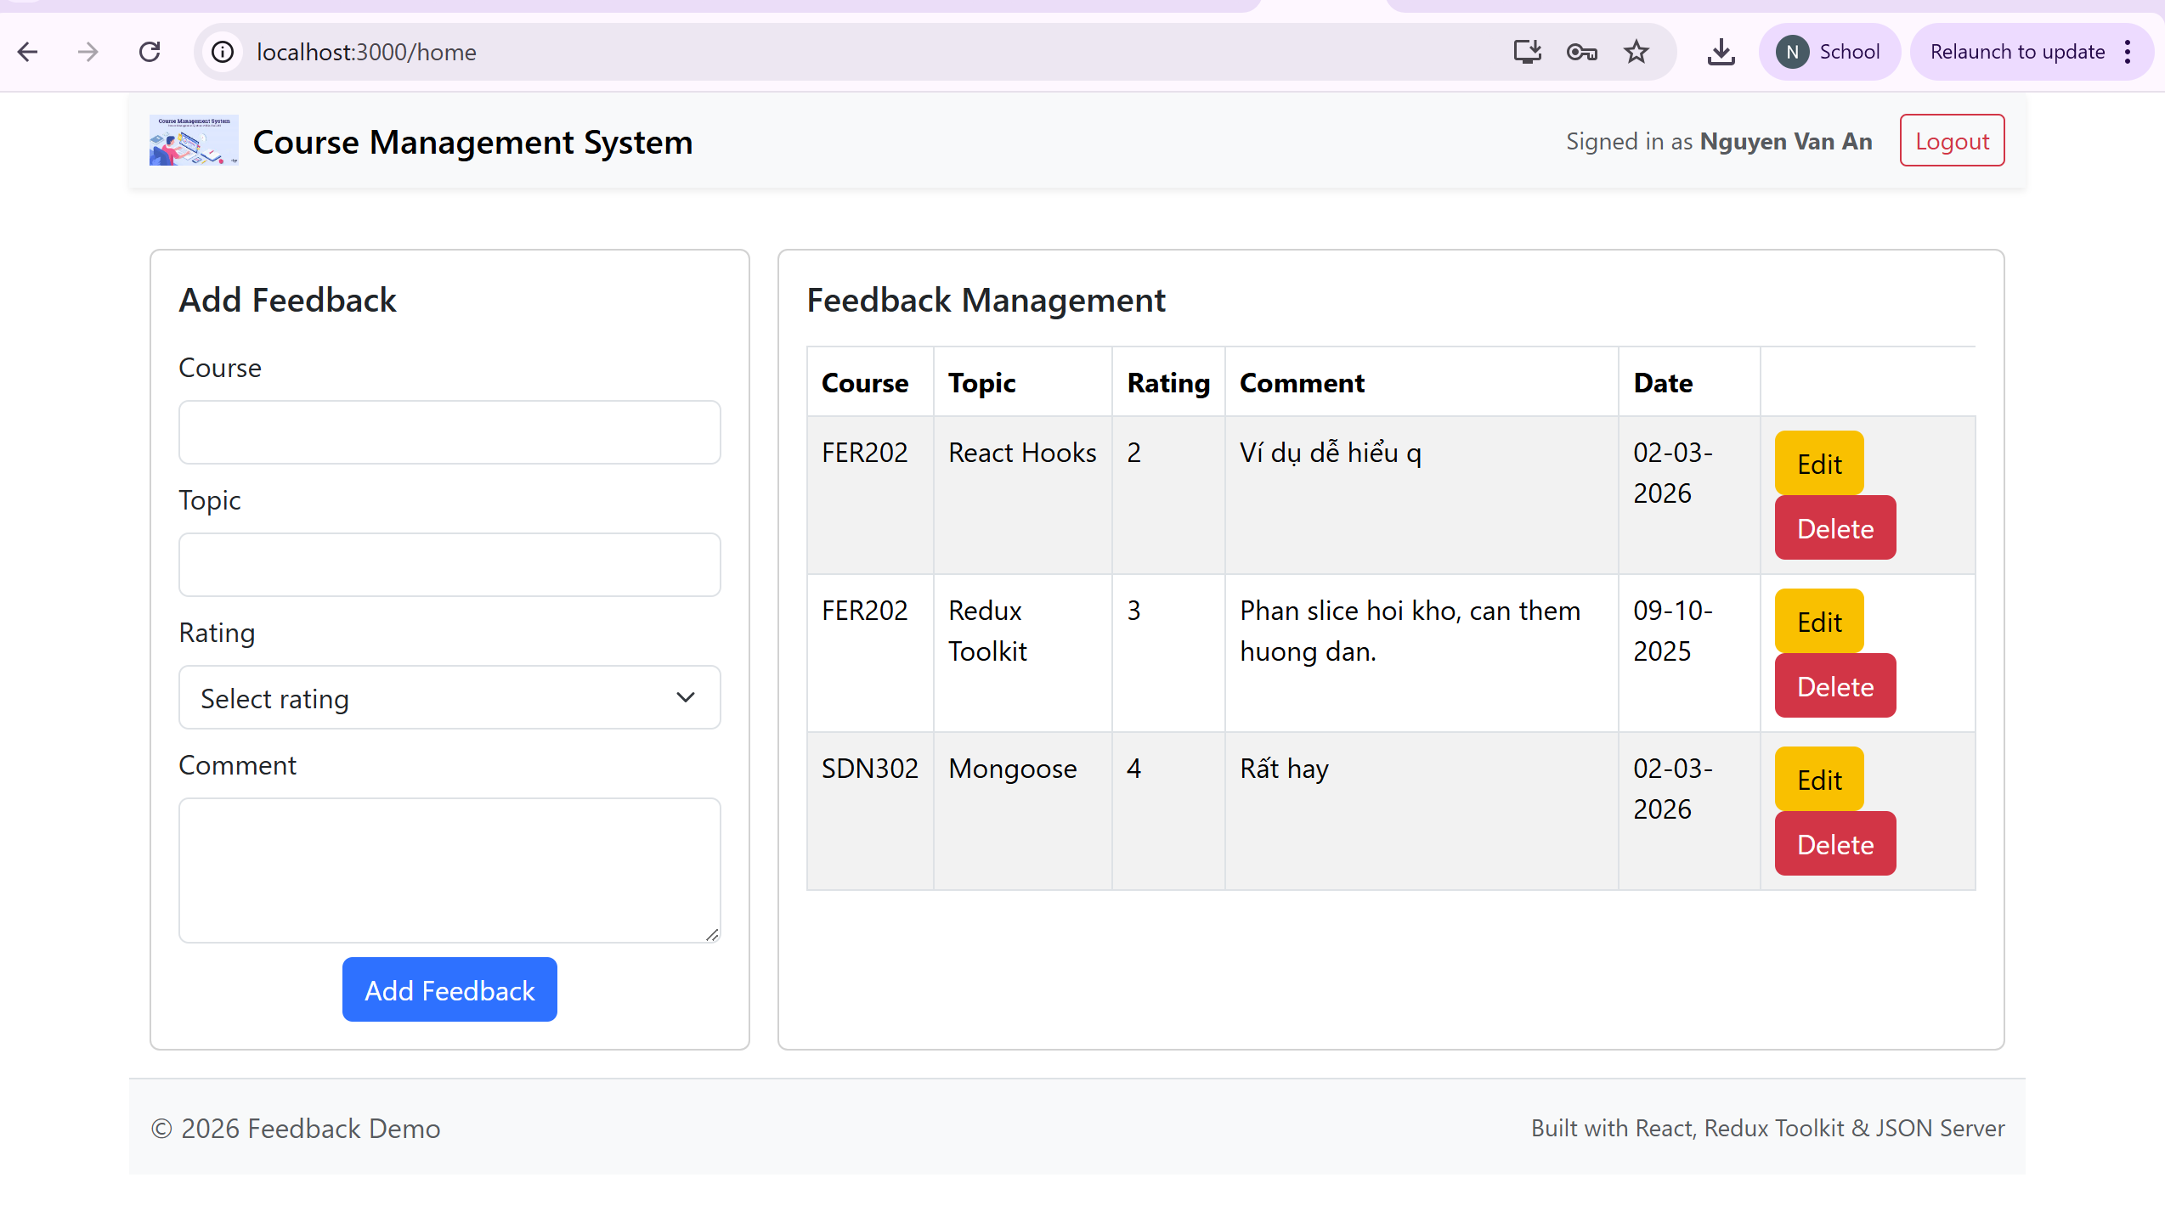
UI Components
Header (navbar) (1 mark)
- Left side: Application named Couse Management System with logo.
- Right side: Text “Signed in as <FullName>” and a Logout button (redirects to /login and clears token/state).
Card: Add Feedback (Form) (0.5 mark)
- Input fields: Course (text), Topic(number), Rating (number from 1 to 5), Comment (text) Date (get current day), Button: Add feedback
Card: Feedback Management of user (Table) (0.5 mark)
- Columns: Course | Topic | Rating | Comment | Date
Footer (0.5 mark)
- Real-time Feedback Operations (3.5 marks)
- List Feedbacks (1 mark)
List feedbacks for current user (0.5 mark)
Date is displayed in DD-MM-YYYY format (as shown in the example) (0.5 mark).

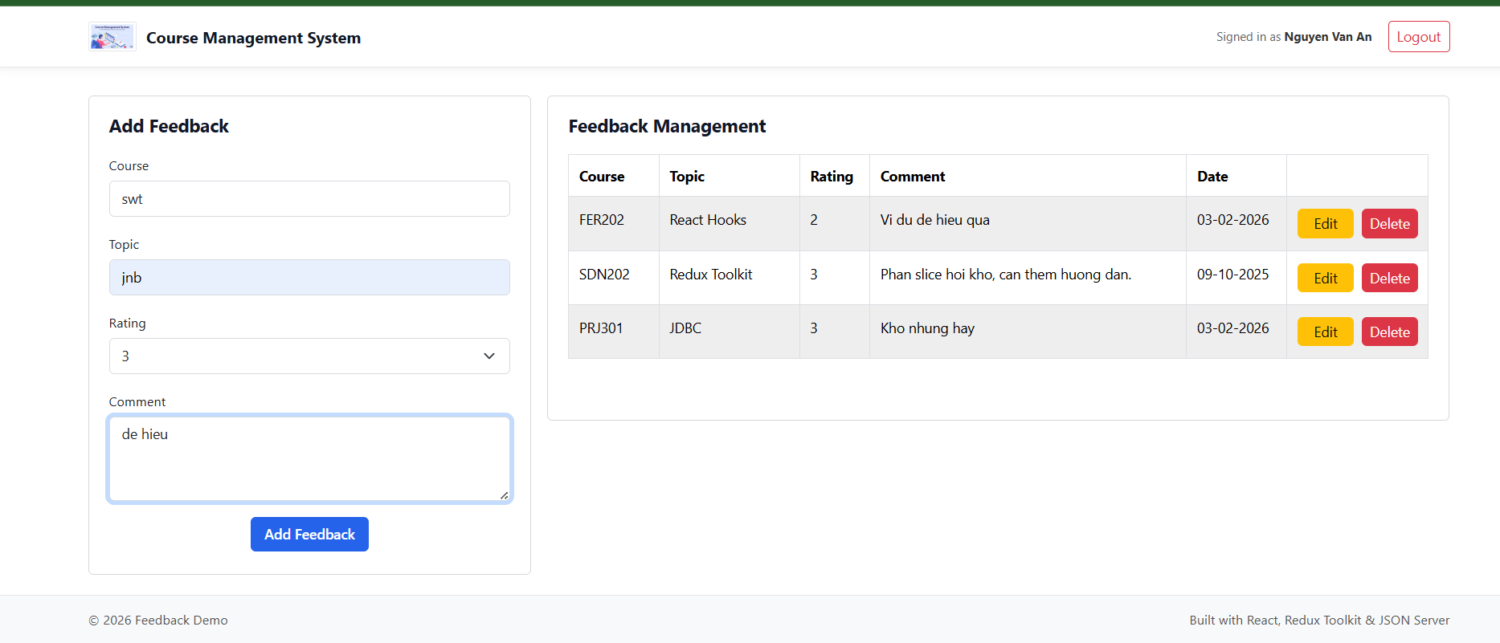

- Add Feedback (1 mark)
Add successfully (0.5 mark)
Validation (0.5 mark):
- Course name not empty
- Rating between 1 and 5

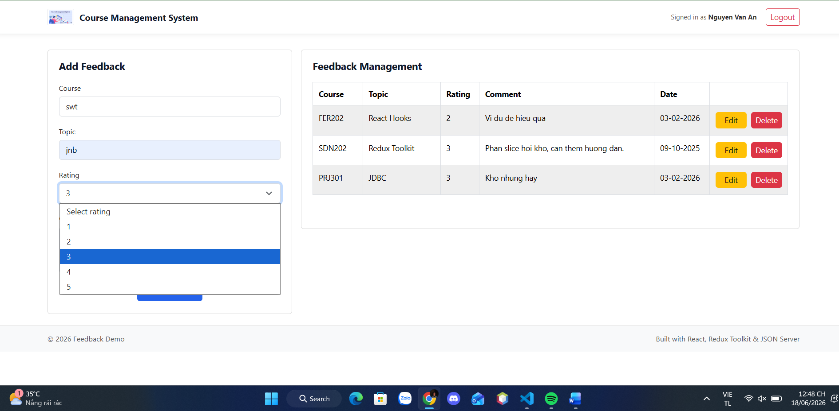
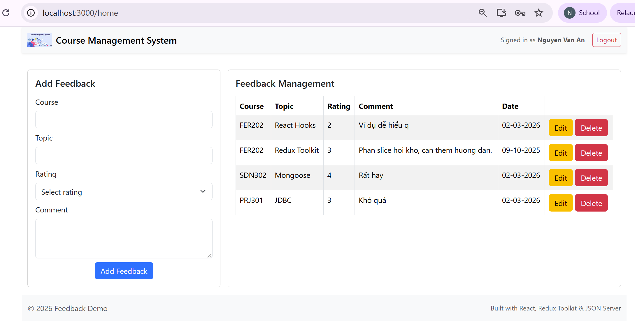
- Edit Feedback (1 mark)

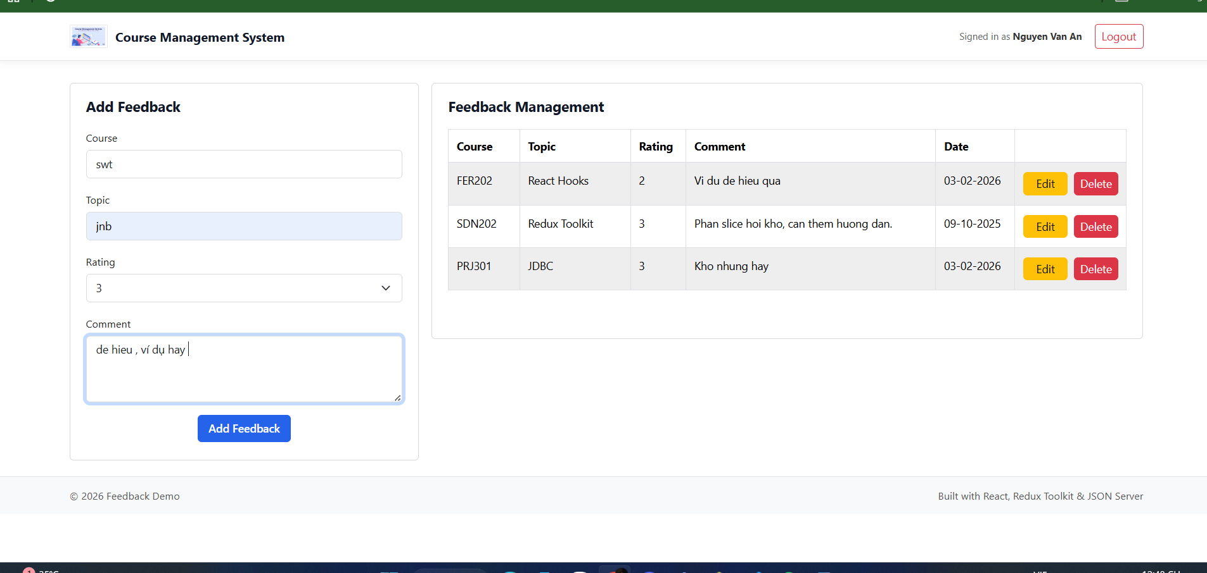
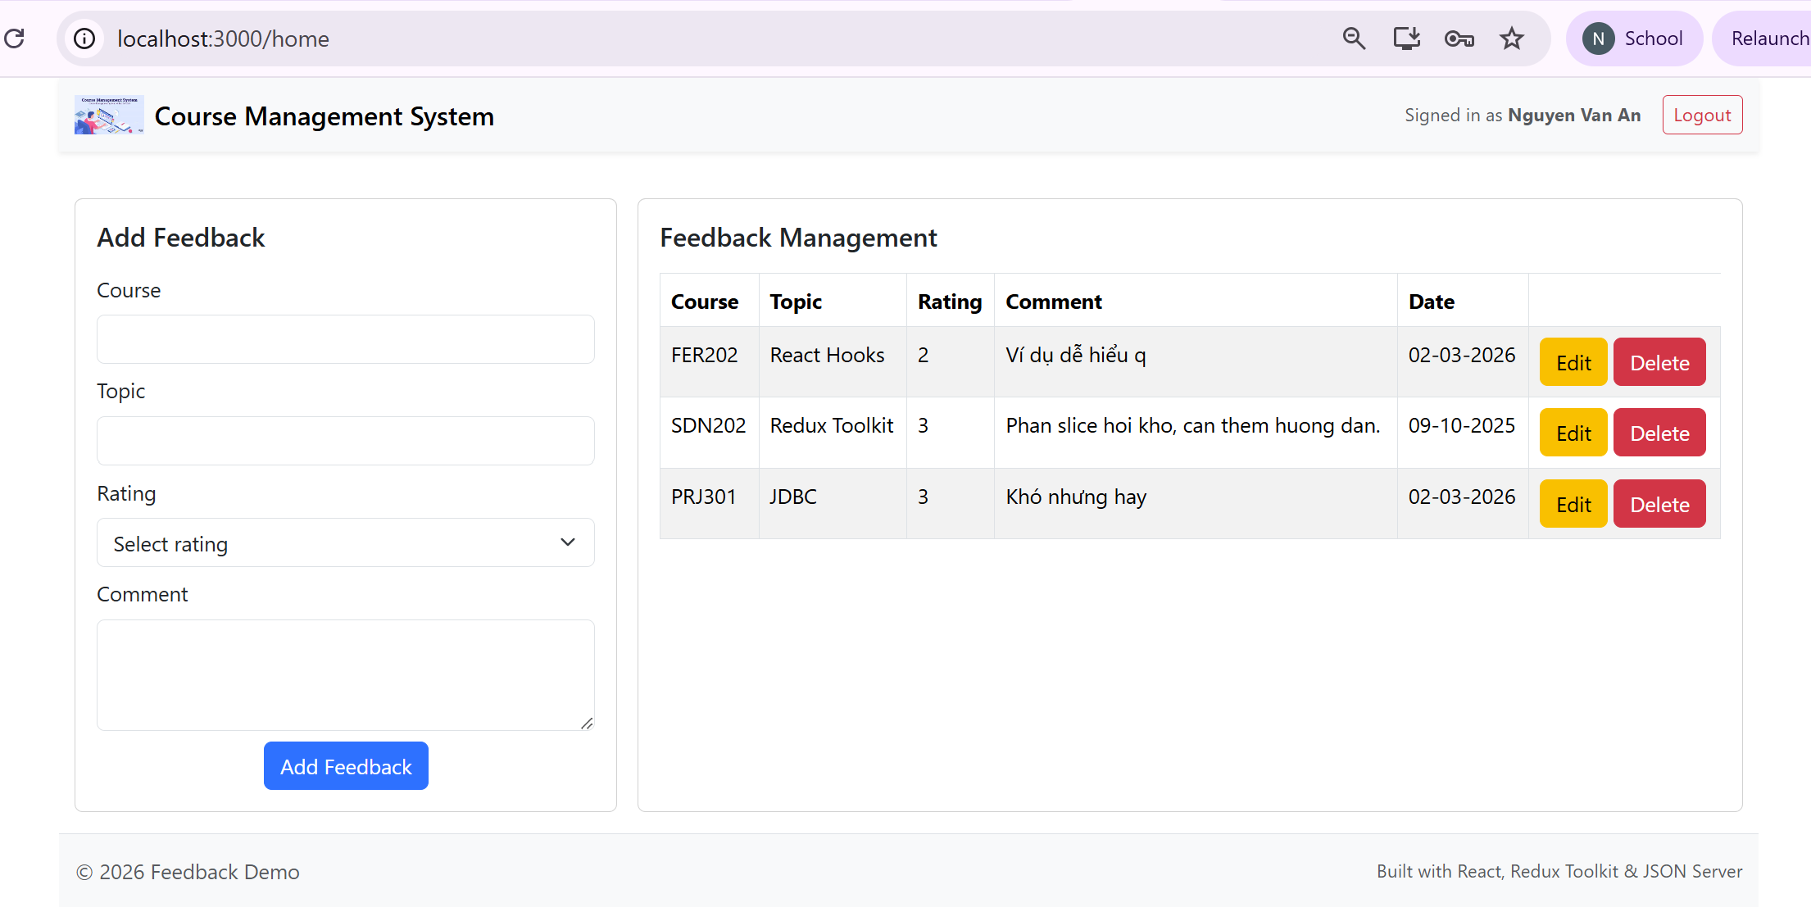

- Delete Feedback (0.5 mark)
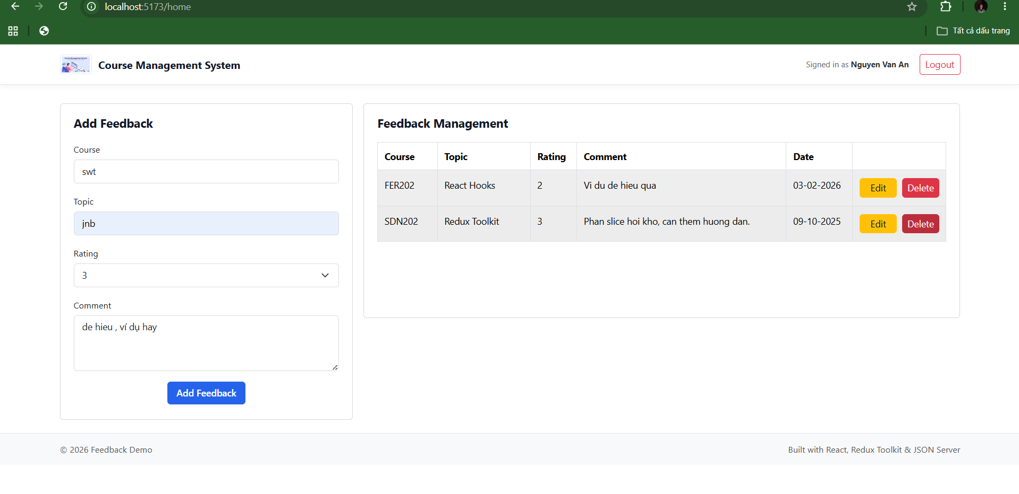

Edit
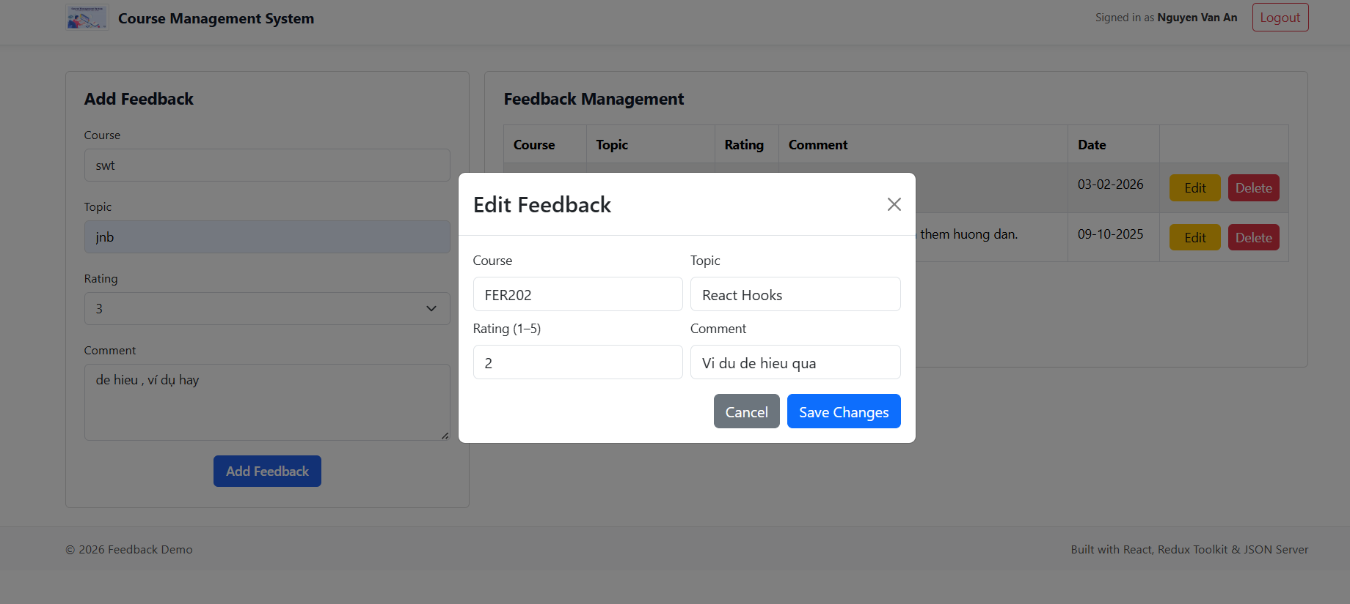

---END---

