02-08-2019

Lion and Tourists
STT | New Words | Pronunciation | Meaning | Ex
1 | Buggy (n) | /ˈbʌɡi/ | 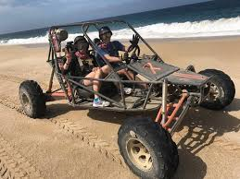 | One lion gets in a buggy.
2 | Lick (v) | /lɪk/ | 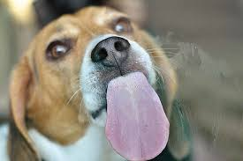 | It licks and cuddles the tourists.
3 | Cuddle (v) | /ˈkʌdl/ |  | It licks and cuddles the tourist.
4 | Release (v) | /rɪˈliːs/ |  | A Safari park in Crimea, Russia released a video showing a lion get in a buggy, cuddle and lick the tourists.
5 | Footage (n) | /ˈfʊtɪdʒ/ |  | Russia released footage
6 | Encounter (n) | /ɪnˈkaʊntə(r)/ |  | Zubkov supervised the encounter.
7 | Maul (v) | /mɔːl/ | 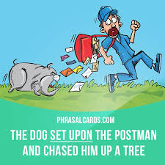 | However, this come just week after a different lion mauled a woman in the same park.

