************************ SETUP GUIDE **********************

- Install Tools: you need install tool: "git", "Live-server" and "Json-server"

+ Git: <https://git-scm.com/downloads>

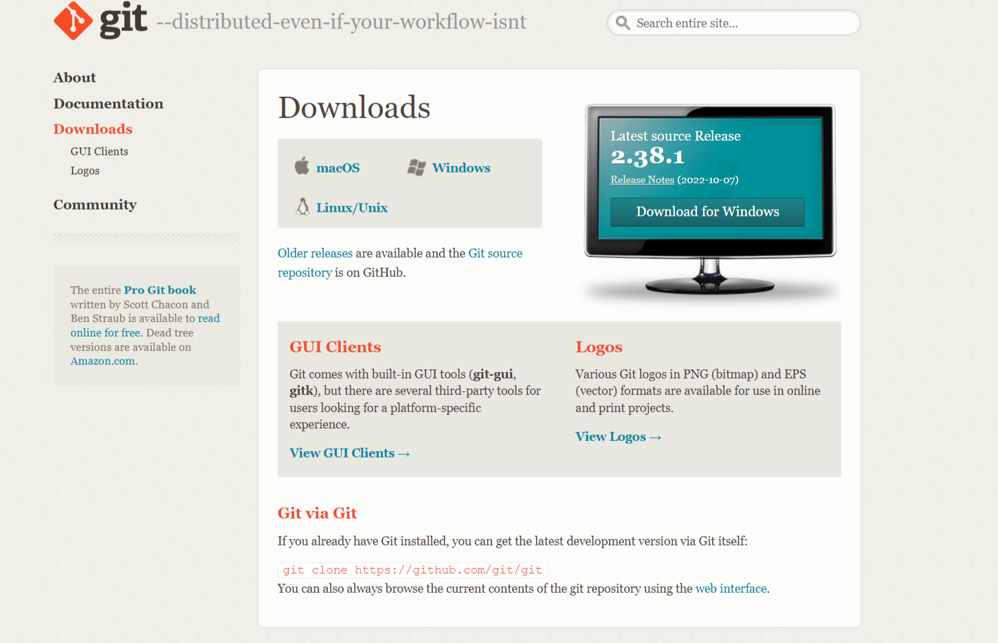

-download according to your operating system

+ live-server: <https://www.npmjs.com/package/live-server>

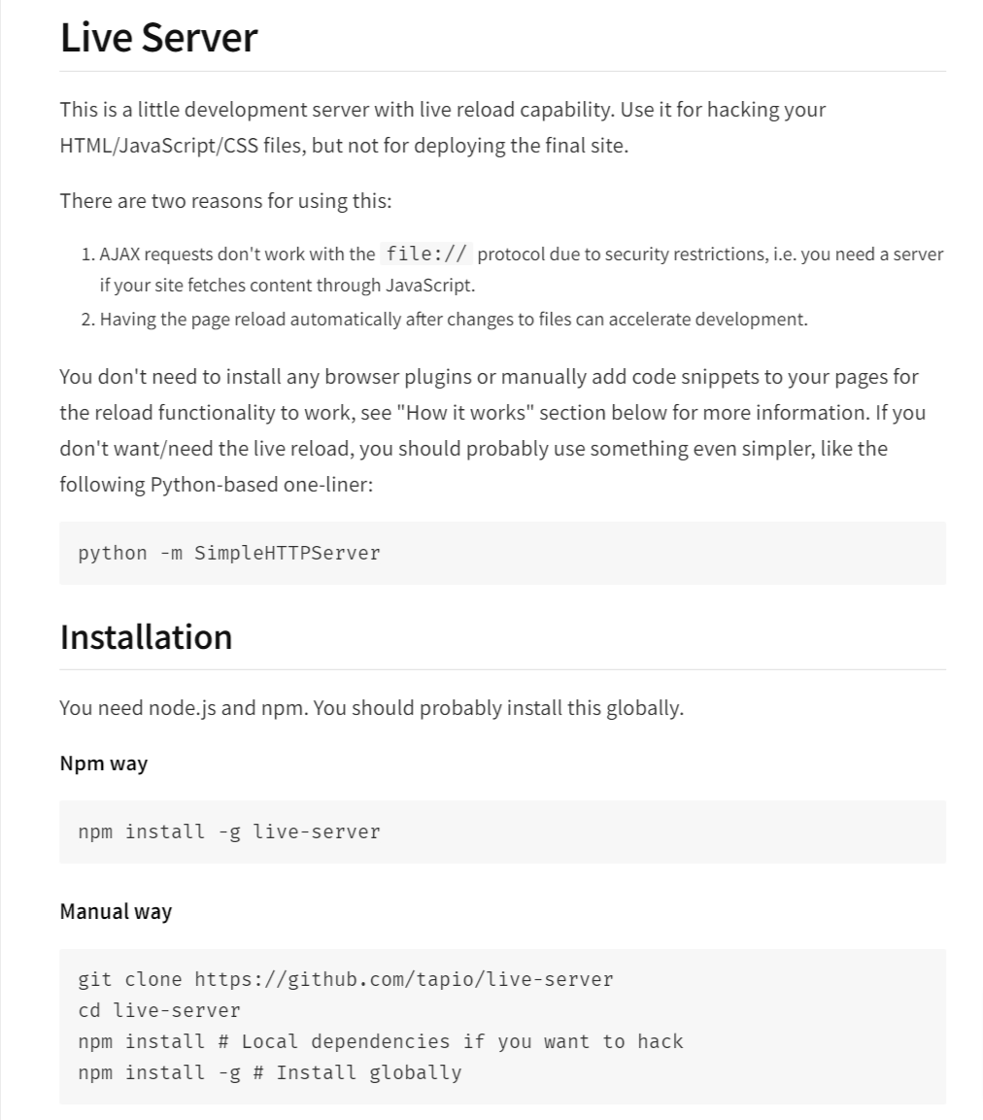

**NOTE: you can use live-server on VSCode**

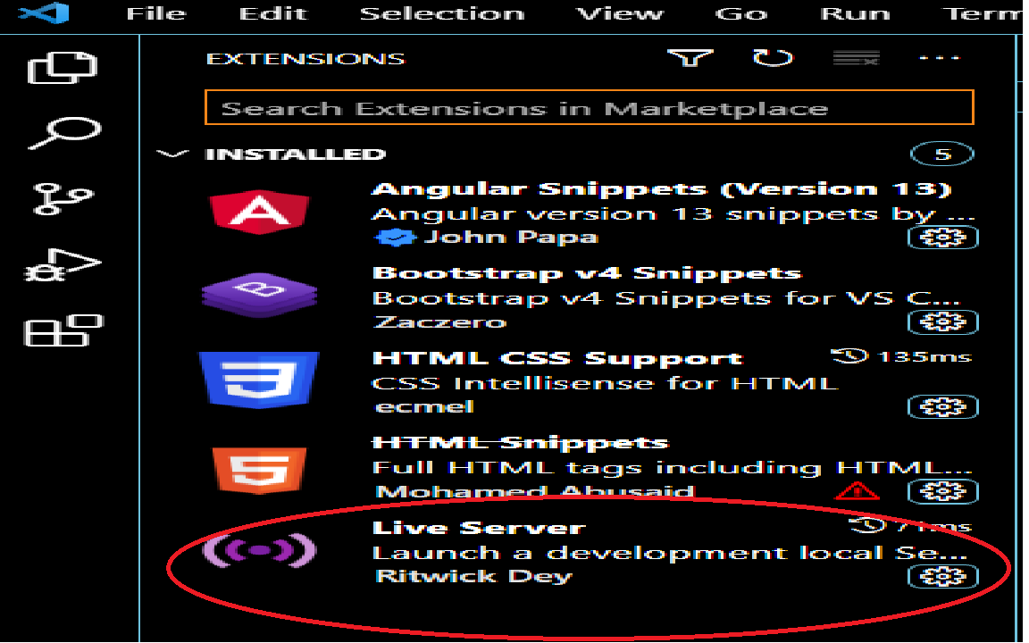

+ json-server: <https://www.npmjs.com/package/json-server>

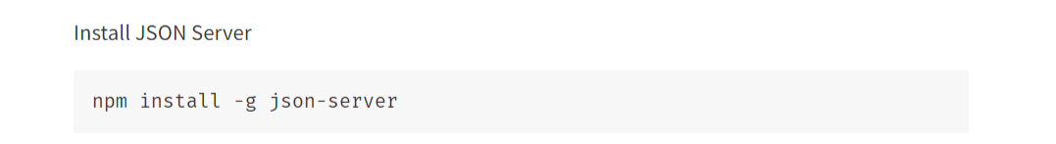

- Setup:

+ live-server:

"cd" or "git bash" in "project" Folder.

write command: "live-server"

+ json-server:

"cd" or "git bash" in "project->server" Folder.

write command: "json-server --watch server.json"

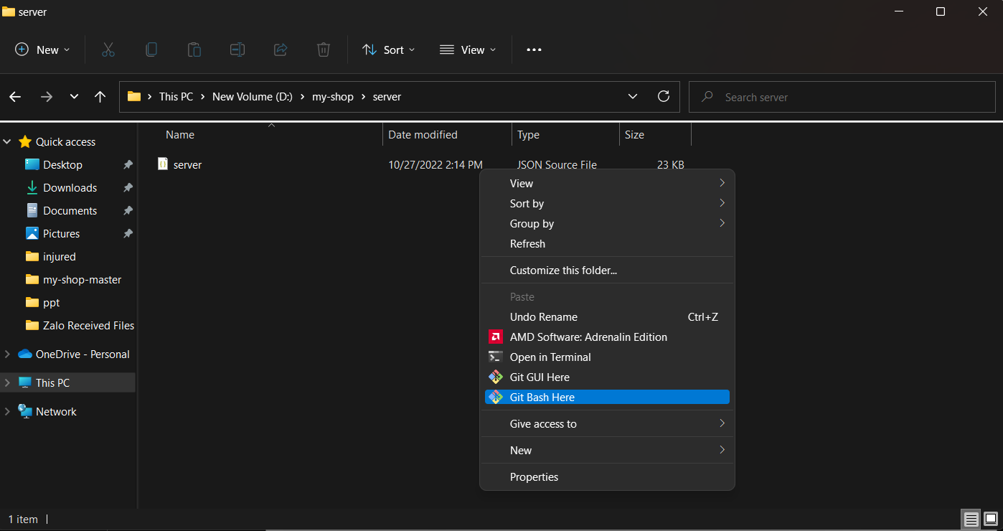

Step 1: Go to file server in folder my-shop, right-click choose “Git Bash Here”

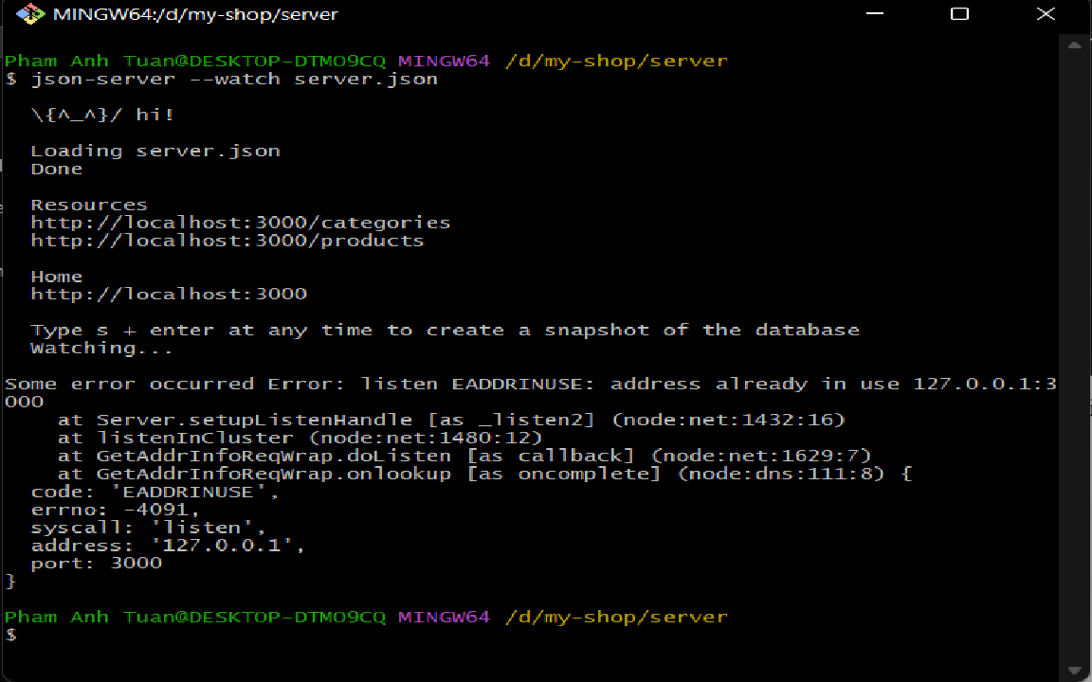

Step 2: Enter command “json-server –watch server.json”

***-Or you can run server on VSCode with Terminal(Ctrl+Shift+`)***

**-step 1: go to file server with command “cd server”**

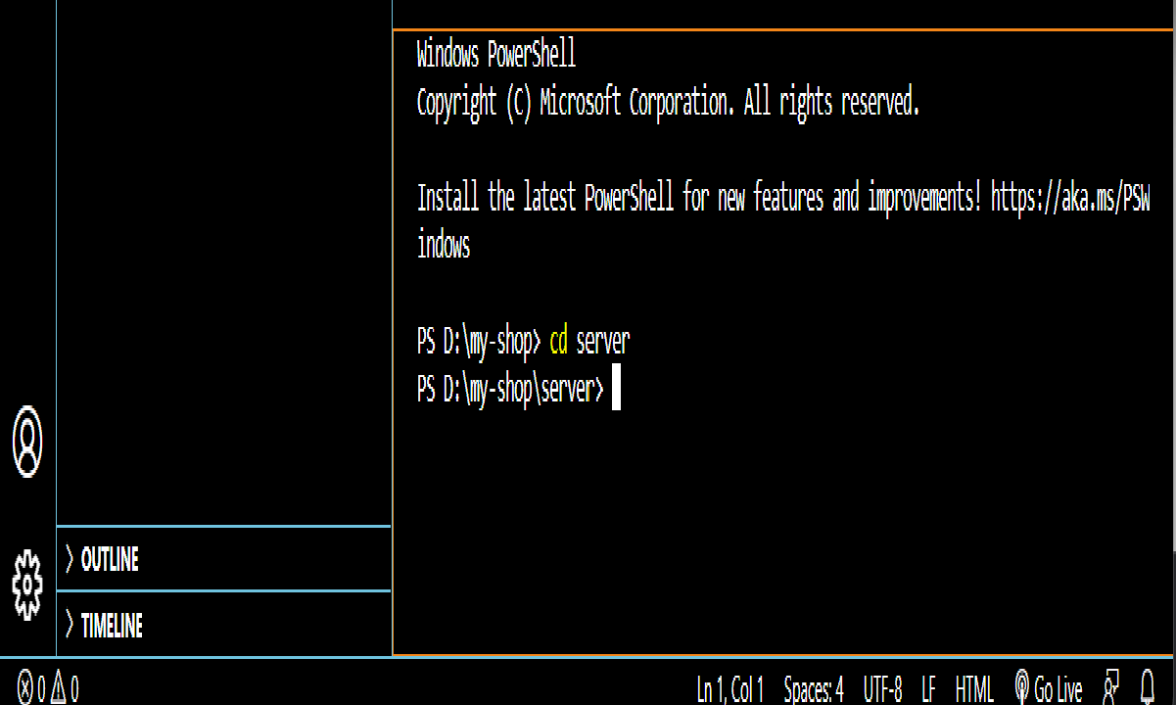

**-Step 2 : Run file server.json with command : "json-server --watch server.json"** 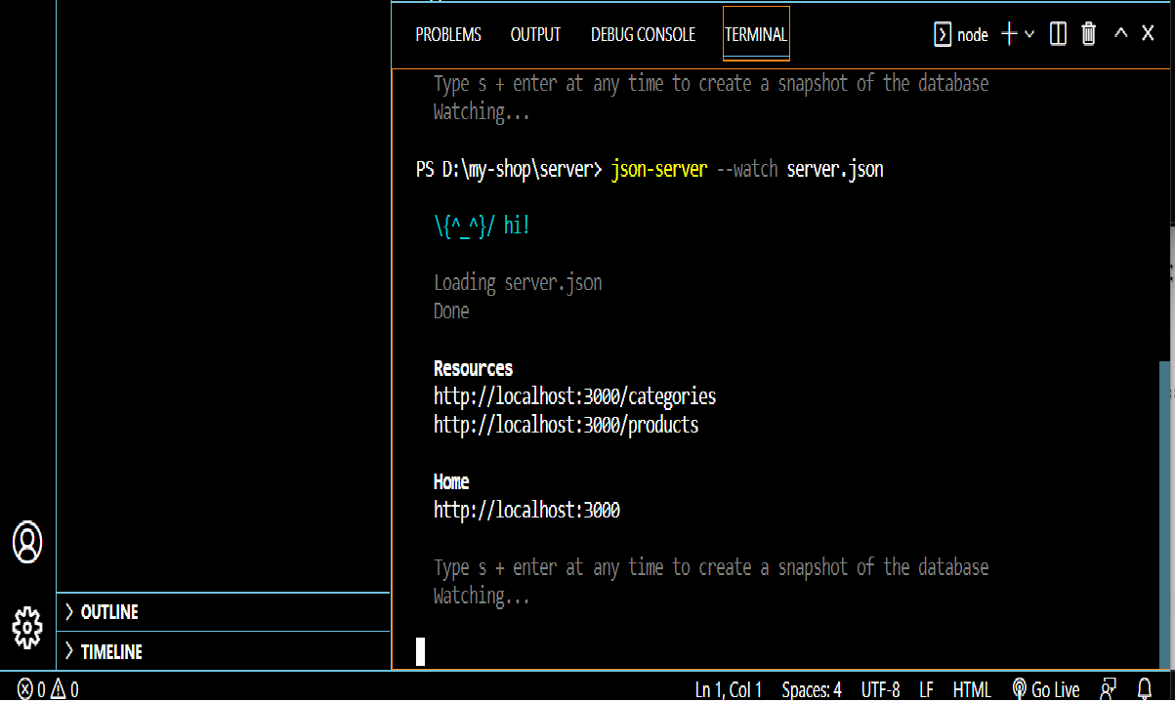

**-Server be run complete.Now,you can “Open with live server file index.html”** 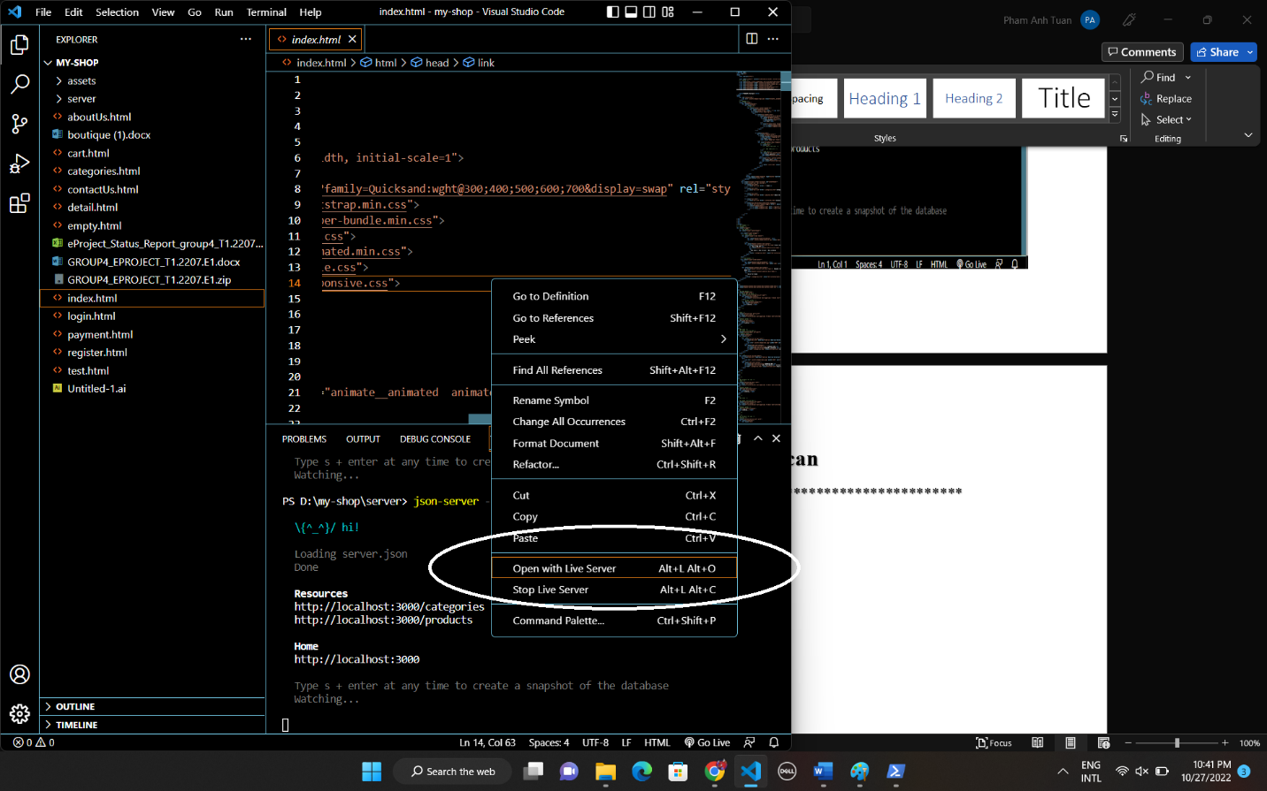

**-This is result:**



******************** END GUIDE **************************