.

**INTERNATIONAL SCHOOL**

**Hotel Management System Project**

**Project Plan**

**Project Code:**

**Document Code: v.1.1**

**Mentor:** MSc. Thuan, Nguyen Trung

**Group:** 6 Team

1. SV 1: Ngô Minh Quyến
2. SV 2: Nguyễn Nhật Hoàng

3. SV 3: Dương Phạm Minh Khoa

4. SV 4: Trần Đức Đại Lộc

**Approved by**

**Project - Mentor:**

Name **Thuan, Nguyen Trung** Signature Date

**PROJECT INFORMATION**

|  |  |  |  |
| --- | --- | --- | --- |
| **Document Title** | Hotel Management | | |
| **Lead Institution** | International School, Duy Tan University | | |
| **Project Mentor** | Msc. Thuan, Nguyen Trung | | |
| **Project Leader & contact details** | Trung, Dang Quang  Email: quangtrung061019@gmail.com  Tel: 0941981831 | | |
| **Partner Organization** |  | | |
| **Project Web URL** |  | | |
| **Team members** | Name | Email | Tel |
| Member, Product Owner | Ngô Minh Quyến | [Bonclay205@gmail.com](mailto:Bonclay205@gmail.com) | 0394565155 |
| Member | Nguyễn Nhật Hoàng | [Hoangzieo@gmail.com](mailto:Hoangzieo@gmail.com) | 0976563935 |
| Member, Scrum master | Dương Phạm Minh Khoa | [Duongphamminhkhoa@gmail.com](mailto:Duongphamminhkhoa@gmail.com) | 0354672843 |
| Member | Trần Đức Đại Lộc | [Tranddloc@gmail.com](mailto:Tranddloc@gmail.com) | 0394238942 |

**SIGNATURE PAGE**

|  |  |  |
| --- | --- | --- |
| AUTHOR: | Ngô Minh Quyến  Scrum master | <Date> 24/11/2024 |
| REVIEWERS: | Nguyễn Nhật Hoàng  Member | <Date>24/11/2024 |
|  |  |  |
|  | Dương Phạm Minh Khoa  Member | <Date>24/11/2024 |
|  | Trần Đức Đại Lộc  Member | <Date>24/11/2024 |

**RECORD OF CHANGE**

*A - Added M - Modified D – Deleted

|  |  |  |  |
| --- | --- | --- | --- |
| **Effective Date** | **Changed Item** | **A* M, D** | **Change Description** |
| 26/08/2025 | Project plan | A | Create Project plan |
| 10/09/2025 | Agile/ Scrum Process | A | Add detail Scrum Process |
| 12/09/2025 | Detail Schedule | M | Update task mission and schedule of sprint |
| 20/09/2025 | Project Milestone & Deliverables | M | Modified target sprint |
| 23/09/2025 | WBS | A | Add WBS |
| 27/09/2025 | WBS | M | Modified WBS |

**Contents**

1. PROJECT OVERVIEW 8

1.1. Project Description 8

1.2. Scope and Purpose 8

1.2.1. Purpose 8

1.2.2. Scope 9

1.3. Project Objectives 9

1.3.1. Standard Objectives 9

1.3.2. Specific Objectives 10

1.4. Project Risk 10

2. PROJECT DEVELOPMENT APPROACH 12

2.1. Technical Process 12

2.1.1. Reasons for selecting 12

2.1.2. Agile Methodology 12

2.1.3. Scrum Process 13

2.2. Quality Management 14

2.2.1. Estimates of Defects to be detected 14

2.2.2. Measurements Program 16

2.3. Unit Testing Strategy 16

2.4. Integration Testing Strategy 17

2.5. System Testing Strategy 17

3. ESTIMATION 18

3.1. Effort 18

3.2. Schedule 19

3.2.1. *Project Milestone & Deliverables* 19

3.2.2. *Detailed Schedule* 20

3.3. Resource 43

3.4. Infrastructure 44

3.5. Training Plan 45

3.6. Finance 46

4. PROJECT ORGANIZATION 46

3.7. Organization Structure 47

3.8. Project Team 48

5. CONFIGURATION MANAGEMENT 55

6. SECURITY ASPECTS 56

7. REFERENCES 56

8. DEFINITIONS AND ACRONYMS 57

# PROJECT OVERVIEW

## Project Description

|  |  |  |  |
| --- | --- | --- | --- |
| **Project code** | CT E-learning | **Contract type** | Internal Contract |
| **Customer** | Dr. Man, Nguyen Duc | **End-user** | Subject teachers, Homeroom teachers,  school leaders, students  parents |
| **Project Type** | Internal Project | **Division** | C2SE.06 Team |
| **Project Category** | Management | **Scrum master** | Ngô Minh Quyến |
| **Application type** | Web application | **Business domain** |  |

## Scope and Purpose

### Purpose

This document provides a summary of the project objectives, tasks, milestones, required resources, overall schedule, and budget allocation. The document is used to build an intelligent and secure hotel management system, ensuring on-time completion, meeting the specified requirements, and adhering to the plan.

### Scope

* Provide solutions to automate hotel operations and optimize resource management while enhancing the overall guest experience, addressing challenges in traditional hotel management processes.
* The focus of the project is to integrate IoT devices for real-time monitoring and predictive analytics to streamline operations, combined with features like personalized guest services through a mobile app to improve customer satisfaction. Meanwhile, management functionalities are included to provide a comprehensive system for hotel staff and administrators.
* The project will develop this system within 110 days with a budget of $5280 for a 4-member team.

## Project Objectives

### Standard Objectives

|  |  |  |  |
| --- | --- | --- | --- |
| **Metrics** | **Unit** | **Committed** | **Note** |
| Start Date | 24/11/2024 | Completed on time | 5 Springs of the Scrum Process. |
| End Date | 22/12/2024 |
| Duration | 30 days | can be completed sooner if possible |
| Team Size | 4 persons | Commit to enough members in the implementation process. | 4 dev:  2 back-end,  2 front-end,  1 data analysis |

### Specific Objectives

## Functional goals: Meet the requirements from hotel administrators, staff, and guests to ensure seamless operations and improved guest satisfaction.

## Strategic goals:

## Within six months of the product launch, the system must be implemented in over 20 hotels, earning their trust and positive feedback.

## Within one year, expand the system to serve 50 hotels, including both independent hotels and small chains, with multi-platform compatibility.

## Future goals include achieving high reliability, widespread usage, and becoming competitive with top-tier hotel management solutions like Oracle Hospitality.

## Business goals: Achieve sales of $82,100 within the first year of launch, with steady profit growth expected in subsequent years.

## Quality goals: Minimize operational risks, ensure high system reliability, and address errors promptly to maintain customer satisfaction.

## Organizational goals: Enhance team competencies, adopt innovative processes, and gain proficiency in cross-platform technologies to support ongoing product development and scalability.

# PROJECT DEVELOPMENT APPROACH

## Technical Process

* Operating System: Window
* Development Tools: Visual Studio Code,
* Version Control System: GitHub
* Language: JavaScript, Html/CSS
* Framework: ReactJS, Nodejs
* Database: Firebase

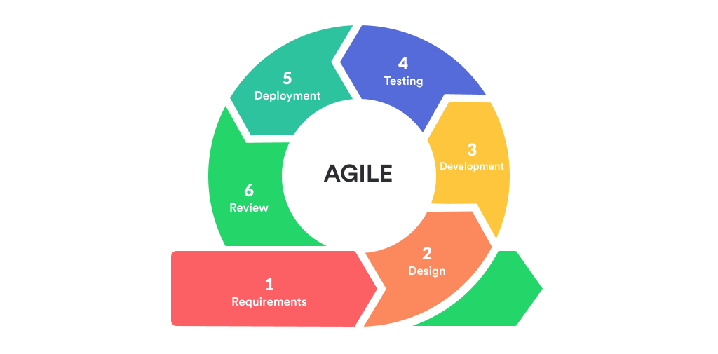 “***Agile Methodology- the SCRUM PROCESS”***

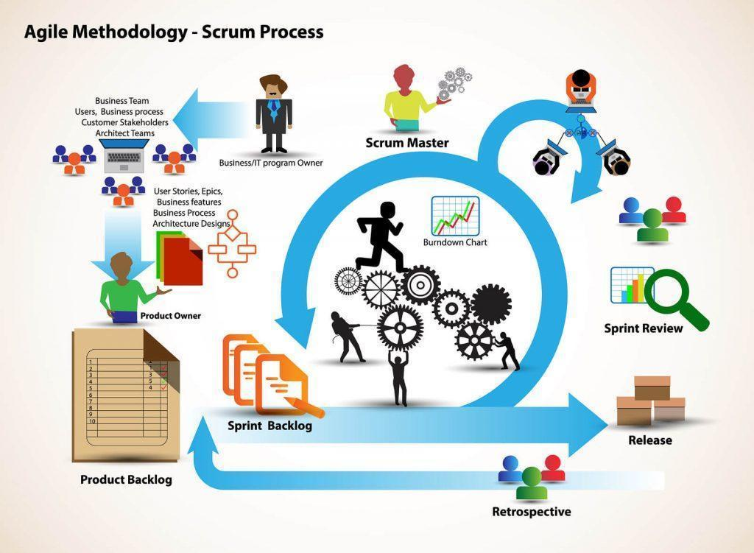



### Reasons for selecting

SCRUM is a very suitable approach for the hotel management website development project due to its flexibility, quick responsiveness to changes, and focus on delivering continuous value.. Therefore, the SCRUM process is the most suitable method to apply project management because it is dynamic and flexible, easy to change, and makes it more convenient to manage project and team progress.

* Flexibility and Quick Adaptation: Quickly respond to changes in requirements and customer feedback.
* Enhanced Interaction and Collaboration: Strengthening communication and cooperation among team members and with stakeholders.
* Continuous Improvement: Continuously improving the product and processes based on real-world feedback.
* Customer Focus: Ensuring the product meets the needs and enhances the experience of customers.

### Agile Methodology

* What is Agile Methodology?

Agile is an iterative approach to project management and software development that helps teams deliver value to their customers faster and with fewer headaches. Instead of betting everything on a "big bang" launch, an agile team delivers work in small, but consumable, increments. Requirements, plans, and results are evaluated continuously so teams have a natural mechanism for responding to change quickly.

* [Agile Manifesto](https://agilemanifesto.org/):
  + Individuals and interactions over processes and tools
  + Working software over comprehensive documentation
  + Working software over comprehensive documentation
  + Responding to change over following a plan
* Agile Life Cycle:
  + Project Initiation
  + Planning
  + Development
  + Production
  + Retirement

### Scrum Process

* Scrum is an iterative and incremental agile software development framework for managing software projects and product or application development.
* Scrum focuses on project management institutions where it is difficult to plan ahead.
* Mechanisms of empirical process control, where feedback loops that constitute the core management technique are used as opposed to traditional command- and-control management.
* Its approach to planning and managing projects is by bringing decision-making authority to the level of operation properties and certainties.
* Benefit of the methodology:
  + Project can respond easily to change.
  + Problems are identified early.
  + Customers get the most beneficial work first.
  + Work done will better meet the customer’s needs.
  + Improved productivity.
  + Ability to maintain a predictable schedule for delivery.

## Quality Management

### Estimates of Defects to be detected

**Pre-release review defects**

|  |  |  |
| --- | --- | --- |
| **Process** | **Planned found by review** | **Actual found by review** |
| **Requirement** | Not mentioned | NA |
| Requirement is not clear | NA |
| Is changed | NA |
| **Design** | Performance Issues | NA |
| Data Security | NA |
| Cross-Platform Compatibility | NA |
| Feedback and Improvement | NA |
| Reliability and Stability | NA |
| **Coding** | Software complexity | NA |
| Schedule pressure | NA |
| Plain dumb mistakes | NA |
| **Total** | **11** | **0** |

### Measurements Program

|  |  |  |  |
| --- | --- | --- | --- |
| **Data to be collected** | **Purpose** | **Responsible** | **When** |
| Size: No. of KLOC// FP | Determine the cost of the project | SM | At the end of stages |
| Effort: 4 person/day | Estimate the amount of effort required to complete the project with inadequate, uncertain and no contradiction | Team members | Daily |
| Quality: No. defects detected | Identify causes of defects, improve processes to avoid repeating defects, improve product quality | Reviewer, Tester | Right after the review/test |
| Schedule | Complete the goal on time, meet the full working hours | SM | Weekly and at the end of stages |

## Unit Testing Strategy

The system is tested using Unit Testing, a testing technique that uses individual modules tested to determine if there are any problems caused by the developer himself. It is concerned with the functional correctness of the independent modules. And the project will be tested by the black box and white box technique of unit testing:

* Black Box Testing - Using which the user interface, input and output are tested.
* White Box Testing - used to test each one of those functions’ behaviors is tested.
* **Completion criteria:**

Acceptance criteria for product quality:

* User can register, login, logout successfully
* Users can report issues of personal property damage due to hotel liability
* Users can order food, book rooms, and use hotel-related amenities.
* Users can contact the hotel manager or reception.
* **Influences might include:**
  + Need for non-test resources to support/participate in the test.
  + Need to have a personal computer connected to the network.
* **Testing may be stopped when:**
  + It becomes unproductive.
  + It requires a certain coverage.
  + It requires a certain number of errors to be found.
  + Schedule time runs out.

## Integration Testing Strategy

* The test is executed successfully when the combination of each module is unit tested and the functional test is combined. Once all the individual units are created and tested, we start combining the tested modules and start doing integration testing. The main goal here is to test the interfaces between units/modules.
* Testing may be stopped when:
* Out of funds
* Time up
* All test cases have been executed
* All defects have been fixed

## System Testing Strategy

* Tests performed successfully on a fully integrated system are based on an assessment of the system's compliance with its specific requirements.
* The test may be stopped when:
* Out of funds
* Time up
* All test cases have been executed
* All defects have been fixed

# PROJECT ORGANIZATION

* Cùng với sự phát triển nhanh chóng của Công nghệ Thông tin, quản lý khách sạn đang dần trở nên hiệu quả và thân thiện hơn. Trong bối cảnh ngành du lịch và khách sạn ngày càng phát triển, việc quản lý khách sạn thông qua các hệ thống trực tuyến đã mang lại nhiều lợi ích vượt trội. Tuy nhiên, vấn đề khó kiểm soát việc đặt phòng, quản lý dịch vụ khách hàng và tạo ra trải nghiệm tuyệt vời cho khách hàng vẫn còn nhiều thách thức. Vì vậy, dự án được tạo ra nhằm xây dựng một trang web quản lý khách sạn để giải quyết các khó khăn trong việc quản lý và nâng cao trải nghiệm của khách hàng khi sử dụng dịch vụ khách sạn trực tuyến.
* Ứng dụng web của chúng tôi đảm bảo rằng khách hàng sẽ nhận được dịch vụ tốt nhất. Đảm bảo tất cả thông tin của khách hàng sẽ được bảo mật tuyệt đối.

# CONFIGURATION MANAGEMENT

|  |  |  |
| --- | --- | --- |
| **No.** | **Tools** | **content** |
| 1 | Excel | Use this tool to track membership. At the end of each day, the group members will post on the Time Table and Scrum Master will check |
| 2 | Weekly meeting | Organize a meeting every week to assign tasks to each member.  If there are some emergencies but we cannot sit together, we can use Facebook, Discord to discuss online. |
| 3 | Document | All meetings must be recorded. |

# SECURITY ASPECTS

* Only the administrator has extensive access to the system and reconfigures the system.
* Project information will remain private.
* All project members must agree to respect the confidentiality of project information.

# REFERENCES

|  |  |  |  |
| --- | --- | --- | --- |
| **No** | **Reference item** | **Source** | **Note** |
| 1 | Proposal | 1. [Proposal](http://../1.%20Proposal/Proposal_Ver1.2.docx) |  |
| 2 | Product backlog | 4. [Product](http://../3.%20Product%20Backlog/ProductBacklog%20v1.1.xlsx) Backlog |  |
| 3 | Scrum Process | [Scrum.org](https://www.scrum.org/) |  |
| 4 | GitHub | <https://github.com/> |  |
| 5 | Reactjs | <https://reactjs.org/> |  |
| 5 | Nodejs | <https://nodejs.org/en/docs/> |  |

# DEFINITIONS AND ACRONYMS

|  |  |
| --- | --- |
| **Acronym** | **Definition** |
| **PM** | Project Manager |
| **PTL** | Project Technical Leader |
| **QA** | Quality Assurance Officer |
| **CC** | Infrastructure Configuration Controller |
| **DV** | Developer |
| **URD** | User Requirement Document |
| **SRS** | Software Requirement Specification |
| **ADD** | Architecture Design Document |
| **DDD** | Detail Design Document |
| **TP** | Test Plan |
| **TC** | Test Case |
| **SC** | Source Code |
| **CM** | Configuration Management |
| **CSCI** | Computer Software Configuration Items |
| **CI** | Configuration Item |
| **CCB** | Change Control Board |