**STYLE DETECTION TOOL**

**Technologies and Tools Used:**

- Frontend: Angular (Typescript), Tailwindcss

- Backend: .NET core (C#), Playwright, AngleSharp

Link github: <https://github.com/quyenptt03/Style-detection-tool>

**1. Installation & Setup**

a. backend (.NET)

- Prerequisite: .NET 8

- Install NuGet Packages:

dotnet add package Microsoft.AspNetCore.Mvc

dotnet add package Microsoft.Playwright

dotnet add package AngleSharp

dotnet add package Polly

dotnet add package Microsoft.Extensions.Http

dotnet add package Microsoft.Extensions.Logging

- Setup Playwright

dotnet tool install --global Microsoft.Playwright.CLI

playwright install

- Run the app:

dotnet build

dotnet run

b. Frontend (Angular)

- Prerequisite: NodeJS, NPM, Angular

- Install & run:

cd StyleDetectionTool/ClientApp/client-app

npm install

ng serve

Open in browser: <http://localhost:4200>  
**2. How to Use**

1. **Enter the URL**: Input the main URL of your project in the **URL** field.
2. **Choose a Theme File**
3. **Submit the Form**

**Result Overview**

* After submission:
* **Project Pages**  
  A list of all detected categories in the project will be displayed in the **textarea field**.
* **Style Analysis Panel**  
  On the right panel:
  + All styles defined in the uploaded .JSON theme file will be shown.
  + **Unused styles** (i.e., not found in any categories) will be **highlighted in green** for easy identification.

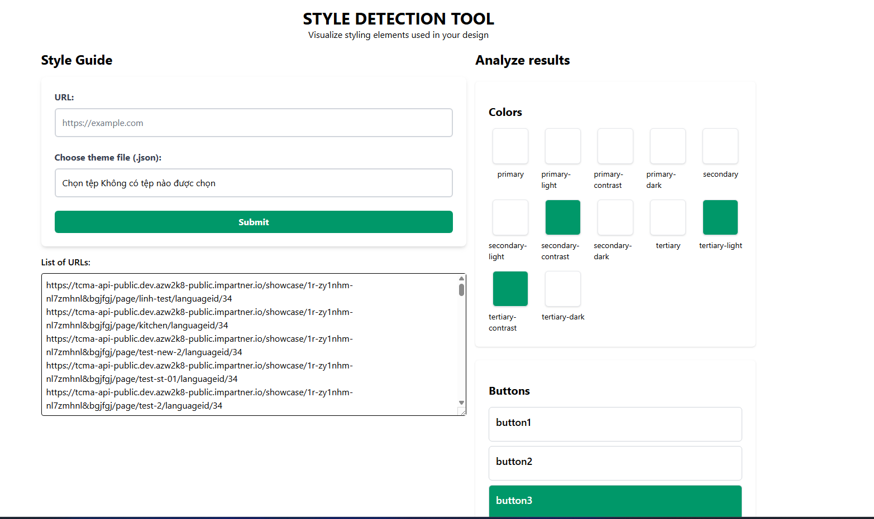

When clicking on a style in the right panel:

* If the style is used:
  + A dialog will appear showing:
    - The categories and sections where this style is applied.

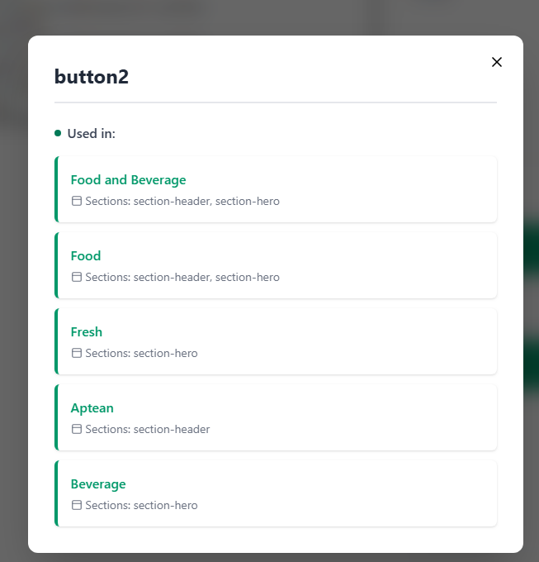

* If the style is not used:
  + An alert will notify you that "This style was not used anywhere in the project."

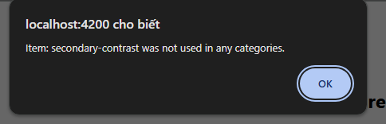

Note: Colors will be used in some styles (e.g., buttons use the secondary color for the background, or headings use the primary color for the font).