Bai 1:

1.

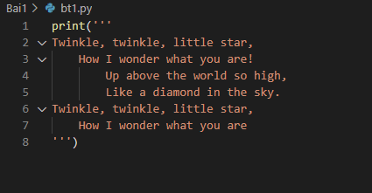

2. Write a Python program to find out what version of Python you are using.

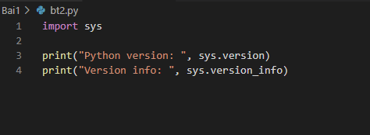

3. Write a Python program to display the current date and time.

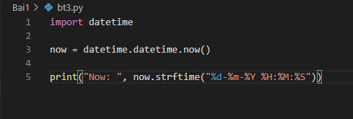

4. Write a Python program that calculates the area of a circle based on the radius entered by the user.

Sample Output :

r = 1.1

Area = 3.8013271108436504

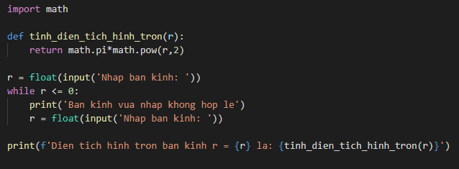

5. Write a Python program that accepts the user's first and last name and prints them in reverse order with a space between them.

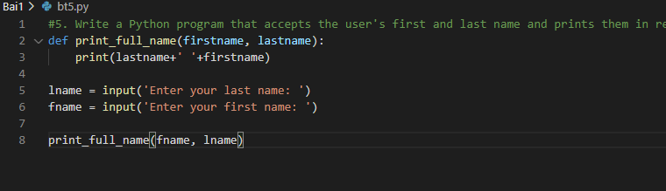

6. Write a Python program that accepts a sequence of comma-separated numbers from the user and generates a list and a tuple of those numbers.

Sample data : 3, 5, 7, 23

Output :

List : ['3', ' 5', ' 7', ' 23']

Tuple : ('3', ' 5', ' 7', ' 23')

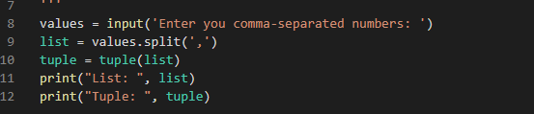

7. Write a Python program that accepts a filename from the user and prints the extension of the file.

Sample filename : abc.java

Output : java

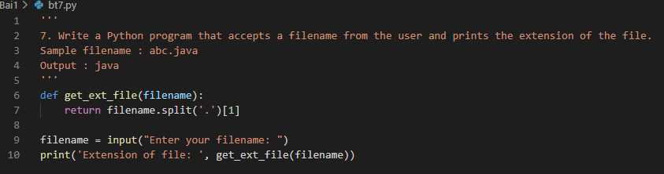

8. Write a Python program to display the first and last colors from the following list.

color_list = ["Red","Green","White" ,"Black"]

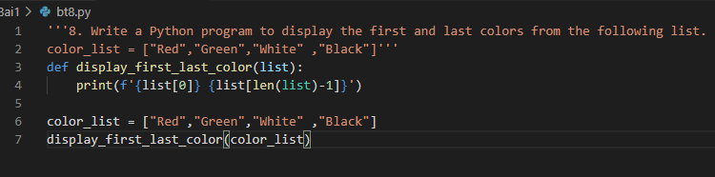

9. Write a Python program to display the examination schedule. (extract the date from exam_st_date).

exam_st_date = (11, 12, 2014)

Sample Output : The examination will start from : 11 / 12 / 2014

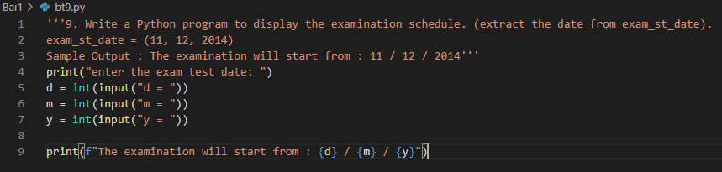

10. Write a Python program that accepts an integer (n) and computes the value of n+nn+nnn

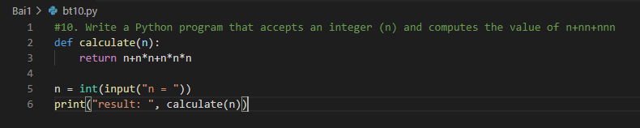

12. Write a Python program that prints the calendar for a given month and year.

Note : Use 'calendar' module.

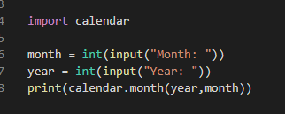

14. Write a Python program to calculate the number of days between two dates.

Sample dates : (2014, 7, 2), (2014, 7, 11)

Expected output : 9 days

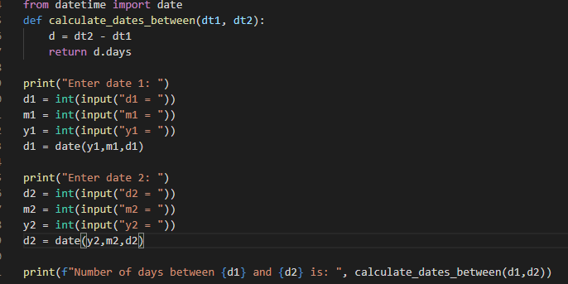

15. Write a Python program to get the volume of a sphere with radius six.

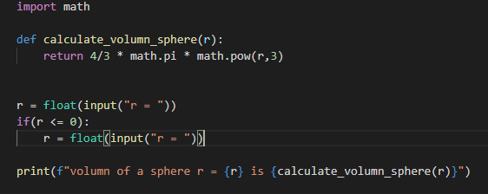

16. Write a Python program to calculate the difference between a given number and 17. If the number is greater than 17, return twice the absolute difference.

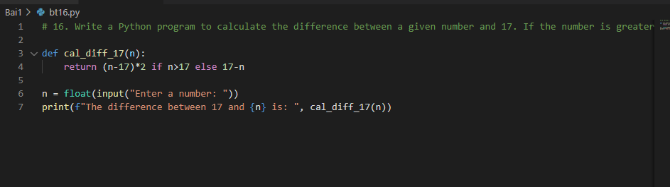

18. Write a Python program to calculate the sum of three given numbers. If the values are equal, return three times their sum.

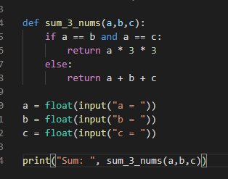

34. Write a Python program to sum two given integers. However, if the sum is between 15 and 20 it will return 20.

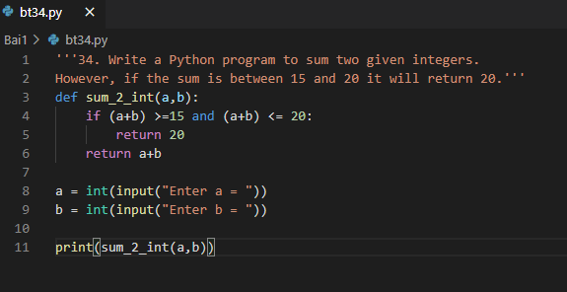

38. Write a Python program to solve (x + y) * (x + y).

Test Data : x = 4, y = 3

Expected Output : (4 + 3) ^ 2) = 49

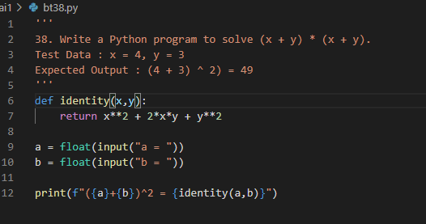

40. Write a Python program to calculate the distance between the points (x1, y1) and (x2, y2).

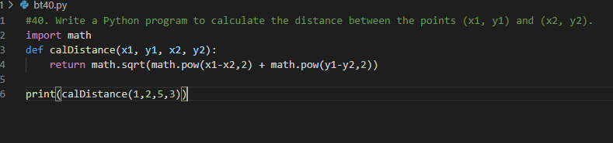

65. Write a Python program that converts seconds into days, hours, minutes, and seconds.

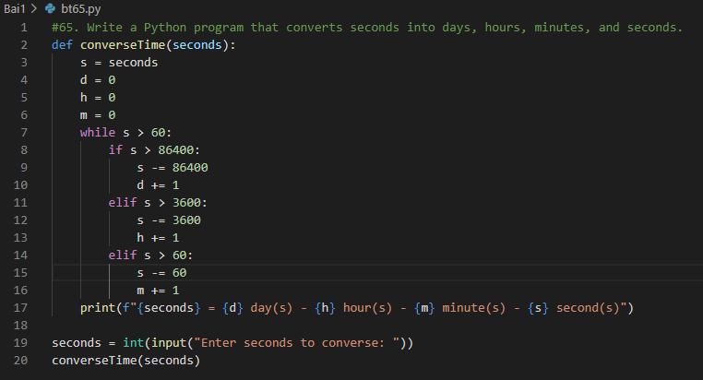

68. Write a Python program to calculate sum of digits of a number.

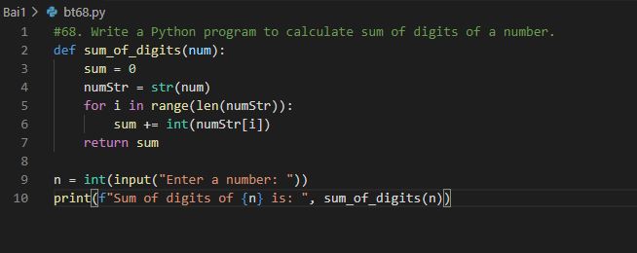

73. Write a Python program to calculate the midpoints of a line.

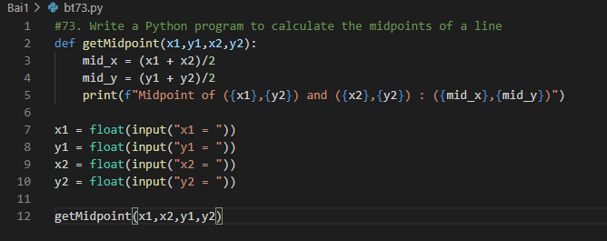

86. Write a Python program to get the ASCII value of a character.

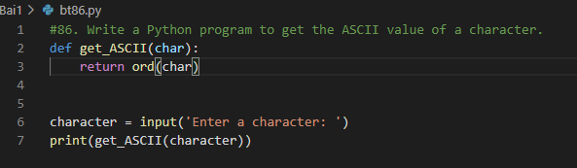

Bai 2:

1. Tính:

a) (a + b),

b) a/b,

c) a^b

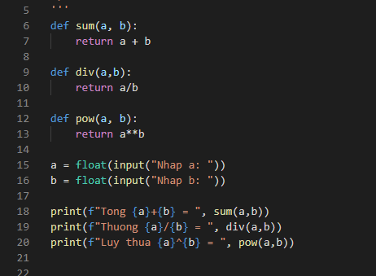

8. Giải phương trình bậc 2: ax2 + bx + c=0

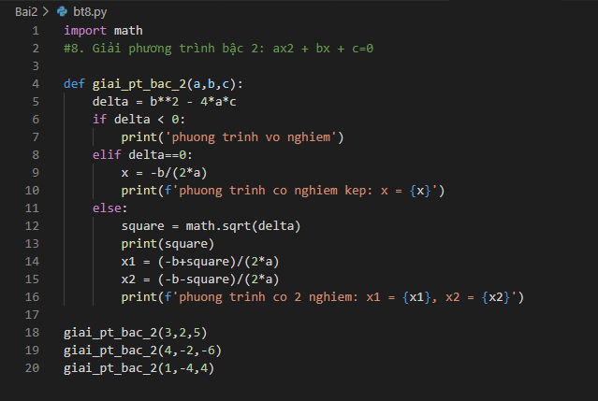

9. Tính n!

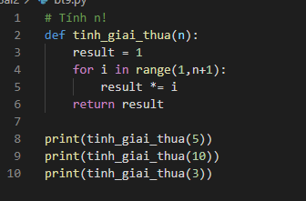

10.In * dạng tam giác dưới như hình bên, đầu vào là số hàng(cột)

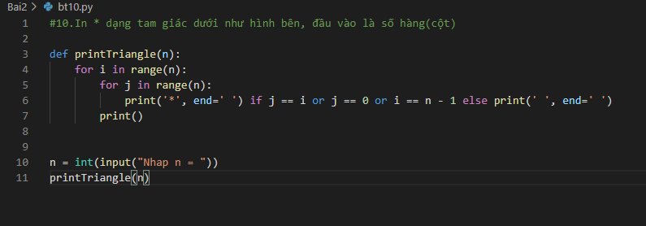

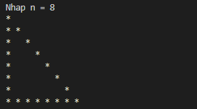

11. Đổi giờ - phút – giây: thời gian đầu vào là giây được đổi thành giờ, phút, giây.

Xuất kết quả ra màn hình dưới dạng: giờ:phút:giây. Ví dụ: soGiay = 3770 thì xuất

ra màn hình 1:2:50.

