My answer of lab 2: PROBLEM MODELING AND ENCAPSULATION

1. UML and Astah
2. Problem statement of AIMS Project
3. Use case diagram

1. UML Class diagram for use case related to cart management

1. Create Aims project

1. Create the DigitalVideoDisc class and its properties

1. Create accessor and mutator for the class DigitalVideoDisc

1. Create Constructor method

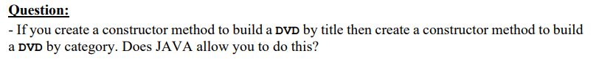

Answer: Yes, JAVA allow we create 2 constructors that have the same name and diffirent argument... It is called OVERLOADING TECHNIQUE. Two method can be the same name and another one, but they must differ in signature.

1. Create cart class to work with DigitalVideoDisk

Code: My code is available in “Lab_2” folder or you can see them in the below

1. Removing items from cart

My code: is available in “LAB_2” folder or you can see them below

