# Software Requirement Specifications

## User Requirement Specification

### Guest Requirement

Guest is a person who loves to play football. Guest can do the following functions:

* Sign up
* Sign in

### User Requirement

User is a person who represents a football team to reserve field. User can do the following functions:

* Manage account:
  + View profile
  + Edit profile
* Search field
* Reserve field
* Manage reservation requests:
  + Create reservation requests
  + View reservation requests
  + Cancel reservation requests
* Accept match
* View list of opponents
* Send feedback
* Send report
* Checkout transaction.

### Field Owner Requirement

Field owner is a person who has football fields and let users reserve his/her fields by using our application. The following functions are available for field owner to use:

* Manage account:
  + View profile
  + Edit profile
* Manage field:
  + Update timeline
  + Create field
  + Update price
  + Disable field
  + Remove field
  + Create promotions
* Send feedback
* Send report

### Admin Requirement

Admin is an employee from our company. Admin is responsible for managing service provider system and accounts. Admin can do following functions:

* Update users’ accounts
* Review reports

### Staff Requirement

Staff is an employee from our company. Staff’s primary job is to manage profit. Staff can do following functions:

* Manage profit:
  + View sales statistics.
  + Set percent commission.

### Payment System Requirement

Payment system is an online payment portal. Payment system’s function is to execute online transactions.

## Software Requirement Specification (WIP)

### External Interface Requirement (Template)

#### User Interface

* The user interface uses Vietnamese as main language for users and English for Staff, Manager and Admin on both Mobile and Web application.

#### Hardware Interface

* Android Smartphone: Nexus 4 or later.

#### Software Interface

* Web application: work with Firefox (v30 or above), Chromes (v25 or above)
* Mobile Application: Android 4 (or later)

#### Communication Protocol

* Use HTTP protocol 1.1 for communication between the web browser and the web server.
* Use HTTP protocol 1.1 for communication between the mobile application and the web service.
* Use HTTP protocol 1.1 for communication between the server and the Microsoft service.

### System Overview Use Case (Template)

### List of Use Case

#### Field Owner Overview Use Case

<Hinh o day>

*Figure x: <Admin> Overview Use Case*

##### <Field Owner> Create account (FO01)

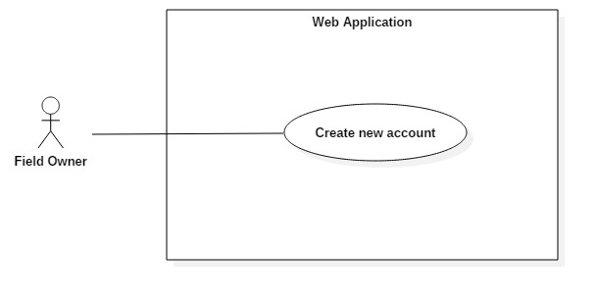

*Figure x+1: <Field Owner> Create account (*FO01*)*

|  |  |  |  |
| --- | --- | --- | --- |
| **USE CASE – UC_FO01** | | | |
| **Use Case No.** | FO01 | **Use Case Version** | 0.1 |
| **Use Case Name** | Create account | | |
| **Author** | HuanPM | | |
| **Date** | 17/9/2017 | **Priority** | Normal |
| **Actor:**   * Field Owner   **Summary:**   * This use case allows field owner to create a new account on the system.   **Goal:**   * Field owner have account for logging in.   **Triggers:**   * Field owner open web application.   **Preconditions:**   * N/A.   **Post Conditions:**   * **Success:** An account is created on system. System displays successful message. * **Fail:** System displays error message.   **Main Success Scenario:**   |  |  |  | | --- | --- | --- | | Step | Actor Action | System Response | | 1 | Actor goes to Create account view. | System displays Create account view and requires information from field owner:   * **Username**: free text input, required, length 8–40 characters. * **Field name**: free text input, required, length 8–40 characters. * **Phone**: free text input, required, length 10-11 digits. * **ATM card no:** digit input, required, length 16 digits. * **CVC:** digit input, required, length 3 to 4 digits. | | 2 | Actor inputs information.  [Alternative 1] |  | | 3 | Actor sends command to create account.  [Alternative 1] | System validates information.  [Exception 1, 2, 3, 4, 5] | | 4 |  | System adds a new account.  System display successful message. |   **Alternative Scenario:**  *[Alternative 1]*   |  |  |  | | --- | --- | --- | | Step. | Actor Action | System Response | | 1 | Actor sends command to cancel. | System cancels creating new account and redirect to home page. |   **Exceptions:**   |  |  |  | | --- | --- | --- | | No. | Cause | System Response | | 1 | Invalid Username format. | System shows error message: “Username cannot be blank and must be 8-40 characters long”. | | 2 | Invalid Field name format. | System shows error message: “Field name cannot be blank and must be 8-40 characters long”. | | 3 | Invalid Phone format. | System shows error message: “Phone cannot be blank or contain alphabetical characters and must be 9-11 digits”. | | 4 | Invalid ATM Card format | System shows error message: “ATM Card cannot be blank and must be 16 digits”. | | 5 | Invalid CVC format. | System shows error message: “CVC name cannot be blank and must be 3-4 digits”. |   **Relationships:**   * N/A   **Business Rules:**   * N/A | | | |
|  | | | |

##### <Field Owner> View field timeline (FO02)

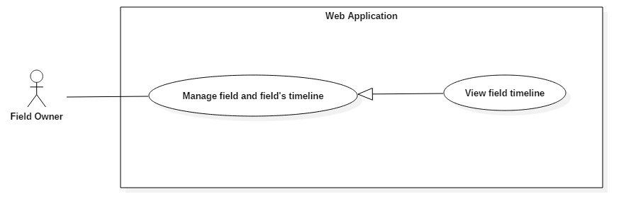

*Figure x+1: <Field Owner> View field timeline (FO02)*

|  |  |  |  |
| --- | --- | --- | --- |
| **USE CASE – UC_FO01** | | | |
| **Use Case No.** | FO02 | **Use Case Version** | 0.1 |
| **Use Case Name** | View field timeline | | |
| **Author** | HuanPM | | |
| **Date** | 17/9/2017 | **Priority** | High |
| **Actor:**   * Field Owner   **Summary:**   * This use case allows field owner to view field’s timeline.   **Goal:**   * Field owner can view timeline of a specific field.   **Triggers:**   * Field owner open web application.   **Preconditions:**   * Field owner logged in to the system.   **Post Conditions:**   * **Success:** System displays field timeline. * **Fail:** System displays error message.   **Main Success Scenario:**   |  |  |  | | --- | --- | --- | | Step | Actor Action | System Response | | 1 | Actor goes to Field management view. | System shows field list.  [Exception 1] | | 2 | Actor clicks a field  [Alternative 1] | System displays field details and timeline. |   **Alternative Scenario:**  *[Alternative 1]*   |  |  |  | | --- | --- | --- | | Step. | Actor Action | System Response | | 1 | Actor clicks a disabled field | System displays field details and enable button, |   **Exceptions:**   |  |  |  | | --- | --- | --- | | No. | Cause | System Response | | 1 | There are no fields. | System shows message: “The list is empty”. |   **Relationships:**   * N/A   **Business Rules:**   * N/A | | | |
|  | | | |

##### <Field Owner>Disable field timeline (FO03)

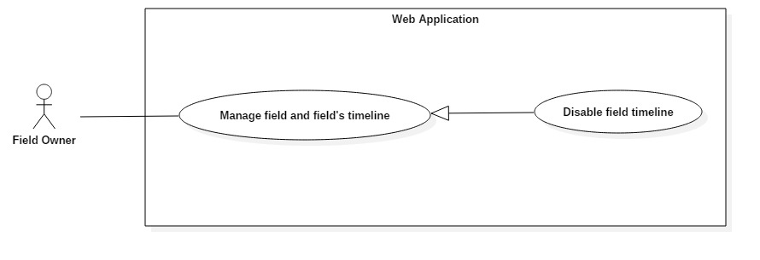

*Figure x+1: <Field Owner> Disable field timeline (FO03)*

|  |  |  |  |
| --- | --- | --- | --- |
| **USE CASE – UC_FO01** | | | |
| **Use Case No.** | FO03 | **Use Case Version** | 0.1 |
| **Use Case Name** | Disable field timeline | | |
| **Author** | HuanPM | | |
| **Date** | 17/9/2017 | **Priority** | High |
| **Actor:**   * Field Owner   **Summary:**   * This use case allows field owner to disable specific field’s timeline.   **Goal:**   * Field owner can disable a specific timeline of a specific field.   **Triggers:**   * Field owner open web application.   **Preconditions:**   * Field owner logged in to the system.   **Post Conditions:**   * **Success:** System displays successful message. * **Fail:** System displays error message.   **Main Success Scenario:**   |  |  |  | | --- | --- | --- | | Step | Actor Action | System Response | | 1 | Actor goes to Field management view. | System shows field list.  [Exception 1] | | 2 | Actor clicks Disable button on a field. | System displays a modal and requires information from field owners.   * From hours: * From date: * To hours: * To date: | | 3 | Actor inputs required information.  [Alternative 1] | System validates information.  [Exception 2,3,4,5] | | 4 | Actor send commands to submit.  [Alternative 1] | System displays successful message. |   **Alternative Scenario:**  *[Alternative 1]*   |  |  |  | | --- | --- | --- | | Step. | Actor Action | System Response | | 1 | Actor clicks Cancel on modal | System cancels operation and close modal. |   **Exceptions:**   |  |  |  | | --- | --- | --- | | No. | Cause | System Response | | 1 | There are no fields. | System shows message: “The list is empty”. | | 2 |  |  | | 3 |  |  | | 4 |  |  | | 5 |  |  |   **Relationships:**   * N/A   **Business Rules:**   * N/A | | | |
|  | | | |

##### <Field Owner>Record match score (FO04)

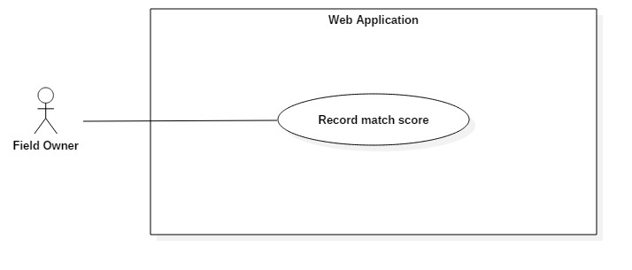

*Figure x+1: <Field Owner> Record match score (FO04)*

|  |  |  |  |
| --- | --- | --- | --- |
| **USE CASE – UC_FO01** | | | |
| **Use Case No.** | FO04 | **Use Case Version** | 0.1 |
| **Use Case Name** | Record match score | | |
| **Author** | HuanPM | | |
| **Date** | 17/9/2017 | **Priority** | Medium |
| **Actor:**   * Field Owner   **Summary:**   * This use case allows field owner to record match score.   **Goal:**   * Field owner can record match score.   **Triggers:**   * Field owner open web application. * Field owner choose notification about finished match.   **Preconditions:**   * Field owner logged in to the system. * Match has to be finished. * Notification has to be sent to field owner.   **Post Conditions:**   * **Success:** System displays successful message. * **Fail:** System displays error message.   **Main Success Scenario:**   |  |  |  | | --- | --- | --- | | Step | Actor Action | System Response | | 1 | Actor clicks Notifications | System shows notification list.  [Exception 1] | | 2 | Actor clicks a match notification | System displays a modal and requires information from field owners.   * Home Score: * Team Score: * Comments: optional | | 3 | Actor inputs required information.  [Alternative 1] | System validates information.  [Exception 2] | | 4 | Actor send commands to submit.  [Alternative 1] | System displays successful message. |   **Alternative Scenario:**  *[Alternative 1]*   |  |  |  | | --- | --- | --- | | Step. | Actor Action | System Response | | 1 | Actor clicks Cancel on modal | System cancels operation and close modal. |   **Exceptions:**   |  |  |  | | --- | --- | --- | | No. | Cause | System Response | | 1 |  |  | | 2 |  |  |   **Relationships:**   * N/A   **Business Rules:**   * N/A | | | |
|  | | | | |

##### <Field Owner>Rate teams (FO05)



*Figure x+1: <Field Owner> Record match score (FO05)*

|  |  |  |  |
| --- | --- | --- | --- |
| **USE CASE – UC_FO01** | | | |
| **Use Case No.** | FO05 | **Use Case Version** | 0.1 |
| **Use Case Name** | Rate teams | | |
| **Author** | HuanPM | | |
| **Date** | 17/9/2017 | **Priority** | Medium |
| **Actor:**   * Field Owner   **Summary:**   * This use case allows field owner to record match score.   **Goal:**   * Field owner can record match score.   **Triggers:**   * Field owner open web application. * Field owner choose notification about finished match.   **Preconditions:**   * Field owner logged in to the system. * Match has to be finished. * Notification has to be sent to field owner.   **Post Conditions:**   * **Success:** System displays successful message. * **Fail:** System displays error message.   **Main Success Scenario:**   |  |  |  | | --- | --- | --- | | Step | Actor Action | System Response | | 1 | Actor clicks Notifications | System shows notification list.  [Exception 1] | | 2 | Actor clicks a match notification | System displays a modal and requires information from field owners.   * Score: * Comments: optional | | 3 | Actor inputs required information.  [Alternative 1] | System validates information.  [Exception 2] | | 4 | Actor send commands to submit.  [Alternative 1] | System displays successful message. |   **Alternative Scenario:**  *[Alternative 1]*   |  |  |  | | --- | --- | --- | | Step. | Actor Action | System Response | | 1 | Actor clicks Cancel on modal | System cancels operation and close modal. |   **Exceptions:**   |  |  |  | | --- | --- | --- | | No. | Cause | System Response | | 1 |  |  | | 2 |  |  |   **Relationships:**   * N/A   **Business Rules:**   * Field owners gets 15% discount when they do rate teams. | | | |
|  | | | | |