#### User

* + - 1. **<User> Get History List**

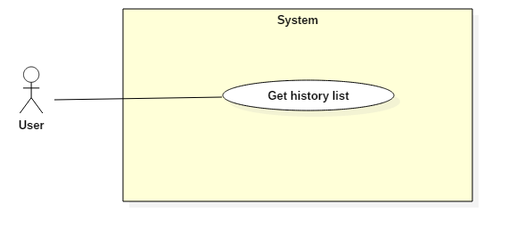

|  |  |  |  |
| --- | --- | --- | --- |
| **USE CASE – UC014** | | | |
| **Use Case No.** | 14 | **Use Case Version** | 1.0 |
| **Use Case Name** | Get history list | | |
| **Author** | Phan Minh Huấn | | |
| **Date** | 2/12/2017 | **Priority** | Normal |
| **Actor:**   * User   **Summary:**   * This use case allows Actor to get Actor’s history list.   **Goal:**   * System gets history list and display it to Actor.   **Triggers:**   * Actor sends get history command.   **Preconditions:**   * Actor has accessed the system under User role.   **Post Conditions:**   * **Success:** History list is displayed. * **Fail:** N/A   **Main Success Scenario:**   |  |  |  | | --- | --- | --- | | Step | Actor Action | System Response | | 1 | Actor sends get history list command. | System gets history list.  [Exception 1]  System displays history list to Actor. |   **Exceptions 1:**   |  |  |  | | --- | --- | --- | | Step | Cause | System Response | | 1 | Actor’s history list is empty | System shows error message “Không có danh sách lịch sử”. |   **Relationships:**  N/A  **Business Rules:**   * History consists of reserved matches and pending matching requests. | | | |

* + - 1. **<User> Set favorite field**

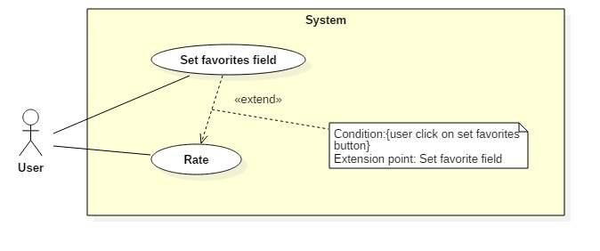

|  |  |  |  |
| --- | --- | --- | --- |
| **USE CASE – UC014** | | | |
| **Use Case No.** | 14 | **Use Case Version** | 1.0 |
| **Use Case Name** | Set favorites field | | |
| **Author** | Phan Minh Huấn | | |
| **Date** | 2/12/2017 | **Priority** | Normal |
| **Actor:**   * User   **Summary:**   * This use case allows Actor to add a field to favorite field list.   **Goal:**   * System update favorite field list.   **Triggers:**   * Actor sends add to favorite command.   **Preconditions:**   * Actor has accessed the system under User role.   **Post Conditions:**   * **Success:** Favorite field is saved in the system. * **Fail:** N/A   **Main Success Scenario:**   |  |  |  | | --- | --- | --- | | Step | Actor Action | System Response | | 1 | Actor sends add to favorite command. | System adds field to Actor’s favorite field list.  System displays message “Bạn đã thêm sân vào danh sách yêu thích”. |   **Relationships:**  Extends use case Rate.  **Business Rules:**   * The field in favorite list has higher priority (than others field) when Actor search field. | | | |

* + - 1. **<User> Add opponent to blacklist**

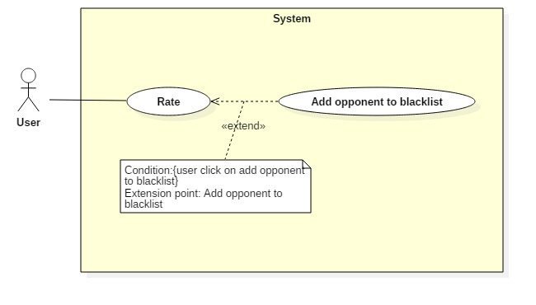

|  |  |  |  |
| --- | --- | --- | --- |
| **USE CASE – UC015** | | | |
| **Use Case No.** | 15 | **Use Case Version** | 1.0 |
| **Use Case Name** | Add opponent to blacklist | | |
| **Author** | Phan Minh Huấn | | |
| **Date** | 2/12/2017 | **Priority** | Normal |
| **Actor:**   * User   **Summary:**   * This use case allows Actor to add another Actor to blacklist.   **Goal:**   * System update Actor’s blacklist.   **Triggers:**   * Actor sends rating command.   **Preconditions:**   * Actor has accessed the system under User role.   **Post Conditions:**   * **Success:** The rating is created. Actor’s blacklist is updated. * **Fail:** N/A   **Main Success Scenario:**   |  |  |  | | --- | --- | --- | | Step | Actor Action | System Response | | 1 | Actor sends add User to blacklist command. | System saves User’s information to Actor’s blacklist.  System displays message “Bạn đã thêm đối thủ vào danh sách chặn” |   **Relationships:**  Extends use case Rate.  **Business Rules:**   * User that is in Actor’s blacklist cannot find Actor when using find matching request function. | | | |

##### <User> Exchange voucher

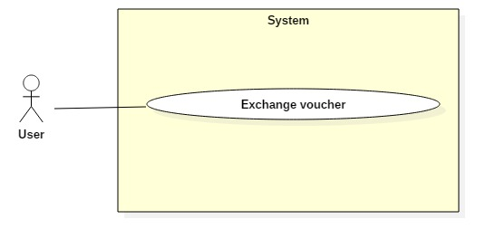

|  |  |  |  |
| --- | --- | --- | --- |
| **USE CASE – UC017** | | | |
| **Use Case No.** | 17 | **Use Case Version** | 1.0 |
| **Use Case Name** | Create reservation request | | |
| **Author** | Phan Minh Huấn | | |
| **Date** | 2/12/2017 | **Priority** | Normal |
| **Actor:**   * User   **Summary:**   * This use case allows Actor to exchange bonus point to voucher code.   **Goal:**   * Update voucher bonus point after exchange, save voucher code in database.   **Triggers:**   * Actor sends exchange voucher command.   **Preconditions:**   * Actor has accessed the system under User role.   **Post Conditions:**   * **Success:** System updated Actor’s balance and bonus point. * **Fail:** N/A   **Main Success Scenario:**   |  |  |  | | --- | --- | --- | | Step | Actor Action | System Response | | 1 | Actor sends get voucher list command | System displays voucher list. | | 2 | Actor sends exchange voucher command.  [Alternative 1] | System checks if Actor’s bonus point is enough to exchange voucher.  [Exception 1]  System updates Actor’s bonus point and balance.  System display successful message “Bạn đã đổi thưởng thành công”.  System creates voucher code and display voucher code. |   **Alternative Scenario 1:**   |  |  |  | | --- | --- | --- | | Step | Actor Action | System Response | | 1 | Actor send cancel command. | System back to previous window and allow Actor choose other voucher. |   **Exceptions 1:**   |  |  |  | | --- | --- | --- | | Step | Cause | System Response | | 1 | Actor’s bonus point is not enough to exchange the voucher. | System shows error message “Không đủ điểm để đối thưởng”. |   **Relationships:** N/A  **Business Rules:**   * Voucher code is used to discount field’s price. | | | |

#### Staff

* + - 1. **<Staff> Get Report List**

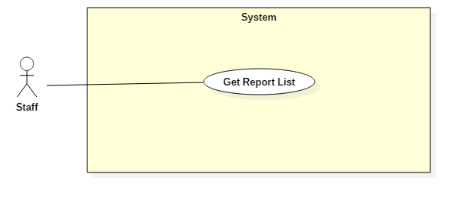

|  |  |  |  |
| --- | --- | --- | --- |
| **USE CASE – UC027** | | | |
| **Use Case No.** | 27 | **Use Case Version** | 1.0 |
| **Use Case Name** | Get Report List | | |
| **Author** | Phan Minh Huấn | | |
| **Date** | 2/12/2017 | **Priority** | Normal |
| **Actor:**   * Staff   **Summary:**   * This use case allows Actor to get report list.   **Goal:**   * System gets report list and display it to Actor.   **Triggers:**   * Actor sends get report list command.   **Preconditions:**   * Actor has accessed the system under Staff role.   **Post Conditions:**   * **Success:** Report list is displayed. * **Fail:** N/A   **Main Success Scenario:**   |  |  |  | | --- | --- | --- | | Step | Actor Action | System Response | | 1 | Actor sends get report list command. | [Exception 1]  System displays report list to Actor. |   **Exceptions 1:**   |  |  |  | | --- | --- | --- | | Step | Cause | System Response | | 1 | Report list is empty | System shows error message “Không có danh sách tố cáo”. |   **Relationships:**  N/A  **Business Rules:**   * Report consists of field owner report and user report. | | | |

* + - 1. **<Staff> Send lock account request**

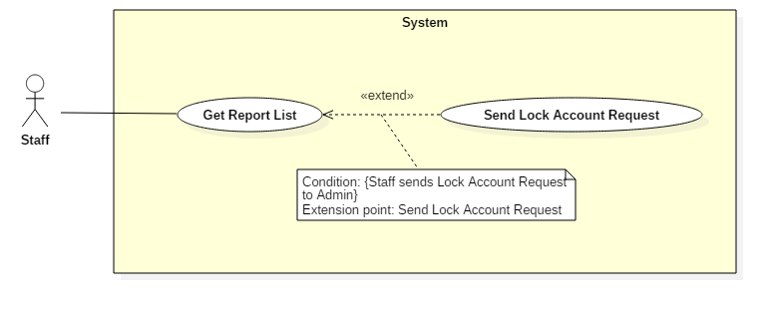

|  |  |  |  |
| --- | --- | --- | --- |
| **USE CASE – UC028** | | | |
| **Use Case No.** | 28 | **Use Case Version** | 1.0 |
| **Use Case Name** | Send lock account request | | |
| **Author** | Phan Minh Huấn | | |
| **Date** | 2/12/2017 | **Priority** | Normal |
| **Actor:**   * Staff   **Summary:**   * This use case allows Actor to send lock account request.   **Goal:**   * System saves lock account request and notify to Admin.   **Triggers:**   * Actor sends lock account request command.   **Preconditions:**   * Actor has accessed the system under Staff role.   **Post Conditions:**   * **Success:** Lock account request is saved. * **Fail:** N/A   **Main Success Scenario:**   |  |  |  | | --- | --- | --- | | Step | Actor Action | System Response | | 1 | Actor sends lock account request command. | System checks account information.  [Exception 1]  System saves request and notify to Admin.  System displays message “Đã gửi yêu cầu thành công”. |   **Exceptions 1:**   |  |  |  | | --- | --- | --- | | Step | Cause | System Response | | 1 | Account does not exist. | System shows error message “Tài khoản không tồn tại”. |   **Relationships:**  Extends use case Get report list  **Business Rules:**  N/A | | | |

#### Admin

* + - 1. **<User> Lock Account**

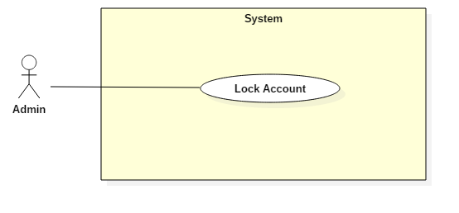

|  |  |  |  |
| --- | --- | --- | --- |
| **USE CASE – UC034** | | | |
| **Use Case No.** | 34 | **Use Case Version** | 1.0 |
| **Use Case Name** | Lock Account | | |
| **Author** | Phan Minh Huấn | | |
| **Date** | 2/12/2017 | **Priority** | Normal |
| **Actor:**   * Admin   **Summary:**   * This use case allows Actor to get Actor’s history.   **Goal:**   * System gets history list and display it to Actor.   **Triggers:**   * Actor sends get history command.   **Preconditions:**   * Actor has accessed the system under User role.   **Post Conditions:**   * **Success:** History list is displayed. * **Fail:** N/A   **Main Success Scenario:**   |  |  |  | | --- | --- | --- | | Step | Actor Action | System Response | | 1 | Actor sends lock account command. | System requests confirmation from Actor. | | 2 | Actor confirms request. | System checks account information.  [Exception 1]  System displays message “Đã khóa tài khoản thành công”. |   **Exceptions 1:**   |  |  |  | | --- | --- | --- | | Step | Cause | System Response | | 1 | Account does not exist. | System shows error message “Tài khoản không tồn tại”. |   **Relationships:**  N/A  **Business Rules:**  N/A | | | |