1. Literature Review

1.1 Airfare Prediction and Purchase-Timing Research
Airfare research has addressed two related but analytically distinct questions: how accurately a future fare can be estimated, and whether purchasing should occur immediately or be deferred. Etzioni et al. (2003) developed Hamlet, an early decision-support system that learned from historical fare trajectories and issued BUY or WAIT recommendations. Groves and Gini (2015) subsequently estimated the expected minimum future fare from recent quotations across competing airlines and incorporated that estimate into an explicit purchase-timing policy. These studies established that airfare forecasting is not solely a price-estimation problem; its practical value also depends on how predictions alter purchase decisions.
Later work concentrated more directly on supervised fare prediction. Tziridis et al. (2017) compared eight machine-learning algorithms using data from 1,814 Aegean Airlines flights. Santana et al. (2017) formulated next-day and seven-day airfare estimation as multi-target regression, while Wang et al. (2019) combined aviation and macroeconomic variables to predict quarterly market-level fares. More recently, Kalampokas et al. (2023) evaluated conventional machine learning, deep learning and quantum machine-learning approaches across 136,917 observations. Although these studies differ in temporal resolution, market scope and target construction, they consistently report that airfare movements contain exploitable predictive structure.

1.2 Modelling Strategies and Evaluation Practice
Published modelling strategies range from rule induction and reinforcement learning to autoregressive forecasting, partial least-squares regression, support-vector regression, decision trees, random forests, bagging, neural networks and stacked ensembles. Hamlet combined RIPPER, Q-learning, time-series forecasting and stacked generalisation (Etzioni et al., 2003). Groves and Gini (2015) used lagged fare predictors with partial least-squares regression, whereas Santana et al. (2017) combined random-forest and support-vector regressors within a multi-target stacking architecture. This methodological diversity reflects differences in target definition, data frequency and operational objective rather than a settled preference for one universal model class.
Evidence from wider tabular-learning research supports heterogeneous model selection. Gorishniy et al. (2021) showed that Feature Tokenizer Transformers can be competitive on tabular data, while gradient-boosted decision trees remain difficult to displace consistently. Model architecture should therefore be selected against task-specific temporal validation rather than assumed superior in advance. Evaluation practice must also match prediction type. Classification requires discrimination, probability accuracy and calibration; regression requires monetary or percentage error; probabilistic forecasts require proper scores and interval diagnostics; ranking requires query-level ordering measures; and purchase policies require decision loss rather than predictive accuracy alone. Weighted interval score (WIS) provides a proper score for interval and quantile forecasts (Bracher et al., 2021), while normalised discounted cumulative gain (NDCG) evaluates graded rankings with greater emphasis on highly ranked items (Järvelin and Kekäläinen, 2002).

1.3 Research Gap
Existing airfare studies commonly examine one response variable, a restricted set of model families, or retrospective data partitions that do not fully reproduce deployment-time information constraints. Evidence remains limited on whether a specification selected without access to future labels can support classification, regression, probabilistic forecasting, offer ranking and purchase timing within one temporally coherent system. This study addresses that gap using 150 consecutive observation days: 128 development days, followed by two non-overlapping prospective test periods of 11 days each. Model architectures, features, hyperparameters, ensemble rules, calibration procedures and decision thresholds were fixed before prospective evaluation. The study consequently tests whether gains identified during development persist across sequential unseen periods without conflating model selection, prospective validation and final production refitting.

2. Results

2.1 Analytical Sample and Prospective Test Structure
The analytical record covered 150 consecutive observation days. The first 128 days, ending on 28 July 2026, formed the development period. Following harmonisation, this period contained 923,855 standardised offers. Of these, 636,436 contributed labelled observations to binary classification, while 916,696 contributed labelled observations to fare regression and probabilistic forecasting. Model selection, temporal calibration and hyperparameter determination were conducted exclusively within this development period using rolling-origin validation.
The remaining 22 days were reserved for sequential prospective evaluation. Test 1, covering 29 July–8 August 2026, comprised 41,573 classification observations and 95,962 regression or probabilistic observations. Test 2, covering 9–19 August 2026, comprised 42,146 classification observations and 94,127 regression or probabilistic observations. No observation or ranking query appeared in both test periods. The complete modelling specification was frozen before Test 1. Before Test 2, parameters were refitted using only information available before 9 August 2026, including labels that had matured during Test 1; architectures, features, hyperparameters, ensemble weights and decision thresholds remained unchanged. Test 2 therefore assessed a prespecified expanding-window update, not retrospective reselection after observing Test 1 performance.
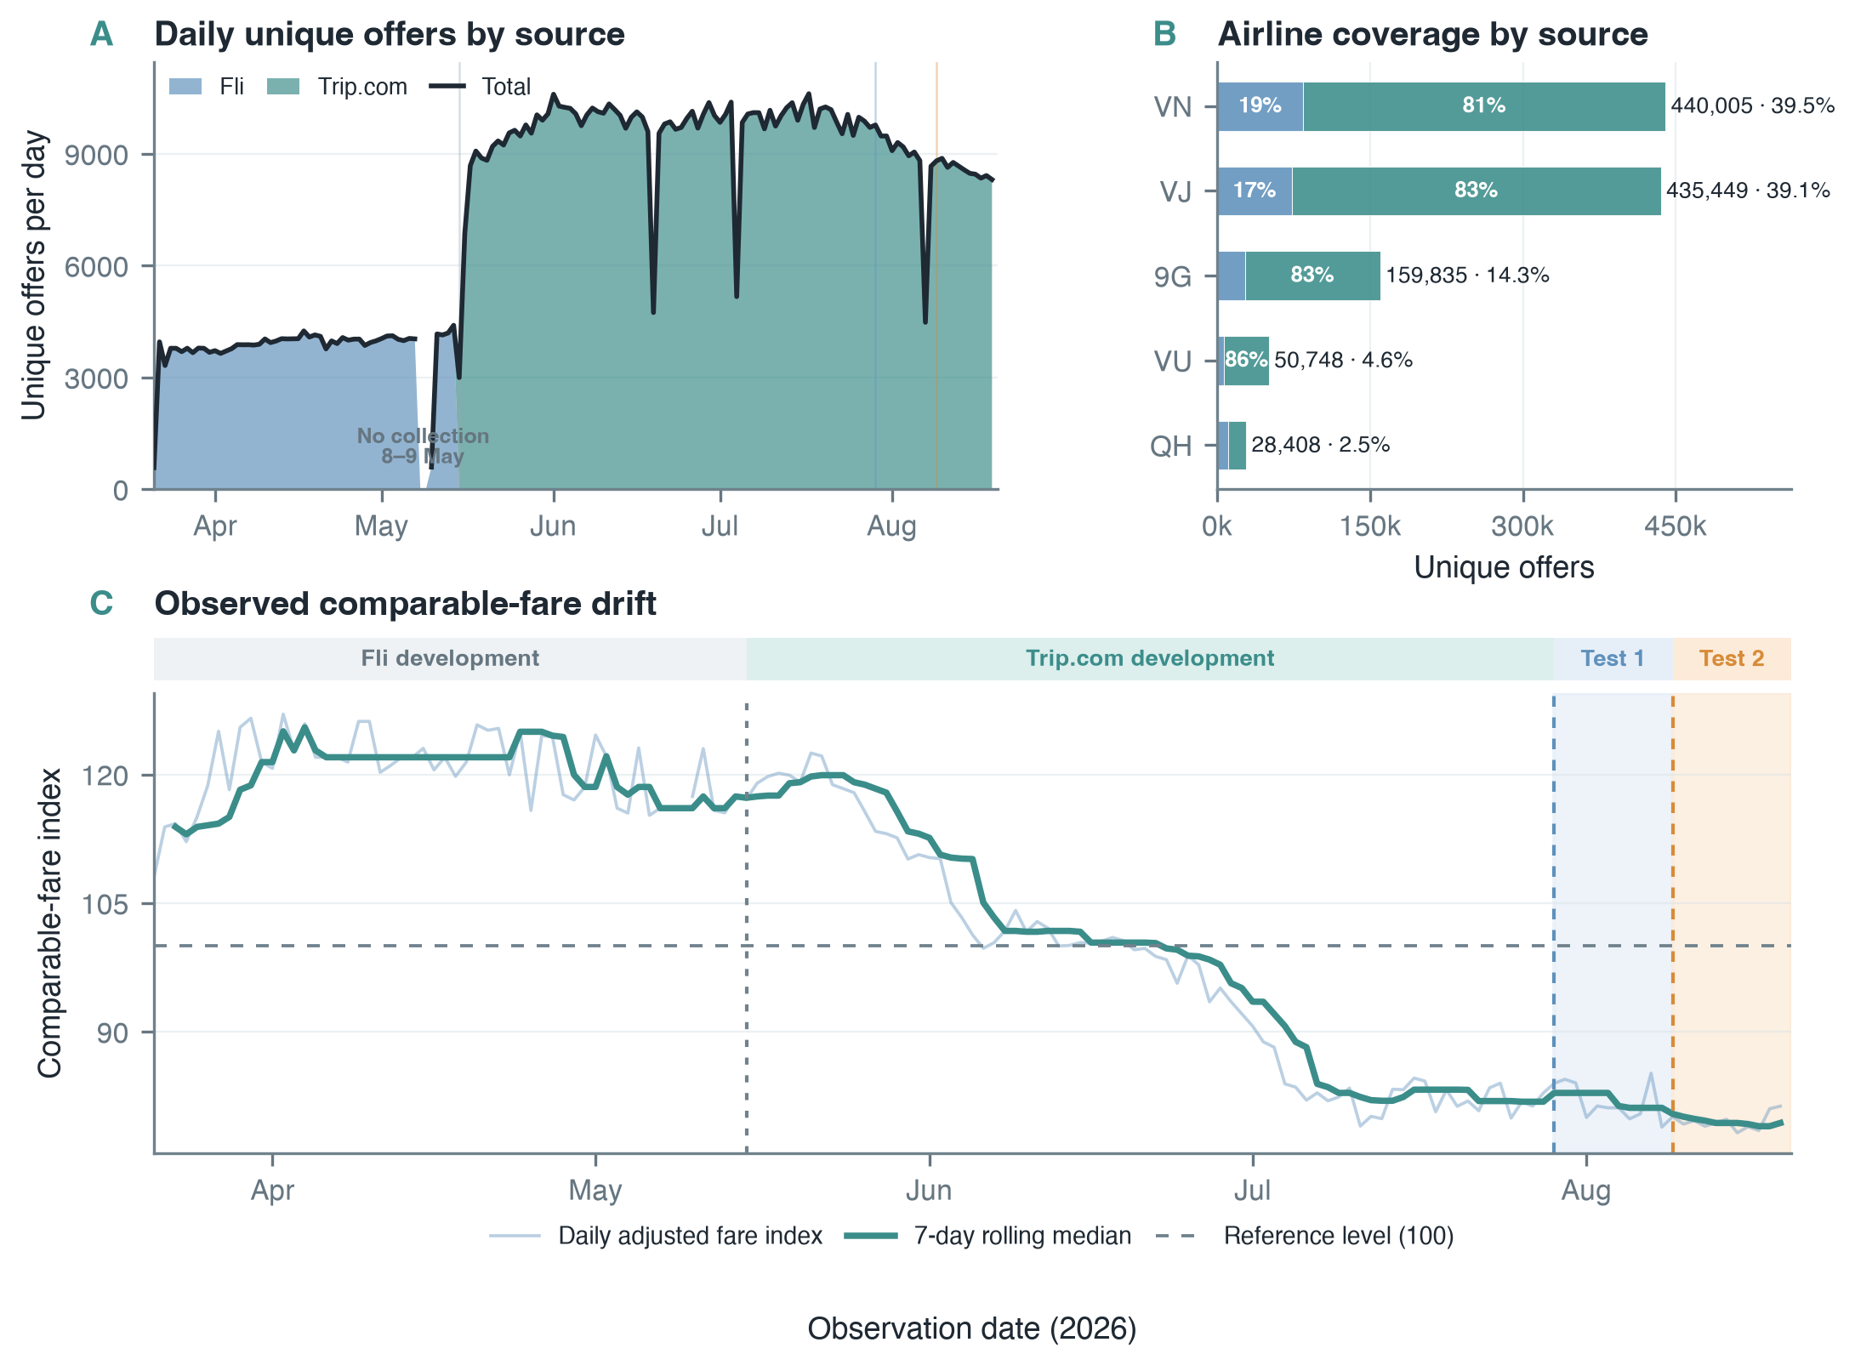
Figure 1. Data-source coverage and observed fare drift across 150 observation days. Daily unique-offer volume was higher after collection-source expansion; observations were concentrated in VN and VJ, and standardised comparable fares shifted materially before the prospective test periods. Shaded regions identify Test 1 and Test 2; temporal co-occurrence is descriptive rather than causal.

2.2 Prediction Tasks and Evaluation Criteria
Five related predictive and decision tasks were evaluated. Table 1 defines each target and its prespecified evaluation criteria.
Table 1. Scientific formulation of evaluated tasks
Task | Target | Primary evaluation criteria
Binary classification | Probability that fare decreases by at least 5% in next observed booking window | Area under receiver operating characteristic curve (AUC), Brier score, logarithmic loss and expected calibration error using 15 bins (ECE15)
Regression | Future fare in VND across days-until-departure 1–60, using exact observed target where available and time-consistent interpolation otherwise | Mean absolute percentage error (MAPE), median absolute percentage error, mean absolute error (MAE), root mean squared error (RMSE) and coefficient of determination (R²)
Probabilistic forecasting | Seven conditional quantiles of anchor-relative log fare change at levels 0.05, 0.10, 0.25, 0.50, 0.75, 0.90 and 0.95 | Weighted interval score (WIS), mean pinball loss, empirical interval coverage and quantile-crossing rate
Learning-to-rank | Query-specific ordering of offers by subsequently realised fare, assigning greater relevance to lower future fares | Normalised discounted cumulative gain at rank 5 (NDCG@5) and pairwise concordance
Purchase-timing decision | Cost-aware BUY or WAIT action derived from calibrated fare-drop probability | Mean decision regret, 95% conditional value at risk (CVaR95) and wait rate

Lower Brier score, logarithmic loss, MAPE, MAE, RMSE, WIS, regret and CVaR95 indicate better performance. Higher AUC, R², NDCG@5 and pairwise concordance indicate better performance. R² quantifies variance explained relative to a mean-only benchmark and can be negative when predictions perform worse than that benchmark.

2.3 Frozen Finalist Models
No architecture dominated every task. Each component therefore retained two task-specific finalists and averaged three seeded fits per architecture, yielding six ensemble members. Table 2 identifies these models; Figures 2–5 show their task-specific modelling pipelines.
Table 2. Frozen finalist models used in prospective evaluation
Task | Model architecture | Configuration and prediction role
Binary classification | Feature Tokenizer Transformer (FT-Transformer) classifier | Numerical and categorical fields were represented as 48-dimensional feature tokens and processed through three Transformer blocks with four attention heads and dropout of 0.15; output was probability of a fare decrease of at least 5%
Binary classification | Exact-history gated recurrent unit (GRU) multi-task classifier | A 64-unit GRU processed ordered observed-fare history and jointly estimated the 5% fare-drop event, three-class price direction and continuous log return; fare-drop head supplied classification probability
Regression | Exact-history GRU regressor | A 64-unit GRU processed exact observed-fare history and minimised Huber loss to estimate future fare
Regression | Exact-history long short-term memory (LSTM) regressor | A 64-unit LSTM processed exact observed-fare history and minimised Huber loss to estimate future fare
Probabilistic forecasting | CatBoost multi-quantile regressor | A depth-7 gradient-boosted tree model jointly estimated seven conditional fare quantiles
Probabilistic forecasting | XGBoost quantile regressor | A depth-7 gradient-boosted tree model estimated the same seven conditional fare quantiles
Learning-to-rank | LightGBM XE-NDCG ranker | An XE-NDCG learning-to-rank objective with 63 leaves was fitted using the most recent 84 development days
Learning-to-rank | LightGBM LambdaRank model | A LambdaRank objective with 63 leaves was fitted using the most recent 84 development days

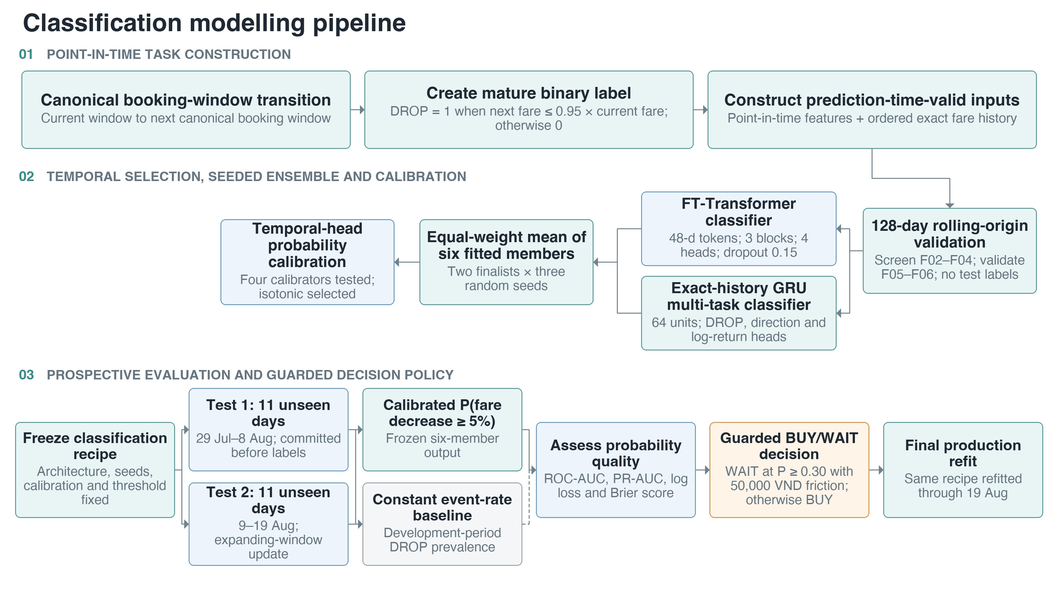
Figure 2. Classification pipeline for prospective fare-drop prediction and guarded BUY/WAIT decisions.
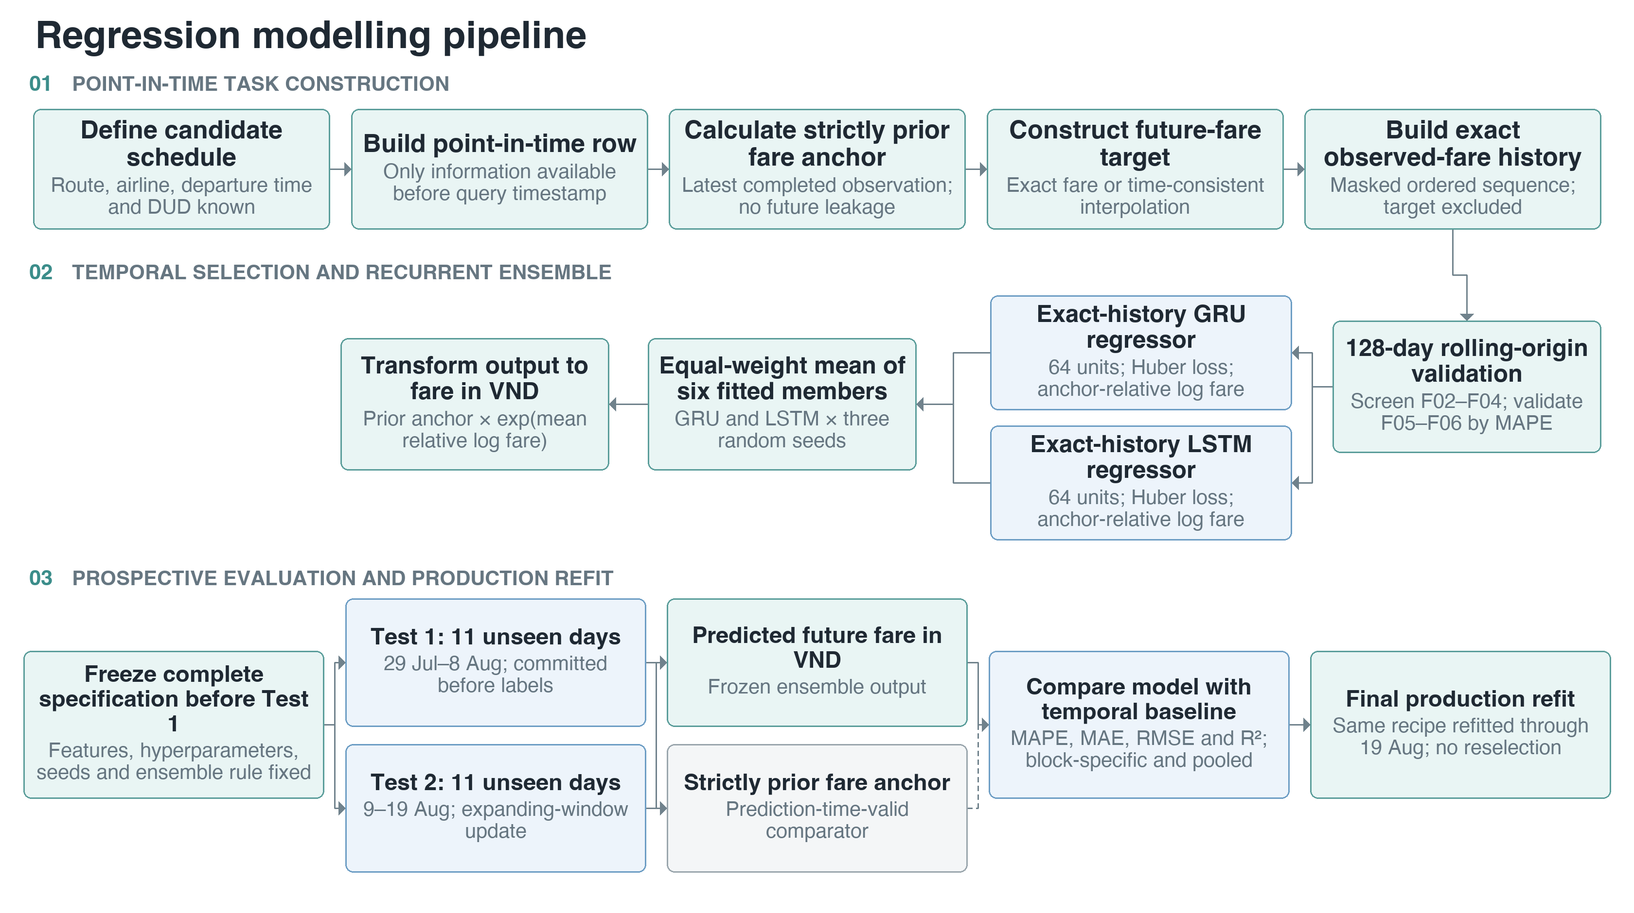
Figure 3. Regression pipeline for future-fare estimation across DUD 1–60.

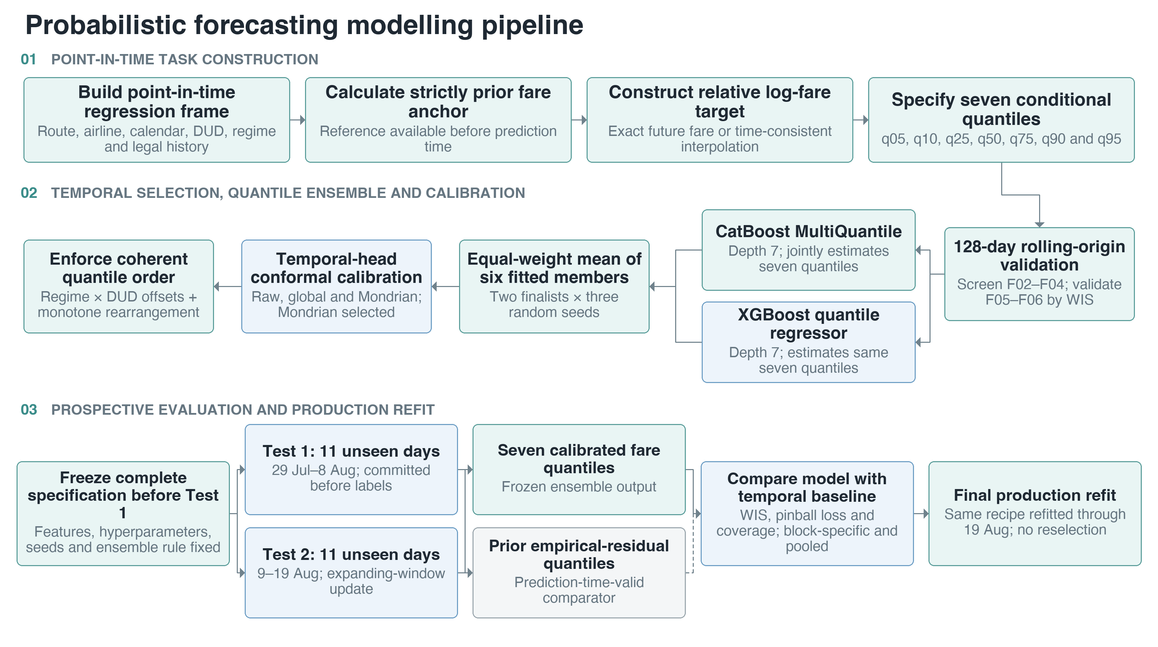
Figure 4. Probabilistic forecasting pipeline for calibrated conditional fare quantiles.
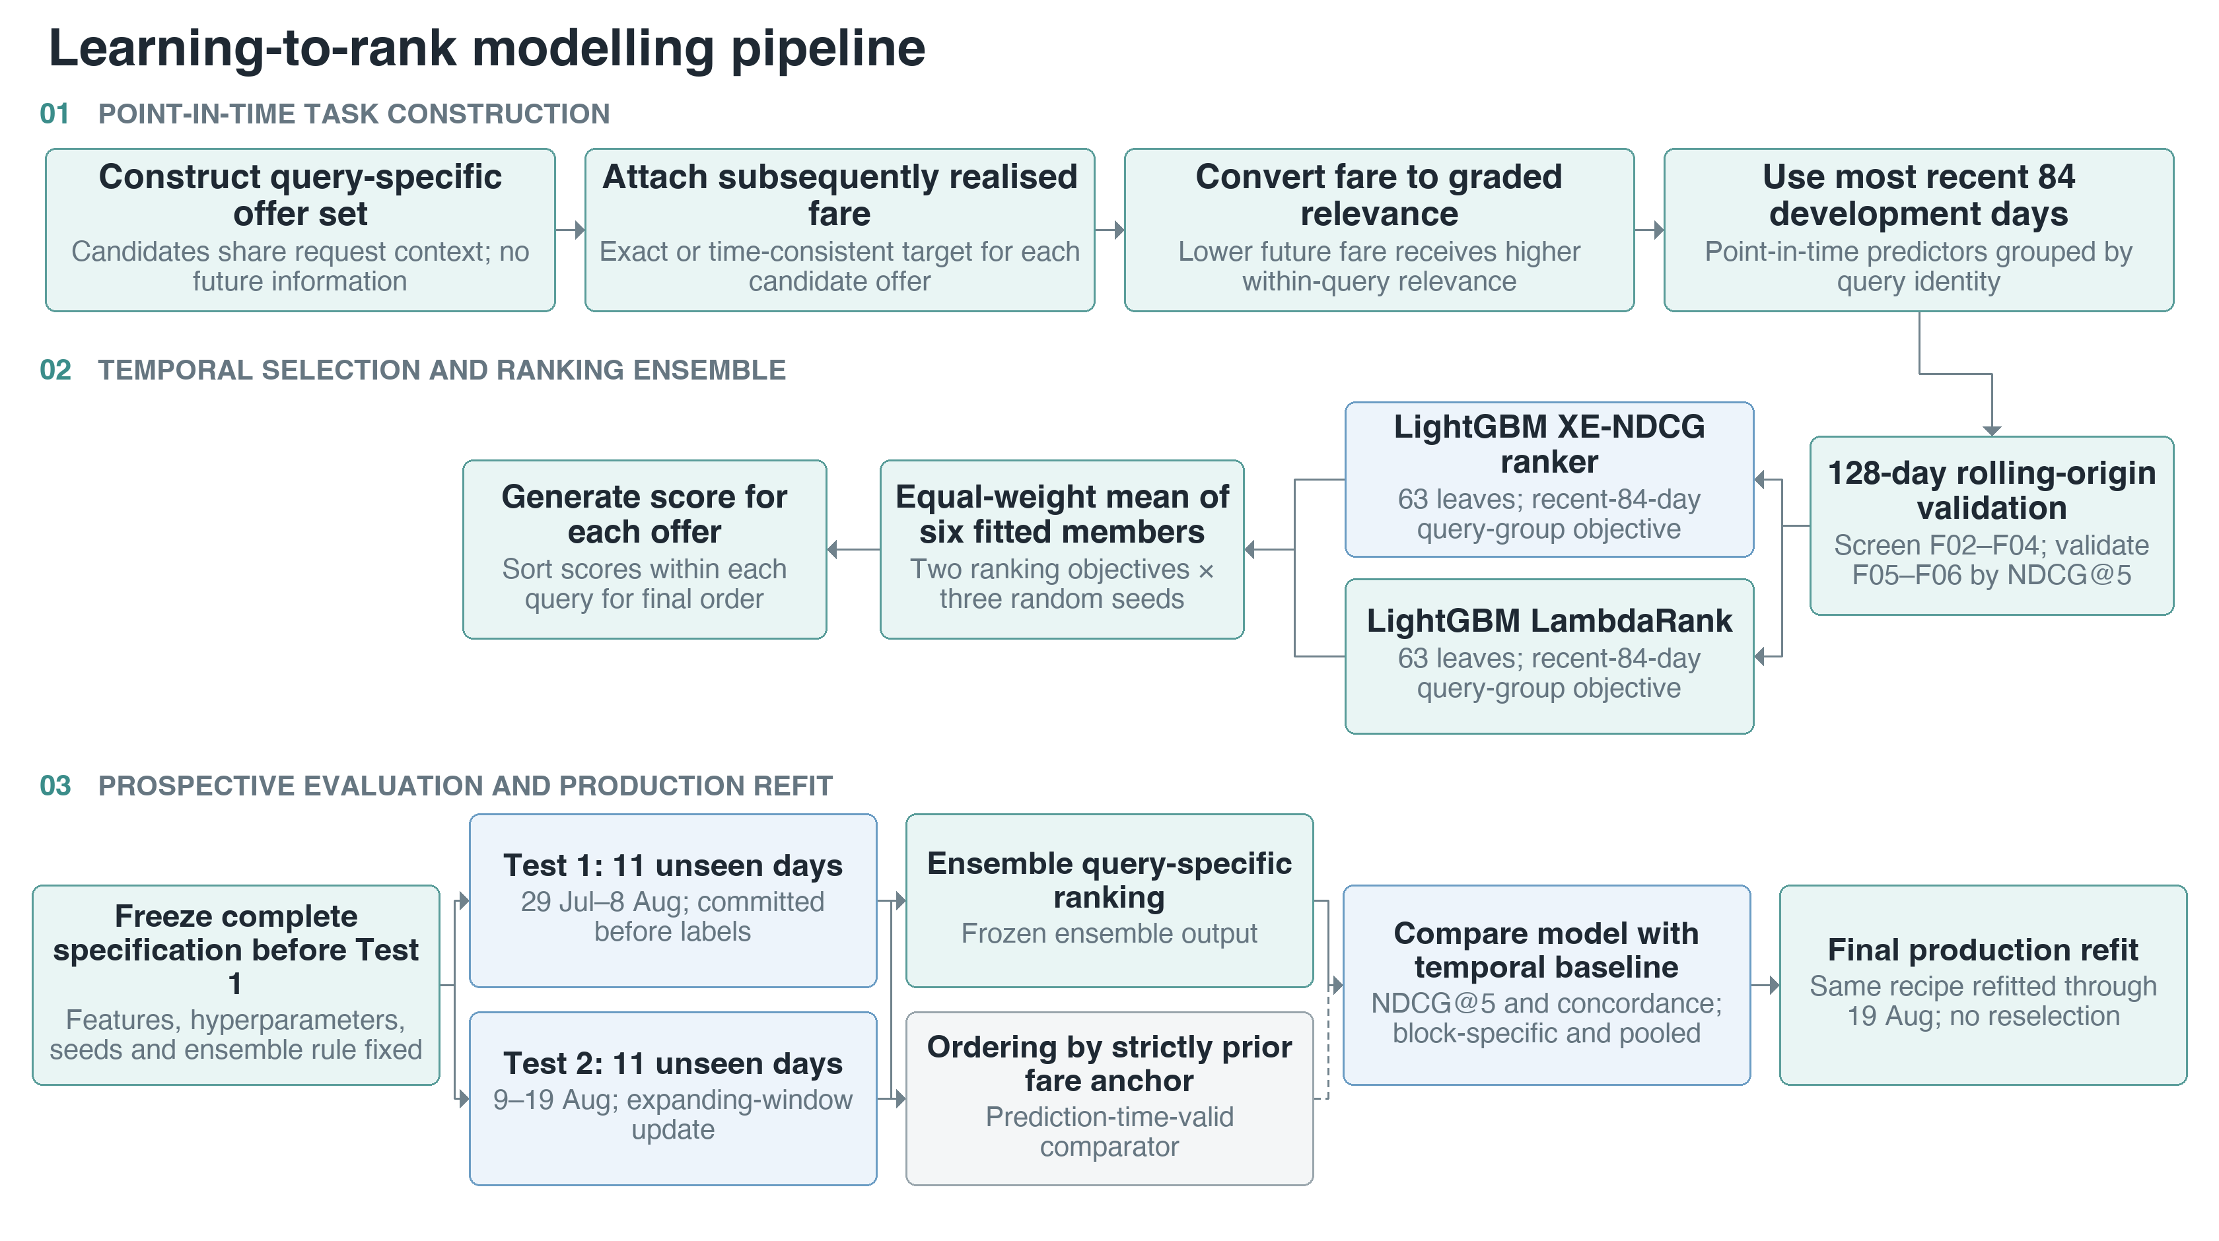
Figure 5. Learning-to-rank pipeline for query-specific ordering of flight offers.

Classification used temporally selected isotonic calibration, while conditional quantiles used Mondrian conformal calibration by history availability and days-until-departure band. Regression and ranking used unweighted six-member means. All preprocessing, calibration and aggregation rules remained fixed across both prospective tests.

2.4 Prospective Performance by Test Period
All four predictive tasks outperformed their prediction-time-valid baselines in both prospective periods (Table 3). Binary classification was compared with a constant development-period event-rate predictor. Regression was compared with latest strictly prior fare. Probabilistic forecasting was compared with empirical distribution of development residuals. Learning-to-rank was compared with ordering based on strictly prior fare anchor.
Table 3. Primary predictive performance by prospective test period
Task and primary metric | Test 1 model | Test 1 baseline | Test 2 model | Test 2 baseline
Binary classification, Brier score | 0.0982 | 0.1301 | 0.1268 | 0.1443
Regression, MAPE | 0.0731 | 0.1418 | 0.0687 | 0.1336
Regression, R² | 0.8520 | 0.5542 | 0.8125 | 0.4945
Probabilistic forecasting, WIS | 0.0614 | 0.0955 | 0.0610 | 0.0922
Learning-to-rank, NDCG@5 | 0.8179 | 0.6446 | 0.8235 | 0.6736

Classification AUC reached 0.6626 in Test 1 and 0.6552 in Test 2, compared with 0.5000 for the constant event-rate baseline. Improvement was therefore reproduced after the development cutoff and after the prespecified expanding-window update. Variation in block-specific classification scores nevertheless indicates temporal heterogeneity, supporting separate reporting of Test 1 and Test 2 rather than reliance on pooled estimates alone.

2.5 Pooled Predictive Performance Across Test 1 and Test 2
Pooled evaluation comprised 83,719 classification observations, 190,089 regression or probabilistic observations, and 9,447 ranking queries. Results are separated by task in Tables 4A–4D because their metrics represent different estimands and scales.
Table 4A. Pooled binary-classification performance across Test 1 and Test 2
Metric | Classification ensemble | Constant event-rate baseline | Relative change
AUC | 0.647594 | 0.457940 | Not applicable
Brier score | 0.112568 | 0.137265 | 17.99% lower
Logarithmic loss | 0.379316 | 0.454836 | 16.60% lower
ECE15 | 0.018056 | 0.145403 | Not reported as relative effect

Table 4B. Pooled regression performance across Test 1 and Test 2
Metric | Regression ensemble | Strictly prior fare baseline | Comparative effect
MAPE | 0.070909 | 0.137707 | 48.51% lower
Median absolute percentage error | 0.03310 | 0.08092 | 59.10% lower
MAE (VND) | 117,355 | 225,845 | 48.04% lower
RMSE (VND) | 227,178 | 383,223 | 40.72% lower
Coefficient of determination (R²) | 0.833902 | 0.527357 | +0.306545 absolute

Table 4C. Pooled probabilistic-forecasting performance across Test 1 and Test 2
Metric | Quantile ensemble | Empirical-residual baseline | Relative change
WIS | 0.061212 | 0.093850 | 34.78% lower
Mean pinball loss | 0.030606 | 0.046925 | 34.78% lower

Table 4D. Pooled learning-to-rank performance across Test 1 and Test 2
Metric | Ranking ensemble | Prior-fare ranking baseline | Relative change
NDCG@5 | 0.820768 | 0.659424 | 24.47% higher
Pairwise concordance | 0.869721 | 0.715912 | 21.48% higher

Across pooled observations, classification ensemble reduced Brier score by 17.99% and logarithmic loss by 16.60% relative to block-specific constant event-rate predictions. The baseline's pooled AUC was 0.4579, rather than 0.5000, because it assigned different constants to test periods with different event prevalence; within each period its AUC remained 0.5000. Regression MAPE was 48.51% lower, while MAE decreased from 225,845 VND to 117,355 VND. Regression R² increased from 0.5274 under strictly prior fare baseline to 0.8339 under ensemble, an absolute gain of 0.3065. Quantile ensemble reduced both WIS and mean pinball loss by 34.78% relative to empirical-residual baseline. Ranking ensemble increased NDCG@5 from 0.6594 to 0.8208 and pairwise concordance from 0.7159 to 0.8697. Day-stratified bootstrap intervals for prespecified primary differences excluded zero in the favourable direction for all four predictive tasks. Improvement was observed in both prospective blocks for every task.

2.6 Calibration and Ranking Diagnostics
Seven-quantile forecasts exhibited no quantile crossings. Empirical coverage was 48.65% for nominal 50% interval, 78.12% for nominal 80% interval and 88.53% for nominal 90% interval. Forecast intervals therefore showed modest undercoverage at each reported level, despite lower WIS and pinball loss. Better aggregate proper scores indicate an improved balance between sharpness and calibration; they do not imply exact nominal coverage at every interval level.
Ranking ensemble achieved NDCG@5 of 0.8208 and pairwise concordance of 0.8697, compared with 0.6594 and 0.7159, respectively, under prior-fare ordering. These measures evaluate a different estimand from regression. Regression quantifies expected monetary fare, whereas learning-to-rank assesses whether offers with lower subsequently realised fares are placed near top of each query-specific choice set.

2.7 Purchase-Timing Policy
Prespecified decision policy recommended WAIT when calibrated probability of a fare decrease exceeded 0.30, after inclusion of 50,000 VND transaction friction. Across both prospective tests, mean regret was 29,695.45 VND under model policy and 30,419.95 VND under always-BUY policy, a difference of 724.50 VND, or 2.38%. CVaR95 decreased from 416,654.08 VND to 400,395.87 VND, while WAIT was recommended for 1.35% of observations. Always-WAIT policy performed markedly worse, with mean regret of 157,664.22 VND.
Day-block bootstrap estimate for model-policy regret minus always-BUY regret was −697.73 VND, with 95% confidence interval from −1,671.25 to 187.37 VND. Because interval included zero, prospective evidence did not establish superiority over immediate purchase. Predictive components were supported, but BUY remained defensible default action. WAIT should therefore be interpreted as a restricted experimental recommendation, not a validated replacement policy.

2.8 Final Production Refit
After model selection, both prospective tests and all reported analyses had been frozen, the unchanged specification was refitted using labels available through 19 August 2026. Full-data refit used 1,114,445 standardised offers, including 720,155 classification observations and 1,106,785 regression or probabilistic observations. This refit produced a final inference artefact but supplied no additional evidence of predictive performance. Because no untouched observations remained after fitting on all 150 days, all generalisation claims remain anchored to Test 1 and Test 2.

2.9 Integrated Prospective Evaluation
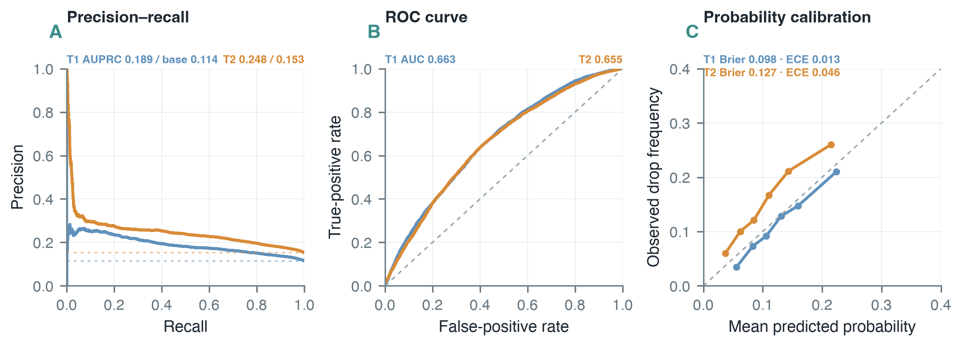
Figure 6. Prospective classification diagnostics. Precision–recall and receiver-operating-characteristic curves demonstrate discrimination above prevalence and chance references in both test periods; reliability curves report block-specific calibration. Final Brier scores were 0.0982 and 0.1268.
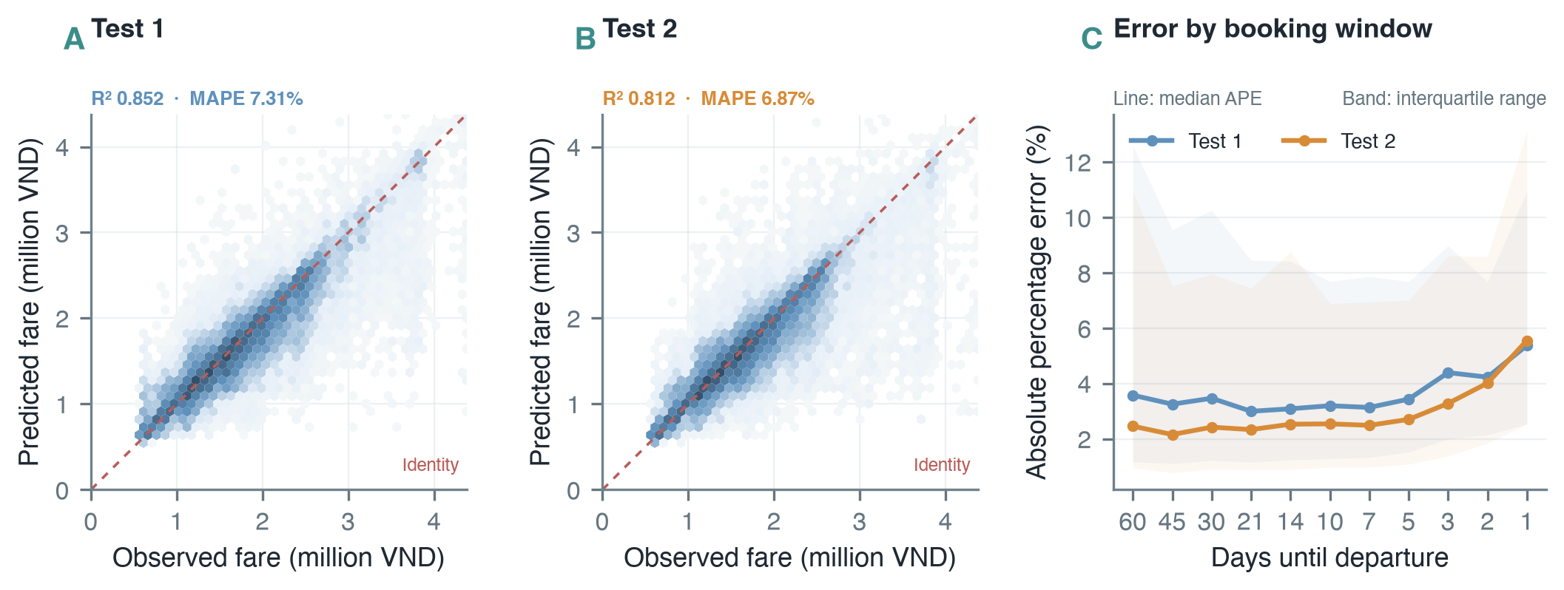
Figure 7. Prospective regression diagnostics. Predicted and realised fares remained closely aligned in both tests, with R² of 0.852 and 0.812 and MAPE of 7.31% and 6.87%; booking-window panels reveal residual heterogeneity concealed by pooled averages.
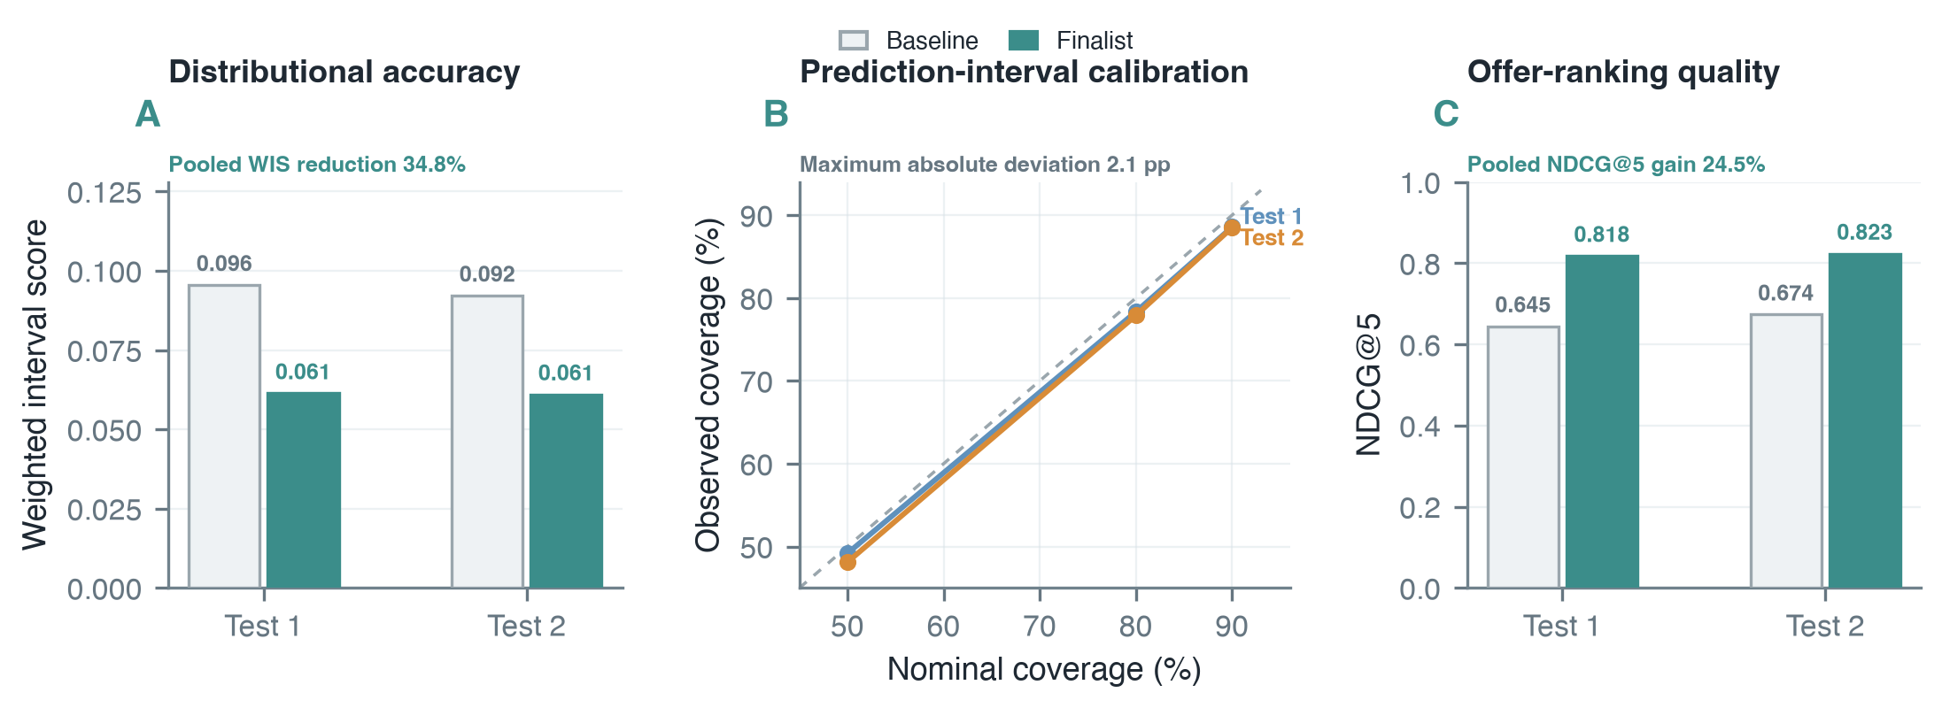
Figure 8. Prospective probabilistic-forecasting and ranking diagnostics. Finalists reduced pooled WIS by 34.8% and increased pooled NDCG@5 by 24.5% relative to prediction-time-valid baselines; maximum absolute interval-coverage error was 2.1 percentage points.

References
Bracher, J., Ray, E.L., Gneiting, T. and Reich, N.G. (2021) ‘Evaluating epidemic forecasts in an interval format’, PLOS Computational Biology, 17(2), e1008618. [Online]. [Accessed 24 August 2026]. Available from: https://doi.org/10.1371/journal.pcbi.1008618.
Etzioni, O., Tuchinda, R., Knoblock, C.A. and Yates, A. (2003) ‘To buy or not to buy: mining airfare data to minimize ticket purchase price’, in Proceedings of the Ninth ACM SIGKDD International Conference on Knowledge Discovery and Data Mining, pp. 119–128. [Online]. [Accessed 24 August 2026]. Available from: https://doi.org/10.1145/956750.956767.
Gorishniy, Y., Rubachev, I., Khrulkov, V. and Babenko, A. (2021) ‘Revisiting deep learning models for tabular data’, in Advances in Neural Information Processing Systems, 34, pp. 18932–18943. [Online]. [Accessed 24 August 2026]. Available from: https://proceedings.neurips.cc/paper/2021/hash/9d86d83f925f2149e9edb0ac3b49229c-Abstract.html.
Groves, W. and Gini, M.L. (2015) ‘On optimizing airline ticket purchase timing’, ACM Transactions on Intelligent Systems and Technology, 7(1), article 3. [Online]. [Accessed 24 August 2026]. Available from: https://doi.org/10.1145/2733384.
Järvelin, K. and Kekäläinen, J. (2002) ‘Cumulated gain-based evaluation of IR techniques’, ACM Transactions on Information Systems, 20(4), pp. 422–446. [Online]. [Accessed 24 August 2026]. Available from: https://doi.org/10.1145/582415.582418.
Kalampokas, T., Tziridis, K., Kalampokas, N., Nikolaou, A., Vrochidou, E. and Papakostas, G.A. (2023) ‘A holistic approach on airfare price prediction using machine learning techniques’, IEEE Access, 11, pp. 46627–46643. [Online]. [Accessed 24 August 2026]. Available from: https://doi.org/10.1109/ACCESS.2023.3274669.
Santana, E.J., Mastelini, S.M. and Barbon Jr., S. (2017) ‘Deep regressor stacking for air ticket prices prediction’, in Proceedings of the XIII Brazilian Symposium on Information Systems, pp. 25–31. [Online]. [Accessed 24 August 2026]. Available from: https://doi.org/10.5753/sbsi.2017.6022.
Tziridis, K., Kalampokas, T., Papakostas, G.A. and Diamantaras, K.I. (2017) ‘Airfare prices prediction using machine learning techniques’, in Proceedings of the 25th European Signal Processing Conference (EUSIPCO), pp. 1036–1039. [Online]. [Accessed 24 August 2026]. Available from: https://doi.org/10.23919/EUSIPCO.2017.8081365.
Wang, T., Pouyanfar, S., Tian, H., Tao, Y., Alonso Jr., M., Luis, S. and Chen, S.-C. (2019) ‘A framework for airfare price prediction: a machine learning approach’, in Proceedings of the 20th IEEE International Conference on Information Reuse and Integration for Data Science, pp. 200–207. [Online]. [Accessed 24 August 2026]. Available from: https://doi.org/10.1109/IRI.2019.00041.

