# Assignment1a

**COS20019**

**Cloud Computing Architecture**



**Student ID: 104198996**

**Student Name: Lau Ngoc Quyen**

**Task 1:**

Step 1: I created an instance in EC2

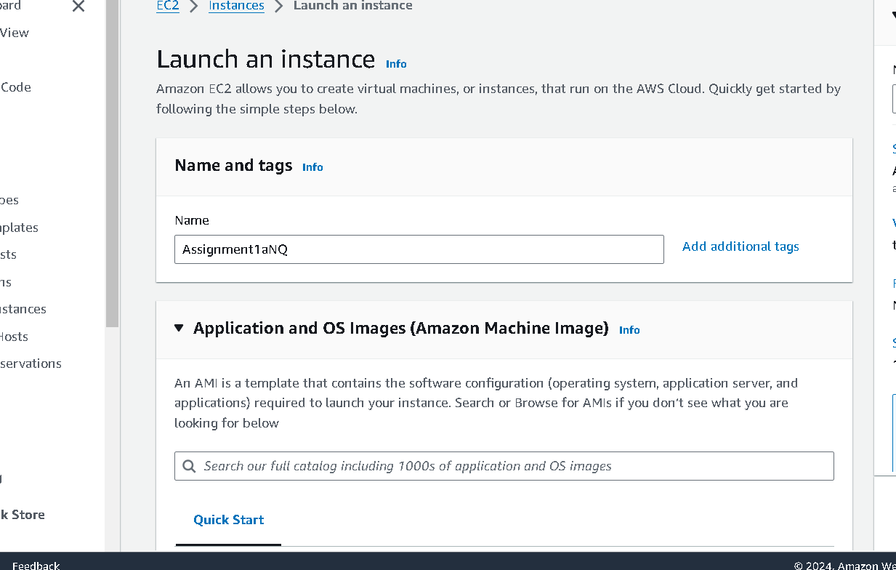

Step 2: Select all the Assignment 1 task 1 requirements

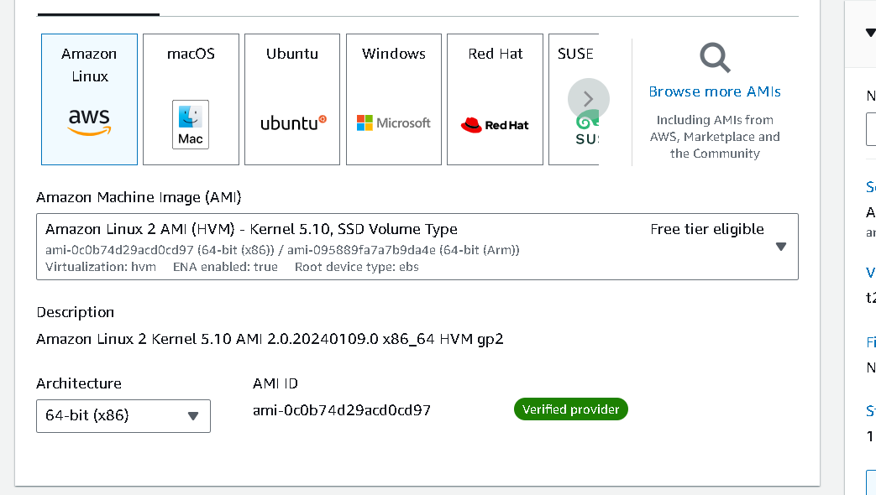

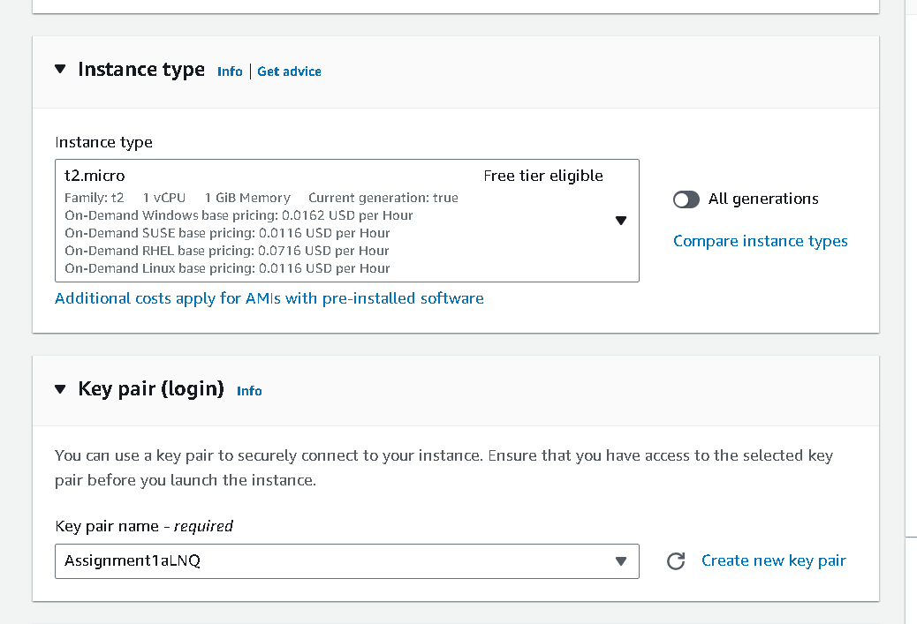

Step 3: Finish Lauching Instance and I drag the DNS into the file to

open the phpinfo.php file

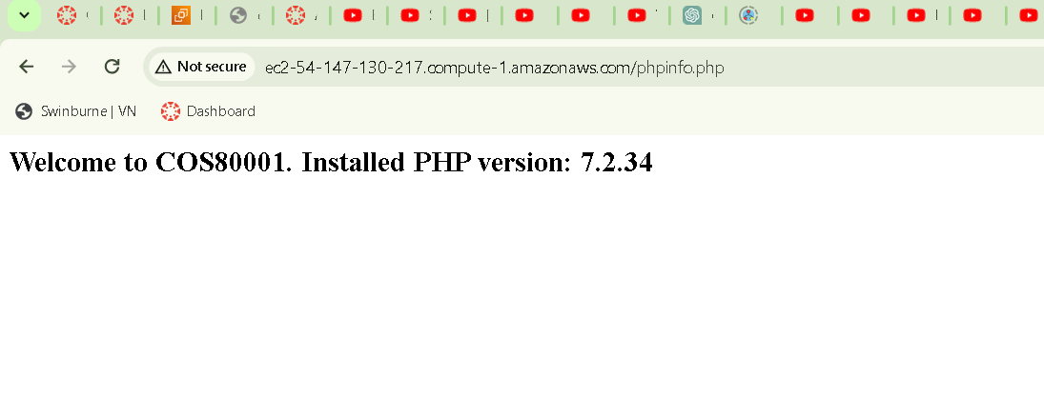

Step 4 : Stop the Lauching Instance

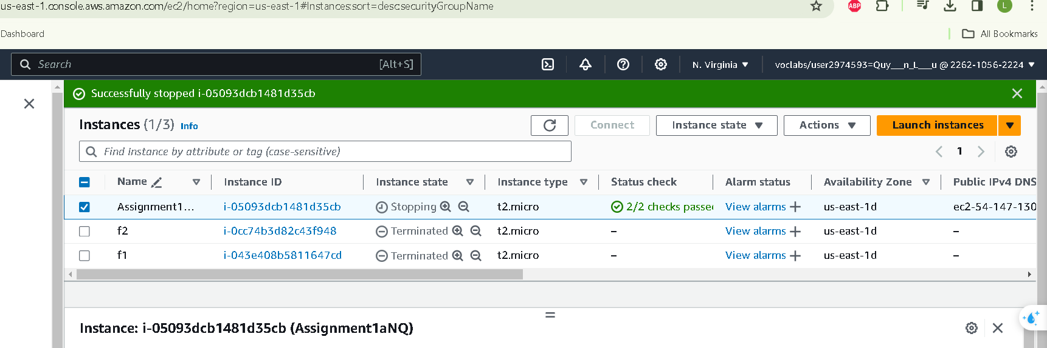

**Task2 :**

**Photoloader.php s**

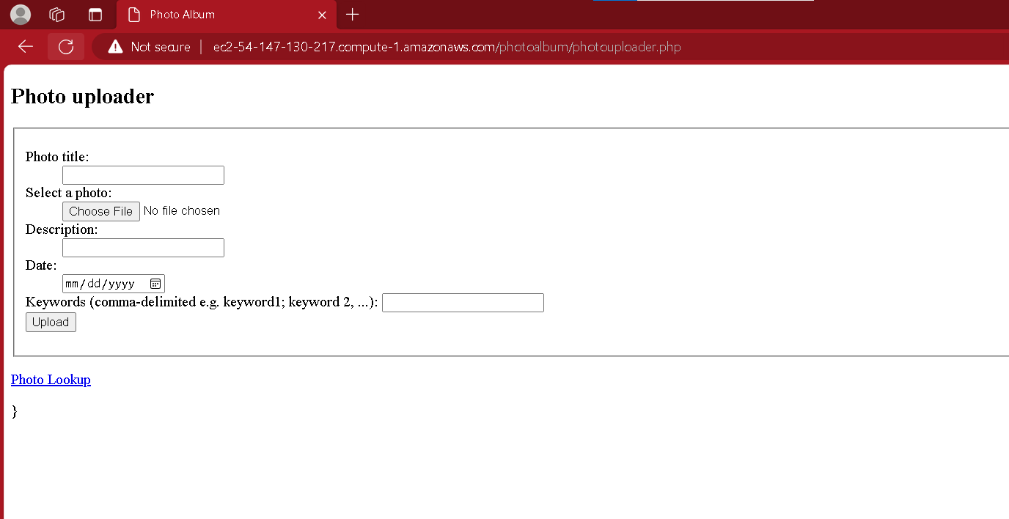

**Photolookup.php**

